Your First Java Program - Part 2!

- public class MyFirstProgram {
- public static void main(String[] args)
- {
- System.out.println("Hello, world!");
- }
- }

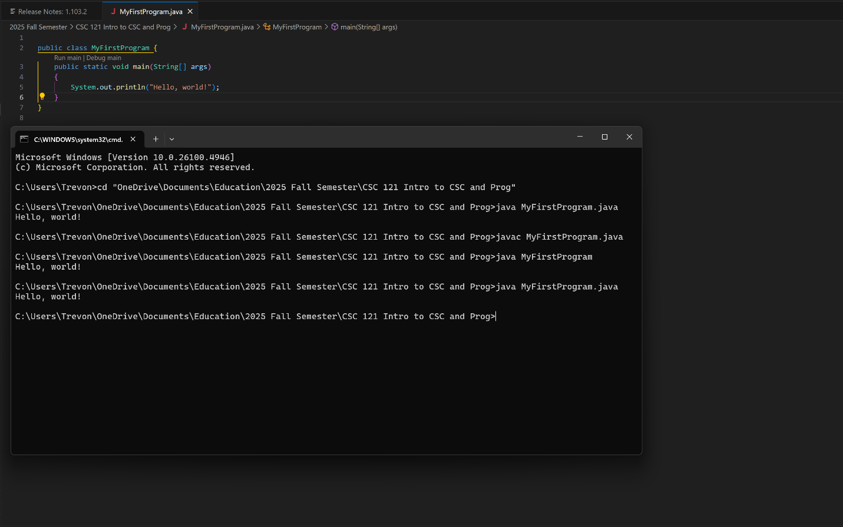

Key Vocabulary
- This part of the computer fetches instructions, carries out the operations commanded by the instructions, and produces some outcome or resultant information.
b. CPU
- A byte is made up of eight
d. bits
- Each byte is assigned a unique
a. address
- This type of memory can hold data for long periods of time—even when there is no power to the computer.
c. secondary storage
- If you were to look at a machine language program, you would see _________.
b. a stream of binary numbers
- This type of program is designed to be transmitted over the Internet and run in a Web browser.
b. applet
- These are words that have a special meaning in the programming language.
c. key words
- These are symbols or words that perform operations on one or more operands.
d. operators
- These characters serve specific purposes, such as marking the beginning or ending of a statement, or separating items in a list.
a. punctuation
- These are words or names that are used to identify storage locations in memory and parts of the program that are created by the programmer.
b. programmer-defined names
- These are the rules that must be followed when writing a program.
a. syntax
- This is a named storage location in the computer’s memory.
c. variable
- The Java compiler generates __________.
b. byte code
- JVM stands for __________.
d. Java Virtual Machine

Short Answer
- Both main memory and secondary storage are types of memory. Describe the difference between the two.
Main memory is volatile and extremely fast. It will handle most of the I/O activity while the computer is on and needs things stored to execute properly. Secondary storage in nonvolatile and much slower than main memory, so it is used for information that should persist across boots of a computer.
- What type of memory is usually volatile?
Main memory is usually volatile.
- What is the difference between operating system software and application software?
Operating system software are programs that manage the hardware of a computer and their processes. Application software are the programs that make a computer useful to its user.
- Why must programs written in a high-level language be translated into machine language before they can be run?
Machines only communicate in 0s and 1s as that’s how their memory is stored. All the letters and other numbers mean nothing since they can’t really be stored on the computer as anything other than a set of 0s and 1s.
- Why is it easier to write a program in a high-level language than in machine language?
Humans don’t communicate in 0s and 1s, so this would be very hard for us when we try to create instructions and share that code with others to work on. High-level languages are also independent of the processors computers have, which make it easier to write instructions for a variety of computers.
- What is a source file?
It is a file with the set of instructions, written in one of the various programming languages, that a compiler can translate into an executable form.
- What is the difference between a syntax error and a logical error?
Syntax errors are when the programmer breaks the rules of the programming language. Logical errors are when the instructions create erroneous behavior.
- What is an algorithm?
An algorithm is a set of instructions that perform a task.
- What is a compiler?
A compiler is a program that translates source code into an executable form.
- What is the difference between an application and an applet?
An application is stand-alone software that can be run on the computer. An applet is a small bit of software that must run on a web browser.

- Are Java applets still widely used today? Are they safe?
Yes, applets are still used to enhance the capabilities of web browsers. They are safe because they only run within the environment established for them by the Web browser.
- What must a computer have in order for it to execute Java programs?
The JVM.
- What is the difference between machine language code and byte code?
Machine language code can be read directly by the CPU while byte code can only be read by the JVM.
- Why does byte code make Java a "portable" language?
The byte code allows the instructions to be the same across different types of computers. This allows one computer to make the code and any kind of computer with a JVM is able to read that.
- Is encapsulation a characteristic of procedural or object-oriented programming?
Encapsulation is a characteristic of object-oriented programming. It is the action of taking data and methods and putting them into one object.
- Why should an object hide its data?
It prevents accidental corruption.
- What part of an object forms an interface through which outside code may access the object’s data?
The object’s methods.
- What type of program do you use to write Java source code?
A text editor.
- Will the Java compiler translate a source file that contains syntax errors?
No.

- What does the Java compiler translate Java source code to?
The Java compiler translates Java source code into bytecode that the JVM will not read.
- Suppose you have just written a Java program in a file named "LabAssignment.java". Assuming you are using the JDK, what command would you type at the operating system command prompt to compile the program LabAssignment.java?
javac LabAssignment.java
- Assuming there are no syntax errors in the LabAssignment.java program when it is compiled, answer the following questions.
  - What file will be produced?
A .class file
  - What will the file contain?
The instruction you wrote in the “LabAssignment.java” in bytecode form.
  - What command would you type at the operating system command prompt to run the program
java LabAssignment

