NLP


CP#3
NAME: INSHRAH ALAM
ROLL NUM:L1F22BSCS0384
SEC : G3

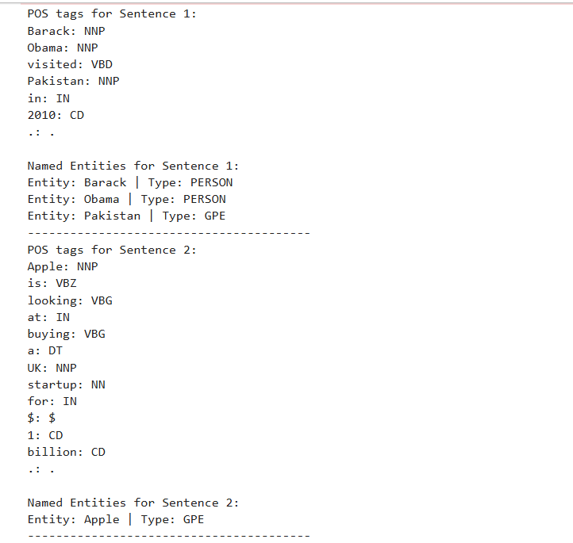
POS Tagging AND Named Entity Recognition (NER) using NLTK OUTPUT:

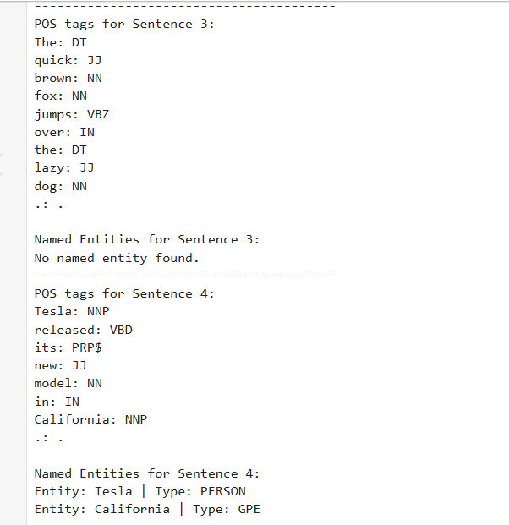

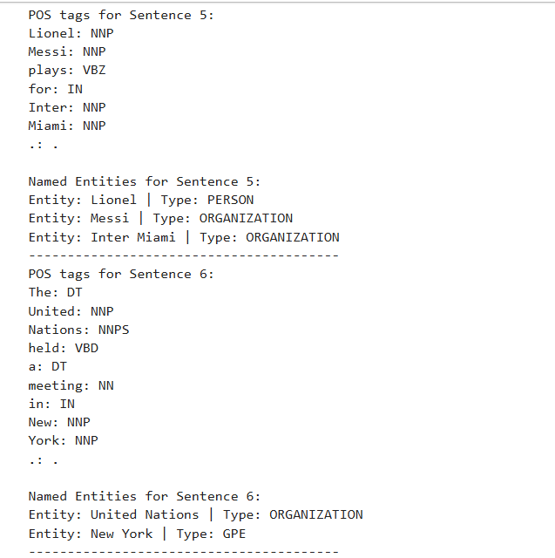

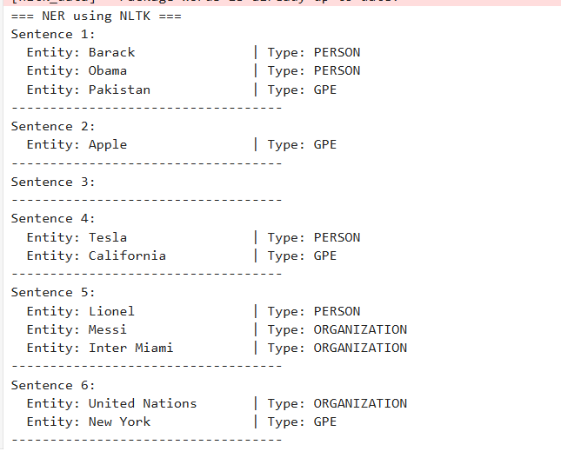

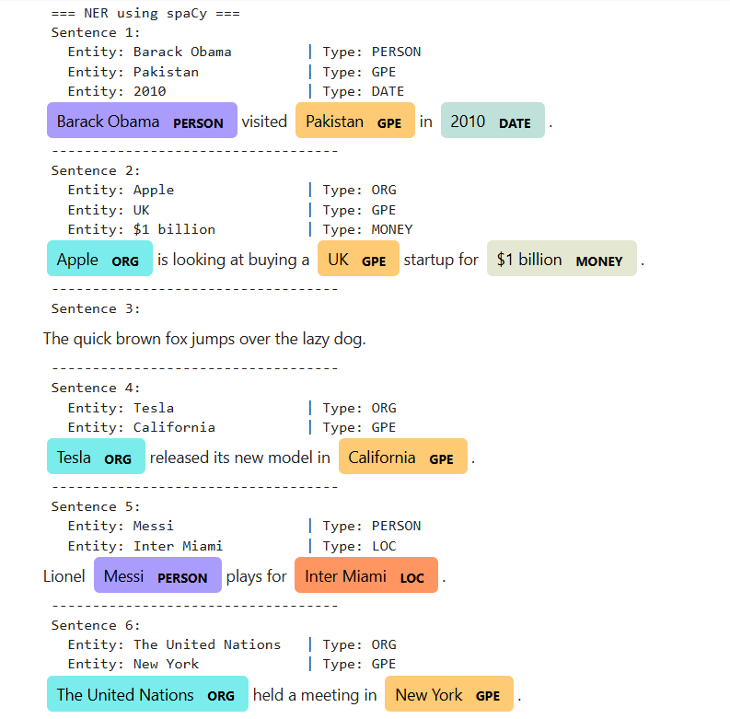
BONOUS POINT:

Task 4: Compare Results (POS Tags vs. NER Results)
Which sentences contain the most named entities?
Sentences 1 (“Barack Obama visited Pakistan in 2010.”),
2 (“Apple is looking at buying a UK startup for $1 billion.”),
4 (“Tesla released its new model in California.”),
5 (“Lionel Messi plays for Inter Miami.”),
and 6 (“The United Nations held a meeting in New York.”) contain the most named entities.
These sentences mention multiple people, organizations, and locations, which are detected as entities by NER tools.

Why are some sentences more entity-rich than others?
Some sentences are more entity-rich because they refer to specific names of persons, organizations, or places
these are the main categories NER models recognize, like PERSON, ORGANIZATION, and GPE (Geo-Political Entity).
For example, Sentence 3 (“The quick brown fox jumps over the lazy dog.”) contains only common nouns and adjectives, with no real-world named entities, so NER finds nothing there. Sentences that mention recognizable names or locations will always have more named entities

