Volobuev Oleg | Frontend developer

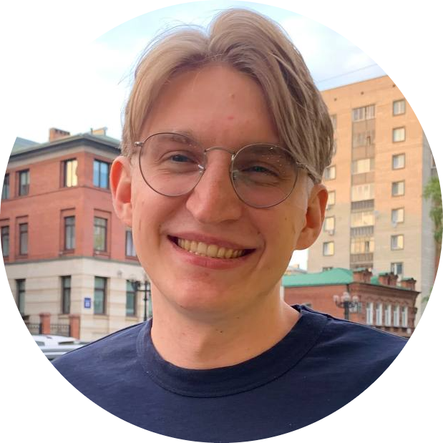

I'm an aspiring self-taught front-end developer. In the past, I have been working in Industrial and Civil engineering as a structural engineer and an Architect.

As for now, I'm Looking for job as FrontEnd Developer. All acquired skills you can reach below.

In early May of 2022, I have passed async [Profession React Developer](https://htmlacademy.ru/profession/react), which includes 3 complex courses as:

* [Professional development of web interfaces using JavaScript](https://htmlacademy.ru/intensive/javascript);

* [Architecture of client applications](https://htmlacademy.ru/intensive/ecmascript);

* [Development of complex client applications using **React**](https://htmlacademy.ru/intensive/react).

[Telegram](https://t.me/oleeeeeeeeeeg)

[Email](mailto:VolobuevBP@ya.ru): VolobuevBP@ya.ru

[GitHub](https://github.com/Insid1/): [Link](https://github.com/Insid1/)

[LinkedIn](https://www.linkedin.com/in/oleg-volobuev-aa6898153/): [Link](https://www.linkedin.com/in/oleg-volobuev-aa6898153/)

**Key Skills**

• JavaScript (ES6+ standard)

• TypeScript

• Node.js

• React (RFC)

• React router

• Redux

• Redux Toolkit

• Flux

• MVP(MVC) Architecture

• WebPack

• Fetch API

• REST API

• DOM API

• React Testing Library

• Axios

• Jest

• MVP(MVC) Architecture

• GIT

• Docker

• BEM methodology

• Responsive Design

• HTML

• Unit testing

• ESLint

• CSS

• SCSS/SASS

• Material UI

• ServiceWorkers

• English (Upper-Intermediate)

• Python (v.3+)

• JAVA Core, EE

• FIGMA (for markup)

• npm

• External API and libraries (leaflet, flatpickr, lodash, dayjs, chartjs)

**Job experience**

* [S](http://six-cities-gamma.vercel.app/)crile. Fullstack developer (May 2022 – current time)

Scrum framework with agile methodology. Engagement with 2 different projects.

Crosschecked code-review in team.

Most of the work was with frontend.

**Frontend stack:** React(hooks), redux, RTK, MUI, Typescript. HTML, SCSS, JSP.

**Backend stack:** Java EE, Spring, Docker, Docker-compose.

**Pet-Projects**

* Escape Room. React App [GitRepo](https://github.com/Insid1/escape_room)

SPA for company that works with offline quests with different levels of complexity and thematic.

**STACK**: *TypeScript, React, Redux, ReduxToolKit, react-hook-form, StyledComponents, Axios, WebPack, Lodash, EsLint, JSONServer, leaflet, re-reselect*

* [Rick and Morty.](http://rick-and-morty-app-mu.vercel.app/) React App [GitRepo](https://github.com/Insid1/Rick-and-morty-app)

Application to navigate through Rick and morty characters, episodes and locations.

***STACK****: React, Redux, ReduxToolKit, Material UI, TypeScript, Axios, WebPack, Lodash, EsLint*

* [SixCities](http://six-cities-gamma.vercel.app/). React App [GitRepo](https://github.com/Insid1/Six_Cities)

Six Cities is a service for travelers. Choose one of the six popular cities to travel to and get an up-to-date list of rental offers. Detailed information about housing, the display of the object on the map, as well as the concise interface of the service will help you quickly choose the best offer.

**STACK**: *React, Redux, JavaScript ES6, Jest, Axios, React Testing Library, WebPack, CSS3, HTML5, Leaflet*

* [BigTrip](https://insid1.github.io/Big_Trip/). SPA [GitRepo](https://github.com/Insid1/Big_Trip)

The SPA service helps to plan a detailed trip route, calculate the cost of travel and get information about attractions. SPA project was performed without any framework. It represents MVP architecture with OOP principles and offline mode through service workers.

**STACK**: *JavaScript ES6, OOP, MVP, REST API, ServiceWorkers, WebPack, CSS3, HTML5*

* [KeksoBooking](https://insid1.github.io/keksoBooking/). Application [GitRepo](https://github.com/Insid1/keksoBooking)

A service is created to place ads for renting real estate in the centere of Tokyo. Users can place ads about their real estate or see already placed ads.

**STACK**: *JavaScript ES6, WebPack, CSS3, HTML5*

**Education**

* **Master Of Science (2018-2020)** – «Civil Engineering» with a specialization in Structural mechanics.

**Uni**: *National Research University Moscow State University of Civil Engineering.*

* **Bachelor Of SCIENCE (2014-2018)** – «Civil Engineering»

with a specialization in Soil Mechanics and Geotechnics

**Uni**: *National Research University Moscow State University of Civil Engineering.*

**Extra information and certificates**

**Not related job experience you may see on my** [**LinkedIn**](https://www.linkedin.com/in/oleg-volobuev-aa6898153/) **profile.**

**JavaScript learning source:** [**React Developer Profession**](https://htmlacademy.ru/profession/react) [MDN](https://developer.mozilla.org/ru/), [Learn.JavaScript](https://learn.javascript.ru/).

**Computer Science + Python learning source (Certificates):**

[Introduction to Computer Science and Programming](https://courses.edx.org/certificates/73e17081e08e49d598fce4b9b58fa032);

[Using Databases with Python](https://coursera.org/share/3a83d44e866bd8e499dba03024b1117f), [Using Python to Access Web Data, Python Data Structures](https://coursera.org/share/394ac080edbc6d08e6a5082d2de5a43a); [Capstone: Retrieving, Processing, and Visualizing Data with Python](https://coursera.org/share/0d162f33e0b5a0c3cff9c23fa3c62b38)