Kaggle Dataset: https://www.kaggle.com/datasets/sobhanmoosavi/us-accidents

Traffic Accident Analysis and Risk Prediction

Problem: Identify factors that contribute to traffic accidents and predict high-risk areas

Data cleaning:
- Handle any missing data with pr
  - Median imputation for numeric features
  - Most-frequent imputation for categorical features
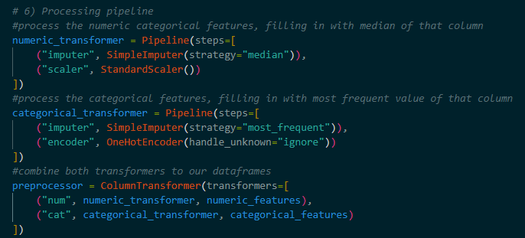
- Only processed data from Georgia
- New temporal features
  - Hour
  - DayOfWeek

Pattern discovery:
- Correlation of accidents with weather, time of day, location, and vehicle type
- Weather & visibility strongly correlated with accident frequency.
- Rush-hour peaks (7–9 AM and 4–6 PM) showed the highest risk.
- Urban concentration: accidents cluster around Atlanta metro areas.
- Severity distribution:
  - Severity 1 = rare (< 1%)
  - Severity 2 ≈ 50%
  - Severity 3 ≈ 45%
  - Severity 4 ≈ 4%

Predictive modeling:
- Classification of high-risk vs low-risk zones
- Regression for accident counts
- Logistic regression
- Random Forest -> best performer
- K-Nearest Neighbors

Visualization:
- Heatmaps of accident locations
- Bar plots of accidents by weather conditions

Recommendations:
- Road safety interventions
- Targeted traffic management
- Driver awareness campaigns
- New locations for first responders

Future Additions:
- Include real-time weather + traffic feeds for dynamic prediction.

NOTES
1) Where accidents happen a lot (hot spots)– see if it makes sense to have a new location of first responders closer to these areas
2) Potentially station police officers in high risk areas depending on the weather to caution drivers to drive safer for current conditions
3) Poster/public announcement campaigning for drivers to drive better
Use the model to predict if the current day is high risk or low risk

For binary classification confusion matric random forest
- If we did it based on each of the 4 individual severities, wouldn’t be as accurate bc approx 50% of total accidents in dataset rated severity 2
- Therefore we categorized the severity into low (1-2) and high (2-4)

Column Name | Description
ID | Unique identifier of the accident record
Severity | Severity of the accident (1 to 4; 1 = least impact, 4 = greatest)
Start_Time | Start time of the accident (local timezone)
End_Time | End time (when the impact on traffic is dismissed)
Start_Lat | Latitude of the start point
Start_Lng | Longitude of the start point
End_Lat | Latitude of the end point
End_Lng | Longitude of the end point
Distance(mi) | Road extent affected by the accident (in miles)
Description | Natural language description of the accident
Number | Street number in the address
Street | Street name in the address
Side | Side of street (Right / Left)
City | City in address
County | County in address
State | State in address
Zipcode | Zip code in address
Country | Country in address
Timezone | Time zone of the accident location
Airport_Code | Nearest airport weather station code
Weather_Timestamp | Timestamp of the weather observation (local time)
Temperature(F) | Temperature in Fahrenheit
Wind_Chill(F) | Wind chill in Fahrenheit
Humidity(%) | Humidity as percentage
Pressure(in) | Air pressure (inches)
Visibility(mi) | Visibility (miles)
Wind_Direction | Wind direction
Wind_Speed(mph) | Wind speed in mph
Precipitation(in) | Precipitation in inches
Weather_Condition | Weather condition (e.g. rain, snow, fog, etc.)
Amenity | Indicates if there is an amenity nearby
Bump | Indicates presence of speed bump / hump nearby
Crossing | Indicates presence of crossing nearby
Give_Way | Indicates presence of give_way nearby
Junction | Indicates presence of junction

