ReadMe-Methods created 03/29/01


Welcome to the National Library of Medicine Insight Segmentation and Registration Toolkit (ITK).
This document provides a description of the methods implemented in the Toolkit.

INTRODUCTION 1
What is ITK? 1
What Methods are in ITK? 1
SEGMENTATION 4
Philosophy and Taxonomy 4
Data Representations 4
Density Functions 4
Classifiers and Clusterers 4
Examples 4
REGISTRATION 5
Philosophy and Taxonomy 5
Methods 11
IMAGE PROCESSING 12
Philosophy and Taxonomy 12
Filters 12
Pixel Operations 12
APPENDIX (Unsupported) 13
ImageIO: Design of an Extensible Image Input/Output Library 13

INTRODUCTION

What is ITK?
ITK is an open-source software toolkit for performing registration and segmentation. Segmentation is the process of identifying and classifying data found in a digitally sampled representation. Typically the sampled representation is an image acquired from such medical instrumentation as CT or MRI scanners. Registration is the task of aligning or developing correspondences between data. For example, in the medical environment, a CT scan may be aligned with a MRI scan in order to combine the information contained in both.

For more information see the file Insight/Documentation/README.

What Methods are in ITK?

ITK contains a mixture of “tried and true” techniques as well as some “research” methods. Regarding the methods, ITK’s goal is not to provide a complete set of methods, but instead, it seeks to provide a class hierarchy that directly supports specific segmentation and registration taxonomies and yet does not limit the exploration of novel methods.

Each section of this document provides an introduction and explanation of the philosophy and taxonomy that drove the class development.

Method highlights include:

Registration
Class hierarchy de-couples metric, transformation, and optimization algorithms
Metrics:
Mutual Information
Least-squared Difference
Landmark Distance
Transformations
Affine
Translation
Kernel-based (e.g., Elastic-Body Splines and Thin-Plate Splines)
Optimization Algorithms
Conjugate Gradient
Gradient Descent
Levenberg Maquardt
Amoeba

Segmentation
Class hierarchy being implemented
Data storage
Dense and Sparse Histograms
PointSets
Images as data containers

Image Processing
Contrast Enhancement
Power-law Adaptive Histogram Equalization

SEGMENTATION

Philosophy and Taxonomy

Data Representations

Density Functions

Classifiers and Clusterers

Examples

REGISTRATION

Philosophy and Taxonomy
The purpose of this part is to suggest an architecture for image registration tasks using ITK. It is, thus, a high-level document containing only tentative class descriptions and no other aspects of implementation.

Introduction

It is interesting to note that few, if any, of the generally available textbooks on image processing contain a chapter on registration. One has to look to the robotics literature, and there the treatment is necessarily slanted to the peculiar demands of robot vision. (This partly explains the length of this document). Petra van den Elsen, et. al1, have proposed a taxonomy of registration techniques, with particular emphasis on the matching of medical images. Her categories may be used as a starting point to clarify the capabilities that must be provided in the development of a registration component of Insight. However, she does not list all possibilities.

The process of image registration, is in general an optimization task. It takes two images, a reference and a target, and determines the "best" spatial transformation to apply to the reference to make it fit the target image. For some kinds of registration, direct computation of a transformation is possible, referred to by van den Elsen as "direct parameter determination". This can however, be considered to be a degenerate subcase of the general optimization framework. The process of registration can be diagrammed as the following pseudo-program.

input images;
initialization;
while (metric is unsatisfactory)
{
compute transformation;
apply transformation;
compute metric;
apply user control;
};
output result;

For our purposes, registrations should never be considered automatic. This means that there will always be either user-assisted initialization, guidance by the user during refinement, or both. Such methods are termed semi-automatic. Purely interactive methods may be considered a degenerate case, in which no automatic processing occurs. In the pseudo-program, the user's control is applied in the inner loop, but this is, of course, a simplification. It may, for example happen that some number of steps are performed automatically before the user's help is needed. It may also be initiated by the user's interrupting the loop to make adjustments, when he sees that guidance is needed.

This loop is also a simplification in another way: it implies that the images are entirely treated in each cycle; this is often not true. For example, the refinement may occur in a down-through-scale manner. Or, it may start at landmark correspondences provided in the initialization phase, broadening from there to cover all pixels of the input images. A registration also may consist of a series of refinements, each using a different matching method. For example, a gross rigid registration may be followed by an affine warp, which is in turn followed by a set of local adjustments. In a sense then, the pseudo-program may be executed several times in succession, each time getting closer to the desired result.

The first step, reading the input images, needs little explanation, but is not entirely straight forward. Either or both the input images may require resampling and interpolation to make them commensurate. They typically will not overlap exactly, and thus their intersection will have to be determined. Of course the functions and values needed to convert between image (i.e. pixel) space to the real world (i.e. patient) coordinates, usually given in cm. from some designated origin, must be available. Finally, various kinds of preprocessing of the intensities may be needed to improve the reliability of the following registration. A typical example of this is removal of bias field artifacts from MRI images prior to registration.

The initialization phase may include the specification of pairs of landmarks, as mentioned above. Other actions are often included, however. Typically, regions of interest will be specified, within which the registration is to take place, the user not caring about the quality of registration outside of these regions. Notice that specification of the region of interest may require a partial segmentation of the image, which will generally be done as a preliminary step prior to running the actual registration program. In the initialization phase, other computation-intensive operations may take place, such as the generation of pyramids from the raw images or distance maps from models. Starting values for the optimization and transformation parameters must also be specified.

The first step in the loop, computation of the transformation, is short hand for several possible methods. It may imply special techniques for sampling the image, for example, stochastic sampling, to be employed in the next step. Thus, these two steps may be interdependent. There may not be a single transformation specification, such as a transformation matrix, but may be a set of them, a general vector field or other alternatives. The transformation usually will not be applied by actually warping the image to get another image inside the loop. Rather, it can be viewed merely as a mapping used whenever transformed pixels are needed, for display purposes and especially for computation of the metric. It is important to realize that the transformation may not be an invertible function, which will affect which image is designated the target and which the reference.

The metric may include may factors, of course, and should not necessarily be considered to be a single number. This is principally dependent on the optimization method built into this loop: a genetic algorithm will have a considerably different metric than gradient descent. Determination of the value of the metric will often include a comparison of samples taken from the target image and the transformed reference image. Thus, it will often be an image match operation.

Notice that a sampling method will rarely be as simple as looking up the intensity of a pixel. At a minimum, it will typically involve interpolation, of which there are several different useful methods. One may expect samples to be randomly drawn from the ROI, and the set of all samples taken will usually be a subset of the ROI. Samples will be taken at a specific scale, either explicitly or implicitly specified.

The application of user control will typically result in a partial or complete re-initialization, and thus results in a breaking out of the loop with subsequent re-entry from above.

The output stage may consist of production of a mapping of the one image, transformed so that it is registered to the other image. It will usually include the specification of the mapping, which maybe as simple as a transformation matrix and as complex as a vector field. In a general toolkit like ITK, both capabilities will be needed.

Finally, a brief word about display. Although the display of the images is not a function of the ITK project, it can have a significant impact on registration methodology because registration must typically be done under user control, with the user able to see the intersecting image volumes or slices. Fast access to the original and transformed images in the same space is necessary. Also, information associated with the images, but not part of them, such as contours of objects, may need to be transformed using the same parameters applied to the images.

Architecture

Using these considerations, a software architecture to perform registration tasks will now be suggested.

The first thing to recognize is that optimization, while central to registration, may be a separate issue. It will often be preferable to separate the highly specific needs of optimization software design from the application to which it is to be applied. Thus a separate optimization library, within or external to ITK, must be available, at least to contain the more complex optimization algorithms. If designed properly, there should be little loss of performance by this approach. Even if the code for optimization is written directly into the final version of a program, having library implementations available may expedite prototyping. Probably it makes sense for most registration classes to contain default optimization, which may still take the form of calls to an external optimization library. If so, they may also provide methods for specifying an alternate, external optimizer. With some algorithms, the mathematics of optimization and of registration are so intertwined that the use of external optimization will not be possible.

The capabilities of reading and writing images, interpolating missing slices, converting pixel coordinates to patient coordinates and back, and designating and working with a region of interest must all be contained in ITK. The less essential auxiliary capabilities of the specification, transformation, and I/O of contours should also be present, but may be provided later. Designers should, however, keep the need for them in mind.

In designing an architecture, we need not worry about the dimensionality of the input images: if we assume all methods work in 3D, we will have covered 2D adequately (in the implementation this will be an issue, of course). Based on the cited reference, we now have four criteria to consider:

1. Intrinsic or extrinsic image properties
2. Global versus local transformation domain
3. Elasticity of transformation: rigid, affine, projective, or curved
4. Tightness of coupling: interpolating or approximating.

The first of these refers to the possible use of external fiducials applied at image collection time. If external markers are applied before the patient is scanned, they may be used as landmarks for rapid registration. The actual determination of these landmarks is a segmentation task that can be performed prior to registration. All that then remains is the generation of the transformation based on the landmark coordinates. The other situation is when anatomical features contained in the images are used for registration. This too will require prior segmentation and must usually be done manually or under interactive control. The first criterion, then, will have no significant effect on the design of the registration architecture and need not be considered further here.

The second criterion essentially determines whether there is a single transformation or multiple transformations. If the architecture is formulated to support multiple regions of interest, each with a separate mapping, then the global case will automatically be supported. The only significant issue will be in how the disparate regions will be connected after a single registration step, while avoiding overlap and the introduction of holes.

Tightness of coupling refers to the kind of transformation used. Interpolating methods assume no error in the location of image properties, such as pixel intensity, while approximating methods determine the transformation by spreading error over the image properties. Correlation methods, for example, are approximating. Since the tightness of coupling is a property of the method, it can be considered in combination with the third criterion.

Now as an illustration, let's imagine what a program to do registration might look like. It must first create two image objects, into which the input images will be read. (Actually, it should also be possible to register sets of points, so the reference and target objects should not be limited to images). Their mappings to and from patient coordinates will be assumed to be stored in the objects. If the registration requires pyramids, these must also be computed. Any required regions of interest must be specified.

A transformation object must be defined, which will be dependent on the registration method and will be used by the optimization methods to be employed. Thus a class hierarchy for all of these will be needed. Notice that in some cases it might be possible to compose the registration transformation with the image space to patient space transformations, but in general this cannot be done and doing so will not gain significant speed, so architecturally it would be a poor choice.

There is a choice of where to put the optimization loop, in the registration method or in the optimization library with callbacks provided to allow the optimizer to get the information it needs from the application. Both methods could be supported, and the choice is merely an implementation decision. Note that allowing the use of external optimizers would provide significant flexibility. The contents of the loop will, of course, have to be specified in the registration program. In this example, it will be clearest to assume that the loop is external to the optimization code.

Code to compute a metric inside the loop will be needed. This and the transformation object collectively define the essence of the registration method (the optimization method is also important, of course). The application of user control simply will be a call to a callback function provided by the user.

Computation of the resulting image will consist of application of the refined transformation object to the input image after completion of the loop. This may also be necessary at various times during the loop, if an interactive application is desired. A capability for writing the final transformation to a file should also be provided in the transformation class.

The following sample pseudo-program will help clarify these ideas.

AffineMIRegistration::find_next_warp(Image & reference, Image & target)
{
... // Determine the next best transformation using
... // the intensities.
}

float AffineMIRegistration::metric(Image & reference, Image & target)
{
... // Compute a metric based on comparing the transformed
... // reference image to the target using mutual information.
}

void AffineMIRegistration::register(Image & reference, Image & target)
{
while (gdopt.evaluate(metric(reference, target)))
{
find_next_warp(reference, target);
test_for_user_interaction();
}
}

void query_user()
{
... // Handle feedback from the user
}

int main()
{
Image reference("file1");
Image target("file2");
AffineMIRegistration areg; // Affine mutual information registration
GradientDecentOptimizer gdopt;
areg.initialize(); // Start with the unity transformation.
areg.setOptimizer(gdopt);
areg.SetUserCallback(query_user);
areg.register(reference, target);
areg.save_transformation(); // Output the transformation matrix
Image result = areg.map(reference);
result.save(); // Output the transformed reference image
}

The registration method clearly has three basic categorizations, the kind of transform (here, affine),the kind of metric (e.g. mutual information), and the kind of optimization (e.g. gradient descent).The loop is an integral part of the registration method. The metric must take into account the transformation, which would be stored inside the AffineRegistration object in this example.

In order to implement these categorizations, we propose to use the “strategy” pattern described by Gamma, et. al2. A strategy allows selecting among a variety of behaviors, all providing the same capability. For example, the general API of all optimizers would be the same, but the internal implementations would define a specific behavior. It then becomes easy to select at compile time which specific optimization algorithm will be used. The same idea applies to the metrics, so that a choice between mutual information or intensity correlation is easily supported.

The choice of kind of registration determines the kind of transform used. Essentially, the name of the registration class indicates both the algorithm and the kind of transformation used. Because registration can be determined by a mapping of a few points, as by with transformation matrix, or by a general vector field over the image space, the transform classes (not explicitly shown in the program above) must act as filters for these kinds of objects. The registration method classes thus will all use one or more transformation method classes.

At this point, it is possible to suggest a rough block-diagram for a class hierarchy to serve as the basis for the registration component of the ITK toolkit. This is not intended to be the actual inheritance hierarchy of ITK, and in any case, only a subset is shown. Rather, it is meant to indicate a few base classes and to serve as a guide indicating how the completed tree could look. For example, a Linear Affine class might not be necessary or desirable, but certainly a capability for using mutual information for affine registration of images should ultimately be provided.

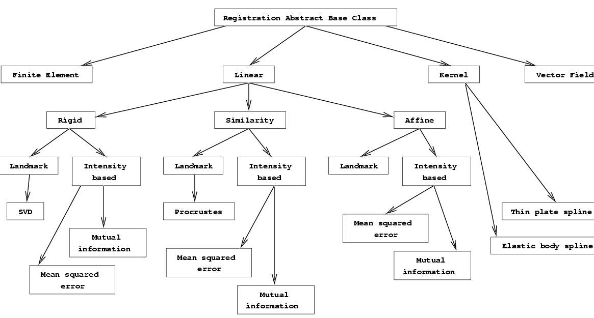

The following diagram gives a simplified view of the various objects required for defining a single registration method. Only a representative sampling of the data values and pointers for the various classes is shown, to avoid making the diagram too complex.

The box at the top represents a class for controlling the registration. It contains the optimization loop and is templated over the type of the metric and the type of the optimization method. Note that this will work for external, general-purpose optimization libraries, which typically allow one to run n steps of optimization at a time or to run until some criteria are met, i.e. the metric is smaller than some value. The Optimizer class will typically be a wrapper for some external optimization method. The registration method classes will usually specify a default optimization method.

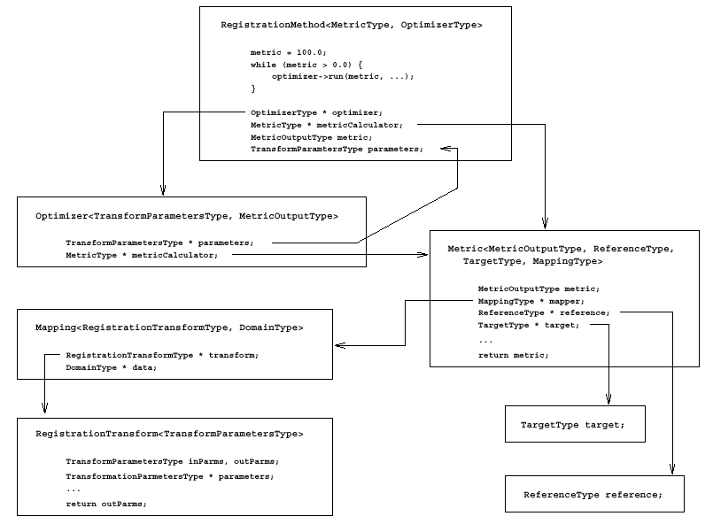

The image match or point match capabilities are contained in the metric. The "domain" of the registration is considered to be images or sets of points, so the ReferenceType and TargetType refer to either types of images or point sets. Because there must be regions of interest, projections, patient space to pixel space mappings, and so forth, a separate Mapping class to handle these is proposed. It would act as a filter used by the Metric when it accesses the reference or target. Notice that the Mapping class is templated over the DomainType, which refers to the type of images or sets of points to be registered. The mapping must also take into account the registration transformation. The transformation parameters, required by the optimizer, are essentially the search space of the optimizer. For example, the transformation matrix when optimizing an affine transformation with respect to some metric. These parameters must be available to the RegistrationTransform class. A set of ITK files is available. It provides a sample of the header and template files needed to implement a complete example of the registration hierarchy.

References

1 | Petra A. van den Elsen, Evert-Jan D. Pol, and Max A Viergever, "Medical image matching –  a review with classification", IEEE Eng. in Med. and Biol., 1993, 12(1), pp. 26-39
2 | Erich Gamma, Richard Helm, Ralph Johnson and John Vlissides, Design Patterns,  Addison-Wesley, 1995.

Methods

Metrics

Transformations

Optimizers

Examples

IMAGE PROCESSING

Philosophy and Taxonomy

Filters

Convolutions

RecursiveGaussian

DanielssonDistance

Contrast Enhancement

Power-Law Adaptive Histogram Equalization

Feature Measurements

Moments

Pixel Operations

Adaptors

Sin
Cos
Tan
…

Interpolators

linear

APPENDIX (Unsupported)

ImageIO: Design of an Extensible Image Input/Output Library

Introduction

The synthesis of computer graphics and image processing techniques has resulted in a number of useful applications in fields as diverse as computer vision, geographic information systems, and medical imaging, just to name a few. These applications provide researchers with new ways to visualize their data and gain insight into its structure. Their design also poses sizeable challenges to software engineers. One such challenge that often arises concerns file input and output: How can these software systems be designed so that they will work with data stored in a variety of different file formats stored on disk?
At first, the solution may seem easy enough: simply decide on a few formats to support, and hard-code the routines to handle them directly into the program. This approach may be valid for applications that are intended for use in a vacuum, by a single team working on a very specific problem. However, these development scenarios arise infrequently, and what is increasingly the norm are teams of software developers working on versatile systems that can be used for a variety of purposes. This is especially true in the research community, where teams are scattered across different institutions around the globe, and each one of them has a vested interest in its own file format(s). Even if all of these teams could decide on a common file format to use, they would lose the ability to use their existing datasets with this new code base, unless they wrote conversion routines. Moreover, the spiraling costs of software development are causing a greater emphasis to be placed on extensibility and modularity, so that current efforts can be reused in future endeavors. All of these factors render this simplistic approach virtually useless, and hence it is necessary to develop a framework just for file input and output. We have developed one such framework, targeted towards image processing, as part of our research in medical imaging at the University of North Carolina (UNC). The design and some C++ implementation details are presented in this article.

Design Framework

A good design for an image input/output (image I/O) library should strive to meet the following criteria. By following these design principles, we developed a library that has turned out to be easy to use, maintain, and extend.

Portability - The library should operate on multiple computer architectures. For our work, this meant supporting at least Windows, Linux, and SunOS. Because all of the driving applications that will be using the library are written in C++, the library was also written in C++. There are good, standards-compliant compilers available for every platform, and because image I/O is a high level function that does not make use of any system-specific routines, the library is platform-independent.

Modularity - The library should be self-contained and decoupled from the other parts of the application, so that it can be reused in other software systems. The reader should note that, for the purposes of this discussion, images exist in two forms: externally as files on disk, and internally as data structures in memory. By making this library responsible only for loading and saving images to and from disk, I/O functionality is completely decoupled from any application-specific notion of an image. This division of responsibility mandates that an intermediary class be used to convert between an image as stored in the I/O class, and the image data structure in memory that will ultimately be used by the application.

Extensibility - Support for new file types can be added by third parties without modifying existing code. It is not possible to anticipate what additional image formats will arise in the future, nor is it feasible for one party to provide support for all existing formats. Therefore, it is essential that the image I/O framework be "open to extension, but closed to modification". This goal is met through the use of a compound design pattern known as the pluggable object factory, and by defining a standard interface through an abstract superclass.

Transparency - Ideally, application programmers should be able to pass a filename or file handle to an appropriate class and then access the image data stored in the file, without having to worry about the details of a particular file format. Transparency is achieved through two mechanisms. First, features that are common to all image formats are "factored out" and made members of an abstract superclass, from which format-specific subclasses are derived. In this way, an application developer can work with any supported image through a common interface. Secondly, the pluggable object factory can be used to automatically instantiate at runtime the correct subclass that handles a given filetype. The details of this mechanism are given below.

Class Structure

Figure 1. Class Hierarchy
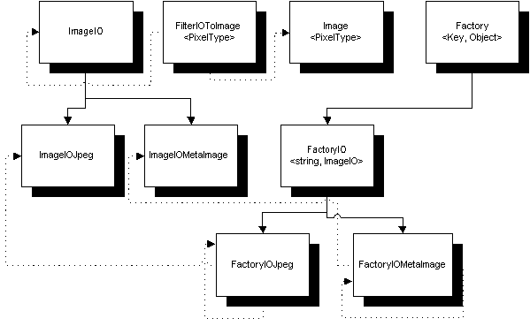
In the above diagram, each class is shown as a box, with solid lines representing inheritance relationships (e.g. ImageIOJpeg derived from ImageIO), and dashed lines depicting instance ownership relationships (e.g. FactoryJpeg has an instance of ImageIOJpeg). Template parameters appear in brackets < >.

ImageIO is the heart of the library. This abstract class handles images stored on disk, and defines the interface that application programmers can use to interact with the library. It provides methods for loading and saving images, as well as for reading any pertinent header information (image dimensions, color depth, etc.) about a file. Notice that in addition to default Load() and Save() methods, we define specialized versions of these methods that allow us to, for example, use 2D image formats to assemble 3D volumes, and to extract a single slice or a range of slices from a 3D image.

class ImageIO {
public:
virtual void Load() = 0;
virtual void Save() = 0;
virtual void Save2DSlice(int sliceNumber) = 0;
virtual void Assemble3DVolume(std::list<string> sliceNames) = 0;
/* This method returns the file extensions corresponding to the filetypes that this class can handle */
virtual string GetSupportedFileExtensions() const = 0;
private:
void* imageData;
}

class ImageIOJpeg {
public:
string GetSupportedFileExtensions() const { return ".jpg"; }
}

The member imageData is defined to a be a pointer to void so that it can store image data of any type. The Load and Save methods typecast this pointer to the appropriate data type that is needed by the specific file format. For example, ImageIOJpeg treats the data as unsigned shorts, because that is the data type of grayscale JPEG images.

Factory<Key, Object> is the pluggable object factory base class. The pluggable object factory [1] is essentially a composition of several design patterns described in [2]: the Abstract Factory, which provides a mechanism for instantiating classes from a given hierarchy of classes; the Singleton, which ensures that only one instance of a particular class exists and that it is globally accessible; and the Prototype, which we use to specify the abstract pluggable object factory from which other, concrete factories are derived. This class maintains a dictionary, which maps keys (words) to instances of objects (definitions). It is parameterized (templated) over the key type and the object type.

class Factory<Key, Object> {
public:
static O* Create (const Key k) {
Factory<Key, Object>* f = (dictionary->find(k))->second;
if (!f) return NULL
else return f->MakeObject();
}
protected:
Factory(const Key k) {
static bool dictionaryInitialized = false;
if (!dictionaryInitialized) {
dictionary = new Dictionary;
dictionaryInitialized = true;
}
dictionary->insert(std::make_pair(k, this);
}
virtual Object* MakeObject() const {
/* implemented by subclasses. return instance of object that subclass is responsible for */
}
private:
typedef Factory<Key, Object>* FactoryPtr;
typedef std::map<Key, FactoryPtr> Dictionary;
static Dictionary* dictionary;
}

The public member Create() is the only method visible to the application programmer. Its only parameter is a key, which is used to index into the internal dictionary. If the key is found in the dictionary, the corresponding factory is called on to create an instance of the object that factory is responsible for. Note that this dictionary is a static member variable, because we want a single copy of it to be shared among all concrete instances of the object factory.

The constructor for the abstract factory takes as a parameter a key and inserts into the dictionary a mapping between that key and the subclass (concrete factory) that invoked this constructor (via this, which C++ provides to refer to oneself). We shall refer to this process of concrete factories becoming listed in the master dictionary as registration. Note the use of the static boolean variable inside the constructor. This is used as a flag to ensure that the registry is initialized exactly once, just before the first concrete factory attempts to register itself. It is necessary because the order of static initializations across different compiled source files varies between platforms and compilers, and hence cannot be known in advance. Therefore, it is necessary to have this simple check in place to ensure that the dictionary is always initialized before any registration attempts are made.

We then derive FactoryIO<string, ImageIO> from this, taking advantage of the fact that each file format will have a unique file extension associated with it (e.g. .bmp, .jpg, .png, etc.), and hence can be used as a key value. From this class we in turn derive a separate concrete factory for each file format, and each of these factories is responsible solely for creating instances of its corresponding ImageIO class. Below is an example taken from our code for loading JPEG images.

class FactoryIOJpeg : public FactoryIO {
public:
static const ImageIOJpeg myObject;
FactoryIOJpeg() : FactoryIO(myObject.GetSupportedFileExtensions()) {}
ImageIO* MakeObject() const { return new ImageIOJpeg; }
static const FactoryIOJpeg registerMyself;
}

There are two key points to note in the implementation of this concrete factory. First, each concrete factory contains a static instance of itself, used solely for the purposes of registering the factory with the dictionary. Secondly, each concrete factory also has a static instance of the ImageIO object it is responsible for cloning. This is used simply for determining the key values to use in the registration process.

Image<PixelType> is the class we use to maintain an image in memory. Its design and implementation details are not important for this discussion. Suffice it to say that the class is parameterized on the datatype of the pixels that the application needs to work with (this is not the same as the datatype of the image as stored on disk).

The final component of this framework is FilterIOToImage<PixelType>. Recall that because we make the distinction between images residing on disk and those in memory, and because we want the two classes to know nothing of each other, we must use an intermediary filter class to translate image data between the two. This class performs exactly that function.

class FilterIOToImage<PixelType> {
public:
virtual void CopyPixelsToIO() = 0;
virtual void CopyPixelsToImage = 0;
private:
ImageIO* io;
Image<PixelType>* image;
}

This class contains within it a reference to an ImageIO object and a reference to an Image object. Notice that FilterIOToImage and Image are both parameterized on PixelType. This is so that the former has knowledge of the latter's template parameter. As the names suggest, CopyPixelsToIO() and CopyPixelsToImage() translate image data from one representation to the other. By deriving from FilterIOToImage, this translation can be anything from simple typecasting or rescaling to more complex operations such as grayscale conversion.

Implementation Details

In many cases we have encountered, subclassing ImageIO involves interfacing with a third-party library written in C. This will be the case for commonly used image formats, as good low-level C libraries exist for nearly all of them, and there is little sense in rewriting these routines. Whenever possible, we have leveraged this existing code by writing our ImageIO classes to effectively wrap the interface provided by these third-party libraries. By using the extern "C" directive, we are able to mix C and C++ code, and can therefore compile the third party library along with our C++ classes into self-contained libraries, one for each image format.

Although it is certainly simpler to compile each library statically and link them all in at compile time (and indeed, this is the route we are currently using), we would like to advocate the use of dynamic link libraries instead. It is possible to define a high-level class that abstracts away the platform-specific details of loading and importing the symbols of dynamic link libraries. With this in place, it becomes possible to simply place new libraries that support additional filetypes into a single directory that is scanned at program startup. Now it is no longer necessary to even re-link existing applications in order for them to take advantage of support for new image types. Furthermore, if an unsupported filetype is encountered, rather than returning a NULL pointer to indicate this condition, we can scan an additional library path at runtime to see if a library supporting this filetype does in fact exist. If it does, the library can be imported, at which time the object factory for that image type will be dynamically registered with the dictionary, and the application can in turn repeat its request for an object to handle this filetype.

Analysis

The following sample program illustrates the interface presented to the application programmer by this library.

void main () {
const Factory<ImageIO> ioFactory;
ImageIO* io;
FilterIOToImage<float>* ioFilter;
Image<float>* image;
io = ioFactory.Create(ParseFileExtension("sample.jpg"));
if (io == NULL) { exit }
io->SetFileName("sample.jpg");
io->Load();
image = new Image<float>;
ioFilter = new FilterIOToImage(io, image);
ioFilter->CopyPixelsToImage();
// Ready to process
}

Although a few extra lines of code are required to instantiate the object factory and to transfer the image data between the two representations, the underlying framework is still reasonably transparent and easy to use for the developer.

One drawback to this design concerns efficiency. Because Image, ImageIO, and the third-party library being used (if any) each maintain a separate copy of the image data, it is possible to have three separate copies of the same data in memory at once (albeit only for a short while since once the data has been transferred over to Image, the other two copies can be deleted). This can become a problem when dealing with very large images, as memory constraints become an issue. If the application is forced to page to disk for memory, then I/O operations can become slow. Fortunately, this penalty is offset by the fact that I/O is a relatively infrequent operation: usually, an image is loaded into the application at startup, and then saved to disk once processing is finished.

Even with this potential inefficiency, the advantages we gain in extensibility and ease-of-maintenance are worth the trade-off. Support for new image types can be added by third parties, and even integrated into applications during execution by dynamic linking, all without modifying existing code or recompiling. I/O classes are kept completely separate from the rest of the application, so that they can be reused in other programs. The library is written in completely portable C++ code, so it runs on both Windows and several variants of Unix with only a recompilation required. Finally, the interface we have defined in the base ImageIO class provides added flexibilty by enabling 2D image formats to be used in a 3D sense, and vice versa.

References

1 | Culp, Timothy R. Industrial Strength Pluggable Object Factories. In C++ Report Online.
2 | Gamma, Erich et. al. Design Patterns: Elements of Reusable Object-Oriented Software. Addison-Wesley, Massachusetts, 1995.

