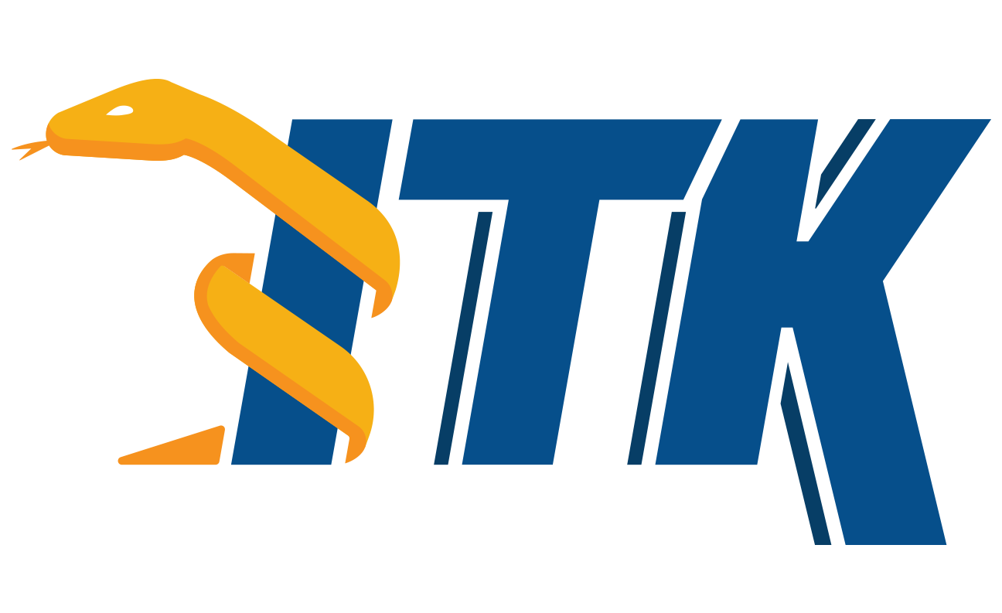
The ITK Software Guide

The Insight Toolkit (ITK) is an open-source, cross-platform system for medical image processing. It provides medical imaging researchers with an extensive suite of leading-edge algorithms for registering, segmenting, analyzing, and quantifying medical data. It is used in thousands of research and commercial applications, from major labs to individual innovators.
This ITK Software Guide is the handbook for developing software with ITK. It is divided into two companion books.
The first book covers building and installation, general architecture and design, as well as the process of contributing in the ITK community.
The second book covers detailed design and functionality for reading and writing images, filtering, registration, segmentation, and performing statistical analysis.

NOTICE: This PDF is a concatenation of both Book 1 and Book 2 of the ITK Software Guide into a single document.

The ITK Software Guide
Book 1: Introduction and Development Guidelines ……….Pages 2 - 405
Book 2: Design and Functionality …………………………Pages 406 - 941

