Style Guidelines for Final Year Project ReportsVibeShift

Final Year Project Proposal

Session Fall 2025

A 4th Year Student

BSc. (Hons.)BS in Artificial Intelligence



Department of AI
Fast School of Computing
Fast National University, Karachi Campus
22 September 2025

Project Registration
Project ID (for office use) |  |  | F25-244
Type of project |  |  | [ ] Traditional [✓] Industrial [ ] Continuing
Nature of project |  |  | [ ] Development [✓] Research & Development [ ] Research
Sustainable Development Goals(SDGs) |  |  | [ ] Good Health and Well-Being [ ] Quality Education  [✓ ] Industry, Innovation, and Infrastructure [ ] Gender Equality  [✓] Decent Work and Economic Growth [ ] Climate Action
Area of specialization |  |  | [✓ ] Artificial Intelligence (AI) [ ] Data Science and Analytics  [ ] Internet of Things (IoT) [ ] Blockchain  [ ] Mobile App Development [ ] Web Development [ ] Cybersecurity  [ ] Game Development [ ] Natural Language Processing (NLP)  [ ] Other
Project Group Members
Sr.# | Reg. # | Student Name |  | CGPA | Email ID | Phone # | Signature
(i) | Group Leader | Mehreen Saghar |  | 3.16 | k224107@nu.edu.pk | 0335 2435486 | 
(ii) | Member - I | Syeda Fatima Zafar |  | 3.17 | k224124@nu.edu.pk | 0317 2279641 | 
(iii) | Member - II | Insiya Fakhruddin |  | 3.62 | k224103@nu.edu.pk | 0336 1524000 | 
Declaration: FYP group members have cleared all prerequisite courses For FYP-I as per their degree requirements.

Project Abstract
Music genre transformation is an emerging challenge in audio signal processing and machine learning. While commercial platforms such as Spotify excel at recommendation and playlist curation, they lack the capability to algorithmically reimagine tracks across genres while preserving musical coherence. This project, VibeShift , addresses this gap by developing an AI-driven system that combines source separation, style transfer, and user-centered design. The system decomposes uploaded audio into instrumental and vocal stems, enabling flexible manipulation of musical attributes, and applies genre-transfer models to generate coherent remixes aligned with user-specified styles. Delivered through an intuitive app interface, VibeShift empowers DJs, producers, and learners to explore creative transformations, supports music education, and democratizes remixing beyond professional studios. By bridging audio source separation, generative modeling, and interactive design, the project contributes to advancing music technology and expanding the creative possibilities of AI-assisted composition.

Introduction
Traditional remixing requires significant expertise and access to costly tools. While machine learning has advanced in audio tasks like source separation (Demucs, Spleeter) and genre classification, a system that combines these to allow interactive genre transformation remains missing in mainstream platforms.
This project expands upon the title “AI-Powered Music Genre Transformation and Remixing”. It aims to:
- Enable music dimixing by accurate separation of instrument stems ( e.g., vocals, drums, guitar, piano, bass, etc ).
- Provide interactive editing of stems (pitch, timbre, solo, loudness, base, volume adjustments).
- Support instrument addition/removal.
- Develop models to shift a track from one genre to another (e.g., Classical → Pop).
By systematically addressing these objectives, the system will offer a platform that can be evaluated through both objective audio quality metrics and subjective user feedback, ensuring measurable success.

Success Criterion
The success of the proposed system will be measured by its ability to effectively perform music demixing, stem-level editing, and genre transformation while maintaining audio quality and usability. The key criteria include:
2.1 Accuracy of Source Separation
The system should reliably isolate vocals and instrumental stems from mixed audio tracks, minimizing artifacts and maintaining natural timbre. Metrics such as Signal-to-Distortion Ratio (SDR) or Signal-to-Interference Ratio (SIR) can be used to quantify performance.

Quality of Genre Transformation
The system must successfully transform the musical style or genre of a track while preserving the original melody, rhythm, and harmonic structure. Subjective evaluation by listeners and objective feature analysis (e.g., timbre and spectral characteristics) will assess this.
2.3 Stem-Level Control
Users should be able to add, remove, or adjust individual instruments with responsive and intuitive controls, supporting creative manipulation of music tracks.
2.4 User Experience and Interface
The web interface should be intuitive, responsive, and visually clear, allowing users with minimal technical knowledge to perform demixing and genre editing seamlessly.
2.5 Integration and Performance
The system should process tracks efficiently, with minimal latency during editing and genre transformation, and all modules (demixing, editing, genre transformation) should work cohesively in the integrated platform.
2.6 Reproducibility and Reliability
The system should produce consistent results across different music tracks and genres, demonstrating robustness and generalizability.

Related Work
Music source separation, also known as demixing, has evolved from traditional signal processing approaches to modern deep learning-based techniques. Early methods such as Independent Component Analysis (ICA) and Non-negative Matrix Factorization (NMF) attempted to isolate individual instruments and vocals from mixed audio, but their performance was limited for complex polyphonic music [5]. These classical methods laid the foundation for understanding the challenges of overlapping frequency components and audio interference.
With the rise of deep learning, models such as Spleeter [2] and Demucs [1] leverage convolutional, recurrent, and transformer architectures to achieve high-quality stem separation. These approaches provide real-time extraction of vocals and instrumental stems, facilitating applications in remixing, karaoke, and adaptive music production. Compared to classical methods, deep learning models demonstrate superior accuracy, generalization across genres, and robustness to noisy or unseen audio.
In addition to separation, genre classification and transformation have progressed significantly. Earlier classification techniques relied on hand-crafted features such as MFCCs and chroma vectors [3]. Contemporary approaches utilize neural networks and generative models, enabling not only accurate genre recognition but also creative style transfer, where instrumentation, rhythm, or musical style can be modified while maintaining natural timbre [4].
Despite these advances, challenges remain in combining high-quality source separation, stem-level editing, and genre adaptation in a single user-friendly system. Existing works often focus on one aspect—either demixing or genre transfer—without providing an integrated, interactive platform. This gap motivates the proposed project, which aims to deliver an end-to-end music editing system that supports demixing, genre transformation, and stem-level manipulation in an intuitive interface, enhancing both creative and practical music production workflows.

Project Rationale
This project addresses a clear gap in music technology: the absence of accessible tools that allow everyday users to experiment with genre transformation and remixing. Current professional software is costly and designed for experts, leaving casual listeners and learners excluded from creative opportunities. By leveraging AI to democratize access, the project empowers users to explore musical creativity, learn through experimentation, and personalize their listening experience. Beyond individual use, it holds promise for applications in music education, content creation, and next-generation entertainment.

Aims and Objectives
The project seeks to integrate cutting-edge audio signal processing with machine learning to enable creative yet technically robust remixing. Specific Objectives include :
- Develop a demixing module to isolate stems from any uploaded song with high accuracy. Build editing tools for pitch, loudness, and instrument control.
- Design and train genre transfer models capable of mapping a song from one genre to another while preserving musical coherence. Evaluate usability with user studies and audio quality tests.
- Engineer a scalable architecture combining Python-based ML modules with a React/Next.js front-end and cloud deployment.
- Validate performance using quantitative measures (SDR, SNR, accuracy) and qualitative evaluation through structured user listening tests.

Scope of the Project

This project will deliver a next-generation music remixing system that bridges artificial intelligence, audio signal processing, and human creativity. Its scope extends beyond basic music editing by combining music demixing, interactive stem manipulation, and genre transformation into a unified platform.
- Music Demixing Engine – isolate stems such as vocals, drums, bass, and instruments with near state-of-the-art accuracy.
- Intelligent Stem Editing – provide users with precise control over pitch, timbre, loudness, and instrument layers.
- Automated Genre Transformation – enable seamless conversion of a track from its original genre (e.g., classical) to a target genre (e.g., pop or jazz) while preserving melodic and lyrical integrity.
- User Interface – A simple, accessible dashboard for uploading songs, controlling tracks, and downloading remixed versions.
- Deployment – The platform will be deployed on a cloud service (e.g., AWS or Azure) for scalability and availability.
4.2.1 Strategic Boundaries
- The project is limited to remixing and transformation of existing audio tracks; it does not involve original composition or lyric generation.
- The system will initially support a curated set of genres, with scalability for future extensions.
- Licensing, copyright management, and industrial distribution pipelines are beyond the project’s immediate scope.

Proposed Methodology and Architecture

Proposed Methodology
5.1.1 Requirements Analysis and Planning
- Define objectives: stem separation, editing, instrument addition/removal, and genre transformation.
- Identify target users: DJs, musicians, learners, and casual users.
- Develop a roadmap with milestones for data preparation, model integration, UI design, testing, and deployment.
5.1.2 Data Collection and Preprocessing
- Gather multi-genre datasets (e.g., MedleyDB, GTZAN, FMA).
- Standardize audio formats (resampling, normalization, beat/key alignment).
- Perform augmentation (tempo/pitch shifts) to increase dataset robustness.
5.1.3 System Design
- Define modular architecture: React/Next.js frontend, Node.js backend, Python ML microservices, PostgreSQL database, and cloud storage.
- Create wireframes for intuitive UI (upload, stem controls, genre selection, export).
5.1.4 Model Development and Integration
- Demixing: Use pretrained models (Demucs, Spleeter) to isolate stems.
- Editing: Implement pitch-shifting, loudness adjustment, mute/solo, and EQ (Librosa, Pydub).
- Genre Transformation: Train deep learning models (CNNs, Transformers, GANs/diffusion) to adapt rhythm, instrumentation, and timbre to target genres.
- Integrate APIs for communication between frontend, backend, and ML services.
5.1.5 Feature Implementation
- Enable real-time stem editing and instrument addition/removal (sample libraries, AI-generated riffs).
- Provide playback and preview of transformed genres before final export.
- Allow exporting remixed tracks in MP3/WAV formats.
5.1.6 Testing and Evaluation
- Unit Testing: Validate each module (demixing, editing, transformation).
- Integration Testing: Ensure smooth interaction between components.
- Performance Evaluation: Use metrics like Signal-to-Distortion Ratio (SDR), Signal-to-Noise Ratio (SNR), and genre classification accuracy.
- User Testing: Gather feedback from DJs, musicians, and students through structured listening tests.

5.1.7 Deployment
- Containerization: Docker for environment consistency across development and deployment.
- Hosting: Deploy on a cloud platform such as AWS, Azure, or Vercel.
- CI/CD Pipeline: Github or Jenkins for automated testing, building, and deployment for faster iteration and reliability.

System Architecture
5.2.1 Frontend
- Framework: React.js / Next.js / Flask for building a responsive and interactive web application.
- Functionality: enables users to upload songs (MP3/WAV), manipulate demixed stems via intuitive controls, select and preview target genre transformations, and finally export the remixed track for download.
5.2.2 Backend
- Framework: Node.js/Express for server-side logic and API handling.
- Integration: Python (Flask/FastAPI) microservices for ML models such as demixing and genre transfer.
- Responsiblities : Handles user requests (upload, edit, transform, export) , route audios files to the ML processing layer.
- Databse: PostgreSQL / MySQL for storing user accounts, authentication data, remix history and metadata.

5.2.3 Machine Learning and Processing Layer
- Technology: Python microservices (Flask/FastAPI) for audio processing.
- Demixing Module: Pretrained models like Demucs and Spleeter for high-quality stem separation.
- Stem Editing Module: Librosa and Pydub for pitch shifting, equalization, and dynamic range adjustments.
- Genre Transformation Module: Deep learning models (CNN, RNN, Transformer, or diffusion-based) trained to re-map musical features (tempo, timbre, instrumentation) from source to target genres.
- Scalability: Each ML service containerized via Docker and deployed independently, enabling parallel processing of multiple requests.
This deliverable will serve as an AI-powered remixing tool, offering both casual music lovers and aspiring producers the ability to creatively experiment with songs in real-time. The system architecture that enables this functionality is depicted in Fig. 1, which outlines the automated pipeline for processing a user's track through sequential AI modules for remixing and transformation
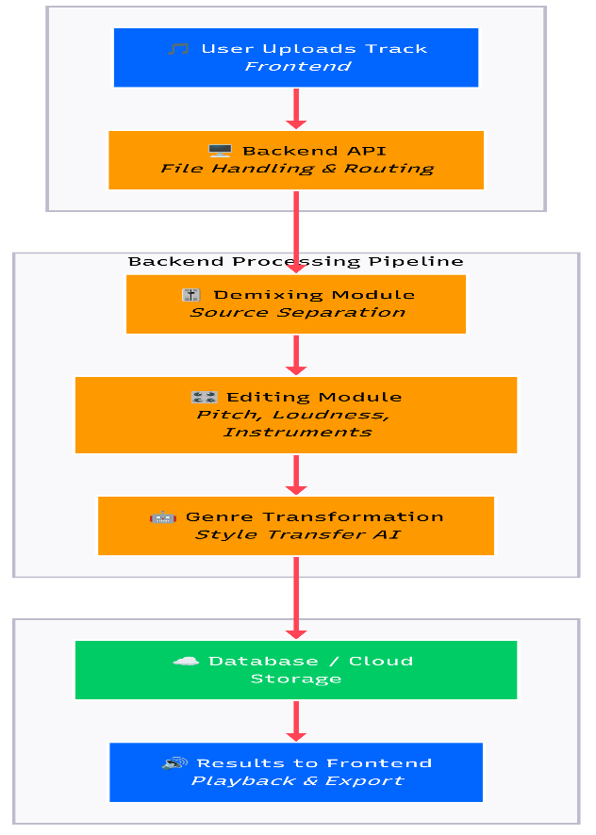
Fig. 1. Music Transformation Pipeline Workflow Diagram

Individual Task

TABLE I. TENTATIVE PROJECT SCHEDULE
Team Member | Activity | Tentative Date
Mehreen | Requirement Analysis | 8 Sep 2025
Fatima | Datast preparation | 15 Sep 2025
Mehreen | UI Wireframing | 20 Sep 2025
Fatima | Demixing | 10 Nov 2025
Insiya | Genre classification Model | 15 Nov 2025
Mehreen | Frontend Prototyping | 20 Nov 2025
Inisya | Stem Editing | 15 Dec 2025
Fatima | Genre Transformation | 15 Jan 2026
Insiya | Instrument addition/remova; | 20 Jan 2026
Mehreen | Backend – Frontend Integration | 15 Feb 2026
Fatima | Deployment | 8 Mar 2026
Fatima , Insiya | Testing ML modules | 10 Mar 2026
Mehreen , Insiya | Performance Checks | 23 Mar 2026
Fatima , Mehreen | User acceptance testing | 15 Apr 2026
All Participate | Final Integration, documentation and submission | 15 May 2026
Fig. 2. Division of Tasks and Tentative Timetime for Group Members

Gantt Chart
In accordance with the individual tasks detailed in Table I, Fig. 2 illustrates the Gantt chart, providing a comprehensive visual representation of the project timeline. The chart delineates the start and end dates for each task, specifies the duration of activities, and clearly identifies tasks that are scheduled to be executed concurrently versus those carried out sequentially. This graphical overview facilitates a clear understanding of task dependencies, resource allocation, and the overall workflow, thereby serving as an essential tool for effective project planning and monitoring.
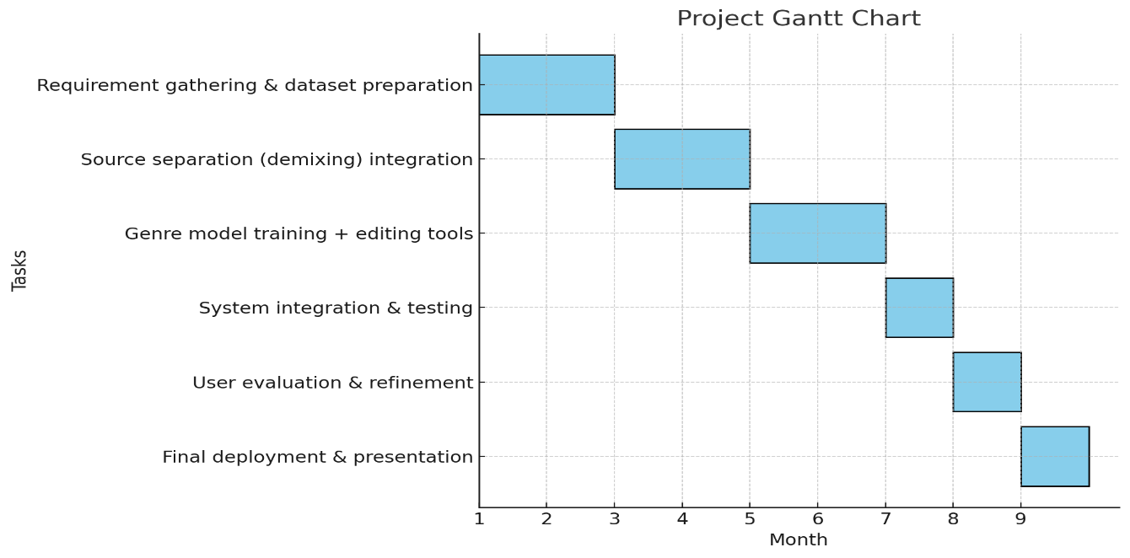
Fig. 3. Proposed Timeline for Project Exceution

Tools and Technologies
The project will employ a combination of modern frameworks, machine learning models, and deployment platforms to ensure scalability, performance, and security.
8.1 Frontend
React.js / Next.js / Flask – frameworks for building responsive and interactive web applications, allowing song upload, stem manipulation, genre selection, and track export. Redux or Context API will manage application state reliably.
8.2 Backend
Node.js / Express – handles server-side logic, request routing, and API management. Python (Flask / FastAPI) microservices serve ML models for demixing and genre transformation.
8.3 AI Models & Libraries
Demucs and Spleeter for audio source separation; Librosa and Pydub for audio editing (pitch, timbre, dynamics); CNN, RNN, Transformer, diffusion-based models for genre transfer.
8.4 Database
PostgreSQL / MySQL – stores user accounts, authentication data, remix history, and audio metadata.
8.5 Deployment & Scalability
Docker – containerizes ML services for independent deployment and parallel processing. AWS / Azure for cloud-based deployment.
8.6 Security
JWT Authentication and HTTPS – secure user access and encrypted communication.
8.7 Development Tools
Python, Jupyter Notebook, VS Code, GitHub – used for coding, experimentation, and version control as we can see n Fig. 4 below.
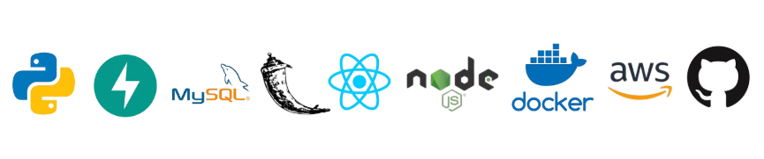
Fig. 4. Technology and Tools to be used

References
[1] A. Défossez, N. Usunier, L. Bottou, and F. Bach, “Demucs: Music source separation with transformers,” arXiv preprint arXiv:2111.03600, 2021.
[2] R. Hennequin, A. Khlif, F. Voituret, and M. Moussallam, “Spleeter: A fast and state-of-the-art music source separation tool,” in Proc. Int. Soc. Music Information Retrieval Conf. (ISMIR), 2020.
[3] J. Foote, “Automatic audio genre classification,” in Proc. ACM Int. Multimedia Conf., 1997, pp. 397–400.
[4] C. Donahue, J. McAuley, and M. Puckette, “Adversarial audio synthesis,” in Proc. Int. Conf. Learning Representations (ICLR), 2019.
[5] Z. Rafii and B. Pardo, “A music/voice separation system based on the similarity matrix,” in Proc. IEEE Int. Conf. Acoustics, Speech, Signal Process. (ICASSP), 2013, pp. 41–44.

