Software Design Specifications

VibeShift

Version: 01.08

Project Code | F24-244
Supervisor | Sir Zain ul Hassan
Co Supervisor | Miss Sania Urooj, Zehra Fatima
Project Team | Fatima Zafar  Insiya Fakruddin  Mehreen Saghar
Submission Date | 04/12/2025

Document History
Version | Name of Person | Date | Description of change
1.0 | Mehreen Saghar | 10/13/25 | Document Created
1.1 | Mehreen Saghar | 10/19/25 | ERD design
1.2 | Mehreen Saghar | 10/29/25 | Relations between entities
1.3 | Fatima Zafar | 11/12/25 | Data Dictionary for all tables
1.4 | Fatima Zafar | 11/22/25 | Sequence Diagram 1
1.5 | Fatima Zafar | 11/27/25 | Sequence Diagram 2,3  Architecture Diagram
1.6 | Insiya Fakhruddin | 12/01/25 | State Diagram 1,2
1.7 | Insiya Fakhruddin | 12/02/25 | Data Flow Diagram

Distribution List

Name | Role
Sir Zain Ul Hassan | Supervisor
Miss Sania Urooj | Co Supervisor
Zehra Fatima | Co Supervisor

Document Sign-Off

Version | Sign-off Authority | Project Role | Signature | Sign-off Date
1.8 | Supervisor | Supervisor | Sir Zain Ul Hassan | 12/4/2025

Document Information

Category | Information
Customer | FAST-NU
Project | VibeShift
Document | Software Design Specification
Document Version | 1.8
Status | Draft
Author(s) | Fatima Zafar  Insiya Fakhruddin  Mehreen Saghar
Approver(s) | Sir Zain Ul Hassan
Issue Date
Document Location | FAST-NU
Distribution | Advisor  Project Coordinator’s Office (through Advisor)

Definition of Terms, Acronyms and Abbreviations

Term | Description
ASP | Active Server Pages
DD | Design Specification
KPI | Key Performance Indicator
AI | Artificial Intelligence
TF | Tensor Flow
HOD | Head of Department

Table of Contents
1 Introduction 7
1.1 Purpose of Document 7
1.2 Intended Audience 7
1.3 Document Convention 7
1.4 Project Overview 7
1.5 Scope 7
2 Design Considerations 8
2.1 Assumptions and Dependencies 8
2.2 Risks and Volatile Areas 8
3 System Architecture 9
3.1 System Level Architecture 9
3.2 Software Architecture 10
4 Design Strategy 11
5 Detailed System Design 12
5.1 Database Design 12
5.1.1 ER Diagram 12
5.1.2 Data Dictionary 12
5.1.2.1 Data 1 12
5.1.2.2 Data 2 12
5.1.2.3 Data 3 12
5.1.2.3 Data 4 12
5.1.2.3 Data 5 12
5.1.2.3 Data 6 12
5.1.2.3 Data 7 12
5.2 Application Design 14
5.2.1 Sequence Diagram 14
5.2.1.1 <Sequence Diagram 1> 14
5.2.1.2 <Sequence Diagram 2> 14
5.2.1.3 <Sequence Diagram 3> 14
5.2.2 State Diagram 14
5.2.2.1 <State Diagram 1> 14
5.2.2.2 <State Diagram 2> 14
6 References 15
7 Appendices 16

Introduction

Purpose of Document

The purpose of this Software Design Specification (SDS) is to describe the architectural and detailed design of VibeShift. It translates the requirements defined in the SRS into a technical blueprint, specifying the system structure, database schema, and interface logic. This document serves as the primary reference for the development team during implementation and testing.
- To provide a clear communication framework among stakeholders
- To act as a reference document for developers during the system’s design, implementation, and testing phases.
- To ensure that the system’s design and implementation align with the business objectives
- To establish a foundation for requirement traceability throughout the project lifecycle

Intended Audience

- Jury Panel ( FAST NUCES)
- Supervisor ( Sir Zain Ul Hassan)
- Students of Fast NU
- Our Team(Designer, Developer, Tester)
- Potential Users of this product

Document Convention
- Font Family = Arial
- Font Size = 12 for headings, 10 for the rest of the content

Project Overview
VibeShift is an AI-powered web platform designed to democratize music remixing. It integrates three core technologies: Audio Source Separation (Demixing), Interactive Stem Editing, and Generative Genre Transformation. The system allows users to upload tracks, isolate instruments (vocals, drums, bass), manipulate them in a web-based studio, and apply AI style transfer to change the track's genre.

Scope
Included Functionalities:
• User Authentication (JWT-based Login/Signup)
• High-fidelity audio upload (MP3/WAV) with validation.
• AI-driven Stem Separation (Demucs/Spleeter integration).
• Web-based interactive waveform editor (Volume, Mute, Solo, Pitch, EQ).
• Generative Genre Transformation (Style Transfer).
• Cloud-based storage and retrieval of projects.

Excluded Functionalities:
- Creation of original music compositions from scratch.
- Automatic lyric generation.
- Real-time live DJ mixing hardware integration.

- Design Considerations

Assumptions and Dependencies

- GPU Availability: The system assumes access to a GPU-enabled server (AWS EC2 g4dn or similar) to run the Demucs and Genre Transfer models efficiently.
- Internet Connectivity: High-speed internet is required for uploading large audio files (50-100MB) and streaming stems during editing.
- Browser Compatibility: The frontend waveform editor depends on modern browser Web Audio API support (Chrome, Firefox, Edge).

Risks and Volatile Areas

• Inference Latency: Heavy traffic could slow down the Python ML microservices. Mitigation: Implementation of a job queue (e.g., BullMQ/Redis) to manage load.
• Audio Artifacts: Genre transformation models may occasionally produce audio artifacts. Mitigation: Providing users with "Retry" options and model parameter tuning.

System Architecture

This section provides a high-level overview of how the VibeShift functionality is partitioned and assigned to specific subsystems. The system utilizes a Microservices Architecture to decouple the user interface from the computationally intensive AI processing layers.

System Level Architecture

The system level architecture defines the physical deployment environment. VibeShift is designed to run on a cloud infrastructure (e.g., AWS or Azure) using containerization (Docker) to ensure scalability and environment consistency.

    - Deployment Diagram

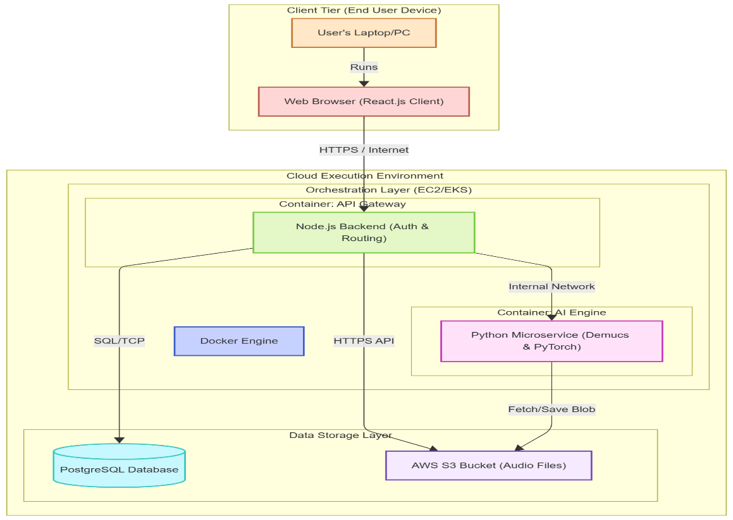

System decomposition into elements
- Client Side: The application is accessed via a standard web browser on the client's device. The React.js frontend handles the UI rendering and interacts with the cloud via secure HTTPS requests.
- Containerization (Docker): The backend components are wrapped in Docker containers. This separates the Node.js API server from the Python AI Environment, allowing them to run on the same physical server without conflict.
- Cloud Infrastructure: The system is hosted on cloud servers (EC2 instances) capable of GPU processing
- Managed Services: * S3 Storage: Handles the heavy input/output of large audio files (MP3/WAV).
- PostgreSQL: Handles structured data like user profiles and remix history.

Software Architecture

The software architecture follows a layered approach, ensuring separation of concerns between the User Interface, the Business Logic, and the Data Access layers.

    - Architectural Diagram

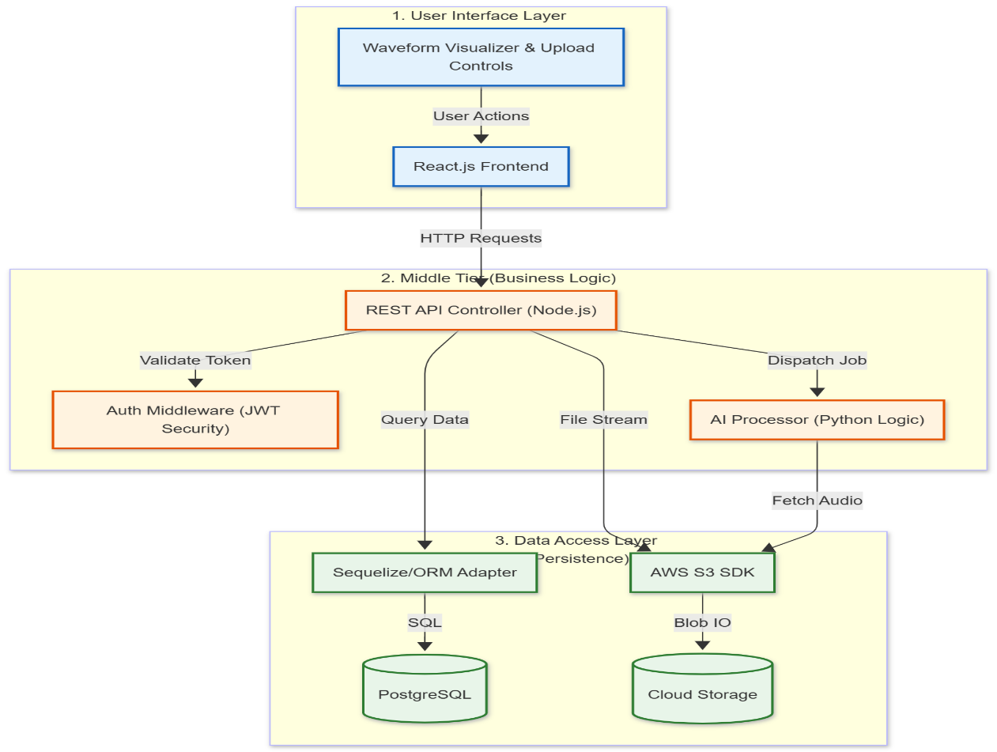
- User Interface Layer (Frontend)
  - Built using React.js / Next.js.Responsible for waveform visualization, capturing user inputs (upload, edit commands), and playing back audio streams.
- Middle Tier (Backend API
  - Built using Node.js/Express.
  - Acts as the API Gateway. It validates user tokens (JWT), manages session state, and routes complex processing jobs to the AI layer.
- AI Microservices Layer
  - Built using Python (FastAPI).
  - Contains the Demixing Service (running Demucs/Spleeter) for separating stems.
  - Contains the Genre Service for performing style transfer inference.
  - These services run asynchronously to prevent blocking the main web server.
- Data Access Layer
  - PostgreSQL: Stores metadata (User IDs, Track names, File paths).
  - Object Storage (S3): Stores the actual binary audio files. The API generates secure URLs for the Frontend to upload/download these files directly.

Design Strategy
The design strategy for VibeShift prioritizes modularity, scalability, and user responsiveness. Given the computationally intensive nature of audio source separation and genre transformation, the system is architected to decouple the user interface from the backend processing logic.
  - Data Flow Diagram( Level 1)

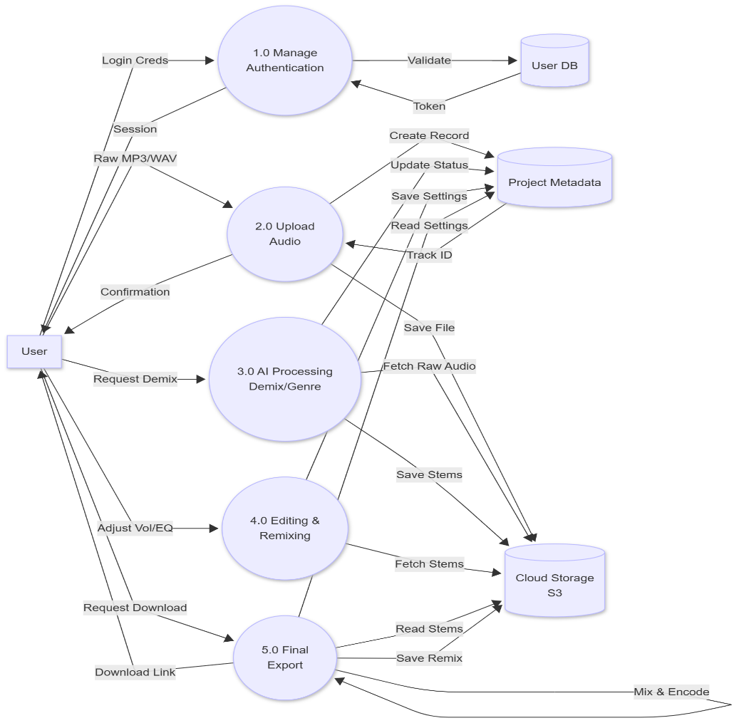

4.2 Future System Extension or Enhancement
- Microservices Architecture: Decouples the Node.js application logic from Python AI services. This allows individual ML models to be upgraded (e.g., swapping Demucs for a newer model) without disrupting the core web server.
- Containerization: Uses Docker to isolate dependencies, simplifying the integration of future features like "Voice Cloning" or new genre models.

4.3 System Reuse
- Component-Based UI: Utilizes reusable React components for interface elements (Waveform Visualizers, Sliders) across different views (Editing, Preview, History) to maintain consistency.
- Shared Middleware: Implements reusable backend middleware for authentication and file validation, ensuring uniform security policies across all API endpoints.

4.4 User Interface Paradigms
- Single Page Application (SPA): Adopts Next.js/React to enable a seamless desktop-like experience, eliminating page reloads that would interrupt audio playback.
- Optimistic UI: Provides immediate visual feedback (e.g., progress bars) for long-running AI tasks, preventing the browser from appearing "frozen" while waiting for the server.
- Direct Manipulation: Mimics physical audio hardware with visual faders and toggle buttons for intuitive control.

4.5 Data Management (Storage, Distribution, Persistence)
- Hybrid Storage Model: Stores structured metadata (user profiles, logs) in PostgreSQL for relational integrity, while offloading large binary audio files to AWS S3 for performance.
- Non-Destructive Editing: Preserves original uploads as immutable entities; all stems and remixes are generated as new file instances to prevent data loss.

4.6 Concurrency and Synchronization
- Asynchronous Job Queues: Implements a Producer-Consumer pattern (using Redis/Bull) to manage AI tasks. This prevents heavy GPU processes from blocking the main web server for concurrent users.
- State Synchronization: Uses frontend polling to synchronize the local UI state with the server’s processing status (e.g., transitioning from "Processing" to "Ready").

Detailed System Design

Database Design

ER Diagram
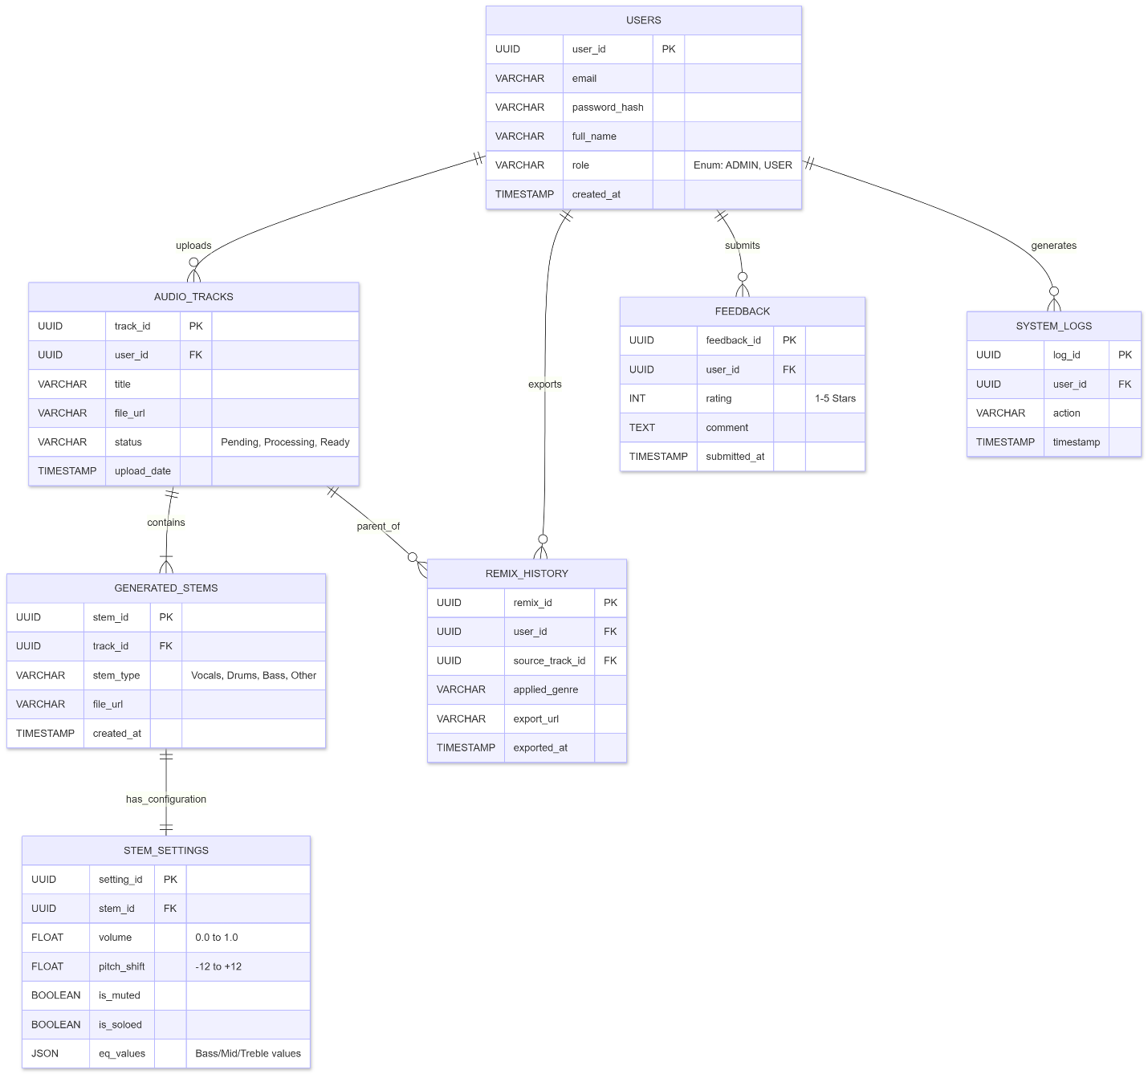
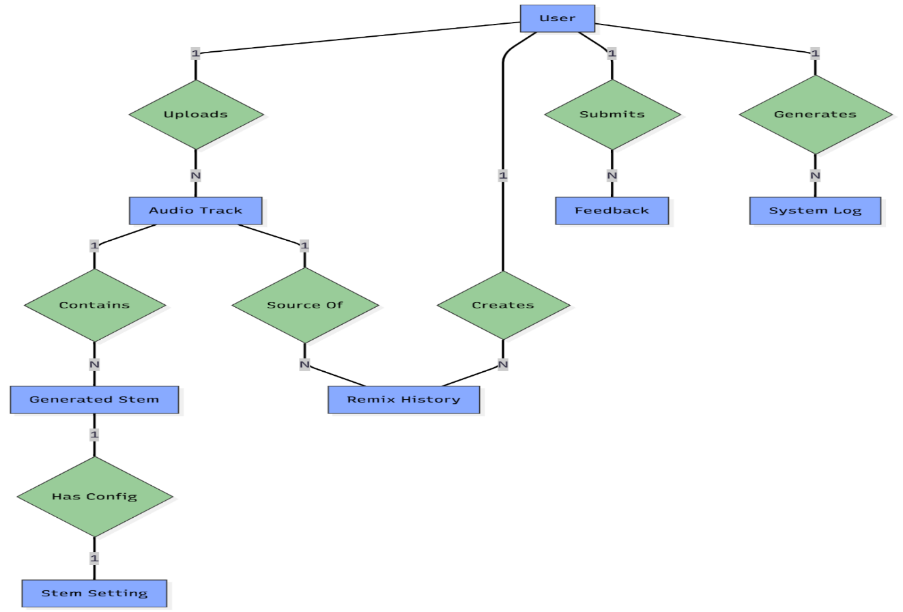

    - Class Diagram

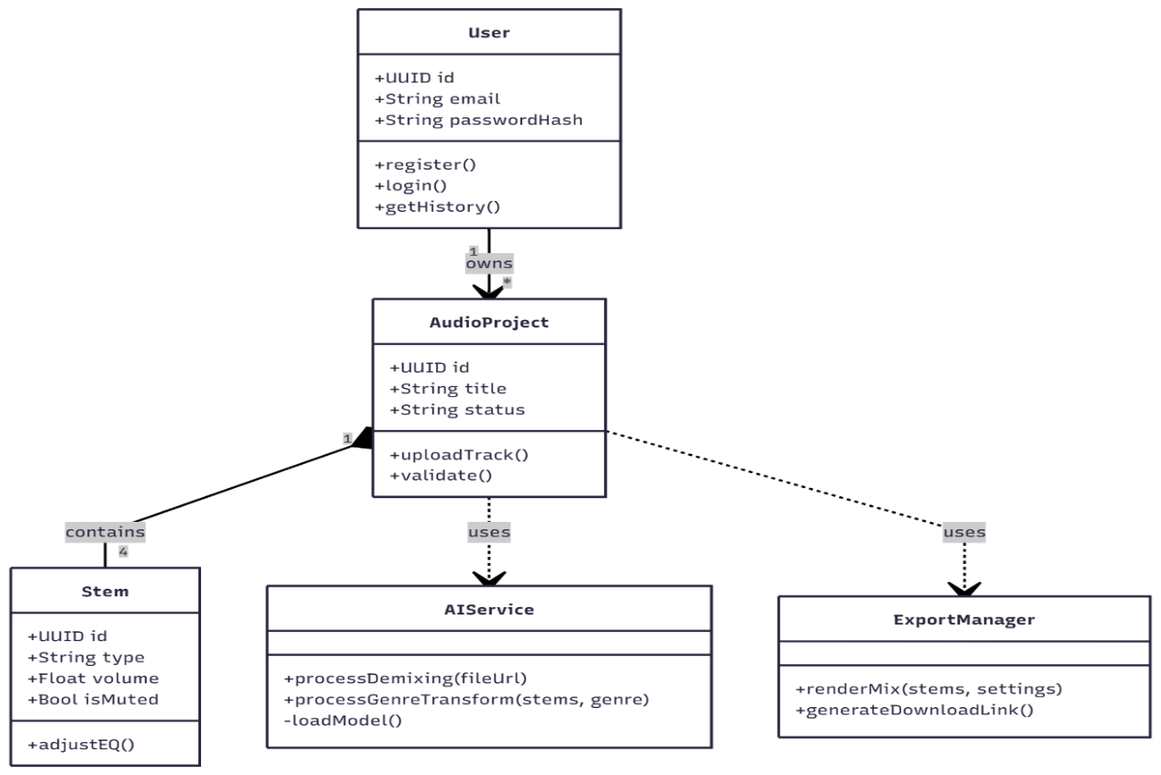

Data Dictionary

Data 1

Users
Name |  | The registered user (Admin or Regular User) of VibeShift
Alias |  | User
Where-used/how-used |  | Used for authentication and role management. When a visitor signs up, a record is created here. It links to all other entities (tracks, history, feedback) to identify ownership.
Content description |  | Notation for representing content.
Column Name | Description |  | Type | Length | Null able | Default Value | Key Type
User_id | unique identifier |  | UUID | 36 | NO | UUID() | PK
email | unique email address |  | Varchar | 255 | NO | None
Password_hash | Encrypted Password string |  | Varchar | 255 | NO | None
full_name | First Name |  | Varchar | 100 | NO | None
role | User Role |  | Varchar | 20 | NO | USER
created_at | Time of registration |  | Timetamp | - | NO | Current_Time

Data 2

Audio Tracks
Name |  | The original music file uploaded by the user
Alias |  | Original Track
Where-used/how-used |  | Created when a user uploads an MP3/WAV file. This serves as the parent record for generated stems. It tracks the processing status (Pending, Ready).
Content description |  | Notation for representing content.
Column Name | Description |  | Type | Length | Null able | Default Value | Key Type
track_id | unique identifier |  | UUID | 36 | NO | UUID() | PK
User_id | Owner of the track |  | UUID | 255 | NO | None | FK
title | Name of the song/file |  | Varchar | 256 | NO | None
File_url | S3 cloud URL of original fil |  | Varchar | 500 | NO | None
status | Process_state(pending, ready) |  | Varchar | 50 | YES | Pending
upload_date | Date of upload |  | Timestamp | - | NO | Current_time

.
.

Data 3

Generated Stems
Name |  | The isolated instrument tracks (stems)
Alias |  | Stem
Where-used/how-used |  | Created by the Demux AI service. Contains links to the separated audio files (Vocals, Drums, Bass) used in the editor.
Content description |  | Notation for representing content.
Column Name | Description |  | Type | Length | Null able | Default Value | Key Type
Stem_id | unique identifier |  | UUID | 36 | NO | UUID | PK
track_id | employee’s cnic |  | UUID | 36 | NO | None | FK
Stem_type | absent or present |  | Varchar | 50 | NO | None
File_url | date |  | Varchar | 500 | NO | None
Created_at |  |  | Timestamp | - | NO | Current_Time

Data 4

Stem Settings
Name |  | Configuration for the interactive mix
Alias |  | Mix Settings
Where-used/how-used |  | Stores the user's editing choices (Volume, EQ, Mute/Solo) for a specific stem. Allows users to "Resume" editing a project later.
Content description |  | Notation for representing content.
Column Name | Description |  | Type | Length | Null able | Default Value | Key Type
Setting_id | unique identifier for setting |  | UUID | 36 | NO | UUID() | PK
stem_id | Linked Stem Identifier |  | UUID | 36 | NO | None | FK
volume | Volume level(0.1 to 1.0) |  | Float | - | NO | 1.0
Pitch_shift | Semitone shift(-12 to +12) |  | Float | - | NO | 0
Is_muted | Track mute status |  | Boolean | 1 | NO | False
Is_soloed | Track solo status |  | Boolean | 1 | NO | False
eq_values | JSON object for EQ(Low/Mid/High) |  | JSON | - | YES | NULL

Data 5

Remix History
Name |  | Log of exported projects
Alias |  | Export History
Where-used/how-used |  | Created when a user clicks "Export". Stores the final output URL and details about the genre transformation applied (if any).
Content description |  | Notation for representing content.
Column Name | Description |  | Type | Length | Null able | Default Value | Key Type
remix_id | unique identifier |  | UUID | 36 | NO | UUID() | PK
user_id | User who created the remix |  | UUID | 36 | NO | None | FK
Source_track_id | Original source track used |  | UUID | 36 | NO | None | FK
Applied_genre | Target genre |  | Varchar | 100 | YES | NULL
Export_url | S3 Cloud URL of final mix |  | Varchar | 500 | NO | None
Exported_at | Date of export |  | Timestamp | - | NO | Current_Time

Data 6

Feedback
Name |  | User feedback and rating
Alias |  | Reviews
Where-used/how-used |  | Users submit this form to rate the quality of the AI demixing or genre transformation. Admins read this table to improve models.
Content description |  | Notation for representing content.
Column Name | Description |  | Type | Length | Null able | Default Value | Key Type
feedback_id | unique identifier |  | Int | 36 | NO | UUID() | PK
User_id | User submitting feedback |  | Varchar | 36 | NO | None | FK
rating | Star rating(1-5) |  | Int | 1 | NO | None
comment | Name of the research paper |  | Text | - | YES | NULL
Submitted_at | employee’s cnic |  | Timestamp | - | NO | Current_Time

Data 7

System Logs
Name |  | Security and Audit Logs
Alias |  | Logs
Where-used/how-used |  | Automatically populated by the backend to track critical user actions (Login, Upload, Delete) for security and debugging.
Content description |  | Notation for representing content.
Column Name | Description |  | Type | Length | Null able | Default Value | Key Type
log_id | Unique identifier |  | UUID | 36 | NO | UUID() | PK
User_id | User performing action |  | UUID | 36 | YES | NULL | FK
action | Action type (Login, upload,export) |  | Varchar | 255 | NO | None
timestamp | Time of occurence |  | Timestamp | - | NO | Current_Time

Application Design

Sequence Diagram

<Sequence Diagram 1>

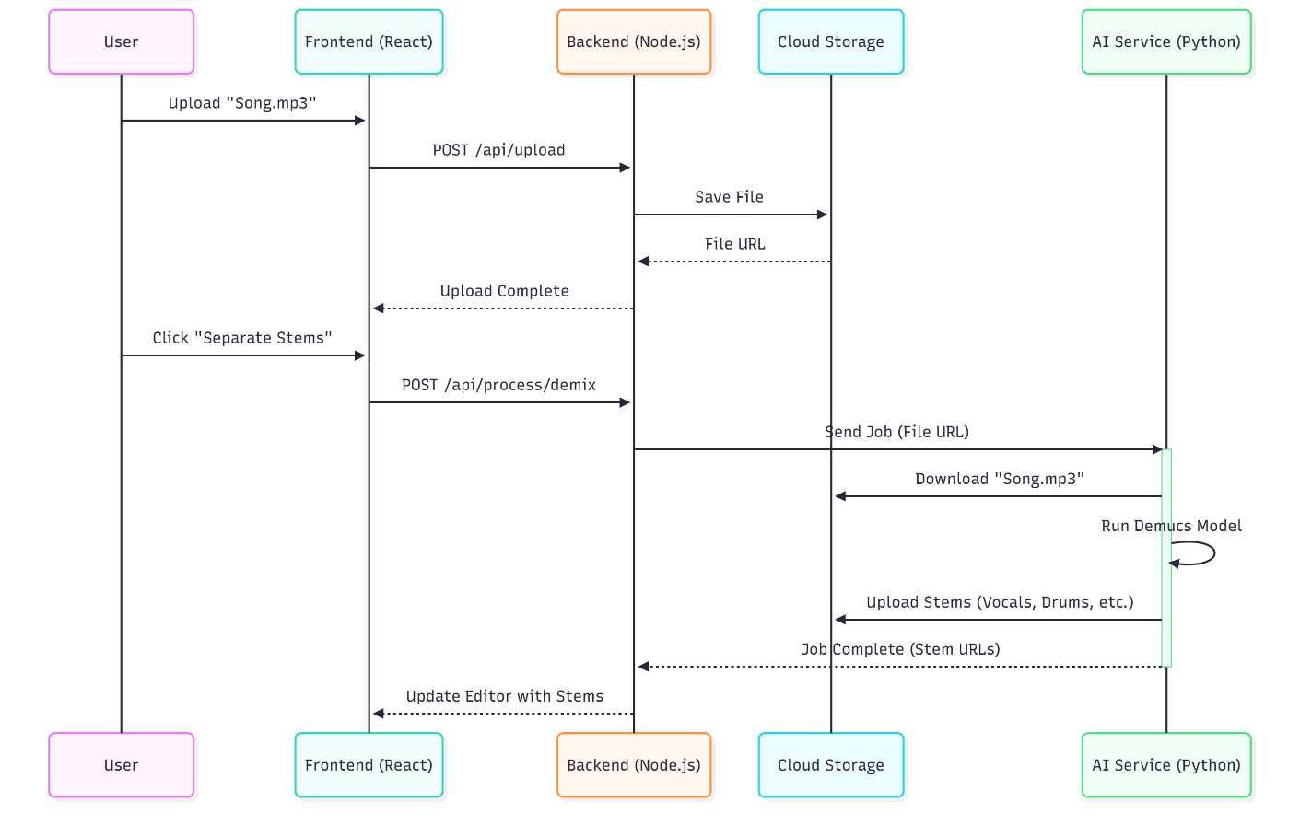
- The workflow initiates when the user uploads an audio file, which is transmitted via the frontend to the backend API and securely saved in cloud storage.
- Once the file is persisted and its URL generated, the system confirms the upload to the user, enabling the stem separation feature.
- The user triggers the demixing command, prompting the backend to dispatch an asynchronous processing job to the Python AI microservice.
- The AI service retrieves the source audio from cloud storage and executes the Demucs model to separate the track into distinct instrument stems.
- Upon completion, the generated stems are uploaded back to storage, and the backend updates the frontend editor to display the new waveforms

<Sequence Diagram 2>

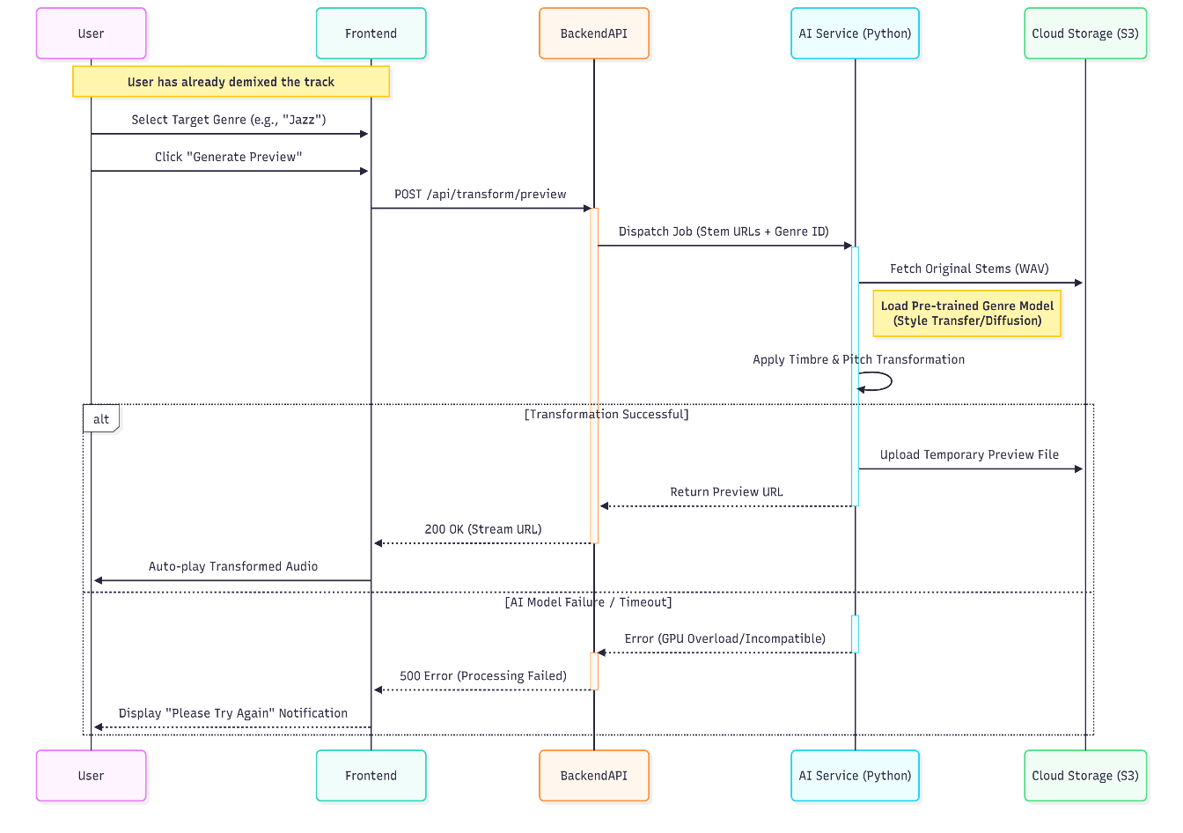
- The user initiates the session by submitting their email and password through the frontend, triggering a secure authentication request to the backend API.
- The backend validates the credentials by querying the database for the user's record and verifying the provided password against the stored hash.
- Upon successful verification, the system generates a JSON Web Token (JWT) and returns it to the client to authorize the session.
- The frontend securely stores the token and automatically requests the user's remix history to initialize the dashboard environment.
- The database retrieves the associated project records, which are returned to the frontend to populate the user's view with past activities.

<Sequence Diagram 3>

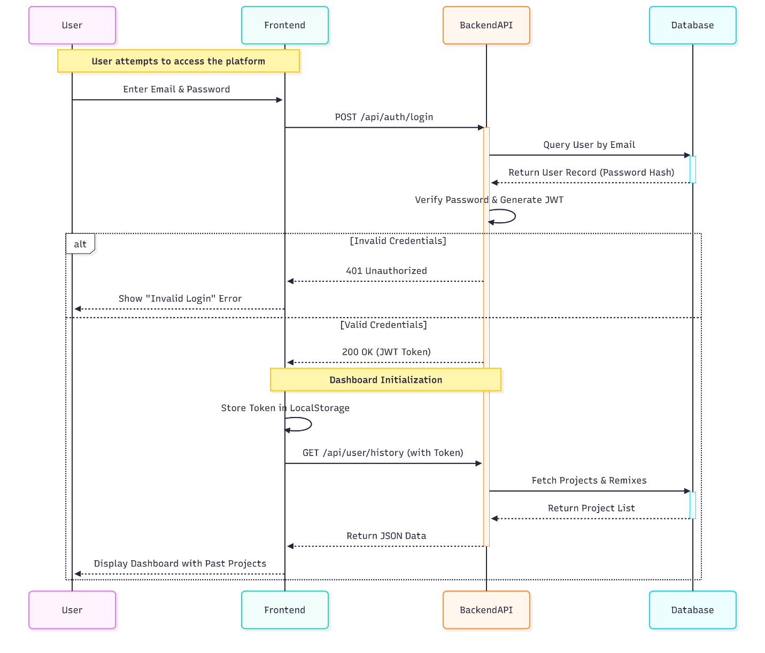

- Depicts the high-level logical structure connecting the primary User entity to core media assets like Audio Tracks and Remix History.
- Visualizes the structural dependency where generated Stems are defined as derivative entities that strictly belong to a parent Audio Track.
- Enforces One-to-Many cardinality constraints, illustrating that a single user manages multiple uploads and distinct project configurations.
- Highlights the separation of operational data by distinguishing between raw media files and their configurable Mix Settings.
- Establishes a clear data lineage that links final Remix outputs back to their original Source Tracks for auditability.

State Diagram

<State Diagram 1>

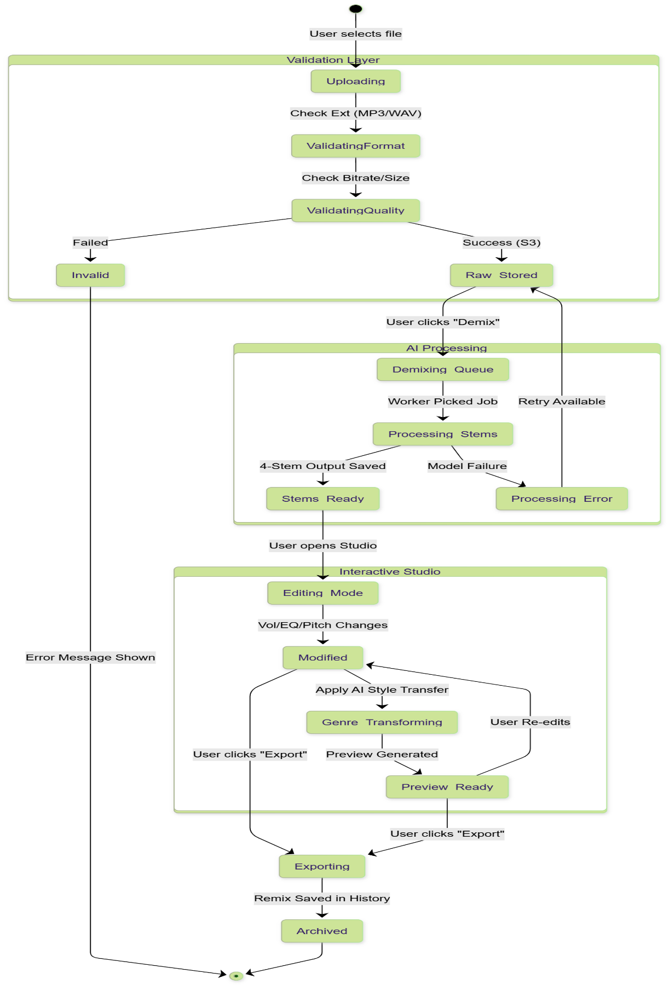
- Tracks the complete project lifecycle from file upload to final archival.
- Enforces strict file format and quality validation before storage.
- Visualizes the asynchronous AI job queue with automatic retry logic.
- Depicts the iterative loop for editing, genre transformation, and previewing.
- Finalizes the workflow by logging the exported remix in user history.

<State Diagram 2>
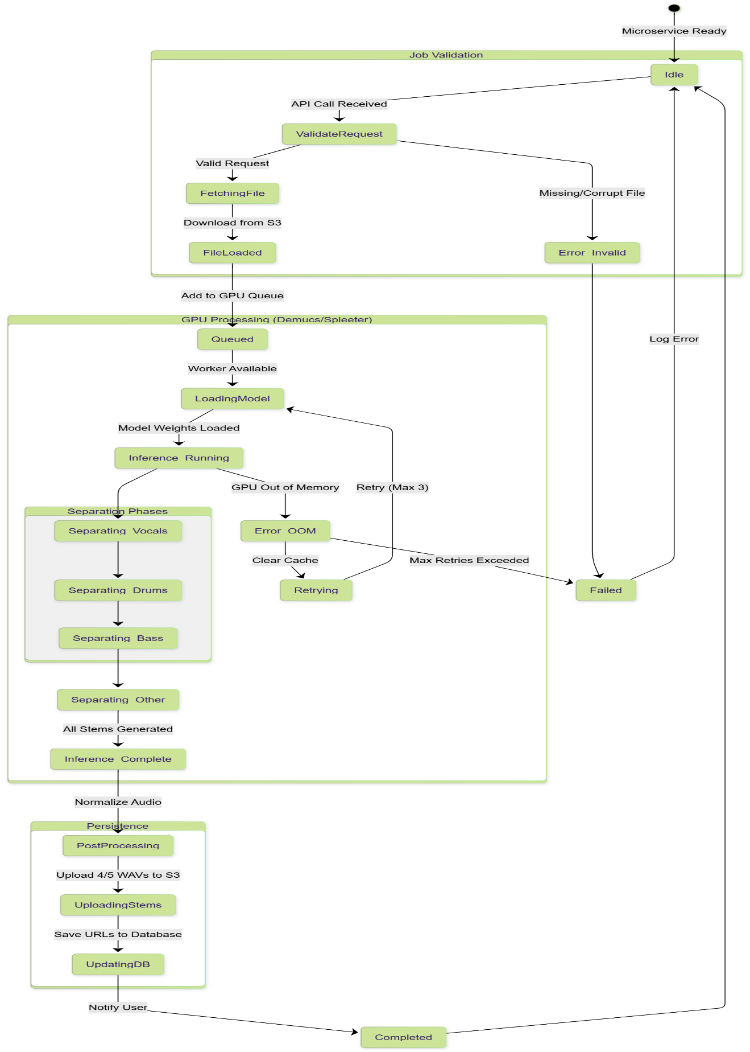

- Tracks the AI microservice lifecycle from idle status through validation to job completion.
- Enforces file integrity validation before queuing computationally intensive GPU tasks.
- Manages concurrent requests via a GPU queuing mechanism to optimize resource allocation.
- Visualizes sequential separation phases and includes automatic retry logic for memory errors.
- Finalizes the workflow by persisting audio to cloud storage and updating database status.

References
- [1] A. Défossez, N. Usunier, L. Bottou, and F. Bach, “Demucs: Music source separation with transformers,” arXiv preprint arXiv:2111.03600, 2021.
- [2] R. Hennequin, A. Khlif, F. Voituret, and M. Moussallam, “Spleeter: A fast and state-of-the-art music source separation tool,” in Proc. Int. Soc. Music Information Retrieval Conf. (ISMIR), 2020.
- [3] J. Foote, “Automatic audio genre classification,” in Proc. ACM Int. Multimedia Conf., 1997, pp. 397–400.
- [4] C. Donahue, J. McAuley, and M. Puckette, “Adversarial audio synthesis,” in Proc. Int. Conf. Learning Representations (ICLR), 2019.
- [5] Z. Rafii and B. Pardo, “A music/voice separation system based on the similarity matrix,” in Proc. IEEE Int. Conf. Acoustics, Speech, Signal Process. (ICASSP), 2013, pp. 41–44.

Appendices
[ Not applicable ]

