Men's Ethnic Wear – Listing Details
Cream Beige Embroidered Paper Cotton Kurta
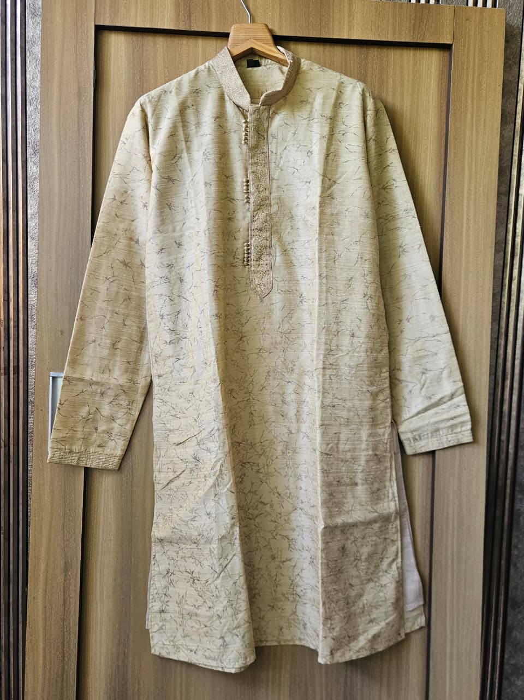 | Basic Info  Brand: Trowano  Category: Apparel – Men's Ethnic Wear  Size: L  Condition: Good  Rental Pricing  Per Day: ₹500  Per Week: ₹2,800  Technical Details  Fabric: Art Silk / Dupion-look fabric  Color: Cream / Beige  Style: Traditional Ethnic  Sleeve: Full Sleeve  Pattern: Abstract twig/branch print with gold zari embroidery at collar & placket  Weight: Medium  Description  A classic cream kurta with a delicate all-over twig/abstract motif print. Features a band collar with gold zari embroidery and decorative cord buttons along the chest placket. The cuffs carry matching embroidery detail, adding a regal touch. Ideal for festive occasions, Eid, pujas, or semi-formal gatherings.

Teal Blue Heavy Embroidered Silk Kurta
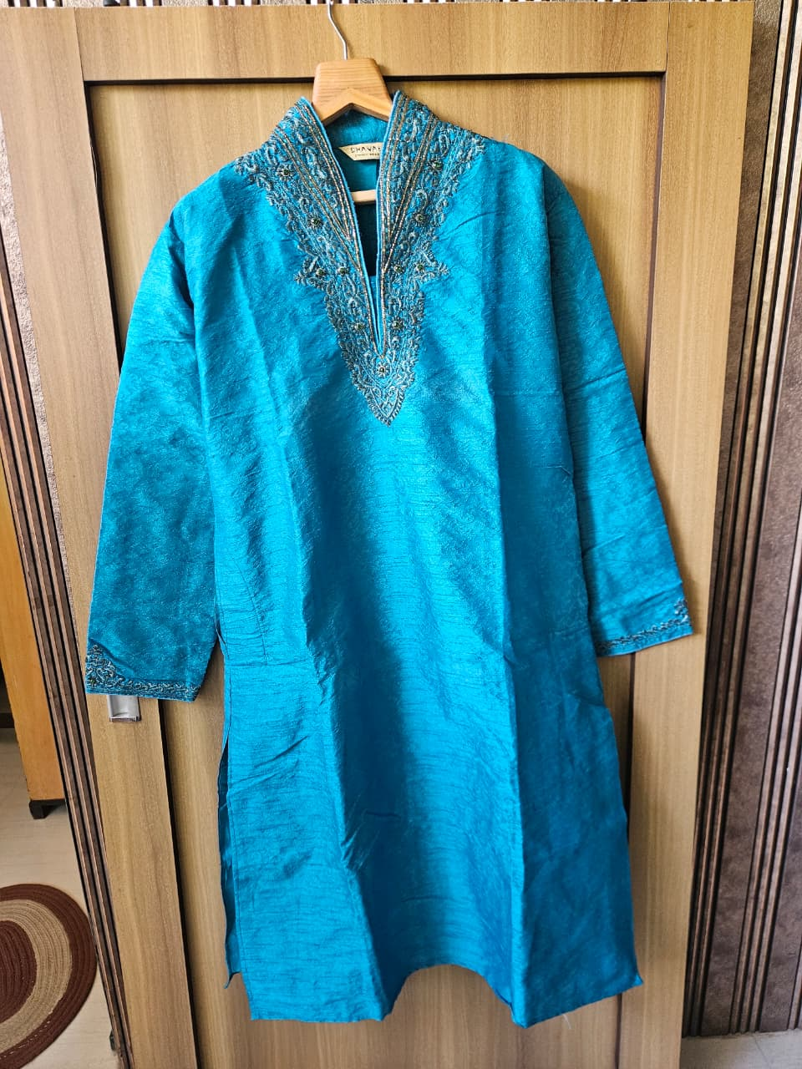 | Basic Info  Brand: Dhaval  Category: Apparel – Men's Ethnic Wear  Size: XL  Condition: Excellent  Rental Pricing  Per Day: ₹700  Per Week: ₹3,800  Technical Details  Fabric: Raw Silk / Dupion Silk  Color: Teal Blue  Style: Festive / Designer Ethnic  Sleeve: Full Sleeve with Embroidered Cuffs  Pattern: Solid with heavy zardozi/zari V-neck yoke embroidery  Weight: Medium-Heavy  Description  A striking teal blue silk kurta with a deep V-shaped embroidered yoke featuring intricate zardozi and bead-work in gold, silver, and dark thread. The wide sleeves have matching embroidered cuff bands. A showstopper for weddings, receptions, or sangeet ceremonies.

White & Blue Floral Printed Nehru Waistcoat
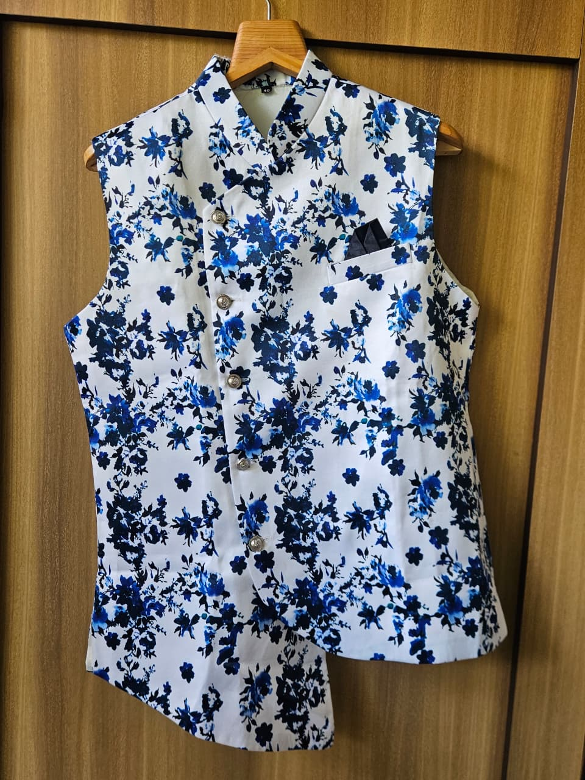 | Basic Info  Brand: Dhaval  Category: Apparel – Men's Ethnic Wear  Size: 40 (M/L)  Condition: Excellent  Rental Pricing  Per Day: ₹400  Per Week: ₹2,200  Technical Details  Fabric: Cotton Blend / Poly-Cotton  Color: White with Blue Floral Print  Style: Contemporary Festive / Indo-Western  Sleeve: Sleeveless (Waistcoat / Bandi)  Pattern: All-over blue floral digital print on white base  Weight: Light  Description  A bold and vibrant sleeveless Nehru waistcoat covered in a rich blue floral print on a white base. Silver-toned metal buttons run down the centre placket, with a breast pocket finished with a dark pocket square. Perfect layered over a plain white or off-white kurta for weddings, mehendi, or cocktail events.

Teal Paisley Printed Asymmetric Sherwani Kurta
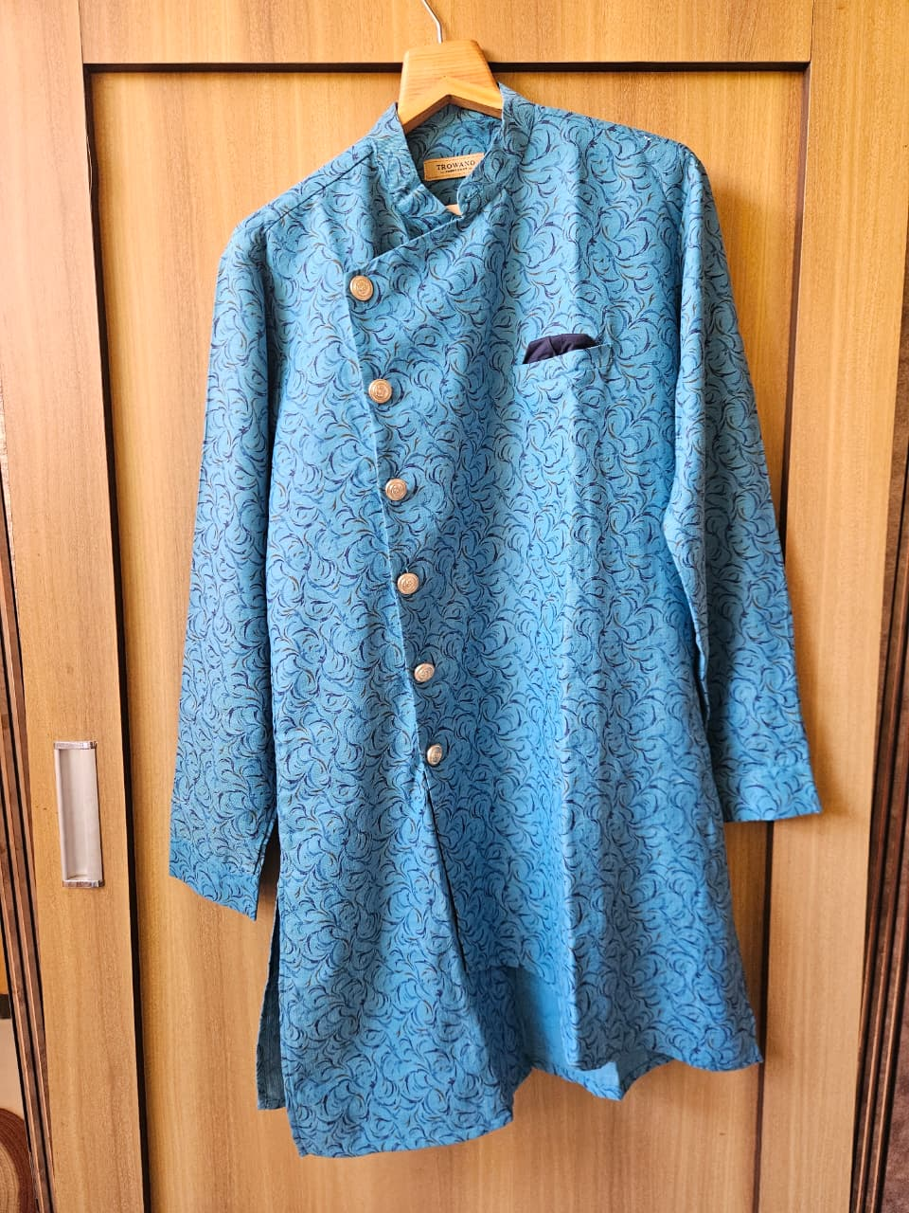 | Basic Info  Brand: Trowano  Category: Apparel – Men's Ethnic Wear  Size: XL  Condition: Excellent  Rental Pricing  Per Day: ₹400  Per Week: ₹2,200  Technical Details  Fabric: Cotton / Linen Blend  Color: Teal / Sky Blue  Style: Designer Indo-Fusion / Contemporary  Sleeve: Full Sleeve  Pattern: Paisley / swirl all-over print with asymmetric front placket  Weight: Medium  Description  A designer teal kurta-sherwani hybrid with an elegant asymmetric crossover button placket. The fabric features a rich paisley/swirl jacquard-style print throughout. Bronze-finish metal buttons and a navy chest pocket square add sharp contrast. A standout choice for wedding functions, cocktail dinners, or festive celebrations.

Mustard Yellow Chikankari Cotton Kurta
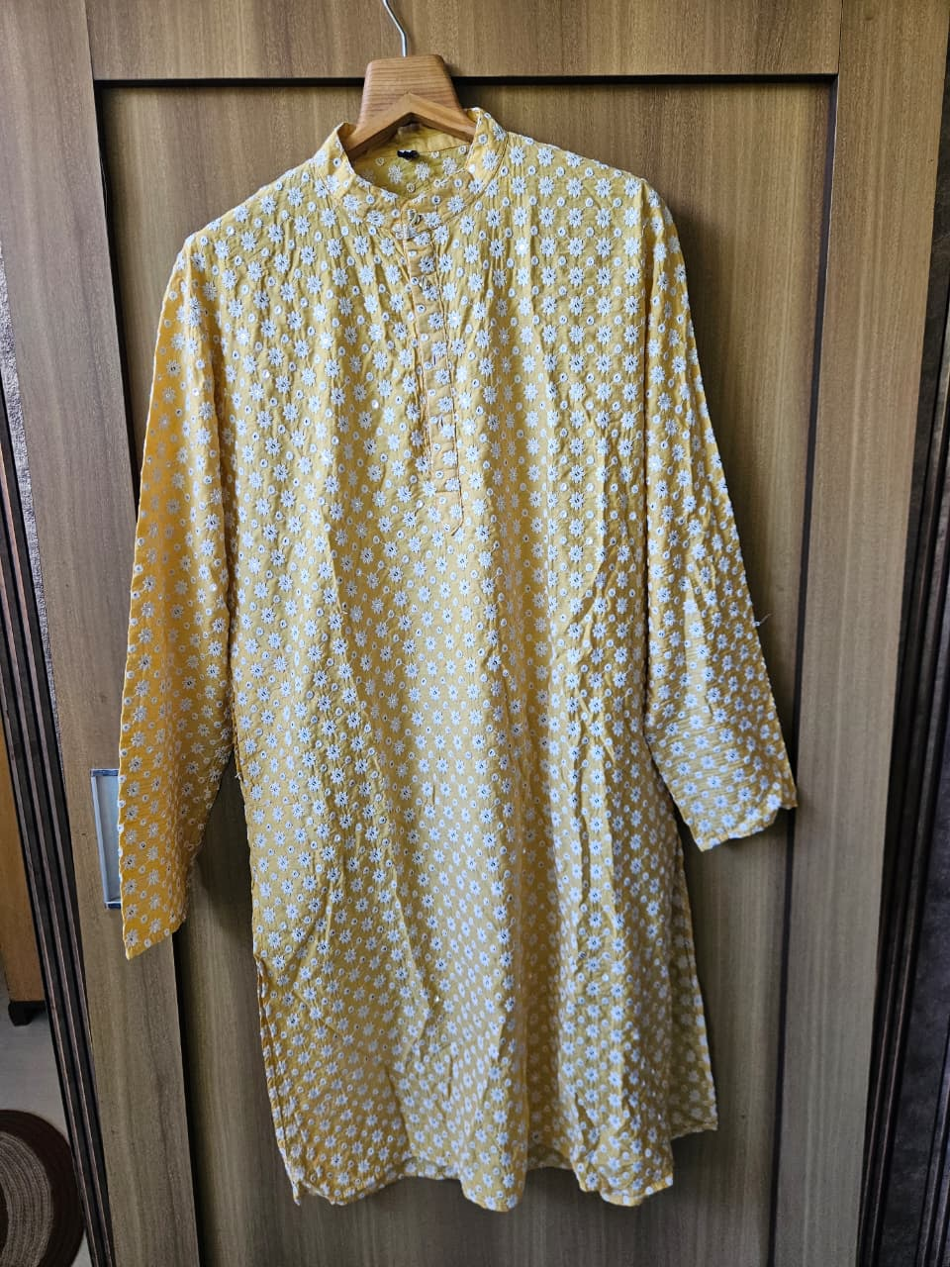 | Basic Info  Brand: Yash’s  Category: Apparel – Men's Ethnic Wear  Size: L/XL  Condition: Good  Rental Pricing  Per Day: ₹350  Per Week: ₹1,900  Technical Details  Fabric: Cotton (Chikankari embroidered)  Color: Mustard Yellow  Style: Casual Ethnic / Lucknowi  Sleeve: Full Sleeve  Pattern: All-over white Chikankari floral embroidery on mustard base  Weight: Light  Description  A breezy mustard yellow cotton kurta with traditional Lucknowi Chikankari white floral embroidery all over the fabric. The mandarin collar, centre button placket, and relaxed straight-cut silhouette make it ideal for daytime festive wear, Eid, Holi, or casual cultural events. Very comfortable for warm weather.

Navy Blue Peacock Embroidered Satin Kurta
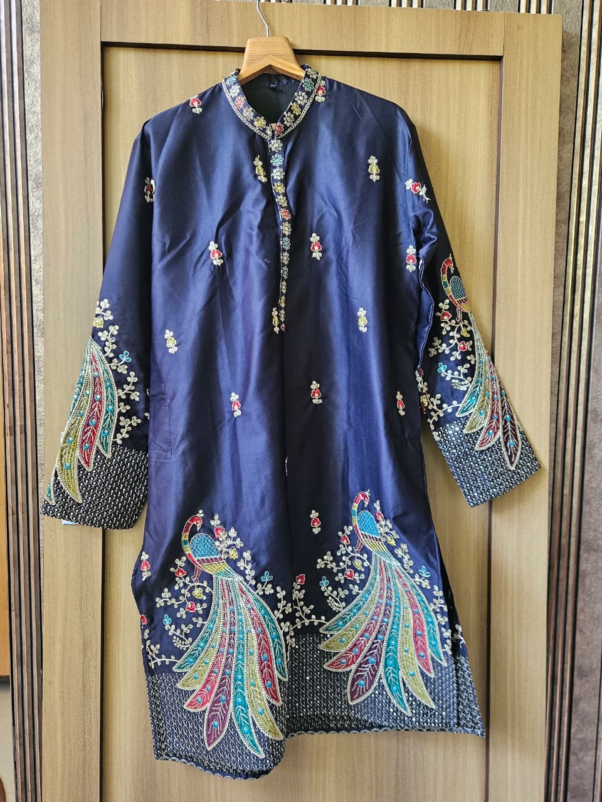 | Basic Info  Brand: House of Pataudi  Category: Apparel – Men's Ethnic Wear  Size: M/L  Condition: Excellent  Rental Pricing  Per Day: ₹800  Per Week: ₹4,500  Technical Details  Fabric: Satin / Smooth Silk-like fabric  Color: Navy Blue  Style: Royal Festive / Bridal Party  Sleeve: Full Sleeve with Heavy Embroidered Hem Cuffs  Pattern: Scattered floral butis + large peacock motifs at hem and cuffs  Weight: Heavy  Description  An opulent navy blue satin kurta adorned with elaborate peacock embroidery at the hem and sleeve cuffs in vibrant multicolour threads — teal, gold, red, and white. Scattered floral butti motifs run across the body. The hem and cuffs also feature dense geometric border work. A regal choice for groom's family, baraat functions, or high-end wedding events.

White Chikankari Mukaish Kurta
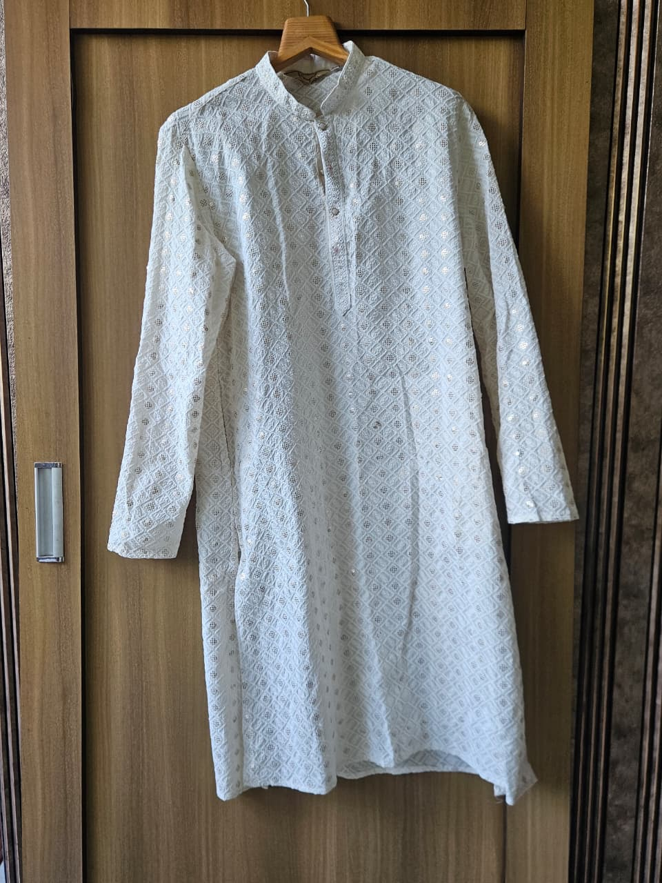 | Basic Info  Brand: Yash’s  Category: Apparel – Men's Ethnic Wear  Size: L  Condition: Good  Rental Pricing  Per Day: ₹500  Per Week: ₹2,800  Technical Details  Fabric: Cotton (Chikankari + Mukaish / Sequin work)  Color: White / Off-White  Style: Classic Lucknowi / Formal Ethnic  Sleeve: Full Sleeve  Pattern: All-over diamond lattice Chikankari with silver mukaish (metal wire) dots  Weight: Light-Medium  Description  A refined white cotton kurta featuring a full-body diamond lattice Chikankari pattern with silver mukaish (metal wire) embellishments scattered throughout. The subtle shimmer catches light beautifully. A mandarin collar with a short button placket keeps it elegant and traditional. Suitable for religious ceremonies, formal pujas, Eid, or any white-dress-code event.

Beige Textured Khadi Nehru Waistcoat
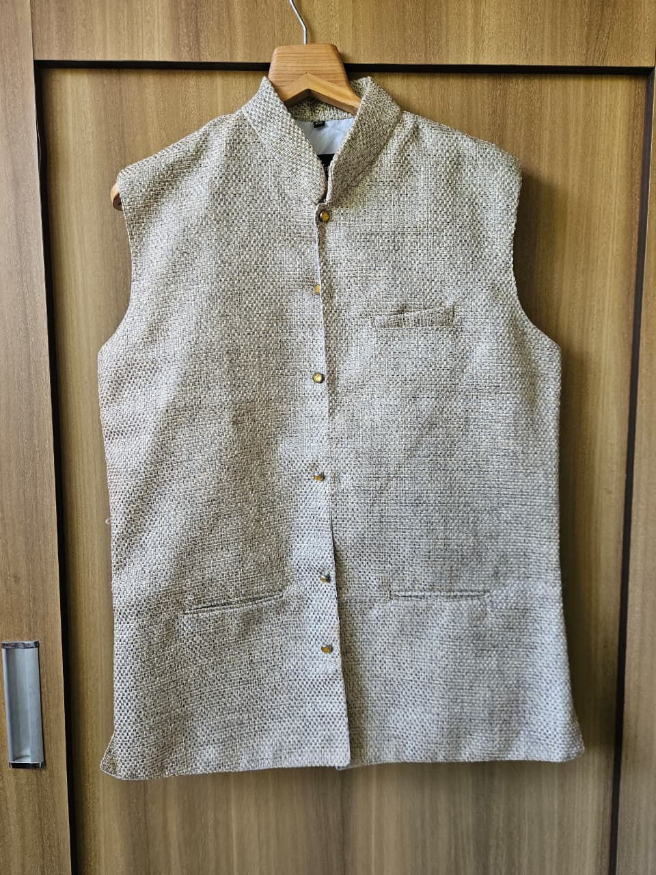 | Basic Info  Brand: Khaki  Category: Apparel – Men's Ethnic Wear  Size: M/L  Condition: Excellent  Rental Pricing  Per Day: ₹350  Per Week: ₹1,900  Technical Details  Fabric: Khadi / Handloom Cotton  Color: Beige / Natural Off-White  Style: Classic Ethnic / Minimalist  Sleeve: Sleeveless (Waistcoat / Nehru Jacket)  Pattern: Solid with textured weave  Weight: Medium  Description  A versatile beige handloom khadi Nehru waistcoat with a clean, structured silhouette. Gold/bronze snap buttons run down the centre placket, with a chest pocket and two lower pockets for functionality. The natural textured weave gives it a subtle artisanal look. Pairs well with any kurta – white, beige, or pastel – for weddings, traditional events, or smart-casual fusion looks.

