A Circular AI-Driven Platform for Garment Lifecycle Management & Redistribution

1st Nida Bepari
K.J. Somaiya Institute of Technology Mumbai, India
nida.bepari@somaiya.edu

4th Dr. Sarika Mane
K.J. Somaiya Institute of Technology Mumbai, India
sarika@somaiya.edu

2nd Insiyah Bhatia
K.J. Somaiya Institute of Technology Mumbai, India
insiyah.b@somaiya.edu

3rd Molisha Jain
K.J. Somaiya Institute of Technology Mumbai, India
molisha.jain@somaiya.edu

Abstract—Fashion sits among the planet’s most wasteful in-dustries. The Ellen MacArthur Foundation places annual textile waste beyond 92 million tonnes, with garment value exceeding USD 500 billion discarded from clothes barely worn. Simul-taneously, the global secondhand clothing market is growing roughly five times faster than new apparel sales, projected to reach USD 367 billion by 2029. This paper reviews 15 peer-reviewed sources, industry reports, and empirical studies that underpin KaPhor, a circular fashion platform built for the Indian market and powered by AI to steer garments toward their next best use. A primary consumer survey conducted by the KaPhor team supplements the academic literature and validates design decisions. Ten research gaps are identified, each mapped to a specific KaPhor feature. The platform integrates a peer-to-peer thrift marketplace, a traditional-wear rental service, an AI personalisation engine, a Lifecycle Optimisation Engine (LOE), an eco-impact tracker, a gamification system, upcycling tutorials, and an automated recycling routing service.
Habib quantifies the attitude–behaviour gap: 65 percent of consumers want to shop sustainably, yet only 26 percent do. KaPhor targets the Indian market specifically, because no existing global platform addresses the cultural centrality of high-value occasion wear, sarees, lehengas, sherwanis, creating a distinct and underserved rental opportunity. This paper presents a systematic review of the 15 sources grounding KaPhor’s design. Section II surveys five thematic clusters. Section III presents primary survey findings with charts. Section IV provides the approach adopted, whereas Section V provides the results and synthesis table respectively. Sections VI and VII provide summary and future direction respectively.
Index Terms—Circular fashion, sustainable platforms, AI rec-ommendation, garment lifecycle, multi-sided platforms, second-hand markets, Indian fashion, eco-gamification

- Introduction
The fashion industry’s environmental toll is well-documented. The fashion industry emits 1.2 billion metric tons of CO₂ equivalent per year, surpassing the amount of carbon emitted by airlines and maritime transport in their entirety. According to the Ellen MacArthur Foundation, there are 92 million metric tons of clothes waste generated every year. Currently, USD 500 billion worth of clothing is wasted after just four wears [1]. Second-hand clothes are expected to create
a revenue generation of USD 367 billion with a CAGR of 10% till 2029 [3].
These two trends run in parallel rather than counterbalanc-ing each other because no single platform has closed the loop between them. Hagiu and Wright establish that multi-sided platforms create value by reducing friction between supply and demand, precisely the problem in circular fashion where garments and buyers are widely dispersed [12]. Geissdoerfer et al. demonstrate that combining circular strategies in one integrated system captures far more value per garment than operating each channel separately [7].
- Literature Review
- Platform Design and Supply Activation
Hagiu and Wright [12] discuss the basic economics of Multi-sided Platforms; Value is generated by reducing transac-tion costs between two groups of users directly to consumers rather than the intermediary. The problem of chicken-and-egg dilemma is resolved by stimulating the supply side first. Zervas, This conclusion is verified by Proserpio and Byers [13] analysis of the Airbnb data. Listing density across geographic area is the most significant variable for predicting critical mass. Oberg and Shansavar [8] use this concept to analyze the fashion resale industry. It must be noted that proper categorization and sizing of clothing should be available in sufficient numbers before buyers come into picture.
As per Rietveld and Schilling [10], the Freemium business model growth not only the number of users but also the revenue stream through commission rates of more than 15 percent. The platform must ensure a significant number of transactions occur off-platform as this would result in di-versification of revenue stream which would lower financial risk considerably. According to Kenney and Zysman [9] it is quality rather than quantity i.e. how effectively does the correct clothing reach the correct consumer.
- Circular Economy Business Models
Geissdoerfer et al. [7] organise circular business model innovations into three types: slowing resource loops through

reuse and rental, closing them through recycling, and narrow-ing them through better product design. Combining strategies in one platform yields a far stronger business case than run-ning them separately. Bocken et al. [16] identify a culturally specific gap: platforms designed for Western markets cannot be transplanted into India, where premium traditional occasion wear represents a distinct rental opportunity unaddressed by any global platform. Blackburn et al. [15] confirm in a 2025 systematic review that non-Western market research remains persistently absent.

- Consumer Behaviour and the Attitude–Behaviour Gap
According to ThredUp [3], “48 percent of shoppers say that AI personalization makes resale products just as accessible as new products.” Meanwhile, Porter and Kramer [2] claim that incorporating sustainability into the product creates commu-nity loyalty that rivals are unable to disrupt. White, Hardisty, and Habib identify five interventions that reduce the intention–action gap: social proof, gain framing, making impact tangible, setting sustainable defaults, and simplifying the decision [6].

- AI Personalisation and Recommender Systems
AI fashion recommendation approaches are covered by Deldjoo et al. [5], including neural networks, collaborative filtering, and multimodal frameworks. Fashion settings require stylistic matching to be more significant than item matching, but no recommender system considers sustainability as an integral part of its scoring algorithm. Fkih [6] assesses 13 similarity measures in sparse data environments, and cosine similarity is always efficient. Implicit feedback yields higher precision, while temporal decay enhances results. Banerjee et al. [13] prove that no fashion recommender system integrates ethical considerations from the supply chain into its ranking process.

- Circular Platform Technology and Behavioural Engineer-ing
Todeschini et al. [2] from ten years of literature find that digitization is the most reliable way forward in overcoming consumer resistance to circular fashion. Dekhili et al. [10] highlight a crucial objection: sustainable platforms can elicit a moral licensing backlash such that buying secondhand prod-ucts would make consumers feel entitled to consume more. They suggest intentional friction in the design of the platform. Peleg Mizrachi et al. [14] support this point on a national level (r = 0.58, p < 0.01) and cite impact disclosure per transaction as the most effective structural solution. Zhou et al. [11] report that all published condition assessment systems require professional equipment; nothing works from a normal phone camera.
Neri et al. identify the ownership-and-use phase as the most overlooked lifecycle stage, no system captures in-use signals and routes garments automatically. Fernandes et al. report no prior work on gamification applied to textile sustainability [9].
- Primary Survey: Consumer Behaviour in India
  - Survey Design and Scope
The team conducted an anonymous 14-item survey, “KaPhor: A Survey on Conscious Clothing Choices”, address-ing purchase accumulation, disposal habits, resale platform ex-posure, adoption barriers, and openness to circular behaviours. Results localise largely Western secondary literature findings in an Indian consumer context.
  - Purchase Frequency and Wardrobe Accumulation
Respondents most commonly purchased clothes monthly or every few months. On idle inventory, 42 percent own more than ten unworn items; a further 31 percent reported six to ten, roughly three-quarters holding significant latent supply, confirming the bottleneck Oberg and Shansavar identify as central to peer-to-peer resale viability.
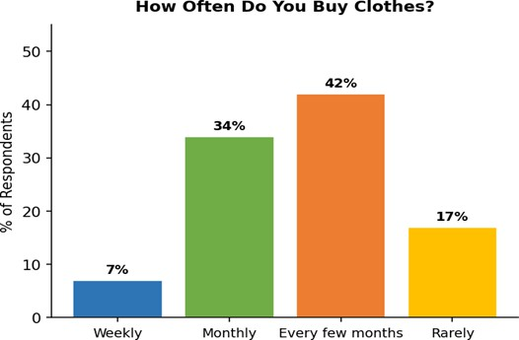
Fig. 1. Clothing purchase frequency among survey respondents.

  - Disposal Behaviour
The most frequent disposal method was keeping clothes unused (48 percent), followed by donation (30 percent), selling or swapping (15 percent), and upcycling (7 percent). The pattern mirrors White et al.’s prediction: when no frictionless resale path exists, even motivated consumers default to the lowest-effort option, validating KaPhor’s Lifecycle Optimisa-tion Engine.
  - Barriers to Thrift Platform Adoption
Quality and condition uncertainty was flagged by 68 per-cent, the single largest barrier. Trust issues were cited by 62 percent, hygiene concerns by 54 percent. Forty-one percent specifically cited the absence of Indian or traditional wear, directly confirming the cultural gap Bocken et al. identified.
  - Openness to Circular Behaviours
On clothing swaps, 38 percent said yes and 35 percent said maybe. On DIY tutorials, 52 percent said yes with short video as the preferred format, consistent with KaPhor’s 18–35 target demographic. In-app styling content rated positively, confirming the AI style guide is a primary draw.

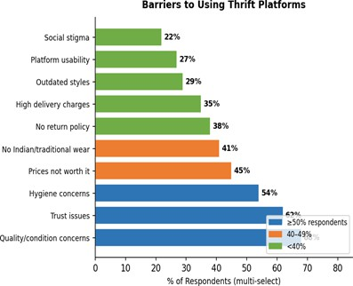

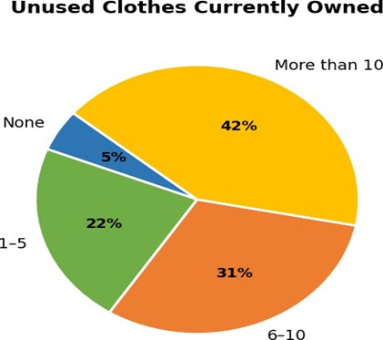
Fig. 2. Number of unworn garments held by respondents.

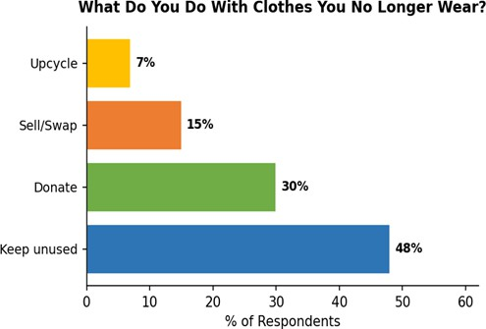

Fig. 3. Disposal methods for unwanted clothing.

  - Willingness to Pay
When asked whether they would regularly use a sustainable fashion app if fairly priced, 51 percent said yes and 35 percent said maybe, 86 percent positive or open. This validates KaPhor’s freemium architecture, which Rietveld and Schilling identify as the structure that simultaneously maximises user base and revenue capture.

  - Survey Implications
The survey confirms each design assumption the literature pointed toward. The idle wardrobe problem is large enough to sustain resale supply. Barriers—condition uncertainty, trust deficits, hygiene concerns, absence of ethnic wear—are con-crete and addressable. The conditional willingness to pay validates the freemium model.
Fig. 4. Barriers to thrift platform adoption (multi-select).
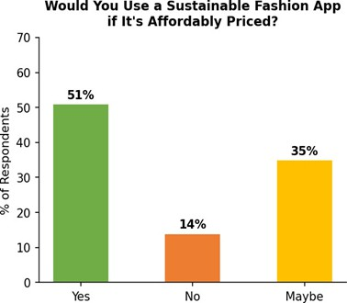

Fig. 5. Openness to circular behaviours.

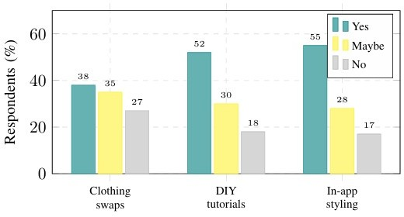

Fig. 6. Openness to circular behaviours.

- Methodology
This review draws on 15 sources selected from a broader corpus assembled across three documents: a Research Paper Analysis, a Literature Review, and a Technical Validation Doc-ument. Sources were selected for direct relevance to KaPhor’s eight feature areas: the source had to address at least one design decision theoretically or empirically, and had to state an explicit research gap or provide quantitative evidence used in the design process. Papers are organised into two clusters: Cluster A covers platform design, market economics, circular business models, and consumer behaviour; Cluster B covers AI personalisation, garment lifecycle engineering, and circular platform technology.
A research gap was counted only where the original authors explicitly stated something was absent or in need of further work, and where KaPhor had a named, implemented feature designed to address it. Environmental and market data in Table I come directly from the reviewed sources. Table II maps each of ten identified gaps to the KaPhor component that closes it.
- Results and Discussion
- Environmental Evidence Summary
Table I consolidates eight data points from the reviewed lit-erature establishing the scale of the problem and the direction of viable solutions. The Ellen MacArthur Foundation [1] gives information about baseline waste and emissions. ThredUp [3] provides current data on market size and consumer behavior. White et al. [6] gives the most accurate information about intention-action gap. Geissdoerfer et al. [7] argue that circular strategies combined is more effective than applying them individually. All of these sources are cited in KaPhor’s Eco-Impact Meter, displaying information about CO₂, H₂O, and tree savings per purchase.
- Research Gap Synthesis
10 gaps have been identified by reviewing 15 articles. Table II links each gap with the particular KaPhor feature intended to address the gap. Gaps 1 to 5 arise from the platform design and business model body of knowledge; Gaps 6 to 10 from artificial intelligence, lifecycle engineering, and behavioural technology.
- Cluster A: Platform Design and Business Model
KaPhor’s two-sidedness is consistent with what is said by Hagiu and Wright [12], in which platforms that lower the friction costs between garment sellers and appropriate buyers create value precisely because there is such friction in the market. Starting the India launch through the supply-side ap-proach with occasion wear aligns with the sequence suggested in [8], [12], [13] to create a category-specific supply base prior to investing in demand generation. The multi-stream revenue model (commission, subscription, rental fees, upcycling, and a B2B API) implements Rietveld and Schilling’s [10] finding that revenue diversification reduces platform volatility. Porter and Kramer’s [2] evidence that embedding sustainability in the
core product generates community identity that competitors find difficult to displace grounds KaPhor’s positioning.
- Cluster B: AI and Lifecycle Technology
KaPhor’s recommendation engine uses cosine similarity between user and garment embedding vectors producing a Fit Score from 0–100%. Fkih [6] found cosine similarity consistently competitive on sparse datasets, the exact condition a new platform faces at launch. The temporal decay factor (−0.02 per inactive day) implements his finding that down-weighting older signals improves accuracy. Seven implicit signal types (view, save, wishlist, add-to-cart, purchase, share, report) implement his finding that implicit signals outperform explicit ratings. Where KaPhor extends beyond the literature is in using compatibility scores to route physical garments rather than simply rank displayed results, the direction Banerjee et al. [13] call for and confirm no existing system has taken.
Smartphone photo condition assessment closes the gap Zhou et al. [11] document as the most practically significant limitation of existing AI systems. The saturation mechanism (S_{sat} > 0.7) is the practical realization of the concept proposed by Dekhili et al. [10] called “Intentional Friction Design” to avoid the moral licensing effect. The BehaviourEvent and BehaviourSignal model solves the problem identified by Neri et al. [15] as the most important challenge for further research: the creation of a system that collects usage signals and directs the clothing automatically.
- Conclusion
Multi-sided platforms, circular business models, AI rec-ommendations, condition assessment of garments, saturation prevention, and gamification of the impact of each transaction are each concepts that can be found in the literature referenced herein. The combination of all these ideas in one system aimed at the Indian market is missing from any of the literature surveyed. Specifically, there is no description of a system combining data-driven matching [10], [12], a five-modality cir-cular model [7], [15], AI-based garment routing after purchase [6], [15], a consumer-level garment condition assessment [11], saturation prevention [10], [16], and transaction-based impact disclosure with gamification [6], [9]. The primary survey provides evidence for the above through direct data from consumers in India.
Respondents hold measurable idle wardrobe inventory, face concrete and addressable barriers, and express strong condi-tional willingness to engage if the platform is affordable and easy enough to use. The ten gaps in Table II are each explicitly stated in the reviewed literature, and each has a named KaPhor feature designed to close it.
- Future Scope
Six directions follow from the literature’s identified gaps. First, longitudinal studies tracking whether KaPhor’s satu-ration mechanism and tier rewards actually reduce rebound consumption in Indian users, the empirical test Dekhili et al. [10] and Peleg Mizrachi et al. [14] call for. Second,

TABLE I
Environmental & Market Evidence Mapped to KaPhor Features

Dimension | Finding | Ref. | KaPhor Feature
Textile waste | 92M tonnes/yr; USD 500B value lost from barely-worn garments | [1] | Thrifting Marketplace
GHG emissions | ∼1.2B tonnes CO2e/yr, exceeding aviation and shipping | [1] | Eco-Impact Tracker
Carbon savings | 23% circular share cuts CO2e by ∼1.1B tonnes by 2030 | [4] | Rental Service, Resale
Utilisation gap | Avg. dress worn ∼20× before disposal; re-sale/rental can double use | [4] | Lifecycle Optimisation Engine
Post-consumer waste | Over 50% of textile waste is post-consumer | [4] | Recycling & Upcycling Services
Market growth | USD 367B by 2029 (CAGR 10%), 5× faster  than new apparel | [3] | Thrifting Marketplace, Rental
Attitude–behaviour gap | 65% want sustainable shopping; only 26% do—39-point gap | [6] | Eco-Impact Tracker, Rewards
AI in resale | 48% say AI personalisation makes second-hand as easy as buying new | [3] | AI Style Guide & Personalisation

TABLE II
Research Gap Synthesis: Literature Gaps and KaPhor Solutions

Research Gap in Literature | KaPhor Solution Component | Source(s)
No AI lifecycle management—all plat-forms are passive listing markets | LOE: 7-state Garment Lifecycle Intelli-  gence (LISTED → RECYCLE) | [1], [7], [8]
Platforms are reactive—no system pre-dicts garment decline before discard | LOE proactively promotes, schedules garments | [2], [7], [9]
Behavioural signal processing absent, re-vealed preference not captured | BehaviourEvent: every view, save, swap,  restyle → structured signal | [6], [8], [10]
Attitude–behaviour gap not closed by any existing resale platform | Carbon badges + CO2 savings at point of transaction | [6], [9]
No platform designed for Indian ethnic wear, absent from global resale research | Ethnic wear rental module for sarees, lehengas, sherwanis | [13], [16]
No platform unifies resale + rental + swap + upcycle + recycle in one app | KaPhor unifies all five modalities with diversified revenue | [7], [10]
Saturation and recommender fatigue un-addressed in all CE platform literature | Ssat > 0.7 triggers cooldown—first anti-fatigue mechanism in CE lit | [10], [16]
Consumer-facing condition assessment without industrial equipment | Mobile photo + AI condition assessment from any smartphone | [11]
In-use phase data never captured to trig-ger automated circular routing | BehaviourSignal → LOE → Circula-tionSchedule | [15]
Gamification for textile sustainability: no prior published work exists | Tier-based rewards with per-transaction carbon badges and streaks | [9]

extending condition assessment to identify textile fibre compo-sition would enable more accurate recyclability routing beyond visual-only systems [11]. Third, licensing the Garment Lifecy-cle Intelligence API to fashion brands and NGOs would shift KaPhor from a consumer app to sector-level infrastructure.
Fourth, direct comparison against Western platforms, mea-suring per-transaction carbon reduction and rebound incidence, would fill the comparative gap Blackburn et al. [15] flag as consistently absent. Fifth, KaPhor’s upcycling and repair ecosystem presents a concrete opportunity for localised job generation, training and certifying independent tailors, upcy-clers, and textile artisans as verified service providers on the platform, creating a structured gig economy layer within the circular fashion supply chain. Sixth, integrating a community-driven social feed would allow users to share outfit restyling, upcycling outcomes, and circular milestones, reinforcing the behavioural nudges that White et al. [6] identify as most effective for closing the attitude–behaviour gap through peer social proof and visible community participation.
References
- Ellen MacArthur Foundation, “A New Textiles Economy: Redesigning Fashion’s Future,” EMF, 2017.
- B. Todeschini, M. Cortimiglia, and J. de Medeiros, “Can digital tech-nologies increase consumer acceptance of circular business models? The case of second-hand fashion,” Sustainability, vol. 14, no. 8, p. 4589, MDPI, 2022.
- ThredUp & GlobalData, “Annual Resale Report, 12th & 13th Editions,” ThredUp Inc., Oakland, CA, 2024/2025.
- Ellen MacArthur Foundation, “Circular Business Models: Redefining Growth for a Thriving Fashion Industry,” EMF, 2021.
- Y. Deldjoo, M. Nazari, and F. B. Selem, “Study of AI-driven fashion recommender systems,” SN Computer Science, vol. 4, p. 514, Springer Nature, 2023.
- K. White, D. J. Hardisty, and R. Habib, “The elusive green consumer,” Harvard Business Review, Jul.–Aug. 2019.
- M. Geissdoerfer, M. P. P. Pieroni, D. C. A. Pigosso, and K. Soufani, “Circular business models,” Journal of Cleaner Production, vol. 277,
p. 123741, 2020.
- C. Oberg and S. Shansavar, “Why do people buy from resale markets?” International Journal of Production Economics, vol. 222, p. 107494, 2020.
- S. Fernandes et al., “Eco-gamification platform to promote consumers’ engagement in the textile and clothing circular value chain,” Sustain-ability, vol. 15, no. 6, p. 5398, MDPI, 2023.
- S. Dekhili, M. Achabou, and F. Codecà, “When pro-ecological intentions of second-hand platforms backfire: The Vinted case,” Journal of Cleaner Production, vol. 482, p. 144188, 2024.
- J. Zhou et al., “Reimagining fashion and textiles sustainability with AI: A circular economy approach,” Applied Sciences, vol. 15, no. 10,
p. 5691, 2025.
- A. Hagiu and J. Wright, “Multi-sided platforms,” International Journal of Industrial Organization, vol. 43, pp. 162–174, 2015.
- A. Banerjee, S. Ray, and T. Chakraborty, “Agentic personalized fashion recommendation in the age of generative AI,” arXiv:2508.02342, 2025.
- M. Peleg Mizrachi, G. Saranga, and A. Tal, “Secondhand fashion con-sumers exhibit fast fashion behaviors despite sustainability narratives,” Scientific Reports, Nature Portfolio, 2025.
- O. Blackburn, P. Ritala, and J. Keranen, “Circular economy platforms: A systematic review,” Business Strategy and the Environment, Wiley, 2025.
- N. M. P. Bocken et al., “A literature and practice review to develop sustainable business model archetypes,” Journal of Cleaner Production, vol. 65, pp. 42–56, 2014.

