White Chikankari Lehenga with Multicolour Patchwork Blouse & Dupatta
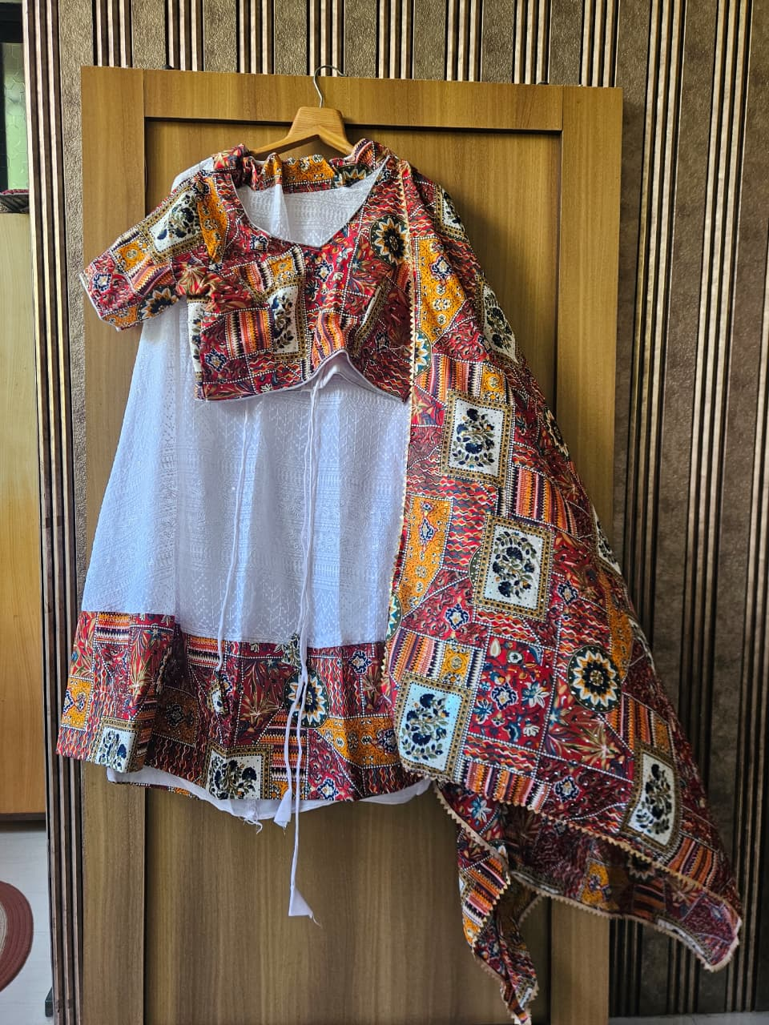
Title | White Chikankari Lehenga with Multicolour Patchwork Blouse & Dupatta
Description | A stunning white chikankari lehenga with intricate self-fabric embroidery throughout the skirt. Paired with a vibrant multicolour patchwork blouse in red, yellow, navy, and ivory block-print geometric panels. The matching dupatta carries the same bold patchwork design with decorative borders. Ideal for Navratri, Garba, mehendi, or festive celebrations.
Brand | Unknown
Category | Apparel
Size | L
Condition | Excellent
Rental / Day | ₹800
Rental / Week | ₹4,500
Fabric | Cotton Chikankari (Lehenga) / Printed Cotton (Blouse & Dupatta)
Color | White with Multicolour Patchwork
Style | Ethnic / Festive
Sleeve Type | Short Sleeve Blouse
Fit / Shape | Flared Lehenga
Pattern | Chikankari + Patchwork Print

Rust Orange Floral Silk Saree with Plain Blouse Piece
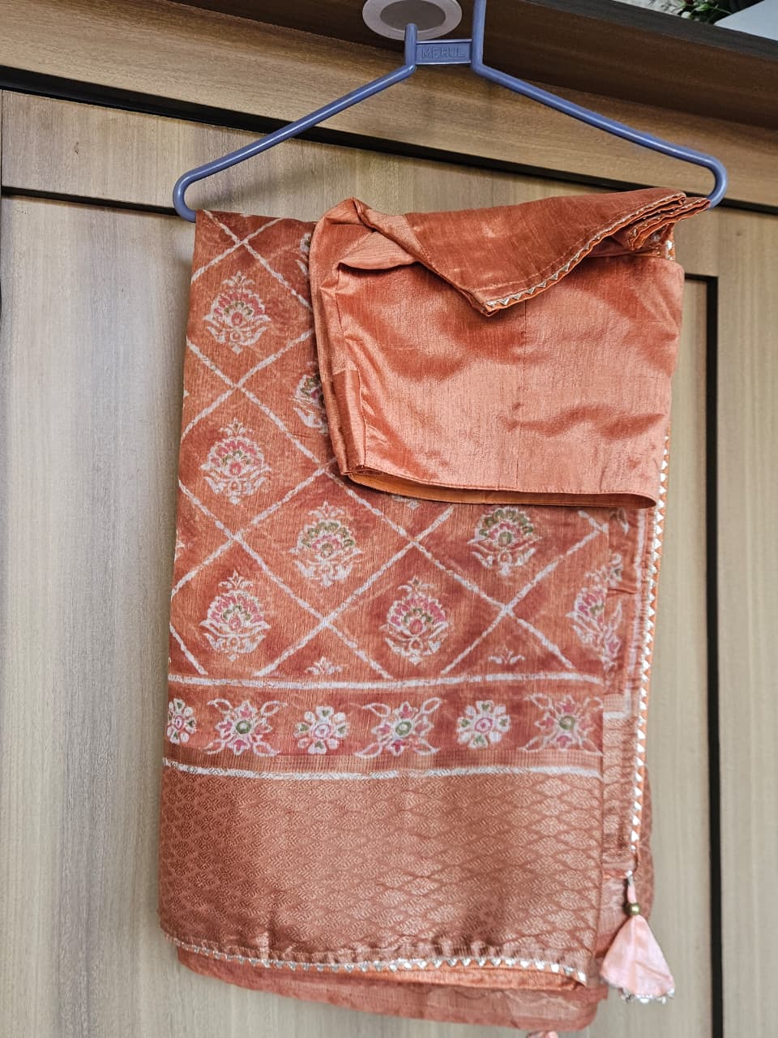
Title | Rust Orange Floral Silk Saree with Plain Blouse Piece
Description | Elegant rust/terracotta-toned silk saree with a diamond lattice pattern filled with delicate floral motifs in pink, white, and gold. Features a decorative continuous floral border and a rich textured pallu. Small silver/mirror trim at edges and a tassel finish. Comes with a plain rust-toned silk blouse piece. Suitable for weddings, receptions, and formal occasions.
Brand | Unknown
Category | Apparel
Size | OS (One Size)
Condition | Excellent
Rental / Day | ₹700
Rental / Week | ₹3,800
Fabric | Silk
Color | Rust / Terracotta
Style | Ethnic / Formal
Sleeve Type | N/A
Fit / Shape | Drape / Saree
Pattern | Floral Diamond Lattice

Sky Blue Georgette Saree with Red Smocked Blouse & Elephant Motif
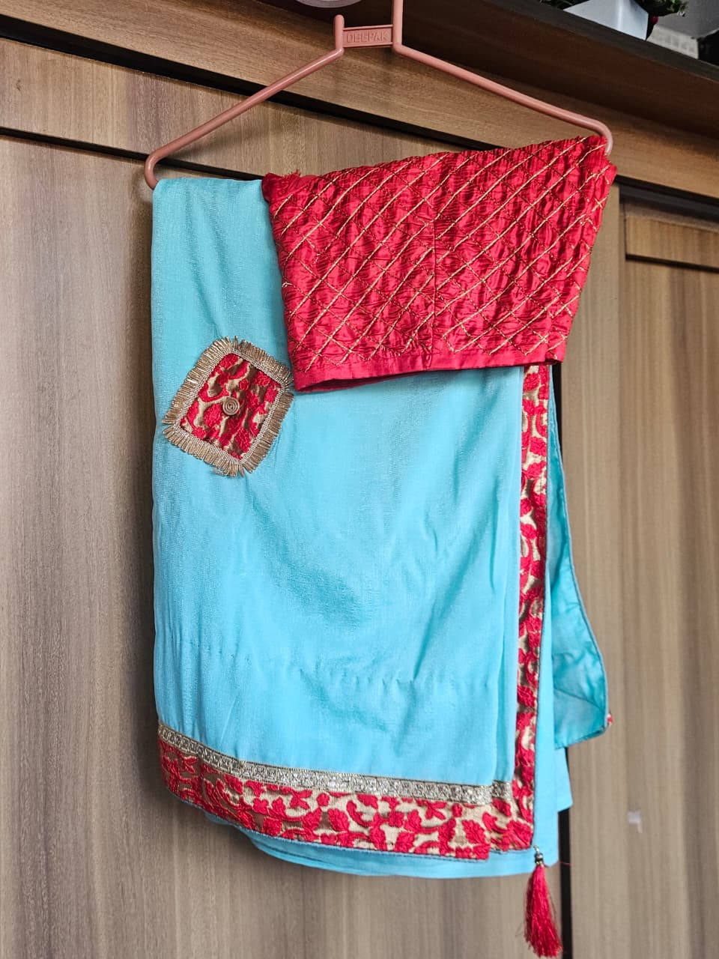
Title | Sky Blue Georgette Saree with Red Smocked Blouse & Elephant Motif
Description | Striking sky blue georgette saree with a deep red contrast blouse featuring diamond smocking and gold zari threadwork. The saree has a red and gold embroidered floral border along the pallu edge. An appliqué square patch with a golden elephant motif sits on the saree body. Red silk tassels at the corner complete the look. Perfect for weddings and festive occasions.
Brand | Unknown
Category | Apparel
Size | OS (One Size)
Condition | Good
Rental / Day | ₹600
Rental / Week | ₹3,200
Fabric | Georgette (Saree) / Silk (Blouse)
Color | Sky Blue & Red
Style | Ethnic / Wedding
Sleeve Type | Sleeveless Blouse
Fit / Shape | Drape / Saree
Pattern | Solid with Embroidered Border & Appliqué Elephant Patch

Ombre Red to Pink Bandhani Saree with Zari Border & Silk Blouse
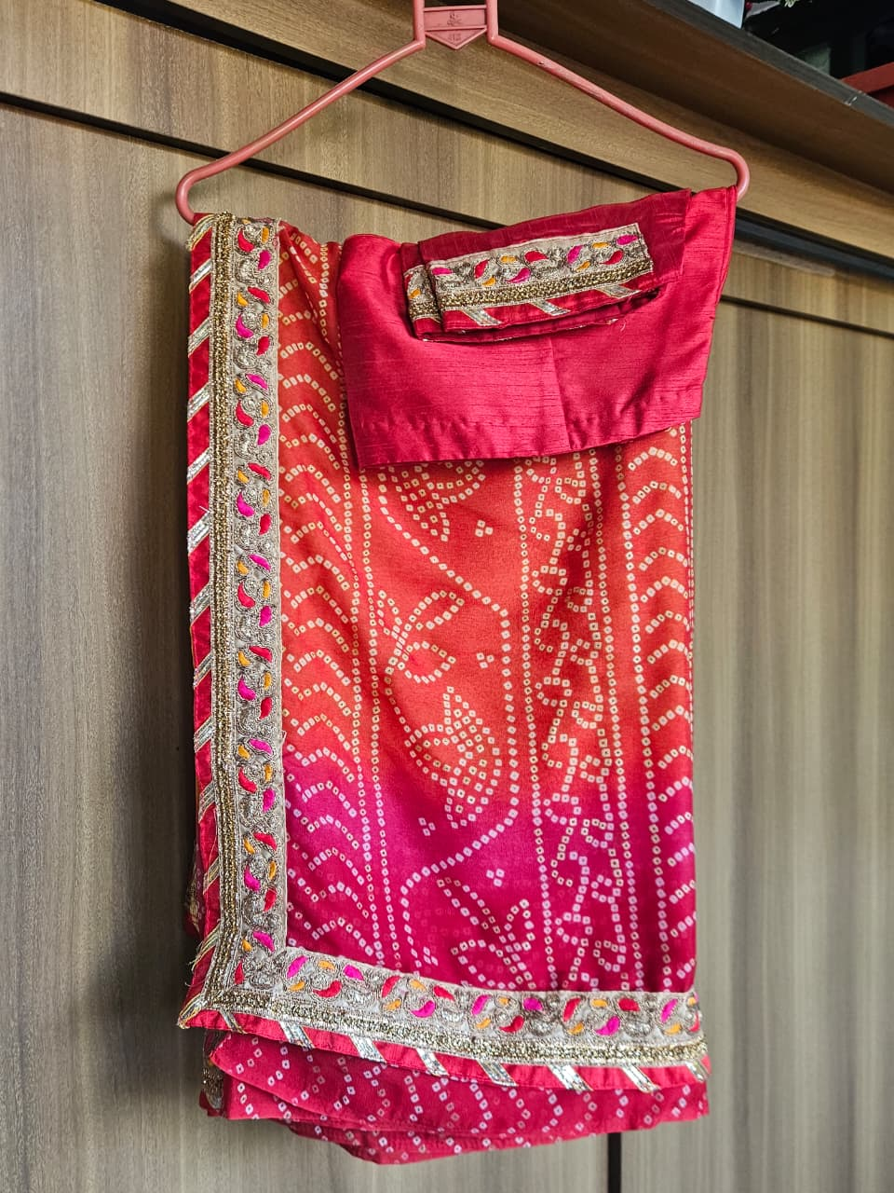
Title | Ombre Red to Pink Bandhani Saree with Zari Border & Silk Blouse
Description | Vibrant ombre tie-dye (bandhani) saree transitioning from deep red at the top to hot pink at the hem, with classic white dot patterns throughout. Features a rich gold zari and multi-colour embroidered border with leaf and paisley motifs. Comes with a matching deep red/pink raw silk blouse. Ideal for weddings, sangeet, and festive wear.
Brand | Unknown
Category | Apparel
Size | OS (One Size)
Condition | Excellent
Rental / Day | ₹750
Rental / Week | ₹4,000
Fabric | Georgette (Saree) / Raw Silk (Blouse)
Color | Red to Pink Ombre
Style | Ethnic / Bridal
Sleeve Type | N/A
Fit / Shape | Drape / Saree
Pattern | Bandhani Tie-Dye with Zari Border

Baby Pink Organza Saree with Zardosi Paisley Embroidery & Plum Blouse
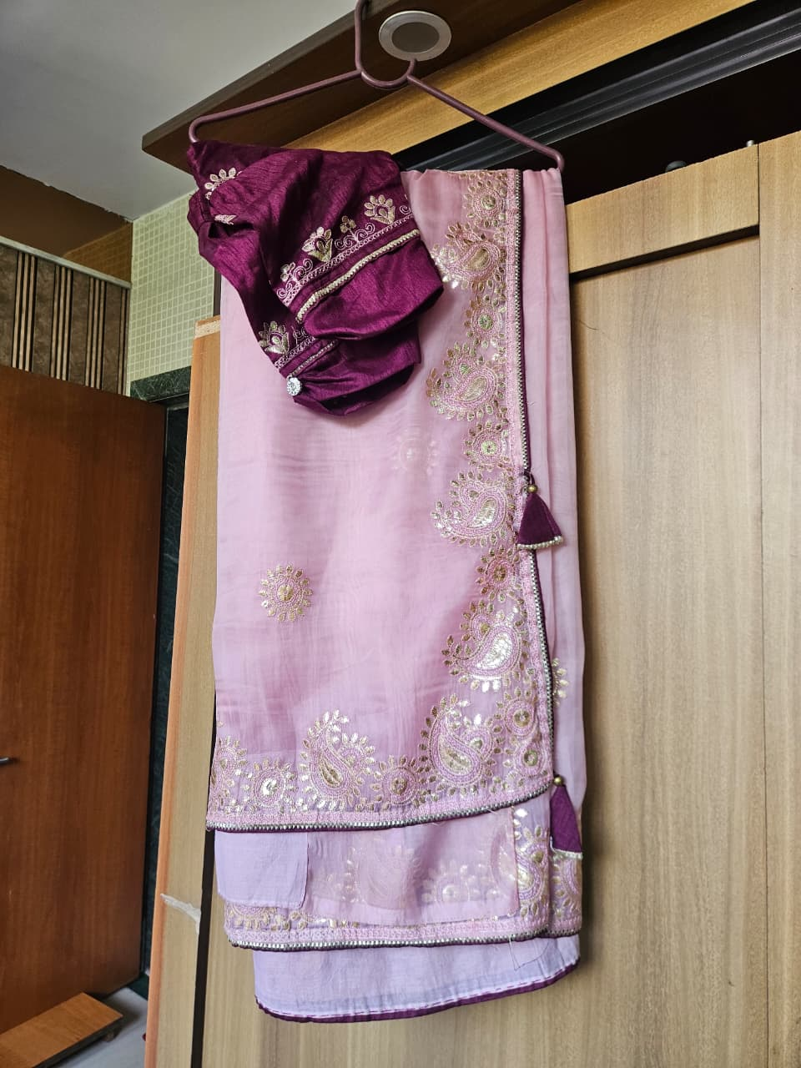
Title | Baby Pink Organza Saree with Zardosi Paisley Embroidery & Plum Blouse
Description | Delicate baby pink organza saree adorned with gold and silver zardosi embroidered paisley (keri) motifs along the pallu and border. A rich circular embroidered medallion sits on the body. Paired with a deep plum/wine silk blouse with matching zardosi embroidery and pearl trim. Plum tassels at corners complete the ensemble. Perfect for weddings and cocktail events.
Brand | Unknown
Category | Apparel
Size | OS (One Size)
Condition | Excellent
Rental / Day | ₹900
Rental / Week | ₹5,000
Fabric | Organza (Saree) / Silk (Blouse)
Color | Baby Pink & Plum
Style | Ethnic / Bridal
Sleeve Type | N/A
Fit / Shape | Drape / Saree
Pattern | Zardosi Paisley Embroidery

Royal Purple Banarasi Silk Saree with Heavy Silver Zari Weave & Blouse
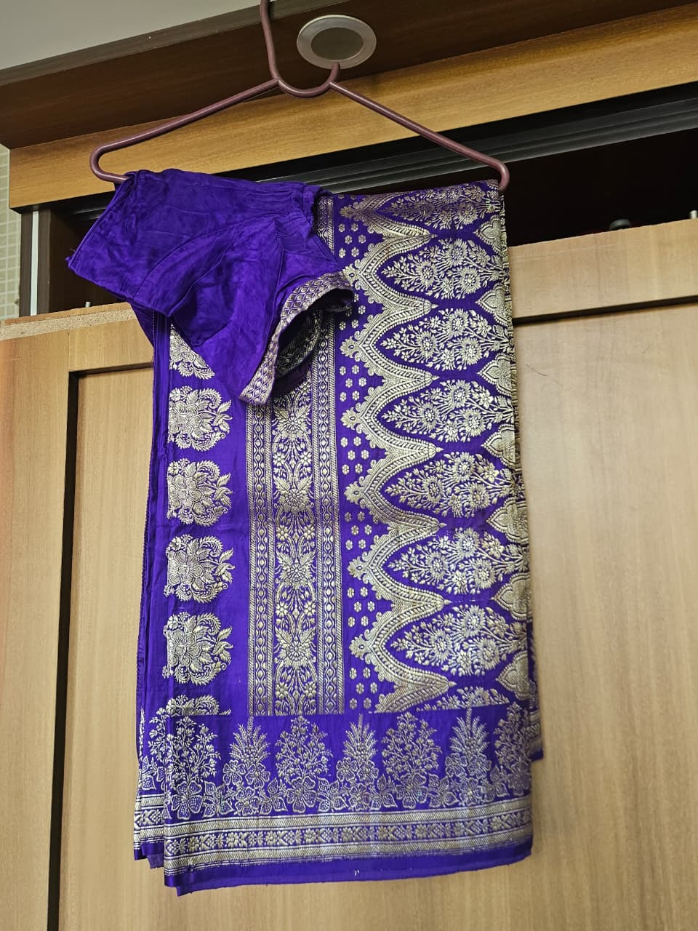
Title | Royal Purple Banarasi Silk Saree with Heavy Gold Zari Weave & Blouse
Description | Magnificent royal purple Banarasi pure silk saree with all-over dense gold zari woven floral, leaf, and paisley motifs. The pallu features large arch-shaped (mango/kairi) patterns with intricate detailing. Rich gold zari border on all sides. Comes with a matching purple velvet/silk blouse. Ideal for weddings, pujas, and grand celebrations.
Brand | Unknown
Category | Apparel
Size | OS (One Size)
Condition | Pristine
Rental / Day | ₹1,200
Rental / Week | ₹6,500
Fabric | Banarasi Pure Silk
Color | Royal Purple & Gold
Style | Ethnic / Bridal / Traditional
Sleeve Type | N/A
Fit / Shape | Drape / Saree
Pattern | Banarasi Zari Weave — Floral & Paisley

Teal Blue Satin Saree and Blouse with Heavy Zardosi Floral Embroidery
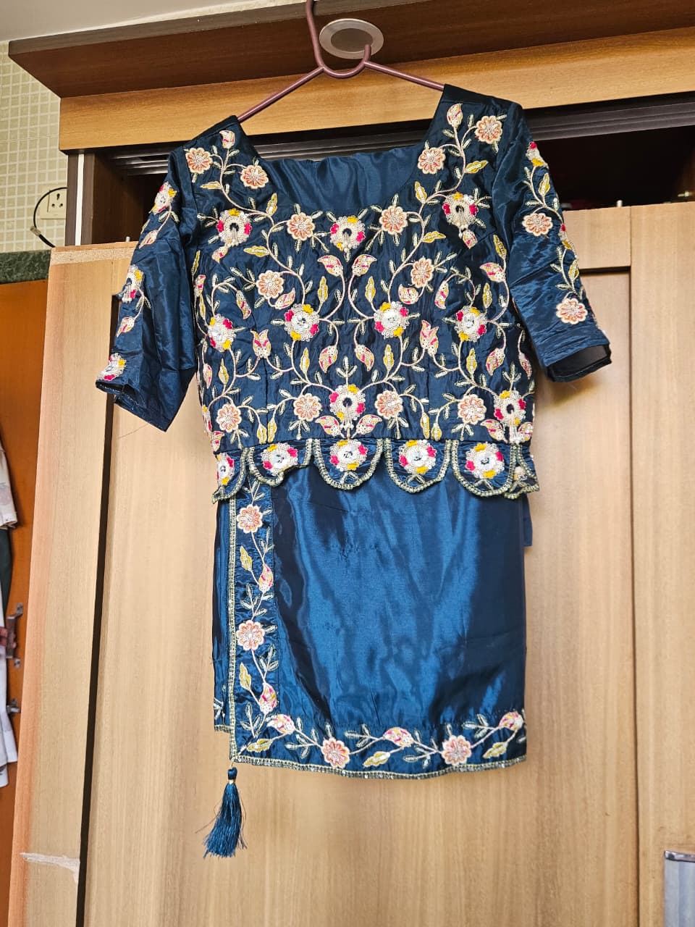
Title | Teal Blue Satin Saree and Blouse with Heavy Zardosi Floral Embroidery
Description | Exquisite deep teal/navy blue satin blouse with dense all-over floral and vine embroidery in white, peach, yellow, red, and pink threads with gold zari and sequin accents. Features a scalloped hem with gold trim and a teal tassel. Comes with matching plain teal satin fabric (saree/skirt piece). The three-dimensional embroidery makes it ideal for weddings or receptions.
Brand | Unknown
Category | Apparel
Size | L
Condition | Excellent
Rental / Day | ₹700
Rental / Week | ₹3,800
Fabric | Satin Silk
Color | Teal / Navy Blue
Style | Ethnic / Bridal
Sleeve Type | 3/4 Sleeve
Fit / Shape | Blouse with Matching Fabric
Pattern | Dense Zardosi Floral Embroidery

Slate Blue Mirror Work Nayra Cut Suit with Floral Embroidered Dupatta and Plazo
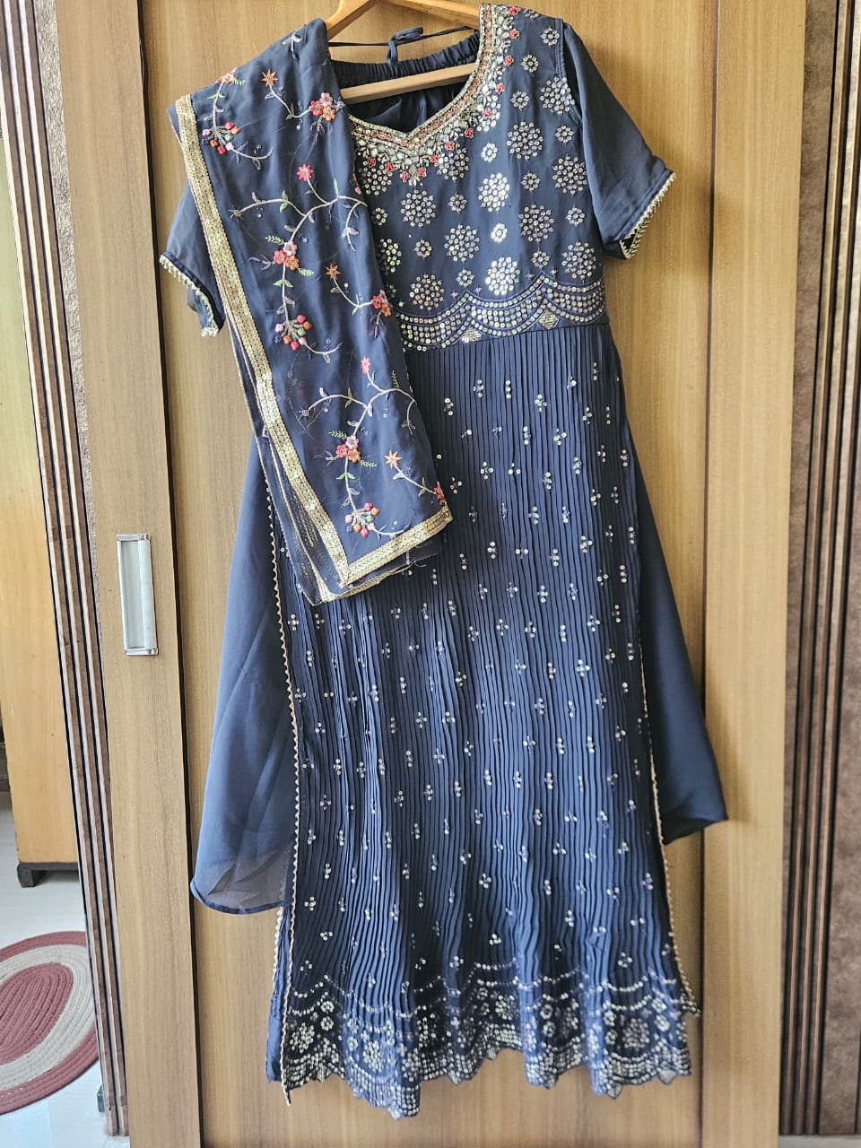
Title | Slate Blue Mirror Work Nayra Cut Suit with Floral Embroidered Dupatta and Plazo
Description | Elegant slate/charcoal blue Anarkali suit with dense mirror and sequin work across the yoke in circular floral patterns. Knife-pleated skirt with scattered mirror embellishments throughout. Paired with a sheer matching dupatta featuring delicate colourful floral embroidery with a gold zari border. Ideal for weddings, receptions, and festive occasions.
Brand | Unknown
Category | Apparel
Size | XL
Condition | Excellent
Rental / Day | ₹850
Rental / Week | ₹4,500
Fabric | Georgette (Suit) / Chiffon (Dupatta)
Color | Slate / Charcoal Blue
Style | Ethnic / Festive
Sleeve Type | Short Sleeve
Fit / Shape | Anarkali / Flared
Pattern | Mirror & Sequin Work

Pastel Pink Printed Kurta with Sharara & Plain Dupatta
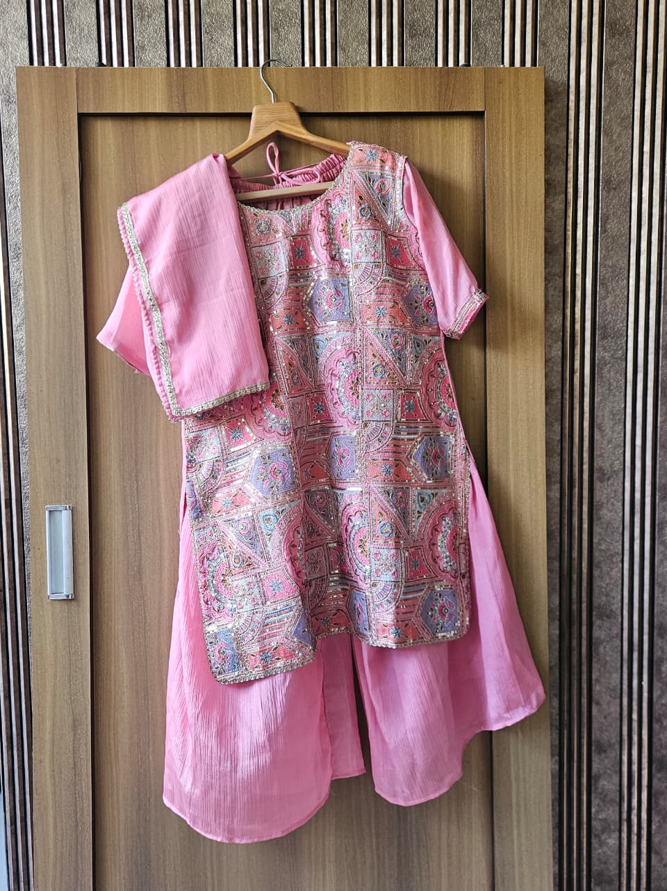
Title | Pastel Pink Printed Kurta with Sharara & Plain Dupatta
Description | Charming pastel pink kurta set featuring an ornate patchwork-style printed front panel in pink, lavender, blue, and gold geometric/mandala motifs with sequin detailing. Ruched elastic neckline. Paired with matching solid pink flared sharara pants and a plain pink dupatta with delicate gold lace trim. Great for festive, semi-formal, or daytime events.
Brand | Unknown
Category | Apparel
Size | XL
Condition | Excellent
Rental / Day | ₹600
Rental / Week | ₹3,200
Fabric | Crepe / Chinon
Color | Pastel Pink with Multicolour Print
Style | Ethnic / Festive / Indo-Western
Sleeve Type | Short Sleeve
Fit / Shape | Straight Kurta + Sharara
Pattern | Digital Print with Sequin Accents

Coral Orange Anarkali Suit with Zardosi Motifs & Bandhani Dupatta
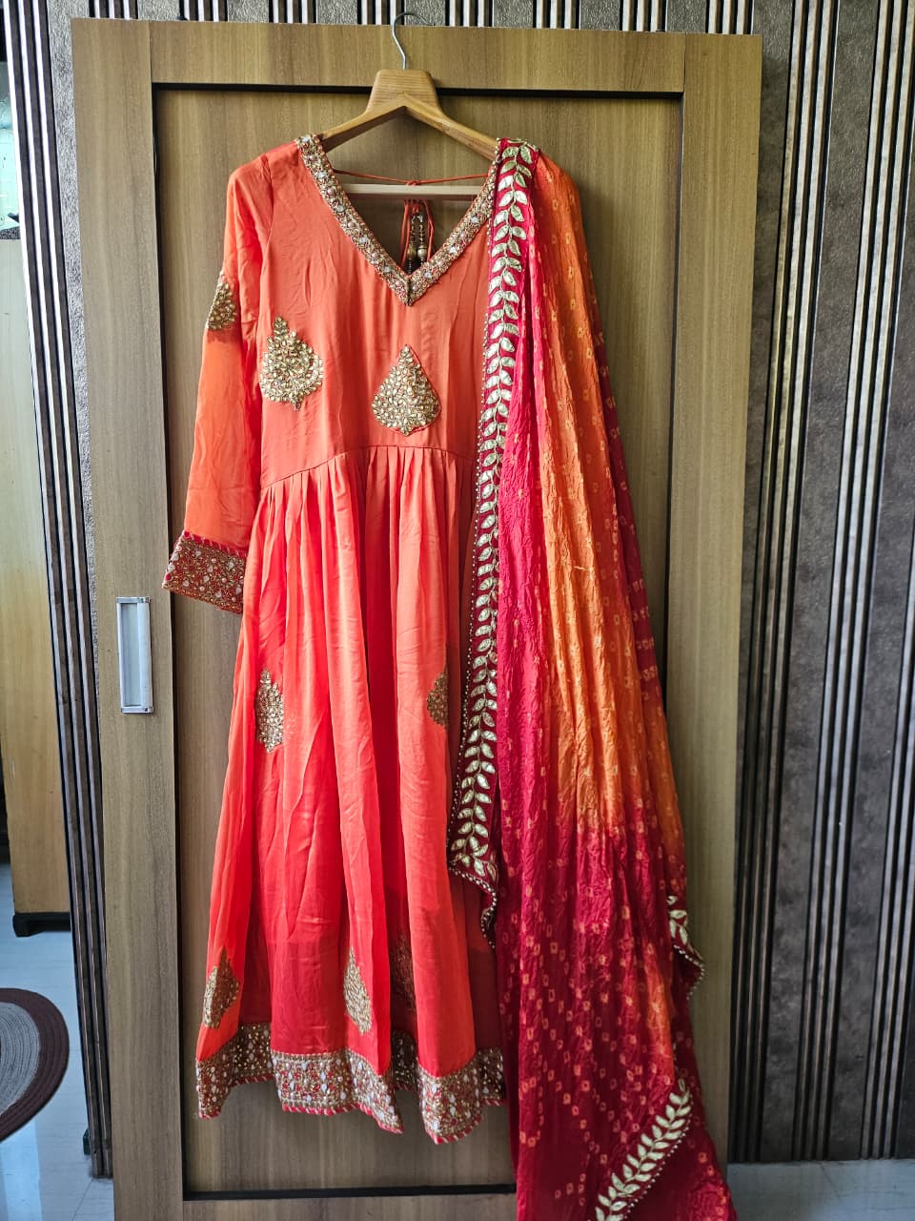
Title | Coral Orange Anarkali Suit with Zardosi Motifs & Bandhani Dupatta
Description | Gorgeous coral/orange floor-length Anarkali suit with intricate gold zardosi embroidered tear-drop motifs on the body, neckline, cuffs, and hem. V-neckline with gold embroidered trim and decorative tassel key. Paired with a contrasting ombre red-to-orange bandhani dupatta with gold leaf-pattern lace border. Ideal for sangeet, mehndi, and festive celebrations.
Brand | Unknown
Category | Apparel
Size | L
Condition | Good
Rental / Day | ₹750
Rental / Week | ₹4,000
Fabric | Georgette / Silk
Color | Coral Orange & Red
Style | Ethnic / Festive / Bridal
Sleeve Type | Full Sleeve
Fit / Shape | Anarkali / Flared
Pattern | Zardosi Tear-Drop Motifs + Bandhani Dupatta

Teal Green Straight Kurta Set with Gold Embroidery & Hot Pink Ruffle Dupatta
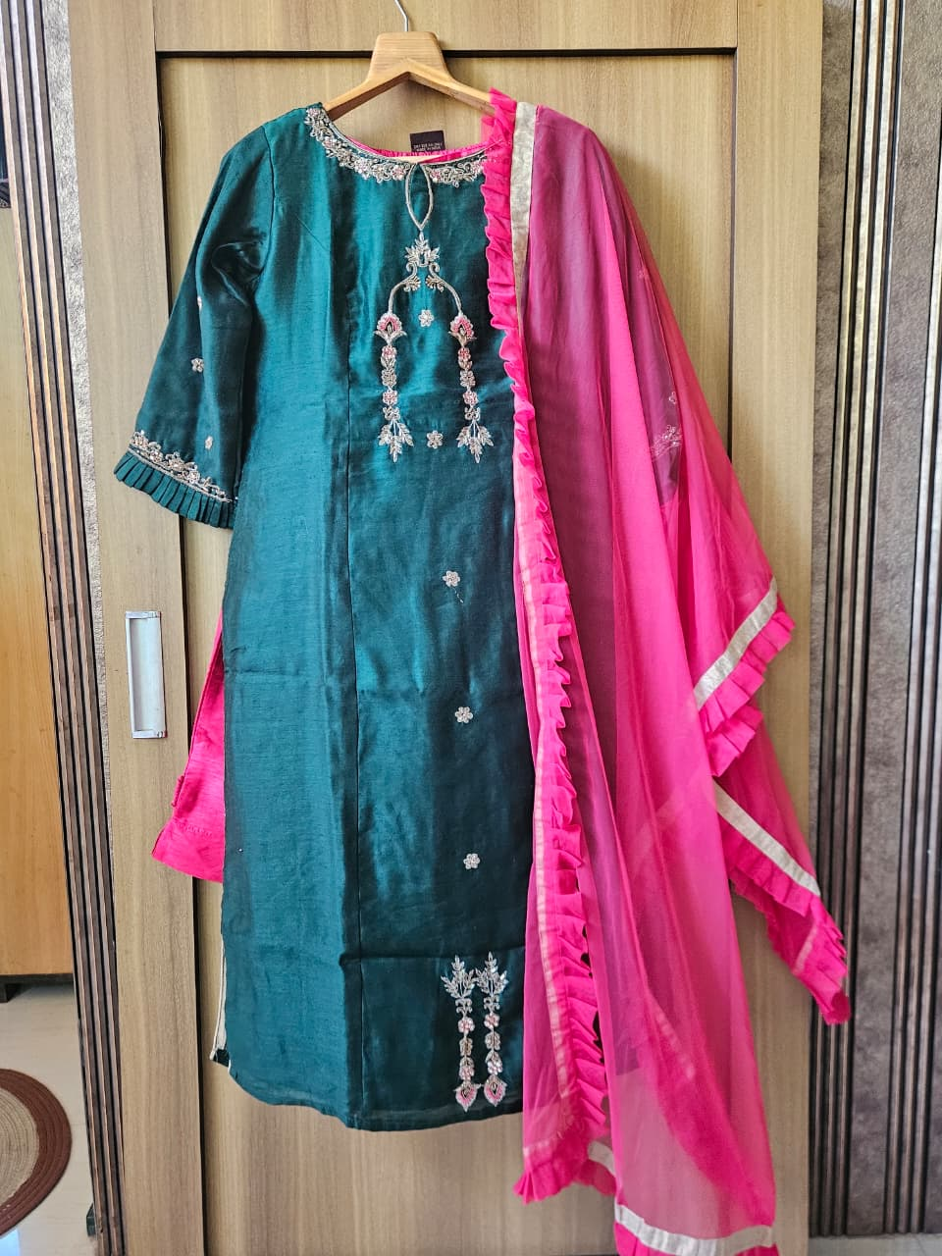
Title | Teal Green Straight Kurta Set with Gold Embroidery & Hot Pink Ruffle Dupatta
Description | Sophisticated teal/dark green raw silk straight-cut kurta with delicate silver zardosi and floral embroidery at the neckline, cuffs, and hem in a chandelier/jhalar pattern. Subtle scattered floral motifs adorn the body. Paired with a vibrant hot pink chiffon dupatta with ruffle/frill edges and silver border. A bold colour-block combination perfect for festive events.
Brand | Unknown
Category | Apparel
Size | L
Condition | Excellent
Rental / Day | ₹650
Rental / Week | ₹3,500
Fabric | Raw Silk (Kurta) / Chiffon (Dupatta)
Color | Teal Green & Hot Pink
Style | Ethnic / Festive
Sleeve Type | Elbow/3-Quarter Sleeve
Fit / Shape | Straight Cut Kurta
Pattern | Silver Zardosi Floral Embroidery

Steel Blue Peplum Kurta with Gharara & Embroidered Dupatta Set
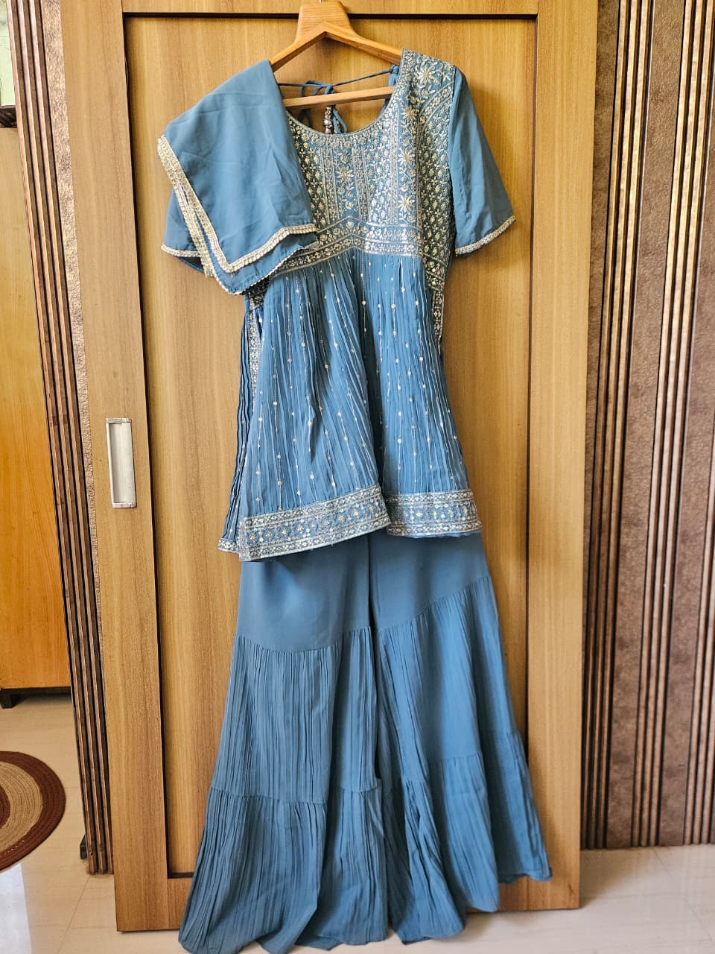
Title | Steel Blue Peplum Kurta with Gharara & Embroidered Dupatta Set
Description | Trendy steel/greyish-blue peplum kurta with rich gold and silver embroidery across the yoke and hem in floral and geometric patterns. Pleated peplum hem adds elegant volume. Paired with matching tiered gharara pants with knife pleats and a matching dupatta with gold trim. Perfect for weddings, mehndi, and festive occasions.
Brand | Unknown
Category | Apparel
Size | XL
Condition | Excellent
Rental / Day | ₹850
Rental / Week | ₹4,500
Fabric | Georgette / Crepe
Color | Steel / Slate Blue
Style | Ethnic / Festive / Contemporary
Sleeve Type | Short Sleeve
Fit / Shape | Peplum Kurta + Tiered Gharara
Pattern | Zari Floral Embroidery on Yoke

Crimson Red Tiered Lehenga with Blouse and Kalamkari Multicolour Dupatta
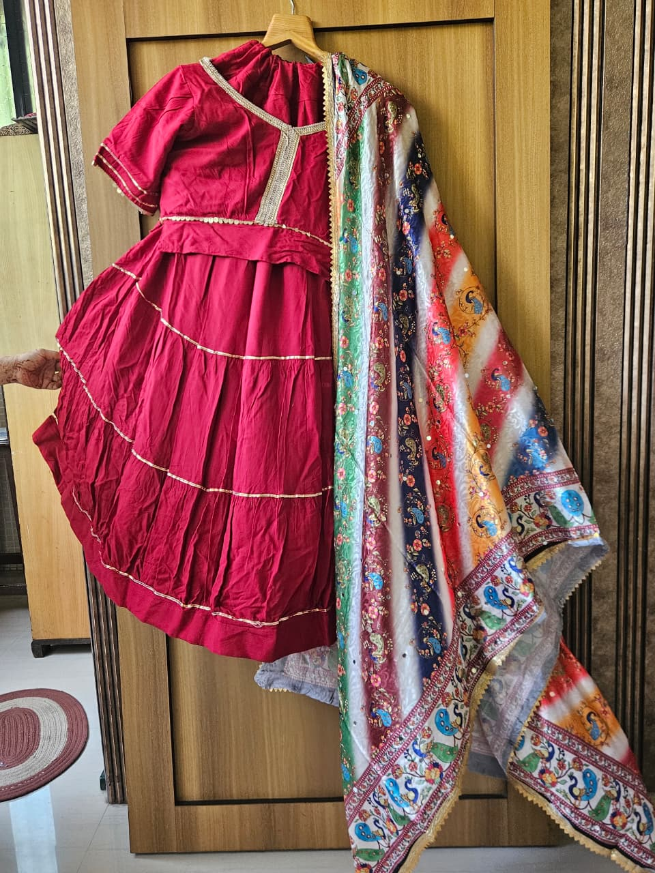
Title | Crimson Red Tiered Lehenga with Blouse and Kalamkari Multicolour Dupatta
Description | Vibrant crimson/magenta red tiered Anarkali suit with horizontal gold gota-patti lace stripes across each tier creating a layered look. V-neckline with gold trim and coin detailing. Paired with a stunning multicolour Kalamkari-style printed dupatta featuring peacocks, paisleys, and floral motifs in blue, green, red, white, and gold. Perfect for Navratri, Diwali, or sangeet.
Brand | Unknown
Category | Apparel
Size | M
Condition | Good
Rental / Day | ₹700
Rental / Week | ₹3,800
Fabric | Cotton Silk (Suit) / Printed Silk (Dupatta)
Color | Crimson Red & Multicolour
Style | Ethnic / Festive
Sleeve Type | Short Sleeve
Fit / Shape | Tiered Anarkali / Flared
Pattern | Gota-Patti Stripes + Kalamkari Print Dupatta

