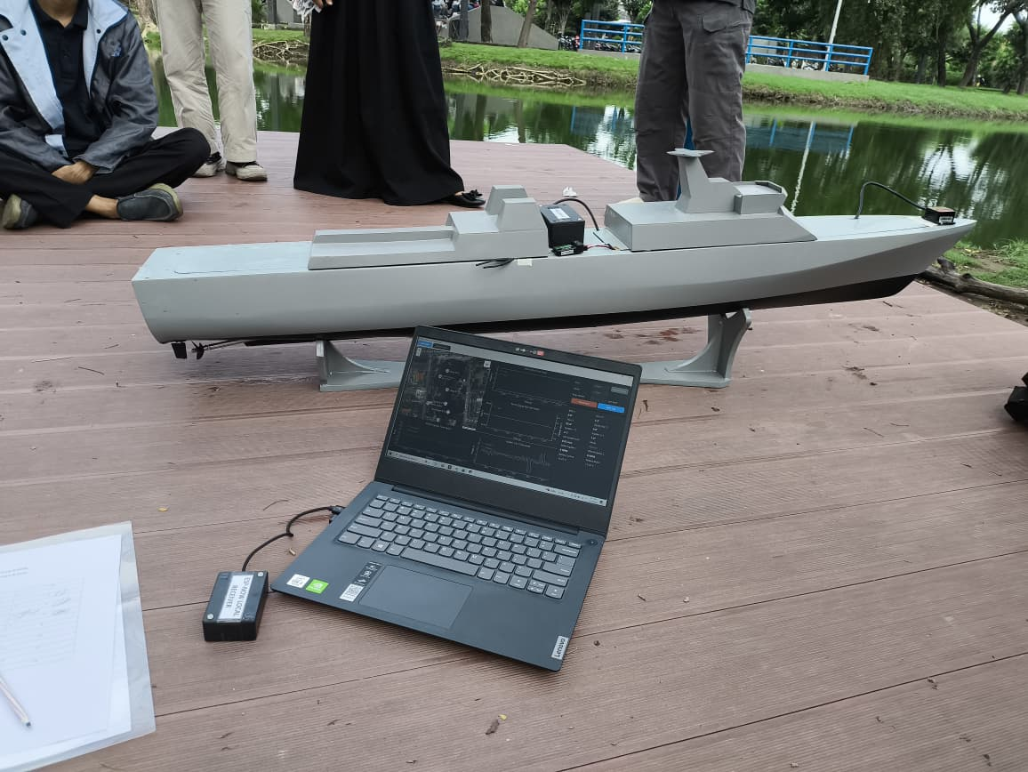
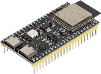

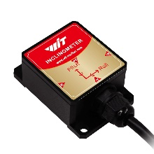
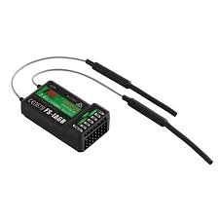
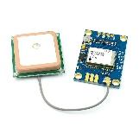
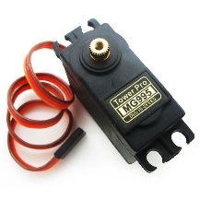
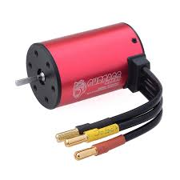
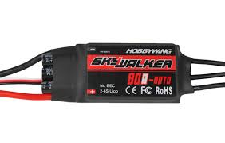
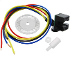
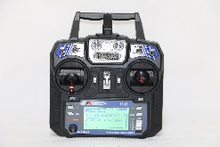
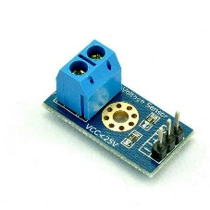
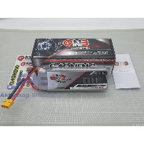
GPS GY-Ublox Neo 7M
with Antenna
Motor Propeller ESC x2 Hobbywing Skywalker 80A
AHRS HWT905 TTL
Euler Angle (Roll, Pitch & Yaw)
ESP32-S3
Control & Sensor Aquisition Unit
Transmitter ESP-NOW
Motor Propeller x2 BLDC Surpass hobby 3660 2200Kv
Motor Propeller RPM Sensor x2 Photoelectric Rotary Encoder with Plate
Receiver RC Flysky FS-iA6B
Transmitter RC Flysky FS-i6
Laptop dengan Aplikasi Python untuk akusisi data
ESP32-S3 Receiver ESP-NOW
Motor Rudder x2 Motor Servo MG995
Battery Volt level Sensor x 2
Battery 3S 5000mAH x 2

Battery Voltage Sensor
Rudder Angle Sensor
Motor Rudder
ESC Driver
Motor Propeller
Motor Propeller RPM Sensor Photoelectric Rotary Encoder with Plate

ESP32-S3
Control &Sensor Acquisition Unit ESPNOW Transmitter
RC Receiver
Battery Voltage Sensor
GPS GY-Ublox Neo 7M
with Antenna
AHRS HWT905TTL
Euler Angle
Roll Pitch Yaw Sensor

