**Department :** Computer Engineering

**Class :** SE

**Subject :** Data Structure Lab

**Name:** Kartiki Uday Khare.

**Roll no:** 21494

**Batch:** H4

**Assignment No : 03**

* **Problem Statement:**

Write a python program to compute following computation on matrix:

a) Addition of two matrices

b) Subtraction of two matrices

c) Multiplication of two matrices

d) Transpose of a matrix

* **Code:**

|  |
| --- |
| class matrix_operations: def getMatrix(self):  R=int(input("Enter number of rows : "))  C=int(input("Enter number of columns : "))  matrix1 = [] for iin range(0,R):  a=[] for j in range(0,C): num = int(input("Enter number at index " +str(i) +" " + str(j)+" ")) a.append(num)  matrix1.append(a) return matrix1 *#print(matrix1)* def addMatrices(self):  m1 = self.getMatrix()  m2 = self.getMatrix() *# calculating number of rows and columns in matrix1 and matrix2* row_m1=0 col_m1=0 row_m2 = 0 col_m2 = 0 for iin m1:  row_m1 = row_m1+1 *#print(row_m1)* for iin m1[0]:  col_m1 = col_m1+1 *# print(col_m1)* for iin m2:  row_m2 = row_m2+1 *# print(row_m2)* for iin m2[0]:  col_m2 = col_m2+1 print(col_m2) if(row_m1==row_m2 and col_m1==col_m2): for iin range(row_m1): for j in range(row_m1):  m1[i][j] = m1[i][j]+m2[i][j] for r in m1: print(r) else: print("Addition not possible")  def subMatrices(self):  m1 = self.getMatrix()  m2 = self.getMatrix() *# calculating number of rows and columns in matrix1 and matrix2* row_m1=0 col_m1=0 row_m2 = 0 col_m2 = 0 for iin m1:  row_m1 = row_m1+1 *#print(row_m1)* for iin m1[0]:  col_m1 = col_m1+1 *# print(col_m1)* for iin m2:  row_m2 = row_m2+1 *# print(row_m2)* for iin m2[0]:  col_m2 = col_m2+1 *# print(col_m2)* if(row_m1==row_m2 and col_m1==col_m2): for iin range(row_m1): for j in range(row_m1):  m1[i][j] = m1[i][j]-m2[i][j] for r in m1: print(r) else: print("subtraction not possible")  def multiplyMatrices(self):  m1 = self.getMatrix()  m2 = self.getMatrix() *# calculating number of rows and columns in matrix1 and matrix2* row_m1=0 col_m1=0 row_m2 = 0 col_m2 = 0 result=[] for iin m1:  row_m1 = row_m1+1 *#print(row_m1)* for iin m1[0]:  col_m1 = col_m1+1 *# print(col_m1)* for iin m2:  row_m2 = row_m2+1 *# print(row_m2)* for iin m2[0]:  col_m2 = col_m2+1 *#print(col_m2)* if(row_m2 == col_m1): for iin range(row_m1):  temp = [] for j in range(col_m2):  a=0 for k in range(row_m2):  a=a+(m1[i][k] * m2[k][j]) temp.append(a) result.append(temp) for r in result: print(r) else: print("multiplication not possible")  def transposeMatrix(self):  m1 = self.getMatrix()  for min m1: print(m)  row_m1 = 0 col_m1 = 0 result = [] for iin m1:  row_m1 = row_m1+1 for iin m1[0]:  col_m1 = col_m1+1 for iin range(col_m1):  temp = [] for j in range(row_m1): temp.append(m1[j][i]) result.append(temp) for r in result: print(r)  def assignment3(self): while True: print("********************") print("1. Addition of two matrix") print("2. Subtraction of two matrices") print("3. Multiplication of two matrices") print("4. Transpose of matrix")  n = int(input("Enter your choice: ")) if (n == 1): self.addMatrices() if(n==2): self.subMatrices() if (n == 3): self.multiplyMatrices() if(n==4): self.transposeMatrix()  user_input=input("Do you want to continue?y/n") if user_inputin 'Yy': continue  else: break  object = matrix_operations() object.assignment3() |

* 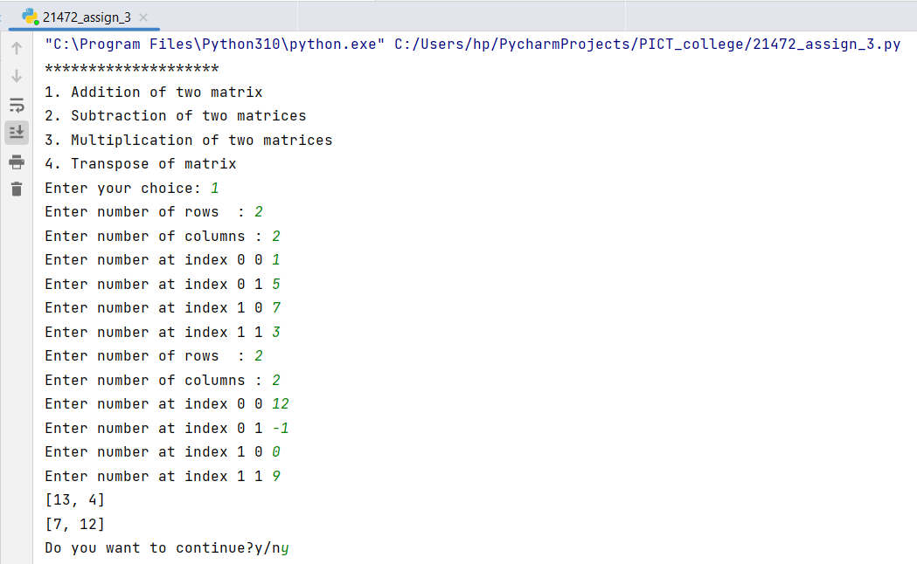**Output:**

