**Department :** Computer Engineering

**Class :** SE

**Subject :** Data Structure Lab

**Name:** Kartiki Uday Khare.

**Roll no:** 21494

**Batch:** H4

**Assignment No : 04**

* **Problem Statement:**

a) Write a python program to store roll nos. of students in array who attended training program in random order. Write for function for searching whether particular student attended training program or not, using Linear and Sentinel Search.

b) Write a python program to store roll nos. of students in array who attended training program in random order. Write for function for searching whether particular student attended training program or not, using Binary and Fibonacci Search.

**Code:**

**1. Assignment 4A:**

|  |
| --- |
| class Assignment_4:  def getInput(self):  rollno = []  # rollsearch = 0  n = int(input("Number of students : "))  for i in range(0,n):  student = int(input("Enter student's rollno : "))  rollno.append(student)  print("Roll numbers are : ",rollno)  # rollsearch = int(input("Enter rollno to search in list : "))  return rollno,n  def sequential_search(self,rollno , n):  rollsearch = int(input("Enter rollno to search in list : "))  i=0  for i in range(n):  if(rollno[i] == rollsearch):  return print("Rollno has attended the training program")  return print("This rollno has not attended the training program")  def sentinal_search(self,rollno ,n):  rollsearch = int(input("Enter rollno to search in list : "))  rollno.append(rollsearch)  i=0  while(rollno[i]!=rollsearch):  i=i+1  if(i<n):  return print("Rollno has attended the training program")  return print("This rollno has not attended the training program")  def choice(self):  while True:  print("1.Sequential search.")  print("2.Sentinal search.")  choice1 = int(input("Enter your choice : "))  if choice1==1:  object.sequential_search(rollno, n,)  if choice1==2:  object.sentinal_search(rollno, n)  userinput = input("do you want to continue?y/n")  if userinput in 'Yy':  continue  else:  break  object = Assignment_4()  rollno , n = object.getInput()  object.choice() |

**Output of 4A:**

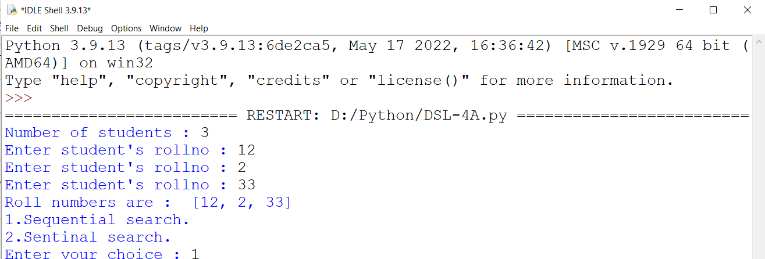

**\*\*\*\*\*\*\*\*\*\*\*\*\*\*\*\*\*\*\*\*\*\*\***

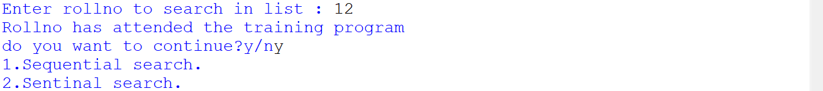

**\*\*\*\*\*\*\*\*\*\*\*\*\*\*\*\*\*\*\*\*\*\*\***



**2. Assignment 4B:**

|  |
| --- |
| class Assign4b:  def getInput(self):  rollno= []  n = int(input("Enter total students who attended training program : "))  for i in range(n):  student = int(input("Enter students rollno : "))  rollno.append(student)  print("Students who attended training are : ",rollno)  return rollno , n  def sort(self,rollno ,n):  temp =0  i=0  j=0  for i in range(n-1):  for j in range(n-i-1):  if(rollno[j]>rollno[j+1]):  temp = rollno[j]  rollno[j] = rollno[j+1]  rollno[j+1] = temp  def binarysearch(self,rollno ,n,rollsearch): #binary iterative  low = 0  high = n-1  while(low<=high):  mid = int((low+high)/2)  if(rollno[mid] < rollsearch):  low = mid+1  elif(rollno[mid] > rollsearch):  high = mid-1  else:  return print("Roll no found at location : " ,mid)  return print("This Roll no not attended training program.")  def recursive_search(self,rollno,low,high,rollsearch): #binary recursive  #object.sort(rollno,n)  if(low == high):  if(rollno[low] == rollsearch):  return print("Roll no found at location : ",low)  else:  mid = int((low+high)/2)  if(rollno[mid] == rollsearch):  return print("Roll no found at location : ",mid)  elif(rollno[mid]<rollsearch):  return object.recursive_search(rollno,mid+1,high,rollsearch)  else:  return object.recursive_search(rollno,low,mid-1,rollsearch)  return print("This Roll no not attended training program.")  def fibonacci_Search(self,rollno,rollsearch,n):  object.sort(rollno,n)  f=0  a,b=0,1  c=a+b  while c<n:  a=b  b=c  c=a+b  offset=-1    while c>1:  i=min(offset+a,n-1)  if rollno[i]<rollsearch:  c=b  b=a  a=c-b  offset=i  elif rollno[i]>rollsearch:  c=a  b=b-a  a=c-b  else:  print("Roll No ",rollsearch," attended the program")  f=1  break  if f==0 and b!=0 and rollno[offset+1]==x:  print("Roll No ",rollsearch," attended the program")  exit  if f==0:  print("Roll No: ",rollsearch," didn't attend the program")      def choice(self):  while True:  print("1.Binary search.")  print("2.Recursive Binary search.")  print("3. Fibonacci Search.")  choice1 = int(input("Enter your choice : "))  if choice1==1:  object.sort(rollno, n)  print("Sorted list of rollno : ", rollno)  rollsearch = int(input("Enter rollno to search in list : "))  object.binarysearch(rollno, n,rollsearch)  if choice1==2:  low = 0  high = n - 1  object.sort(rollno,n)  print("Sorted list of rollno : ", rollno)  rollsearch = int(input("Enter rollno to search in the list :"))  object.recursive_search(rollno,low,high,rollsearch)  if choice1==3:  object.sort(rollno,n)  print("Sorted list of rollno : ", rollno)  rollsearch = int(input("Enter rollno to search in the list :"))  object.fibonacci_Search(rollno,rollsearch,n)    userinput = input("do you want to continue?y/n")  if userinput in 'Yy':  continue  else:  break  object = Assign4b()  rollno ,n = object.getInput()  object.choice() |

**Output of 4B:**

