**Goal**: Bettering vehicle traffic over urban areas

**Problem:** As Automotive sector advances, there will be more and more vehicles available to the end-user. More the number of vehicles more the congestion on the roads. Roads are not widening enough as the rate of increment in vehicles. So we have to consider the scenarios of congestion

over the roads.

**Solution:**

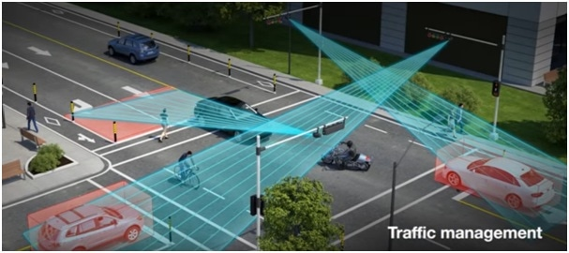

Crossroads with LiDAR

We can provide them the solution to mitigating these kind of scenarios. Following is the proposed solution that can improve traffic utilization.

At every crossroads connecting via common route, are connected with the sensors via mesh/star topology. This crossroads, lets call them nodes of the route, would provide the current traffic update to the nearer crossroads (nearest neighbouring node). And according to that traffic update, they would flash out lights so the route can be effectively cleared out. In this way, it would ensure the least waiting period for arriving vehicle on that particular node(next crossroads).

Product would have wireless connectivity between them. (*Protocols to be used LoRaWAN for typical nodeID).This device would have GPS sensors that can easily be interfaced with Microcontroller. Overall system can have multiple sensors that can measure insights like position detection(LiDAR), visual inspection(CCTV), CO2/CO gas sensors, Thermal profiling (temperature sensors)etc. These parameters are suitable to provide positive insights towards bettering traffic management system.

All the sensor data acquired by microcontroller attached to it. Via GPRS module this data can be transmitted to central server. Database created by this information has been served by this server. Our application server have statistical model upon this information. This model would be trained by various scenarios like emergency vehicle passage, Green corridor, Major-minor Accidental case etc. Upon training the model, model would be helpful in showcasing fastest route or optimized route for the vehicle.

**Tentative Block Diagram:-**

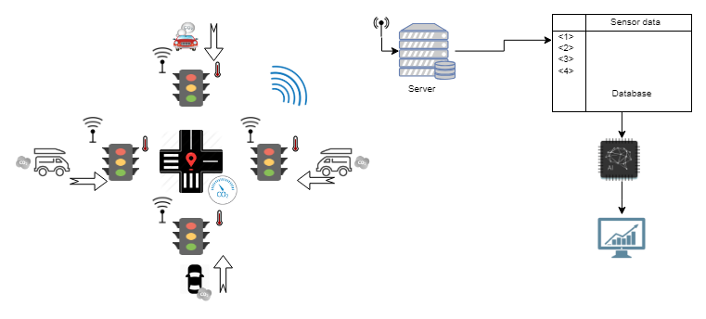

Here, as shown in the above figure, there are multiple parts involved in this project:

1. Individual road traffic signal sensors (LiDAR, temperature, level sensor, CCTV)
2. Common Sensors on the crossroad- GPS, Carbon emission sensor
3. Connection between individual traffic signal to the star topology (via. 6LoRaWAN, Zigbee, etc.)
4. Connection between crossroad junction to the application/database server (Via GPRS)
5. Data modelling using AI/ ML algorithms (Using frameworks like Tensorflow, Caffe, Theano)
6. User Interface(Based on Mobile, Desktop application)

Communication protocols can be used:

6LoRaWAN, GPS, GPRS, (Any Mesh network topology like Zigbee)

Sensors used:

Carbon emission Sensor, Temperature Sensor, LiDAR sensor(Level sensor)

Power Supply:

Onboard with Battery Backed up. Will use power supply from Traffic pole itself.

Computing system:

Any SoC or microcontrollers interfaced with above mentioned sensors suitably.

Casing:

Acrylic plastic case that can sustain IP65, IP67, IP68, IEC/EN 60079-18(*every other possible ratings.)

Application/ Database Server :

AWS or Azure or GCP.