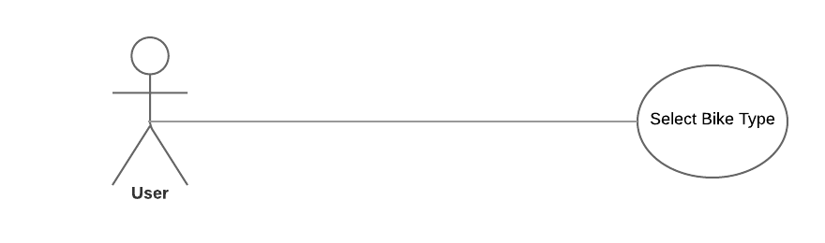

**1 User Selects Bike type:**

|  |  |  |
| --- | --- | --- |
| **Use Case Name:** | Select Bike type | |
| **ID:** | UC-SBT-01 | |
| **Actors Involved:** | User | |
| **Brief Description** | User selects a bike type from a list of options | |
| **Pre-Conditions** |  | |
| **Post-Conditions** |  | |
| **Normal Flow of Events:** | **Actor Action** | **System Response** |
| 1. Selects a bike type from a list of options 2. Clicks the submit button. | 1. Redirects the user to a page that displays spare parts for their particular bike type. |

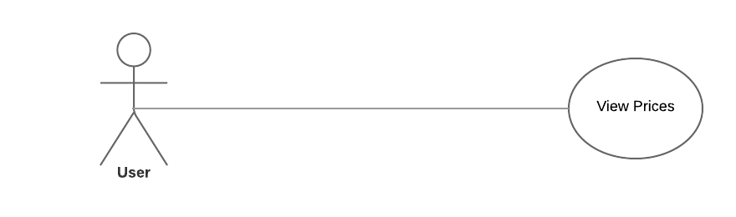

|  |  |  |
| --- | --- | --- |
| **Use Case Name:** | View Prices | |
| **ID:** | UC-VP-02 | |
| **Actors Involved:** | User | |
| **Brief Description** | User can view prices of bikes according to company name. | |
| **Pre-Conditions** |  | |
| **Post-Conditions** |  | |
| **Normal Flow of Events:** | **Actor Action** | **System Response** |
| 1. User clicks the View prices button. 2. User can compare two motorbike models. 3. User can view reviews for any motorbike model | 1. Redirects the user to a page that displays prices for bikes according to company name. |

**2 User views prices:**

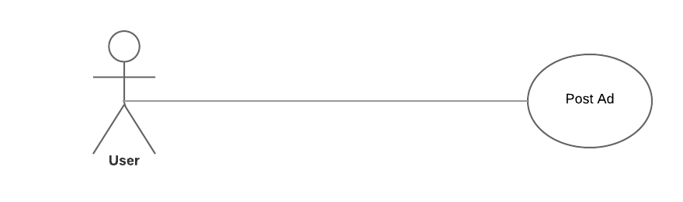

**3 User Posts an ad:**

|  |  |  |
| --- | --- | --- |
| **Use Case Name:** | Post Ad | |
| **ID:** | UC-PA-03 | |
| **Actors Involved:** | User | |
| **Brief Description** | User can post an ad for selling their bikes. | |
| **Pre-Conditions** | User must submit pictures of the motorbike, along with contact information and address. | |
| **Post-Conditions** | All user submitted information is inserted into the latest entry in the ad page. | |
| **Normal Flow of Events:** | **Actor Action** | **System Response** |
| 1. User clicks the submit ad button. 2. User submits their contact information, their home address, and pictures of the motorbike that they are putting up for sale. 3. The user will then click on the submit button. | 1. Redirects the user to a page where he can post an advertisement for their motorbike. 2. If the user submits the form, the information is then added to the database and is shown in the Ads page on the website. 3. If a field is left empty an error message will be displayed. |

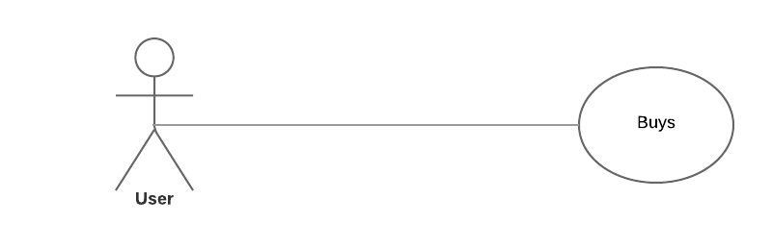

**4 User Buys:**

|  |  |  |
| --- | --- | --- |
| **Use Case Name:** | Buys | |
| **ID:** | UC-BS-06 | |
| **Actors Involved:** | User | |
| **Brief Description** | The user can purchase New and Used motorbikes. | |
| **Pre-Conditions** |  | |
| **Post-Conditions** | A voucher is generated for the user specifying the billing information and date of the corresponding purchase. | |
| **Normal Flow of Events:** | **Actor Action** | **System Response** |
| 1. The user selects the Purchase motorbikes button. 2. The user then chooses whether to purchase a new or a used motorbike. 3. The user then selects the product they wish to purchase. 4. The user then submits their contact information and payment options. 5. The user clicks the submit button. | 1. The contact information and payment information are saved in the respective database. 2. If a field is left empty an error message will be displayed. |

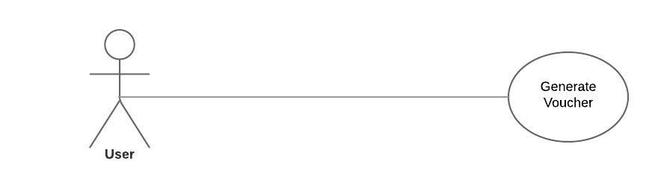

**5 Generate Voucher:**

|  |  |  |
| --- | --- | --- |
| **Use Case Name:** | Generate voucher | |
| **ID:** | UC-GV-09 | |
| **Actors Involved:** | User | |
| **Brief Description** | A voucher is generated by the system specifying the billing and contact information for a particular purchase | |
| **Pre-Conditions** | A transaction has been made. | |
| **Post-Conditions** | A voucher has to be generated for any particular purchase. | |
| **Normal Flow of Events:** | **Actor Action** | **System Response** |
| 1. A purchase has been made. 2. A voucher is generated for that particular transaction. | 1. The system processes any transaction being made. 2. All information about that transaction has been saved in the database. 3. The system then generates a voucher from that information. |

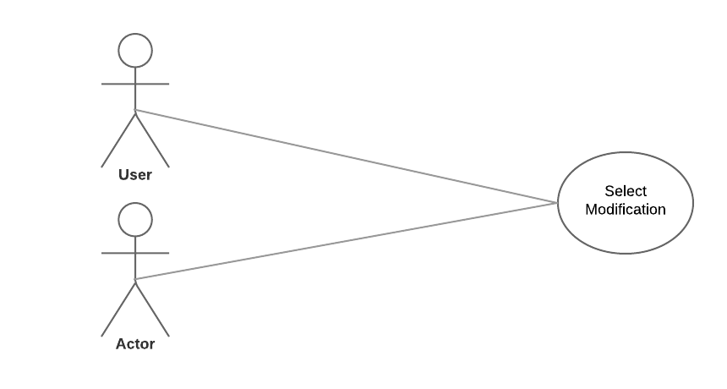

**6 Select Modification:**

|  |  |  |
| --- | --- | --- |
| **Use Case Name:** | Select Modification | |
| **ID:** | UC-SM-04 | |
| **Actors Involved:** | User, Mechanic | |
| **Brief Description** | The Select Modification use case is for users who want to modify their motorbike according to their preferences. | |
| **Pre-Conditions** | Cancellation charges may apply. | |
| **Post-Conditions** | A voucher is then generated for the user specifying the billing information and date of the corresponding modifications. | |
| **Normal Flow of Events:** | **Actor Action** | **System Response** |
| 1. User clicks the bike modification button 2. The user submits a form with a list of parts to modify. 3. If needed, the user can add more modification options to the form. 4. The user is then prompted to submit personal information and payment options. 5. The user clicks the submit button. | 1. The modification options, personal information and payment options selected by the user are saved to the respective database. 2. If a field is left empty an error message will be displayed. |

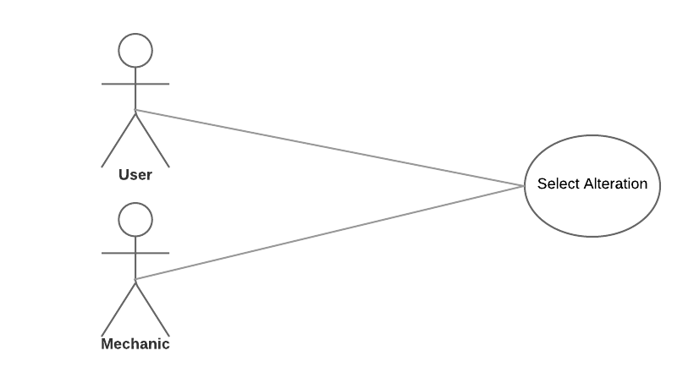

**7 Select Alteration:**

|  |  |  |
| --- | --- | --- |
| **Use Case Name:** | Select Alteration | |
| **ID:** | UC-SA-05 | |
| **Actors Involved:** | User, Mechanic | |
| **Brief Description** | The Select Alteration use case is for users who want to alter their motorbike according to their preferences. The user can alter their motorbike by Engine, or by Parts. | |
| **Pre-Conditions** | Cancellation charges may apply. | |
| **Post-Conditions** | A voucher is then generated for the user specifying the billing information and date of the corresponding alteration. | |
| **Normal Flow of Events:** | **Actor Action** | **System Response** |
| 1. The user clicks the bike alteration button. 2. The user then selects whether they want to alter their motorbikes engine, or alter the motorbikes parts. 3. The user is then prompted to submit personal information and payment options. 4. The user clicks the submit button. | 1. The alteration options, personal information and payment options selected by the user are saved to the respective database. 2. If a field is left empty an error message will be displayed. |

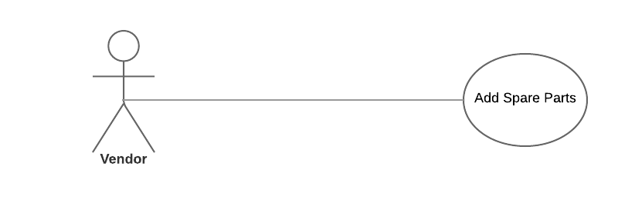

**8 Add spare parts:**

|  |  |  |
| --- | --- | --- |
| **Use Case Name:** | Add Spare Parts | |
| **ID:** | UC-SP-08 | |
| **Actors Involved:** | Vendor | |
| **Brief Description** | The Vendor adds the updated prices of spare parts to the database. | |
| **Pre-Conditions** | The Vendor is logged in to their account. | |
| **Post-Conditions** |  | |
| **Normal Flow of Events:** | **Actor Action** | **System Response** |
| 1. The vendor clicks on the Add spare parts button. 2. They then specify in the form all details of the part/parts that they are adding. 3. The vendor clicks the submit button | 1. The information submitted by the vendor is then updated in the database. 2. If a field is left empty an error message will be displayed. |

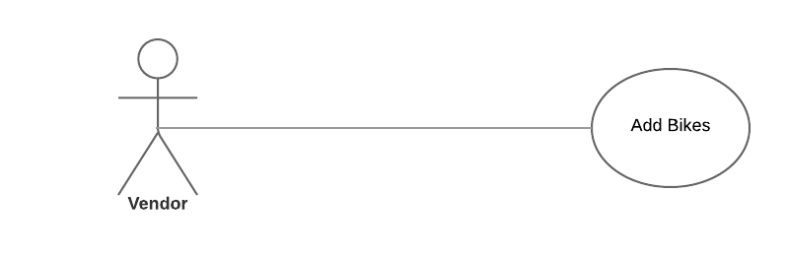

**9 Add bikes:**

|  |  |  |
| --- | --- | --- |
| **Use Case Name:** | Add bikes | |
| **ID:** | UC-AB-07 | |
| **Actors Involved:** | Vendor | |
| **Brief Description** | The Vendor adds the updated prices of motorbikes to the database. | |
| **Pre-Conditions** | The Vendor is logged in to their account. | |
| **Post-Conditions** |  | |
| **Normal Flow of Events:** | **Actor Action** | **System Response** |
| 1. The vendor clicks on the Add bikes button. 2. They then specify in the form all details of the motorbike. 3. The vendor clicks the submit button | 1. The information submitted by the vendor is then updated in the database. 2. If a field is left empty an error message will be displayed. |

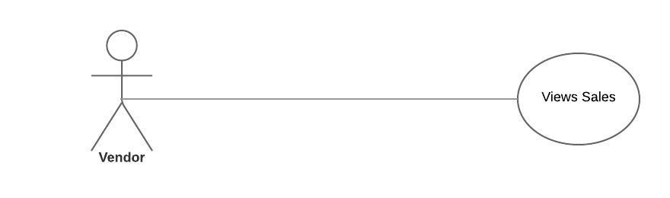

**10 View Sales:**

|  |  |  |
| --- | --- | --- |
| **Use Case Name:** | View Sales | |
| **ID:** | UC-VS-07 | |
| **Actors Involved:** | Vendor | |
| **Brief Description** | The Vendor views the sales that have been made through the website. | |
| **Pre-Conditions** | The Vendor is logged in to their account. | |
| **Post-Conditions** |  | |
| **Normal Flow of Events:** | **Actor Action** | **System Response** |
| 1. The vendor clicks on the View Sales button. 2. They then search for a particular sale (Optional). | 1. The website displays past Sales. 2. If a search query is prompted the website displays the most relevant result. |

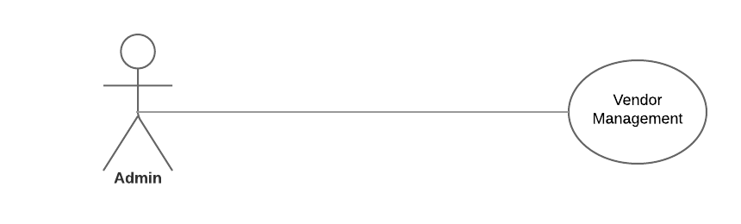

**11 Vendor Management:**

|  |  |  |
| --- | --- | --- |
| **Use Case Name:** | Vendor Management | |
| **ID:** | UC-VM-10 | |
| **Actors Involved:** | Admin | |
| **Brief Description** | The admin can manage all vendor related work, including price updates on motorbikes and their parts. | |
| **Pre-Conditions** | The Admin is logged in to their account. | |
| **Post-Conditions** |  | |
| **Normal Flow of Events:** | **Actor Action** | **System Response** |
| 1. The Admin clicks on the vendor management button. 2. They can then manage all vendor related work. | 1. The system displays all vendors, and any product updates from said vendors. |

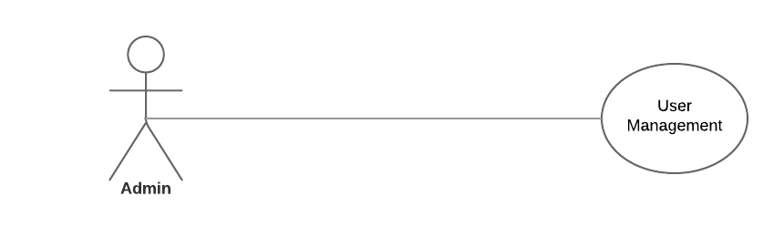

**12 User Management:**

|  |  |  |
| --- | --- | --- |
| **Use Case Name:** | User Management | |
| **ID:** | UC-UM-11 | |
| **Actors Involved:** | Admin | |
| **Brief Description** | The admin can manage all User related work, including ad posts, motorbike purchases, and spare parts purchases. | |
| **Pre-Conditions** | The Admin is logged in to their account. | |
| **Post-Conditions** |  | |
| **Normal Flow of Events:** | **Actor Action** | **System Response** |
| 1. The Admin clicks on the User management button. 2. They can then manage all User related work. | 1. The system displays User related information such as any transactions or any ad posts made by any user. |

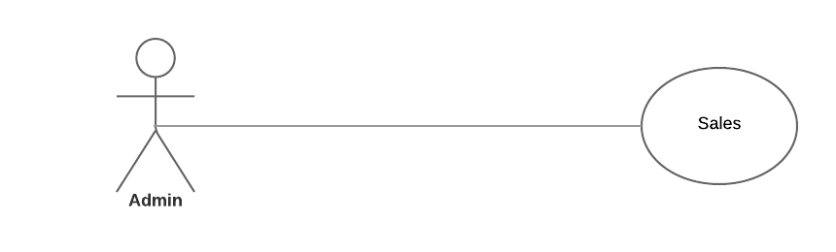

**13 Sales:**

|  |  |  |
| --- | --- | --- |
| **Use Case Name:** | Sales | |
| **ID:** | UC-SL-12 | |
| **Actors Involved:** | Admin | |
| **Brief Description** | The admin can check sales and purchases made. | |
| **Pre-Conditions** | The Admin is logged in to their account. | |
| **Post-Conditions** |  | |
| **Normal Flow of Events:** | **Actor Action** | **System Response** |
| 1. The Admin clicks on the Sales button. 2. They can view and select any particular transactions made. | 1. The system displays Sales related information such as any transactions made by any User. |

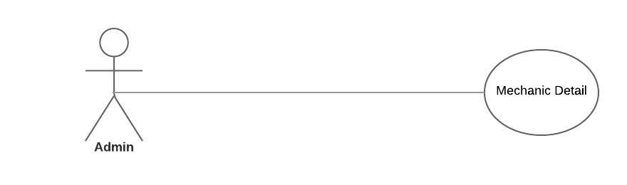

**14 Mechanic Detail:**

|  |  |  |
| --- | --- | --- |
| **Use Case Name:** | Sales | |
| **ID:** | UC-MD-12 | |
| **Actors Involved:** | Admin | |
| **Brief Description** | The admin has the name, address and contact information of the Mechanic, and can inform the Mechanic of any incoming jobs. | |
| **Pre-Conditions** | The Admin is logged in to their account. | |
| **Post-Conditions** |  | |
| **Normal Flow of Events:** | **Actor Action** | **System Response** |
| 1. The Admin clicks on the Mechanic Detail button. 2. They can then view the incoming requests from users, such as Modification or an Alteration job, and then forward the job to the Mechanic. |  |