

**TRIBHUVAN UNIVERSITY**

IOE Paschimanchal Campus

Lamachaur, Pokhara

**PROJECT REPORT ON  
HOSPITAL MANAGEMENT SYSTEM WITH OPD**

**SUBMITTED BY:**

SAMMAN SHRESTHA (PAS076BEI029)  
SANDIP SHRESTHA (PAS076BEI032)  
SAMUNDRA POUDEL (PAS076BEI030)  
SANDHYA SHRESTHA (PAS076BEI031)

Table of Contents

1. INTRODUCTION: 1

1.1 ADVANTAGE OF HOSPITAL MANAGEMENT SYSTEM: 1

2. PROBLEM STATEMENT: 2

3. OBJECTIVE: 2

4. PROPOSED SYSTEM: 2

5. METHODOLOGY: 3

5.1 FRONT END DEVELOPMENT: 3

5.2 BACK END DEVELOPMENT: 3

5.3 DATABASE: 3

5.4 XAMPP: 3

6. ENTITIES: 6

6.1 Doctor: 6

6.2 Patient: 6

6.3 Drug: 6

6.4 Pharmacy: 6

6.5 Pharmaceutical Companies: 6

6.6 Supervisor: 6

7. SCREENSHOTS OF THE PROJECT: ……………………………………………………………………………………………………………… 10

8. CONCLUSION: 19

# 1. INTRODUCTION:

Hospital Management System Project is a software developed for monitoring and maintaining various activities in the Hospital. We can improve the hospital's productivity by computerizing some of its functions overcoming the limitations of the current system. Hospital Management System Project will play a key role in minimizing human strain and errors. Moreover, it will be instrumental in data processing and improving security. Other advantages of Hospital management system project are as follows.

* Easy record-keeping
* Data consistency
* Easy information refreshing

Hospital Management System Project will work and update the patient's records, OPD records, doctor’s records, appointments records, pharmacy record, pharmaceutical company records, contracts records. Hospital Management System Project is additionally used to add doctors, add patients, prescribe patients, and see available drugs. It monitors the number of patients, doctors and pharmacies. It helps the hospital from the manual work from which it is tough to find the patients' records, OPD records, doctor’s records, appointments records. In short, it is a comprehensive tool that can efficiently record, maintain, and manage hospital affairs. It can be further customized to work for large or small hospitals.

## 1.1 ADVANTAGE OF HOSPITAL MANAGEMENT SYSTEM:

* Easy for doctors to prescribe their patients
* Easy to add doctors and patients
* Data security and correct data retrieval made possible
* Reduces scope for Error
* Improved Efficiency by avoiding human errors
* Time-saving Technology
* Easy monitoring of drugs in inventory
* Easy access to patient data with correct patient history
* Easy monitoring of drugs in inventory
* Easy to Manage commonly and recently used medicines.

# 2. PROBLEM STATEMENT:

1. **Lack of immediate retrievals:**

The information is very difficult to retrieve and to find particular information like- E.g. - To find out about the patient’s history and the doctor’s and their related patient, the user has to go through various registers. This results in in convenience and wastage of time.

1. **Lack of immediate information storage:**

The information generated by various transactions takes time and efforts to be stored at right place.

1. **Lack of prompt updating:**

Various changes to information like patient details or immunization details of child are difficult to make as paper work is involved.

1. **Error prone manual calculation:**

Manual calculations are error prone and take a lot of time this may result in incorrect information.

1. **Preparation of accurate and prompt reports:**

This becomes a difficult task as information is difficult to collect from various register.

# 3. OBJECTIVE:

The aim of this project is to develop a software for the effective management of hospital management system with OPD that will be able to achieve the following objectives:

* To manage the details of Drugs, Pharmacy, Sells.
* To minimize human errors.

# 4. PROPOSED SYSTEM:

* The new proposed system stores and maintains all the doctors and patients details**.**
* Admin should be able to add, delete and update doctors, patients, pharmacies and provide unique primary key for each.
* System should be able to keep track of available drugs and their manufactures.
* Doctors should be able to manage/prescribe their respective patients and no other doctor can manage other doctor’s patients.

# 5. METHODOLOGY:

## 5.1 FRONT END DEVELOPMENT:

**Flutter** has been used to develop frontend for this application. Flutter is an open source framework by Google for building beautiful, natively compiled, multi-platform applications from a single codebase based on dart language

## 5.2 BACK END DEVELOPMENT:

**PHP** has been used for backend. PHP is a server-side scripting language designed specifically for web development. It is open-source which means it is free to download and use. It is very simple to learn and use. The files have the extension “.php”.

## 5.3 DATABASE:

**MySQL** has been used as a database.MySQL is developed, distributed, and supported by Oracle Corporation. MySQL is a Database system used on the web it runs on a server. MySQL is ideal for both small and large Applications. It is very fast, reliable, and easy to use. It supports standard SQL. MySQL can be compiled on number of platforms.

## 5.4 XAMPP:

We use XAMPP for server hosting and managing ports of the system.

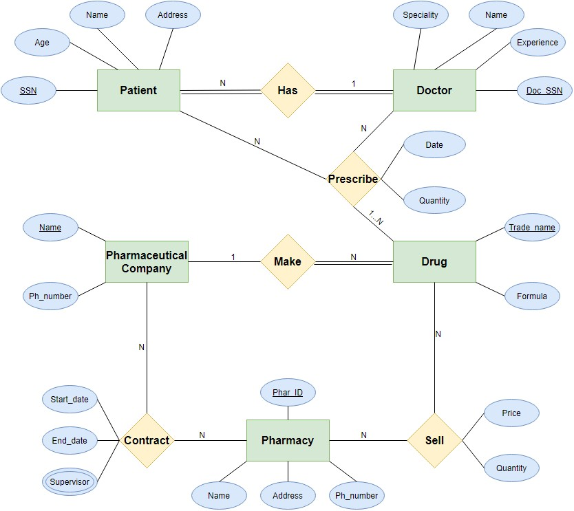**ERD OF PHARMACY MANAGEMENT SYSTEM:**

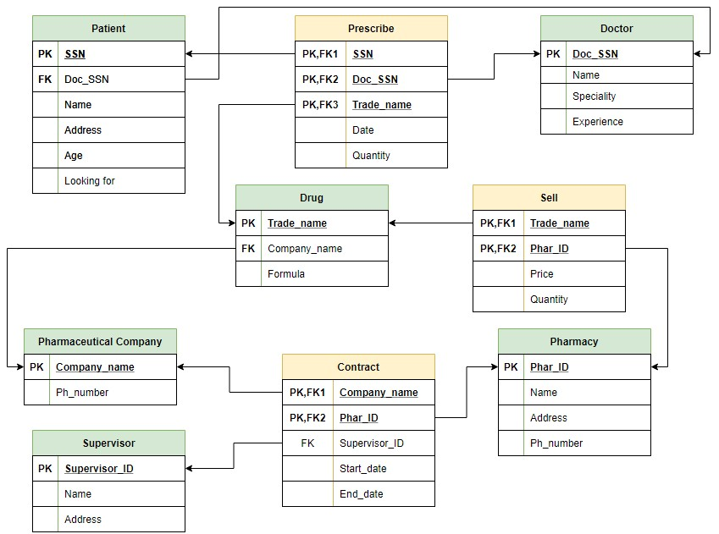**RELATIONAL SCHEMA OF PHARMACY MANAGEMENT  
SYSTEM:**

# 6. ENTITIES:

## 6.1 Doctor:

Doctors are identified by an SSN. For each doctor, the name, specialty, and years of experience are recorded. Every doctor has at least one patient and can prescribe one or more drugs to his/her patient.

## 6.2 Patient:

Patients are identified by an SSN, and their names, addresses, and ages must be recorded.

## 6.3 Drug:

Drug has the trade name and formula. Each drug is sold by a given pharmaceutical company, and the trade name identifies a drug uniquely from among the products of that company.

## 6.4 Pharmacy:

Pharmacy has a name, address, and phone number.A pharmacy can contract with several pharmaceutical companies.

## 6.5 Pharmaceutical Companies:

Each pharmaceutical company is identified by name and has a phone number. A pharmaceutical company can contract with several pharmacies. and

## 6.6 Supervisor:

Supervisor has a Supervisor ID, name and address. Pharmacies appoint a supervisor for each contract. There is supervisor for each contract, but the contract supervisor can change over the lifetime of the contract.

**QUERIES USED IN THIS PROJECT.**

1. $query="SELECT COUNT(*) FROM `doctor`";

2. $query="SELECT company_name FROM pharmaceutical_company

WHERE company_name not in (SELECT company_name FROM contract WHERE phar_id='".$phar_id."');";

3. $query="SELECT COUNT(*) FROM `patient`";

4. $query="SELECT COUNT(*) FROM `pharmacy`";

5. $query="DELETE FROM `pharmaceutical_company` WHERE Company_name = '$id'";

6. $query="DELETE FROM `doctor` WHERE Doc_SSN = '$id'";

7. $query="DELETE FROM `drug` WHERE Trade_name = '$id'";

8. $query="DELETE FROM `patient` WHERE SSN = '$id'";

9. $query="DELETE FROM `pharmacy` WHERE Phar_ID = '$id'";

10. $query="DELETE FROM `supervisor` WHERE supervisor_ID = '$id'";

11. $query="SELECT `Doc_SSN` ,`Name` FROM `doctor`";

12. $query="SELECT `Trade_name` FROM `drug`";

13. $query="INSERT INTO `pharmaceutical_company` (`Company_name`, `Ph_number`)

VALUES ('$name', '$Ph_number')";

14. $query="INSERT INTO `contract` (`Phar_ID`, `Company_name`, `supervisor_ID`, `start_date`, `end_date`)

VALUES ('$Phar_ID', '$Company_name', '$supervisor_ID', '$start_date', '$end_date')";

15. $query="INSERT INTO `doctor` (`Doc_SSN`, `Name`, `Speciality`, `Experience`)

VALUES ('$Doc_SSN', '$name', '$speciality', '$experience')";

16. $query="INSERT INTO `drug` (`Trade_name`, `Formula`)

VALUES ('$Trade_name', '$Formula')";

17. $query="INSERT INTO `patient`(`SSN`, `Name`, `Address`, `Age`, `Doc_SSN`)

VALUES ('$SSN','$name','$address','$age','$Doc_SSN')";

18. $query="INSERT INTO `pharmacy` (`Phar_ID`, `Name`, `address`, `ph_number`)

VALUES ('$Phar_ID', '$name', '$address', '$phnumber')";

19. $query="INSERT INTO `prescribe`(`SSN`,`Doc_SSN`,`Quantity`) VALUES ('$SSN','$Doc_SSN','0')";

20. $query="INSERT INTO `sell`(`Trade_name`, `Phar_ID`, `Price`, `Quantity`)

VALUES ('$Trade_name','$Phar_ID','$Price','$Quantity')";

21. $query="INSERT INTO `supervisor`(`supervisor_ID`, `Name`, `Address`)

VALUES ('$supervisor_ID','$name','$Address')";

22. $query="SELECT * FROM `doctor` WHERE Doc_SSN = '".$doc_ssn."' AND Name ='".$name."'";

23. $query="SELECT * FROM `pharmacy` WHERE Phar_ID = '".$Phar_ID."' AND Name = '".$name."'";

24. $query="SELECT * FROM `prescribe` WHERE Doc_SSN = '".$doc_ssn."'";

25. $query="SELECT Trade_name, SUM(Quantity) FROM `sell` GROUP BY Trade_name";

26. $query="SELECT supervisor_id, name FROM supervisor ;";

27. $query="SELECT `Trade_name` FROM `drug`";

28. $query ="UPDATE `pharmaceutical_company` SET `Company_name`='$name',`Ph_number`='$Ph_number' WHERE `Company_name`='$oldName'";

29. $query ="UPDATE `doctor` SET `Name`='$name',`Speciality`='$speciality',`Experience`='$experience' WHERE `Doc_SSN`='$Doc_SSN'";

30. $query ="UPDATE `drug` SET `Trade_name`='$Trade_name',`Formula`='$Formula' WHERE `Trade_name`='$oldName'";

31. $query ="UPDATE `patient` SET `Name`='$name',`address`='$address',`age`='$age' WHERE `SSN`='$SSN'";

32. $query ="UPDATE `pharmacy` SET `Name`='$name',`address`='$address',`Ph_number`='$Ph_number' WHERE `Phar_ID`='$Phar_ID'";

33. $query ="UPDATE `prescribe` SET `Trade_name`='$Trade_name',`Prescribe_date`='$Prescribe_date',`Quantity`='$Quantity'

34. $query =" UPDATE `supervisor` SET `Name`='$name',`Address`='$address' WHERE `supervisor_ID`='$Supervisor_ID'";

35. $query="SELECT * FROM `pharmaceutical_company`";

36. $query="SELECT * FROM `contract` WHERE `Phar_ID`='".$Phar_ID."'";

37. $query="SELECT * FROM `doctor`";

38. $query="SELECT * FROM `drug`";

39. $query="SELECT * FROM `patient`";

40. $query="SELECT * FROM `pharmacy`";

41. $query="SELECT * FROM `supervisor`";

**7. SCREENSHOTS OF THE PROJECT:**

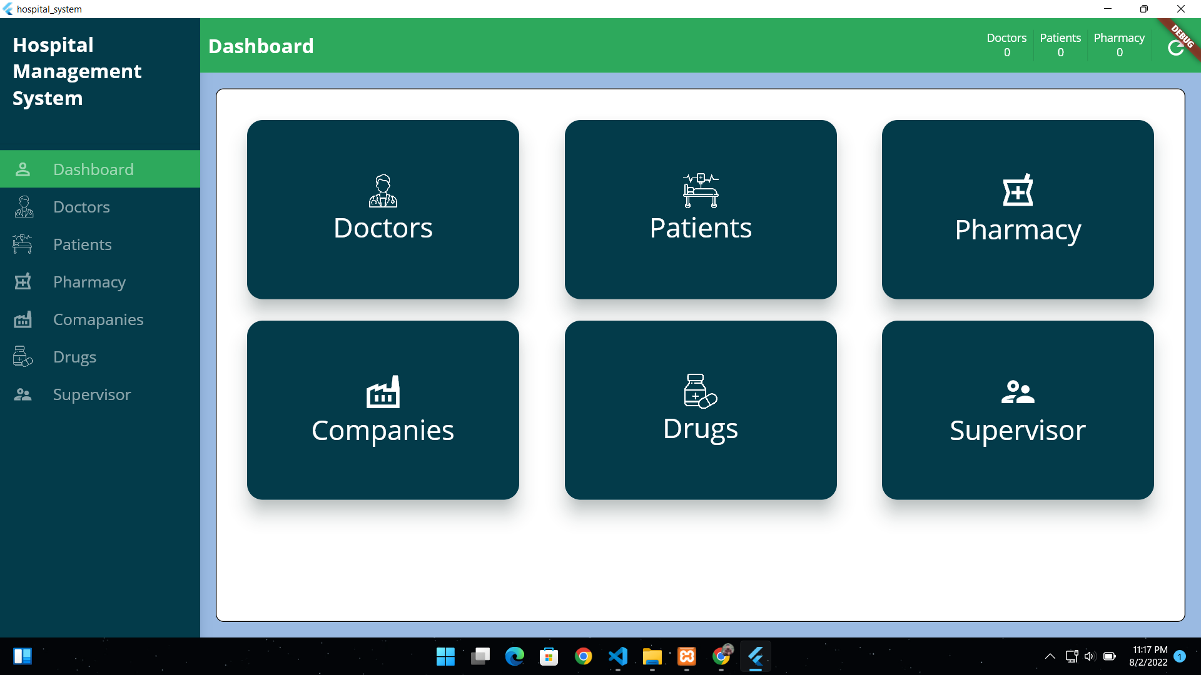

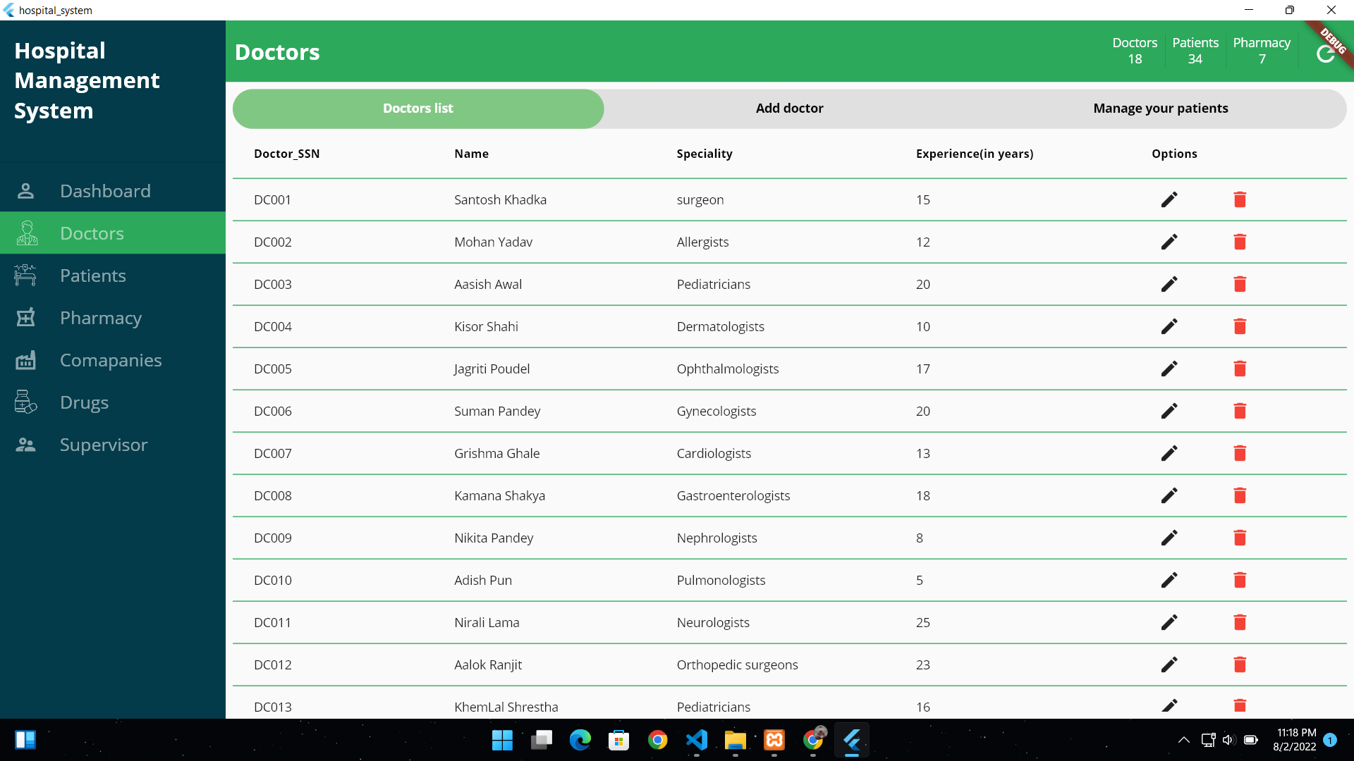

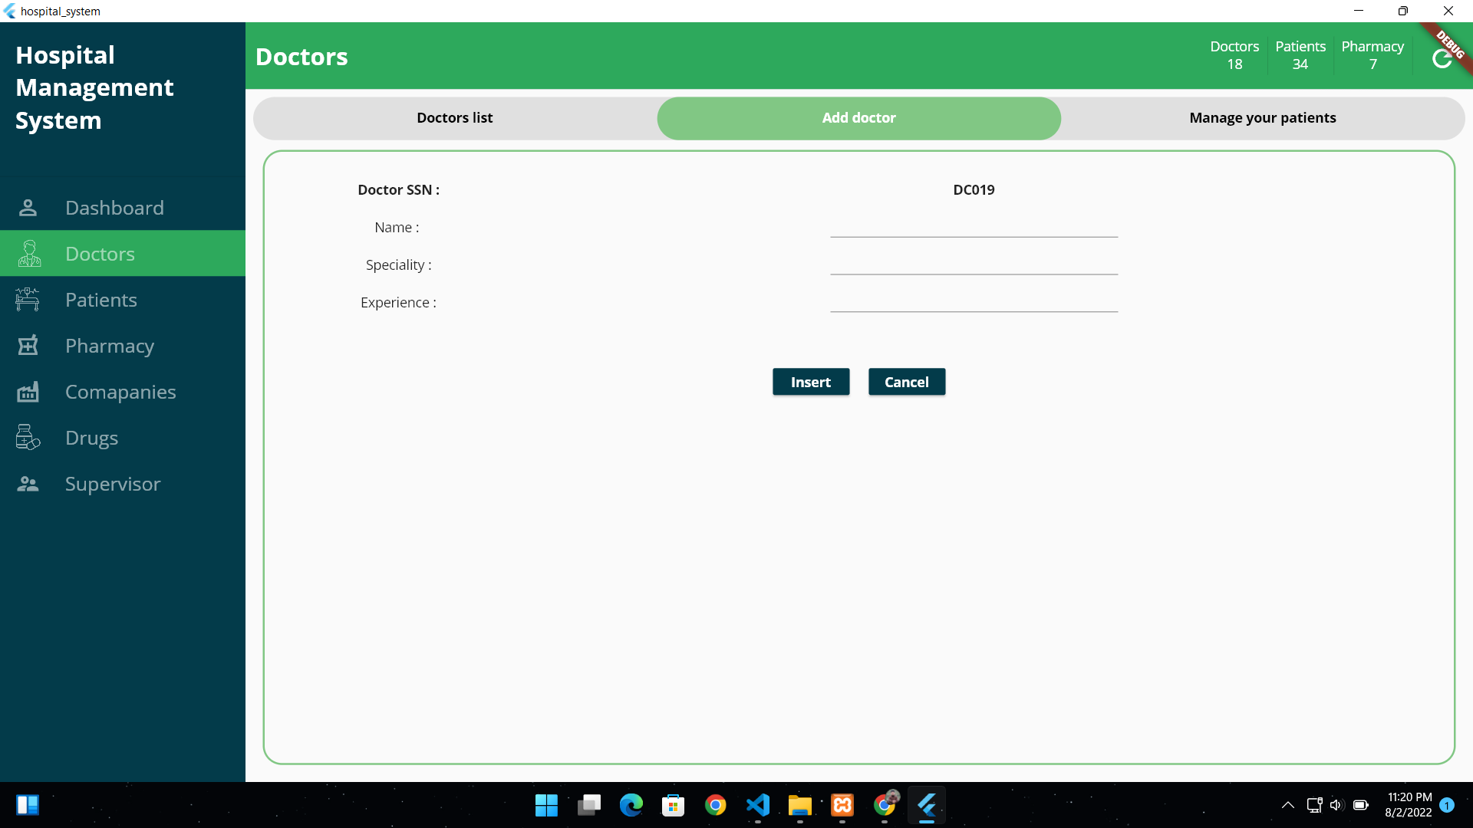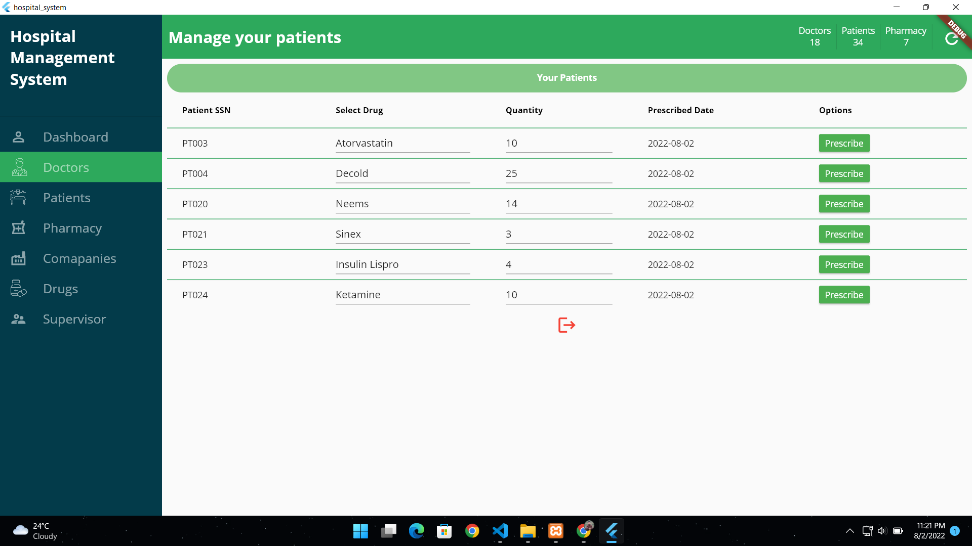

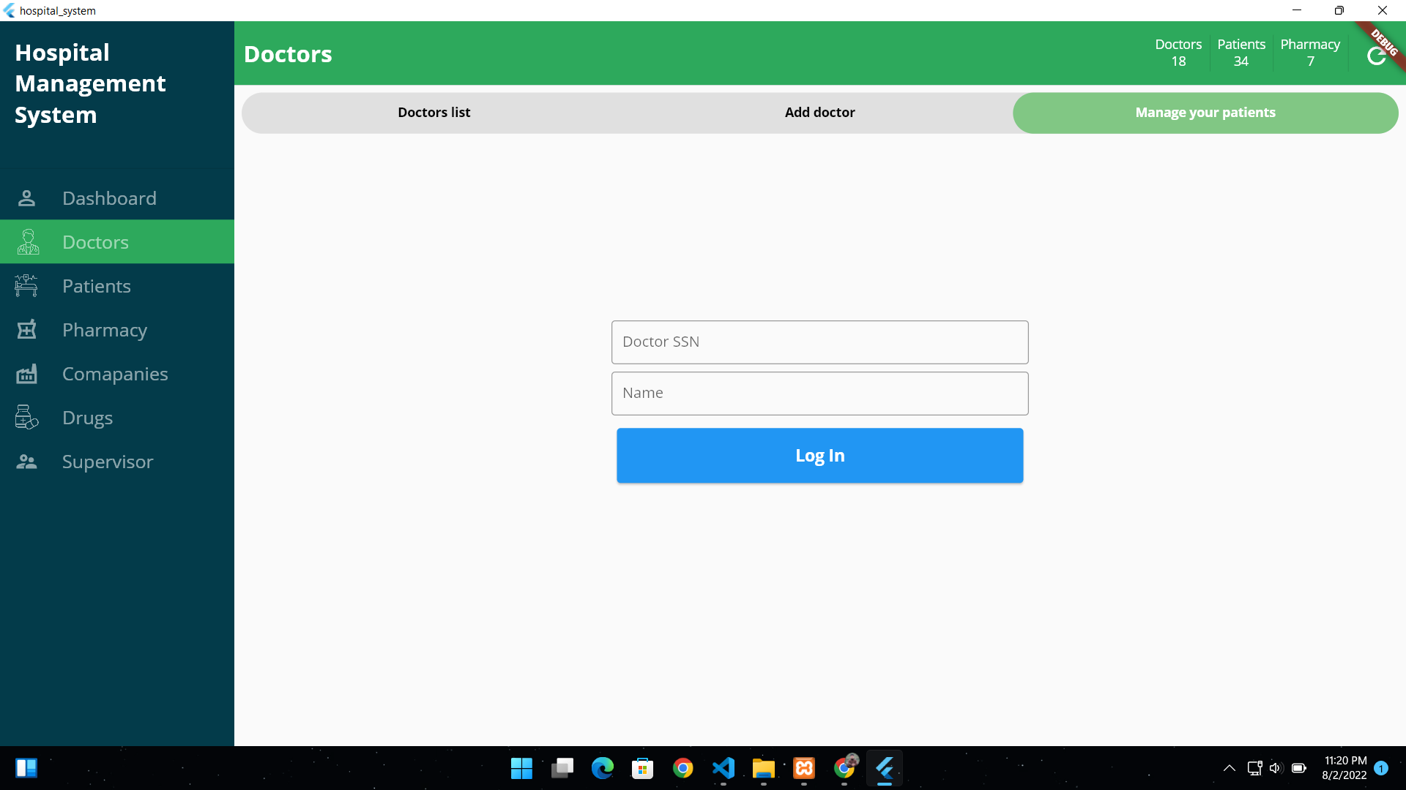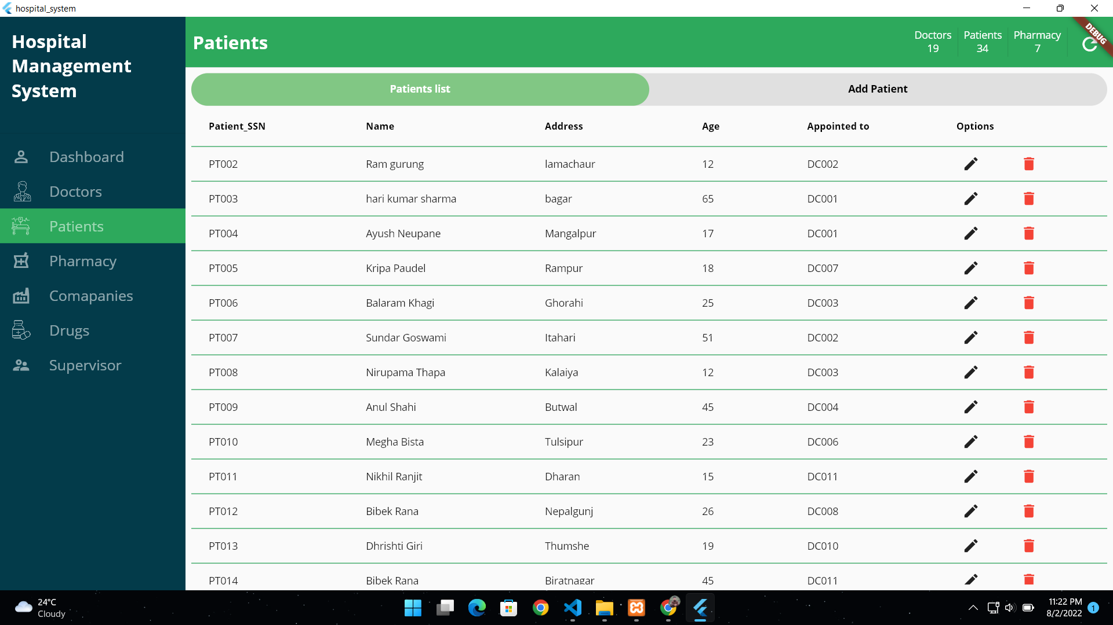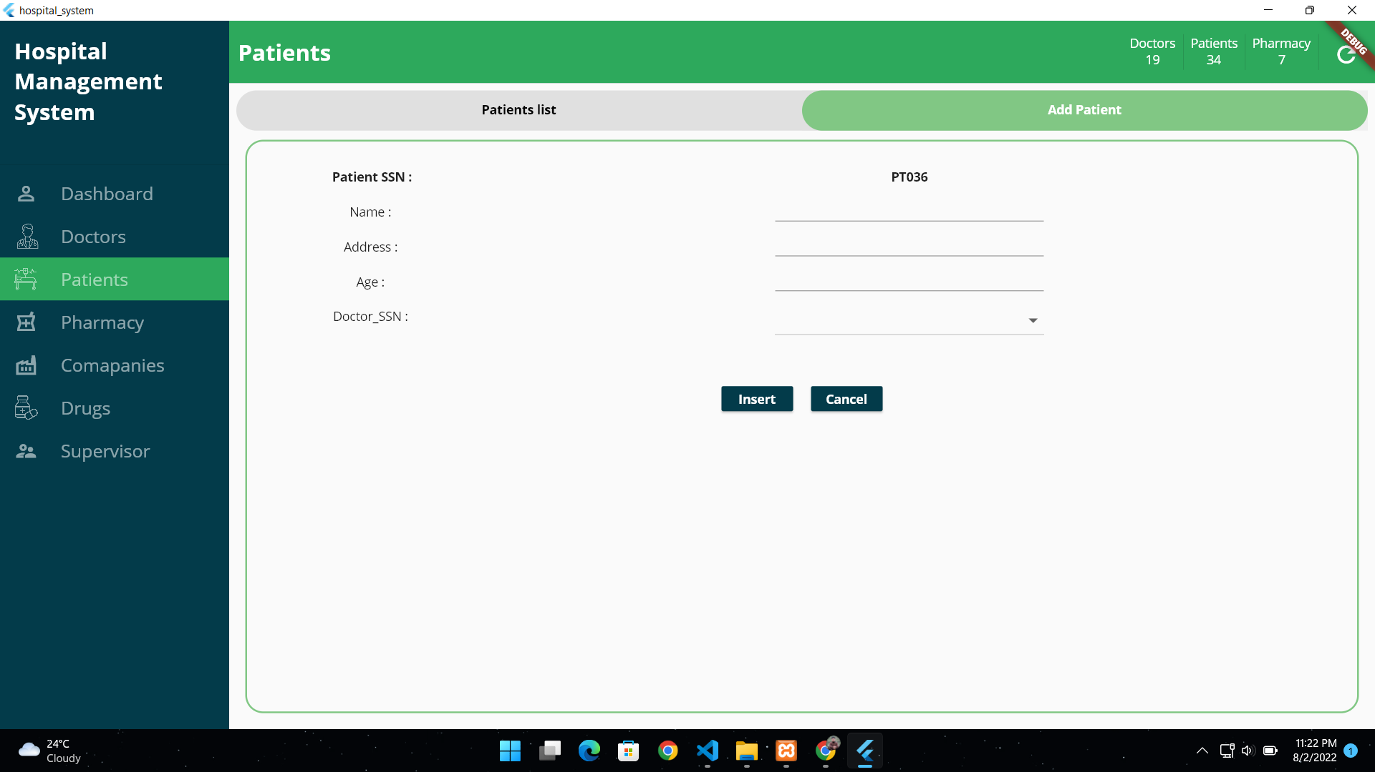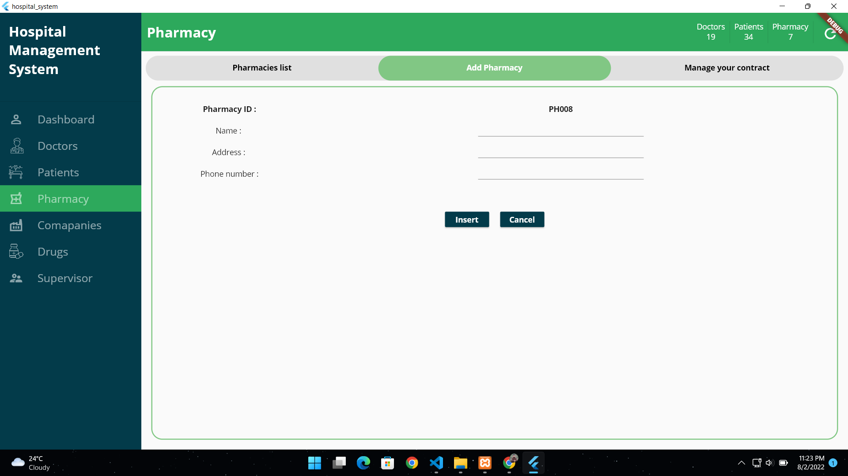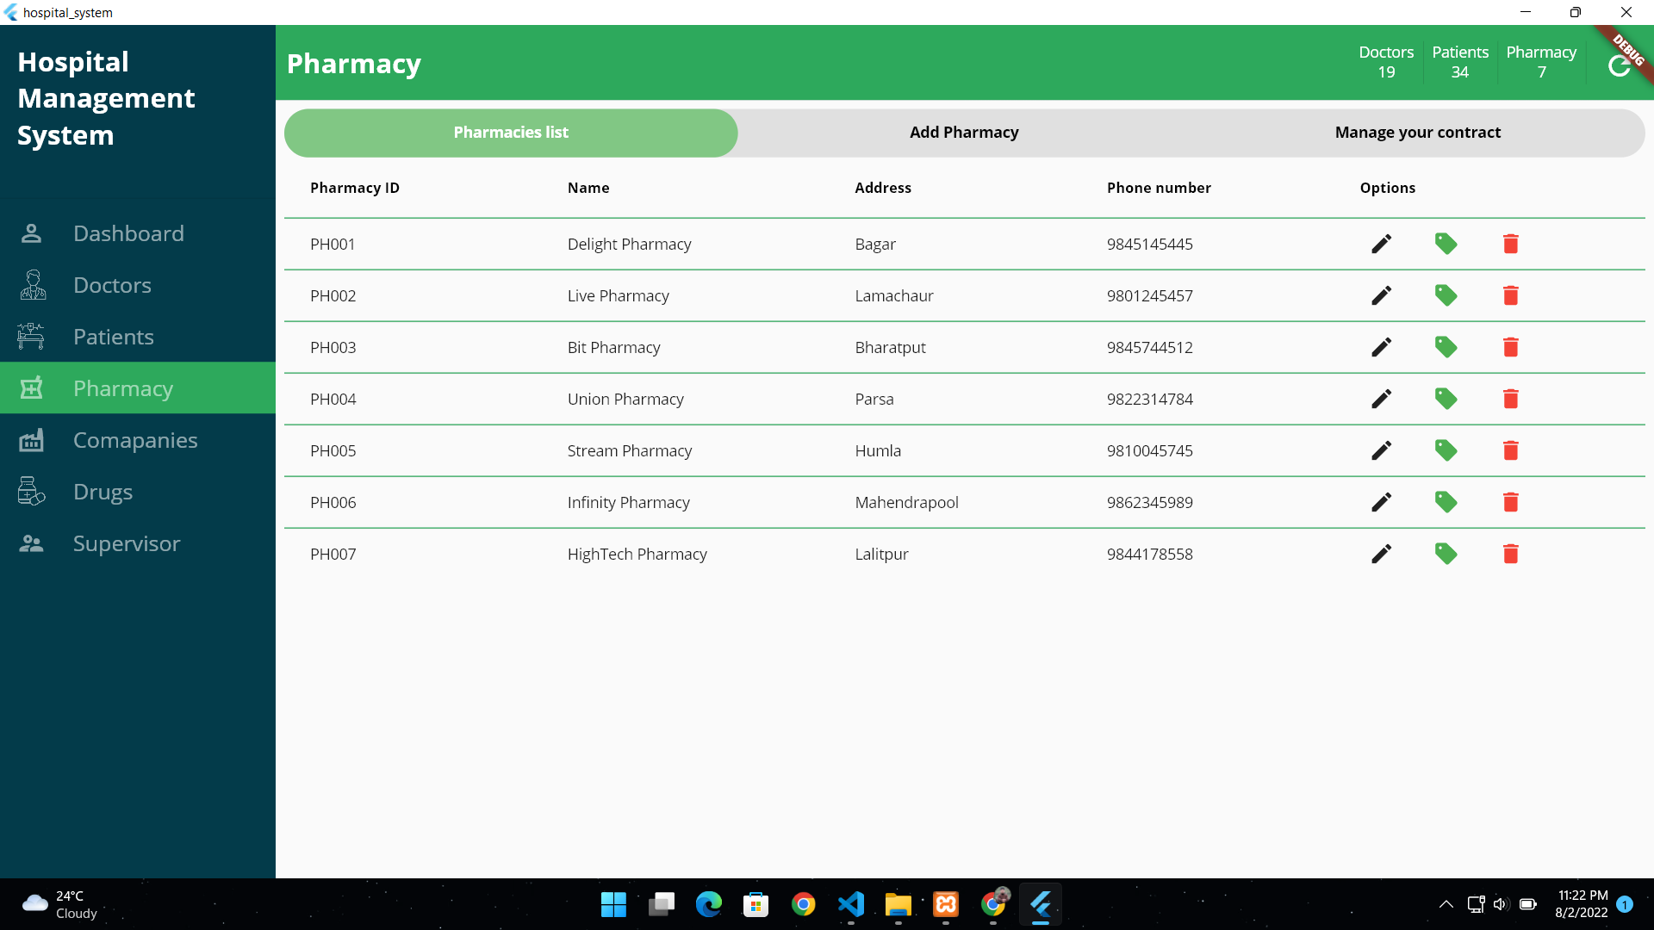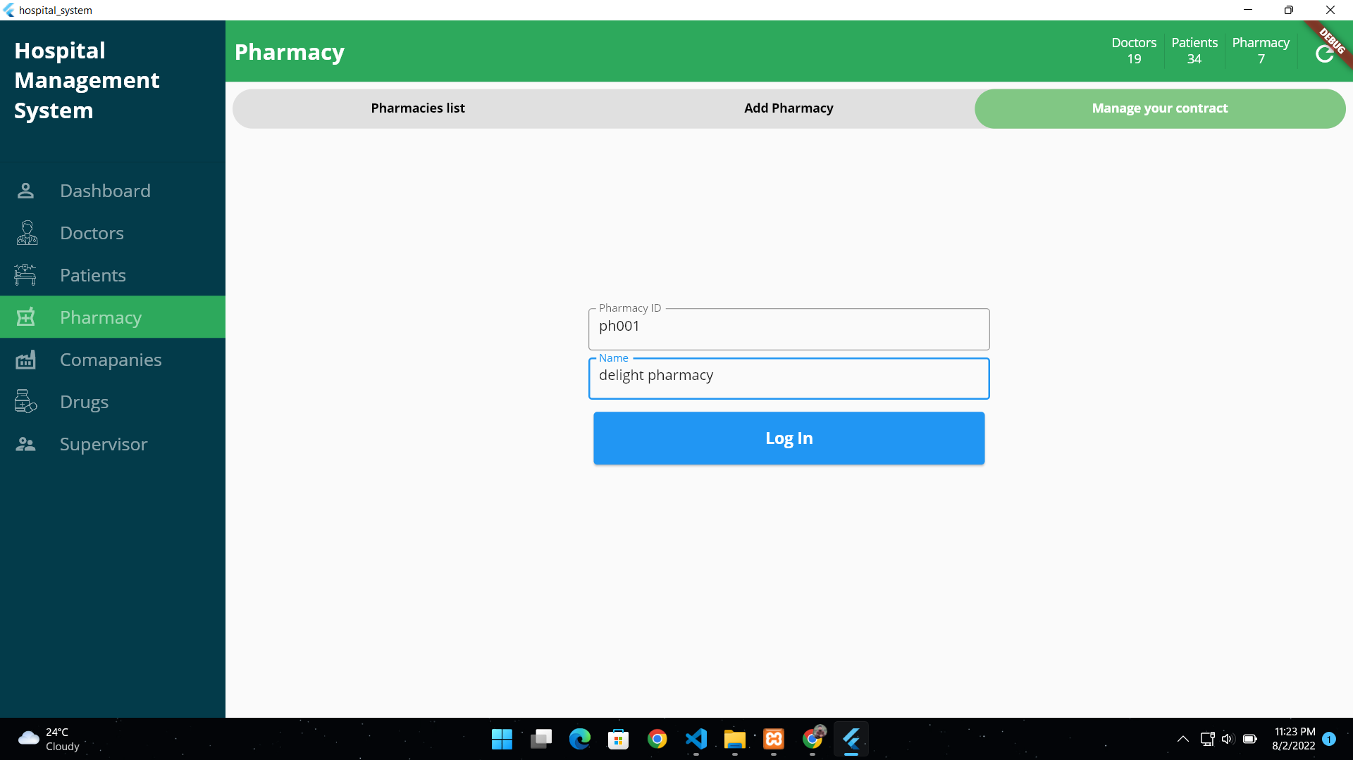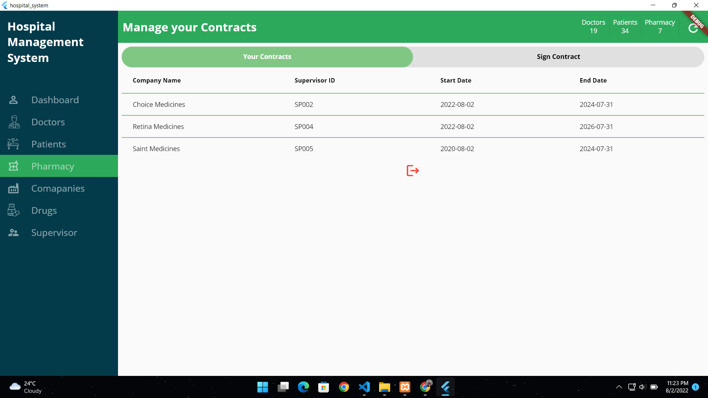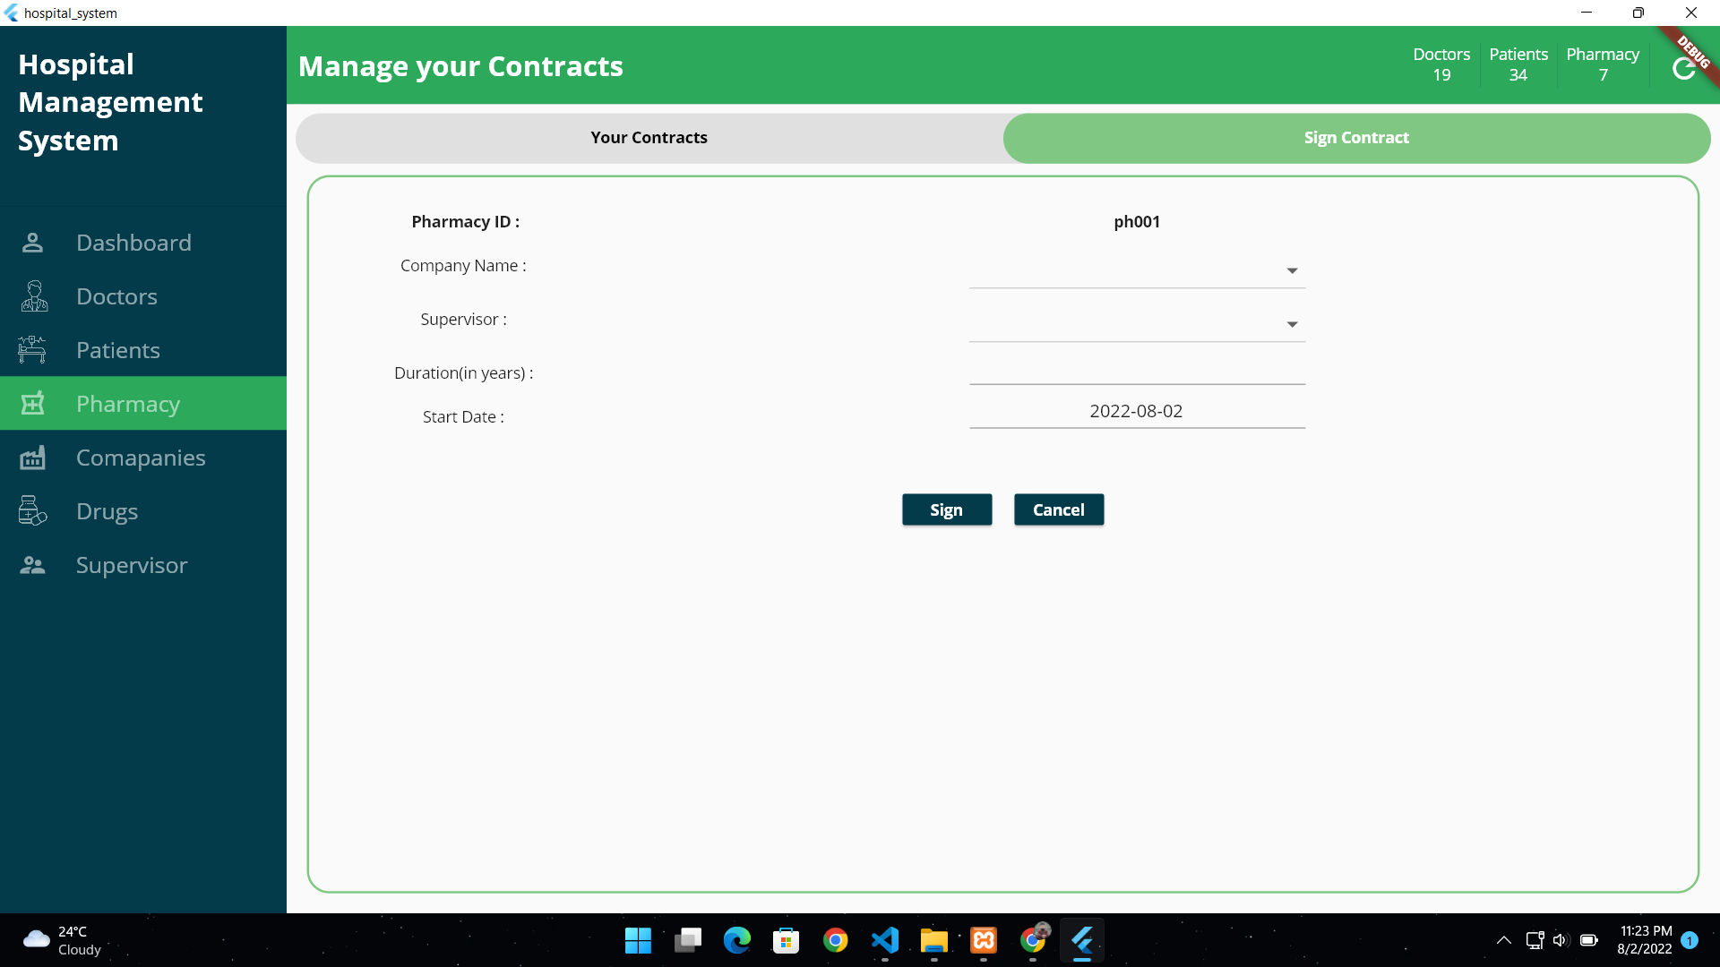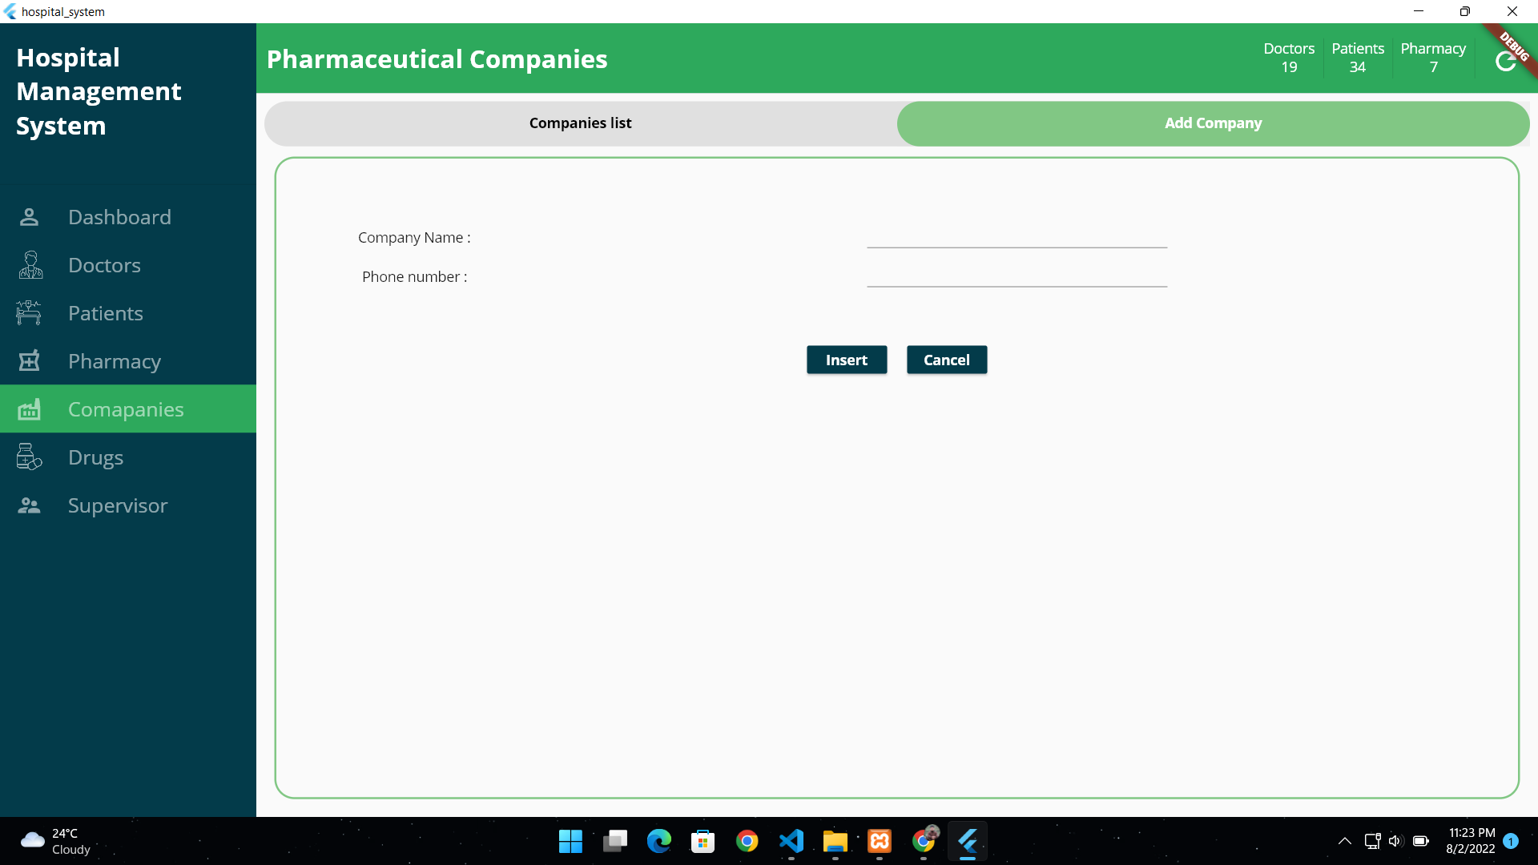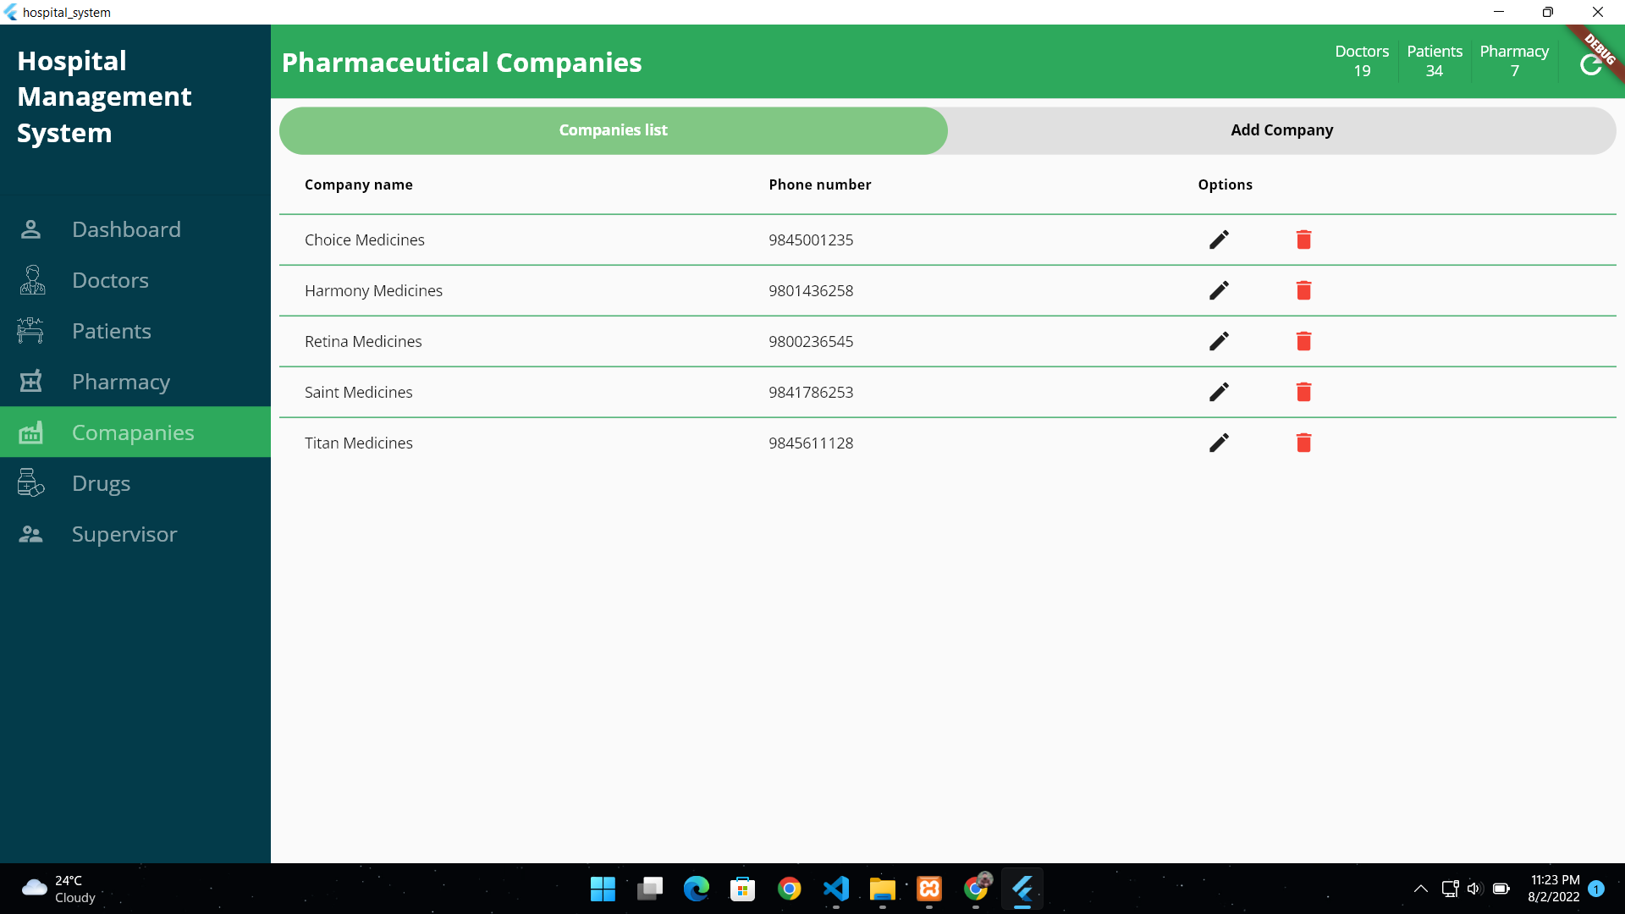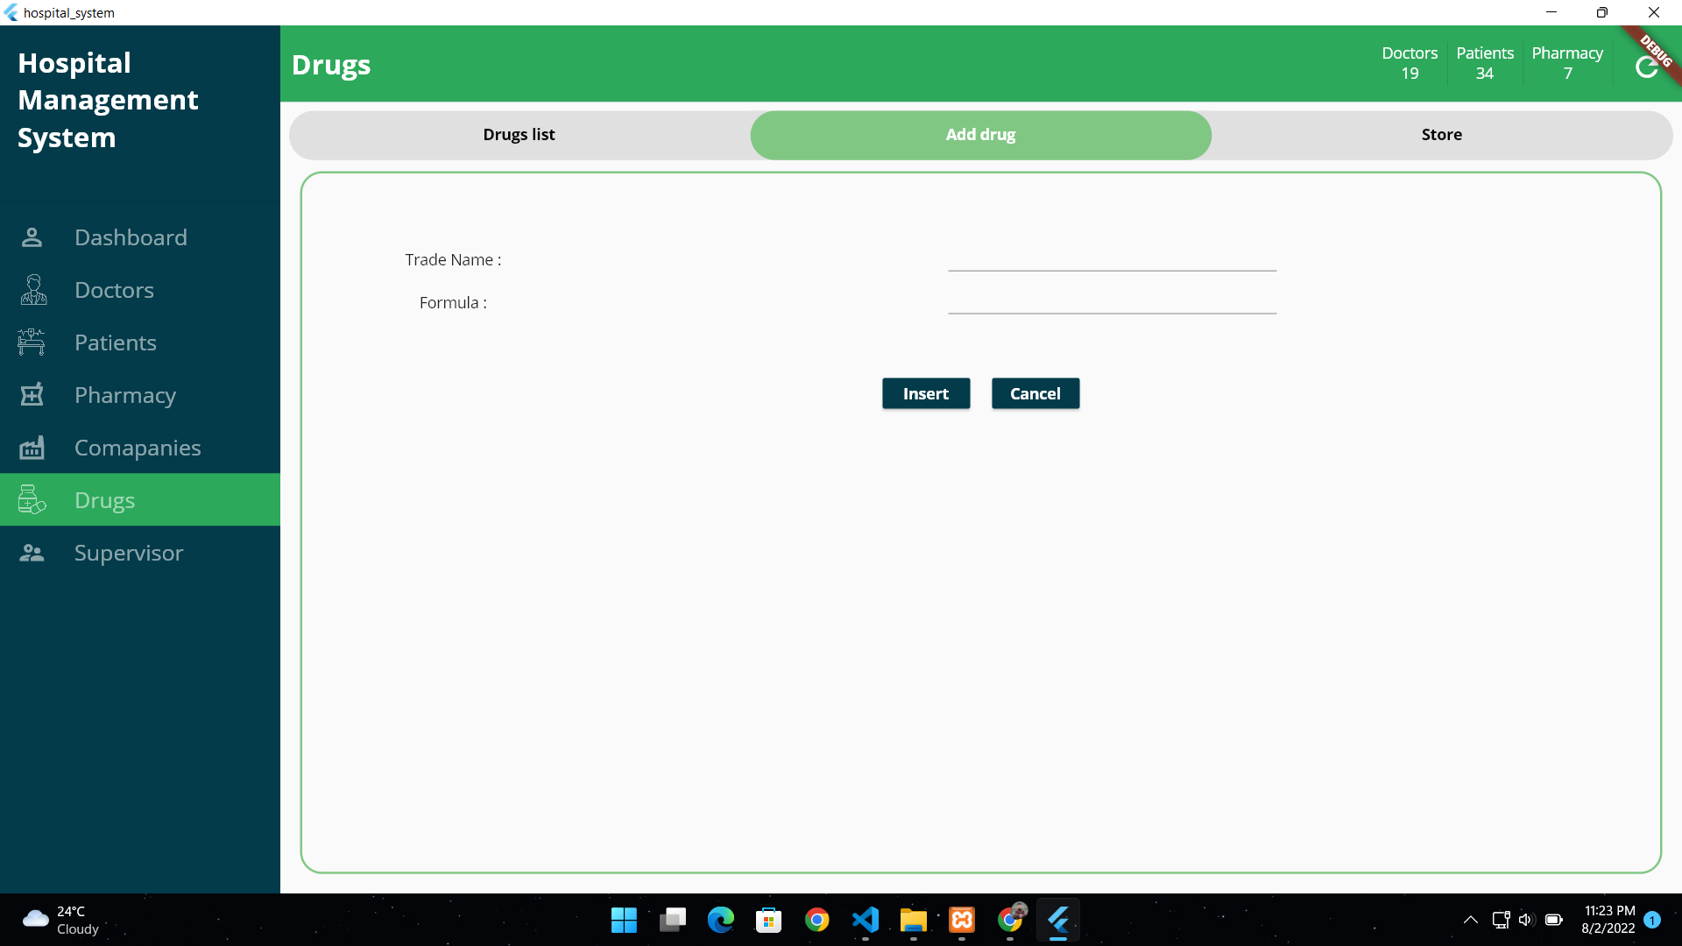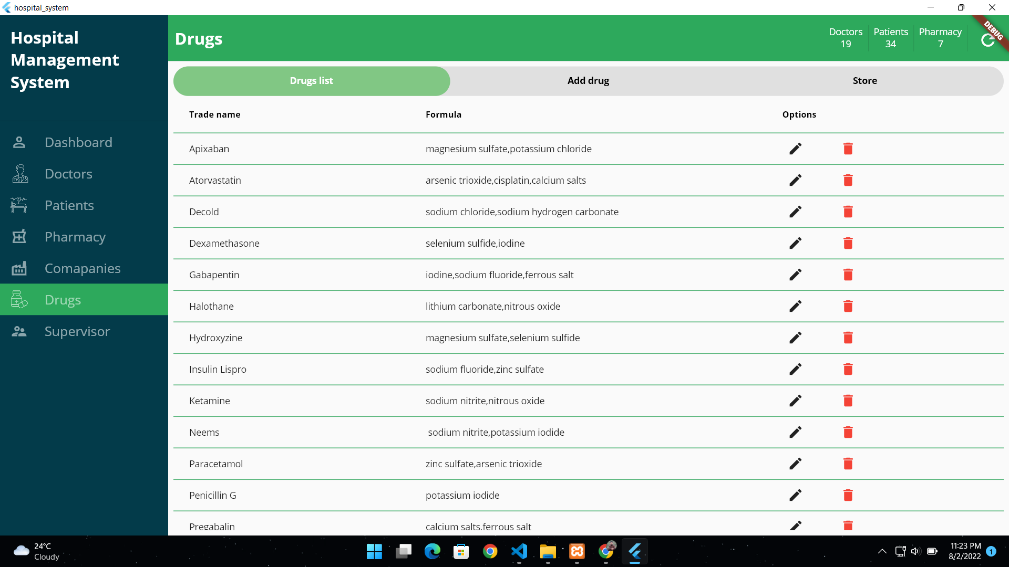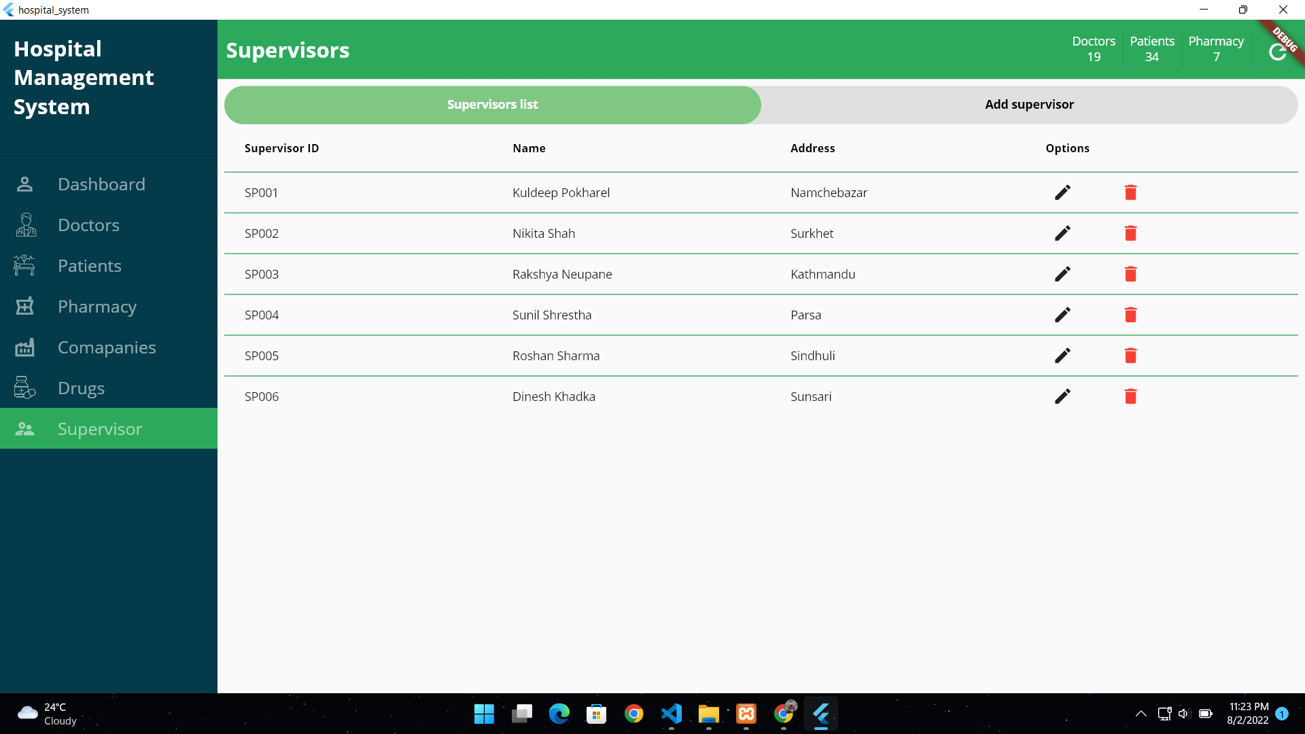

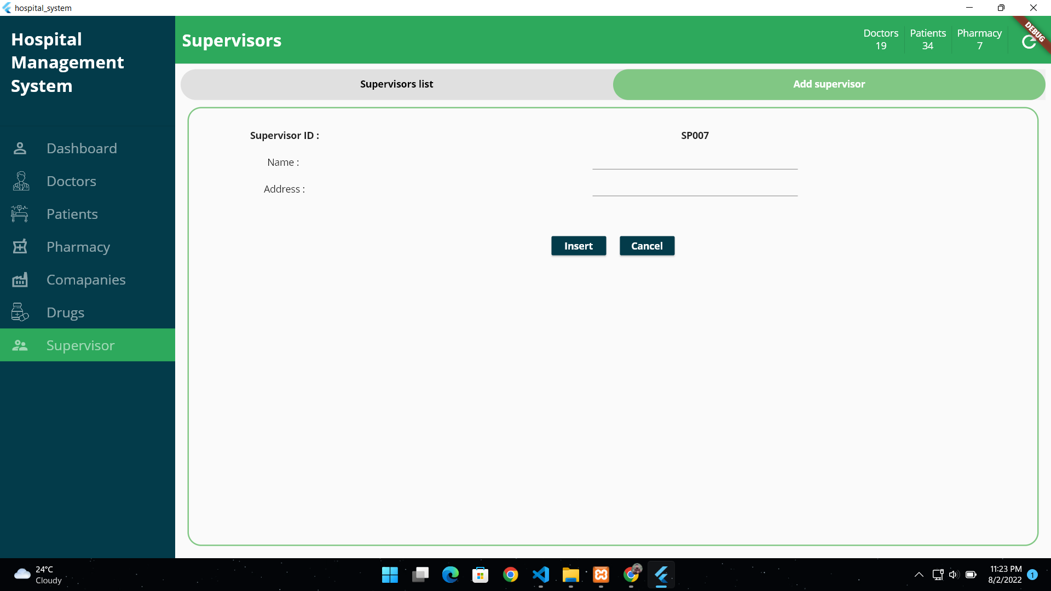

# 8. CONCLUSION:

Since we are entering details of the patients electronically in the” Hospital Management System”, data will be secured. Using this application we can retrieve patient’s history with a single click. Thus processing information will be faster. It guarantees accurate maintenance of Patient details. It easily reduces the book keeping task and thus reduces the human effort and increases accuracy speed