Messenger

Development Documentation

V1.0
Table of Contents
Introduction 3
Document Identifier 3
Overview 3
Requirements 3
Platform 3
Functional 3
Verification 3
Documentation 3
Implementation 3
Performance 3
Project Management 3
Schedule 3
Use cases 4
Using First Time 4
Logging Out 5
Functionality Description 5
Registration 5
Login/Logout 5
Messaging 5
Error Handling 5
Solution 5
Source Code Organization 5
GUI 6
Core 6

Introduction

Document Identifier
This document includes all the project requirements, description of the use cases, functionality description, architecture overview.

Overview
Messenger – program which gives opportunity to communicate with other users using local network. Program allows us to detect other all registered users in local network and set up communication with them.

Requirements

Platform
Local Network - LAN
OS – Linux Ubuntu 12.04
Memory – RAM 1Gb
CPU - 1GHz

Functional

At first program shows GUI which consists of :
- window for login/authorization
- main window
  - list of users
  - message text box
  - short dialog history

Verification
Manual testing will be performed based on the Test plan document.

Implementation
C++11, Qt4, POSIX thread, socket

Performance
Receiving and sending message shouldn't take more than a second. Also the online users list should be updated every 5 seconds. The process of registration and login shouldn't be more than 1 second.

Project Management

Schedule
- Milestone 1: Shell version + Development Documentation – 2016-Aug-26
- Milestone 2: Prototype – 2016-Aug-31
- Milestone 3: Beta version – 2016-Sep-01
- Milestone 4: Release - 2016-Sep-05

Use cases

Using First Time
Before running messenger we should choose a computer for installing the Main Server. After running Messenger user can register or login. After login in main window user can see list of users , choose one of them and chatting with him. He can also see their dialog history.

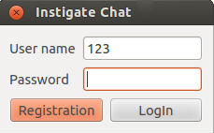
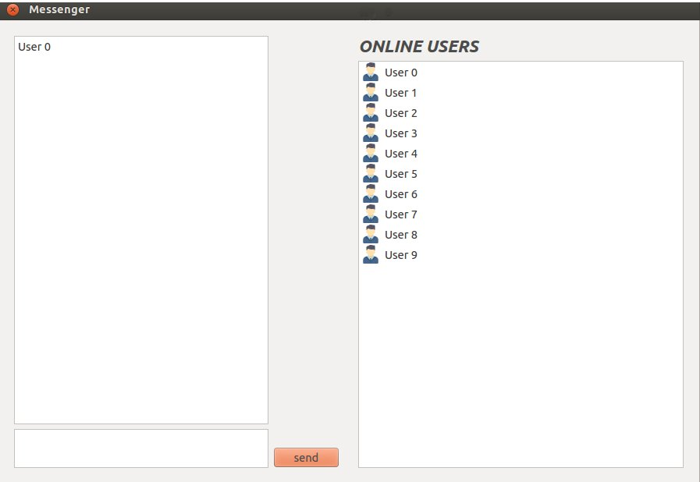

Registering
For registering user must fill name and password fields, then click on Registration button.

Logging In
For logging in user must fill name and password fields, then click on Login button. After that main window will be shown using which user can communicate with other users of the list.

Logging Out
For logging out user must click on Logout button. After that window for login will appear.

Sending message
For sending message user must input text in text box and click on Send button.

Functionality Description

Registration
GUI should support registration of new messenger clients. This should be supported with a login GUI window. On the login window the user should specify:
- user name – this is an identifier string containing all literals, digits, special characters except ';'
- password – this is a string which shouldn't contain only spaces
Wrong input of the user shouldn't be accepted. The user should be warned. The fields should be highlighted red and the window should vibrate.
In case of proper syntax of the user name and password the user should be successfully registered. The messenger window should open, with the just registered user logged in.
Once the user has registered, next time when he opens the messenger, the login window should open for the user to login.
In case if the user tries to register with a name which already exists in the system, he should get a pop up window notification and will have to retype the user name.

Login/Logout

Messaging

Error Handling

Solution
After running the program at first opens the graphic user interface.
GUI
DISPATCHER CLASS
MAIN_CLIENT CLASS
SERVER CLASS
CLIENT 1
CLIENT 2
CLIENT N
MAIN SERVER

Source Code Organization
core – includes sources of the messaging functionality
gui – includes gui sources
main – includes executable
README – describes the installation and execution steps
makefile – to build the project

GUI

Core
The class Dispatcher is used for interacting with GUI.
Slots:
registration() - registrating new users
login() - login registrated users
logout() - exitting profile
send_to() - sending messages

Components:
vector<Client> client_list – the list of users with whom we are connected
Main_Server* m_client – pointer
Server* serv;

Class Main_Cilent:
This class is used to keep connection with main server.
Functions:
Main_Cilent() - constructor receives IP of computer of main server
registration() - registrating new users
login() - login registrated users
logout() - exitting profile
give_online_list() - give list of online users from main server

Class Client:
This class is used to create new communication.
Functions:
Client() - constructor which receives name of user with whom we want to connect

Class Server:
This class is used to receive messages. When starting program Server object is created.
Functions:
Server() - constructor for creating new object and starting server which waits for messages.
stop_server() - closes sockets and calls destructor

Main Server

