Noticed that ConfuserExCallFixer sometimes fixes wrong calls. Example:

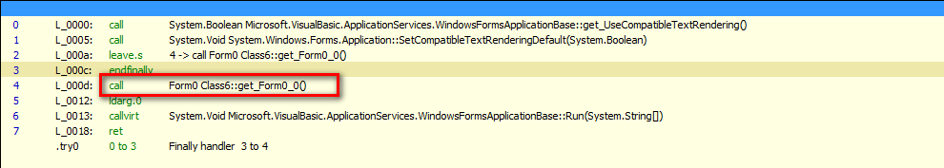

Inside call:

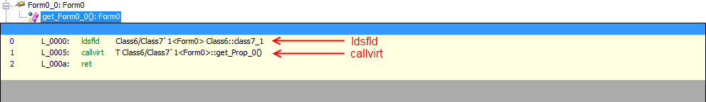

This what we get after ConfuserExCallFixer:

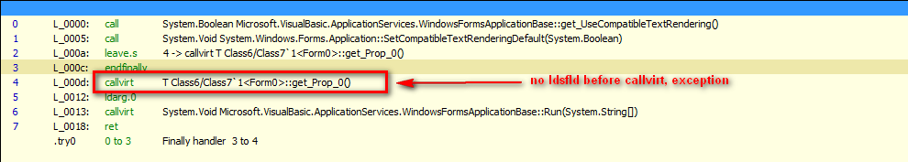

Attached a small fix just for that type of files.
Also attached a small tool called ProxyClean, which completely removes trash methods after fixing with ConfuserExCallFixer (version from this post)

