Anatomy-Weighted CTDIvol from Routine CT Metadata: A Patient-Specific, Multi-Vendor Study Using Deep-Learning Segmentation
Shuji Yamamoto
Institute of One, LISIT Co., Ltd., Tokyo, Japan; yamamoto@lisit.jp; ORCID 0000-0001-9211-1071
Correspondence: yamamoto@lisit.jp

Simple Summary
CT scanners report a single dose number for the whole scan, yet the dose is delivered unevenly across organs. We built an open, freely available software pipeline that uses deep-learning segmentation to outline each abdominal organ on routine CT images and then derives a patient-specific, organ-level dose index directly from data the scanner already records. Across scans from four manufacturers we found that this organ-level information can be recovered for some scanners but is entirely absent for others, because the values it needs were not kept in the archived scan records. All software, results, and data provenance are fully open so the work can be reproduced and extended.

Abstract
CTDIvol is a scanner-output index, not a patient or organ dose, and cannot express how tube-current modulation varies along a patient. An organ-specific weighted CTDIvol addressing this problem has been reported previously, but primarily in single-institution cohorts and often using inputs that routine image archives do not retain. We operationalised it openly across manufacturers, from routine DICOM metadata and automated segmentation alone; it is not an estimate of absorbed organ dose. Forty abdominal CT series, ten per manufacturer, were drawn from The Cancer Imaging Archive and twelve organs segmented with TotalSegmentator at inference only. Of 480 requested organ–series combinations, 455 records were produced. A rule-based acquisition-constancy criterion admitted 39 of the 40 series to the quantitative modulation analysis. Modulation weights spanned 0.59 to 1.69, so the index departs from the whole-scan CTDIvol by up to 70% within one acquisition. A recorded CTDIvol was retained in the archived headers of 29 of 40 series, reconstructable in 5 and unavailable in 6, with availability differing markedly between manufacturers in this sample. Estimated organ mass was broadly consistent with ICRP 89 values for liver and kidneys. Conversion to absorbed organ dose requires Monte-Carlo coefficients this index does not replace; the implementation is open.
Keywords: computed tomography; CTDIvol; tube-current modulation; deep-learning segmentation; TotalSegmentator; image-based dosimetry indices; reproducibility; open data

1. Introduction
Two different things are routinely conflated when CT dose is discussed. The first is that a dose index is not a dose: CTDIvol describes the output of a scanner into a standard cylinder of acrylic, and is a property of the acquisition rather than of the patient in it — a distinction set out explicitly by McCollough et al. [1]. The second is that a single value per series cannot express variation along the patient: almost every modern acquisition modulates the tube current longitudinally, so the conditions over the liver and over the bladder are not the same, and one number for the series conceals that.
That second point is well established. Khatonabadi et al. demonstrated that a regional or organ-specific CTDIvol, formed from the modulation profile over an organ’s own location, tracks Monte-Carlo organ dose far better than the whole-scan value, raising the coefficient of determination for liver dose from 0.26 to 0.86 [2]. Tian et al. formalised a weighted organ-specific CTDIvol computed from the modulation profile and used it, with organ-dose coefficients, to predict organ dose prospectively [3].
The quantity examined here is therefore not new, and no new index is proposed. This study takes the organ-specific weighted CTDIvol already reported in that literature and asks a different question: what happens when it is operationalised openly, end to end, on heterogeneous archived data from four manufacturers, using automated segmentation and nothing but the metadata a scanner already writes?
Existing work only partially answers that question. Longitudinal dose indices, DICOM-header-derived modulation profiles and TotalSegmentator-assisted dose calculations have each been investigated, but in different settings and for different endpoints. Li et al. characterised the size-specific dose estimate as a function of longitudinal position, SSDE(z), under both fixed and modulated tube current [4]. Nuntue et al. derived tube-current-modulation profiles from DICOM headers and used them, with Monte-Carlo simulation and physical measurement, to improve absorbed organ dose estimates in abdominal CT [5]. Eom et al. incorporated TotalSegmentator into an automated effective-dose calculation on clinical PET/CT [6]. What remains insufficiently characterised is whether the organ-weighting layer can be reconstructed end to end from heterogeneous archived DICOM alone, how often the required inputs survive archive curation and de-identification, how acquisition-parameter constancy can be verified, and how the resulting quantity behaves across manufacturers when patient-specific contours are obtained automatically. Deep-learning segmentation is what makes the attempt practical at scale: a general-purpose segmenter such as TotalSegmentator [7], built on nnU-Net [8], produces abdominal organ masks from a routine series in seconds at inference only, so the anatomy is now effectively free.
This study is accordingly an open, multi-vendor operationalisation and empirical characterisation of a previously reported quantity: the whole-scan CTDIvol scaled by a dimensionless, organ-specific weight formed from the recorded per-slice tube current over that organ’s segmented longitudinal extent, referred to here as the anatomy-weighted CTDIvol index. It is explicitly not an estimate of absorbed organ dose, and Section 2.10 sets out what it does not account for.
Converting an index of this kind into an absorbed organ dose in milligray requires CTDIvol-normalised organ-dose coefficients, computed by Monte-Carlo simulation over anthropomorphic patient models and corrected for patient size [3]. Such coefficient sets exist, are well validated, and are in routine use; the index reported here does not replace them and is not offered as a surrogate for their output.
The contributions are:
- An open, end-to-end implementation of the organ-specific weighted CTDIvol computed entirely from data a scanner already records, requiring neither projection data nor manual contouring.
- A multi-vendor empirical characterisation of that quantity on public archive data: its range, its within-acquisition spread and its behaviour across four manufacturers.
- A description, for this archive sample, of how often the required inputs are actually retained in archived DICOM headers — a precondition for any retrospective study of this kind, and one that has not been well characterised.
- A rule-based acquisition-constancy criterion that makes the assumption underlying the weighting testable rather than implicit.
- An external reference comparison of attenuation-derived estimated organ mass against ICRP 89 reference values [9], and the practical limits an organ-level modulation analysis must handle.

2. Materials and Methods

2.1. Data Selection Without Bulk Download
Handing a collection manifest to a bulk downloader fetches an entire collection, which for the low-dose CT collection is of the order of 600 GB, most of it raw projection data irrelevant to this work. We therefore used a metadata-first procedure over the public NBIA REST API with four stages — index, screen, probe, download — in which only the last transfers a series.
All imaging was drawn from The Cancer Imaging Archive [10]. The candidate index was built from 47,181 CT series across 21 abdominal collections, read as series-level JSON with no pixel data. Candidates were seeded from the public-archive survey distributed with the companion software release [11] — a software record, not a peer-reviewed study — and supplemented by direct collection queries. A metadata screen then rejected, in order and with each rejection counted: non-patient collections (imaging phantoms and de-identification benchmarks); projection and raw-data series, of which 398 were refused at this stage; non-diagnostic series (localisers, dose reports, screen captures); series shorter than 40 or longer than 1200 images; and series outside the abdomen. One series was retained per patient per collection, and each manufacturer’s quota was drawn round-robin across its collections so that manufacturer was not confounded with a single collection.

2.2. Inclusion Criteria and Header Probing
Sixty-two surviving candidates were probed by fetching six image headers each and judged on four requirements: per-slice tube current present on every probed slice; that current genuinely modulated (peak-to-peak over mean at least 0.02, so header rounding is not mistaken for modulation); a defined Hounsfield rescale; and a reconstructed-image SOP class with at least 40 slices spanning at least 120 mm. Forty series were kept, ten per manufacturer.
No imaging is redistributed. Each retained series is identified in the shipped provenance record by collection, collection DOI, Series Instance UID, manufacturer, model, licence and retrieval date. All forty series were retrieved under Creative Commons Attribution licences — 33 under CC BY 4.0 and 7 under CC BY 3.0, as recorded per series in data/PROVENANCE.json; users must in every case observe the licence terms of the originating collection and the TCIA Data Usage Policy.

2.3. Resolving the Slice Grid
Organ volume is a voxel count multiplied by a voxel volume, so slice spacing multiplies every volume and every mass estimate. Two properties of archived series make the obvious calculation wrong, and both are silent.
First, the file count is not always the position count. One series in this cohort contains 160 images at 119 distinct longitudinal positions; taking the spacing as the extent divided by the number of images gives 3.71 mm where the true spacing is 5.0 mm, and stacking the duplicated images repeats anatomy so that organs occupy more slices than they physically do. We therefore resolve the grid explicitly: one image per position, spacing from the median step between neighbouring positions, and a uniformity check that refuses a series whose steps vary by more than 2%. Two series proved to be a pair of reconstructions interleaved under a single Series Instance UID; for these the largest regular sub-grid was taken, accepted only when it preserves the full longitudinal extent.
Second, the ordering of the slice axis is not guaranteed. Slice Location (0020,1041) runs opposite in sign to Image Position (Patient) on three of the four manufacturers in this sample, so a series sorted by the former arrives head-first. The segmentation is unaffected, because the geometry handed to the segmenter is built from patient coordinates; but the array index ceases to mean “towards the head”, which reverses every reported organ extent. Volumes are therefore canonicalised so that index zero is the most inferior slice, with the tube current reordered alongside, since I(z) is paired to the slice axis by index.

2.4. Reading Hounsfield Units
Outside the reconstruction circle an image carries a padding value rather than a measurement, and that value must be replaced with air before anything is measured. Pixel Padding Value (0028,0120) has a value representation that depends on Pixel Representation, and this is not reliably honoured: in this sample one export writes 63,536 with an unsigned representation on signed pixel data, which is the two’s complement encoding of the −2000 intended. Read literally, that places the padding threshold above every Hounsfield value in the image, and the volume becomes uniform air. Four series were affected, with no symptom other than a segmenter returning empty masks. We reinterpret the padding value against Pixel Representation, and additionally refuse any padding rule that would blank essentially the whole image.

2.5. Segmentation
Twelve abdominal organs were segmented with TotalSegmentator v2.17 [7], total task, 1.5 mm full-resolution model, at inference only; no weights were trained, modified or redistributed. Inference runs in a separate child process, because nnU-Net spawns its own workers and doing so from a long-lived parent leaks processes on Windows.
The series is written to NIfTI by our own code, with an affine constructed from the DICOM patient coordinates, and the masks return on that same grid; the correspondence between mask voxel and image voxel is therefore the identity by construction, and is asserted rather than assumed. A mirrored segmentation would otherwise produce entirely plausible volumes and Hounsfield values while pairing every organ with the wrong anatomy.
The patient outline, used for the water-equivalent diameter, was taken from a deterministic threshold contour following AAPM Report 220 [12]. Figure 1 illustrates the segmentation output and its correspondence with the CT anatomy in the representative acquisition used for the end-to-end example.

2.6. Attenuation-Derived Estimated Organ Mass
Hounsfield units were converted to mass density by piecewise-linear interpolation through reference tissue anchor points, taking the densities from ICRU Report 44 [13] and the construction from Schneider et al. [14]. Estimated organ mass is the sum of local density over mask voxels multiplied by the voxel volume.
These are model-based estimates, not measurements. Contrast enhancement, tube voltage, reconstruction kernel and scanner-specific HU calibration may all affect attenuation-derived density estimates, and none was controlled in this archive cohort: contrast phase in particular varies between and within collections. The reported masses should therefore be interpreted as model-based estimates rather than physical ground truth. The HU-to-density curve itself is replaceable and travels into the provenance of every estimate; abdominal soft tissue is relatively insensitive to the choice, since perturbing the water-to-muscle slope by 10% changes an abdominal organ-mass estimate by less than 1%.

2.7. The Anatomy-Weighted CTDIvol Index
For an organ o occupying slices with per-slice voxel counts n_o(z), and a series with per-slice tube current I(z), the organ-specific modulation weight is
w_o = [ Σ_z n_o(z) I(z) / Σ_z n_o(z) ] / mean_z I(z) (1)
and the anatomy-weighted CTDIvol index is CTDIvol · w_o. The weight is dimensionless and is the transferable quantity: it expresses the recorded longitudinal tube-current conditions over the organ relative to the scan mean, independently of the scanner’s own output.
The weighting assumes that, within each series, tube voltage, rotation or exposure time, pitch and beam collimation remain fixed, so that longitudinal changes in scanner output are proportional to the recorded tube current.

2.8. The Acquisition-Constancy Criterion
We formalised this assumption as a rule-based eligibility criterion and applied it mechanically:
A series is eligible for quantitative anatomy-weighted CTDIvol analysis only when the acquisition parameters required for scanner output to remain proportional to the recorded tube current are constant within that series, to the extent verifiable from the archived DICOM headers.
Every slice header of every series was read and each output-governing attribute — tube voltage, exposure time, rotation time, pitch and total collimation width — classified into one of four states. Verified constant: one value throughout. Absent: never written to the archived headers, so constancy can be neither confirmed nor refuted; absence alone does not disqualify a series, since excluding on it would remove series for a property of the de-identified export rather than of the acquisition. Negligible variation: varying by less than a relative tolerance of 0.02, attributable to the numeric representation — exposure time is written as an integer number of milliseconds, so a one-unit step on a value of a few hundred is a rounding artefact. Materially variable: varying by at least that tolerance, which disqualifies the series. The tolerance is not fitted to these data: any value between roughly 1% and 50% classifies this cohort identically, because the only material variation observed is a factor of two.
Tube voltage was verified constant in all 40 series, as were Image Type and convolution kernel, so no series mixes acquisition or reconstruction types. Exposure time was verified constant in 35 series, negligibly variable in 3, materially variable in 1 and absent in 1; rotation time verified constant in 20, materially variable in 1 and absent in 19; pitch verified constant in 32 and absent in 8; total collimation width verified constant in 31 and absent in 9. The full record is shipped as results/acquisition_constancy.json and the eligibility decision for every series in results/analysis_1.5mm.json.
Series failing the criterion are retained for the archive-availability, segmentation, estimated-mass and provenance analyses, and excluded only from quantitative modulation-weight and anatomy-weighted-index summaries.
CTDIvol was taken from the image header (0018,9345) where present. Where absent, it was reconstructed from acquisition physics against an openly licensed normalised-CTDI database [15]; recorded and reconstructed values are never merged, and each series records which it carries. A recorded value outside the physically possible range is treated as a corrupt attribute and falls through to reconstruction — one series records CTDIvol as −3.7 × 10^19 mGy.
An organ whose mask reaches the first or last slice of the series continues beyond the scan; its estimated mass is that of the scanned part and its weight describes only the exposed part. Such organs are flagged and excluded from whole-organ comparisons.

2.9. Organ Record Flow
Forty series and twelve requested organs give 480 organ–series combinations. Records were produced for 455. The remaining 25 are organs that lay outside the scanned longitudinal range, so their masks were empty and no record exists: urinary bladder in 10 series, gallbladder in 8, and seven further organs in a single 41-slice pelvic acquisition that does not reach the upper abdomen.
Two further conditions apply to the 455 records, and they are independent axes rather than nested subsets. Truncation is a property of the organ: 408 records are untruncated and 47 reach a scan boundary. Index availability is a property of the series: before application of the acquisition-constancy criterion, 386 records from 34 series had a recorded or reconstructed CTDIvol and were computationally capable of carrying an index, while the remaining 69 records, from 6 series, carry a modulation weight but no index because those series have no CTDIvol by either route. The two conditions hold together for 345 records; 41 truncated records still carry an index, and 63 untruncated records do not.
After exclusion of the one materially variable series, 375 records from 33 series were eligible for the quantitative anatomy-weighted-index analysis; the 11 excluded records belong to that series. The external reference-mass comparison, which does not depend on the modulation weighting, uses the 177 untruncated records of the five solid organs across the whole cohort. The full flow is in the shipped results/analysis_1.5mm.json.

2.10. What the Index Does and Does Not Represent
The anatomy-weighted CTDIvol index describes organ-specific longitudinal tube-current modulation relative to the whole-scan CTDIvol. It does not account for scattered radiation; irradiation originating outside the organ’s segmented longitudinal extent; angular (in-plane) tube-current modulation; organ depth, position or attenuation; patient-specific Monte-Carlo radiation transport; or absorbed organ dose in milligray. It is therefore not a surrogate for absorbed organ dose and must not be read as one. What it does provide is a dimensionless, patient-specific, organ-specific measure of longitudinal modulation, and a derived index in the units of the parent CTDIvol.

2.11. Verification and Reproducibility
Every series is screened against facts of gross anatomy that hold for any adult: the left kidney lies to the patient’s left of the right kidney and the spleen to the left of the liver; the liver lies superior to the bladder and the adrenal glands superior to the kidneys; solid-organ mass estimates fall within a wide band of reference values; and the organ weights vary within a series. These screens exist because the failures they catch leave no other trace.
Analyses were run with Python 3.14 (the package supports 3.10 and later), TotalSegmentator v2.17 (total task, 1.5 mm full-resolution model) on PyTorch 2.11 with CUDA 12.8, pydicom 3.0 and NumPy 2.5, using an NVIDIA RTX 3080. Every reported value is re-derived from the per-series records by the test suite, including regenerating the complete analysis table and comparing it. The acquisition, organ, analysis and figure layers are regenerated by tools/select_and_download.py, tools/run_organ_dose.py, tools/make_analysis.py and tools/make_figures.py respectively; the acquisition-parameter check by tools/verify_acquisition_constancy.py. The repository, its release tag, commit hash and archived version DOI are given in the Data Availability Statement.

3. Results

3.1. Cohort and Records
Forty series were analysed — ten from each of GE, Siemens, Canon/Toshiba and Philips — drawn from 21 collections and 23 scanner models. Of 480 organ–series combinations, 455 organ records were produced across 12 organs, with the flow as given in Section 2.9. Figure 1 shows the segmentation output for a representative acquisition.
Of the 40 segmented series, 39 met the acquisition-constancy criterion of Section 2.8. One archived GE series contained two blocks with different exposure and rotation times; it was retained for the segmentation, estimated-mass and archive-availability analyses and excluded from the modulation-weight and anatomy-weighted-index summaries. The quantitative modulation analysis therefore rests on 375 organ records from the 33 eligible series that also carry a CTDIvol.
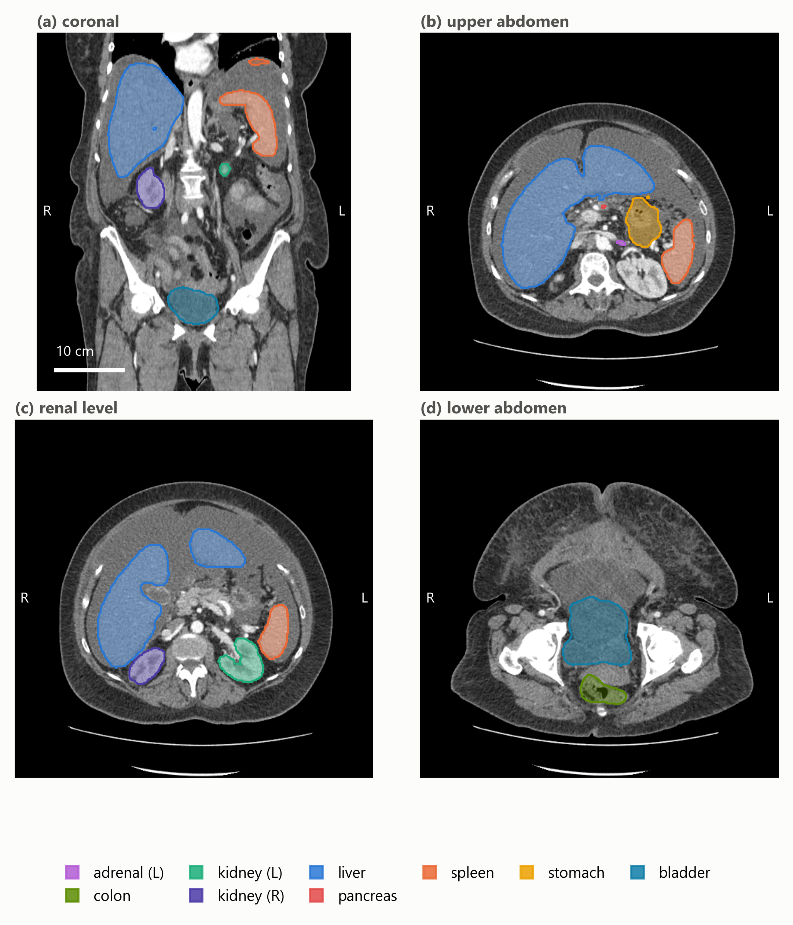
Figure 1. Representative TotalSegmentator output from one abdominal CT series used in the analysis. (a) Coronal reformat with multi-organ overlays. (b–d) Axial levels through the upper abdomen, the renal level and the lower abdomen. Masks were generated with TotalSegmentator v2.17 using the 1.5 mm full-resolution total task and returned to the native DICOM-derived image grid; overlays are translucent so the anatomy they are drawn against remains visible, and the key lists the structures actually shown. The same acquisition appears in Figure 2. Images are displayed in radiological convention, with the patient’s left on the viewer’s right. Only de-identified imaging from The Cancer Imaging Archive is shown.

3.2. Organ-Specific Modulation Weights
Across the eligible series, organ-specific modulation weights span 0.59 to 1.69. The anatomy-weighted index therefore departs from the whole-scan CTDIvol by up to roughly 70% in either direction within a single acquisition, which is the variation the index exists to express.
Figure 2 shows one acquisition end to end: a Canon/Toshiba Aquilion PRIME series of 268 slices with a recorded CTDIvol of 16.1 mGy and a scan mean tube current of 265 mA. The small bowel and colon, lying in the inferior abdomen where the modulation raised the current to about 447 and 435 mA, take weights of 1.69 and 1.64 respectively, giving indices near 27 mGy; the left kidney and stomach, higher in the scan, take weights of 0.94 and indices near 15 mGy. Two organs in the same acquisition thus differ by a factor of 1.8 in their anatomy-weighted index, a difference no whole-scan value can express.
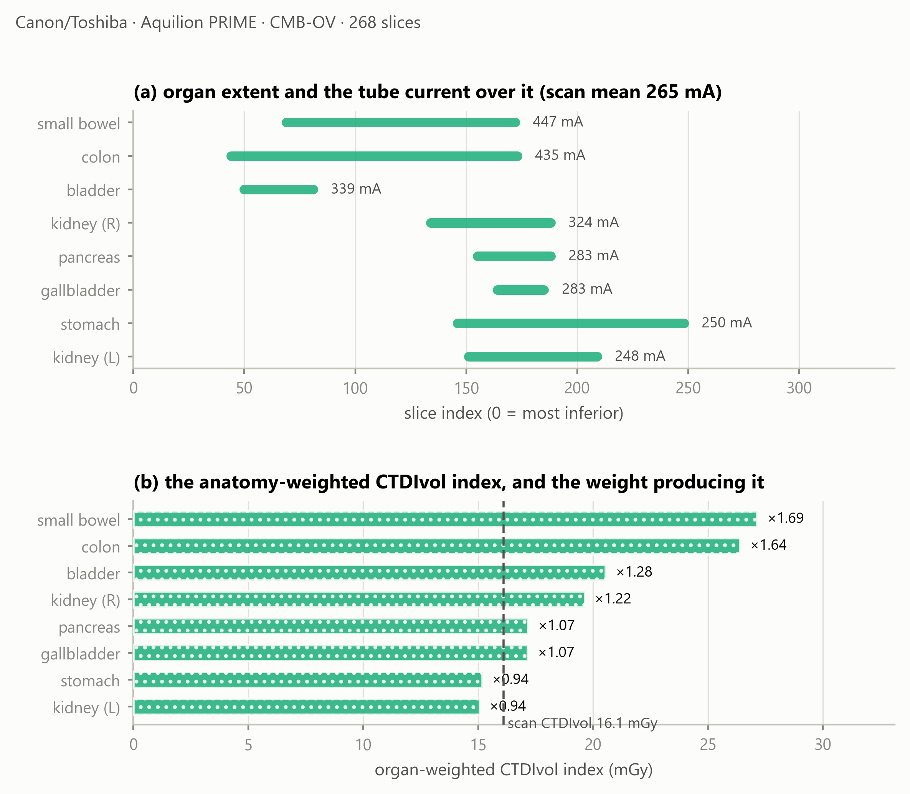
Figure 2. One acquisition end to end. (a) Each organ’s longitudinal extent, annotated with the mean tube current recorded over it, against a scan mean of 265 mA. (b) The resulting anatomy-weighted CTDIvol index, with the organ-specific modulation weight beside each bar; the dashed line is the whole-scan CTDIvol of 16.1 mGy. The bars are modulation-weighted indices, not absorbed doses.

3.3. Availability of a Dose Index in the Archived Headers
Across the cohort, 29 of 40 series retained a recorded CTDIvol in the archived DICOM headers, 5 were reconstructable from acquisition physics, and 6 were neither (Figure 3).
All 6 unrecoverable series are GE, and none of the ten sampled GE series retained a recorded CTDIvol in the archived headers; the other three manufacturers retained one in 29 of 30. These counts are reported descriptively. No significance test is applied: series drawn from a curated archive are not independent with respect to collection, contributing site, scanner model, export pathway or de-identification, and a p-value computed over that structure would describe a sampling model the data do not satisfy. For the six unrecoverable series the organ masks, volumes, mass estimates and modulation weights are all computable and reported, but no anatomy-weighted index exists for them.
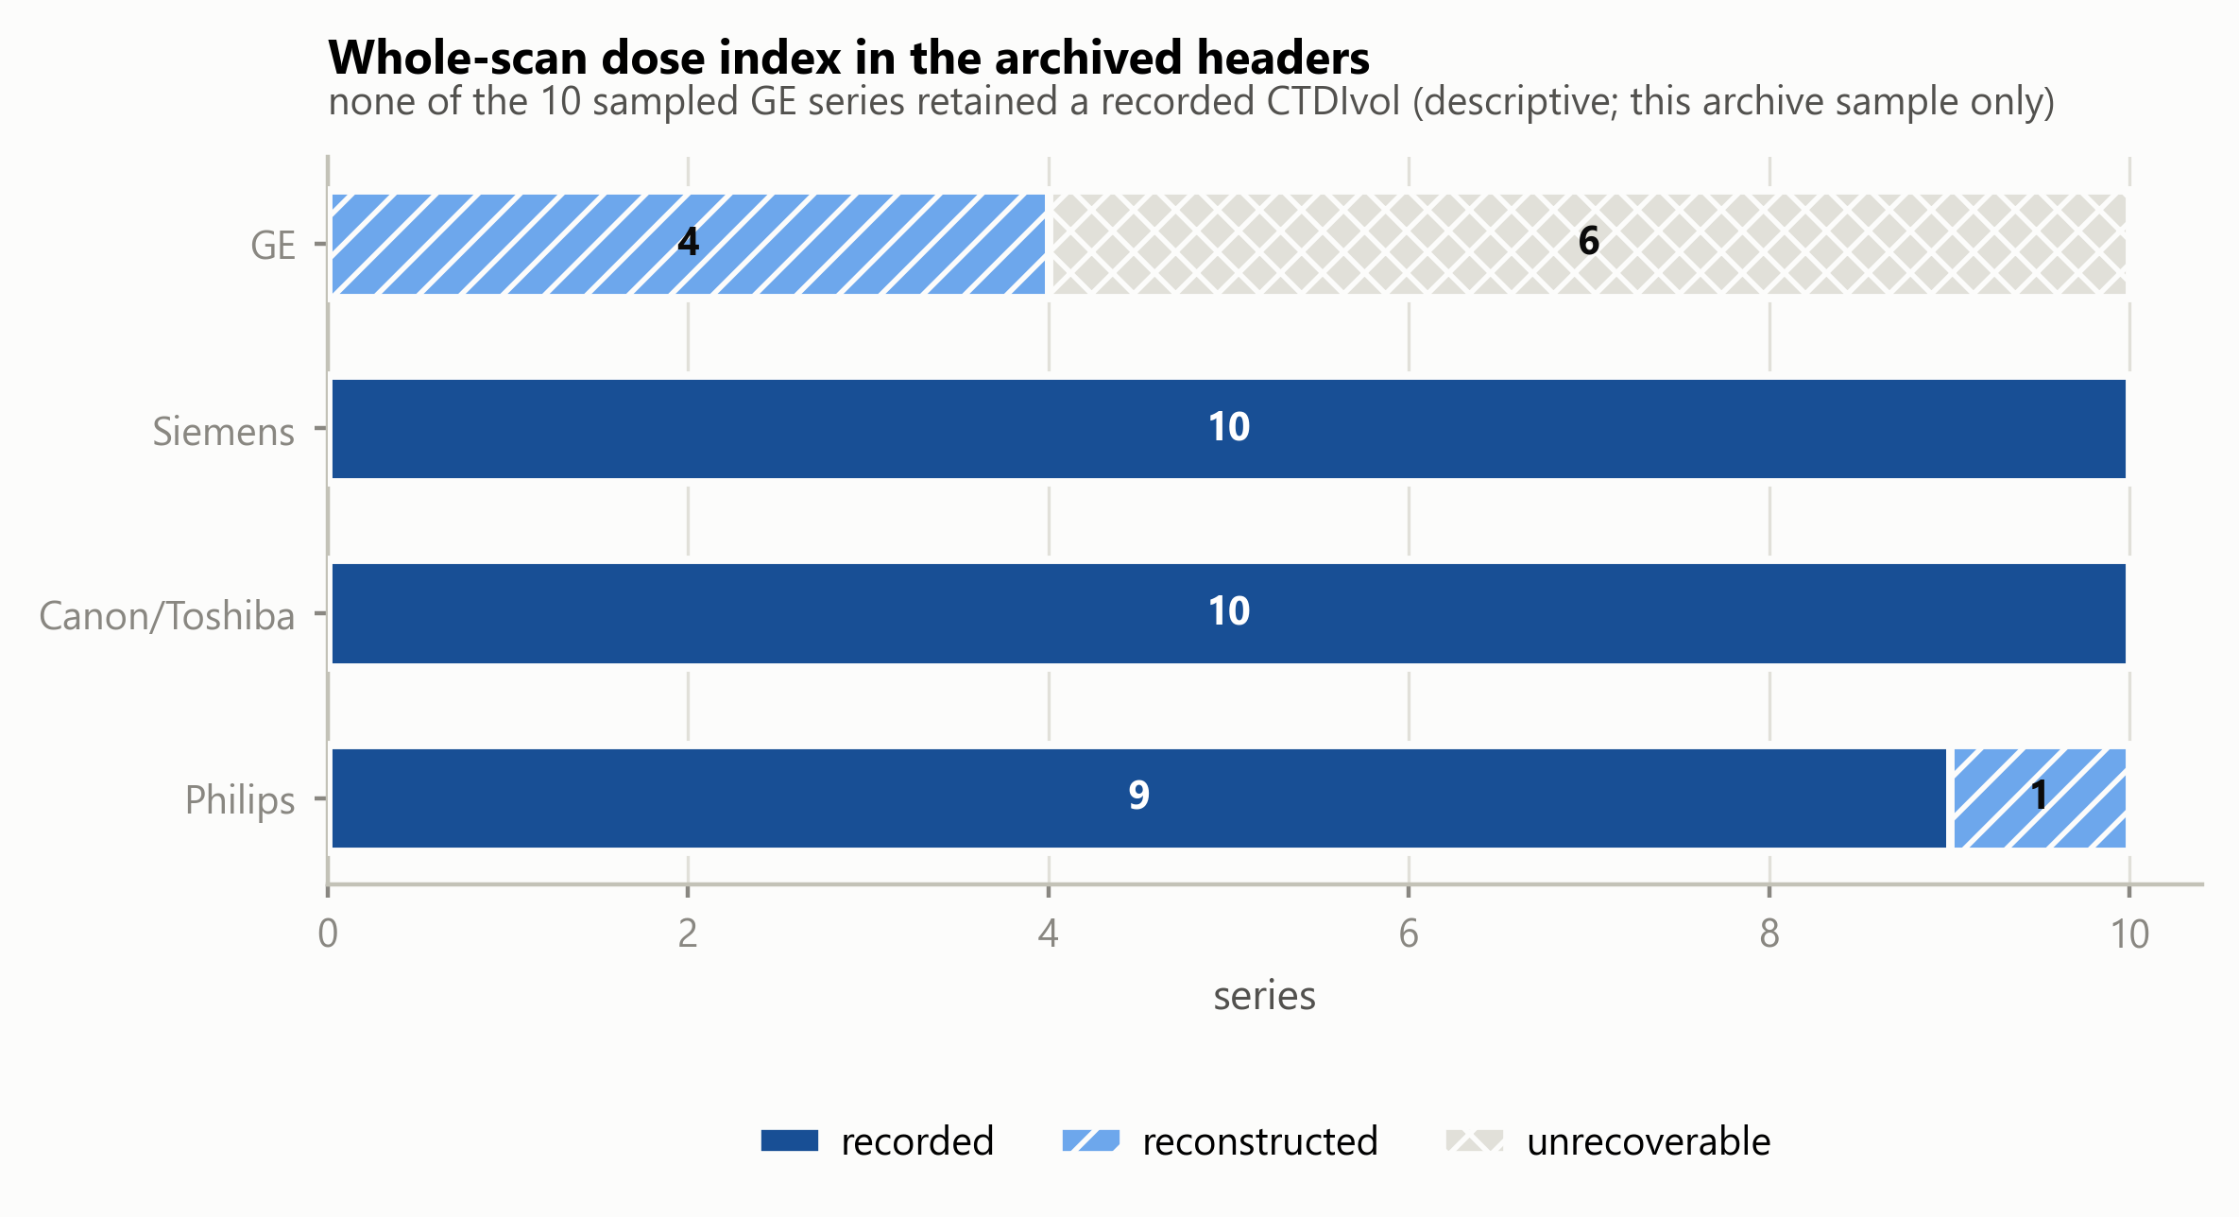
Figure 3. Availability of a whole-scan dose index in the archived DICOM headers, by manufacturer, in this TCIA sample. A series counted unrecoverable retained no CTDIvol in its header and its scanner lies outside the open coefficient database. Segments are distinguished by fill pattern as well as tone.

3.4. External Reference Comparison of Estimated Organ Mass
Table 1 and Figure 4 place attenuation-derived estimated organ mass beside the ICRP 89 reference adult male values [9], over the 177 untruncated records of the five solid organs.
Table 1. Attenuation-derived estimated organ mass beside ICRP 89 reference adult male values, untruncated organs only. The reference is an external anchor, not a subject-level ground truth.
organ | n | median estimated mass | ratio to ICRP 89
liver | 34 | 1901 g | 1.06
spleen | 38 | 259 g | 1.72
kidney (left) | 34 | 179 g | 1.15
kidney (right) | 35 | 182 g | 1.17
pancreas | 36 | 86 g | 0.61
Estimates for the liver were broadly consistent with the reference value, within 6%, and the kidneys within 17%. Two organs departed more substantially: the pancreas estimate was 39% below the reference and the spleen 72% above. Neither was adjusted; possible explanations are examined in Section 4.
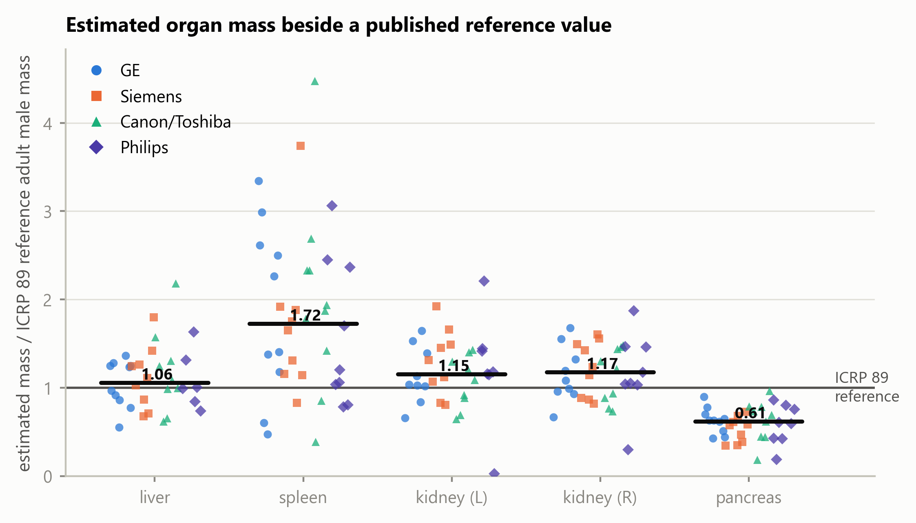
Figure 4. Attenuation-derived estimated organ mass relative to the ICRP 89 reference adult male mass, by manufacturer. Each marker is one organ in one series; the horizontal bar is the median across all manufacturers. Organs truncated by the scan boundary are excluded. Manufacturer is encoded by marker shape as well as colour, so the figure is readable in greyscale.

3.5. What Limits an Organ-Level Modulation Analysis
Two conditions reduce what such an analysis can measure, and both differ across the sampled manufacturers (Figure 5).
Truncation by the scan boundary affected 5.2% of organ records on GE, 5.5% on Siemens, 10.4% on Canon/Toshiba and 20.0% on Philips, reflecting the scan ranges of the sampled acquisitions rather than any property of the scanners. The organs most often cut are the colon and small bowel.
Three of the 39 series eligible for quantitative modulation analysis showed a peak-to-peak spread of organ weights below 0.02: their tube current does not vary across the abdominal organs, so the weighting has nothing to express. These series passed the modulation screen at selection, where the current varies across the whole scan; the flatness is local to the abdomen. They are uninformative for this analysis rather than faulty.
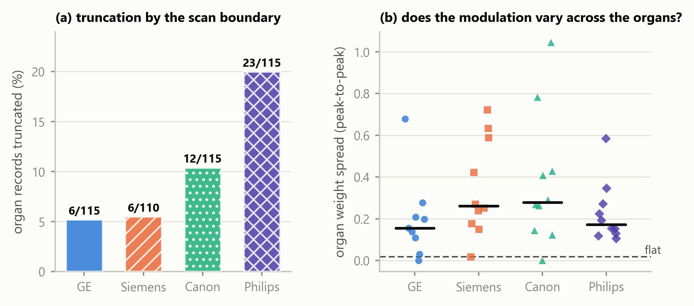
Figure 5. What limits an organ-level modulation analysis. (a) Percentage of organ records truncated by the scan boundary, by manufacturer, annotated with the counts, over all 40 segmented series. (b) Peak-to-peak spread of the organ-specific modulation weights within each of the 39 series eligible for quantitative modulation analysis; the dashed line is the threshold below which a series carries no usable variation.

4. Discussion
Principal finding. Organ-specific modulation weights span 0.59 to 1.69 across the eligible cohort, and within a single acquisition two organs differed by a factor of 1.8 in their anatomy-weighted index. Longitudinal modulation therefore produces organ-specific exposure conditions that a single whole-scan CTDIvol cannot represent, and the magnitude is large enough to matter for any organ-level analysis built on that value.
Interpretation. The weight is a direct, dimensionless summary of how the recorded tube current was distributed over an organ’s own longitudinal extent in that patient. It requires no phantom, no simulation and no additional acquisition — only metadata the scanner already writes and a segmentation obtained at inference.
Relation to previous work. The quantity is that of Khatonabadi et al. [2] and Tian et al. [3], who established the organ-specific weighted CTDIvol and validated it against Monte-Carlo organ dose; this study did not invent it, and adds nothing to those validations. What differs is the setting. That line of work, and the modulation dosimetry around it, proceeded from single-institution cohorts with one or two scanner models and manual or semi-automatic contours, drawing in part on raw projection data or vendor-supplied modulation profiles that archived DICOM does not retain. Here the same quantity is obtained from archived headers alone, across four manufacturers and 23 scanner models, with contours produced automatically.
Three recent studies sit closest and differ in endpoint rather than in quality. Li et al. [4] characterise SSDE(z), a patient-size-adjusted dose index evaluated at each longitudinal position; that is related but not the same quantity, since the weighting here is by segmented organ occupancy of the tube-current profile rather than by patient size at a given position. Nuntue et al. [5] also derive modulation profiles from DICOM headers, and go further than this work in estimating absorbed organ dose with Monte-Carlo simulation and measurement validation; this study deliberately stops short of absorbed dose and addresses instead archive feasibility, multi-vendor availability, quality control and an open implementation. Eom et al. [6] likewise use TotalSegmentator for automated dose calculation, but their endpoint is effective dose from body regions and DLP conversion factors, whereas the present work uses individual organ masks, the per-slice tube current and an organ-specific longitudinal weighting.
The contribution is therefore not a new dose index or an improvement on the published Monte-Carlo validations. It is an open, multi-vendor operationalisation and empirical characterisation of the organ-weighting layer under the constraints of real archived DICOM.
What the index is, and what it is not. As set out in Section 2.10, the index addresses longitudinal modulation alone. It does not account for scatter, for irradiation originating outside the organ’s segmented extent, for angular modulation, for organ depth and attenuation, or for radiation transport, and it is not an estimate of absorbed organ dose in milligray. Its value lies in isolating one well-defined contribution — the longitudinal one — and reporting it patient-specifically and reproducibly.
External reference comparison of estimated mass. Liver and kidney estimates were broadly consistent with ICRP 89 reference values, which is the expected behaviour if the segmentation and the density model are working. The pancreas estimate sits 39% below the reference. The pancreas is the weakest of these organs in TotalSegmentator’s own validation (Dice 0.887, against 0.965 for the liver, 0.983 for the spleen and 0.953 and 0.939 for the kidneys [7]), which supports reduced boundary agreement; but Dice is symmetric and does not establish the direction of a disagreement, so it does not by itself demonstrate under-segmentation. Contrast phase, reconstruction kernel and genuine anatomical variation in this cohort are alternative contributors that the present design cannot separate. The source of the discrepancy cannot be determined without subject-level reference contours or clinical ground truth.
The spleen estimate sits 72% above the reference. The four largest cases — 4.47, 3.74, 3.34 and 3.06 times the reference value — were reviewed slice by slice against their own images: each contour follows the splenic boundary with correct laterality, tracks the notch at the hilum, shows no leakage into liver, kidney or stomach, and forms a single connected component, so no accessory spleen was included. Their mean densities, 1.052 to 1.078 g/cm³, are unremarkable for splenic tissue, so the elevation arises from segmented volume rather than from the density model; and the spleen is the best-segmented of these organs in the segmenter’s validation. The cases arise on four different manufacturers. The cohort is oncological — renal cell, colorectal and adrenal carcinoma — in which splenomegaly is common, and the ICRP reference adult is not that population. The observed elevation was most consistent with cohort anatomy among the explanations examined, although subject-level pathological confirmation was unavailable.
Availability in archived headers, and its confounders. In this sample, availability of a recorded CTDIvol differed markedly with manufacturer. This is an observation about archived DICOM headers in one curated archive, not a statement about scanner implementations. The present design cannot distinguish between scanner implementation, scanner generation, acquisition site, DICOM export pathway, PACS processing, de-identification, archive curation and collection composition as the origin of a missing attribute; several of these are confounded with manufacturer through collection membership. The practical consequence stands regardless of cause: a retrospective organ-level analysis drawn from an archive will lose a manufacturer-associated fraction of its cohort before segmentation is considered, and a study that does not report which series were lost will under-represent that manufacturer silently.
Why acquisition constancy has to be screened. The acquisition-constancy criterion identified one series in which tube current alone was not proportional to scanner output, because the acquisition changed rotation and exposure time part-way through. Excluding it prevents a mixed acquisition from entering the quantitative modulation analysis, and illustrates why constancy must be verified rather than assumed: nothing in the images, the segmentation or the weights themselves would have revealed it. A current–time product would be the more faithful weighting in general; it is not adopted here because exposure time is absent from the archived headers of one other series and could not be applied uniformly across the cohort.
Reproducibility and open implementation. The implementation is MIT-licensed, no imaging is redistributed, and every reported value is re-derived from the per-series records by an automated test suite that regenerates the analysis tables and compares them. The acquisition procedure, the analysis and the figures are each a single command. The components differ in status and are not claimed as uniformly open: the imaging is publicly accessible under collection-specific licences; the segmentation software and the total task weights are openly redistributable; the normalised-CTDI database is CC BY; the HU-to-density anchor values are used by citation to ICRU Report 44 [13] and Schneider et al. [14] rather than redistributed; and no Monte-Carlo coefficient table is included at all.
The boundary to absorbed organ dose. Converting an anatomy-weighted index into an absorbed organ dose requires CTDIvol-normalised coefficients with a patient-size correction, of the kind applied over patient model libraries by Tian et al. [3], together with the transport considerations listed in Section 2.10. Those coefficient sets are published in subscription journals or distributed with research software under terms granting use but not redistribution, which reflects a publishing convention for Monte-Carlo reference data rather than any deficiency in the coefficients themselves. Normalised-CTDI data of the kind used here to reconstruct a missing whole-scan index has been published under CC BY [15], which shows the convention is movable. The software accordingly refuses to emit a dose in milligray unless supplied with a coefficient table carrying its citation, DOI, licence and source hash.
Limitations. Ten series per manufacturer supports a median and an interquartile range, not a distributional claim, and series within the archive are not independent with respect to collection, site, scanner model or export pathway. The cohort is oncological and not a reference population. Contrast phase, tube voltage and reconstruction kernel were not controlled, and all affect attenuation-derived mass estimates. A single segmentation model was used, so segmentation behaviour and cohort anatomy cannot be separated. There is no subject-level ground truth for organ mass. Rotation time, pitch and collimation are absent from the archived headers of some series (19, 8 and 9 respectively), so their constancy within those series could not be fully verified and is assumed from the single-acquisition representation; the acquisition-constancy criterion is therefore a screen against detectable violations rather than a guarantee. The index addresses longitudinal modulation only, as set out in Section 2.10, and no absorbed dose is reported.
Future work. Coefficients computed with an open-source Monte-Carlo engine would carry no licensing constraint and would permit the transport terms this index omits; an independent segmentation model on the same series would separate segmentation behaviour from cohort anatomy for the pancreas and spleen; and a larger archive cohort would allow the availability observation to be examined with collection and site modelled explicitly rather than confounded.

5. Conclusions
This study did not compute absorbed organ dose, and did not propose a new index. It took an organ-specific weighted CTDIvol already reported in the literature and established what it yields when operationalised openly across manufacturers, from metadata a scanner already records and organ masks obtained at inference. Organ-specific modulation weights spanned 0.59 to 1.69, and two organs within one acquisition differed by a factor of 1.8 in their index, so the variation a single whole-scan value conceals is substantial. The approach ran across four manufacturers using publicly accessible imaging data and openly redistributable software components, and in this archive cohort the availability of the whole-scan CTDIvol the index scales varied markedly between manufacturers, which constrains any retrospective analysis of this kind. The index is a step before conversion to absorbed organ dose, not a substitute for it: that conversion requires Monte-Carlo coefficients and the transport terms this index omits. The implementation and derived records are openly available, provenance-aware and reproducible from the shipped results.

Author Contributions
S.Y.: conceptualisation, methodology, software, validation, formal analysis, investigation, data curation, writing — original draft, writing — review and editing, visualisation. The author has read and agreed to the published version of the manuscript.

Funding
This research received no external funding.

Institutional Review Board Statement
Not applicable. This study analyzed only publicly available, fully de-identified human imaging data obtained from The Cancer Imaging Archive (TCIA) under Creative Commons Attribution (CC BY) licenses. Because the data are publicly available and not individually identifiable, the work does not constitute human-subjects research under the U.S. Common Rule (45 CFR 46.102(e)); TCIA distributes these collections after HIPAA-compliant de-identification. No new data were collected from human participants and no protected health information was accessed. Institutional review board approval and informed consent were therefore not required.

Informed Consent Statement
Not applicable. This study used only publicly available, de-identified imaging from The Cancer Imaging Archive.

Data Availability Statement
The software supporting this study, ctsegdose-core, is openly available under the MIT licence at https://github.com/Institute-of-One/ctsegdose-core, release v0.1.1 (commit 46edee6423ddc19b47efae180d8edf527299d066), archived at Zenodo under 10.5281/zenodo.21817307. The machine-readable results the manuscript quotes, the per-organ records, the analysis tables, the acquisition-parameter check and the figure scripts are included in that repository, together with the mask-review overlays underlying Section 4.
No DICOM imaging is redistributed. Every series analysed is identified in data/PROVENANCE.json by collection, collection DOI, Series Instance UID, manufacturer, model, licence and retrieval date, and is retrievable directly from The Cancer Imaging Archive by following docs/REPRODUCING_DATA.md. The forty series were retrieved under Creative Commons Attribution licences (33 under CC BY 4.0, 7 under CC BY 3.0) as recorded per series; the licence terms of each originating collection and the TCIA Data Usage Policy apply.
Segmentation used TotalSegmentator [7]. Its software code is distributed under the Apache 2.0 licence, and the total task model weights used here are likewise stated by the project to be openly available under Apache 2.0; other tasks in that project require a separate licence and were not used. No model weights are redistributed with this work.
No organ-dose coefficient table is redistributed, for the licensing reasons set out in Section 4.

Conflicts of Interest
The author is the representative of LISIT Co., Ltd. (Tokyo, Japan) and Chief Executive Officer of TexelCraft OÜ (Estonia), and has a commercial interest in downstream products that may incorporate or build upon the methods described here. The software reported in this article is released under the MIT licence. No patient data, customer data or proprietary clinical data were used; all imaging is publicly available and de-identified.

Use of Generative Artificial Intelligence
A generative artificial intelligence assistant (Claude, Anthropic) was used as a tool in the development of the software and in drafting and editing the text of this manuscript. All reported results are produced by executable code contained in the cited repository, are re-derived from the underlying per-series records by an automated test suite, and were verified by the author. All scientific judgements, interpretations and conclusions are the author’s, who takes full responsibility for the content of this article.

References
- McCollough, C.H.; Leng, S.; Yu, L.; Cody, D.D.; Boone, J.M.; McNitt-Gray, M.F. CT Dose Index and Patient Dose: They Are Not the Same Thing. Radiology 2011, 259, 311–316. https://doi.org/10.1148/radiol.11101800
- Khatonabadi, M.; Kim, H.J.; Lu, P.; McMillan, K.L.; Cagnon, C.H.; DeMarco, J.J.; McNitt-Gray, M.F. The Feasibility of a Regional CTDIvol to Estimate Organ Dose from Tube Current Modulated CT Exams. Med. Phys. 2013, 40, 051903. https://doi.org/10.1118/1.4798561
- Tian, X.; Li, X.; Segars, W.P.; Frush, D.P.; Samei, E. Prospective Estimation of Organ Dose in CT under Tube Current Modulation. Med. Phys. 2015, 42, 1575–1585. https://doi.org/10.1118/1.4907955
- Li, X.; Marschall, T.A.; Yang, K.; Liu, B. Technical Note: Advancing Size-Specific Dose Estimates in CT Examinations: Dose Estimates at Longitudinal Positions of Scans. Med. Phys. 2022, 49, 1303–1311. https://doi.org/10.1002/mp.15402
- Nuntue, C.; Matsubara, K.; Watanabe, S.; Fukushima, K.; Tantiwetchayanon, K. Improved Organ Absorbed Dose Estimation in Abdominal CT Using DICOM Header-Based Tube Current Modulation Profiles: Validation with Measurements and Monte Carlo Simulations. J. Appl. Clin. Med. Phys. 2025, 26, e70321. https://doi.org/10.1002/acm2.70321
- Eom, Y.; Park, Y.-J.; Lee, S.; Lee, S.-J.; An, Y.-S.; Park, B.-N.; Yoon, J.-K. Automated Measurement of Effective Radiation Dose by 18F-Fluorodeoxyglucose Positron Emission Tomography/Computed Tomography. Tomography 2024, 10, 2144–2157. https://doi.org/10.3390/tomography10120151
- Wasserthal, J.; Breit, H.-C.; Meyer, M.T.; Pradella, M.; Hinck, D.; Sauter, A.W.; Heye, T.; Boll, D.T.; Cyriac, J.; Yang, S.; Bach, M.; Segeroth, M. TotalSegmentator: Robust Segmentation of 104 Anatomic Structures in CT Images. Radiol. Artif. Intell. 2023, 5, e230024. https://doi.org/10.1148/ryai.230024
- Isensee, F.; Jaeger, P.F.; Kohl, S.A.A.; Petersen, J.; Maier-Hein, K.H. nnU-Net: A Self-Configuring Method for Deep Learning-Based Biomedical Image Segmentation. Nat. Methods 2021, 18, 203–211. https://doi.org/10.1038/s41592-020-01008-z
- ICRP. Basic Anatomical and Physiological Data for Use in Radiological Protection: Reference Values. ICRP Publication 89. Ann. ICRP 2002, 32 (3–4).
- Clark, K.; Vendt, B.; Smith, K.; Freymann, J.; Kirby, J.; Koppel, P.; Moore, S.; Phillips, S.; Maffitt, D.; Pringle, M.; Tarbox, L.; Prior, F. The Cancer Imaging Archive (TCIA): Maintaining and Operating a Public Information Repository. J. Digit. Imaging 2013, 26, 1045–1057. https://doi.org/10.1007/s10278-013-9622-7
- Yamamoto, S. ctdose-core: open, auditable CT dose surveillance from DICOM, with a physics reconstruction when the dose attributes are missing (Version 0.1.1) [Software]. Zenodo, 2026. https://doi.org/10.5281/zenodo.21636719
- McCollough, C.; Bakalyar, D.M.; Bostani, M.; Brady, S.; Boedeker, K.; Boone, J.M.; Chen-Mayer, H.H.; Christianson, O.I.; Leng, S.; Li, B.; et al. Use of Water Equivalent Diameter for Calculating Patient Size and Size-Specific Dose Estimates (SSDE) in CT: The Report of AAPM Task Group 220. AAPM Report No. 220, 2014. https://doi.org/10.37206/146
- ICRU. Tissue Substitutes in Radiation Dosimetry and Measurement. ICRU Report 44; ICRU: Bethesda, MD, USA, 1989.
- Schneider, U.; Pedroni, E.; Lomax, A. The Calibration of CT Hounsfield Units for Radiotherapy Treatment Planning. Phys. Med. Biol. 1996, 41, 111–124. https://doi.org/10.1088/0031-9155/41/1/009
- Dinwiddie, L.E.; Baggett, J.M.; Kofler, J.M.; et al. Survey of Normalized CTDIvol Values Across Four Major Computed Tomography Vendors for Use in the MIRDct Software. J. Appl. Clin. Med. Phys. 2026, 27, e70473. https://doi.org/10.1002/acm2.70473

