Supplementary material
Mathematical characterization of task detectability limits in AI-denoised CT: implications for task-based dose optimization

S1. Supplementary Methods: the gauge, and the two failure measures

S1.1 The verdict rules in full
The gauge is an auditable rule-based translation of the measured quantities; its thresholds are task-specific values fixed in advance, not clinically validated criteria. Let C be the input’s analytic ceiling d', T and T_input the cross-fitted prewhitening d' on the processed and unprocessed images, S the SSIM of the processed images against the noise-free object, F and F_input the lesion-like response rates, and ρ the contrast recovery.
level | rule | reads as
red | C < 5.0 | the input does not meet the prespecified requirement, and no processing can restore it
red | S ≥ 0.7 and T ≤ 1.0 | high fidelity with inadequate task performance
red | F > 0.2 and F > F_input | excess lesion-like responses over the input
red | ρ < 0.5 | erasure of true contrast
amber | C < 1.2 × 5.0 | marginal: a small dose change crosses the floor
amber | 1 − T/T_input > 0.2 | severe task degradation relative to the input
green | none of the above | —
Any red rule outranks any amber rule; within a level every rule that fired contributes a reason, in the order listed. The adequacy threshold on T is a threshold for inadequate performance, not for chance performance: d' = 1.0 corresponds to an AUC of about 0.76 for an equal-variance Gaussian decision variable, whereas chance would be d' = 0, AUC 0.5.

S1.2 Lesion-like responses and contrast recovery
In signal-absent trials the underlying object is spatially uniform, although the acquired image contains noise; noise alone therefore produces lesion-like structure, and any measure of “invented” structure must be read against the unprocessed input rather than absolutely.
A matched-filter amplitude map is formed with the known lesion profile, mean-subtracted and normalised so that an image containing exactly one true lesion reads 1.0 at that location. The map is evaluated over all positions (a full 2-D correlation in same mode with zero padding; the lesion is centred and the image is 64 pixels across, so boundary effects fall outside the lesion support). For each image the maximum over positions is taken, and the lesion-like response rate is the fraction of signal-absent images whose maximum reaches 0.5 of a true lesion’s amplitude — a round fraction chosen in advance rather than tuned. The same statistic is computed on the unprocessed input of the same condition, and the gauge fires only on an excess over it.
Contrast recovery is the projection of the class-mean difference image onto the same mean-subtracted lesion profile, divided by that profile’s squared norm: the amplitude of the surviving lesion in units of the true contrast. It is 1 when contrast is preserved and 0 when it is erased; values above 1 mean the processing amplified the mean difference. Values are not clipped.

S2. Closed-form validation of the analytic observer

S2.1 Result (Table S1)
In white noise the analytic ideal linear (prewhitening) observer satisfies d' = ‖s‖₂/σ exactly. Both columns of Table S1 are computed analytically and neither is estimated from image samples — the left from the identity, the right by the implementation from the analytic noise power spectrum — so the residual is numerical rather than statistical, and the comparison tests the implementation rather than a sample.
Table S1. The analytic ideal linear (prewhitening) observer against its closed form on the unprocessed input. Both columns are analytic and neither is estimated from image samples, so the residual is numerical rather than statistical. Largest relative error: 1.3×10⁻¹⁶, against a criterion of 1 % fixed in advance.
noise σ | radius (mm) | contrast | d′ closed form | d′ computed | rel. error
15 | 1.5 | 20 | 6.7412 | 6.7412 | 1.3e-16
15 | 3 | 20 | 13.8634 | 13.8634 | 1.3e-16
15 | 5 | 20 | 23.2881 | 23.2881 | 0.0e+00
30 | 1.5 | 20 | 3.3706 | 3.3706 | 1.3e-16
30 | 3 | 20 | 6.9317 | 6.9317 | 1.3e-16
30 | 5 | 20 | 11.6440 | 11.6440 | 0.0e+00
60 | 1.5 | 20 | 1.6853 | 1.6853 | 1.3e-16
60 | 3 | 20 | 3.4659 | 3.4659 | 1.3e-16
60 | 5 | 20 | 5.8220 | 5.8220 | 0.0e+00
120 | 1.5 | 20 | 0.8427 | 0.8427 | 1.3e-16
120 | 3 | 20 | 1.7329 | 1.7329 | 1.3e-16
120 | 5 | 20 | 2.9110 | 2.9110 | 0.0e+00

S3. Estimator sensitivity

S3.1 Cross-fitting against a single split (Table S2)
Table S2 compares the cross-fitted estimator used throughout this study with the single 50/50 split used in the earlier single-realisation analysis, at matched conditions of the dose sweep in the representative realisation. Recovery is the estimated d' as a fraction of the analytic ceiling of the same input; recovery slightly above 100 % at the highest doses is sampling noise in the d' estimate, not a breached bound, since the ceiling test is armwise, in AUC, and carries its own margin (Section 3.4).
Table S2. Estimator sensitivity on unprocessed images of the dose sweep in the representative realisation (seed 20260101): the 5-fold cross-fitted estimator used throughout against the single 50/50 split used in the earlier single-realisation analysis. Recovery is the estimated d′ as a fraction of the analytic ceiling of the same input. Recovery slightly above 100 % at the highest doses is sampling noise in the d′ estimate, not a breached bound: the ceiling test is armwise, in AUC, and carries its own margin (Section 3.4).
mAs | ceiling d′ | cross-fit d′ | recovery | split d′ | recovery
200 | 9.803 | 9.840 | 100% | 9.873 | 101%
100 | 6.932 | 6.899 | 100% | 6.880 | 99%
50 | 4.901 | 4.824 | 98% | 4.828 | 98%
25 | 3.466 | 3.407 | 98% | 3.310 | 96%
12.5 | 2.451 | 2.256 | 92% | 2.216 | 90%
6.25 | 1.733 | 1.554 | 90% | 1.357 | 78%
3.125 | 1.225 | 1.054 | 86% | 0.850 | 69%

S4. The learned denoiser used in the synthetic demonstration
This network is the synthetic-arm demonstration network and is distinct from the real-data CNNs described in Section 2.9.
The convolutional network is a small residual (DnCNN-style) model trained deterministically on CPU on synthetic pairs spanning dose, with a checkpoint whose parameter hash is recorded in results/cnn_training.json. It is blind to the noise level at inference: each image is normalised by a noise standard deviation estimated from that image alone. It is evaluated at one prespecified low-dose setting outside the primary matrix and contributes to no primary endpoint.
Figure S1 is the red-lamp console at three settings of the demonstration, with the network as the processing: the unprocessed input, the processed image, both verdicts and the reason each earned. The interactive version of the same record is paper/figures/redlamp_console.html in the repository.
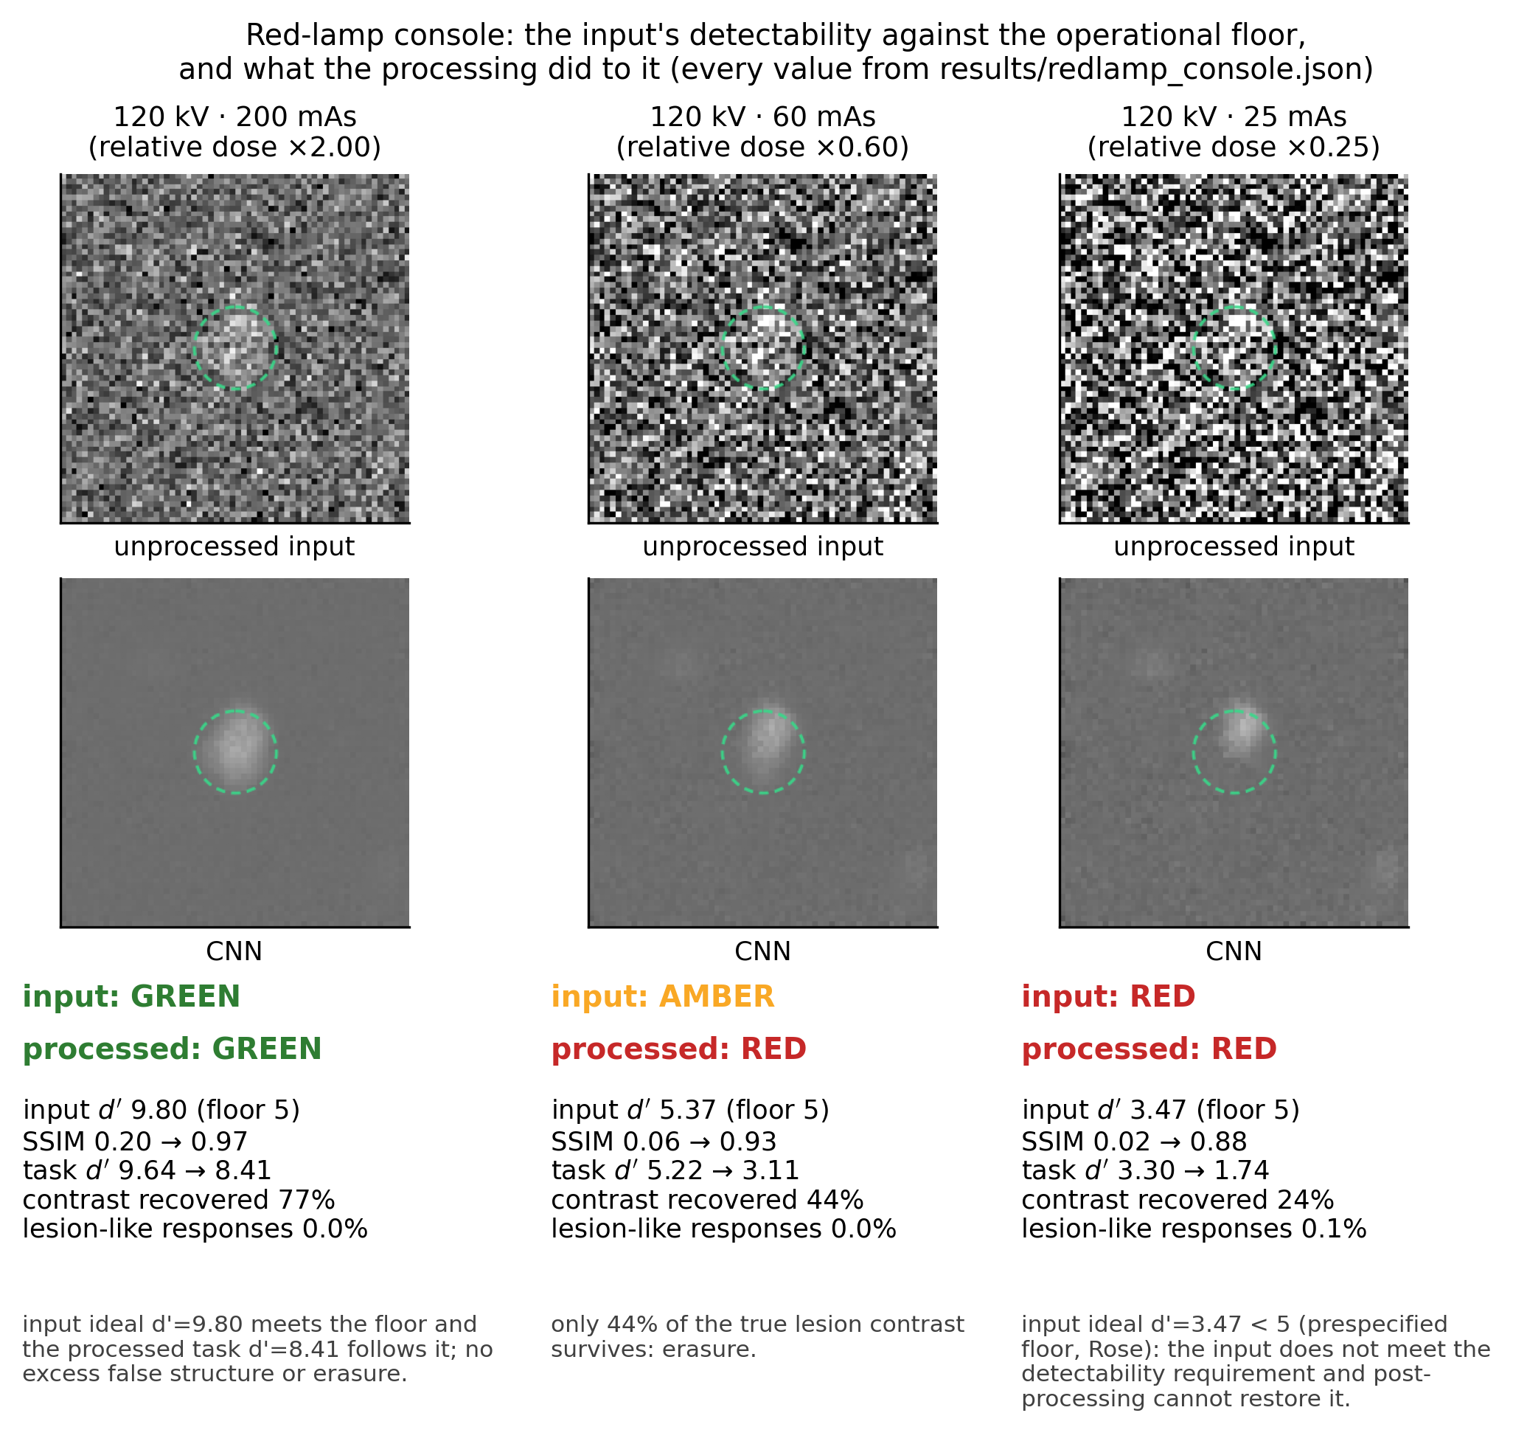
Figure S1. The red-lamp console for the learned denoiser: the input’s detectability against the floor, unprocessed and processed tiles, and each verdict with its reason.

S5. Floor-stratified failure patterns

S5.1 Full comparison (Table S3)
Table S3 gives every stratified quantity of Section 3.5 with its clustered interval: divergence rate, erasure rate, excess lesion-like response rate, observer-dependent benefit, mean task degradation and the verdict distribution, for each of the three strata.
Table S3. Failure patterns by floor stratum, as rate or mean [95 % CI] from the clustered bootstrap. The columns are the divergence rate, the contrast-erasure rate, the excess lesion-like response rate (excess resp.), the mean task degradation (task degr.), the observer-dependent benefit and the gauge verdict counts. Strata are defined by the analytic ceiling of the input condition against the prespecified requirement; the floor stratifies conditions and is not claimed to cause the failures. Verdict counts are the gauge’s, and below the floor they are red by construction, since an input that fails the requirement is itself a red rule.
stratum | above floor | marginal | below floor
n | 130 | 30 | 390
divergent | 100.0% [100.0%, 100.0%] | 100.0% [100.0%, 100.0%] | 83.3% [81.3%, 85.4%]
erasure | 3.8% [1.5%, 6.2%] | 0.0% [0.0%, 0.0%] | 5.1% [5.1%, 5.1%]
excess resp. | 0.0% [0.0%, 0.0%] | 0.0% [0.0%, 0.0%] | 0.0% [0.0%, 0.0%]
task degr. | 30.3% [29.9%, 30.8%] | 5.1% [4.8%, 5.4%] | 14.7% [14.1%, 15.3%]
benefit B | +2.59 [+2.55, +2.63] | +1.17 [+1.14, +1.21] | +0.64 [+0.63, +0.65]
green / amber / red | 70 / 55 / 5 | 0 / 30 / 0 | 0 / 0 / 390

S6. Per-denoiser endpoints

S6.1 Divergence endpoints in full (Table S4)
Table S4 gives, for each denoiser, the Spearman correlation between ΔSSIM and Δd'(PW), the divergence rate, the mean ΔSSIM and Δd' for all three observers, the observer-dependent benefit, and the Holm-adjusted p-values within each family.
Table S4. Fidelity–task divergence per denoiser: the Spearman correlation between ΔSSIM and Δd′(PW), the fraction of divergent evaluations (ΔSSIM > 0 with Δd′(PW) < 0), and the mean changes, each as value [95 % CI] from the clustered bootstrap. p-values are two-sided bootstrap values for the correlation, Holm-adjusted across denoisers. Columns are the denoisers.
measure | gaussian(1.5 px) | TV(0.4 sd) | NLM(0.6 sd) | All
Spearman ρ | +0.10 [+0.01, +0.19] | −0.84 [−0.86, −0.82] | −0.85 [−0.86, −0.84] | −0.62 [−0.63, −0.60]
p (Holm) | 0.023 | 0.001 | 0.001 | —
divergent | 100.0% [100.0%, 100.0%] | 62.4% [57.1%, 67.1%] | 99.4% [98.2%, 100.0%] | 88.2% [86.7%, 89.6%]
mean ΔSSIM | +0.304 [+0.304, +0.304] | +0.140 [+0.140, +0.140] | +0.302 [+0.302, +0.302] | +0.252 [+0.252, +0.253]
mean Δd′ PW | −0.91 [−0.94, −0.88] | −0.51 [−0.52, −0.50] | −1.06 [−1.07, −1.04] | −0.83 [−0.85, −0.82]

S7. The four networks of the real low-dose CT arm
These are the networks of Sections 3.6 and 3.6.1, and are distinct from the demonstration network of Section S4.
Two capacities, and at each capacity two objectives. The small configuration is 21385 parameters trained on 800 patches per case for 16 epochs at batch 32; the large is 1849633 parameters on 3000 patches per case for 60 epochs at batch 64, a ratio of 86× in parameters. Capacity, training data and training length move together between the two, so they do not isolate capacity.
Within a capacity they do isolate the objective. The adversarial network is built from the same seed with the same architecture and trained on the same patches, for the same epochs, at the same batch size and learning rate; only the loss differs, by the least-squares adversarial term of Mao et al. [24] against a small patch critic. Its weights — mse_weight = 0.05, adv_weight = 1.0, critic learning rate 1e-03 — were fixed by a sweep recorded in results/adv_weight_sweep.json before this arm was run. A first sweep at the fidelity arm’s pixelwise weight found the adversarial term doing almost nothing across a five-hundred-fold range of weights, because the pixelwise term is in units of the input’s own noise while the least-squares term is bounded when the critic is confused; the weights above are where the term bites, and the effect is flat over more than an order of magnitude around them, so the arm does not sit on a knife edge.
The checkpoint kept for each run is its last epoch rather than its lowest-validation one. The best validation loss reached was 5.642 for the small fidelity arm and 5.000 for the large one; for the adversarial arms the full per-epoch history of the generator loss, the critic loss and the validation mean-squared error is recorded in paper/results/liver_cnn_small_gan.json and paper/results/liver_cnn_large_gan.json. Every checkpoint’s SHA-256 is in the same files.

S8. The ceiling comparison: margin, saturation, and the one exceedance
The comparison of Section 3.4 is made against a margin rather than against the ceiling itself, because an estimated AUC has sampling error and a bound compared without one would be violated by noise alone. The armwise margin is the Hanley–McNeil standard error of the estimated AUC scaled by z; the family-wise statement widens it by Bonferroni over all 760 comparisons, giving z = 3.99 at a family-wise level of 0.05. At the largest excess observed the margin was 7.00×10⁻⁴ in AUC.
An evaluation is treated as saturated when its analytic ceiling AUC exceeds 1 − 10/(n_present · n_absent), which is the regime in which the closed-form interval degenerates: at perfect separation the Hanley–McNeil standard error is identically zero, the margin collapses to a single quantisation step, and no widening of z recovers it. 180 of 760 evaluations met that rule and are analysed separately for this reason and not because excluding them helps: over the remaining 580 the largest excess was 1.64×10⁻⁴ and the mean -0.040.
The single exceedance occurred on an unprocessed arm, where the processing is the identity and cannot create information, so what it measures is the estimator and the finite sample rather than a violated bound. Its analytic ceiling AUC is 0.9999933, the estimator achieved 1.0000000, and the excess is 6.75×10⁻⁶ in AUC against a margin of 6.94×10⁻⁷ — of the order of ten misordered pairs in 1.44 million. The family-wise margin leaves this same 1 exceedance, for exactly that reason. Across the processed arms, which are the ones the claim is about, 0 of 550 exceeded the margin.

