Mathematical characterization of task detectability limits in AI-denoised CT: implications for task-based dose optimization
Shuji Yamamoto Institute of One, LISIT Co., Ltd., Tokyo 150-0044, Japan yamamoto@lisit.jp · ORCID 0000-0001-9211-1071

Abstract
Background. Denoising improves reference-based fidelity metrics and is widely held thereby to permit dose reduction. That does not follow: processing cannot add task information.
Purpose. To characterize task detectability limits in denoised CT by separating the detectability an input offers an ideal observer from that a specified observer achieves, and thereby compare the exposure each method needs.
Methods. Signal- and background-known-exactly detection of a low-contrast disk on phantoms with three classical denoisers and three observers, and on 12 liver cases from LDCT-and-Projection-data with a synthetic lesion in abdominal soft tissue. Each arm is referenced to its unprocessed input and its analytic ceiling [1,2]. Residual CNNs trained on 8 cases were evaluated on 4 never-seen cases, at two capacities, each paired with a counterpart differing only in an adversarial objective. Exposure was compared on a dose simulation rescaling the collection’s measured noise, against d' ≥ 5.
Results. 88.2% of evaluations improved fidelity while detectability fell; denoising helped the inefficient observer more (+1.13). On real data PSNR ranked 9 methods against d' at ρ -0.08, the best-PSNR method ranking 7 of 9 on the task, and 0 arms exceeded the ceiling. The adversarial arms showed no detected increase in lesion-shaped response. Unprocessed images met the criterion to 0.187 of routine exposure; 7 of 8 processed arms needed more.
Conclusions. Separating the input’s ceiling from achieved detectability allows exposure requirements to be compared against a defined criterion. Fidelity gains alone did not establish task preservation. Clinical use requires scanner-specific calibration and human-reader validation.
Keywords: low-dose CT; image denoising; deep learning; task-based image quality; model observer; detectability; fidelity–task divergence.

1. Introduction
Two claims are routinely made about image denoising in medical imaging. The first is that it improves image quality, evidenced by fidelity metrics. The second, following from the first, is that it permits dose reduction. The first claim is measurable and usually true. The second does not follow from it, and this paper is about the gap between them.
The gap has a precise shape. Denoising is a function of the image it is given, so hypothesis H, input image X and processed image Y = g(X) form a Markov chain H → X → Y. Two consequences follow, and they should be distinguished rather than merged. First, the data-processing inequality [1] gives I(H;Y) ≤ I(H;X): processing cannot increase the mutual information between the image and the truth. Second, for binary detection, the Neyman–Pearson lemma [2] implies that the likelihood-ratio test on X attains an ROC curve that no test based only on Y can dominate; in particular its AUC is an upper bound. Mutual information and AUC are not interchangeable, and no monotone map between them is assumed here: they are two distinct consequences of the same Markov structure, and it is the second that this study measures against.
Neither consequence says what denoising does. A bound on what is recoverable is not a statement about whether a given observer recovers it, and real observers are not ideal. A denoiser that suppresses noise where an inefficient observer is overwhelmed does for that observer what it cannot do for itself, and the gain is real even though no information was added. Conversely, processing that improves a picture’s resemblance to the truth may remove precisely the structure a detection task depends on. Which of these happens, when, and by how much is not settled by the theorem, and that is the question this paper answers quantitatively.
We also separate a second question that is often conflated with the first. A study can state how much detectability its task requires. Where the input’s own ideal-observer detectability falls below that requirement, no post-processing can bring the requirement back into reach: that follows from the bound, applied at that condition. We use “information floor” as a concise operational term for the contour at which the input ideal-observer detectability falls below a prespecified task requirement. It is not a zero-information boundary. Conditions below it retain measurable task information; they simply do not meet the requirement that was chosen. What processing can still do below the floor is produce a cleaner-looking image, which is why visual plausibility there does not establish that the required detectability survived.

1.1 Relation to previous work
That denoising can degrade task performance while improving fidelity is established empirically. Li et al. [3] assessed deep denoising on binary signal detection with model observers and connected the result to the data-processing inequality; Yu et al. [4] reported for myocardial perfusion SPECT that denoising improved RMSE and SSIM while frequently degrading detection performance; Li et al. [5] proposed a framework for mapping the nonlinear system and noise response of such algorithms; and task-informed training [6] shows the trade-off can be shifted but not escaped. Hallucination in reconstruction has been characterized in terms of a task-relevant null space [7]. In CT specifically, Eulig et al. [8] benchmarked deep low-dose CT denoisers on the downstream detection and diagnosis of lesions rather than on fidelity alone, and Nelson et al. [9] found that a network trained on adult images changes low-contrast detectability differently on paediatric-sized phantoms. The relation between task-based image quality and dose is treated comprehensively by Barrett et al. [10].
What is not established quantitatively is how these effects vary: how strongly fidelity gains predict task changes across imaging conditions, how the effect depends on the efficiency of the observer doing the looking, and how failure patterns distribute relative to the detectability available in the input.
Task-based evaluation of CT denoising and deep-learning reconstruction is neither new nor uniformly negative, and the scope of what follows is set by that. Greffier et al. characterized two generations of a deep-learning reconstruction against noise power spectrum, task transfer function and a detectability index across dose [11,12]; Fan et al. evaluated a deep-CNN reconstruction with a channelized Hotelling observer on the ACR phantom [13]; and Tivnan et al. optimized a tunable network against low-contrast lesion detectability directly, rather than against fidelity [14]. These report conditions under which such methods raise detectability, not merely fidelity. Toia et al. put the two kinds of observer side by side on one algorithm: dose reductions of up to ninety per cent were judged non-inferior by twenty-four human readers, and up to seventy per cent by a task-based model observer [15].
The question here is therefore not whether denoising can help a task — it can — but how far that depends on which observer is asked and on how much detectability the input carried, and whether a fidelity gain is evidence of either.
A benchmark also answers a different question: it ranks methods against each other, whereas an analytic ceiling bounds what any processing of a given input can attain, so the question becomes how much of the information already present survives. This study measures all three on one controlled matrix, with an analytic reference that removes the usual ambiguity about whether an apparent loss is real or an artefact of the estimator, and with repeated realizations so that effect sizes come with intervals.

1.2 Prespecified hypotheses
We tested three prespecified hypotheses. First, gains in reference-based fidelity would not reliably predict changes in task detectability. Second, the effect of denoising would depend on observer efficiency, with larger benefits for the non-prewhitening observer than for the prewhitening observer. Third, below a prespecified input-detectability criterion, visually plausible outputs would remain possible despite failure to preserve the required task performance.
That no processed arm exceeds its input’s ceiling is not among them: that is a theorem, and its role here is measurement-chain validation and leakage control (Sections 2.5 and 3.4).
Two parts of this paper are not prespecified. The adversarial arms (Sections 2.9 and 3.6.1) were added after the first results, because the denoisers originally tested cannot fabricate and a null from them alone would be uninformative; and the conversion of the floor into an exposure (Section 3.7) analyses data already collected. Both are reported as analyses, not as hypothesis tests.

1.3 Contributions
- Quantification of fidelity–task divergence across denoisers and imaging conditions, with effect sizes and intervals from repeated independent realizations.
- Quantification of observer-dependent denoising benefits, comparing a prewhitening observer, a channelized Hotelling observer and a non-prewhitening observer on identical images.
- Stratification of failure patterns — erasure, excess lesion-like responses, task degradation — by an operational information floor.
- Leakage-controlled measurement against an analytic ceiling, with a positive control asserted to fail when the class label is made available to the processing.
- Confirmation of the divergence and of the ceiling on real low-dose CT — twelve liver cases, a case-disjoint held-out split, and a learned denoiser at two configurations spanning 86× in parameters — showing that the same divergence was also observed with synthetic lesions inserted into real low-dose CT backgrounds.
- An open, deterministic implementation in which every reported number is regenerated from machine-readable outputs.

2. Methods

2.1 Detection task, observers, and the reference input
The task is signal-known-exactly / background-known-exactly (SKE/BKE) detection of a low-contrast disk on a uniform background, the standard paradigm of objective, task-based assessment [16,17]. Trials, phantoms, model observers and the ROC machinery are reused from taskiq-core [18] (version 0.4.0) rather than reimplemented; the trial generator returns, with the image stacks, the analytic noise power spectrum (NPS) of the noise it generated, which is what allows an observer to be evaluated in closed form with nothing estimated. Geometry: 64 × 64 pixels at 0.5 mm, lesion radius 3.0 mm except where the lesion sweep varies it, 1,200 trials per class per arm in the three sweeps and fewer at the atlas settings.
What “input” and “unprocessed” denote. This study concerns post-processing of a defined input image. The unprocessed images are synthetic images formed directly from the acquisition model — not detector projection data, and not the output of a reconstruction. We make no claim about information gained or lost in reconstruction, which is a separate map with its own bound. Throughout, X is the image handed to the denoiser; “raw” appears only as a compact axis or legend label for that same image.
Three observers are estimated from images and scored out of fold (Section 2.5):
- The held-out prewhitening linear observer (PW): the class-mean difference prewhitened by the measured NPS. This is the efficient observer of the study, and the one every processed-image comparison uses.
- A channelized Hotelling observer (CHO) on Laguerre–Gauss channels [19], an intermediate observer: tractable because a channel covariance can be estimated where a pixel covariance cannot.
- A non-prewhitening observer with a Burgess eye filter (NPWE) [20], used as a stylized surrogate for limited noise-prewhitening efficiency. No human observer study was performed here, and NPWE is not offered as a validated model of a human reader.
Separately, and only for the unprocessed input, we compute the analytic ideal linear (prewhitening) observer from the true signal and the analytic NPS. That quantity is exact for the experiment it describes and carries no sampling error; it is the input’s ceiling, and it is the only observer here that is not estimated from images.

2.2 Relative acquisition model
Contrast and noise follow three documented proportionalities relative to a reference setting: photon count N ∝ mAs·kV², noise standard deviation σ ∝ 1/√N, and subject contrast c ∝ kV^(−p) with p = 1.5. The reference setting is 120 kV, 100 mAs, with reference noise 30 and reference contrast 20 in the same arbitrary intensity units. Two consequences are visible in the results: for a fixed signal profile d' ∝ c/σ, so d' ∝ √mAs · kV^(1−p), and the mAs at which a fixed detectability requirement is met scales as mAs_floor ∝ kV^(2p−2), which for this p is linear in kV.
Dose is taken proportional to mAs; it also rises with kV in reality, and that dependence is left out, so every dose comparison in this paper is made at fixed kV. On the kV axis we report kV itself and never a dose ratio. This is a normalized model, not a calibration: it carries no measured dose-to-noise relation for any device and no absolute exposure values.

2.3 Denoisers
Three deterministic classical denoisers: a Gaussian filter of fixed width 1.5 pixels, total variation with weight 0.4 × the noise standard deviation, and non-local means with h = 0.6 × the noise standard deviation. A small residual convolutional network in the style of DnCNN [21] is evaluated separately (Section 3.6) and is not part of the primary matrix.
The Gaussian filter is scipy.ndimage.gaussian_filter with mode='nearest'; total variation is skimage.restoration.denoise_tv_chambolle with channel_axis=None, applied to the mean-removed plane with the mean restored so that the filter is shift-invariant; non-local means is skimage.restoration.denoise_nl_means with fast_mode=True, patch_size=5, patch_distance=6, sigma=h. Library versions are recorded with the provenance of every run.
Where the noise level comes from, and why it does not break the bound. For total variation and non-local means the noise standard deviation used to set the parameter is the true simulation value for that acquisition setting: a setting-informed (oracle) parameterization, stated rather than left implicit, since it is more than a blind method would have. What matters for H → X → Y is that the processing is conditionally independent of the hypothesis given the input: the parameter depends only on the acquisition setting, which is fixed within a condition and identical for its signal-present and signal-absent arms. No denoiser receives the class label, the lesion location, the noise realization, or any other trial’s pixels, and each image is processed independently — all asserted in the test suite.

2.4 Experimental design and independent realizations
The matrix has four domains, described in Table 1. An input condition is one acquisition and phantom setting; an arm is one condition evaluated with one processing, including the unprocessed one; an evaluation is one arm in one realization. Conditions are not shared between domains, so arms need no deduplication: the dose, noise-correlation and lesion domains each generate their own conditions, and the atlas domain adds settings on the kV–mAs plane used for the floor demonstration, where a single denoiser is applied rather than all three. That is why the processed-arm count is 55 rather than three times the 21 input conditions.
The whole matrix was run over 10 independent realizations. The first is the seed of the earlier single-realization study, retained so that the previous result remains inspectable; the others follow from it by a fixed stride recorded in the configuration, so the list is a property of the code rather than of a session. Signal-present and signal-absent trials come from one seeded stream per realization and are independent by construction. Every realization runs the identical matrix, which makes arms pairable across realizations, and per-realization results are written alongside the aggregate. We report 76 unique arms evaluated across 10 independent realizations — 760 arm–realization evaluations — and never as a single inflated condition count. The representative realization used for the example images is the first seed; Figure 1 shows the signal-present and signal-absent images at one setting, for the unprocessed input and each classical denoiser on a common display window.
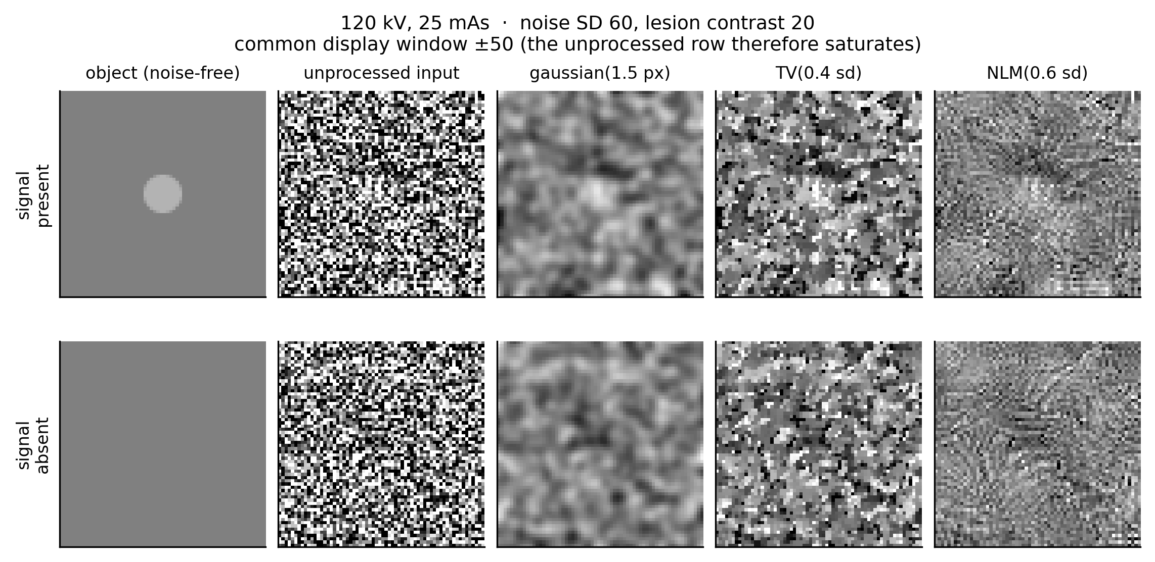
Figure 1. Signal-present and signal-absent images at one setting, for the unprocessed input and each classical denoiser, on a common display window.

2.5 Cross-fitted estimation and the ceiling comparison
On the unprocessed input the ideal linear observer is closed-form. On processed images neither the noise spectrum nor the effective signal is known analytically — a non-linear denoiser has no transfer function — so both are estimated, and the estimate must not be allowed to score itself.
Estimation is cross-fitted over K = 5 folds. Fold membership is by trial index modulo K; the trials are i.i.d. draws from one seeded stream, so a positional partition is already a random one and needs no second random number to record. For each fold, the effective signal Ŝ (the class-mean difference) and the noise spectrum are estimated from the other folds inside a central 24 × 24 pixel window, the prewhitening template Ŵ = Ŝ/NPS is formed, and the held-out fold is scored with it. Pooling the out-of-fold scores gives d' from the pooled-variance separation and AUC from the Mann–Whitney statistic, using every trial exactly once while no score comes from a template that saw its own image. The measured NPS is made invertible by filling the DC bin from its neighbours, adding a ridge of 0.01 × the mean power, and clamping at 1×10⁻⁶ × the peak; these steps stabilize the estimate but may reduce its efficiency relative to the unknown optimum. The same scheme estimates NPWE; the CHO uses the split estimator of the underlying package, which is also held out.
The ceiling comparison, reported as validation in Section 3.4, tests
AUC_PW(g(X)) ≤ AUC_ceiling(X) + m, with m = z·SE + 1/(n₁n₀),
z = 1.96, SE the Hanley–McNeil standard error [22] of the scored AUC, and the second term one quantization step of the Mann–Whitney statistic. The comparison is made at every arm, and it is reported twice: at the armwise margin above, and at a simultaneous margin in which z is widened by Bonferroni to a family-wise level of 0.05 over all arm–realization comparisons. The claim of interest concerns processing, so the simultaneous statement is made over the processed arms; the unprocessed arms are self-comparisons of an input against its own ceiling and are reported separately, since an identity map cannot create information and any excess there measures the estimator and the finite sample. Alongside both we report the largest excess anywhere against the margin at that arm, and we summarize the AUC-saturated arms — those whose analytic ceiling AUC lies within ten quantization steps of 1 — separately, since there the comparison is limited by the resolution of the rank statistic rather than by information.
Estimator efficiency. Applied to unprocessed images the estimator must recover most of the analytic ceiling; otherwise the comparison would be satisfied for statistical rather than informational reasons. We report the distribution of that recovery ratio, and Section 3.8 compares cross-fitting with the single 50/50 split used previously.

2.6 Primary endpoints
For each processed arm, with the unprocessed arm of the same condition and realization as its reference:
ΔSSIM = SSIM(processed) − SSIM(input), and Δd'_O = d'_O(processed) − d'_O(input) for each observer O in {PW, CHO, NPWE}.
Endpoint 1 — fidelity–task divergence. The Spearman correlation between ΔSSIM and Δd'(PW) across evaluations, and the divergence rate: the fraction of evaluations with ΔSSIM > 0 and Δd'(PW) < 0. Both are reported overall, per denoiser, and stratified by floor stratum. An individual arm is called divergent; the phenomenon is fidelity–task divergence.
Endpoint 2 — observer-dependent benefit. B = Δd'(NPWE) − Δd'(PW), the extent to which processing helped the inefficient observer more than the efficient one, reported per denoiser with intervals, together with the fraction of evaluations that improved NPWE while not improving PW, and the observer ordering with CHO in between.
Endpoint 3 — floor-stratified failure patterns. Each input condition is assigned a stratum by its analytic ceiling: above floor, marginal (within the gauge’s marginal factor of the requirement) and below floor. Strata are compared on divergence rate, contrast erasure rate, excess lesion-like response rate, observer-dependent benefit, task degradation and verdict distribution. The floor stratifies conditions by the detectability available in the input; it is not claimed to cause the failures.
Erasure is contrast recovery below the gauge’s threshold, and an excess response is a lesion-like matched-filter rate above the gauge’s allowance and above the same rate measured on the unprocessed input of that condition — in signal-absent trials the object is uniform but the acquired image is not, and noise alone produces such responses. Both definitions, and the matched-filter normalization behind them, are restated in Supplementary Methods.

2.7 Statistical analysis
Arms are not independent observations: all arms of a realization share its noise stream, and the arms of a condition share its images. Intervals therefore come from a cluster bootstrap that resamples whole realizations with replacement (4000 replicates, seeded), carrying every arm of a drawn realization along. Point estimates are the statistic on the full data; intervals are percentile intervals; two-sided bootstrap p-values are reported beside them and Holm-adjusted within each family (denoisers within an endpoint, stratum contrasts within theirs). Proportions are additionally reported with a Wilson interval as the conventional unclustered reference, which is the narrower of the two. Conclusions rest on effect sizes and intervals rather than on p-values. Every statistic in this manuscript is computed by the analysis module and written to results/statistics.json; none is typed.

2.8 The operational information floor
The floor is the contour where the input’s analytic ceiling d' crosses a prespecified requirement, here the Rose criterion [23] at d' = 5. It is a requirement a task imposes, not a boundary of zero information, and it is used in this paper as a stratifying variable.
The study also carries an auditable rule-based translation of the measured quantities into a green / amber / red verdict with the rule that fired attached. Its thresholds are task-specific author-set values, not clinically validated criteria; the complete rule set is given in Supplementary Methods, and verdict counts per stratum are reported in Section 3.5.

2.9 The real low-dose CT arm
Images. Twelve Siemens liver cases from LDCT-and-Projection-data, using the vendor reconstructions of both the routine-dose and the simulated quarter-dose acquisition. Nothing is re-reconstructed. The quarter-dose noise field is taken as the difference between the two reconstructions of the same anatomy, so the noise carried into every trial is the acquisition’s own and not a model of it.
Lesion insertion. A patient scan has no ground truth: the lesions in it were found by a reader, at a contrast nobody measured. A synthetic lesion of known size and amplitude is therefore inserted into real abdominal soft tissue, which keeps the background that makes the task hard and supplies the truth that makes it measurable. The lesion is a disk of 8 mm diameter and -25 HU contrast, with a Gaussian edge of 0.5 mm, rendered on a grid supersampled 4-fold so its own edge is not a one-pixel staircase, and added after reconstruction. The one assumption this makes is stated rather than left implicit: an inserted lesion does not carry the reconstruction’s own response to a real lesion of that contrast, so the arm measures detection of a known additive signal in real anatomy and real noise, not detection of pathology.
Where lesions are placed. Candidate sites are regions of interest of 48 pixels whose mean lies between 0 and 160 HU and whose standard deviation is below 60 HU, drawn from the 25 slices either side of the middle of each case. Up to 250 sites are used per case and a case contributing fewer than 16 is dropped. Signal-present and signal-absent trials are built at the same sites from the same background, so the two members of a pair differ in two respects and in no others: the lesion, which is present in one and absent in the other, and the noise, which is an independent measured realization drawn for each member from a site other than the one supplying the background. The anatomy is common to the pair and cancels in their difference; the noise does not, and that is what the detectability expression below is built on.
That rule admits more than parenchyma: rendering the sites shows bowel, mesentery, vessel and body-wall structure alongside liver. Measured as the standard deviation of a site after a blur that removes the quantum noise, the structure inside an admitted site has a median of 15.4 HU and exceeds the lesion’s own 25 HU depth in 31% of them. This does not bias d', since the background is common to the pair and the noise spectrum comes from paired differences, but the denoisers are non-linear, so a ranking measured on structured tissue need not hold on parenchyma. Section 3.6.2 tightens the rule and reports what changes.
The observer, on anatomical background. A prewhitening matched filter needs the noise power spectrum of the images it scores. On a uniform phantom that spectrum is the noise; on abdominal anatomy an image-by-image estimate would be dominated by the anatomy, which is not noise and does not repeat between trials. The paired construction of the preceding paragraph is what makes the estimate possible: because the signal-present and signal-absent members of a pair are built at the same site from the same background, their difference removes the anatomy and leaves the noise. The noise power spectrum is therefore estimated as the two-dimensional spectrum of those paired differences after their mean is removed, and the anatomy enters neither the template nor the covariance.
The template is formed on training folds and applied to held-out ones. Trials are assigned to 5 folds by trial index modulo the number of folds. Within each training fold the signal is estimated as the difference of the present and absent means rather than assumed known, the noise power spectrum is estimated from the paired differences as above, and the template is the inverse transform of the estimated signal spectrum divided by that noise spectrum. The division is regularized in three steps, because an estimated spectrum has a zeroed DC bin and small high-frequency values that would otherwise dominate the template: the DC bin is replaced by the mean of its four neighbours, a ridge of 0.01 of the spectrum’s mean is added, and a floor of 0.001 of its maximum is applied. Each held-out trial is then scored by the inner product of its image with the template. A template that had seen the trial it scores would report the fit rather than the detectability, which is why the folds are held out.
Detectability. The two members of a pair share a background, so the per-trial difference of their scores removes it and carries two independent noise draws. Its variance is twice that of a single image, and the detectability of one image is therefore
d′ = √2 · mean(Δ) / sd(Δ),
with Δ the per-trial difference of the present and absent scores. Omitting the √2 understates d′ by 29 per cent, which is larger than the differences between denoisers this arm is measuring. The same quantity is computed for the unprocessed quarter-dose images and for every denoised arm, from the same trials, so the comparison across arms is paired throughout.
Denoisers. The classical arms use the implementations of Section 2.3, parameterized in physical units for this data: Gaussian filters of 0.75 mm and 1.00 mm, total variation at 1× and non-local means at 0.8× the measured noise standard deviation.
Network. A residual convolutional denoiser in the DnCNN formulation: the network predicts the noise, which is subtracted from its input. Two configurations are evaluated — the smaller with 6 layers of 24 channels and 3×3 kernels (21385 parameters), the larger with 10 layers of 96 channels and 5×5 kernels (1849633 parameters). Both are trained on 64×64 quarter-dose / routine-dose patch pairs with Adam at a learning rate of 0.001, the smaller for 16 epochs at batch 32 on 800 patches per case, the larger for 60 epochs at batch 64 on 3000 patches per case. The two therefore differ in three respects at once — parameters, training data and training length — and are not a controlled comparison of capacity.
The validation loss quoted below is measured on a 15% split of the patches drawn from the 8 training cases, held out from the gradient. The held-out cases take no part in training or in model selection: they are read once, after training has finished. This is the same discipline Section 2.5 applies to the observers, for the same reason — a quantity that selects a model cannot also be evidence about it.
What the network is and is not shown. Training pairs are normalized exactly as inference normalizes them, by each image’s own mean and estimated noise level; a network trained in absolute HU and deployed through a normalizing wrapper is not the network that was trained. The split is by case: the network sees 8 cases and is evaluated on the 4 it never saw, because slices from one patient are not independent and a network tested on another slice of a liver it trained on is being tested on its own training set. The network never sees a lesion — its targets are routine-dose reconstructions of ordinary anatomy, which is what a denoiser is actually given — so the lesion exists only in the evaluation.
The adversarial arm. Every denoiser above regresses towards the mean, so none of them can fabricate and a null result on fabrication from them alone would be uninformative. At each capacity a second network is therefore trained that differs in the objective and in nothing else: the same architecture built from the same seed, the same patches, the same epochs, the same batch size and the same learning rate, with the generator minimizing mse_weight × MSE + adv_weight × L_adv, where L_adv is the least-squares adversarial term of Mao et al. [24] against a small patch critic. The three weights (mse_weight = 0.05, adv_weight = 1.0, critic learning rate 1e-03) were fixed by a recorded sweep on a subset before this arm was run, and are reported with that sweep rather than chosen from the result. The epoch count is not raised to the sweep’s: holding it at the fidelity arm’s value is what keeps the comparison controlled.
Least squares rather than the log loss, because the instabilities of the log loss are a property of that loss rather than of the question, and bounded gradients keep a seeded run comparable with a rerun. What is claimed is a seeded run with a recorded weight hash, not bitwise equality across machines.
The bound’s premise is preserved rather than assumed. At inference the generator is a deterministic function of its input image and of nothing else — it takes no latent, no class label, no lesion location and no other trial’s pixels — so H → X → Y holds and the data-processing inequality bounds it exactly as it bounds a Gaussian filter. A generator that sampled from a latent would not be covered by that argument, which is why this one does not; a test scores the same image twice and requires the same output.
Fabrication, with the anatomy cancelled. The prespecified criterion of Section 2.8 counts lesion-shaped matched-filter responses in signal-absent images. On a uniform phantom every such response was put there by the noise or by the processing. On real anatomy it is not: abdominal soft tissue carries disc-like structure at around twice this lesion’s contrast, so the rate is already near one before anything is processed and cannot rise. The threshold is not retuned. Instead the measurement is repeated on what the processing added, which this design can isolate because it knows the background exactly: the lesion-free, noise-free anatomy is passed through the same method and subtracted, so the anatomy cancels and every remaining response is one the processing produced. Structure a method invents from the anatomy alone is identical in both classes and cancels too; it carries no information about the hypothesis and so cannot breach the ceiling, which is why this is the right measure for the claim and why it is not a complete account of what a denoiser might put on a screen. The measure’s sensitivity is established by injection rather than assumed, against a denoiser built to stamp a lesion where the noise suggested one.

3. Results

3.1 Study design and evaluated conditions (Table 1)
Table 1 gives the matrix. The primary analysis comprises 21 input conditions and 76 unique arms (21 unprocessed, 55 processed), each evaluated in 10 independent realizations, giving 760 arm–realization evaluations and 1,696,000 scored image trials. Endpoints are computed on the 550 processed evaluations, each paired with the unprocessed arm of its own condition and realization. Figures 2 and 3 give the dose response of the representative realization, in fidelity and in task d' respectively.
Table 1. The experimental matrix. An input condition is one acquisition and phantom setting; an arm is one condition with one processing, including the unprocessed one. The 76 unique arms were each evaluated in 10 independent realizations, giving 760 arm–realization evaluations and 1,696,000 scored image trials. The three sweeps use 1,200 trials per class per arm and the atlas settings fewer, so the trial total is summed rather than assumed. Conditions are not shared between domains, so no deduplication is needed; the atlas domain applies a single denoiser rather than all three, which is why the processed-arm total is not three times the number of input conditions. The learned denoiser is evaluated separately and is not part of this matrix.
domain | varied factor | input conditions | denoisers | unprocessed arms | processed arms
Dose sweep | mAs at fixed kV | 7 | 3 | 7 | 21
Noise-correlation sweep | noise correlation length | 4 | 3 | 4 | 12
Lesion sweep | lesion radius and contrast | 6 | 3 | 6 | 18
Atlas / floor conditions | kV and mAs on the atlas | 4 | 1 | 4 | 4
Total | — | 21 | — | 21 | 55
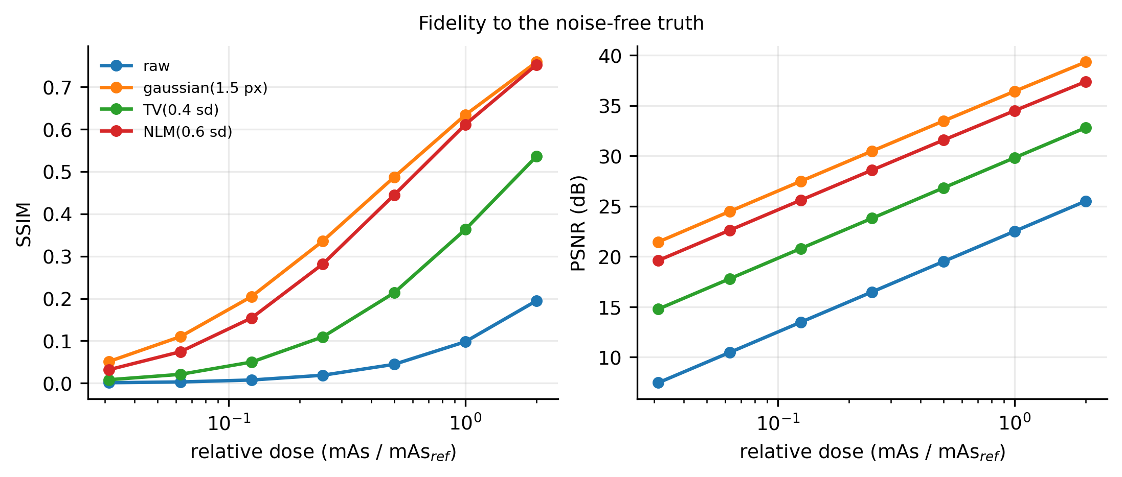
Figure 2. SSIM and PSNR against relative dose in the representative realization — the fidelity view.
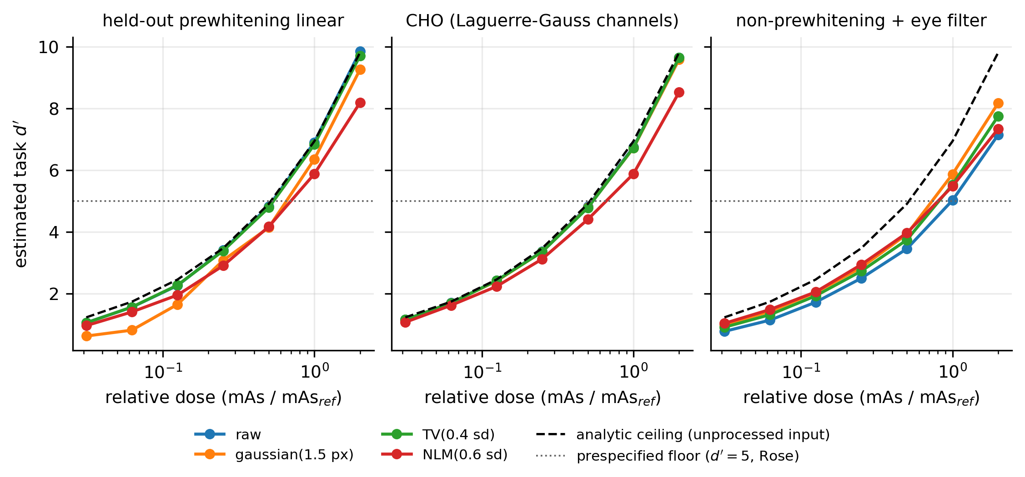
Figure 3. Task d' against relative dose for the three estimated observers, with the analytic ideal-observer ceiling of the unprocessed input.

3.2 Fidelity gains frequently diverge from task performance (Figure 4)
Across all processed evaluations, ΔSSIM and Δd'(PW) were correlated at Spearman ρ = -0.62 (95 % CI -0.63 to -0.60). Mean ΔSSIM was +0.252 (+0.252 to +0.253) while mean Δd'(PW) was -0.832 (-0.846 to -0.819): fidelity improved on average, the task estimate did not.
88.2% of evaluations were divergent — fidelity up, task estimate down — with a clustered 95 % interval of 86.7% to 89.6%. The rate differed by denoiser: 100.0% for the Gaussian filter, 62.4% for total variation and 99.4% for non-local means — an ordering that follows filter strength rather than filter family, with total variation the most conservative of the three at these settings. Figure 4 shows every evaluation in the ΔSSIM–Δd' plane; the quadrant in which fidelity improves while the task estimate falls is where most of the distribution lies.
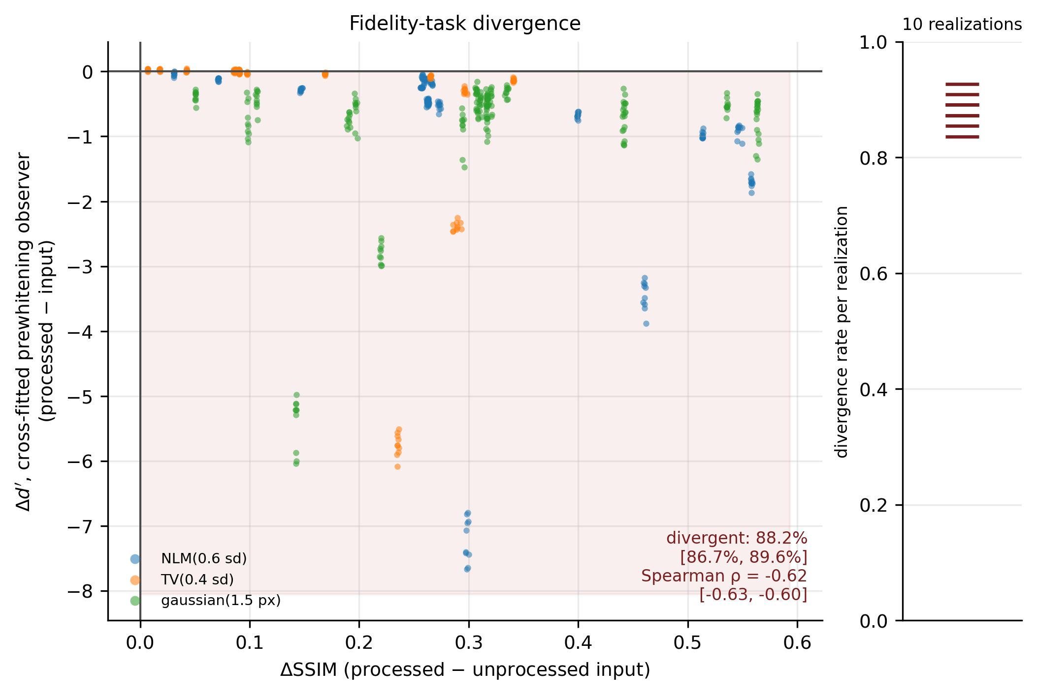
Figure 4. Fidelity–task divergence: ΔSSIM against Δd'(PW), processed minus unprocessed, for every arm–realization evaluation, with the divergent quadrant shaded and the per-realization divergence rates beside it.

3.3 Denoising benefits depend on observer efficiency (Figure 5, Table 2)
On identical images the three observers responded differently to the same processing. Averaged over all evaluations, Δd'(PW) was -0.83 (-0.85 to -0.82), Δd'(CHO) -0.14 (-0.14 to -0.14) and Δd'(NPWE) +0.30 (+0.29 to +0.30) — an ordering consistent with differences in observer efficiency, with the intermediate observer in between.
Table 2. Observer-dependent effects: processed minus unprocessed at the same condition and realization, as mean [95 % CI] from a bootstrap resampling whole realizations. Columns are the denoisers. PW is the cross-fitted prewhitening observer, CHO the channelized Hotelling observer, NPWE the non-prewhitening observer with an eye filter — a stylized surrogate for limited prewhitening efficiency, not a human-reader model. The benefit is B = Δd′(NPWE) − Δd′(PW); p-values are two-sided bootstrap values for B, Holm-adjusted across the three denoisers. None of these columns is the analytic ceiling, which is a property of the unprocessed input and is unchanged by processing.
effect | gaussian(1.5 px) | TV(0.4 sd) | NLM(0.6 sd) | All
ΔSSIM | +0.304 [+0.304, +0.304] | +0.140 [+0.140, +0.140] | +0.302 [+0.302, +0.302] | +0.252 [+0.252, +0.253]
Δd′ PW | −0.91 [−0.94, −0.88] | −0.51 [−0.52, −0.50] | −1.06 [−1.07, −1.04] | −0.83 [−0.85, −0.82]
Δd′ CHO | −0.03 [−0.03, −0.02] | −0.07 [−0.07, −0.06] | −0.35 [−0.35, −0.34] | −0.14 [−0.14, −0.14]
Δd′ NPWE | +0.38 [+0.38, +0.39] | +0.18 [+0.17, +0.18] | +0.30 [+0.30, +0.31] | +0.30 [+0.29, +0.30]
benefit B | +1.30 [+1.27, +1.32] | +0.69 [+0.68, +0.69] | +1.36 [+1.34, +1.38] | +1.13 [+1.12, +1.14]
p (Holm) | 0.001 | 0.001 | 0.001 | —
The observer-dependent benefit was B = +1.13 (+1.12 to +1.14), and 77.8% (75.8% to 79.6%) of evaluations improved the non-prewhitening observer while not improving the prewhitening one. Table 2 gives the per-denoiser effects with intervals and Holm-adjusted p-values; Figure 5 plots them with realization-level uncertainty. The benefit also varied with noise correlation length — the condition that separates an observer that can prewhiten from one that cannot: B = +0.77 at zero correlation against +5.23 at the longest correlation length studied.
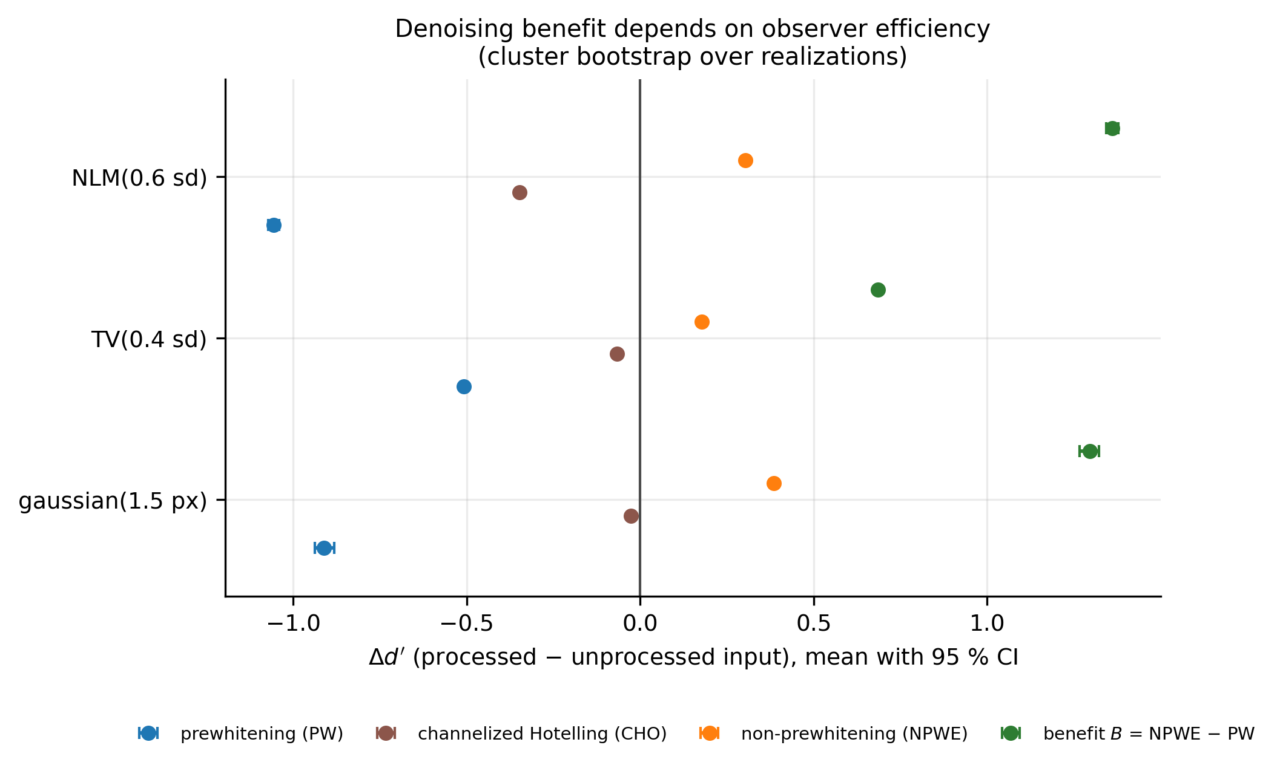
Figure 5. Observer-dependent benefit: Δd' for the prewhitening, channelized Hotelling and non-prewhitening observers, and their difference B, per denoiser with clustered 95 % intervals.

3.4 Performance relative to the data-processing ceiling (Figure 6)
Across 760 arm–realization evaluations the mean excess of the cross-fitted prewhitening AUC over the analytic ceiling of its own input was -0.032, and the largest was 1.64×10⁻⁴.
Stated simultaneously over the whole family, with the armwise margin widened by Bonferroni to a family-wise level of 0.05, 0 of the 550 processed-arm comparisons exceeded the ceiling margin, and the same holds at the unadjusted margin. One exceedance occurred, on an unprocessed arm, where the processing is the identity and cannot create information: it is a degeneracy of the closed-form interval at perfect separation, where the Hanley–McNeil standard error is identically zero and the margin collapses to one quantization step. Excluding the 180 AUC-saturated evaluations, the remaining 580 gave a largest excess of 1.64×10⁻⁴ and 0 exceedances, so nothing rests on the saturated regime. Supplementary Section S8 gives the margin construction, the saturation criterion and the exceeding arm in full.
This validates the measurement chain rather than finding anything: the observer plotted is an estimated linear one, which need not sit on the identity line after a non-linear transformation, so points below it are not evidence of information loss. The unprocessed arms fall slightly below it too, and that offset is the estimator’s own cost, quantified in Section 3.8.

3.5 Failure patterns across the operational information floor (Figures 7–8)
Figure 7 is the kV–mAs atlas with the operational floor drawn as the contour where the input’s analytic ceiling crosses the requirement; Figure 8 and Supplementary Table S3 give the stratified comparison.
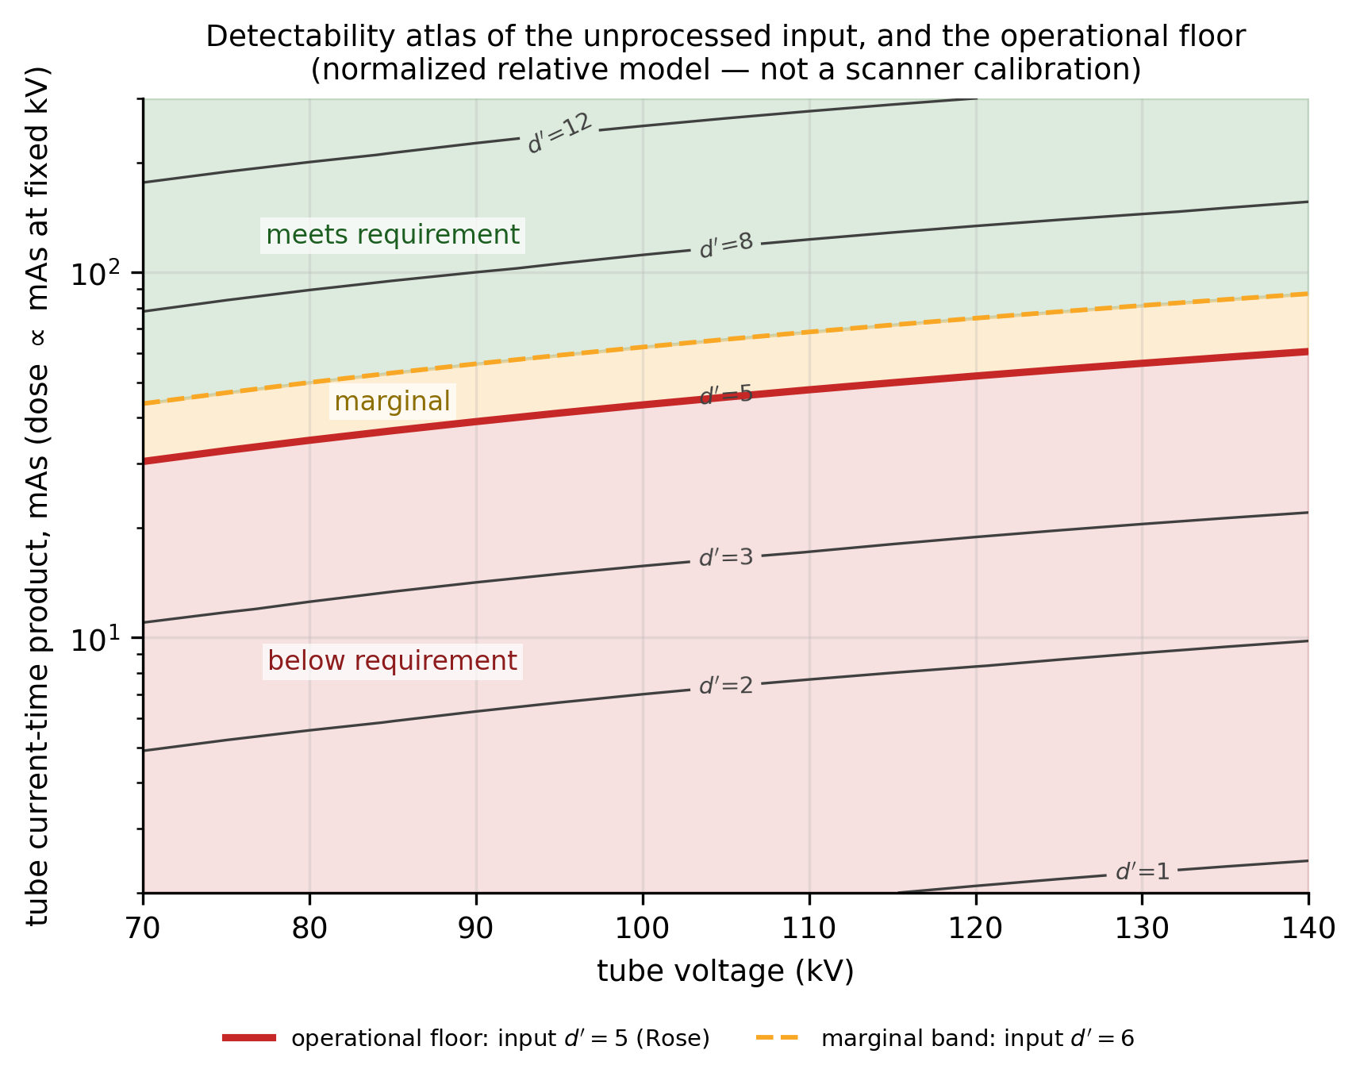
Figure 7. The kV–mAs detectability atlas and the operational floor, the contour where the input’s ideal d' crosses the prespecified criterion.
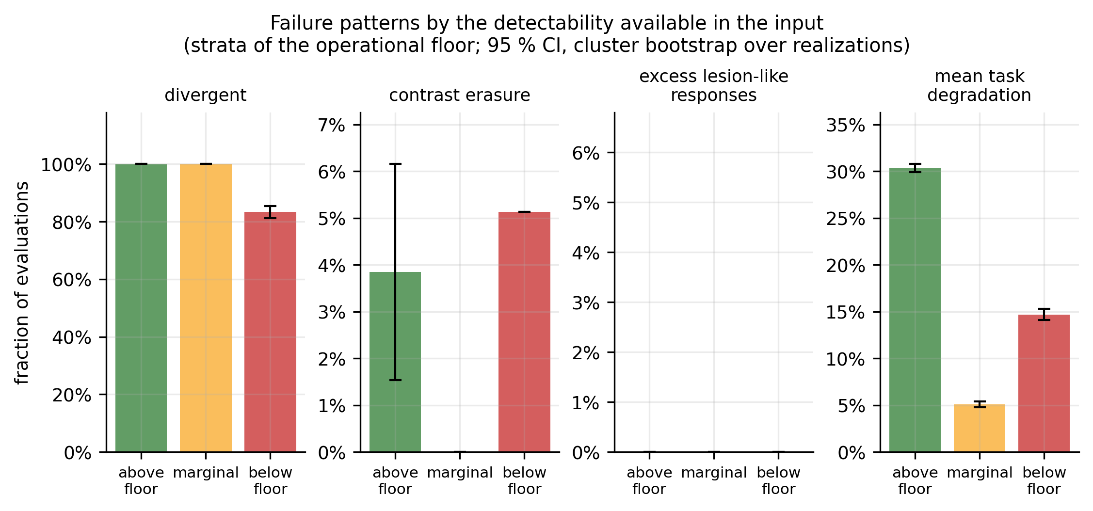
Figure 8. Failure patterns by floor stratum: divergence, contrast erasure, excess lesion-like responses and mean task degradation, with clustered 95 % intervals.
The third hypothesis was supported in one respect and refuted in another.
Supported: plausible output without preserved detectability. Below the floor, processing raised SSIM by +0.210 on average while Δd'(PW) was -0.334, and 83.3% (81.3% to 85.4%) of those evaluations were divergent: visually improved output coexisted, throughout that stratum, with an input that did not meet the requirement and a processed estimate that fell further below it.
Refuted: failures do not concentrate below the floor. The divergent fraction was higher above the floor — 100.0% against 83.3%, a difference of -16.7% (-18.7% to -14.6%) — and so was mean task degradation: 30.3% of the input’s detectability above the floor against 14.7% below it (difference -15.6%, -16.5% to -14.9%). The same ordering appears in the observer-dependent benefit, which was +2.59 above the floor against +0.64 below it. We offer no mechanism for the ordering: the stratum with more detectability available also shows the larger relative loss, but these data do not establish why.
Contrast erasure did not differ appreciably between strata (3.8% above against 5.1% below, Holm-adjusted p = 1.00), and excess lesion-like responses were absent in every stratum. With these denoisers, at this response threshold, the failure mode is erasure and dilution of true contrast rather than fabrication of false structure — a result that should not be generalized to generative or learned methods, whose failure modes may differ. Supplementary Table S3 gives the stratified counts, the interval estimates and the gauge’s verdict breakdown, which reflects the strata by construction: an input that fails the requirement is itself a red rule, so below the floor the informative part is the reason attached rather than the colour.

3.6 The same question on real low-dose CT
The controlled matrix isolates mechanisms by fixing everything. The obvious question about any conclusion drawn from it is whether the conclusion survives an acquisition nobody controlled, so the same measurement was repeated on real data with no change to the framework.
Data and design. Twelve Siemens liver cases from LDCT-and-Projection-data (The Cancer Imaging Archive, CC BY 4.0), vendor reconstructions of both the routine and the simulated quarter-dose acquisition. A lesion of known size and contrast is inserted into real abdominal soft tissue, so that the task has a ground truth the acquisition itself cannot supply. The learned denoiser is trained on quarter-dose / full-dose patch pairs from 8 cases and evaluated on the 4 it never saw (1000 pairs). The split is by case, not by slice: slices from one patient are not independent, and a network tested on another slice of a liver it trained on is being tested on its own training set. Normalization at training matches normalization at inference, since a network trained in absolute HU and deployed through a normalizing wrapper is not the network that was trained. The network never sees a lesion — its targets are full-dose reconstructions of ordinary anatomy, which is what a denoiser is actually given — and the lesion exists only in the evaluation.
Result. Figure 9 draws one held-out site, lesion present and absent, unprocessed and after four denoisers: the panels grow cleaner from left to right as the detectability above them falls. Figure 10 and Table 3 give the held-out comparison against the closed-form ceiling d' = 8.09:
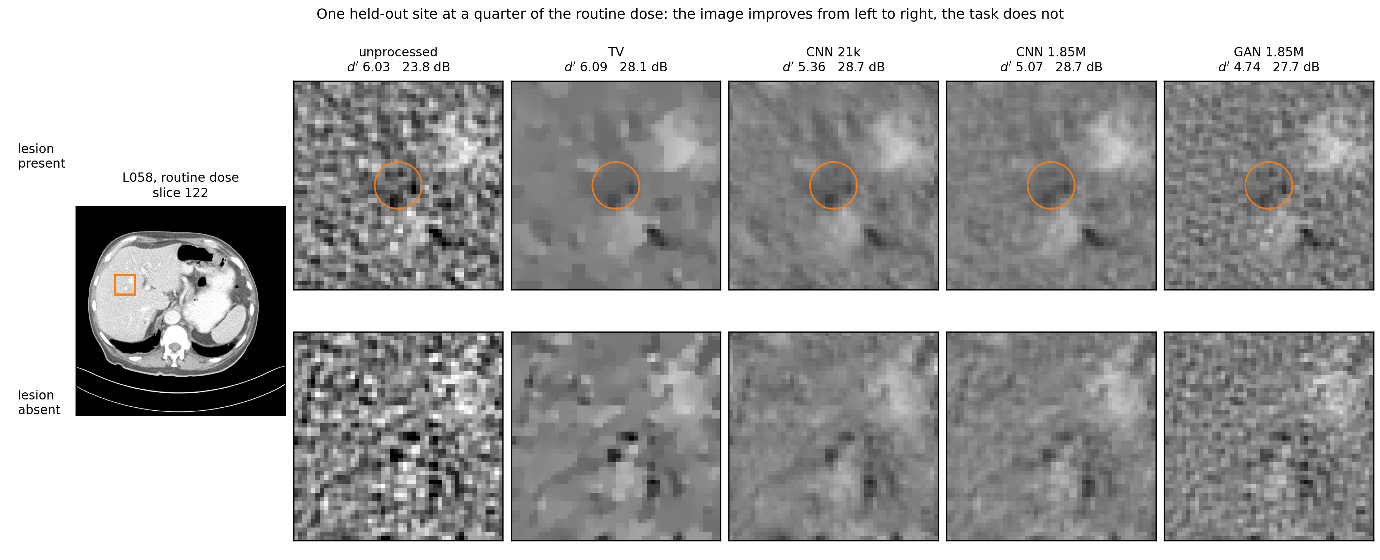
Figure 9. One held-out site at a quarter of the routine dose, lesion present and absent, unprocessed and after four denoisers, with the held-out d' and PSNR of each arm. The site is the admitted one whose anatomical structure is nearest the median of all admitted sites, and every panel shares one display window centred on the lesion-free reference, so no arm is flattered by its display. Images from LDCT-and-Projection-data (The Cancer Imaging Archive), CC BY 4.0, DOI 10.7937/9npb-2637.
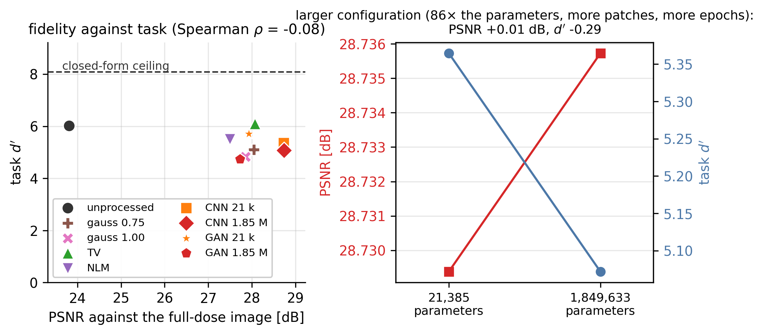
Figure 10. The real low-dose CT arm: task d' against PSNR for the nine held-out methods with the closed-form ceiling marked, and what raising network capacity 86-fold did to each.
Table 3. The 9 arms on the held-out real low-dose CT split, ordered by task detectability. d' is against the closed-form ceiling of the unprocessed input; PSNR is against the full-dose reconstruction. Added is the rate of lesion-shaped structure the method put into a lesion-free image with the anatomy cancelled, and is read against the unprocessed row, which is the rate the noise itself carries; recovery is the fraction of a real lesion’s contrast that survives. The four networks share an architecture and a training split; within each capacity the two differ only in the objective, so that pair is controlled. Across capacities they are not: the larger differs in parameters, training patches per case and epochs at once. The exposure each arm needs to meet the prespecified requirement is given in Section 3.7.
method | d' | of ceiling | PSNR (dB) | added | recovery
tv 1x noise | 6.09 | 0.75 | 28.07 | 0.017 | 0.760
unprocessed | 6.03 | 0.75 | 23.81 | 0.090 | 0.871
GAN, 21385 parameters | 5.70 | 0.71 | 27.93 | 0.014 | 0.772
nlm 0.8x noise | 5.50 | 0.68 | 27.50 | 0.041 | 0.729
CNN, 21385 parameters | 5.36 | 0.66 | 28.73 | 0.013 | 0.771
gaussian 0.75 mm | 5.10 | 0.63 | 28.04 | 0.016 | 0.807
CNN, 1849633 parameters | 5.07 | 0.63 | 28.74 | 0.006 | 0.720
gaussian 1.00 mm | 4.82 | 0.60 | 27.85 | 0.007 | 0.766
GAN, 1849633 parameters | 4.74 | 0.59 | 27.73 | 0.007 | 0.696
Three things follow.
Fidelity carries no usable information about the ranking. Across the 9 arms the rank correlation between PSNR and d' is Spearman ρ = -0.08 (p = 0.83) — not distinguishable from zero, and with 9 arms this study is not powered to distinguish a weak association from none. The claim here is therefore the absence of a usable one, not the presence of an inverse one. What is not in doubt is the consequence: the arm with the best PSNR of all 9 ranks 7 of 9 on the task. Selecting a denoiser by fidelity on these data would have selected close to the worst available option for detection.
Nothing exceeded the ceiling. 0 of 9 arms on the held-out split, and 0 across every real-data arm in this study — the held-out split, the 12-case run, and both operating points of Section 3.6.1. The bound the controlled matrix was built to test is not an artefact of the controlled matrix.
A larger network, trained longer on more data, does not reverse the ordering. The large network has 86 times the parameters of the small one (1849633 against 21385), was trained on 3000 patches per case against 800, and reached a better validation loss. It bought 28.74 dB against 28.73 — the best PSNR in the study — and a d' of 5.07 against 5.36: the configuration that scored better on the objective it was trained against scored worse on the task. Capacity was not varied alone, since parameters, training patches and epochs moved together, so what this shows is that the divergence persisted when the network was made substantially larger and trained longer within this architecture. That weakens the objection that the network was too small to be representative without excluding it, and says nothing about architectures not tried here. The checkpoint kept is each run’s last epoch, not its lowest-validation one; Supplementary Section S7 gives the configuration of all four networks and the best validation loss each reached.
Repeating the measurement at a second and very different acquisition — chest at 10% dose, with 8.2 times the liver’s noise and a ceiling of 2.64 against 9.21 — produced 0 exceedances of its own ceiling, so the bound holds where the task is nearly impossible as well as where it is comfortable.

3.6.1 A denoiser that could fabricate, and did not
Every arm above regresses towards the mean: a Gaussian filter, total variation, non-local means and a network trained on mean-squared error remove contrast rather than inventing it, so the measurement that would catch fabrication has never been aimed at anything capable of it, and a null result from them alone would be uninformative.
The adversarial arms answer that objection. At each capacity a second network was trained that differs from the first in the objective and in nothing else — same architecture, patches, epochs, batch size, learning rate and seed — with a least-squares adversarial term [24] added, so it is rewarded for producing images a critic cannot tell from full-dose ones rather than for being close to them pixel by pixel. Its weight was fixed by a recorded sweep before the arm was run. The bound’s premise survives: at inference the generator is a deterministic function of its input image and of nothing else — no latent, no class label, no lesion location — so H → X → Y holds and the data-processing inequality bounds it as it bounds a Gaussian filter.
The measure did not detect fabrication. Counting lesion-shaped structure that processing put into a lesion-free image, with the anatomy cancelled by passing the lesion-free, noise-free background through the same method and subtracting, 0 of 8 processed arms exceeded the rate the noise itself carries (0.090); the largest of any processed arm was 0.041, and the adversarial arm at 1849633 parameters reached 0.007. What that arm did instead was erase: its contrast recovery, 0.696, is the lowest of every method in the study, and its d' is 4.74 against 5.07 for the same network trained on fidelity. The detector’s sensitivity is not assumed: aimed at a denoiser constructed to stamp a lesion where the noise suggested one, it fires on the majority of images while reading below 0.04 for an honest smoother.
Within the operating points examined, and within the reach of a measure blind to structure invented from the anatomy alone, optimizing a denoiser for appearance produced no detectable excess of lesion-shaped response. What it produced was more erasure of a real lesion, behind a more convincing picture.

3.6.2 Does the ranking depend on where the lesions were put?
The admission rule of Section 2.9 passes structured tissue as well as parenchyma, so the held-out evaluation was repeated with one criterion added — the structure inside a site capped at 10 HU, below half the lesion’s depth — and everything else fixed, including the networks, which were not retrained, and the pairs contributed by each case. Matching those matters: the strict rule admits far fewer sites in the quietest case, so comparing the rules on their natural counts would compare a change of case mix as much as a change of site.
The structure inside a site falls from a median of 15.4 HU to 7.5 HU against a nearly unchanged ceiling (8.09 against 7.94), so the two sets carry comparable noise. The ranking by d' agrees at Spearman ρ = 0.93 (p = 0.0002), with 2 of 9 positions changed, and those two adjacent. The three best and the three worst arms are the same under both rules, the best-PSNR arm ranks fifth of 9 on the task under both, and under both the best-performing arm exceeds the unprocessed input by a margin this design does not resolve. The conclusions of Sections 3.6 and 3.7 do not depend on the admission rule.
One thing does change, and no mechanism is offered for it: every arm’s efficiency falls on the low-structure sites, the unprocessed input from 5.29 to 4.42. A less structured background yields a lower fraction of the available detectability, which these data record without explaining.

3.7 The floor, converted into an exposure
Sections 3.1–3.6 measure. None of them tells a reader what to set. This section converts the operational floor of Section 2.8 into the quantity the decision is actually made in, using the same held-out pairs and the same prespecified requirement, d' = 5.
The dose axis is a simulation anchored on a measured noise realization, and the distinction matters. Because this collection’s low-dose series is a reconstruction of the same projections with noise inserted, the difference of the two reconstructions is a measured realization of the noise that dose reduction costs at one fraction, α, with a real spectrum on real anatomy. Scaling it by k(β) = √((1/β − 1)/(1/α − 1)) produces a realization at any other fraction β. The spectrum and the anatomy are therefore measured; the amplitude at β is modelled. The scaling assumes the inserted noise is independent of the noise already present and that its power follows 1/β − 1, and no independent acquisition at β exists to check it, so only the row at β = α rests on an observed amplitude. The trials are built once at α and recombined linearly, which is exact given the scaling.
Where the task is lost. The unprocessed input meets the requirement down to 0.187 of the routine protocol. Of the 8 processed arms, 7 need more exposure than that to meet the same requirement — up to +51 % for GAN 1.85M — and the best of them differs from doing nothing by -2 %, which is within what this design resolves. No arm measured here extended the exposure floor by an amount this study can distinguish from none.
What the picture claims. A gain of Δ dB in PSNR is the fidelity of an exposure with 10^(Δ/10) times less noise power, so every processed image implies an exposure. At the nominal fraction the implied exposure reaches 2.04× the one actually delivered (CNN 1.85M), and the discrepancy grows as the exposure falls: at 0.062 of routine, gaussian 1.00 mm has the fidelity of 0.302 of routine — 4.8× its own exposure — while delivering d' = 1.35 against the 5 required. The flattery is greatest where the task has already failed.
What an ideal-observer floor omits. A floor computed from an ideal observer is not reachable. The achieved fraction of the ceiling on the unprocessed input at the nominal exposure is 0.745, and exposure enters as a square root; on this axis the ceiling crosses the requirement at 0.113 of the routine protocol while the unprocessed input crosses it at 0.187 — a factor 1.66, or 66 % more exposure than an ideal-observer calculation would ask for. With the requirement as the denominator rather than the ideal floor, the same fact reads: an ideal-observer calculation supplies 60% of the exposure the task needs. The two percentages describe one fact and are not interchangeable.
Holding the efficiency constant and solving for the crossing gives 0.187, within 0.3 % of the measured one, which is the evidence for the conversion. It is local, because efficiency varies along the dose axis, and it is specific to this axis: a site working in the total noise of its own images uses d' ∝ √D, under which the same efficiency implies 1.80 instead. The convention has to travel with the number.
How far the scaling law may be carried. d' ∝ 1/k(β) holds exactly for the ceiling, whose template is the noise’s own: over the 8-fold range measured, d'·k varies by 0.0%. It holds for no achievable observer: the same quantity varies by up to 47% (gaussian 1.00 mm), because observer efficiency is itself a function of exposure. The textbook d' ∝ √dose rule therefore overstates what a denoised image keeps when the exposure is cut, and an efficiency measured at one exposure extrapolates only near it. The crossings above are read from the measured curve for that reason.
The conversions are implemented in denoiq_core.guidance for a reader’s own protocol and task. The absolute exposures here are specific to this lesion and a background treated as known, and are not a clinical recommendation.

3.8 Sensitivity and implementation validation
Estimator efficiency. On unprocessed images the cross-fitted estimator recovered a median 95% of the analytic ceiling d' (interquartile range 86% to 97%), with a minimum of 49% over all evaluations and 93% over conditions at or above the floor. The lowest recoveries occur at the lowest doses, where the signal the template is estimated from is weakest, and the estimator rather than the bound is the limiting factor. Supplementary Table S2 compares the cross-fitted estimator with a single 50/50 split at matched conditions; cross-fitting recovers more of the ceiling at every dose.
Closed form. In white noise the analytic observer must satisfy d' = ‖s‖₂/σ. Over the combinations of noise level and lesion radius in Supplementary Table S1 the maximum relative deviation was 1.32×10⁻¹⁶, against a criterion of 1 % fixed in advance.
Leakage positive control. A processor handed the class label — adding signal to the signal-present stack only — is detected by the ceiling comparison as an exceedance beyond the margin. That control is asserted in the test suite, and it is what gives the negative result of Section 3.4 its content.

4. Discussion
The contribution of this work is a framework that separates two quantities usually reported as one: the detectability an input makes available to an ideal observer, and the detectability a specified observer actually achieves after processing. Holding them apart is what turns a statement about image quality into a statement about an exposure, because the requirement a task imposes can then be placed on the second quantity rather than the first, and the exposure that meets it compared across processing methods.
The ceiling itself is a theorem, so the agreement reported in Section 3.4 establishes not the theorem but that the measurement chain is consistent with it, which is a precondition for trusting anything else the chain reports; the leakage control shows the comparison has the sensitivity to see a violation.
The findings sit on top of that. The first is that reference-based fidelity is a poor predictor of task change: the rank correlation between ΔSSIM and Δd'(PW) was negative, and a large fraction of evaluations improved the picture while the task estimate fell. This is not an artefact of a badly chosen fidelity metric — SSIM is what much of the literature reports and what many learned methods are optimized against — but a consequence of the two quantities measuring different things.
The second is that the effect of denoising is observer-dependent in a systematic, quantifiable way. The same processing on the same images improved the non-prewhitening observer while leaving the prewhitening observer no better, with the channelized observer in between. That ordering is consistent with differences in prewhitening efficiency, and offers a reading of an apparent paradox in the literature: a denoiser could genuinely raise a reader’s performance without information being added, if the reader was not using all of it. The three observers differ in template, channel model and noise handling as well as in prewhitening efficiency, so this is a reading of the ordering rather than a controlled attribution. The corollary is that a reported task improvement is a statement about the observer as much as about the algorithm, and a study that does not say which observer it used has not reported an effect size.
The third prespecified hypothesis was partially refuted, and the part that failed is as informative as the part that held. What held is the coexistence it predicted: below the operational requirement, fidelity still improved — by +0.210 in SSIM — while the task estimate fell, so a visually plausible output there does not establish that the required detectability survived. What failed is the expectation that the failure patterns would concentrate below the floor. Mean task degradation was larger above it (30.3% against 14.7%), which is what a relative loss must do when the input has less to lose; the contrast-erasure rate did not differ appreciably between the strata; and excess lesion-like responses were absent in every stratum, so these denoisers did not invent structure anywhere in the matrix.
The floor should therefore be read for what it is: a boundary of attainable required performance, derived from the input and the requirement alone. It says that no processing of an input below it can bring the requirement back into reach. It does not predict which denoiser will erase contrast, or where lesion-like responses will appear — those are properties of the processing, not of the boundary, and in this matrix they were not stratified by it. Reading the floor as a predictor of denoiser-specific failure modes would over-claim; reading it as a limit on what any processing can deliver is what the bound supports.
The clinical relevance of this framework lies in linking image processing to a specified diagnostic task and performance requirement. For radiologists, it motivates assessing whether improved image appearance preserves the features needed for the intended decision. For radiographers and medical physicists, it provides a basis for jointly evaluating acquisition exposure and post-processing against task-specific performance criteria. The intended patient benefit is to avoid unnecessary exposure while retaining information needed for diagnosis. These are translational objectives, not outcomes demonstrated here: the present study evaluated model observers and synthetic lesions, including lesions inserted into real CT backgrounds. Clinical application requires scanner-specific calibration, representative diagnostic tasks, and validation with human readers.
The gauge is an auditable rule-based translation of the measured quantities, not a clinically validated instrument. Its value is that a verdict naming the rule that fired, on numbers that are written down, can be argued with; an impression that the images look acceptable cannot.

4.1 Limitations
The phantom is a disk on a uniform background with stationary Gaussian noise and the signal is known exactly; non-stationary noise from iterative reconstruction and search tasks are outside the design. The observer evaluated on processed data is a cross-fitted prewhitening linear observer, not the likelihood-ratio ideal observer of the processed data. The Rose criterion d' = 5 is one chosen operational criterion, not a universal information boundary, and every gauge threshold is task-specific: clinical deployment would require re-specifying and validating all of them. No human observer study was performed, so the non-prewhitening observer stands only as a stylized surrogate for limited prewhitening efficiency. The lesion is inserted, not native: what is measured is detection of a specified low-contrast signal, not of hepatocellular carcinoma, haemangioma or any other native lesion, whose contrast, margin and size distributions differ. Whether the ordering reported here transfers to those is a question for readers and for clinical validation, not one this measurement answers. The classical denoisers are parameterized with the true noise level of the acquisition setting, which is more than a blind method would know. The learned denoisers do not represent the state of the art. The acquisition model is relative and analytic: it locates conditions on an axis, not on a scanner. Ten realizations bound sampling variability but do not make the matrix exhaustive. Finally, the scope is post-processing of a defined input image; reconstruction from projection data is a separate map, subject to its own bound, and is not studied here.

5. Conclusion
This study characterizes task detectability limits in denoised CT by separating the input’s ideal-observer ceiling from the performance achieved by specified observers. Controlled experiments and synthetic-lesion evaluations on real CT backgrounds showed observer-dependent denoising effects and divergence between fidelity and detectability. Within the evaluated dose simulation, task thresholds provided a basis for comparing exposure requirements across processing methods. These findings support evaluating acquisition and post-processing jointly against a defined detection requirement. Translation to clinical dose optimization requires scanner-specific calibration and human-reader validation, with the ultimate aim of preserving diagnostic information while avoiding unnecessary patient exposure.

Disclosures
The author declares no financial or commercial conflicts of interest relevant to this work. The controlled arm uses no measured data of any kind. The real-data arm uses de-identified public images from LDCT-and-Projection-data, distributed by The Cancer Imaging Archive under CC BY 4.0; no data were collected for this study, no proprietary software was used, and the work required no additional ethical approval.

Code and Data Availability
The controlled arm is generated analytically from documented seeds. The real-data arm uses the public LDCT-and-Projection-data collection (TCIA, CC BY 4.0, DOI 10.7937/9npb-2637).
Two packages are needed, and neither reproduces the paper alone. The controlled arm, the endpoints, the statistics and the figures are denoiq-core, below. The code that reads the images, inserts the lesion, trains the four networks, realizes the observer of Section 2.9 and scores it is ldct-io, at https://github.com/Institute-of-One/ldct-io, MIT licensed, archived at Zenodo as version 0.2.0, doi:10.5281/zenodo.23095235. Its entry points are examples/liver_cnn.py for the held-out comparison, examples/dose_decision.py for Section 3.7 and examples/site_sensitivity.py for Section 3.6.2; cross_fitted_paired is the observer and PRESETS the four network configurations. Its per-run outputs are committed here under paper/results/ and consolidated into results/real_liver.json. Every number here is produced by the code rather than transcribed. The software is denoiq-core 0.1.0 with taskiq-core 0.4.0, MIT licensed, Python 3.10 to 3.12. The repository — source, tests, generated results, figures and this manuscript’s build — is public at https://github.com/Institute-of-One/denoiq-core and is available at review time; the exact version reported here is archived at Zenodo as version 0.2.0, doi:10.5281/zenodo.23095236.
Realization seeds are the 10 values recorded in results/statistics.json; the bootstrap seed is 20260731 with 4000 replicates. Five commands regenerate everything:
- denoiq_core.experiment.run_primary() — the matrix, endpoints and statistics.
- denoiq_core.experiment.run_all() — the representative-realization artefacts and the atlas.
- paper/make_figures.py — Figs. 1 to 8 and the supplementary figures.
- paper/build_real_liver_results.py — consolidates the real-data runs into results/real_liver.json.
- paper/build_manuscript.py — resolves every number in this manuscript from results/.
pytest runs the consistency suite, which re-derives the reported endpoints, effect sizes and intervals from the same files, checks the design counts and the seed list, and fails if the committed manuscript is out of date, if a number has been typed into the prose, or if the observer and floor terminology has drifted in the text or in a figure label.

Acknowledgments
This work received no external funding.

Declaration of generative AI and AI-assisted technologies in the manuscript preparation process
Generative AI (Claude, Anthropic, through the Claude Code command-line tool) was used as a tool in preparing this work: scaffolding and refactoring the released software, drafting unit tests, writing the figure and analysis scripts, and drafting and revising manuscript prose. It was not used to design the study, to choose the endpoints, or to decide what the results mean.
No numerical result came from the model. Every number, table and figure in this manuscript is emitted by executed code into machine-readable files under results/, and the text resolves against those files at build time; the test suite fails if the two disagree, so a value cannot be typed into the prose. Every reference was checked against its Crossref record before being cited. The author designed the study, re-executed every result and verified all figures, equations and claims against the code, and is solely accountable for the content. No AI system is an author. This disclosure follows ICMJE and COPE guidance.

References
- Cover TM, Thomas JA. Elements of information theory. 2nd ed. Hoboken (NJ): Wiley; 2006.
- Neyman J, Pearson ES. IX. On the problem of the most efficient tests of statistical hypotheses. Philos Trans R Soc Lond A 1933;231:289-337. https://doi.org/10.1098/rsta.1933.0009.
- Li K, Zhou W, Li H, Anastasio MA. Assessing the Impact of Deep Neural Network-Based Image Denoising on Binary Signal Detection Tasks. IEEE Trans Med Imaging 2021;40:2295-305. https://doi.org/10.1109/TMI.2021.3076810.
- Yu Z, Rahman MA, Laforest R, Schindler TH, Gropler RJ, Wahl RL, et al. Need for objective task‐based evaluation of deep learning‐based denoising methods: A study in the context of myocardial perfusion SPECT. Med Phys 2023;50:4122-37. https://doi.org/10.1002/mp.16407.
- Li J, Wang W, Tivnan M, Stayman JW, Gang GJ. Performance assessment framework for neural network denoising. In: Medical Imaging 2022: Physics of Medical Imaging; 2022, p. 64. https://doi.org/10.1117/12.2612732.
- Li K, Li H, Anastasio MA. Investigating the use of signal detection information in supervised learning-based image denoising with consideration of task-shift. J Med Imaging 2024;11:1-20. https://doi.org/10.1117/1.JMI.11.5.055501.
- Bhadra S, Kelkar VA, Brooks FJ, Anastasio MA. On Hallucinations in Tomographic Image Reconstruction. IEEE Trans Med Imaging 2021;40:3249-60. https://doi.org/10.1109/TMI.2021.3077857.
- Eulig E, Ommer B, Kachelrieß M. Benchmarking deep learning‐based low‐dose CT image denoising algorithms. Med Phys 2024;51:8776-88. https://doi.org/10.1002/mp.17379.
- Nelson BJ, Kc P, Badal A, Jiang L, Masters SC, Zeng R. Pediatric evaluations for deep learning CT denoising. Med Phys 2024;51:978-90. https://doi.org/10.1002/mp.16901.
- Barrett HH, Myers KJ, Hoeschen C, Kupinski MA, Little MP. Task-based measures of image quality and their relation to radiation dose and patient risk. Phys Med Biol 2015;60:R1-R75. https://doi.org/10.1088/0031-9155/60/2/R1.
- Greffier J, Dabli D, Frandon J, Hamard A, Belaouni A, Akessoul P, et al. Comparison of two versions of a deep learning image reconstruction algorithm on CT image quality and dose reduction: A phantom study. Med Phys 2021;48:5743-55. https://doi.org/10.1002/mp.15180.
- Greffier J, Si‐Mohamed S, Frandon J, Loisy M, de Oliveira F, Beregi JP, et al. Impact of an artificial intelligence deep‐learning reconstruction algorithm for CT on image quality and potential dose reduction: A phantom study. Med Phys 2022;49:5052-63. https://doi.org/10.1002/mp.15807.
- Fan M, Zhou Z, Vrieze T, Wang J, McCollough CH, Yu L. Efficient evaluation of low-contrast detectability of deep-CNN-based CT reconstruction using channelized Hotelling observer on the ACR accreditation phantom. In: Medical Imaging 2022: Physics of Medical Imaging; 2022, p. 68. https://doi.org/10.1117/12.2612414.
- Tivnan M, Lee TC, Zhang R, Boedeker K, Cai L, Sulam J, et al. Task-driven CT image quality optimization for low-contrast lesion detectability with tunable neural networks. In: Medical Imaging 2023: Physics of Medical Imaging; 2023, p. 61. https://doi.org/10.1117/12.2653936.
- Toia GV, Zamora DA, Singleton M, Liu A, Tan E, Leng S, et al. Detectability of Small Low-Attenuation Lesions With Deep Learning CT Image Reconstruction: A 24-Reader Phantom Study. AJR Am J Roentgenol 2023;220:283-95. https://doi.org/10.2214/AJR.22.28407.
- Barrett HH, Myers KJ. Foundations of image science. Hoboken (NJ): Wiley; 2004.
- Barrett HH. Objective assessment of image quality: effects of quantum noise and object variability. J Opt Soc Am A 1990;7:1266. https://doi.org/10.1364/JOSAA.7.001266.
- Yamamoto S. taskiq-core: task-based image quality on synthetic phantoms. Zenodo; 2026. https://doi.org/10.5281/zenodo.21422924.
- Myers KJ, Barrett HH. Addition of a channel mechanism to the ideal-observer model. J Opt Soc Am A 1987;4:2447. https://doi.org/10.1364/JOSAA.4.002447.
- Burgess AE. Visual signal detection with two-component noise: low-pass spectrum effects. J Opt Soc Am A 1999;16:694. https://doi.org/10.1364/JOSAA.16.000694.
- Zhang K, Zuo W, Chen Y, Meng D, Zhang L. Beyond a Gaussian Denoiser: Residual Learning of Deep CNN for Image Denoising. IEEE Trans Image Process 2017;26:3142-55. https://doi.org/10.1109/TIP.2017.2662206.
- Hanley JA, McNeil BJ. The meaning and use of the area under a receiver operating characteristic (ROC) curve. Radiology 1982;143:29-36. https://doi.org/10.1148/radiology.143.1.7063747.
- Rose A. The Sensitivity Performance of the Human Eye on an Absolute Scale. J Opt Soc Am 1948;38:196. https://doi.org/10.1364/JOSA.38.000196.
- Mao X, Li Q, Xie H, Lau RYK, Wang Z, Smolley SP. Least Squares Generative Adversarial Networks. In: 2017 IEEE International Conference on Computer Vision (ICCV); 2017, p. 2813-21. https://doi.org/10.1109/ICCV.2017.304.

Figure captions
Figure 1. Signal-present and signal-absent images at one setting, for the unprocessed input and each classical denoiser, on a common display window
Figure 2. SSIM and PSNR against relative dose in the representative realization — the fidelity view
Figure 3. Task d' against relative dose for the three estimated observers, with the analytic ideal-observer ceiling of the unprocessed input
Figure 4. Fidelity–task divergence: ΔSSIM against Δd'(PW), processed minus unprocessed, for every arm–realization evaluation, with the divergent quadrant shaded and the per-realization divergence rates beside it
Figure 5. Observer-dependent benefit: Δd' for the prewhitening, channelized Hotelling and non-prewhitening observers, and their difference B, per denoiser with clustered 95 % intervals
Figure 6. Cross-fitted prewhitening AUC after processing against the analytic ceiling of the unprocessed input, with the identity line, and a detail panel over the unsaturated range that marks the arms falling below its floor
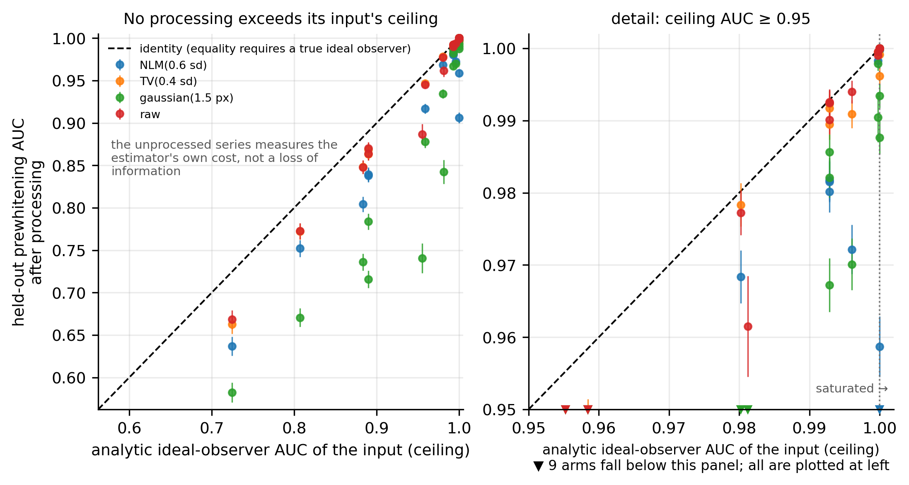
Figure 6. Cross-fitted prewhitening AUC after processing against the analytic ceiling of the unprocessed input, with the identity line, and a detail panel over the unsaturated range that marks the arms falling below its floor.
Figure 7. The kV–mAs detectability atlas and the operational floor, the contour where the input’s ideal d' crosses the prespecified criterion
Figure 8. Failure patterns by floor stratum: divergence, contrast erasure, excess lesion-like responses and mean task degradation, with clustered 95 % intervals
Figure 9. One held-out site at a quarter of the routine dose, lesion present and absent, unprocessed and after four denoisers, with the held-out d' and PSNR of each arm. The site is the admitted one whose anatomical structure is nearest the median of all admitted sites, and every panel shares one display window centred on the lesion-free reference, so no arm is flattered by its display. Images from LDCT-and-Projection-data (The Cancer Imaging Archive), CC BY 4.0, DOI 10.7937/9npb-2637
Figure 10. The real low-dose CT arm: task d' against PSNR for the nine held-out methods with the closed-form ceiling marked, and what raising network capacity 86-fold did to each

