Supplementary material
Cardiac period estimation from non-gated helical CT: sampling criteria and exploratory evaluation
Shuji Yamamoto, Institute of One, LISIT Co., Ltd., Tokyo 150-0044, Japan
This material records a run that is referred to in section 5.4 of the main text and is not used in any estimate there. It is included because the protocol was fixed before the data were fetched and the result should be visible whatever it turned out to be, and because the way it failed is the reason the main text now reports where the tracked border lies.

S1 The session, and the protocol fixed before it
A survey of 156 collections of The Cancer Imaging Archive found 1 session holding both a recorded heart rate and a free-running helical series of the chest: collection VAREPOP-APOLLO, patient AP-26JK, study described as a cardiac CTA. A gated acquisition in that session records 75.0 bpm, with a minimum of 72.0 and a maximum of 78.0 over its own duration, written into the free text of ScanOptions (0018,0022) rather than into HeartRate (0018,1088), which is empty. A helical series covering 630 mm at 208.7 mm/s, lasting 3.02 s, begins ten seconds later.
Before the images were downloaded, an interval for agreement was fixed at five per cent of the recorded rate, 71.25 to 78.75 bpm, in analysis/tcia_search/validation_protocol.md. Five per cent is the tolerance under which Nmin was measured; the range the scanner itself recorded is narrower, at four per cent of the mean. The unmodified pipeline was then run.

S2 What the run returned, and why it is not used
The pipeline returned 67.4 bpm, which is -10.2 per cent from the recorded rate and outside the interval. The frozen criterion rejected the series, on a leave-one-out spread of 28.1 bpm.
Neither figure is evidence about cardiac timing, because the extraction did not return the intended anatomical border (figure S1). The tracked position lies at 0.9 per cent of the image width, where a mediastinum in the cohort lies between 41 and 48 per cent, and at one coronal level it is constant to numerical precision across the whole scan. The acquisition runs from the chin to the pelvis with the arms at the sides; the method takes the left edge of the soft-tissue run crossing the midline of a coronal row, which is the mediastinal border only where a lung breaks that run.
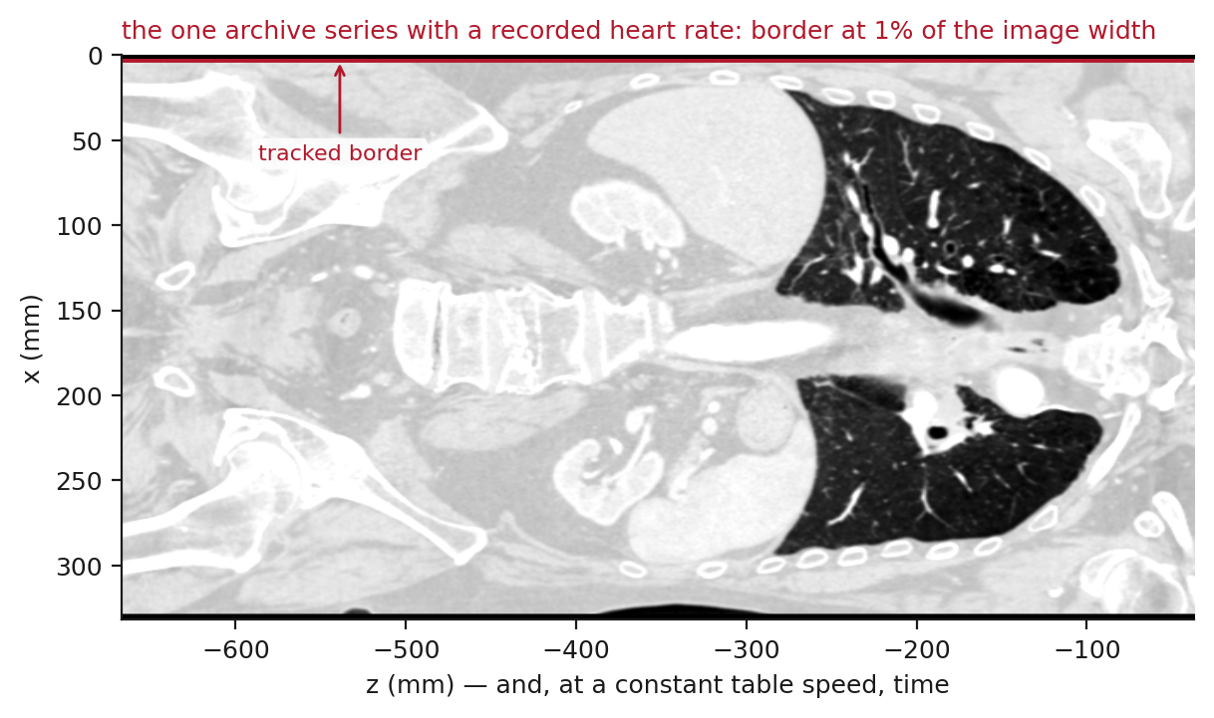
Figure S1. The coronal reformat of the series under test, at its own aspect, with the tracked border drawn on it. Compare figure 4 of the main text, where the same code follows the mediastinum between the two lungs.
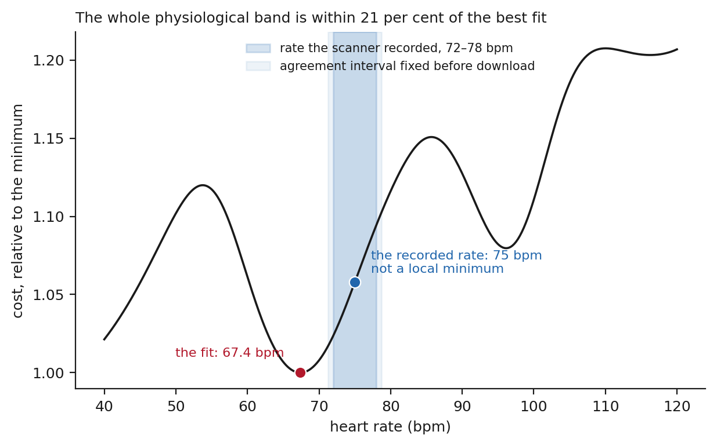
Figure S2. The objective of the joint fit across the physiological band for that series, normalised to its minimum, with the recorded rate and the interval fixed in advance marked. The recorded rate is not a local minimum, and the whole band lies within a fifth of the best fit. Since the trace is not of the intended structure, this says nothing about whether a cardiac period could have been recovered from a scan of this geometry; it is shown because the objective looked no different from those of section 5.3 until the image was drawn.

S3 What followed
analysis/check_border_position.py, which measures where the tracked border lies in every cached series, was written after this run and did not exist while the cohort was analysed. Applied to the cohort it finds 2 of 17 series within 10 per cent of the image edge, and 2 more closer to the edge than to the middle. All were rejected by the frozen criterion, and the 3 admitted series lie at 41 to 43 per cent.

S4 The uncertainty an estimator declares outside its training range
Sections 2 to 5 of the main text concern what an acquisition contains. This section asks a smaller and separate question, in simulation throughout: when an estimator is asked for an answer outside the range it was trained on, what does it report about its own reliability? It is included because an estimate is acted on together with whatever uncertainty accompanies it, so that uncertainty is itself something that has to be checked.

S4.1 The experiment
An estimator was trained on the same simulated traces to predict the period and, alongside it, its own standard deviation.¹ Modern networks are systematically overconfident,² and more so away from the training distribution;³ what is measured here is one such shift, produced by moving the test points outside the range of the target rather than by changing the dataset. Each trace has the same quartic baseline removed as elsewhere in this paper, is divided by its own standard deviation and is resampled to a fixed length, and the target is the period as a fraction of the trace length — the reciprocal of the cycles written — so the standard deviations quoted below are in those units. The model is a small multilayer perceptron with separate heads for the mean and the log variance, trained on 60000 traces by minimising the Gaussian negative log-likelihood; the architecture, the optimiser and the training schedule are set out in the supplementary material and in analysis/learned_estimator.py. Accuracy is scored on 2000 independent traces at each of nine cycle counts within the same 5 per cent tolerance as section 3, and calibration is the ratio of the error actually made to the standard deviation reported, so that 1 is honest and larger is overconfident.
Two models were trained, differing only in the range of traces they saw: one on 2.5 to 8.0 cycles, at or above the bound, and one on 0.5 to 8.0 cycles.
Because the target is a reciprocal, testing below the bound is testing outside the first model's training range. It saw targets between 0.125 and 0.4; at two cycles the correct answer is 0.5 and at half a cycle 2.0, five times the largest value it was ever shown. Its failures there are failures of extrapolation and establish nothing about the information in the trace. Both models are trained and tested on simulated traces only, and nothing in this section is evidence about real chest CT.

S4.2 What the two models report
At and above the bound the model trained there works, reaching 100 per cent accuracy. Below the bound it is wrong in every trial — 0 per cent accuracy at every cycle count tested — while reporting a standard deviation no larger than 0.045, so its calibration ratio there runs from 12.65 to 42.0: the error it makes is between twelve and forty times the uncertainty it declares. The declared uncertainty tightens as the accuracy stays at zero (figure 6). As the number of written cycles rises towards the bound the reported standard deviation falls and the accuracy does not move, so at two cycles the model is at its most certain and still never right, and nothing in what it returns marks those points as different from the ones it can serve.
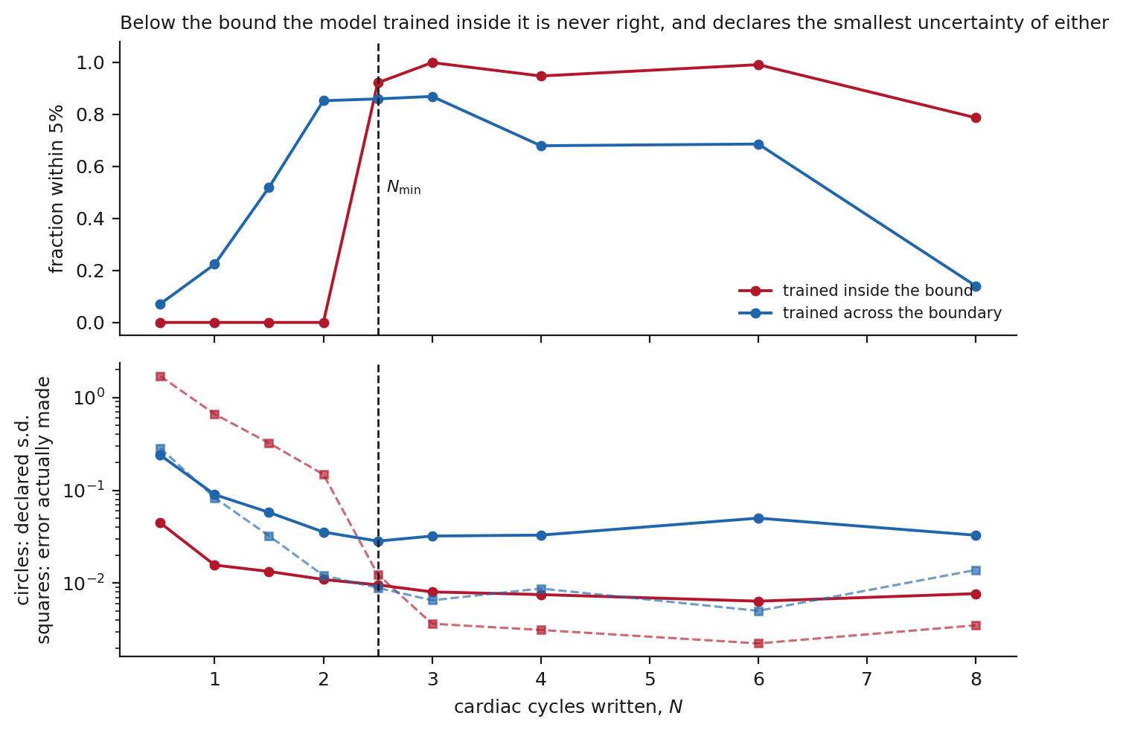
Figure S3. Top: the fraction of estimates within 5 per cent of the prescribed period, against cycles written, for a model trained only at or above the bound and for one trained across it. Bottom, on a logarithmic scale: the standard deviation each model declares (circles) and the error it actually makes (squares). Below Nmin, marked by the dashed vertical, the model trained inside the bound declares the smallest uncertainty of either while its error is largest — the gap between its circles and its squares is the overconfidence. Those test points lie outside the range of the target that model was trained on. The model trained across the boundary keeps the two together.
The model trained across the boundary behaves differently below the bound: its reported standard deviation widens to 0.239 as the cycles run out and its calibration ratio falls into 0.34 to 1.4, which is honest to conservative. Neither model abstains — both always return an estimate, and what differs is the uncertainty attached to it — so whether a scan is declined or flagged remains a decision for whoever deploys such an estimator, and one available to them only if the uncertainty means something.
Two qualifications limit what this comparison supports. The across-trained model also becomes accurate below 2.5 cycles, reaching 85 per cent at two. That is not a violation of the bound but the bound at a different value: Nmin depends on what the estimator knows about the waveform, and a network trained on this exact family of traces has been handed knowledge it would not have in a patient, which is why 2.5 remains the value at which I state the bound. Second, above the bound that model is the less accurate of the two, 87 against 100 per cent. That pair of numbers describes one architecture under one training protocol on one family of traces. It is a reason to measure the trade-off in a given estimator, not a general result that calibration costs accuracy.

S4.3 The estimator in full
Each trace has the same quartic baseline removed as every other estimator in this paper, is divided by its own standard deviation, and is resampled to 128 points, so the model sees one input shape and no absolute scale. The target is the period as a fraction of the trace length, that is the reciprocal of the cycles written; it is dimensionless, and the standard deviations reported in section 6 are in those units.
The model is a multilayer perceptron with three hidden layers of 256 units and rectified linear activations, ending in two linear heads for the mean and the log variance. It is trained by minimising the Gaussian negative log-likelihood with Adam for 40 epochs at a batch size of 256 on 60000 simulated traces. Accuracy is scored on 2000 independent traces at each of nine cycle counts, within the 5 per cent tolerance used in section 3. The learning rate and every remaining setting are in analysis/learned_estimator.py.
Two models were trained under this identical recipe, differing only in the range of cycle counts their traces spanned: 2.5 to 8.0 cycles for the one trained at or above the bound, and 0.5 to 8.0 for the one trained across it.

S5 The admitted series, level by level
Every usable coronal level of each series the frozen criterion admitted, drawn as a reformat at its own aspect with the tracked border on it. These are the images behind section 5.5. Each panel gives the level's position across the image, the excursion of its border, the share of slices for which the tracker returned nothing, and, where it occurs, the longest run of identical values.
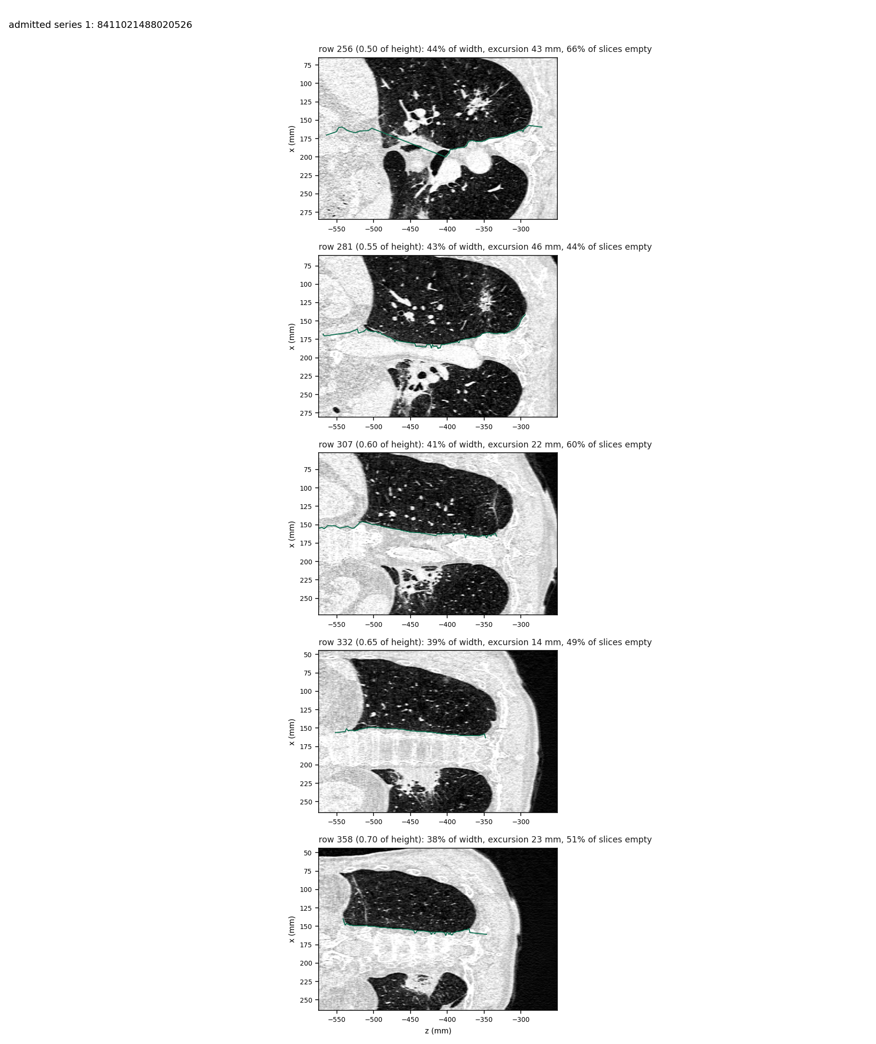
Figure S4. Admitted series 1, five usable levels.
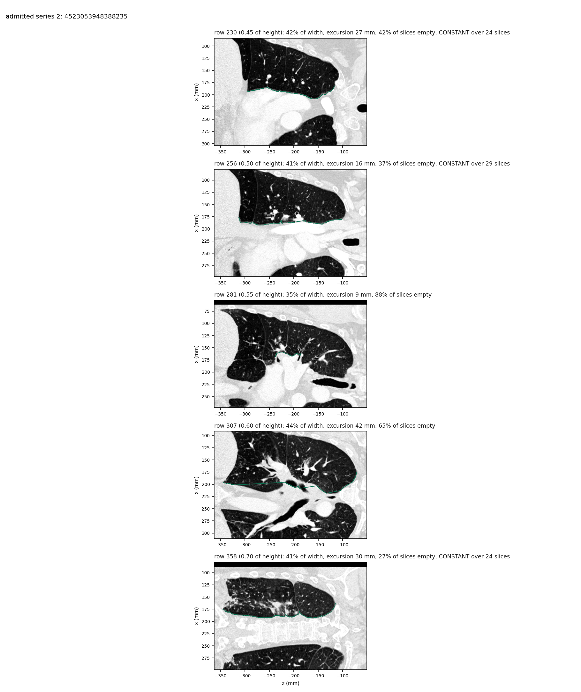
Figure S5. Admitted series 2, five usable levels.
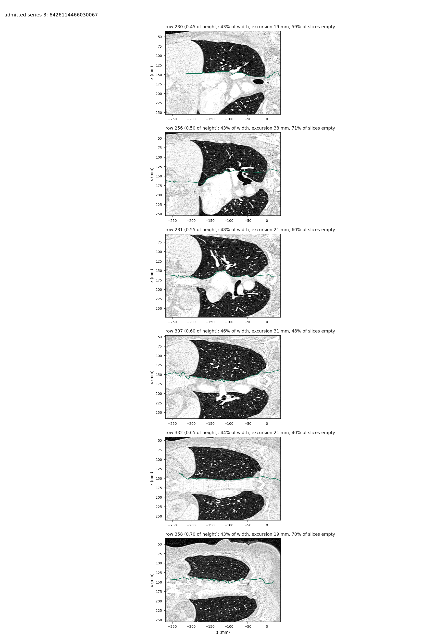
Figure S6. Admitted series 3, six usable levels. The tracked border continues past both ends of the lung, where the image is soft tissue on both sides of it; that is the series whose cycles fall from 2.77 to 1.68 when counted over the stretch where the border is at a lung interface.

Supplementary references
S1. Kendall A and Gal Y. What Uncertainties Do We Need in Bayesian Deep Learning for Computer Vision?. arXiv, https://doi.org/10.48550/arXiv.1703.04977 (2017, accessed 5 November 2026).
S2. Guo C, Pleiss G, Sun Y, et al. On Calibration of Modern Neural Networks. arXiv, https://doi.org/10.48550/arXiv.1706.04599 (2017, accessed 5 November 2026).
S3. Ovadia Y, Fertig E, Ren J, et al. Can You Trust Your Model's Uncertainty? Evaluating Predictive Uncertainty Under Dataset Shift. arXiv, https://doi.org/10.48550/arXiv.1906.02530 (2019, accessed 5 November 2026).

