Supplementary material
How much of a heartbeat a non-gated CT records: a header-computable sampling bound, and what a learned estimator does beyond it
Shuji Yamamoto, Institute of One, LISIT Co., Ltd., Tokyo 150-0044, Japan
This material records a run that is referred to in section 5.4 of the main text and is not used in any estimate there. It is included because the protocol was fixed before the data were fetched and the result should be visible whatever it turned out to be, and because the way it failed is the reason the main text now reports where the tracked border lies.

S1 The session, and the protocol fixed before it
A survey of 156 collections of The Cancer Imaging Archive found 1 session holding both a recorded heart rate and a free-running helical series of the chest: collection VAREPOP-APOLLO, patient AP-26JK, study described as a cardiac CTA. A gated acquisition in that session records 75.0 bpm, with a minimum of 72.0 and a maximum of 78.0 over its own duration, written into the free text of ScanOptions (0018,0022) rather than into HeartRate (0018,1088), which is empty. A helical series covering 630 mm at 208.7 mm/s, lasting 3.02 s, begins ten seconds later.
Before the images were downloaded, an interval for agreement was fixed at five per cent of the recorded rate, 71.25 to 78.75 bpm, in analysis/tcia_search/validation_protocol.md. Five per cent is the tolerance under which Nmin was measured; the range the scanner itself recorded is narrower, at four per cent of the mean. The unmodified pipeline was then run.

S2 What the run returned, and why it is not used
The pipeline returned 67.4 bpm, which is -10.2 per cent from the recorded rate and outside the interval. The frozen criterion rejected the series, on a leave-one-out spread of 28.1 bpm.
Neither figure is evidence about cardiac timing, because the extraction did not return the intended anatomical border (figure S1). The tracked position lies at 0.9 per cent of the image width, where a mediastinum in the cohort lies between 41 and 48 per cent, and at one coronal level it is constant to numerical precision across the whole scan. The acquisition runs from the chin to the pelvis with the arms at the sides; the method takes the left edge of the soft-tissue run crossing the midline of a coronal row, which is the mediastinal border only where a lung breaks that run.
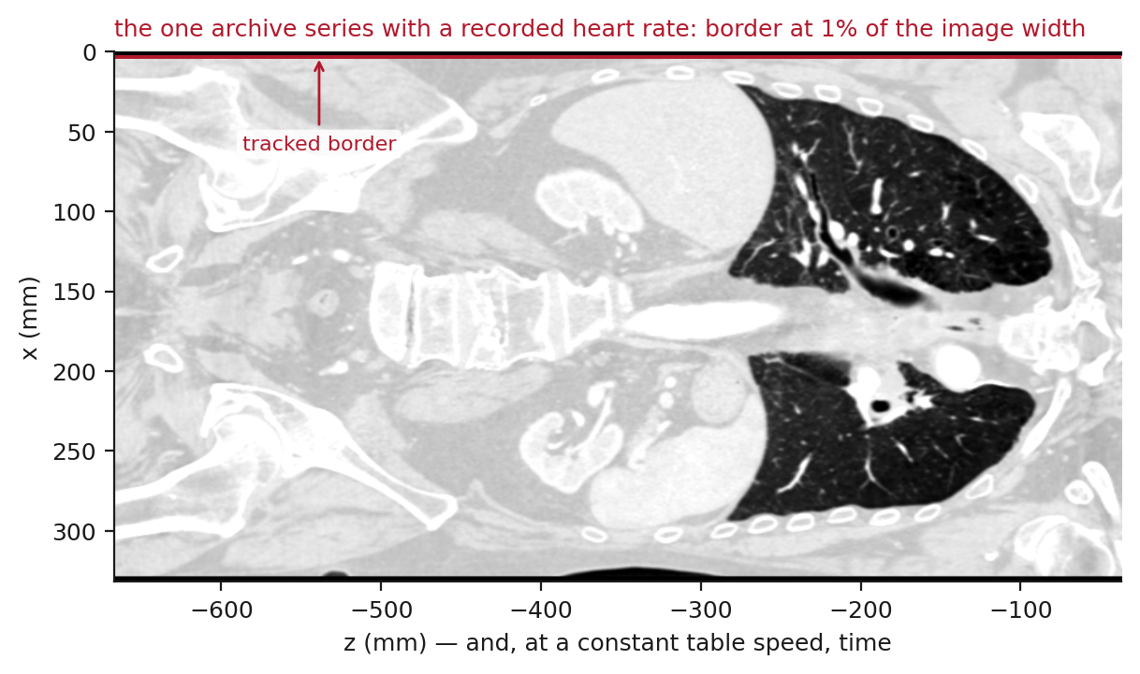
Figure S1. The coronal reformat of the series under test, at its own aspect, with the tracked border drawn on it. Compare figure 5 of the main text, where the same code follows the mediastinum between the two lungs.
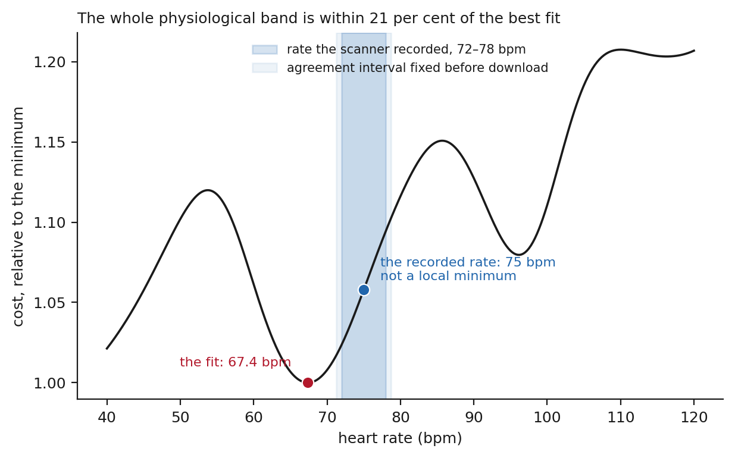
Figure S2. The objective of the joint fit across the physiological band for that series, normalised to its minimum, with the recorded rate and the interval fixed in advance marked. The recorded rate is not a local minimum, and the whole band lies within a fifth of the best fit. Since the trace is not of the intended structure, this says nothing about whether a cardiac period could have been recovered from a scan of this geometry; it is shown because the objective looked no different from those of section 5.3 until the image was drawn.

S3 What followed
analysis/check_border_position.py, which measures where the tracked border lies in every cached series, was written after this run and did not exist while the cohort was analysed. Applied to the cohort it finds 2 of 17 series within 10 per cent of the image edge, and 2 more closer to the edge than to the middle. All were rejected by the frozen criterion, and the 3 admitted series lie at 41 to 43 per cent.

