How much of a heartbeat a non-gated CT records: a header-computable sampling bound, and what a learned estimator does beyond it
Shuji Yamamoto
Institute of One, LISIT Co., Ltd., Tokyo 150-0044, Japan
ORCID 0000-0001-9211-1071. E-mail: yamamoto@lisit.jp

Abstract
Objective. Deep-learning methods read the heart in non-gated chest CT, yet none of the 18 public series analysed here records the heart rate by any of 11 routes, so they cannot be checked against one. We ask what such an acquisition can contain about cardiac timing.
Approach. A helical scan advances the table at constant speed, so its z axis is a time axis along which a periodically moving structure writes its period. We derive the recoverability condition, measure the cycles it requires over 144 simulated conditions, evaluate it on 192 real series from headers alone, test it on 17 image series under a criterion frozen in advance, and train an estimator that reports its own uncertainty.
Main results. Cycles written and samples per cycle multiply to L/dz: speed only divides a fixed budget. Nmin = 2.5 cycles for one estimator; at an assumed cardiac extent, 67 per cent of real series could record a rate below 100 bpm. On images 3 of 17 were admitted, agreeing with the header prediction on 29 per cent. Those admissions sit at the same minimum depth as the rejections, and their coronal levels disagree by 44–59 bpm within a series. The one archive session recording a rate could not be used: there the extraction did not return the intended border. In simulation, an estimator trained inside the bound was never accurate outside it while reporting a standard deviation below 0.045.
Significance. The bound is computable from the header and, under stated assumptions, identifies acquisitions that do not meet the sampling criterion defined here; meeting it does not guarantee recovery. A stability statistic certifies nothing unless reported with the depth of the minimum and a check on what was fitted.

1. Introduction
Chest CT is acquired in very large numbers, and lung cancer screening alone has made it a population-scale examination (National Lung Screening Trial Research Team 2011). The heart is in every one of those scans, and automated methods increasingly read it: fully automated deep-learning coronary calcium scoring now runs on non-gated low-dose chest CT (Kim et al 2025), and its output depends on the acquisition parameters of the scan it is given (Chen et al 2026). In the gated setting, deep learning is also used to remove cardiac motion from the images themselves (Ren et al 2022).
A method of that kind makes a claim about a heart that was never synchronised to the scanner. The obvious way to check such a claim is to compare it with the rate the scanner recorded, and that comparison is not available: of the 18 series whose images we analysed, 0 record the rate by any of 11 routes through which a CT acquisition can write one.
Rather than assess any particular method, we ask what the acquisition can contain. Recovering timing from the image itself is not a new idea in CT. Reconstruction correlated with a recorded electrocardiogram came first (Kachelrieß and Kalender 1998), and was then replaced by a signal read out of the projection data — the kymogram (Kachelrieß et al 2002) — and later by gating estimated from the reconstructed images themselves (Rohkohl et al 2008). The same idea carried small-animal imaging, where respiratory and cardiac gating without a physiological monitor became routine (Badea et al 2004, Bartling et al 2007). Every one of those settings has an acquisition that dwells: a cardiac or micro-CT protocol writes many cycles into the data. That line of work largely stops around 2009.
A separate literature treats the heart in non-gated chest CT, but structurally — thrombus, calcification, aortic root, incidental infarct, epicardial fat. Gating inferred from the data rather than from a monitor has continued elsewhere, in MRI (Larson et al 2003) and in PET, where it now outperforms device-based gating (Walker et al 2020), but not in helical CT of the chest. We found no indexed report that recovers cardiac timing from a non-gated helical CT, and none that states the condition under which it could be recovered.
This paper derives that condition, measures the one constant it depends on, evaluates it against the installed base from headers alone, tests it on images under a criterion frozen in advance, and examines what a learned estimator reports outside its training range. Its central results are negative, and the most useful of them is about how much confidence a criterion and an estimator can express without either being warranted.

2. Theory

2.1 The z axis of a helical scan is a time axis
In a helical acquisition the table advances at a constant speed S while the gantry rotates, so the axial coordinate of the reconstructed volume and the time of acquisition are related by z = St. The scale is known exactly from the header, and it is the same for every voxel at a given z whatever its row or column: a slice is a slice of time as much as of anatomy.
A structure that moves periodically with period T therefore writes that period into the volume as a spatial period along z,
λ = S T.
For the heart this is the wavy left mediastinal silhouette familiar from a coronal reformat, which is usually read as a motion artefact. It is also a record of the cardiac cycle, written whether or not an electrocardiogram was connected. Below the heart the same silhouette continues as the descending aorta against the left lung, extending the length over which the wave is available.

2.2 The recoverability window
Whether λ can be recovered is a sampling question with two sides that pull against each other.
The scan must be slow enough that more than one cycle is written across the structure. If the available craniocaudal extent is L, the number of cycles written is N = L/λ = L/(ST), and measuring a period requires N to exceed some Nmin. This places an upper limit on S.
The scan must be fast enough that each cycle is spread across enough reconstructed samples to be resolved. With reconstruction interval dz, the samples per cycle are n = λ/dz = ST/dz, and this must exceed some nmin. This places a lower limit on S.
The value of nmin is a judgement and is the one such number in this analysis. Two samples per cycle is the formal floor and is not usable, because a two-sample sinusoid is a straight line to any estimator with noise in it. We take eight throughout, and the sweep of section 3 covers 8, 16 and 32 samples per cycle so that the effect of the choice on Nmin can be read off rather than assumed. Nothing in the budget identity below depends on it.
Together they define a window in table speed, in closed form, for a given L, dz and heart rate. The trade-off itself is old — pitch has always been chosen against longitudinal sampling (Wang and Vannier 1997, Kalender 2006) — but the quantity being traded here is cardiac timing rather than spatial resolution. Everything the window needs is in the DICOM header of any helical acquisition: table speed (0018,9309), or equivalently spiral pitch factor (0018,9311) with total collimation (0018,9307) and revolution time (0018,9305). No image and no patient information is required to say whether a given scan could carry the signal.
One ambiguity has to be closed explicitly. The spiral pitch factor of the IEC convention is table travel per rotation divided by the total collimated width, whereas the convention in use on four-row scanners divided by a single row width; the two differ by the number of rows. The implementation converts between them rather than accepting either silently.

2.3 The budget identity
Multiplying the two quantities removes the heart rate and the table speed at once:
N × n = (L/ST) × (ST/dz) = L / dz.
The product of cycles observed and samples per cycle is fixed by the anatomy and the reconstruction interval alone. It does not depend on pitch, on rotation time, or on how fast the heart is beating. A protocol cannot acquire more cardiac timing by running faster or slower; it can only divide a fixed budget between seeing more cycles and resolving each one better. Making a scan slower buys cycles at the cost of resolution within a cycle, and making it faster does the reverse.
This is why the question has a definite answer for each protocol, and why the answer is computable before any image exists (figure 1). It also locates the one quantity the condition still needs: the window is bounded by Nmin, and Nmin is not given by the geometry. Section 3 measures it.
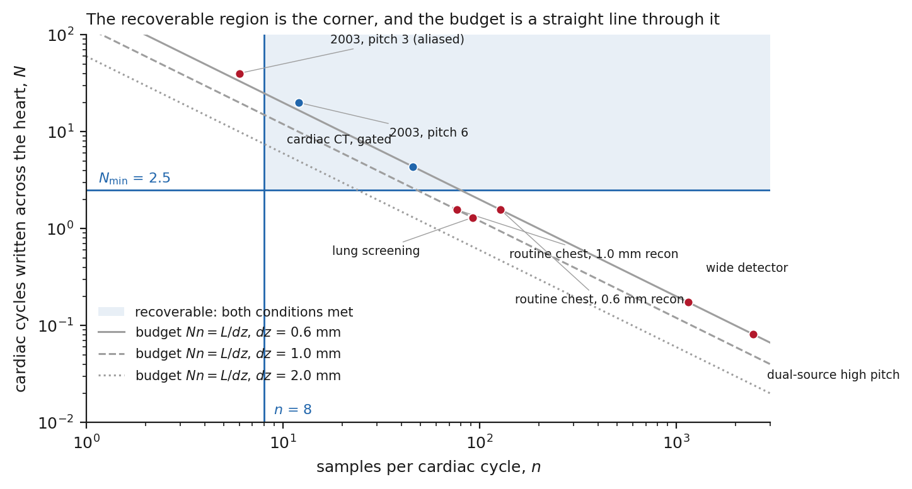
Figure 1. Cycles written across the heart against samples per cardiac cycle, at 60 bpm, on logarithmic axes. Each protocol is a point; the grey lines are the budget N n = L/dz for three reconstruction intervals, and a protocol can move only along its own line. The shaded corner is the region in which both conditions hold, bounded below by Nmin = 2.5 cycles and on the left by n = 8 samples per cycle. Blue points satisfy both conditions, red points fail at least one. The two 2003 four-row protocols are the acquisitions from which this problem originally arose; the modern chest protocols sit an order of magnitude to the right and below the bound, having spent the whole budget on resolution within a cycle.

3. How many cycles are needed

3.1 Simulation design
How precisely a frequency can be estimated from a finite record is a classical question, and the answer depends on the observation length, the signal-to-noise ratio and the estimator (Rife and Boorstyn 1974). What that theory does not give is the number of cycles at which a particular estimator, reading a particular signal, starts to succeed in practice. Nmin is a property of the estimation problem — of noise, of how well the cardiac border can be located against lung and mediastinum, and of how far a real rhythm departs from a fixed period — so it was measured rather than assumed. A periodic border trace was generated with a prescribed period, a polynomial baseline standing for anatomy, additive noise, and beat-to-beat variability, and the period was estimated from it. Recovery was scored against the prescribed period at a tolerance of 5 per cent, and Nmin for a condition was taken as the smallest number of written cycles at which at least 90 per cent of 200 trials succeeded.
The sweep covered 144 combinations, the full grid of 4 noise levels from 0.05 to 0.4 of the wave amplitude, 4 baseline strengths from zero to 2.0 times it, 3 sampling densities of 8, 16 and 32 samples per cycle, and 3 degrees of beat-to-beat variability up to 0.1 of the period. The central condition against which the headline is quoted is noise 0.1, baseline 1.0, 16 samples per cycle and variability 0.05. Reporting the whole grid rather than the central cell is what makes the value a plateau rather than a point.

3.2 How far Nmin moves with the estimator, and with the conditions
Two estimators were run over the same traces: one matched to the generating model, and one using only the fundamental of the trace. The matched estimator reaches 1.5 cycles and the fundamental estimator 2.5 cycles. The remainder of this paper uses 2.5, because the matched value assumes knowledge of the waveform that no real trace supplies, and a bound should be stated at the value a usable estimator can attain.
The figure is stable across the sweep (figure 2): 116 of the 144 cells return exactly 2.5, and the worst cell anywhere in the sweep returns 3.5.
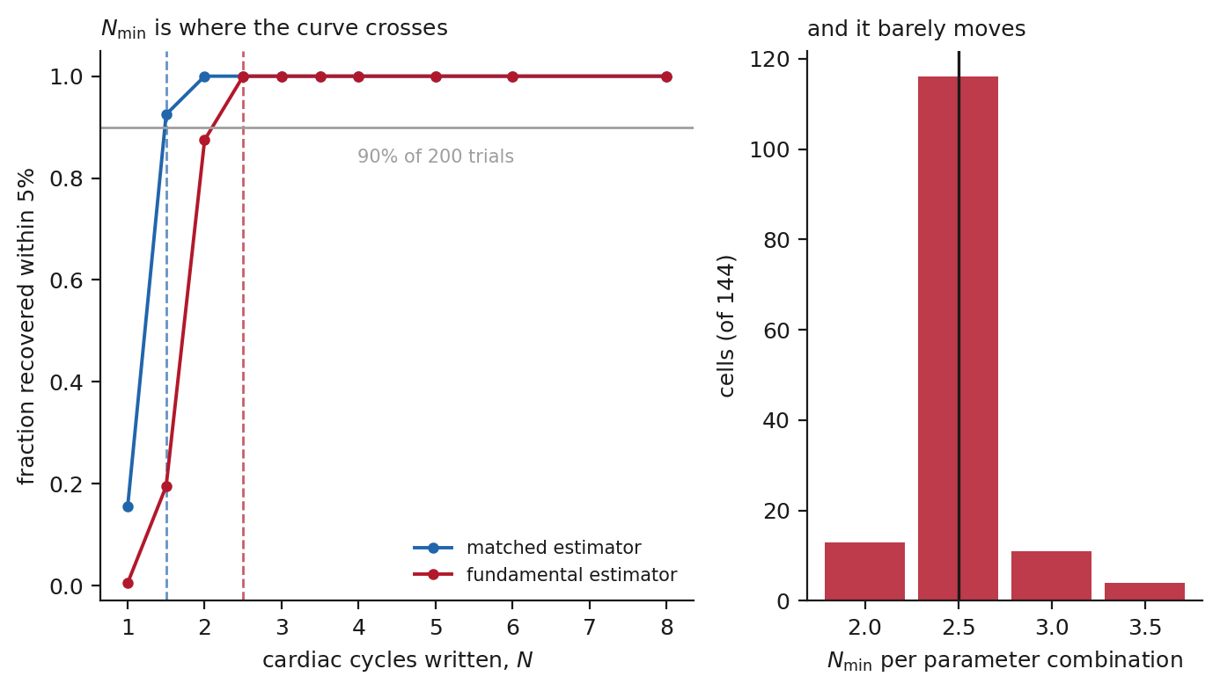
Figure 2. Left: the fraction of 200 trials in which the prescribed period was recovered to within 5 per cent, against the number of cycles written, for the matched and the fundamental estimator at the central parameter condition. Nmin is where each curve crosses 90 per cent, marked by the dashed verticals at 1.5 and 2.5 cycles. Right: Nmin obtained independently in each of the 144 cells of the sensitivity sweep. The constant is a plateau, not a point estimate. The regime that degrades it is coarse sampling within a cycle combined with high noise, which is the corner in which the budget identity of section 2.3 says the two requirements are already competing for the same fixed product.

4. Where real protocols fall

4.1 Half of the public archive cannot be asked
Evaluating the condition needs only header fields, but they have to be published. Of 13 public collections probed in The Cancer Imaging Archive (Clark et al 2013) for acquisition parameters, 6 publish them and 7 do not. For the latter the question cannot be put at all — not because the scans fail the condition, but because nothing in the archive says what the table was doing.
This is worth stating plainly because it bounds any future study of the same kind, including the validation of motion-correction methods that this paper is about. A collection that omits table speed, pitch, collimation and rotation time cannot support a claim about what its scans could or could not have recorded.

4.2 Table speeds and thresholds
The 192 series come from 94 patients in 5 of the 6 collections that publish the parameters, with at most 40 series taken from any one of them so that a single large collection cannot set the distribution. 4 reach that cap and the fifth contributes 32. Table speed runs from 30.0 to 158.8 mm/s, a factor of 5.3, with a median of 55.0 mm/s.
Because faster hearts write more cycles into the same distance, each protocol has a lowest rate it can record. Over the cardiac border alone that threshold has a median of 69 bpm, ranging from 38 to 198 bpm, and 128 of 192 series — 67 per cent — have a threshold below 100 bpm. Using the longer extent available along the descending aorta, the median threshold falls to 28 bpm and 100 per cent of series qualify.
Under the assumptions used here, most of the installed base clears the threshold (figure 3). Because the patients’ own rates are not recorded, that is a statement about what those protocols could record, not a count of acquisitions that did satisfy the condition. It is enough to make section 5 worth performing.
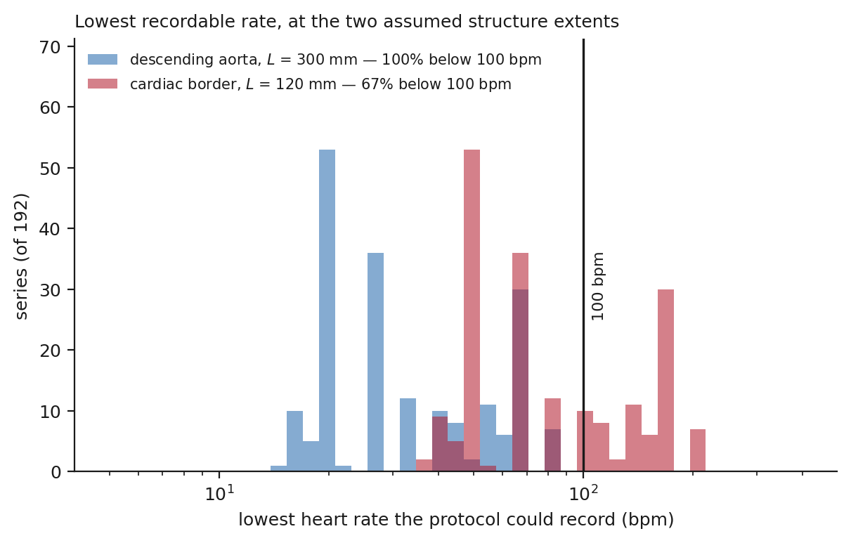
Figure 3. The lowest heart rate each of the 192 real chest CT series could record, computed from its header alone at Nmin = 2.5 cycles, over the cardiac border (L = 120 mm) and over the descending aorta (L = 300 mm). The vertical line is 100 bpm: series to its left could record any physiological rate above their own threshold.
The exceptions are instructive. A wide-detector protocol at 691.2 mm/s has a threshold of 864 bpm, and a dual-source high-pitch protocol at 1474.6 mm/s a threshold of 1843 bpm. Both are far above any physiological rate: these acquisitions cross the heart so quickly that less than one full cycle is written, so the record contains no repetition for anything to measure. That is a statement about the data rather than about any particular estimator, and it is the one place in this paper where such a statement is available.

5. Meeting the threshold does not produce a period

5.1 A cohort under a frozen criterion
The cohort comprised 18 series, of which 17 yielded a volume the extraction could read; the remaining 1 is reported as a technical failure and enters no count. They are drawn from the same 192 series evaluated in section 4 — all 18 of them — one series per patient, so 18 patients contribute one each and no patient appears twice. 3 of them were the pilots on which the extraction was developed, and they are retained rather than dropped because removing them after the fact would be a choice made with the outcomes visible.
A series was admitted when the joint fit spanned at least Nmin = 2.5 cycles, was not pinned at either edge of the physiological band, drew on at least three usable coronal levels, moved by no more than 10 bpm when any one level was dropped, and left a median residual below the amplitude it had fitted. Those thresholds were written down before any series beyond the three pilots was fitted.
One detail of that first condition matters and is easy to miss. The implementation counts cycles over the z span actually analysed, not over L, the extent of the structure that section 2 says can carry the motion. For this cohort the two are close: the analysed spans run from 256 to 654 mm with a median of 324 mm against an aortic extent of 300 mm, and the same 16 series clear Nmin either way. It is stated here because for the one series in section 5.4 the two differ by a factor of two.
What the fit reads is a one-dimensional trace of that border against z (figure 4). At each slice of a coronal row, the candidates are the runs above -300 HU that cross the row's midline and are at least 25 mm wide, and the border is the left edge of the chosen run. The border is followed rather than chosen independently on each slice: tracking begins in the middle of the scan where the mediastinum is widest, each slice takes the candidate nearest to the previous one, and a slice with no candidate within 6 mm is left empty rather than filled with the nearest available structure. 6 rows are used, at fractions 0.45 to 0.7 of the image height, and every one of them is reported rather than the clearest.
The period is fitted to all levels at once. Writing u = (z − z₀)/λ, with λ = ST the spatial period of section 2.1, and v = (z − z₀)/span, each level is modelled as a sinusoid on a quartic baseline, a cos 2πu + b sin 2πu + c₀ + c₁v + c₂v² + c₃v³ + c₄v⁴, whose coefficients are solved by least squares at each trial period; amplitude and phase are therefore free per level while the spatial period λ is common, because there is one heart and because in a helical scan the time coordinate is a function of z alone, so every level shares it exactly. The joint cost at a period is the sum over levels of the residual sum of squares, each weighted by the reciprocal of that level's variance, so a level with a large anatomical swing does not outvote the others. The spatial period is taken as the minimiser over 600 points spanning 40 to 120 bpm at the header's table speed; that band is physiological, and is never set by what the data prefer.
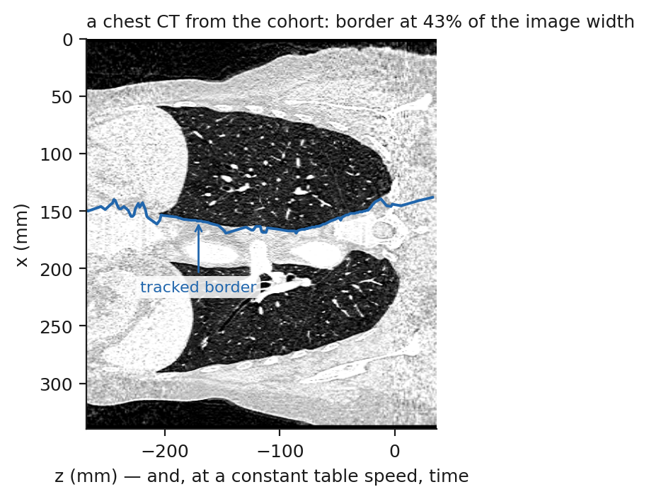
Figure 4. A coronal reformat from one of the admitted series, at its own aspect — one millimetre along z is one millimetre along x — with the tracked border drawn on it. The border follows the mediastinum between the two lungs, which is the structure the method is defined on. Its position, 43 per cent of the image width here, is what section 5.4 measures for every series.
What that criterion measures is self-consistency. Leave-one-out movement and residual size both ask whether the fit holds still; neither compares the fitted rate with the patient's. No series here records one (section 5.4), so correctness was not available to be tested, and the criterion should not be read as if it had been.
3 of the 17 series met it. The header-level condition predicted 13 of them to be recoverable at a ceiling of 100 bpm, and 2 of those 13 were admitted.
The pre-specified summary was the agreement between prediction and outcome, not the admission rate. The two agreed on 5 of 17 series, 29 per cent.
That number needs reading carefully, and we state it descriptively rather than as a test. The prediction is a header-level statement about whether a rate below 100 bpm could in principle be written; the outcome is a self-consistency verdict that never sees a true rate. They are not two measurements of the same thing, so their disagreement is not evidence that either is wrong, and we attach no null distribution to it. What the low agreement does establish is the negative it was designed to catch: the admissions are not tracking the acquisition parameter that the bound says should govern them, so whatever the criterion is responding to, it is not the quantity the header predicts. Sections 5.3 and 5.4 examine what it is responding to instead.

5.2 How real traces differ from the simulated ones
The border traces of the real series do not merely fit worse than simulated ones, they differ in kind. Comparing 85 real traces with 85 simulated ones, 88 per cent of the real signal sits in the smooth baseline the fit removes, against 12 per cent of the simulated signal, and the spread of band power across levels is 7.5 times wider in the real traces (0.625 against 0.083). A real trace is mostly anatomy, and how much of it is anatomy varies from level to level in a way the simulation never produced.
5 properties were measured on both populations: the share of the signal removed by the quartic baseline, the fraction of the remaining power inside the physiological band, that band's enrichment over the rest of the spectrum, the rate of large slice-to-slice steps, and the drift of the wave's amplitude across the scan. Two of the five separate the populations sharply. The baseline share is the one quoted above. The other is the amplitude drift: a real trace's wave grows or shrinks by a median factor of 1.47 from one end of the scan to the other, against 1.04 in simulation, so the amplitude the fit assumes to be constant is not. Large steps are absent from the median trace in both populations but reach 2.0 per hundred slices at the ninetieth percentile of the real ones, against 0.0 in simulation.
These are differences, not causes. We did not put any of them back into the simulator to see whether the failure reappears, and this section should not be read as having excluded them. It establishes that the signal the estimator was designed for is not the signal it is given, and section 5.3 reports a property of the objective that is measured rather than inferred.

5.3 The objective is nearly flat, and the criterion never looked
The criterion asks whether the argmin moves. It does not ask whether the cost surface has a minimum worth finding. Those are different questions whenever the surface is flat, and the following measurement was not part of the frozen analysis; it was added after the fact, for the reason given in section 5.4.
Measure the depth of the minimum as the median cost across the whole physiological band divided by the cost at the period the fit returned. A value of 1.00 would mean the chosen period fits no better than an arbitrary one.
Across the cohort the depth is 1.072 at the median of the rejected series, ranging from 1.012 to 1.465. The 3 admitted series lie inside that range, at 1.106 to 1.142: the period chosen in an accepted series reduces the weighted residual by about a tenth relative to a typical period in the band, which is what the rejected series do as well. On this measure the admissions are not distinguishable from the rejections.
They are also not consensus (figure 5). In each of the 3 admitted series the six coronal levels, fitted independently, prefer rates whose spread — the largest minus the smallest within that series — is 44 to 59 bpm. The joint fit imposes one period on levels that individually disagree by half the physiological range, and returns their weighted compromise.
What follows from this is about the criterion, and we are careful about how far it goes. Two things are measured: the minima the criterion accepted are no deeper than those it rejected, and the levels it combined did not agree. Neither measurement uses a true rate, so neither can show that the three admitted rates are wrong. What they do show is that the criterion admitted them without evidence that they are right, which is a different and weaker claim than the one a reader would take from the word "recovered".
A natural explanation of how that happens is that a flat objective leaves the minimiser unpinned, so removing one level moves it very little, and the leave-one-out test then reports stability that reflects the shape of the objective rather than the strength of a signal. That account is consistent with everything reported here — shallow minima, disagreeing levels, and stable leave-one-out values occurring together — but co-occurrence is not demonstration, and we have not constructed the experiment that would separate the flatness from the stability. We therefore offer it as an explanation to be tested, and rest the conclusion on the measurements rather than on the mechanism.
One reading it does weaken is that the extraction simply locks onto the wrong peak. With the best period fitting only about a tenth better than a typical one, there is no peak in these objectives sharp enough for that description to be apt.
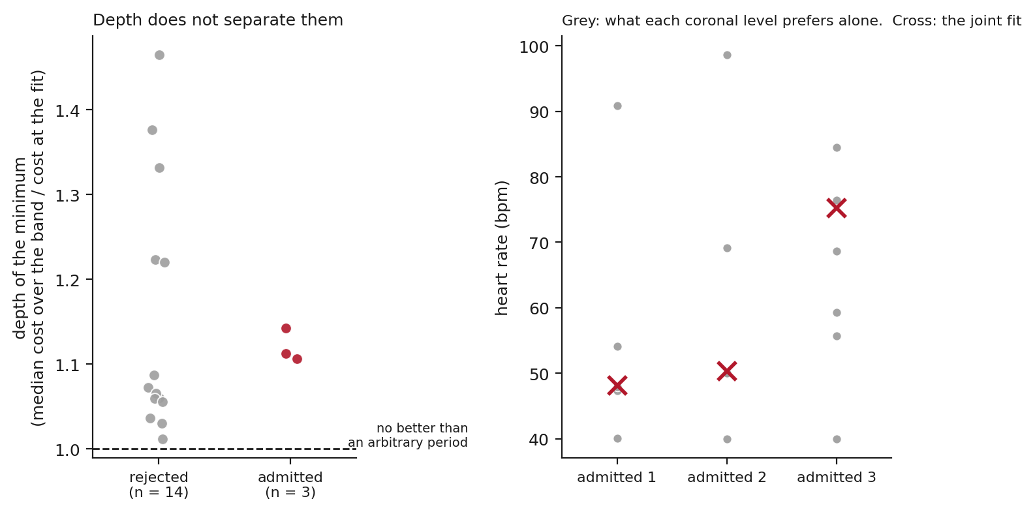
Figure 5. Left: depth of the minimum, defined as the median cost across the physiological band divided by the cost at the period returned, for the series the frozen criterion rejected and for those it admitted. A value of 1.0, the dashed line, would mean the chosen period fits no better than an arbitrary one. The admitted series lie inside the range of the rejected ones. Right: for each admitted series, the rate each of the six coronal levels prefers when fitted alone (grey), against the rate the joint fit returns (cross). The joint fit reports a compromise among levels that do not agree.

5.4 A candidate session with a recorded rate, which could not be used
A criterion that cannot be compared with a true rate can be diagnosed but not convicted, so we searched for a session that records one. Of 156 collections in The Cancer Imaging Archive, 102 hold CT and 57 studies are described as a cardiac examination; 2 sessions record a rate in the header, and 1 contains both a recorded rate and a free-running helical series of the chest.
The rate is not where a reader would look for it. HeartRate (0018,1088) is empty throughout; the scanner writes the rate into the free text of ScanOptions (0018,0022) as a minimum, maximum and average in bpm. A survey restricted to the standard cardiac fields concludes that no public CT records the rate, and is wrong; the count in section 4 was repeated over 11 routes for that reason. In that session a gated acquisition records 75.0 bpm, between 72.0 and 78.0 over its own duration, and a helical series covering 630 mm at 208.7 mm/s begins ten seconds later.
The series could not be used. The extraction did not return the anatomical border the method is defined on. Its tracked position lies at 0.9 per cent of the image width, where a mediastinum in this cohort lies between 41 and 48 per cent, and at one coronal level the value is constant to numerical precision across the whole scan. What structure it locked onto instead is not established. Nothing in the pipeline indicated the failure: the fit converged, the residual test passed and the leave-one-out values clustered, and only two levels departing to the edge of the physiological band kept the series out. The run is reported in the supplementary material with the protocol that was fixed before it, and it does not enter any estimate of recovery accuracy.
Having found it in one series, we measured it in all of them. Of the 17 analysed cohort series, 2 sit within 10 per cent of the image edge and 2 more sit closer to the edge than to the middle. All of the affected series were rejected by the frozen criterion, and the 3 admitted series lie at 41 to 43 per cent, so section 5.3 is unaffected: those three fits are of the intended structure, and they are still not evidence of recovery. The check that measures this, analysis/check_border_position.py, did not exist while the cohort was being analysed.

6. What an estimator does past the bound
Sections 2 to 5 concern what an acquisition contains. This section concerns something separate: what an estimator reports about its own reliability when it is asked for an answer outside the range it was trained on. It is a simulation experiment throughout.

6.1 A model that reports its own uncertainty
An estimator was trained on the same simulated traces to predict the period and, alongside it, its own standard deviation (Kendall and Gal 2017). Reporting an uncertainty is what makes the experiment informative: a point estimate that is wrong outside the bound is unsurprising, whereas an uncertainty that stays small while the estimate is wrong is a property one can measure and act on. That such reports are systematically too confident is established for modern networks in general (Guo et al 2017), and the gap widens when the input is drawn from outside the training distribution (Ovadia et al 2019); what is measured here is one such shift, produced by moving the test points outside the range of the target the model was trained on. Accuracy is counted at the same 5 per cent tolerance used in section 3, and calibration is the ratio of the error actually made to the standard deviation reported, so that 1 is honest and larger is overconfident.
The design, because the reported figures are meaningless without it. Each trace has the same quartic baseline removed as in every other estimator here, is divided by its own standard deviation, and is resampled to 128 points, so the model sees one input shape and no absolute scale. The target is the period as a fraction of the trace length, that is the reciprocal of the cycles written; it is dimensionless, and the standard deviations reported below are in those units. The model is a multilayer perceptron with three hidden layers of 256 units and rectified linear activations, ending in two linear heads for the mean and the log variance, trained by minimising the Gaussian negative log-likelihood with Adam for 40 epochs at a batch size of 256 on 60000 simulated traces. Accuracy is scored on 2000 independent traces at each of nine cycle counts, within the same 5 per cent tolerance as section 3. The learning rate and every other setting are in analysis/learned_estimator.py.
Two training conditions were compared, differing only in the range of traces they saw: one drawing on traces between 2.5 and 8.0 cycles, at or above the bound, and one drawing on 0.5 to 8.0 cycles. Everything else about them is identical.
Because the target is a reciprocal, testing below the bound is testing outside the training range, and that is what this experiment measures. The model trained at or above the bound saw targets between 0.125 and 0.4; at two cycles the correct answer is 0.5 and at half a cycle it is 2.0, five times the largest value it was ever shown. Its failures below the bound are therefore failures of extrapolation, and they do not establish that the trace contains nothing — the model trained across the boundary, which saw targets up to 2.0, recovers the period at two cycles. What the comparison isolates is not the information in the signal but what each model reports about its own reliability where it was not trained.
Both are trained and tested on simulated traces only. Nothing in this section is evidence about real chest CT.

6.2 Trained inside the bound, confident outside it
At and above the bound the model trained there works, reaching 100 per cent accuracy.
Below the bound it is wrong in every trial — 0 per cent accuracy at every cycle count tested — while reporting a standard deviation no larger than 0.045. Its calibration ratio there runs from 12.65 to 42.0: the error it makes is between twelve and forty times the uncertainty it declares.
The declared uncertainty tightens as the accuracy stays at zero (figure 6). As the number of written cycles rises towards the bound, the reported standard deviation falls and the accuracy does not move, so at two cycles the model is at its most certain and still never right. Every one of those test points asks for a target larger than any it was trained on, and nothing in what the model returns marks them as different from the points it can serve.
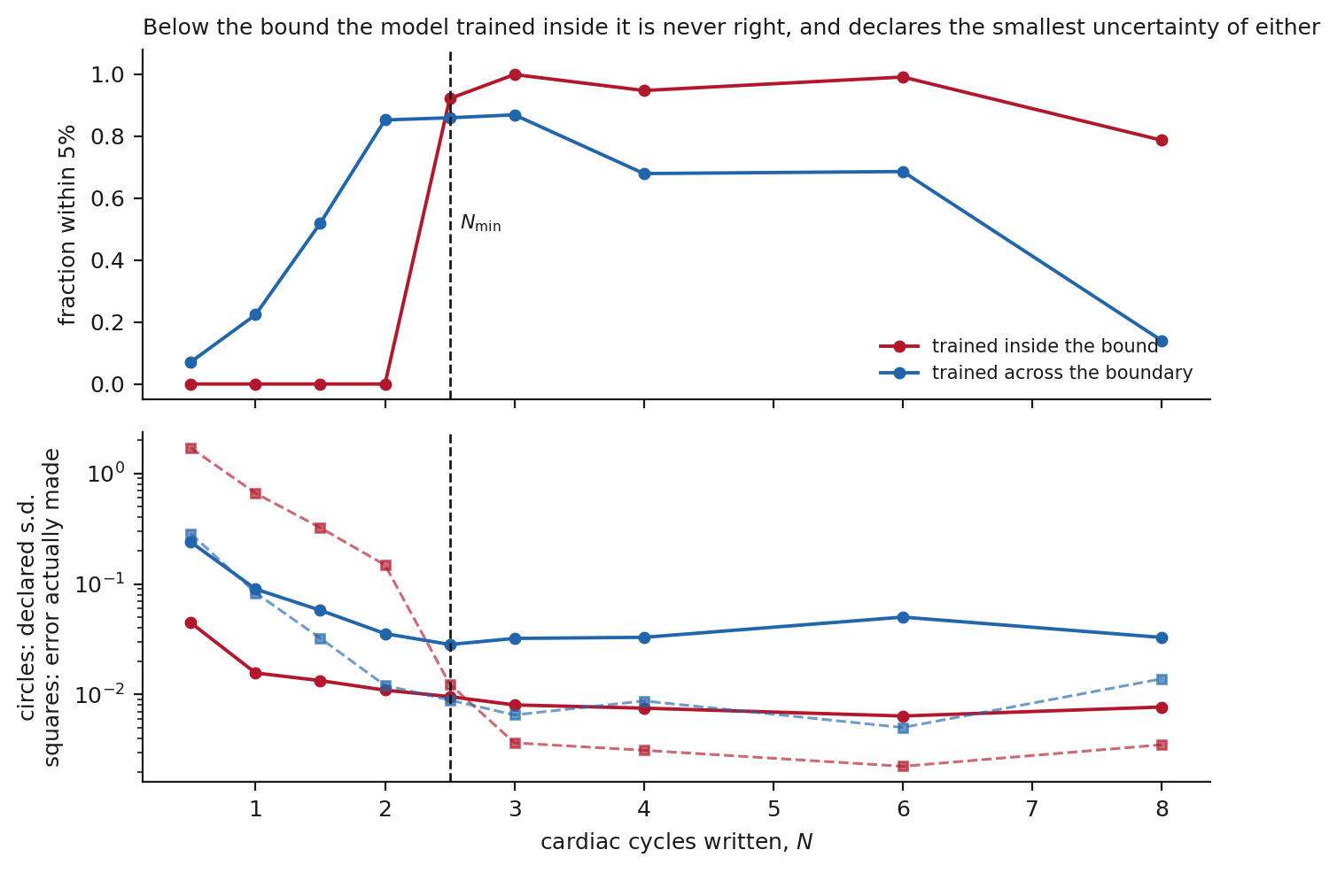
Figure 6. Top: the fraction of estimates within 5 per cent of the prescribed period, against cycles written, for a model trained only at or above the bound and for one trained across it. Bottom, on a logarithmic scale: the standard deviation each model declares (circles) and the error it actually makes (squares). Below Nmin, marked by the dashed vertical, the model trained inside the bound declares the smallest uncertainty of either while its error is largest — the gap between its circles and its squares is the overconfidence. Those test points lie outside the range of the target that model was trained on. The model trained across the boundary keeps the two together.

6.3 Trained across the boundary, it widens its uncertainty — and pays for it
Trained on the whole range, the same architecture behaves differently below the bound: its reported standard deviation widens to 0.239 as the cycles run out, and its calibration ratio falls into 0.34 to 1.4, which is honest to conservative. It reports less certainty where less is warranted. There is no abstention rule in either model: both always return an estimate, and what differs is the uncertainty attached to it. Whether that uncertainty is acted on — by declining to report a rate, or by flagging the scan — is a decision for whoever deploys such an estimator, and it is only available to them if the uncertainty is calibrated in the first place.
Two qualifications belong with that result, and neither is small.
The first is that it also becomes accurate below 2.5 cycles, reaching 85 per cent at two cycles. That is not a violation of the bound; it is the bound at a different value. Nmin depends on how much the estimator knows about the waveform — the matched estimator of section 3.2 reaches 1.5 cycles — and a network trained on this exact family of traces has been handed that knowledge. In simulation such knowledge is free. In the clinic the waveform of a cardiac border in a particular patient is not, so 2.5 remains the value at which we state the bound.
The second is that the calibrated model is worse where the answer is available. Above the bound its accuracy reaches 87 per cent against 100 per cent for the model trained only inside, and at the largest cycle counts tested both models degrade. Training a model to know its limits costs accuracy within them. That is a trade to be made deliberately, and the point of measuring it is that it can be.

7. Discussion
The two empirical halves of this paper describe the same event in different vocabularies.
In section 5 a stability criterion admitted 3 series whose six coronal levels, taken separately, preferred rates spread over 44 to 59 bpm, on cost surfaces whose minima are no deeper than those of the series it rejected. In section 6 an estimator trained only inside the recoverable regime reported a standard deviation of 0.045 while achieving 0 per cent accuracy outside it. One manufactures agreement, the other manufactures precision. Both report confidence in a regime it cannot serve, and neither is told by its own diagnostics that anything is wrong.
The difference between them is instructive. The estimator's failure is a training failure and has a training remedy: shown the boundary during training, the same architecture widens its reported uncertainty to 0.239 and reports it where an answer is not available, while reaching 85 per cent accuracy at two cycles — the calibration is what changes, not a rule about when to answer. The criterion's failure is a design failure, and its remedy is a measurement that costs one line: a stability test certifies nothing unless it is paired with a test that the objective has a minimum worth being stable about. We recommend reporting the depth of the minimum, relative to the median over the searched band, alongside any stability statistic. Had we done so, none of the three admissions would have been reported as recoveries.
None of this weakens the geometry, and it is worth separating what survives at what strength. Three claims of different kinds have been made and should not be read as one.
The budget identity N n = L/dz follows from the definitions and holds for any helical acquisition. It is the firmest thing here.
Nmin = 2.5 cycles is an empirical threshold, measured for one estimator reading one family of simulated traces at one tolerance and one success rate. It is not a universal limit: the matched estimator of section 3.2 reaches 1.5 cycles on the same traces, and the network of section 6.3, trained on that family, is accurate at two. What the bound supports is a practical screen — under the conditions studied here, an acquisition writing appreciably fewer cycles than this should not be expected to yield a period — rather than a statement about every possible estimator.
The header-level evaluation of section 4 is narrower still than it first appears. Of 192 real chest CT series, 67 per cent have a threshold below 100 bpm at an assumed cardiac extent of 120 mm. Because the actual rates are not recorded, that is a statement about what those protocols could record for a patient beating fast enough, not a count of acquisitions that did satisfy the condition.
What sections 5.3 and 5.4 add is that clearing the threshold does not by itself produce a period: on these traces the objective is nearly flat, and the stability the criterion measures is not evidence that a period was found. The bound is a screen, not a promise.
For the clinical situation that motivates the problem, two consequences follow and they point in the same direction. The first is that no public chest CT we could find supports validation against a recorded rate: of 156 collections surveyed, exactly 1 session contains both a recorded rate and a free-running helical series, and the archive is in that respect a single case rather than a dataset. It is worse than scarcity: of 13 collections probed for acquisition parameters, 7 do not publish them at all, so for those the bound cannot even be evaluated. Anyone proposing to validate a cardiac-timing estimate on public chest CT faces that scarcity directly; how far it extends to motion-correction methods, whose output is an image rather than a rate and which may be assessed on image-quality endpoints instead, is a separate question this study does not settle.
The second is narrower than a claim about deployed software. In the simulation of section 6, a model trained only where recovery was possible reported a small uncertainty while being wrong in every trial outside that regime, and a model trained across the boundary did not. Whether any particular clinical method behaves that way is not something we have tested. What the experiment does establish is that the failure mode exists and is invisible from the model's own output, which is an argument for measuring it in a deployed estimator rather than a finding about one.

8. Limitations
The bound was measured where a true period exists, and applied where one almost never does. Nmin = 2.5 cycles was obtained by simulation over 144 parameter combinations, in which the period is prescribed and recovery can be scored against it. It was then evaluated against 192 real series through their acquisition parameters alone, and applied to 17 image series in which no true period is available. Exactly one real reconstructed image in the archive can be scored against a known period, and on that series the extraction did not return the intended border, so it could not be used. No real reconstructed image in this study is scored against a known period.
A fourth candidate cause was found during this revision, and it is the one we can demonstrate. The cohort outcome remains consistent with the acquisitions writing too little of the cycle, with the fit being inadequate on real anatomy, or with cardiac motion departing too far from a fixed period, and this study does not separate those three. To them must be added the possibility that the extraction is not on the intended structure at all: in 2 of the 17 analysed series, and in the one series with a recorded rate, the tracked position lies within 10 per cent of the image edge rather than near the middle where a mediastinum is, and nothing in the pipeline indicated it. What it locked onto instead we have not established. All of those series were rejected, so the admitted set of section 5.3 is not affected, but the general point stands: before this revision the study had no check that it was measuring the right thing.
What the evidence does not support is any claim that no method could recover the period. We can say that this extraction finds no peak worth locking onto in the traces where it is on the mediastinum, and that where it is not on the mediastinum the question was never asked.
No reference heart rate exists in the cohort itself. None of the 18 series retrieved for image analysis records the rate by any of the 11 routes we checked: the 10 standard DICOM cardiac fields, and the free text of ScanOptions, where a Siemens cardiac acquisition writes the rate while leaving the standard fields empty. The one session that does record it is not in the cohort, and its rate is read from a gated series acquired ten seconds before the series under test rather than from that series itself; the recorded minimum and maximum, 72.0 and 78.0 bpm, are the scanner's own measure of how far the rate moved during an acquisition of that length, and are carried into the tolerance rather than ignored. The archive search that found it keys on study descriptions naming a cardiac examination, so 1 is a lower bound.
What would settle it, and what would not. Scans of a moving phantom driven at known periods, repeated across a range of table speeds and pitches, would score recovery against truth in real reconstructed images and would separate the acquisition and extraction causes from each other. We did not have access to a scanner and a motion phantom, and this work does not include such a study. A digital phantom carried through helical forward projection and reconstruction would reach part of the same ground, testing the extraction on images rather than on traces and allowing acquisition conditions to be swept; it would not settle the third cause, because the beat-to-beat variability of such a phantom is an assumption supplied by the modeller rather than a property of a patient.
Two analyses here are post-hoc, and their status differs from the rest. The depth measurement of section 5.3 and the reference case of section 5.4 were added after the cohort had been frozen, fitted and written up, in response to editorial feedback on a presubmission enquiry. The cohort outcome reported in section 5.1 is the frozen one and is unchanged by them. For the reference case the acceptance interval was fixed in the repository before the images were downloaded, and the repository history shows that order; we make no claim to an independently attested timestamp, because a local file and a local commit are both under the author's control.

9. Conclusions
The axial coordinate of a helical CT is a time axis with a scale the header states exactly, so a periodically moving structure writes its period into the volume as a spatial period. The two requirements that follow — enough cycles written, and enough samples within each — multiply to L/dz, fixed by anatomy and reconstruction interval alone. A protocol cannot buy more cardiac timing by changing its speed; it can only spend a fixed budget differently. That identity is a consequence of the definitions and holds for any helical acquisition.
The constant the window depends on was measured rather than assumed, but it is an empirical threshold and not a universal one. An estimator using only the fundamental of the trace needs 2.5 written cycles under the conditions studied here, stable across 116 of 144 parameter combinations; an estimator matched to the waveform needs 1.5. The figure is a practical screen for the estimators examined, not a limit on every possible one.
Evaluated from headers alone, 67 per cent of 192 real chest CT series have a threshold below 100 bpm at an assumed cardiac extent, and 100 per cent do over the aortic extent. Because the patients' actual rates are not recorded, this says what those protocols could record, not what they did.
On images the attempt does not succeed. Under a criterion frozen in advance, 3 of 17 series were admitted, agreeing with the header prediction on 29 per cent of the cohort. Those admissions are not evidence of recovery: their minima are no deeper than those of the rejections, at 1.106 to 1.142 against a rejected median of 1.072, and their coronal levels individually prefer rates that differ, within a series, by 44 to 59 bpm between the highest and the lowest. Without a recorded rate they cannot be shown to be wrong either; what can be shown is that nothing in the criterion measured whether they were right.
The one session in the archive that records a heart rate could not be used, because on it the extraction did not return the intended anatomical border and nothing in the pipeline said so. That is a statement about this implementation and this session, not a proof that no method could be validated on public data.
In simulation, an estimator trained only where recovery is possible was accurate in no trial outside that regime while reporting a standard deviation below 0.045 in the units of its target, which spans 0.125 to 0.4 over the range it was trained on. Its confidence tightened as it approached the boundary from the side where it never succeeded. Those test points lie outside its training range, so this is a statement about extrapolation rather than about the information a scan contains. Whether any deployed method behaves this way is untested here.
Two things follow for anyone measuring cardiac timing in a non-gated chest CT. The bound is worth computing, because it is free, it comes from the header, and under stated assumptions about the structure length and the rate it identifies acquisitions that do not meet the sampling criterion defined here. Failing that criterion is not the same as containing no signal: it means the period could not be estimated to the stated tolerance by the estimators examined. And a fit should be reported with the depth of the minimum it sits in and with a check that the structure it was fitted to is the intended one — this study had neither, and its own frozen criterion certified nothing by having both absent.

Declarations
Author and affiliation. Shuji Yamamoto, Institute of One, LISIT Co., Ltd., Tokyo 150-0044, Japan. ORCID 0000-0001-9211-1071. Correspondence: yamamoto@lisit.jp.
Funding. This work received no external funding. It was carried out within LISIT Co., Ltd.
Competing interests. The author is the representative of LISIT Co., Ltd., a provider of medical imaging analysis services, and this work was carried out within that company. The company received no funding for the study, played no part in its design, analysis or reporting, and markets no product based on the method examined here. The author declares no competing interest beyond the affiliation stated above.
Ethical statement. This study used only publicly available, de-identified imaging distributed by The Cancer Imaging Archive under Creative Commons licences, and generated no new patient data. No institutional review board approval was sought, on the grounds that secondary analysis of de-identified public data does not constitute human subjects research; approval for the original acquisitions rests with the contributing institutions and is recorded by the archive. Patient identifiers and series instance identifiers appearing in the released results are the archive's own de-identified ones.
Data and code availability. All analysis code, the frozen decision rules and every result file from which the figures and numbers in this paper are computed are available at https://github.com/Institute-of-One/non-ecg-core, at the tagged release v0.1.0 that accompanies this manuscript. A clean copy of that release, installed from its own requirements in an empty environment, reproduces every number and every figure in this paper; the script that checks it is in the release. An archived, DOI-bearing copy is being deposited with Zenodo and the identifier will be supplied at revision. No imaging data is redistributed; the analysis retrieves it from The Cancer Imaging Archive by series identifier, and the collections used are cited above.
Use of generative AI. The research question, the physical argument of section 2, the study design and the decision rules recorded in the repository are the author's, and predate the assistance described here. Generative AI (Claude, Anthropic) was used as a tool in preparing this work: to write and test analysis code, to carry out the survey of the public archive reported in section 5.4, to produce the figures from the frozen result files, and to draft manuscript text from results that already existed. No AI system contributed a research idea, chose a decision rule, or determined a result. Every number in this paper is resolved at build time from a result file produced by code in the public repository, every reference is resolved from its DOI rather than written out, and the author has checked the manuscript against those files and takes full responsibility for its content, including the parts drafted with assistance.
Prior contact. The editorial office was consulted before submission regarding the suitability of this work as a Paper.

References
1. Badea C, Hedlund L W and Johnson G A 2004 Micro‐CT with respiratory and cardiac gating Medical Physics 31 3324–3329 (DOI: 10.1118/1.1812604)
2. Bartling S H et al 2007 Retrospective Motion Gating in Small Animal CT of Mice and Rats Investigative Radiology 42 704–714 (DOI: 10.1097/rli.0b013e318070dcad)
3. Chen Y et al 2026 Impact of scanning parameters on deep learning coronary artery calcium scoring in non‑gated chest CT BMC Medical Imaging 26 (DOI: 10.1186/s12880-026-02306-2)
4. Clark K et al 2013 The Cancer Imaging Archive (TCIA): Maintaining and Operating a Public Information Repository Journal of Digital Imaging 26 1045–1057 (DOI: 10.1007/s10278-013-9622-7)
5. Guo C et al 2017 On Calibration of Modern Neural Networks arXiv (DOI: 10.48550/arXiv.1706.04599)
6. Kachelrieß M and Kalender W A 1998 Electrocardiogram‐correlated image reconstruction from subsecond spiral computed tomography scans of the heart Medical Physics 25 2417–2431 (DOI: 10.1118/1.598453)
7. Kachelrieß M et al 2002 Kymogram detection and kymogram‐correlated image reconstruction from subsecond spiral computed tomography scans of the heart Medical Physics 29 1489–1503 (DOI: 10.1118/1.1487861)
8. Kalender W A 2006 X-ray computed tomography Physics in Medicine and Biology 51 R29–R43 (DOI: 10.1088/0031-9155/51/13/R03)
9. Kendall A and Gal Y 2017 What Uncertainties Do We Need in Bayesian Deep Learning for Computer Vision? arXiv (DOI: 10.48550/arXiv.1703.04977)
10. Kim S et al 2025 Performance of fully automated deep-learning-based coronary artery calcium scoring in ECG-gated calcium CT and non-gated low-dose chest CT European Radiology 35 7084–7095 (DOI: 10.1007/s00330-025-11559-4)
11. Larson A C et al 2003 Self‐gated cardiac cine MRI Magnetic Resonance in Medicine 51 93–102 (DOI: 10.1002/mrm.10664)
12. Li P et al 2020 A Large-Scale CT and PET/CT Dataset for Lung Cancer Diagnosis (dataset) The Cancer Imaging Archive (DOI: 10.7937/TCIA.2020.NNC2-0461)
13. National Cancer Institute Clinical Proteomic Tumor Analysis Consortium (CPTAC) 2018 The Clinical Proteomic Tumor Analysis Consortium Lung Adenocarcinoma Collection (CPTAC-LUAD) (dataset) The Cancer Imaging Archive (DOI: 10.7937/K9/TCIA.2018.PAT12TBS)
14. Ovadia Y et al 2019 Can You Trust Your Model's Uncertainty? Evaluating Predictive Uncertainty Under Dataset Shift arXiv (DOI: 10.48550/arXiv.1906.02530)
15. Patnana M, Patel S and Tsao A S 2019 Data from Anti-PD-1 Immunotherapy Lung (dataset) The Cancer Imaging Archive (DOI: 10.7937/TCIA.2019.ZJJWB9IP)
16. Ren P et al 2022 Motion artefact reduction in coronary CT angiography images with a deep learning method BMC Medical Imaging 22 (DOI: 10.1186/s12880-022-00914-2)
17. Rife D and Boorstyn R 1974 Single tone parameter estimation from discrete-time observations IEEE Transactions on Information Theory 20 591–598 (DOI: 10.1109/TIT.1974.1055282)
18. Rohkohl C et al 2008 Cardiac C-arm CT: image-based gating SPIE Proceedings 6913 69131G (DOI: 10.1117/12.770124)
19. Saltz J et al 2021 Stony Brook University COVID-19 Positive Cases (dataset) The Cancer Imaging Archive (DOI: 10.7937/TCIA.BBAG-2923)
20. National Lung Screening Trial Research Team 2011 Reduced Lung-Cancer Mortality with Low-Dose Computed Tomographic Screening New England Journal of Medicine 365 395–409 (DOI: 10.1056/NEJMoa1102873)
21. Research for Precision Oncology Program and the Applied Proteogenomics Organizational Learning and Outcomes (APOLLO) Research Network 2024 VA Research Precision Oncology Program - APOLLO (VAREPOP-APOLLO) (dataset) The Cancer Imaging Archive (DOI: 10.7937/GHKN-MD15)
22. Walker M D et al 2020 Data-Driven Respiratory Gating Outperforms Device-Based Gating for Clinical 18F-FDG PET/CT Journal of Nuclear Medicine 61 1678–1683 (DOI: 10.2967/jnumed.120.242248)
23. Wang G and Vannier M W 1997 Optimal pitch in spiral computed tomography Medical Physics 24 1635–1639 (DOI: 10.1118/1.597971)
24. Zhao B et al 2015 Coffee-break lung CT collection with scan images reconstructed at multiple imaging parameters (dataset) The Cancer Imaging Archive (DOI: 10.7937/K9/TCIA.2015.U1X8A5NR)

