# mOPV/IPV Priming

## Test scenario

humoral and mucosal antibody nAB distribution after 1 mOPV/IPV challenge, among 10,000 naïve population.

## Related Functions

* void SusceptibilityPolio::GetProbabilityInfected(StrainIdentity* strain_id, float* acquired_virus, int n_challenge_strains, float* probability_infected)
* SusceptibilityPolio::ApplyImmumeResponseToInfection()
* SusceptibilityPolio::challengeIPV(float* dose_Dantigen_content)

## Expected behavior

* mOPV:
  + First, calculate the probability of vaccine take. This is done by calculating:

p = host_factor * (1-viral_interference)*p_singlestrain

whereas

p_singlestrain = 1.0f - pow( 1.0f + (challenge_dose), -specificInfectivity * neutralization );

and

viral_interference = 0 for mOPV and any single strain

* + If takes, calculate the priming antibody titer. a Gaussian distribution of antibody titers with mean = Prime_Log2_NAb_Stddev_OPV and stddev = Prime_Log2_NAb_Stddev_OPV (max/min value = mean +/- Max_Rand_Standard_Deviations*stddev), humoral immunity = mucosal immunity
* IPV:
  + Vaccine take = 1, and the immunity priming is immediate
  + humoral immunity boosting calculation is the same as above, the log2 value of mucosal immunity* is reduced by mucosal_immunogenicity_IPV (*note: the mucosal_immunogenicity_IPV is not applied to the original titer)

All primed antibodies are truncated at Max_Log2_Nab (all configurable)

## Scenarios and Results

For all scenarios, the DTK simulation outputs (in blue) have been checked against 10000 outputs randomly calculated according to equation (in green).

### Scenario 1: mOPV

1000 naïve population at age 10, give mOPV1 at day 2, mOPV2 at day 200, mOPV3 at day 400, measuring antibodies at day 401 (1 day after the last challenge). No secondary spread.

### Scenario 2: IPV

1000 naïve population at age 10, give IPV at day 2 measuring antibodies 1 day after challenge.

### Default values from literature review:

|  |  |  |  |
| --- | --- | --- | --- |
| Vaccine Type | Average | Stddev | Max |
| Prime_Log2_Nab_OPV1 | 5.92 | 2.3 | 10.7 |
| Prime_Log2_Nab_OPV2 | 6.66 | 2.5 | 11.3 |
| Prime_Log2_Nab_OPV3 | 5.51 | 2.5 | 15 |
| Prime_Log2_Nab_IPV1 | 3.22 | 0.59 | 15.1 |
| Prime_Log2_Nab_IPV2 | 3.7 | 1 | 15.5 |
| Prime_Log2_Nab_IPV3 | 3.62 | 0.7 | 14.7 |
| Mucosal_immunogenicity_IPV | 0.107 | - | - |
| Max_Rand_Standard_Deviations | 2 | - | - |

#### OPV results

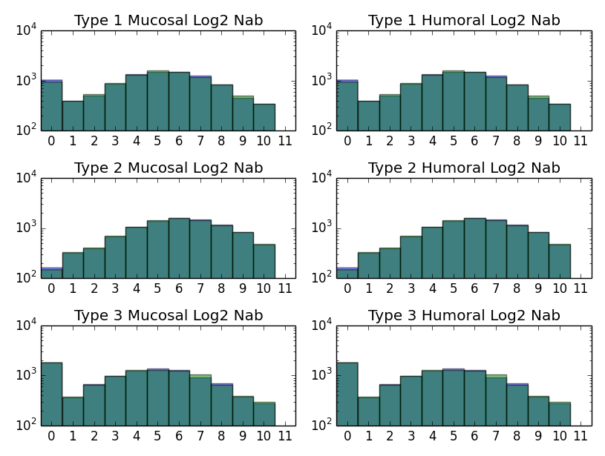

#### IPV results:

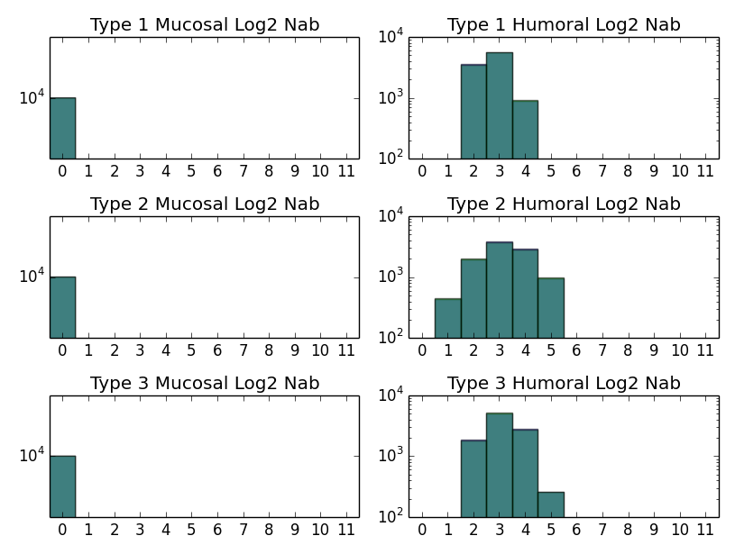

### Hypothetically low values:

|  |  |  |  |
| --- | --- | --- | --- |
| Vaccine Type | Average | Stddev | Max |
| Prime_Log2_Nab_OPV1 | 2 | 1 | 4 |
| Prime_Log2_Nab_OPV2 | 2 | 1 | 4 |
| Prime_Log2_Nab_OPV3 | 2 | 1 | 4 |
| Prime_Log2_Nab_IPV1 | 2 | 1 | 4 |
| Prime_Log2_Nab_IPV2 | 2 | 1 | 4 |
| Prime_Log2_Nab_IPV3 | 2 | 1 | 4 |
| Mucosal_immunogenicity_IPV | 0.01 | - | - |
| Max_Rand_Standard_Deviations | 2 | - | - |

OPV results: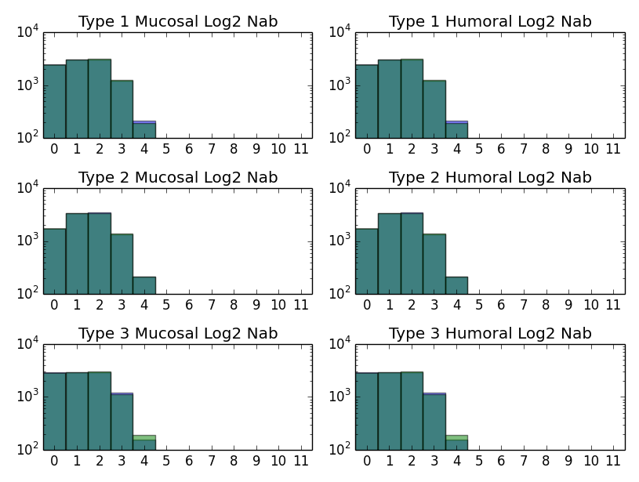

IPV results:

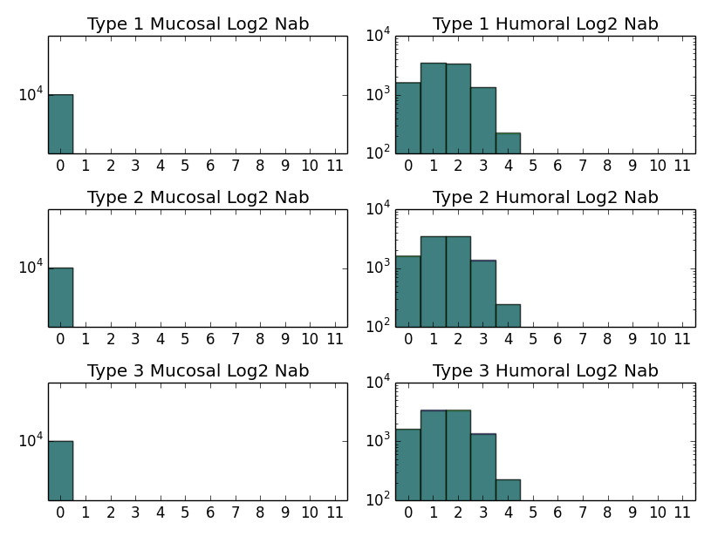

### Hypothetically high values:

|  |  |  |  |
| --- | --- | --- | --- |
| Vaccine Type | Average | Stddev | Max |
| Prime_Log2_Nab_OPV1 | 10 | 3 | 16 |
| Prime_Log2_Nab_OPV2 | 10 | 3 | 16 |
| Prime_Log2_Nab_OPV3 | 10 | 3 | 16 |
| Prime_Log2_Nab_IPV1 | 10 | 3 | 16 |
| Prime_Log2_Nab_IPV2 | 10 | 3 | 16 |
| Prime_Log2_Nab_IPV3 | 10 | 3 | 16 |
| Mucosal_immunogenicity_IPV | 0.9 | - | - |
| Max_Rand_Standard_Deviations | 2 | - | - |

#### OPV results

## 

#### IPV results

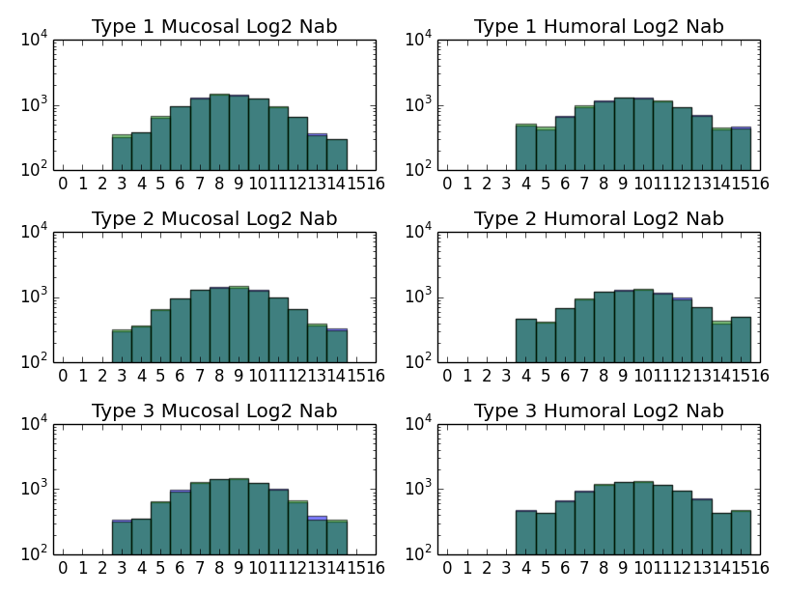

# mOPV/IPV Boosting

## Test scenario

humoral and mucosal antibody nAB distribution after 2,3 mOPV/IPV doses, among 10,000 naïve population.

## Related Functions

* SusceptibilityPolio::ApplyImmumeResponseToInfection()
* SusceptibilityPolio::challengeIPV(float* dose_Dantigen_content)

## Expected behavior

OPV:

* The OPV immunity boosting follows the following process:

log2(NAb2) = log2(NAb1) + boost*(1 - log2(NAb)/maxLog2NAb)

which is represented as:

log(NAb2) = log(NAb1) + boost*(log(2) - log(NAb)/maxLog2NAb) in the simulation and they are equivalent.

The judgment for boosting is whether mucosalMemoryNAb[serotype] > 1.0f, otherwise use priming.

IPV:

* humoralNab boosting is similar to OPV (with its own set of parameters)
* the log2 value of mucosal immunity boosting* is reduced by mucosal_immunogenicity_IPV (*note: the mucosal_immunogenicity_IPV is not applied to the original titer)
* The judgment for boosting is whether humoralMemoryNAb[serotype] > 1.0f, otherwise use priming.

## Scenarios and Results

For all scenarios, the DTK simulation outputs (in blue) have been checked against 10000 outputs randomly calculated according to equation (in green).

### Scenario 3: mOPV

1000 naïve population at age 10, give mOPV1 at day 2, 102, 202, mOPV2 at day 12, 112,212, mOPV3 at day 22,122,222 measuring antibodies at day 25, day 125, day 225. No secondary spread.

### Scenario 4: IPV

1000 naïve population at age 10, give IPV at day 2, 102, 202 measuring antibodies on day 3, 103, 203.

### Bugs and code changes:

ERAD-1435. The probability of infection equation should be:



However the neutralization calculation in DTK is , it was almost the same when Nab is small, but will affect the boosting results when Nab is large.

The below plots only show the results after the fix.

### Default values from literature review:

|  |  |  |  |
| --- | --- | --- | --- |
| Vaccine Type | Average | Stddev | Max |
| Prime_Log2_Nab_OPV1 | 5.92 | 2.3 | 10.7 |
| Prime_Log2_Nab_OPV2 | 6.66 | 2.5 | 11.3 |
| Prime_Log2_Nab_OPV3 | 5.51 | 2.5 | 15 |
| Prime_Log2_Nab_IPV1 | 3.22 | 0.59 | 15.1 |
| Prime_Log2_Nab_IPV2 | 3.7 | 1 | 15.5 |
| Prime_Log2_Nab_IPV3 | 3.62 | 0.7 | 14.7 |
| Mucosal_immunogenicity_IPV | 0.107 | - | - |
| Boost_Log2_Nab_OPV1 | 5.33 | 0.5 | - (same as above) |
| Boost_Log2_Nab_OPV2 | 6.18 | 2.5 | - |
| Boost_Log2_Nab_OPV3 | 3.14 | 0.4 | - |
| Boost_Log2_Nab_IPV1 | 5.08 | 0.9 | - |
| Boost_Log2_Nab_IPV2 | 6.16 | 0.8 | - |
| Boost_Log2_Nab_IPV3 | 6.37 | 0.6 | - |
| Max_Rand_Standard_Deviations | 2 | - | - |

#### OPV:

After 1st dose (same as above):

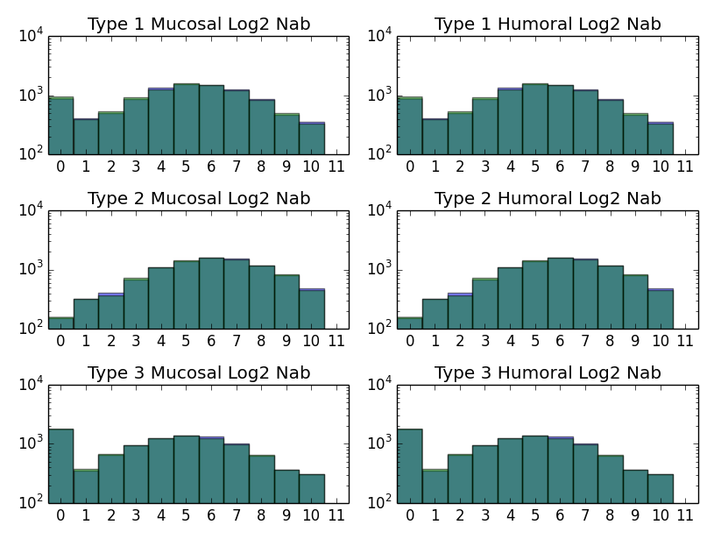

After 2nd dose:

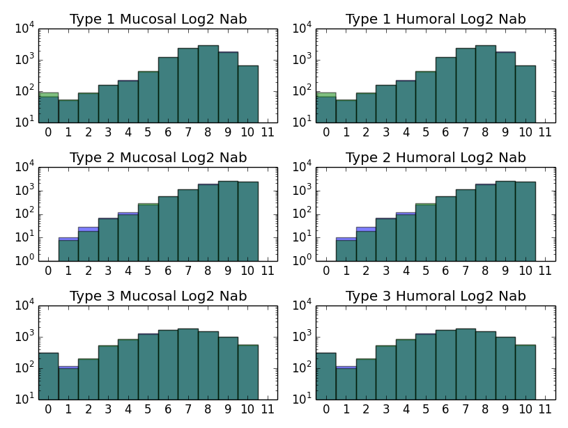

After 3rd dose:

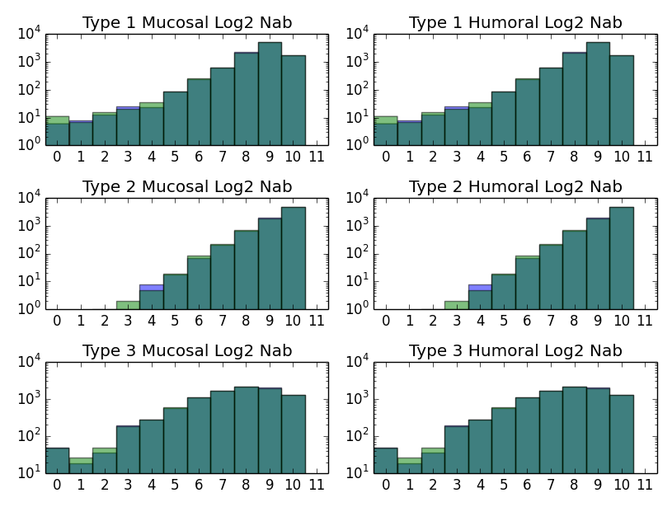

#### IPV:

After 1st dose (same as above):

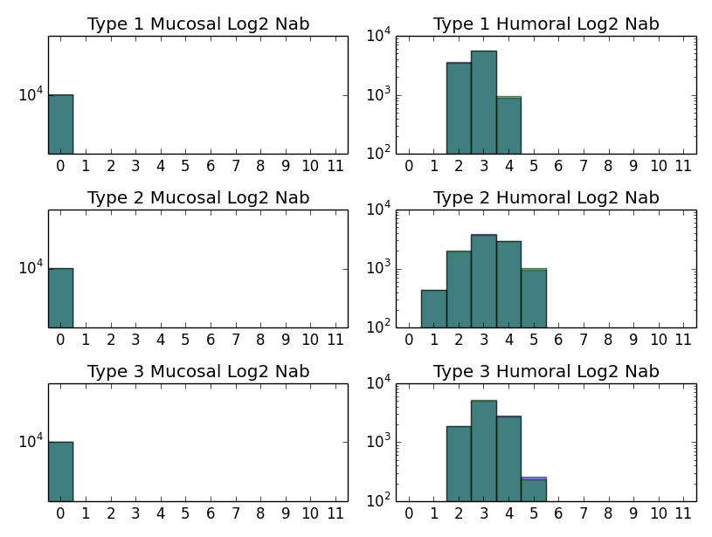

After 2nd dose:

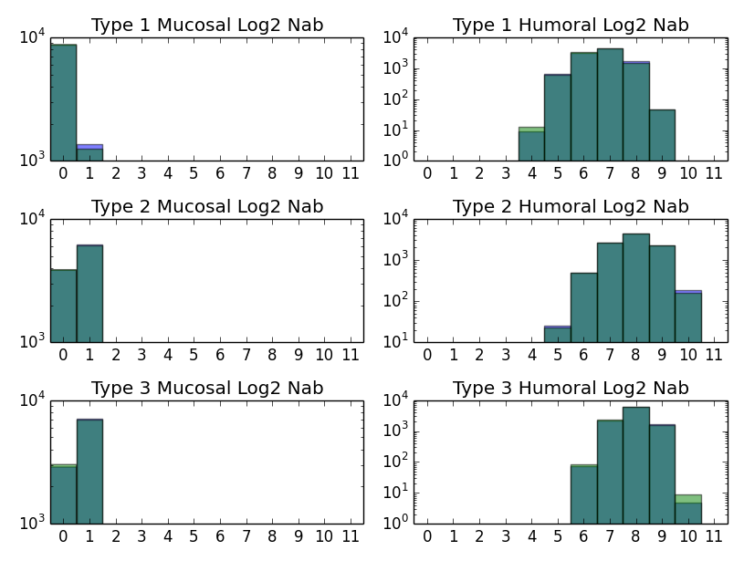

After 3rd dose:

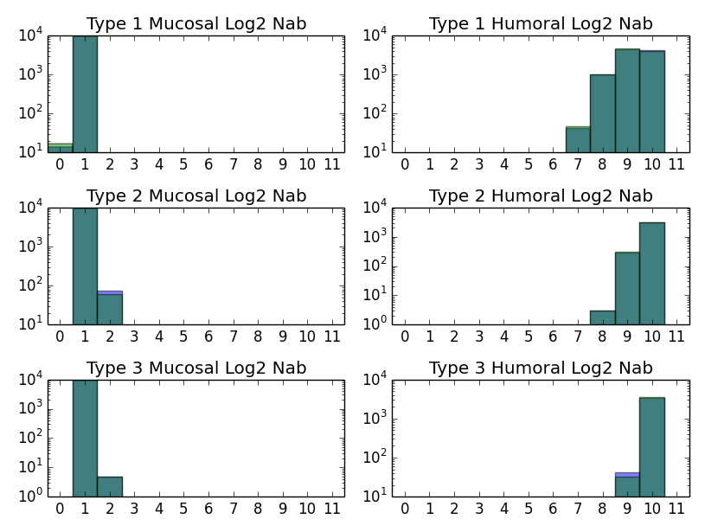

#### IPV (immunogenicity = 0.5):

After 1st dose (same as above):

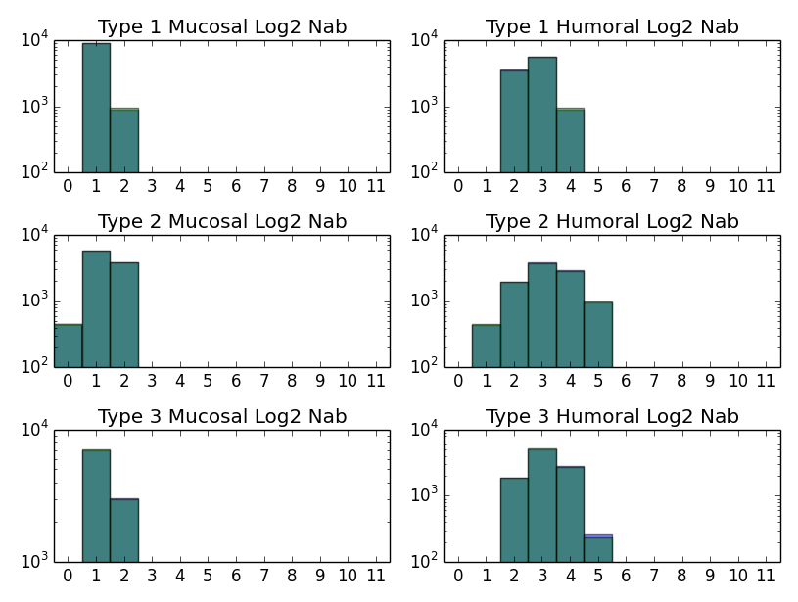

After 2nd dose:

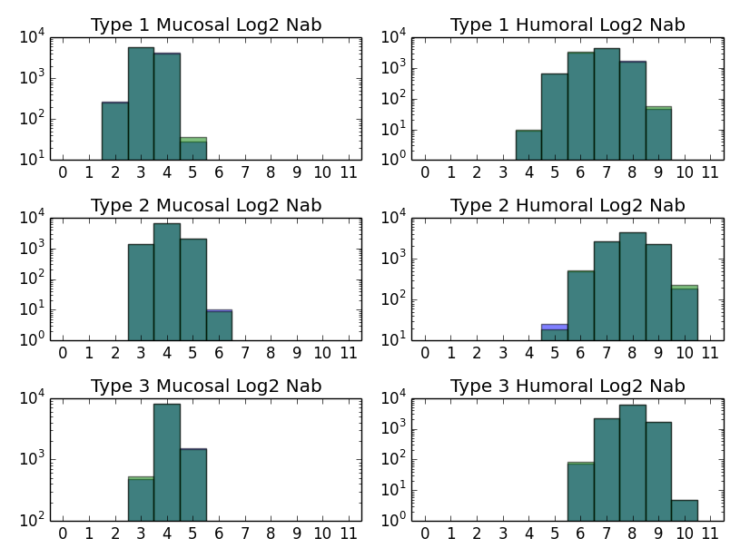

After 3rd dose:

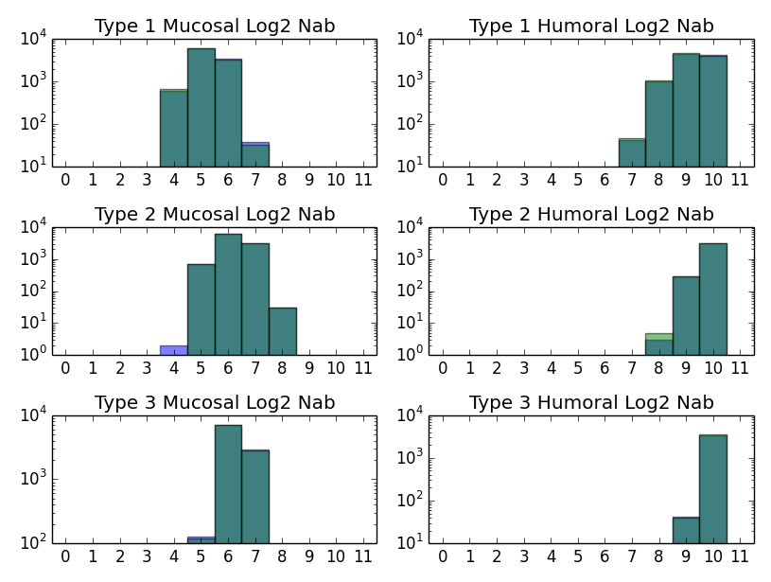

# Viral Interference

## Test scenario

humoral and mucosal antibody nAB distribution after 1 tOPV/bOPV challenge, among 10,000 naïve population.

## Related Functions

* void SusceptibilityPolio::GetProbabilityInfected(StrainIdentity* strain_id, float* acquired_virus, int n_challenge_strains, float* probability_infected)
* SusceptibilityPolio::ApplyImmumeResponseToInfection()

## Expected behavior

* tOPV/bOPV in DTK:
  + For a given type i, if other type j exists for the same challenge, the viral interference will be calculated as:

P_i = host_factor * (1-viral_interference_j)*p_singlestrain_i

whereas

p_singlestrain = 1.0f - pow( 1.0f + (challenge_dose), -specificInfectivity * neutralization );

repeat until all other types have been calculated. viral_interference comes from config file.

* For example,
  + tOPV: type 1 reduction of probability of infection due to interference = (1-0.177)*(1-0.354) = 0.53
  + bOPV: type 1 reduction of probability of infection due to interference = (1-0.354) = 0.646

## Scenarios and Results

For all scenarios, the DTK simulation outputs (in blue) have been checked against 10000 outputs randomly calculated according to equation (in green).

### Results:

Viral interference works as expected. However, bOPV (or mOPV1+mOPV3 given in the same day) behaves more like tOPV without type 2, rather than two separate mOPVs in different days. It is suggestive that we need a pairwise instead of the per-type interference model. Currently for all bOPV campaigns we suggest to use mOPV1+mOPV3 distributed in two consecutive days instead, to avoid the higher interference.

### Scenario 5: tOPV

1000 naïve population at age 10, give tOPV at day 2 measuring antibodies at day 12. No secondary spread.

### Scenario 6: bOPV (with or without type 3 interference)

1000 naïve population at age 10, give bOPV at day 2 measuring antibodies at day 12. No secondary spread.

### Scenario 7: mOPV1+mOPV3

1000 naïve population at age 10, give mOPV1+mOPV3 at day 2 measuring antibodies at day 12. No secondary spread.

|  |  |  |  |
| --- | --- | --- | --- |
| Vaccine Type | Average | Stddev | Max |
| Prime_Log2_Nab_OPV1 | 5.92 | 2.3 | 10.7 |
| Prime_Log2_Nab_OPV2 | 6.66 | 2.5 | 11.3 |
| Prime_Log2_Nab_OPV3 | 5.51 | 2.5 | 15 |
| Max_Rand_Standard_Deviations | 2 | - | - |
| Viral_Interference_Sabin1 | 0 | - | - |
| Viral_Interference_Sabin2 | 0.178 |  |  |
| Viral_Interference_Sabin3 | 0.354 |  |  |

#### tOPV results:

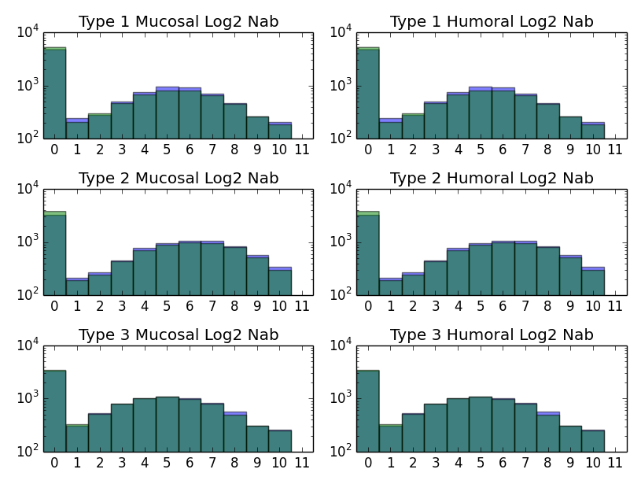

#### bOPV results (default interference):

green = calculated result, with 1-3 interference

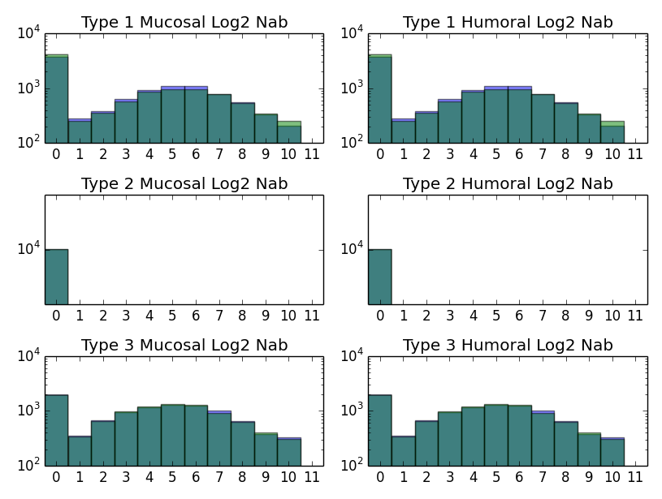

Same simulation, compared with calculated no interference results (green):

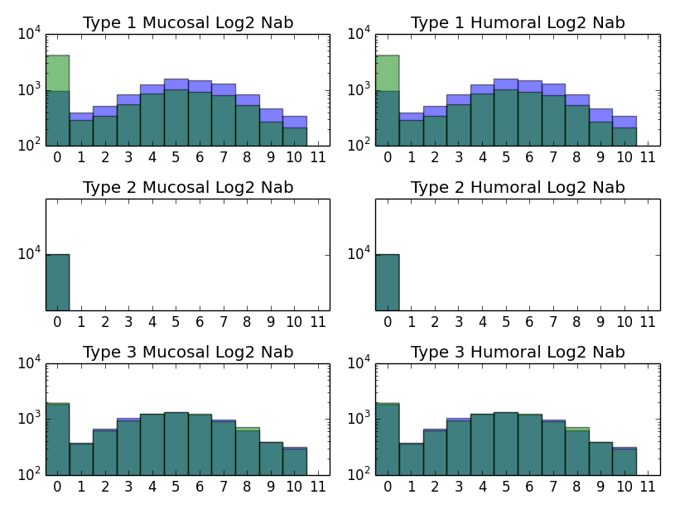

#### bOPV results (no interference):

green = calculated result, no interference

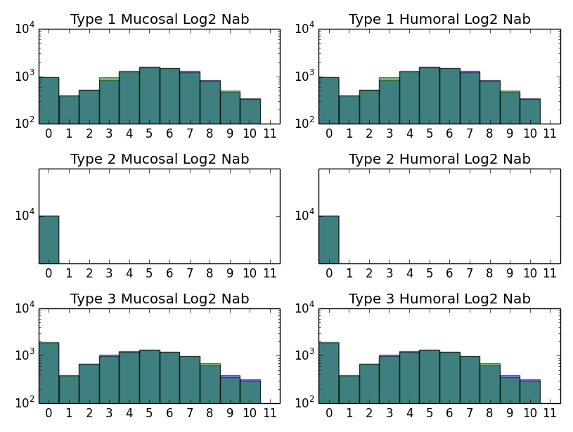

#### mOPV1+mOPV3 results (same day):

green = calculated result, no interference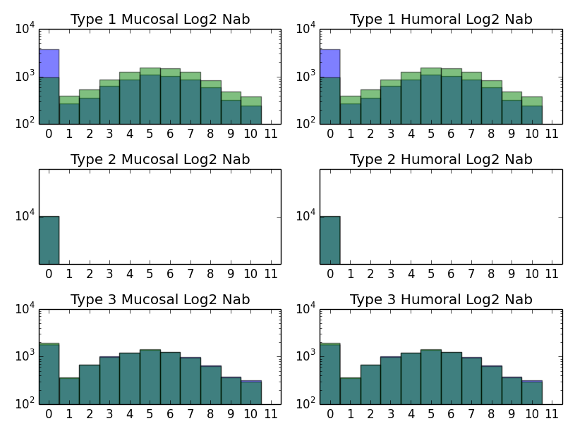

#### mOPV1+mOPV3 results (different day):

green = calculated result, no interference