FRIEND ENGINE FRAMEWORK

Functional Real-Time Interactive Endogenous
Neuromodulation and Decoding
ENGINE FRAMEWORK

GETTING STARTED
version: x.x.x.xxx

16 – October – 2014

D'Or Institute for Research and Education (IDOR)
Neuroinformatics Workgroup
http://idor.org
INDEX

Tip: 6-month-born users can stick to the enhanced light blue text on this tutorial. Unity and Matlab usage is not covered in this tutorial as there is superb documentation on Youtube channels and elsewhere.

1. INTRODUCTION 3
2. COPYRIGHT AND SOFTWARE REGISTRATION 3
3. LICENSE 3
4. INSTALLING FSL ON NON-WINDOWS PLATFORMS 4
5. INSTALLING FSL ON Debian/UBUNTU 4
5.1. Installing NeuroDebian 4
5.2. Download FSL uncompiled sources 4
5.3. Change some environment variables 5
6. FRIEND ENGINE SOFTWARE 5
6.1. Download and installation 5
6.2. Download example data 5
6.3. Study parameters file 5
6.4. MAC+Linux: Engine and plug-ins compilation 5
6.5. Windows: Engine and plug-ins compilation 6
6.6. Engine execution 6
7. MATLAB FRONTEND 6
8. UNITY ENVIRONMENT 6
8.1. Unity installation 6
8.2. Unity account creation 7
8.3. Unity firewall exception 7
9. MEDIEVAL FRONTEND 7
10. FINGERTAP FRONTEND 8
11. PYTHON FRONTEND 8
12. FRONTEND STATE MACHINE 9
13. MISCELLANEOUS 9

INTRODUCTION

The FRIEND Engine Framework is a new implementation of the FRIEND software, a fMRI neurofeedback processing package that has been on the NITRC website since Oct 2013. Its aim is to create a cross-platform framework for a real time neurofeedback processing pipeline that permits interoperability with other applications (e.g.: games engines for the creation of virtual scenarios) and the inclusion of new processing methods through the use of plug-ins provided with the distribution or developed and shared by FRIEND engine users.

The FRIEND engine framework consists of three main parts (Figure 1). The first one is the front end that is responsible for presenting the neurofeedback information to the subject. The second one is the core engine, a multithread application server that listens to a TCP/IP port for request commands issued by the front end and performs the associated command processing. The third one is the plug-in file, a dynamic library file (a .so file Linux file or a Mac OSX dylib file) that implements specific functions that are called internally by the engine at specific times during the pipeline. The engine and plug-in are written in C++, whereas the front end can be written by the user/researcher in any language capable of issuing TCP/IP messages. They can execute on different machines and operational systems as they communicate through a TCP/IP protocol.
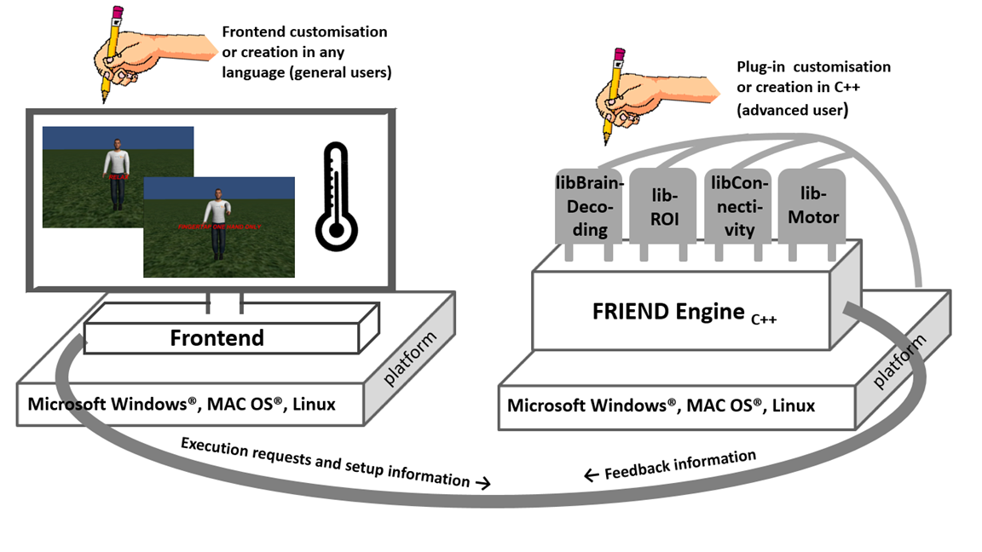

Figure 1. The FRIEND Engine framework comprises three major components: (1) The FRIEND Engine core and (2) plug-ins, written in C++ and operating on the same platform, and (3) the frontend that can be written in any language with sockets support. The TCP/IP communication protocol allows the frontend to be executed on a different computer platform from the FRIEND Engine. Users may customize or write their own frontends. Advanced users can also write their own plug-ins and processing pipelines.

Third-party software is used: the FSL toolbox (http://fsl.fmrib.ox.ac.uk/fsl/fslwiki/), the Alglib library (http://www.alglib.net/), libSVM (http://www.csie.ntu.edu.tw/~cjlin/libsvm/) and SimpleINI (https://github.com/brofield/simpleini).

**Domain**: Clinical Neuroinformatics, MR, Computational Neuroscience

COPYRIGHT AND SOFTWARE REGISTRATION

The FRIEND software was developed at Cognitive and Behavioral Neuroscience Unit and Neuroinformatics Workgroup, D’Or Institute for Research and Education (IDOR, http://www.idor.org) – R. Diniz Cordeiro, 30, 22281-100, Rio de Janeiro, Brazil, Rio de Janeiro, Brazil. The software is registered at the Brazilian agency of patents and trademarks, Instituto Nacional da Propriedade Industrial (INPI – http://www.inpi.gov.br), under request number 137820. FRIEND’s license is open source and free for non-commercial use. It was based on the FSL license and thus follows similar permissions and restrictions.

LICENSE

FRIEND – Functional Real-Time Interactive Endogenous Neuromodulation and Decoding, Release 1.2 (c) 2012, D'Or Institute of Research and Education, Rede D´Or, Rio de Janeiro, Brazil (the "Software").
The Software remains the property of the D´Or Institute of Research and Education ("the Institute").
The Software is distributed "AS IS" under this Licence solely for non-commercial use in the hope that it will be useful, but in order that the Institute protects its assets for the benefit of its educational and research purposes, the Institute makes clear that no condition is made or to be implied, nor is any warranty given or to be implied, as to the accuracy of the Software, or that it will be suitable for any particular purpose or for use under any specific conditions. Furthermore, the Institute disclaims all responsibility for the use which is made of the Software. It further disclaims any liability for the outcomes arising from using the Software.
The Licensee agrees to indemnify the Institute and hold the Institute harmless from and against any and all claims, damages and liabilities asserted by third parties (including claims for negligence) which arise directly or indirectly from the use of the Software or the sale of any products based on the Software.
No part of the Software may be reproduced, modified, transmitted or transferred in any form or by any means, electronic or mechanical, without the express permission of the Institute. The permission of the Institute is not required if the said reproduction, modification, transmission or transference is done without financial return, and the conditions of this Licence are imposed upon the receiver of the product, and all original and amended source code is included in any transmitted product. You may be held legally responsible for any copyright infringement that is caused or encouraged by your failure to abide by these terms and conditions.
You are not permitted under this Licence to use this Software commercially. Use for which any financial return is received shall be defined as commercial use, and includes (1) integration of all or part of the source code or the Software into a product for sale or license by or on behalf of Licensee to third parties or (2) use of the Software or any derivative of it for research with the final aim of developing software products for sale or license to a third party or (3) use of the Software or any derivative of it for research with the final aim of developing non-software products for sale or license to a third party, or (4) use of the Software to provide any service to an external organisation for which payment is received. If you are interested in using the Software commercially, please contact the Technological Innovation Center, the technology transfer department of the Institute, to negotiate a licence. Contact details are: innovation@idor.org quoting reference SW/001.

INSTALLING FSL ON NON-WINDOWS PLATFORMS

To run FRIEND Engine, the FSL software (http://fsl.fmrib.ox.ac.uk/fsldownloads/) must be installed. Please, explicitly check the installed directories to be sure the option you selected allowed the installation of FSL source code. If not available, FRIEND Engine will not be able to compile. The next section resumes the correct installation and preparation for Debian/Ubuntu machines

INSTALLING FSL ON Debian/UBUNTU

Installing NeuroDebian
wget -O- http://neuro.debian.net/lists/trusty.us-ca.full | sudo tee /etc/apt/sources.list.d/neurodebian.sources.list
sudo apt-key adv --recv-keys --keyserver hkp://pgp.mit.edu:80 2649A5A9
sudo apt-get update
sudo apt-get install fsl-complete

Download FSL uncompiled sources

Download from http://fsl.fmrib.ox.ac.uk/fsldownloads/fsldownloadmain.html
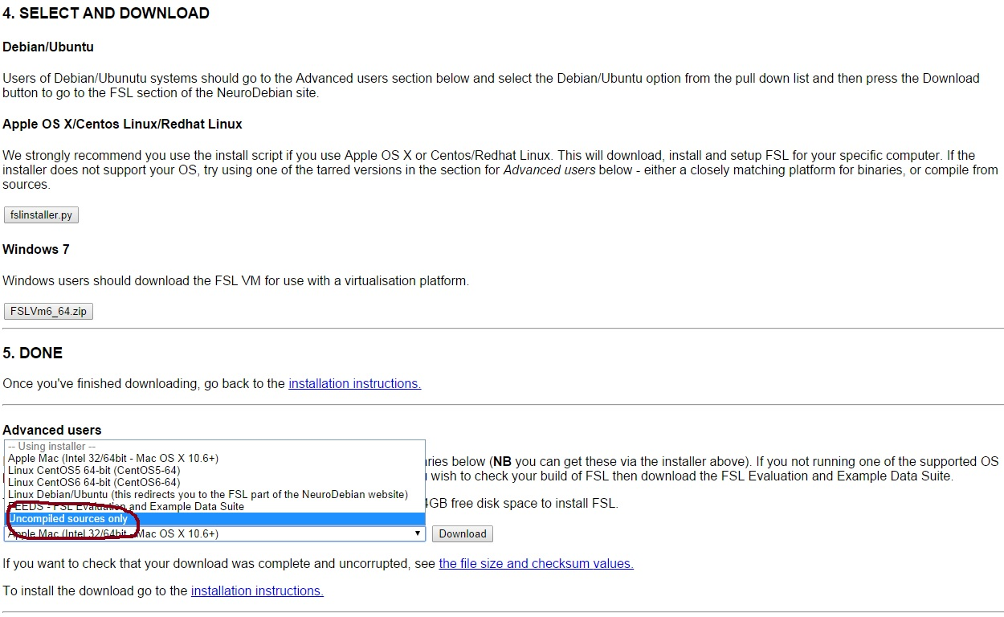

Extract the downloaded file in /usr/local/fsl

Install g++, git and additional libraries

sudo apt-get install g++
sudo apt-get install git

sudo apt-get install libz-dev
sudo apt-get install libpng12-dev
sudo apt-get install libgd-dev

Change some environment variables
export LD_LIBRARY_PATH=$LD_LIBRARY_PATH:/usr/lib/fsl/5.0
export PATH=$PATH:/usr/lib/fsl/5.0
export FSLDIR=/usr/local/fsl
export FSLOUTPUTTYPE=NIFTI_GZ
ln -s /usr/lib/fsl/5.0 /usr/local/fsl/bin

FRIEND ENGINE SOFTWARE

Download and installation
Users can download the Friend Engine software through:
1) a zip file at https://github.com/InstitutoDOr/FriendENGINE.
2) the command:
git clone https://github.com/InstitutoDOr/FriendENGINE.git
Preferred option as the users can keep track of the changes made to the software through git commands.

After unpacking or cloning the FRIEND Engine distribution, the following (reduced for presentation issues) structure will be shown:

Friend_Engine_Sources (aka:FES)
Friend_Engine_Sources (aka:FES)
Alglib
Application
study_params.txt
FRIEND_Engine
build.sh
buildLinux.sh
........
libFiles
liblinear
libsvm
PlugIn
connectivityPlugIn
MotorPlugIn
ROIbasedPlugIn
svmPlugIn
ManualPlugIn.rtf
……..
vardb.cpp
Simpleini
TestData
buildAllLinux.sh
buildUbuntu.sh
buildAllMac.sh
clean.sh
Windows
Application
FriendEngine
libBrainDecoding
libConnectivity
libMotor
libROI
clean.bat
Frontends
Unity/FingerTap
Unity/Medieval
Matlab
Python
fsl
FRIEND_License.txt

Download example data
Example data of a motor study is provided with the distribution (FES/FES/TestData). Other datasets can be downloaded from the NITRC repository: http://www.nitrc.org/projects/friend by registered users.

Study parameters file
Before trying to execute any study, you should take some time to check/modify study configuration parameters (subject directory, data directory, etc.) in Windows: FES\Windows\Application\study_params.txt
MAC + Linux: FES\FES\Application\study_params.txt

MAC+Linux: Engine and plug-ins compilation
Execute the corresponding shell scripts in FES/FES:
OSX 10.9.5 or later (Mavericks): buildAllmavericks.sh
OSX 10.6 to 10.8 (Mountain Lion): buildAllMac.sh
Linux systems installed with fslinstaller.py script provided by FSL site: buildAllLinux.sh
Debian/Ubuntu systems with NeuroDebian installation: buildAllUbuntu.sh

After compilation, the engine executable and plug-ins will be created in FES/FES/Application folder.

Windows: Engine and plug-ins compilation
To compile on Windows, we suggest the Visual Studio Express 2013 for Windows suite, downloaded from: http://www.visualstudio.com/en-us/products/visual-studio-express-vs.aspx. After installation, users can open the solution file at FES\Windows\buildAll\buildAll.sln. After compilation, the engine.exe and plug-ins file will be created in the FES\Windows\Application directory.

Engine execution
After executing, the engine will start listening communication in the default port 5678. To change the port, users can execute the engine passing the number of the desired port as a parameter, e.g. engine 6000.

MATLAB FRONTEND

Matlab → Open file → Frontends\Matlab\Friend.m

Useful information can be found on the manual of the FRIEND standalone version on the NITRC website.

The frontend expects the engine to be already executing on localhost by default. For information about the plug-in or to modify IP and port see: frontends\Matlab\Friend.m, Lines:
host = '127.0.0.1';
port = 5678;
fprintf(mainThread, 'PLUGIN');
fprintf(mainThread, 'libROI');

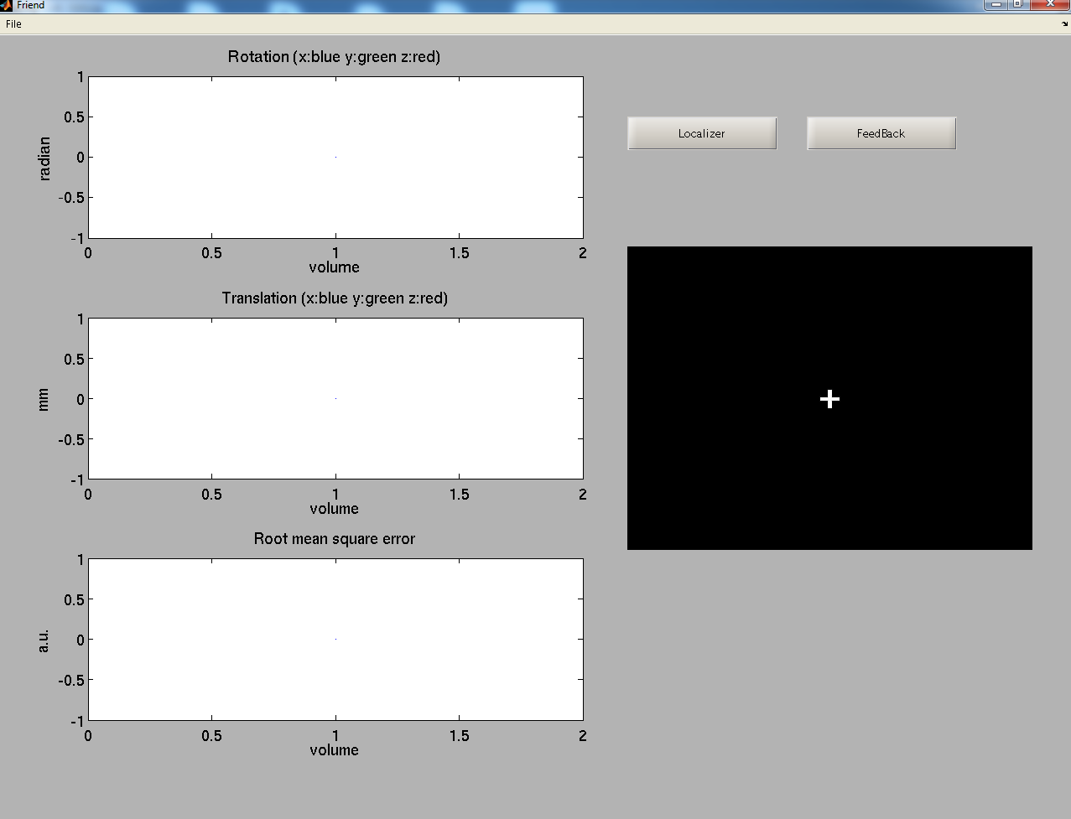

Warning for Matlab academic license: as the Instrument Control Toolbox for TCP/IP communication is not present, the following error might occur:

>> Friend
Undefined function 'tcpip' for input arguments of type
'char'.
Error in Friend>Friend_OpeningFcn (line 100)
mainThread = tcpip(host, port);
Error in gui_mainfcn (line 221)
feval(gui_State.gui_OpeningFcn, gui_hFigure, [],
guidata(gui_hFigure), varargin{:});
Error in Friend (line 42)
gui_mainfcn(gui_State, varargin{:});

This frontend is a two pass execution. In the first execution, click in localizer button, and a localizer run, will be executed, creating a roi file derived from the GLM calculation. After the executtion is finished, close the frontend and execute it again, clicking in the feedback button this time. It will use the ROI file to calculate the feedback information.

UNITY ENVIRONMENT

Unity installation
Download the free version of Unity 4.6.6 (current version) from http://unity3d.com/unity/download.
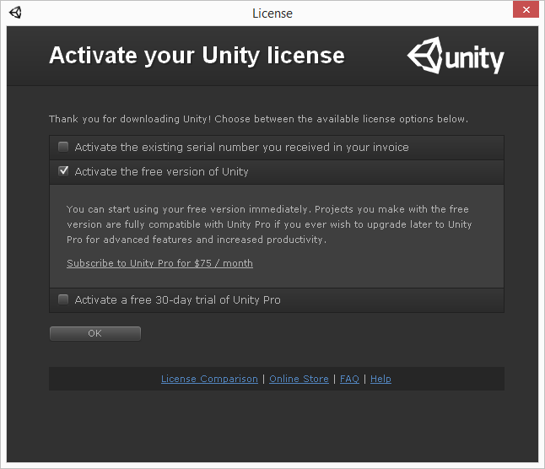

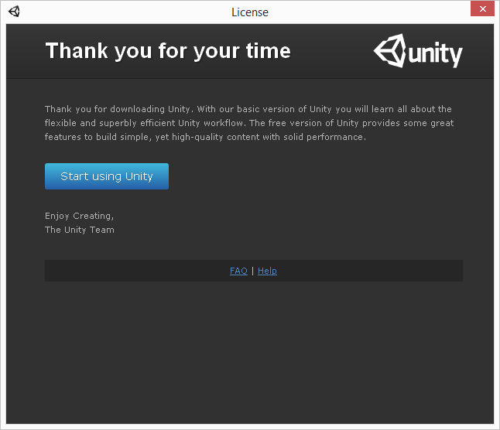

Unity account creation
After pressing the “Start using Unity” in the previous window, you will be prompted to create a Unity user.
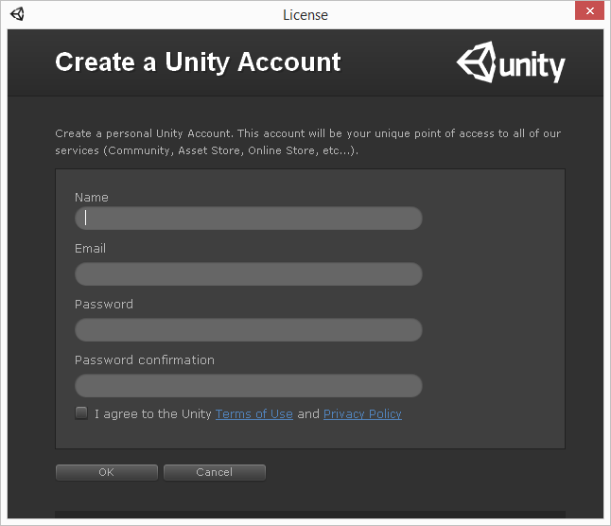

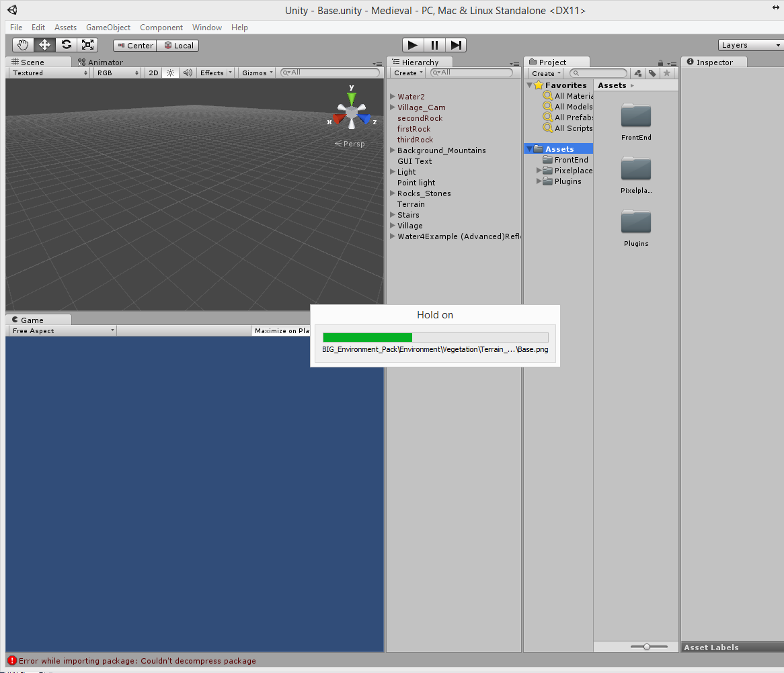

Unity firewall exception
The first time Unity is executed it will produce a firewall exception. Allow access according to your settings (private or public network).
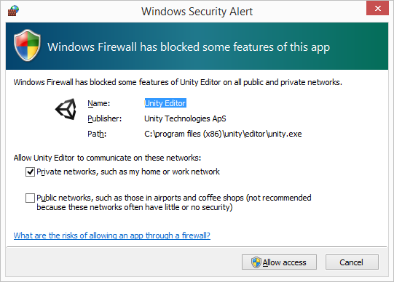

The Unity interface appears after allowing the exception.
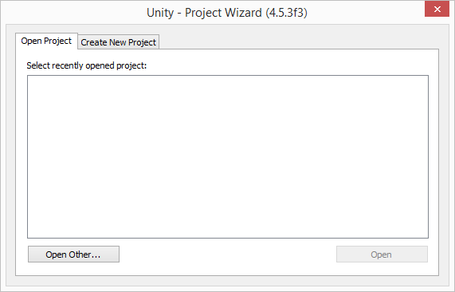

Do not open the .unity file directly (e.g.: using Windows File Explorer to click on it).

MEDIEVAL FRONTEND

The Big Environment Pack (http://u3d.as/content/philipp-schmidt/big-environment-pack/2T9) must be installed:

Unity → File → Assets → Import Package → BIG Environment PackV1.unitypackag → Done

The frontend expects the engine to be already executing on localhost by default. For other IP and port modify:
frontends\Unity\Medieval\Assets\Scripts\movimentaPrimeiroBloco.cs

private String HostData = "127.0.0.1";
private Int32 Port = 5678;

Information about the plug-in used is at:
frontends\Unity\Medieval\Assets\Scripts\FriendEngineComm.cs
mainThread.writeSocket ("PLUGIN");
mainThread.writeSocket ("libROI");

To open the Medieval frontend:

Unity → Open Project → Open Other → FES\frontends\Unity\Medieval directory → Done

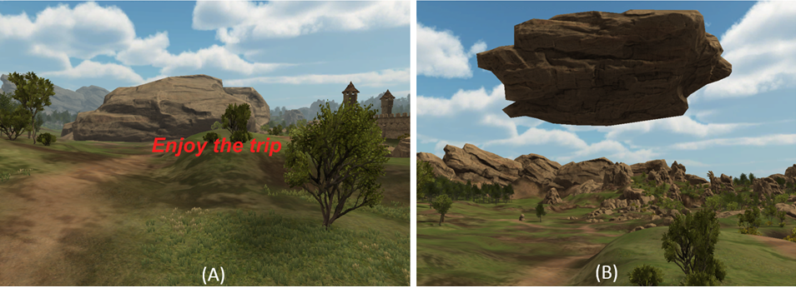
This frontend is a medieval virtual reality scenario in which the avatar, i.e. the participant, hovers over a path and stops in predetermined locations, blocked by a massive rock. Using the same finger tapping neurofeedback procedure exemplified in the Matlab® frontend (alternating rest and finger tapping blocks), and the same libROI plug-in, the feedback information to the participant is now given in a different way. As the participant moves across the scenario and stops right before the rock, he needs to perform the finger tapping task as instructed (as quickly as possible). If the percentage BOLD signal change returned by the engine reaches a predefined threshold the rock levitates, thus unblocking the path so that the journey continues (see figure below). If the threshold is not reached, the player stays at the same location until the next try, i.e. the next activation block. This scenario was constructed using objects from the iTween and iTween path editor (http://itween.pixelplacement.com/index.php) and the Big Environment pack, available in the Unity Assets store.

FINGERTAP FRONTEND

Unity → Open Project → Open Other → FES\frontends\Unity\FingerTap directory → Done

The frontend expects the engine to be already executing on localhost by default. For other IP and port modify:
Frontends\Unity\FingerTap\Assets\Scripts\motorScript.cs
private String HostData = “127.0.0.1;
private Int32 Port = 5678

Information about the plug-in used is at:
Frontends\Unity\FingerTap\Assets\Scripts\MotorComm.cs
mainThread.writeSocket ("PLUGIN");
mainThread.writeSocket ("libMotor");

The finger tapping experiment intercalates blocks of rest and finger tapping. The participant is asked to perform finger tapping with either their left or right hand, alternating with resting blocks. Two ROIs located in the primary motor cortex area of the left and right cerebral hemisphere are used by the libMotor plug-in to calculate the percent BOLD signal change in the left and right ROIs in the same way as the libROI plug-in in the Medieval example. The FingerTap frontend compares the feedback values between both ROIs in such a way that the greater one will inform which hand of the avatar, showed by the frontend, will perform the finger tapping animation. If successfully performed, this conveys a clear impression that the participant is controlling the hands of the avatar with his/her own hands. The avatar and hand animations were implemented using the VR Hands Unity asset (https://serrarens.nl/passervr/downloads/vr-hands/).

PYTHON FRONTEND

The frontend expects the engine to be already executing on localhost by default. For information about the plug-in or to modify IP and port see:

Frontends\Python\frontend.py
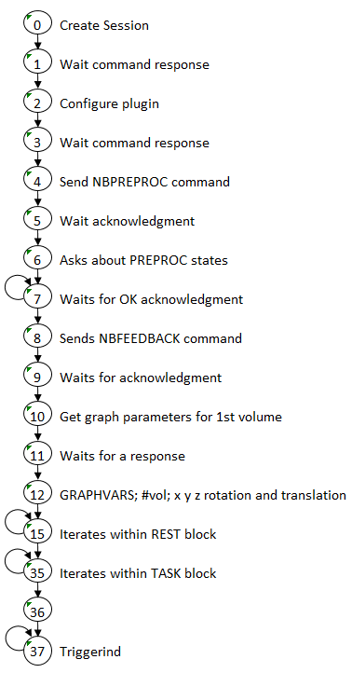
Lines: HOST = ‘127.0.0.1’; PORT = 5678
mainThread.send('PLUGIN\n');
mainThread.send('libROI\n');

Execution of the frontend should follow the steps:

- Execute: python frontendROI.py 1
- A functional localization processing is executed
- Execute: python frontendROI.py 2 to perform neurofeedback processing

Note : All frontends listed here are example frontends. To be used in a real experiment, you need to handle all the presentation of stimuli and time issues.

FRONTEND STATE MACHINE

Frontend processing can assume different states as shown on figure aside.

MISCELLANEOUS

To delete files created during compilation and execution (but preserving changes to source code) execute:
Windows: FES\Windows\clean.bat
MAC + Linux: FES/FES/clean.sh

