Bellabeat Case Study

Caleb

2023-01-13

#Loading Packages

install.packages("tidyverse", repos = "http://cran.us.r-project.org")

## package 'tidyverse' successfully unpacked and MD5 sums checked  
##   
## The downloaded binary packages are in  
## C:\Users\caleb\AppData\Local\Temp\Rtmp6zMBMO\downloaded_packages

install.packages("rmarkdown", repos = "http://cran.us.r-project.org")

## package 'rmarkdown' successfully unpacked and MD5 sums checked  
##   
## The downloaded binary packages are in  
## C:\Users\caleb\AppData\Local\Temp\Rtmp6zMBMO\downloaded_packages

install.packages("ggplot2", repos = "http://cran.us.r-project.org")

## package 'ggplot2' successfully unpacked and MD5 sums checked  
##   
## The downloaded binary packages are in  
## C:\Users\caleb\AppData\Local\Temp\Rtmp6zMBMO\downloaded_packages

install.packages("dplyr", repos = "http://cran.us.r-project.org")

## package 'dplyr' successfully unpacked and MD5 sums checked

## Warning: cannot remove prior installation of package 'dplyr'

## Warning in file.copy(savedcopy, lib, recursive = TRUE): problem copying  
## D:\Program Files\R-4.2.2\library\00LOCK\dplyr\libs\x64\dplyr.dll to D:\Program  
## Files\R-4.2.2\library\dplyr\libs\x64\dplyr.dll: Permission denied

## Warning: restored 'dplyr'

##   
## The downloaded binary packages are in  
## C:\Users\caleb\AppData\Local\Temp\Rtmp6zMBMO\downloaded_packages

install.packages("skimr", repos = "http://cran.us.r-project.org")

## package 'skimr' successfully unpacked and MD5 sums checked  
##   
## The downloaded binary packages are in  
## C:\Users\caleb\AppData\Local\Temp\Rtmp6zMBMO\downloaded_packages

install.packages("janitor", repos = "http://cran.us.r-project.org")

## package 'janitor' successfully unpacked and MD5 sums checked  
##   
## The downloaded binary packages are in  
## C:\Users\caleb\AppData\Local\Temp\Rtmp6zMBMO\downloaded_packages

install.packages("here", repos = "http://cran.us.r-project.org")

## package 'here' successfully unpacked and MD5 sums checked  
##   
## The downloaded binary packages are in  
## C:\Users\caleb\AppData\Local\Temp\Rtmp6zMBMO\downloaded_packages

library(tidyverse)

## ── Attaching packages ─────────────────────────────────────── tidyverse 1.3.2 ──  
## ✔ ggplot2 3.4.0 ✔ purrr 1.0.1   
## ✔ tibble 3.1.8 ✔ dplyr 1.0.10  
## ✔ tidyr 1.2.1 ✔ stringr 1.5.0   
## ✔ readr 2.1.3 ✔ forcats 0.5.2   
## ── Conflicts ────────────────────────────────────────── tidyverse_conflicts() ──  
## ✖ dplyr::filter() masks stats::filter()  
## ✖ dplyr::lag() masks stats::lag()

library(lubridate)

## Loading required package: timechange  
##   
## Attaching package: 'lubridate'  
##   
## The following objects are masked from 'package:base':  
##   
## date, intersect, setdiff, union

library(ggplot2)  
library(rmarkdown)  
library(readr)  
library(dplyr)  
library(skimr)  
library(janitor)

##   
## Attaching package: 'janitor'  
##   
## The following objects are masked from 'package:stats':  
##   
## chisq.test, fisher.test

library(here)

## here() starts at C:/Users/caleb/Documents

#Importing and cleaning datasets ##Loading datasets

daily_activity_df <- read_csv("dailyActivity_merged.csv")

## Rows: 940 Columns: 15  
## ── Column specification ────────────────────────────────────────────────────────  
## Delimiter: ","  
## chr (1): ActivityDate  
## dbl (14): Id, TotalSteps, TotalDistance, TrackerDistance, LoggedActivitiesDi...  
##   
## ℹ Use `spec()` to retrieve the full column specification for this data.  
## ℹ Specify the column types or set `show_col_types = FALSE` to quiet this message.

sleep_day <- read_csv("sleepDay_merged.csv")

## Rows: 413 Columns: 5  
## ── Column specification ────────────────────────────────────────────────────────  
## Delimiter: ","  
## chr (1): SleepDay  
## dbl (4): Id, TotalSleepRecords, TotalMinutesAsleep, TotalTimeInBed  
##   
## ℹ Use `spec()` to retrieve the full column specification for this data.  
## ℹ Specify the column types or set `show_col_types = FALSE` to quiet this message.

##Sorting the Data

daily_activity_df_sorted <- daily_activity_df %>% arrange(Id, ActivityDate)

sleep_day_sorted <- sleep_day %>% arrange(Id, SleepDay)

##removing original datasets

remove(daily_activity_df)

remove(sleep_day)

##cleaning names

daily_activity_df_sorted <- clean_names(daily_activity_df_sorted)

sleep_day_sorted <- clean_names(sleep_day_sorted)

##duplicates

daily_activity_df_sorted <- unique(daily_activity_df_sorted)

sleep_day_sorted <- unique(sleep_day_sorted)

##removing rows with suspiciously low activity (suspected device not used or died early)

daily_activity_df_sorted <- daily_activity_df_sorted %>% filter(total_steps >= 400, total_distance > 0, tracker_distance > 0)

##exporting to fix dates in google sheets

write.csv(sleep_day_sorted, "sleep_day_sorted.csv")

write.csv(daily_activity_df_sorted, "daily_activity_sorted.csv")

#Importing the datasets from google sheets

#importing fixed datasets prepped for merging  
  
activity_day_fixed <- read.csv("activity_day_fixed.csv")

sleep_day_fixed <- read.csv("sleep_day_fixed.csv")

#joining datasets

#joining sleep_day_fixed and activity_day_fixed  
  
activity_joined <- merge(x = activity_day_fixed, y = sleep_day_fixed, by = c("date", "id"))

##removing old dataframes

remove(daily_activity_df_sorted)

remove(sleep_day_sorted)

##renaming datasets

daily_activity <- activity_day_fixed

remove(activity_day_fixed)

sleep_day <- sleep_day_fixed

remove(sleep_day_fixed)

#Checking distinct IDs since I forgot earlier

n_distinct(sleep_day$id)

## [1] 24

n_distinct(daily_activity$id)

## [1] 33

#Making averages datsets for pie charts #making an averages dataframe for each ID in daily_activity

daily_averages <- daily_activity %>%  
 group_by(id) %>%  
 summarize(steps = mean(total_steps), distance = mean(total_distance), very_active_distance = mean(very_active_distance), moderately_active_distance = mean(moderately_active_distance),   
 light_active_distance = mean(light_active_distance), very_active_minutes = mean(very_active_minutes), fairly_active_minutes = mean(fairly_active_minutes),   
 lightly_active_minutes = mean(lightly_active_minutes), sedentary_minutes = mean(sedentary_minutes), average_calories = mean(calories))

#making an averages dataframe for the activity_joined to include sleep analysis

sleep_averages <- activity_joined %>%  
 group_by(id) %>%  
 summarize(steps = mean(total_steps), distance = mean(total_distance), very_active_distance = mean(very_active_distance), moderately_active_distance = mean(moderately_active_distance),   
 light_active_distance = mean(light_active_distance), very_active_minutes = mean(very_active_minutes), fairly_active_minutes = mean(fairly_active_minutes),   
 lightly_active_minutes = mean(lightly_active_minutes), sedentary_minutes = mean(sedentary_minutes), average_calories = mean(calories),  
 average_min_asleep = mean(total_minutes_asleep), average_time_in_bed = mean(total_time_in_bed))

#Making user classifications based averages

##classifying users based on steps according to <https://www.10000steps.org.au/articles/healthy-lifestyles/counting-steps/> ##this allows me to see how many users are active or not to get an idea of the users

activity_status <- daily_averages %>%  
 mutate(activity_status = case_when(steps < 5000 ~ "Sedentary", steps >= 5000 & steps <= 7499 ~ "Low Activity", steps >= 7500 & steps <= 9999 ~ "Medium Activity",   
 steps >= 10000 & steps < 12500 ~ "Active", steps >= 12500 ~ "High Activity"))

##daily step analysis - not used in final analysis

daily_steps <- daily_activity %>%  
 mutate(activity_status = case_when(total_steps < 5000 ~ "Sedentary", total_steps >= 5000 & total_steps <= 7499 ~ "Low Activity",  
 total_steps >= 7500 & total_steps <= 9999 ~ "Medium Activity", total_steps >= 10000 & total_steps < 12500 ~ "Active",   
 total_steps >= 12500 ~ "High Activity"))

##Calculating users sleep based on mayo clinic recommendations for adults. 7-9 hours is the recommended.

sleep_status <- sleep_averages %>%  
 mutate(sleep_duration = case_when(average_min_asleep < 420 ~ "Too Little", average_min_asleep >= 420 & average_min_asleep <= 540 ~ "Good", average_min_asleep > 540 ~ "Too Much"))

##daily sleep analysis - not used in final analysis

daily_sleep <- sleep_day %>%  
 mutate(sleep_duration = case_when(total_minutes_asleep < 420 ~ "Too Little", total_minutes_asleep >= 420 & total_minutes_asleep <= 540 ~ "Good", total_minutes_asleep >540 ~ "Too Much"))

#creating another dataset including activity, sleep, and all ratings

#activity joined + sleep duration rating  
  
activity_join_plus <- activity_joined %>%  
 mutate(sleep_duration = case_when(total_minutes_asleep < 420 ~ "Too Little", total_minutes_asleep >= 420 & total_minutes_asleep <= 540 ~ "Good", total_minutes_asleep > 540 ~ "Too Much")) %>%  
 mutate(activity_status = case_when(total_steps < 5000 ~ "Sedentary", total_steps >= 5000 & total_steps <= 7499 ~ "Low Activity",  
 total_steps >= 7500 & total_steps <= 9999 ~ "Medium Activity", total_steps >= 10000 & total_steps < 12500 ~ "Active",   
 total_steps >= 12500 ~ "High Activity"))

#creating datasets based on activity and sleep status

##analyzing percentages of sleep and activity to get an idea of who is using these products

##activity_status using all daily inputs - not used

daily_activity_percents <- daily_steps %>%  
 group_by(activity_status) %>%  
 summarize(daily_activity_percent = 100 * n() / nrow(daily_steps))

##average activity status per user

avg_activity_percents <- activity_status %>%  
 group_by(activity_status) %>%  
 summarize(average_activity_percent = 100 * n() / nrow(activity_status))

## `summarise()` has grouped output by 'activity_status'. You can override using  
## the `.groups` argument.

#getting percents for sleep trends

##avg sleep % for each user

avg_sleep_percent <- sleep_status %>%  
 group_by(sleep_duration) %>%  
 summarize(average_sleep_percent = 100 * n() / nrow(sleep_status))

##daily sleep % based on all daily inputs - not used

daily_sleep_percent <- daily_sleep %>%  
 group_by(sleep_duration) %>%  
 summarize(daily_sleep_percent = 100 * n() / nrow(daily_sleep))

#rounding the numbers form those percentage sets

#rounding the numbers  
  
avg_activity_percents <- avg_activity_percents %>% mutate_if(is.numeric, round, digits = 2)

## `mutate_if()` ignored the following grouping variables:  
## • Column `activity_status`

daily_activity_percents <- daily_activity_percents %>% mutate_if(is.numeric, round, digits = 2)  
avg_sleep_percent <- avg_sleep_percent %>% mutate_if(is.numeric, round, digits = 2)  
daily_sleep_percent <- daily_sleep_percent %>% mutate_if(is.numeric, round, digits = 2)

#exporting those datasets to make pie charts in google sheets

write_csv(avg_activity_percents, "avg_activity_percents.csv")

write_csv(avg_sleep_percent, "avg_sleep_percent.csv")

write_csv(daily_activity_percents, "daily_activity_percents.csv")

write_csv(daily_sleep_percent, "daily_sleep_percent.csv")

#graphing daily steps compared to calories

#graphing daily_steps  
  
ggplot(data = daily_steps, mapping = aes(x = total_steps, y = calories)) +  
 geom_point(aes(color = activity_status))+  
 geom_smooth() +  
 labs(title = "Bellabeat: Steps Vs Calories", subtitle = "How steps correlate to calories", caption = "FitBit Fitness Tracker Data - MÖBIUS") +  
 annotate("text", x = 17500, y = 1500, label = "Steps appear to correlate to calories", fontface = "bold", angle = 25, size = 6) +  
 annotate("text", x = 32500, y = 4750, label = "Higher is better")

## `geom_smooth()` using method = 'loess' and formula = 'y ~ x'

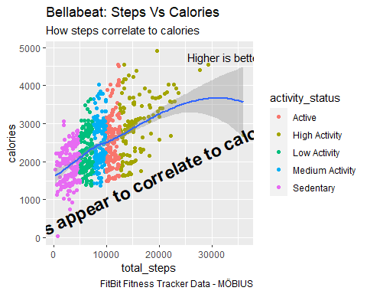

#creating long data to graph the different activity classifications

#creating longer data for daily_steps to graph activity minutes  
  
daily_steps_long <- daily_steps %>%  
 select(id, date, lightly_active_minutes, sedentary_minutes, very_active_minutes, fairly_active_minutes, calories, activity_status, total_steps) %>%  
 pivot_longer(cols = c(lightly_active_minutes, sedentary_minutes, very_active_minutes, fairly_active_minutes), names_to = "Var", values_to = "Val")

activity_joined_plus_long <- activity_join_plus %>%  
 select(id, date, lightly_active_minutes, sedentary_minutes, very_active_minutes, fairly_active_minutes, calories, total_minutes_asleep, sleep_duration, activity_status) %>%  
 pivot_longer(cols = c(lightly_active_minutes, sedentary_minutes, very_active_minutes, fairly_active_minutes), names_to = "Var", values_to = "Val")

#graphing the long data

ggplot(data = daily_steps_long, mapping = aes(x = Val, y = calories)) +  
 geom_point(aes(color = Var)) +  
 geom_smooth() +  
 facet_wrap(~Var) +  
 labs(title = "Bellabeat: Activity Vs Calories", subtitle = "Activity Levels Vs Calories", caption = "FitBit Fitness Tracker Data - MÖBIUS")

## `geom_smooth()` using method = 'loess' and formula = 'y ~ x'

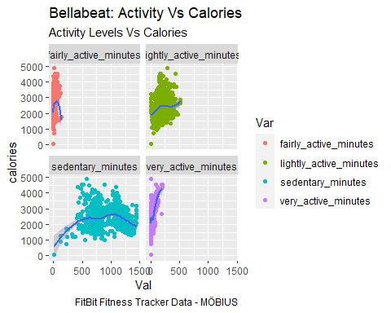

#graphing the above charts seperately to zone in ##graphing very active minutes

ggplot(data = daily_steps, mapping = aes(x = very_active_minutes, y = calories)) +  
 geom_point() +  
 geom_smooth() +  
 labs(title = "Bellabeat: Activity Levels Vs Calories", subtitle = "Very Active Minutes Vs Calories", caption = "FitBit Fitness Tracker Data - MÖBIUS") +  
 annotate("text", x = 100, y = 2000, label = "Large impact on calories above 40 minutes", angle = 35, fontface = "bold", size = 6, color = "blue") +  
 annotate("text", x = 175, y = 4750, label = "Higher is better", color = "blue")

## `geom_smooth()` using method = 'loess' and formula = 'y ~ x'

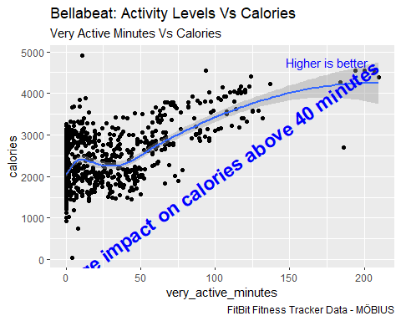

##fairly active minutes graph

ggplot(data = daily_steps, mapping = aes(x = fairly_active_minutes, y = calories)) +  
 geom_point() +  
 geom_smooth() +  
 labs(title = "Bellabeat: Activity Levels Vs Calories", subtitle = "Fairly Active Minutes Vs Calories", caption = "FitBit Fitness Tracker Data - MÖBIUS") +  
 annotate("text", x = 75, y = 500, label = "Does not impact calories in a meaningful way", fontface = "bold", size = 6, color = "blue") +  
 annotate("text", x = 100, y = 4250, label = "Higher is better", color = "blue")

## `geom_smooth()` using method = 'loess' and formula = 'y ~ x'

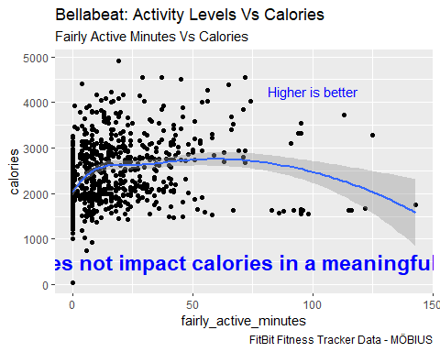

##graphing lightly active minutes

ggplot(data = daily_steps, mapping = aes(x = lightly_active_minutes, y = calories)) +  
 geom_point() +  
 geom_smooth() +  
 labs(title = "Bellabeat: Activity Levels Vs Calories", subtitle = "lightly active minutes Vs Calories", caption = "FitBit Fitness Tracker Data - MÖBIUS") +  
 annotate("text", x = 250, y = 1000, label = "Slight increase in calories on the low end", color = "blue", fontface = "bold", angle = 10, size = 6) +  
 annotate("text", x = 450, y = 4250, label = "Higher is better", color = "blue")

## `geom_smooth()` using method = 'loess' and formula = 'y ~ x'

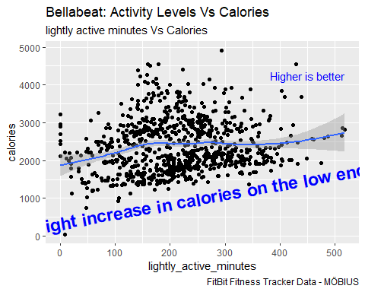

##graphing sedentary minutes

ggplot(data = daily_steps, mapping = aes(x = sedentary_minutes, y = calories)) +  
 geom_point() +  
 geom_smooth() +  
 labs(title = "Bellabeat: Activity Levels Vs Calories", subtitle = "Sedentary Minutes Vs Calories", caption = "FitBit Fitness Tracker Data - MÖBIUS") +  
 annotate("text", x = 750, y = 500, label = "Drops above 1000 minutes", color = "blue", fontface = "bold", size = 6) +  
 annotate("text", x = 1250, y = 4500, label = "Higher cals is better", color = "blue")

## `geom_smooth()` using method = 'loess' and formula = 'y ~ x'

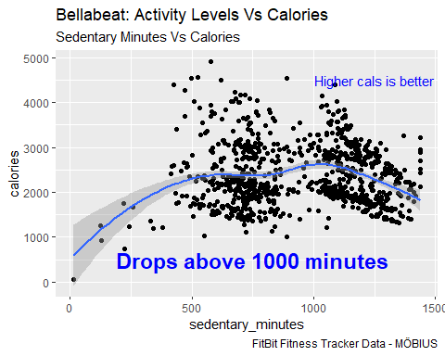

#graphing sleep related data ##graphing sleep and calories

ggplot(data = activity_joined_plus_long, mapping = aes(x = total_minutes_asleep, y = calories)) +  
 geom_point(aes(color = sleep_duration)) +   
 geom_smooth() +  
 scale_x_continuous(breaks = seq(0, 800, by = 100)) +  
 labs(title = "Bellabeat: Sleep Vs Calories", subtitle = "Sleep Duration Vs Calories", caption = "FitBit Fitness Tracker Data - MÖBIUS") +  
 annotate("text", x = 425, y = 1000, label = "Calorie burn is highest in the 5.5-9 hours of sleep range", size = 4, fontface = "bold") +  
 annotate("text", x = 700, y = 4500, label = "Higher is better")

## `geom_smooth()` using method = 'gam' and formula = 'y ~ s(x, bs = "cs")'

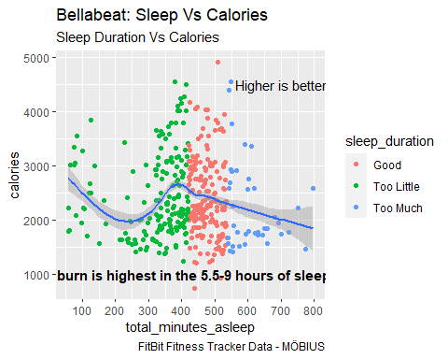

##sleep to sedentary minutes

ggplot(data = activity_join_plus, mapping = aes(x = total_minutes_asleep, y = sedentary_minutes)) +  
 geom_point(aes(color = sleep_duration)) +  
 geom_smooth() +  
 scale_x_continuous(breaks = seq(0, 800, by = 100)) +  
 labs(title = "Bellabeat: Sleep Vs Activity", subtitle = "Sleep Duration Vs Sedentary Minutes", caption = "FitBit Fitness Tracker Data - MÖBIUS") +  
 annotate("text", x = 375, y = 500, label = "Better sleep decreases sedentary minutes", size = 6, angle = 335, fontface = "bold") +  
 annotate("text", x = 600, y = 1200, label = "Lower is better")

## `geom_smooth()` using method = 'loess' and formula = 'y ~ x'

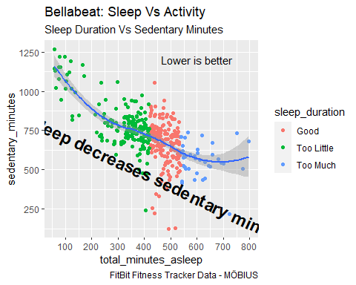

##sleep to very active minutes

ggplot(data = activity_join_plus, mapping = aes(x = total_minutes_asleep, y = very_active_minutes)) +  
 geom_point(aes(color = sleep_duration)) +  
 geom_smooth() +  
 scale_x_continuous(breaks = seq(0, 800, by = 100)) +  
 labs(title = "Bellabeat: Sleep Vs Activity", subtitle = "Sleep Duration Vs Very Active Minutes", caption = "FitBit Fitness Tracker Data - MÖBIUS") +  
 annotate("text", x = 425, y = 150, label = "Increases with better sleep", size = 6, fontface = "bold") +  
 annotate("text", x = 425, y = -25, label = "decreases with too much sleep", size = 6, fontface = "bold") +  
 annotate("text", x = 700, y = 200, label = "higher is better")

## `geom_smooth()` using method = 'loess' and formula = 'y ~ x'

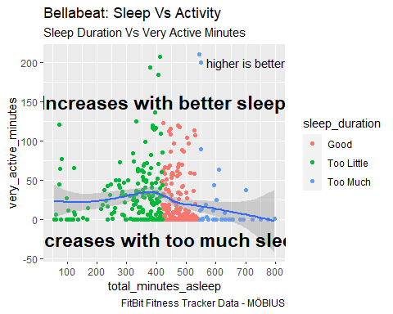

##sleep to fairly active minutes

ggplot(data = activity_join_plus, mapping = aes(x = total_minutes_asleep, y = fairly_active_minutes)) +  
 geom_point(aes(color = sleep_duration)) +  
 geom_smooth() +  
 scale_x_continuous(breaks = seq(0, 800, by = 100)) +  
 labs(title = "Bellabeat: Sleep Vs Activity", subtitle = "Sleep Duration Vs Fairly Active Minutes", caption = "FitBit Fitness Tracker Data - MÖBIUS") +  
 annotate("text", x = 425, y = -10, label = "The majority fall into the 5.5-9 hour range", fontface = "bold", size = 6) +  
 annotate("text", x = 700, y = 125, label = "higher is better")

## `geom_smooth()` using method = 'loess' and formula = 'y ~ x'

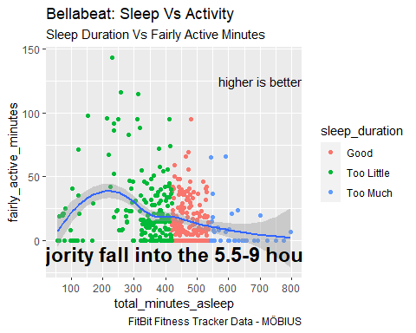

##sleep to lightly active minutes

ggplot(data = activity_join_plus, mapping = aes(x = total_minutes_asleep, y = lightly_active_minutes)) +  
 geom_point(aes(color = sleep_duration)) +  
 geom_smooth() +  
 scale_x_continuous(breaks = seq(0, 800, by = 100)) +  
 labs(title = "Bellabeat: Sleep Vs Activity", subtitle = "Sleep Duration Vs Lightly Active Minutes", caption = "FitBit Fitness Tracker Data - MÖBIUS") +  
 annotate("text", x = 425, y = 25, label = "Increases in the 7-9 hour range with a drop after 9 hours", fontface = "bold", size = 5) +  
 annotate("text", x = 700, y = 500, label = "Higher is better")

## `geom_smooth()` using method = 'loess' and formula = 'y ~ x'

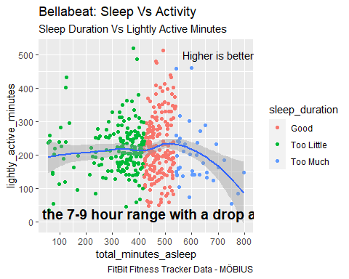

#From this point graphs were exported and used in google slides to make a presentation