**Control the Drone Using Google Glass Head Motion**

Step 1:

Connect the Google Glass to the Drone Free Flight Wi-Fi Connection.

Step 2:

Install the APK file to the glass using following comments in comment prompt.

**Install:** adb install ArDroneAdjuster.apk

**Uninstall:** adb uninstall com.cognizant.ardrone

Note: Before that you have to set the environment variable for Java and Android SDK.

Step 2:

Tap to open the Start Drone Application.

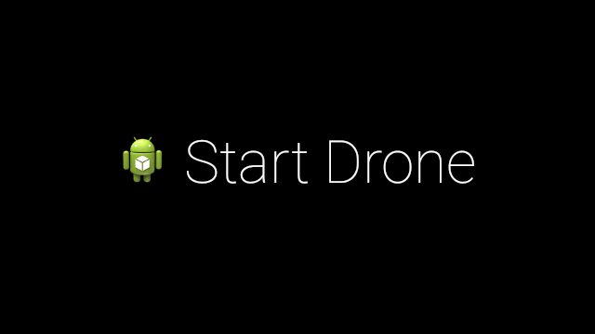

Step 3:

Tap to take of the drone. The drone will be fly based on your head moment.

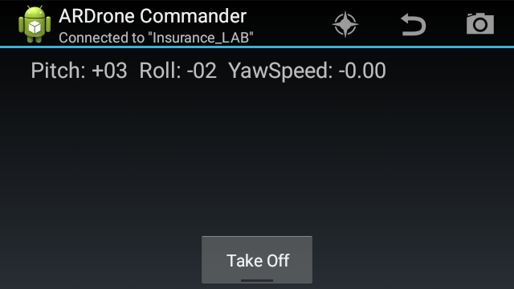

Step 4:

If you want to show drone video stream in web app. You will refer the Third Eye document.

Note: Once the drone flying. You will connect laptop to the drone Wi-Fi and then double click the batch file for running node server.

