Step 1: Login to the <http://glass.google.com/myglass> (Use ur login).

Step2: Click Setup Wi-Fi link below screen(For your Reference See the Video Clips ).

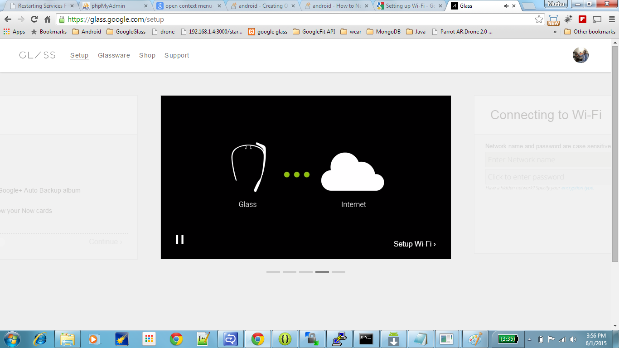

Step3: Enter your Wi-Fi details .

Step4: Click Show QRCode link in below screen.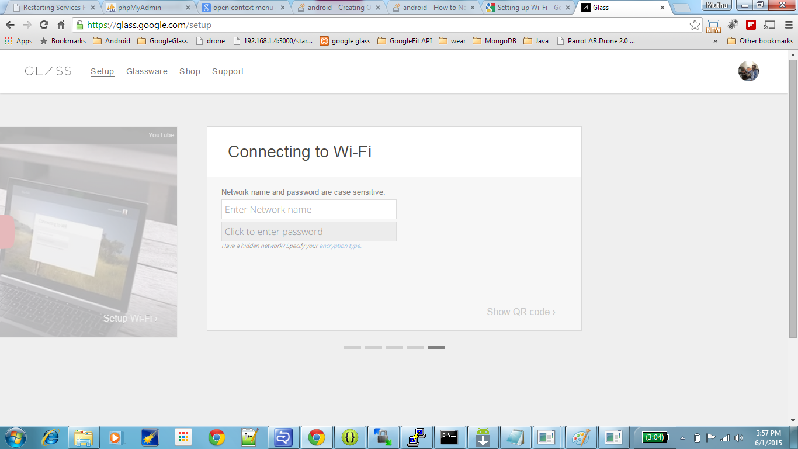

Step5: Scan the QRCode through Your Glass.

