|  |  |
| --- | --- |
| BUE final logo  Informatics and Computer Science | **20CSCI05l**  **2020/2021** |
| Module Title **Logic & Artificial Intelligence** | |
| Module Leader **Professor**  **Samy Ghoniemy** | Semester  **Two** |
|  | |
| Hazem Hesham | 182189 |
| Omar Tarek | 186193 |
| Youssef Ahmed | 181767 |
| File name uploaded: | Submission Date:16/6/2021 |

**Description:**

House prices increment consistently, so there is a need for a program to predict these house prices later on. House cost expectation can assist the developer with deciding the selling cost of a house and can assist the client with organizing the ideal opportunity to buy a house. There are three factors that impact the cost of a house which incorporates states of conditions, concept and area. Data is at the core of specialized advancements, accomplishing any outcome is presently conceivable utilizing prediction models. Machine learning is broadly utilized in this approach. Machine learning implies giving legit dataset and the prediction depend on that, the actual machine figures out how much significance a specific occasion may have on the whole framework based on its pre-stacked data and as needs be predicts the result. Different current utilizations of this procedure incorporate predicting stock costs, predicting the plausibility of a seismic tremor, predicting organization deals and the rundown has unlimited conceivable outcomes. For our examination project, we have thought of Madinaty as our essential area and are predicting constant house costs for different areas in and around it. We have utilized boundaries like ' Avg. Area Income', 'Avg. Area House', ' Avg. Area Number of Rooms', ' Avg. Area Number of Bedrooms', ' Area Population' ,'Price', 'Address' , 'sqft_lot' , 'statezip', 'city'. We have a checked dataset with variety so as give exact outcomes for all conditions. We have utilized different calculations clarified beneath in different blends and the load for each calculation is given dependent on the exactness rate. Subsequent to assessing for different trials we finish up that rather than an individual calculation a progression of calculation yields better outcomes.

**Experiments, results and evaluation.**

-pairplot

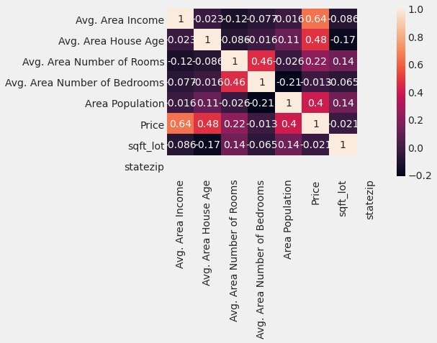

-Distplot

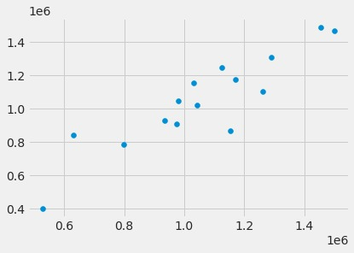

-Heatmap

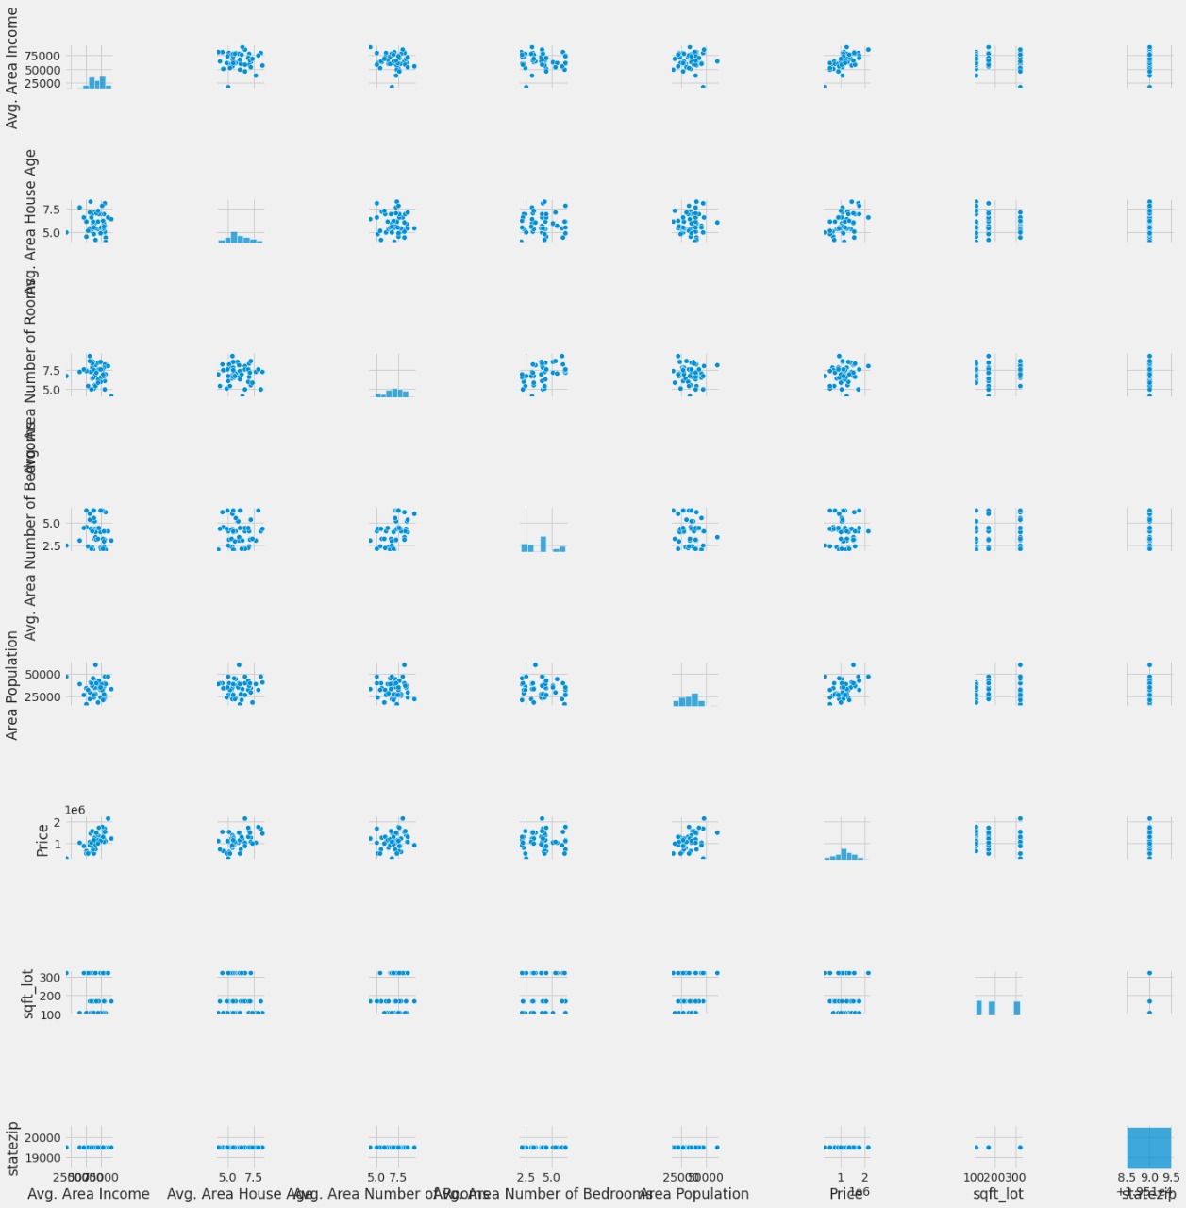

-Scatter

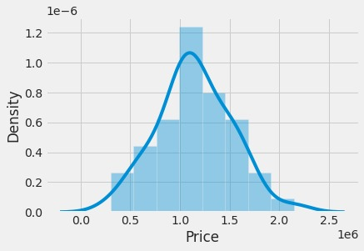

-distplot

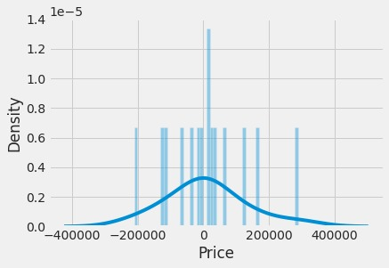

**Summary:**

The house prediction price program utilizes specific libraries and datasets. After importing the required libraries inside our python environment, the dataset gets imported. The three main factors that impact on the prices of the houses are the state of conditions, concept and area. According to these factors the dataset was created including all the needed information of the houses. Machine learning is broadly utilized in this approach. Different calculations were utilized for the exactness rate of the price.

**Software Tools:**

* Online compiler.
* sklearn