MyeliMetric-V2
Improvements over the Published Version, with Validation
Justification for the new version
Standardized g-ratio analysis of axon-myelin integrity
Reference: Ahmad I, Chowdhury FS, Boullerne AI, Gow A, Feinstein DL. MyeliMetric. ASN Neuro. 2026;18(1):2603411.

1. Purpose
This document justifies MyeliMetric-V2 by setting out how it improves on the published version and by demonstrating, with validation tests and figures, that the improvements do not change the underlying g-ratio results. Two lines of evidence are presented: recovery of known ground truth from synthetic data, and reproduction of previously published grand g-ratios from real experimental data. Verification tests for the new features are also reported.
The guiding principle of V2 is that the interface and workflow were improved while the validated computational core was preserved unchanged. The evidence below supports that claim.

2. Summary of improvements over the published version
Aspect | Published version | MyeliMetric-V2
Workflow | Each button ran immediately | Load control, load experimental, then one Analyze step
Save location | Chosen separately per group | One folder; Control, Experimental and Summary created automatically
Safeguards | None on missing save location | Reminds the user to choose a save location before analysis
Number of bins | Fixed at 6 | User adjustable, default 6
Exclusion thresholds | Fixed at 0.15 and 0.03 | User adjustable, same defaults
File input | Excel only | Excel and CSV
Interface | Flat buttons over an image | Sectioned layout, optional advanced panel, activity log
Startup | Crashes if Python packages missing | Opens first; guides the user to install if needed
Outputs | Individual files | Organized folders plus a run log and exclusion audit
Table 1. Principal differences between the published version and MyeliMetric-V2.

3. The computational core is unchanged
All of the following are computed by the same functions used in the published version, so the numerical results are not altered by the V2 interface changes.
- G-ratio defined as axon diameter divided by fiber diameter.
- Fiber diameter defined as axon plus myelin.
- Exclusion of axon diameters below 0.15 and myelin below 0.03 micrometres by default.
- Grouping of fibers into six diameter bins by default.
- Per-bin mean, median, standard deviation and 95 percent confidence interval.
- Shapiro-Wilk normality testing per bin.
- Two-way analysis of variance for the group by subset comparison.

4. Validation 1: recovery of known ground truth (synthetic data)
A synthetic dataset was generated following the method described in the published paper: five animals per group, roughly one thousand fibers each, with g-ratios drawn from a bounded normal distribution centred on 0.70 for the control group and 0.80 for the experimental group, and myelin solved from the g-ratio identity. Because the true g-ratios are built in, the correct output is known in advance.
MyeliMetric-V2 recovered the imposed values almost exactly: a control grand mean g-ratio of 0.704 and an experimental grand mean of 0.800, against imposed values of 0.70 and 0.80 and the published paper values of 0.70 and 0.79.
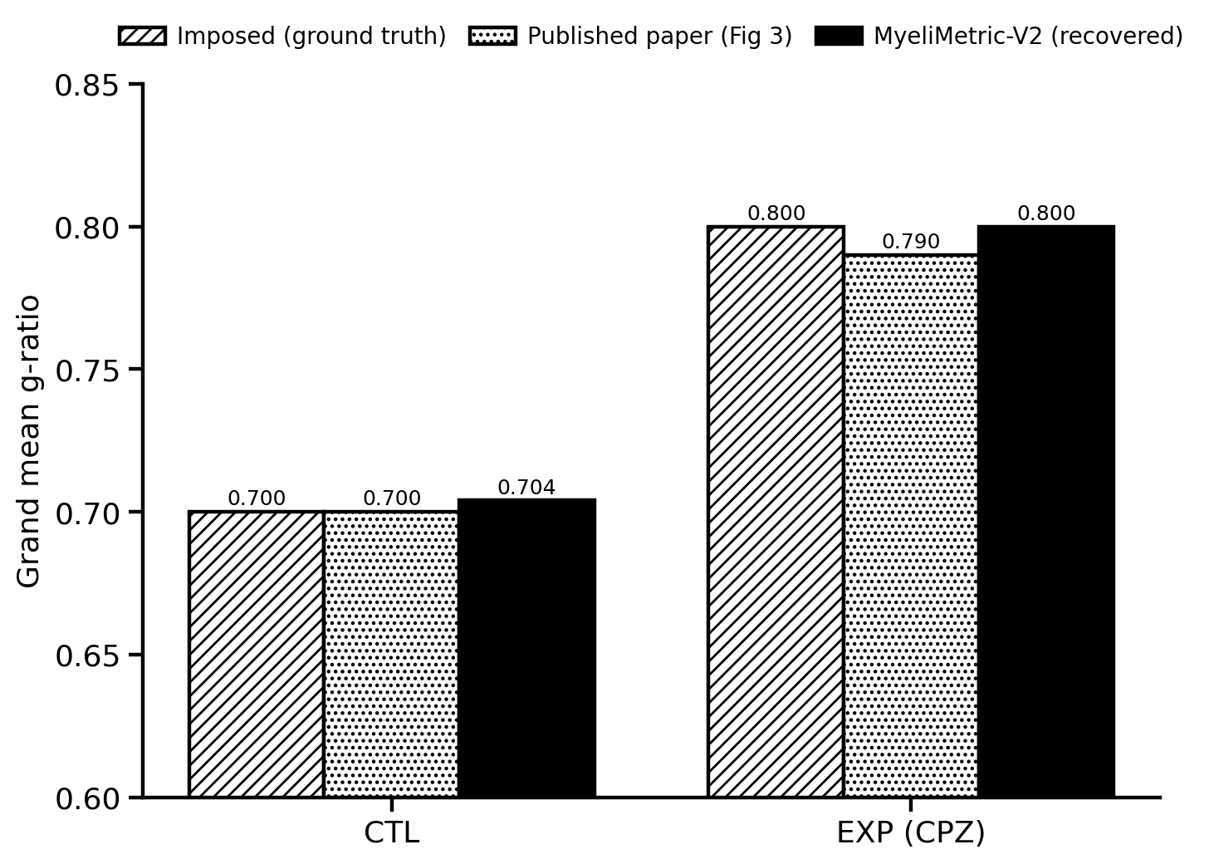
Figure 1. Synthetic data. Grand mean g-ratio: imposed ground truth, the published paper values, and the values recovered by MyeliMetric-V2. Agreement is within 0.01.
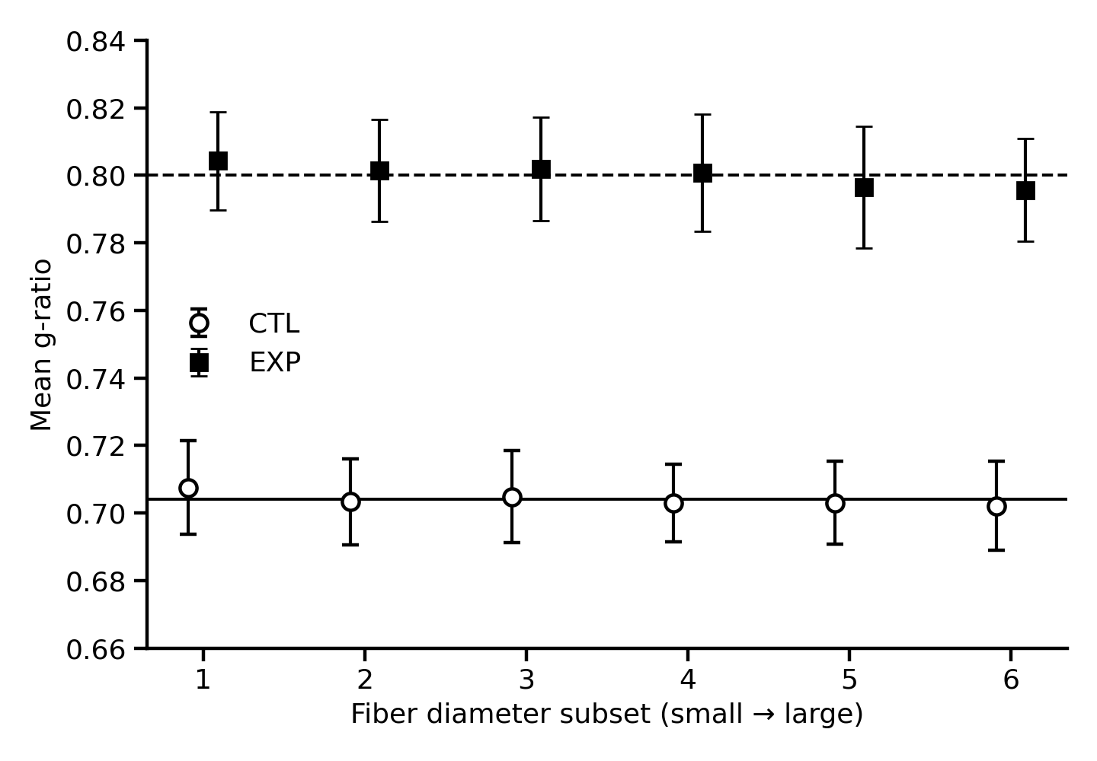
Figure 2. Synthetic data, per-bin means. Both groups sit close to a flat line across the six bins, with a clear control below experimental separation, as expected for constant-g behaviour.

5. Validation 2: reproduction of published values (real data)
A real experimental dataset (control and treated groups, four animals each) was analysed with MyeliMetric-V2. The resulting grand mean g-ratios were 0.784 for the control group and 0.778 for the experimental group. These match the corresponding published grand g-ratios to within 0.01, the same order of small deviation the original paper attributes to differences in outlier exclusion and binning.
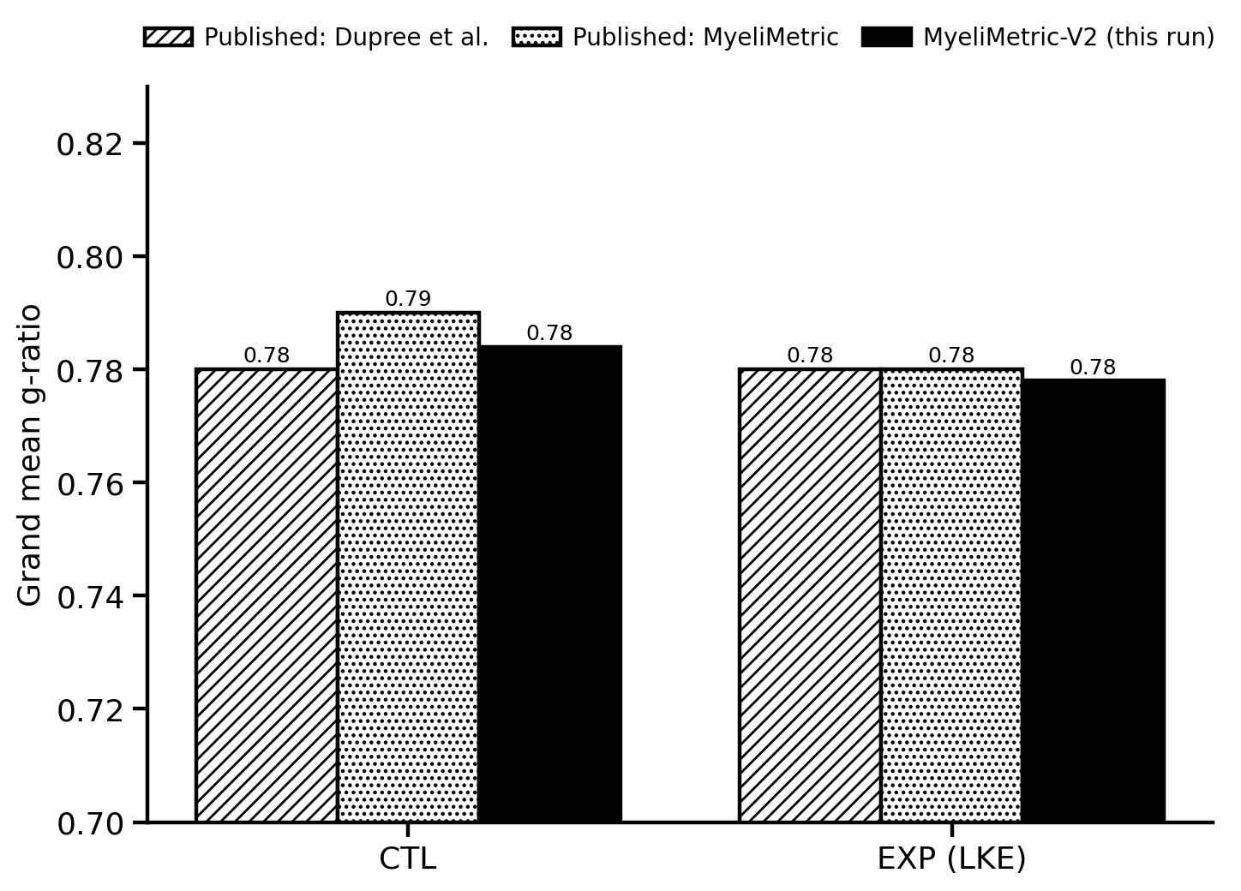
Figure 3. Real data. Grand mean g-ratio from MyeliMetric-V2 compared with the published values (Dupree et al. and the MyeliMetric paper). Agreement is within 0.01.
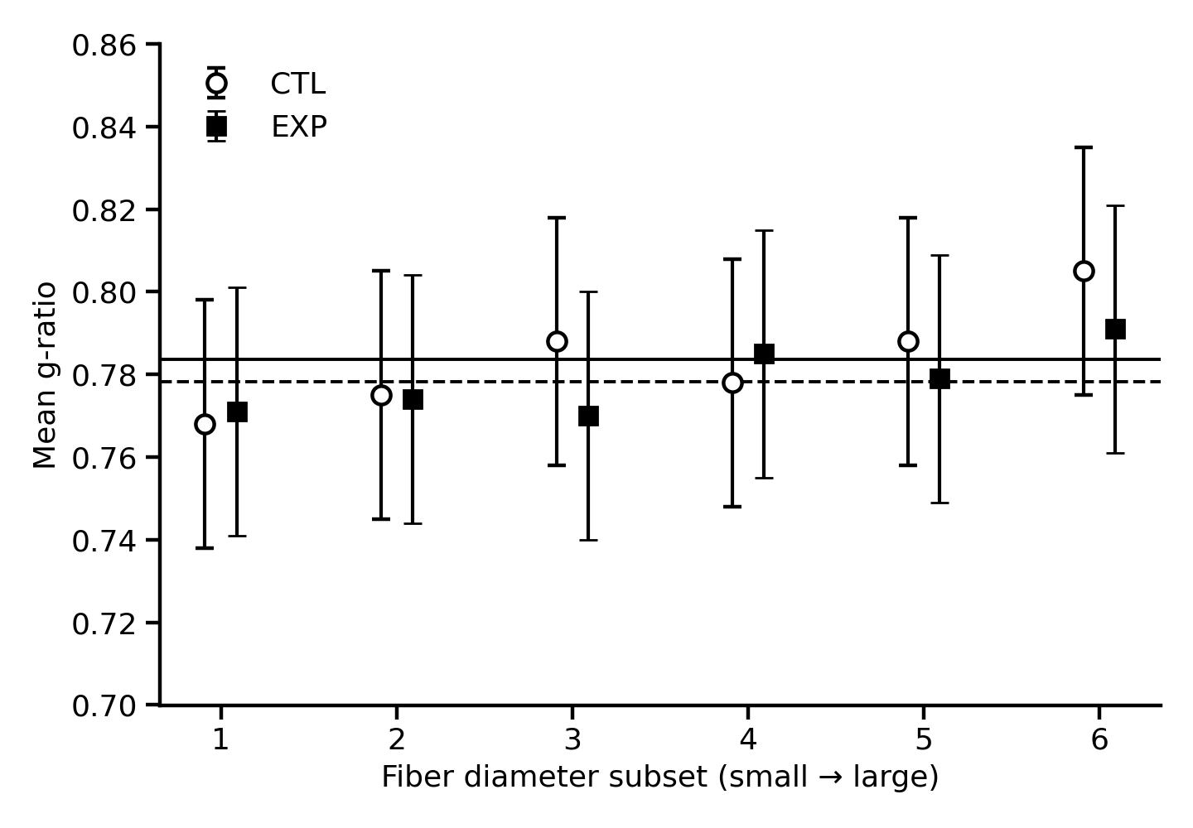
Figure 4. Real data, per-bin means. The control and experimental groups remain close to a flat line across the six bins, consistent with the published analysis.
Group | Published | MyeliMetric-V2 | Difference
CTL | 0.78 to 0.79 | 0.784 | <= 0.01
EXP (treated) | 0.78 | 0.778 | <= 0.01
Table 2. Real-data grand g-ratios: published values versus MyeliMetric-V2.

6. Verification of the new features
Each new feature was tested to confirm it behaves as intended without affecting the core results.
Feature | Test | Result
Adjustable bins | Requested 4, 6 and 8 bins on the same data | Produced exactly 4, 6 and 8 bins; Pass
Adjustable thresholds | Raised the axon threshold from 0.15 to 0.30 | Removed more measurements as expected (400 to 506); Pass
Save-location reminder | Clicked Analyze with no folder chosen | Prompted the user to choose a folder; Pass
Automatic subfolders | Ran a full analysis into one chosen folder | Created Control, Experimental and Summary folders; Pass
Load then analyze | Clicked Step 1 and Step 2 | Loaded data only; processing occurred at Step 3; Pass
Deferred startup | Launched with scientific packages absent | Interface opened without crashing; Pass
Table 3. Verification tests for the new features.

7. Why the new version is an improvement
- Fewer errors. One save location with automatic subfolders and a reminder prevent lost or misplaced results.
- Clearer workflow. Loading the data first and analyzing in a single step matches how users think about the task, and the numbered buttons make the order obvious.
- More flexibility. Adjustable bins, adjustable thresholds and CSV input widen the range of datasets and questions the tool can address.
- More transparent. A run log and exclusion audit record exactly what was removed, supporting reproducibility.
- Easier to distribute. A standalone build lets colleagues without Python use the tool, and the interface opens even before packages are installed.
Crucially, none of these gains came at the cost of the validated results, as Sections 4 to 6 demonstrate.

8. Note on reproducibility
One methodological change should be recorded. The published version derived the fiber-diameter bin ranges from the first control animal. MyeliMetric-V2 derives them from all control animals pooled together, which removes the dependence on which animal is loaded first. Grand g-ratios are essentially unchanged by this, as the validation confirms, but individual bin edges and per-bin sample counts differ slightly from a run of the published version. For an exact match to the publication, this step can be reverted to the first-control method, or offered as a user-selectable option that defaults to the published behaviour.

9. Citation
Ahmad I, Chowdhury FS, Boullerne AI, Gow A, Feinstein DL. MyeliMetric: A Python-Based Toolbox for Standardized G-Ratio Analysis of Axon-Myelin Integrity. ASN Neuro. 2026;18(1):2603411. doi:10.1080/17590914.2025.2603411

