MyeliMetric-V2
User Manual (windows-only version)
Standalone standardized g-ratio analysis of axon-myelin integrity

Version 2 | Windows standalone | Manual updated Sep 2026
Please cite:Ahmad I, Chowdhury FS, Boullerne AI, Gow A, Feinstein DL. MyeliMetric: A Python-Based Toolbox for Standardized G-Ratio Analysis of Axon-Myelin Integrity. ASN Neuro. 2025;18(1):2603411. doi:10.1080/17590914.2025.2603411.

Contents
1. About MyeliMetric-V2
2. Opening the standalone application
3. The MyeliMetric interface
4. Preparing input data
5. Running the standard analysis
6. Worked example using the supplied CTL and EXP files
7. Output folders and files
8. Reading the output figures and statistics
9. Advanced mode
10. Troubleshooting and FAQ
11. Citation and version information

Quick start
- Open MyeliMetric.exe.
- Check the analysis settings. The defaults are 0.15 µm minimum axon diameter, 0.03 µm minimum myelin value, and 6 fiber-diameter bins.
- Click Choose save location and select one folder.
- Click Step 1: Load control data and select the CTL file.
- Click Step 2: Load experimental data and select the EXP file.
- Click Step 3: Analyze.
- Wait for the completion message, then open the Control, Experimental, and Summary folders created in your save location.
No dependency-installation step
The finished standalone MyeliMetric.exe is intended to contain the Python runtime and required scientific packages. End users should not need to install Python or click an Install dependencies button.

1. About MyeliMetric-V2
MyeliMetric-V2 is a graphical research application for standardized g-ratio analysis from post-segmented axon and myelin measurements. It calculates fiber diameter and g-ratio, groups fibers into fiber-diameter subsets, produces descriptive statistics and figures, and compares control (CTL) and experimental (EXP) groups.
The g-ratio is defined as axon diameter divided by total fiber diameter. In the MyeliMetric data structure, fiber diameter is calculated as the axon value plus the full myelin contribution supplied in the paired _My column.
Fiber diameter | Axon diameter + full myelin contribution
g-ratio | Axon diameter / fiber diameter

2. Opening the standalone application
Step 1. Save MyeliMetric.exe in a convenient location, such as a project folder or the Desktop.
Step 2. Double-click MyeliMetric.exe. A one-file standalone application may take several seconds to open.
Step 3. If Windows or institutional security software shows a warning, first confirm that the executable came from the official MyeliMetric source. Follow your institution's IT policy rather than disabling system security globally.
Step 4. When the main window appears, MyeliMetric is ready to use.

3. The MyeliMetric interface
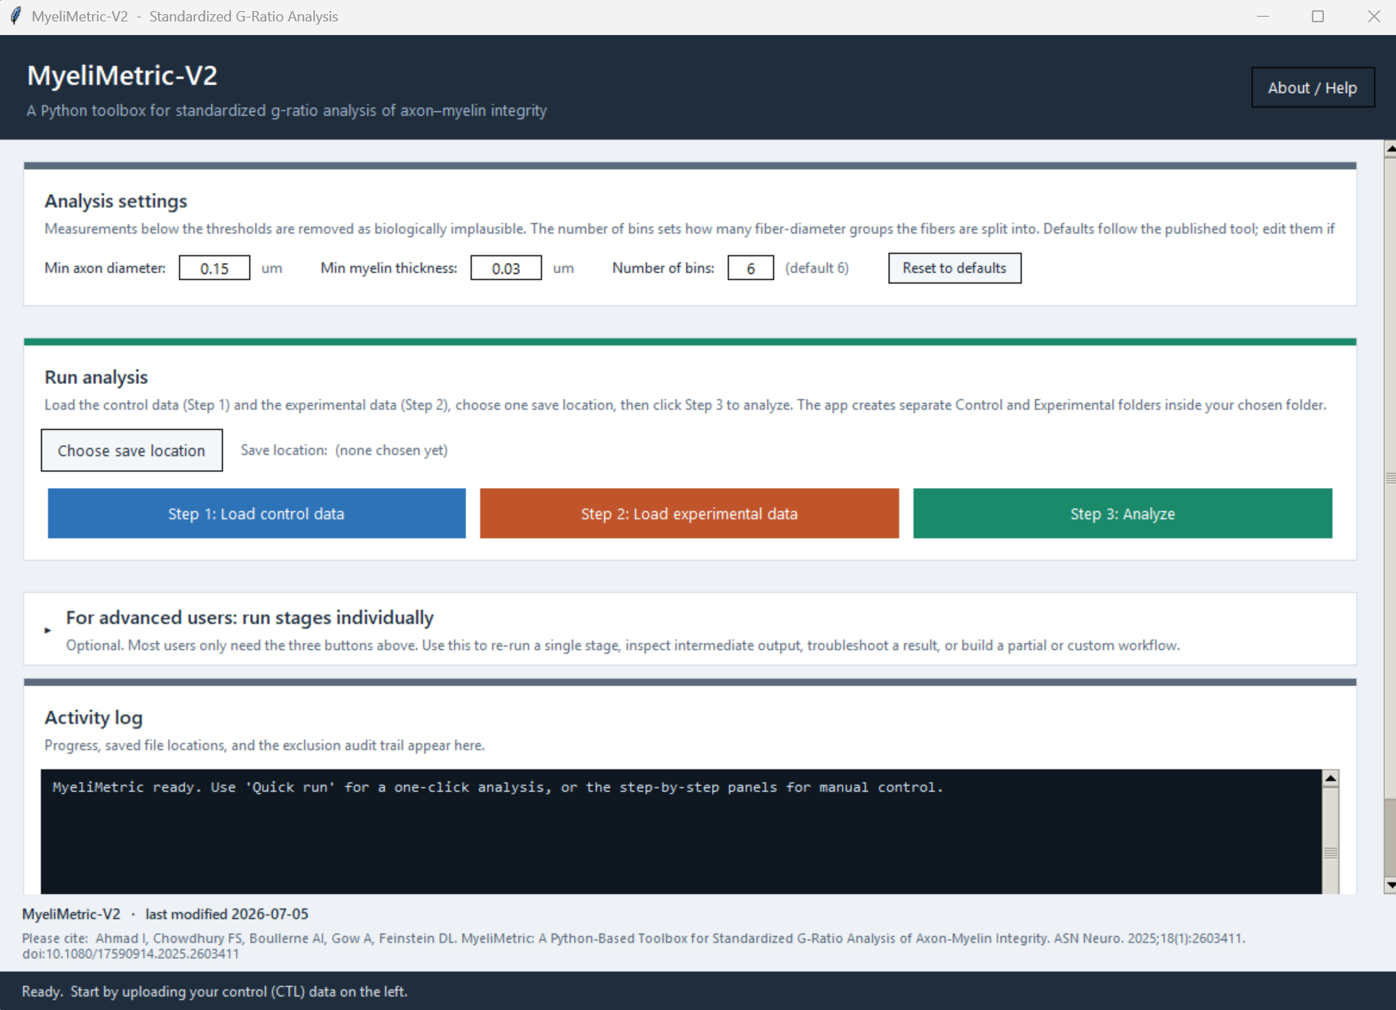
Figure 1. MyeliMetric-V2 as it appears when first opened. The standard workflow is visible immediately, and the advanced CTL/EXP controls are collapsed by default until the user clicks “For advanced users: run stages individually.”

- Analysis settings: minimum axon diameter, minimum myelin thickness/value, number of bins, and Reset to defaults.
- Run analysis: choose one output location, then load CTL and EXP data and run Step 3.
- Advanced mode: optional stage-by-stage CTL and EXP controls. This section is collapsed when MyeliMetric first opens and expands only when selected.
- Activity/status area: reports the current action, completion state, and output information.
- About / Help: application version and citation information.

4. Preparing input data
The standard workflow accepts Excel (.xlsx/.xls) and CSV input. Measurement values should be numeric and use micrometres (µm). Place all control animals in one file and all experimental animals in a second file.

Required column pattern
Each animal needs a paired axon and myelin column. The identifier before the underscore must match exactly.
CTL1_Ax | CTL1_My | CTL2_Ax | CTL2_My
0.80 | 0.24 | 0.65 | 0.24
0.86 | 0.33 | 0.55 | 0.19
0.66 | 0.14 | 0.63 | 0.20
… | … | … | …
Table 1. Example column naming. Experimental samples should use EXP1_Ax / EXP1_My, EXP2_Ax / EXP2_My, and so on.
Important: define the _My value correctly
MyeliMetric calculates fiber diameter as Ax + My. If your measured myelin thickness is a one-sided radial thickness t, enter 2t as the _My value. If your workflow already provides the full myelin contribution across the fiber diameter, do not double it again.

Default analysis settings
Setting | Default | Function
Minimum axon diameter | 0.15 µm | Values below this threshold are excluded
Minimum myelin value | 0.03 µm | Values below this threshold are excluded
Number of bins | 6 | Number of pooled-control fiber-diameter subsets

5. Running the standard analysis
For routine use, the three-button workflow is recommended. Steps 1 and 2 only load the file paths. The actual processing begins when Step 3: Analyze is clicked.
Step 1. Check settings. Use the defaults unless your experimental design requires another threshold or number of bins.
Step 2. Choose save location. Select one writable folder. MyeliMetric creates the organized result folders inside it.
Step 3. Load CTL data. Click Step 1 and select the control file.
Step 4. Load EXP data. Click Step 2 and select the experimental file. This can be skipped for CTL-only analysis.
Step 5. Analyze. Click Step 3. CTL is processed first. Pooled control ranges are calculated and then reused for EXP.
Step 6. Review completion. Read the activity/status information and open the output directory.
Why CTL is processed first
The control data define the pooled fiber-diameter bin ranges. Applying those same ranges to EXP makes CTL and EXP comparisons occur within the same caliber intervals.

6. Worked example using the supplied CTL and EXP files
To verify the complete workflow, the MyeliMetric scripts were run on Example_CTL.xlsx and Example_EXP.xlsx using the defaults (axon ≥ 0.15 µm, myelin ≥ 0.03 µm, 6 bins). Each example file contained three samples with 120 measurement rows per sample. No measurements were removed by the default cleanup thresholds in this example run.

Control-derived fiber-diameter ranges
Subset | Minimum fiber diameter (µm) | Maximum fiber diameter (µm)
CTL_Subset1 | 0.29 | 0.65
CTL_Subset2 | 0.66 | 0.81
CTL_Subset3 | 0.82 | 1.00
CTL_Subset4 | 1.01 | 1.16
CTL_Subset5 | 1.17 | 1.45
CTL_Subset6 | 1.46 | 2.38

Example grand-mean output
Group | Animal-subset means used | Grand mean g-ratio | SD of subset means
CTL | 18 | 0.6978 | 0.0077
EXP | 18 | 0.7889 | 0.0093
Example data are for demonstration
The values and figures in this section demonstrate that the pipeline runs and show what the output looks like. They should not be interpreted as biological findings or validation of an experimental hypothesis.

7. Output folders and files
The standard workflow creates a structured directory under the one save location selected by the user.
Folder | Typical file(s) | Purpose
Control/Cleaned | Cleaned_CTL.xlsx | Cleaned measurements plus calculated fiber diameter and g-ratio
Control/Subsets | Ranges_CTL.xlsx; Subsets_CTL.xlsx | Pooled CTL ranges and CTL subset workbooks
Control/Stats | Stats_CTL.xlsx | Mean, median, SD, 95% CI, Shapiro-Wilk, normality
Control/Histograms | CTL*_Subset*.png | G-ratio frequency distributions
Control/ScatterPlots | CTL*_scatter_plot.png | Fiber diameter versus axon diameter
Control/Figures | Normality_Overview_CTL.png | Normality overview
Experimental/... | EXP equivalents | Same pipeline using CTL-derived ranges
Summary | Summary_Report.xlsx; Summary_CTL_vs_EXP.png | Combined CTL-versus-EXP summary

Actual example output: CTL versus EXP summary
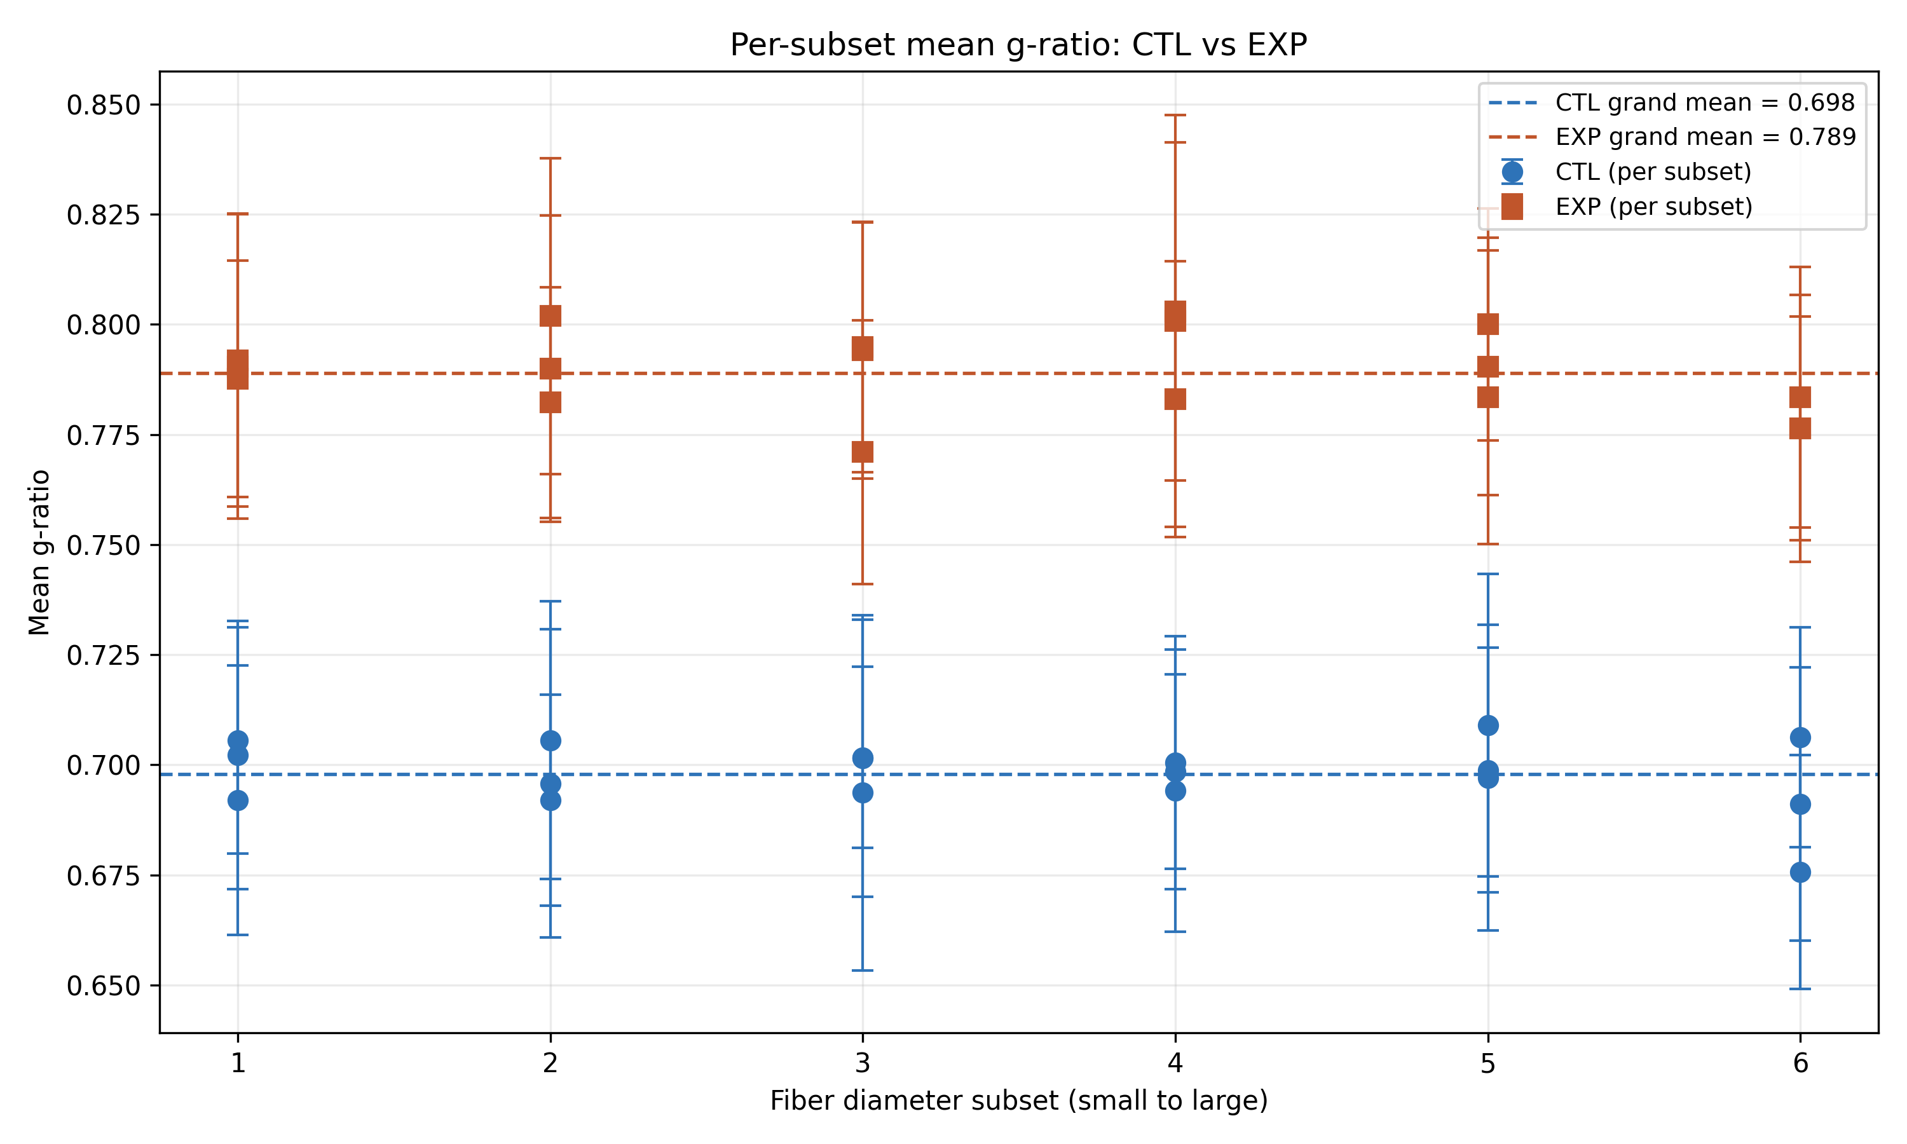
Figure 2. Actual Summary_CTL_vs_EXP.png generated from Example_CTL.xlsx and Example_EXP.xlsx. Each marker is an animal-specific subset mean; the error bars come from the within-subset g-ratio SD. Dashed lines show the grand mean of the animal-subset means for each group.

8. Reading the output figures and statistics

Scatter plots
Scatter plots show axon diameter as a function of total fiber diameter for each sample. The plotted regression line is a descriptive visual aid for the relationship in that sample.
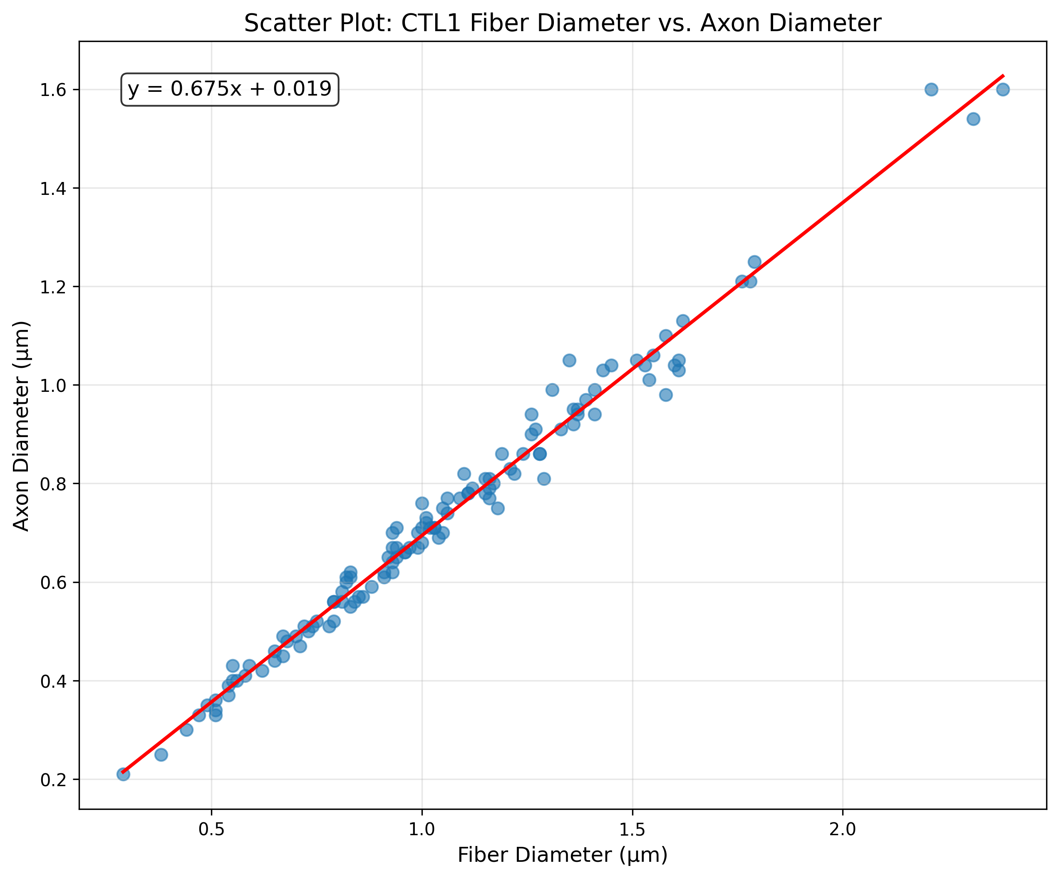
Figure 3. Actual CTL1 scatter plot generated by MyeliMetric from the supplied example control data.

G-ratio histograms
For every animal and fiber-diameter subset, MyeliMetric saves a g-ratio frequency distribution. The y-axis is the proportion of observations falling in each histogram bin.
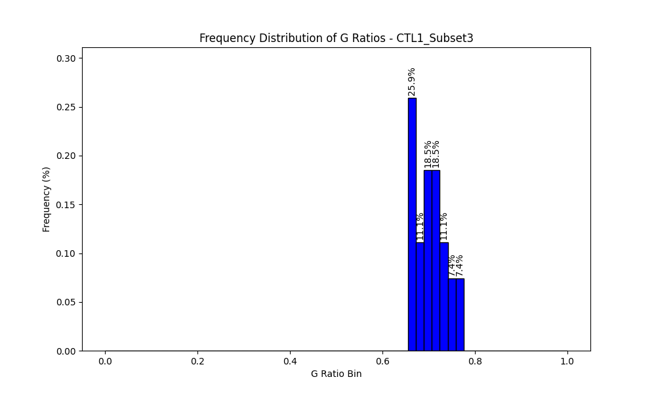
Figure 4. Actual CTL1_Subset3 g-ratio histogram generated by MyeliMetric from the supplied example control data.

Normality overview
The statistics workbook includes a Shapiro-Wilk test for each animal-specific fiber-diameter subset. The normality overview plots the corresponding p-values. Values below 0.05 indicate evidence against a normal distribution for that subset.
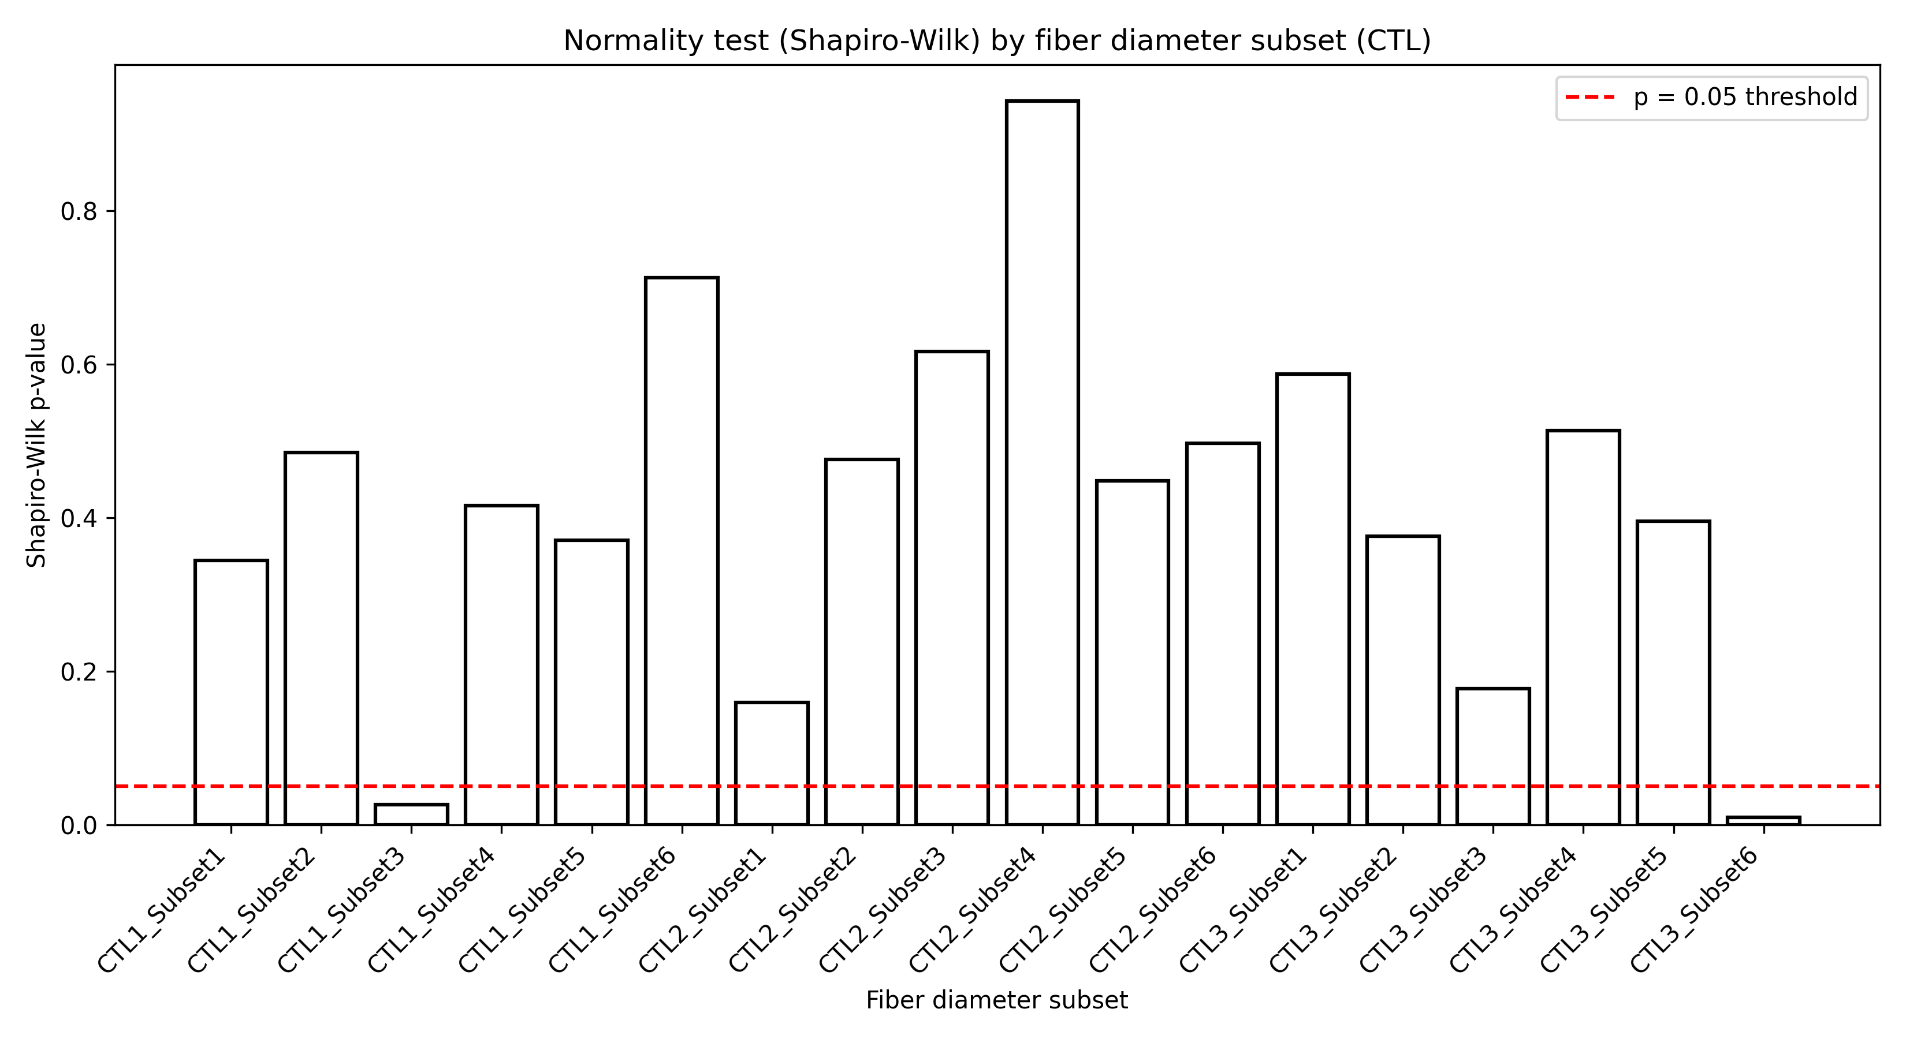
Figure 5. Actual CTL Shapiro-Wilk overview generated from Example_CTL.xlsx. The red dashed line marks p = 0.05.
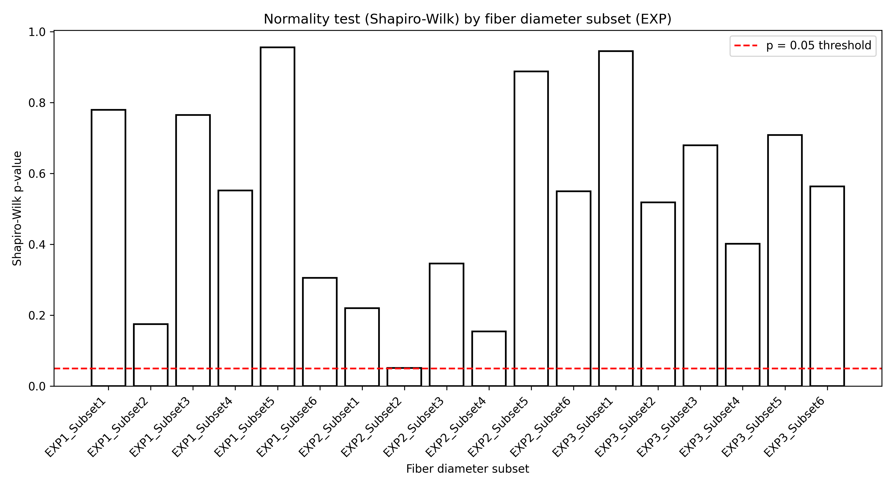
Figure 6. Actual EXP Shapiro-Wilk overview generated from Example_EXP.xlsx using the same control-derived fiber-diameter ranges.
Interpretation caution
A higher g-ratio indicates relatively thinner myelin for a given axon caliber, but g-ratio alone does not establish a biological mechanism. Interpret results together with fiber size, region, model, microscopy/segmentation quality, and the experimental design.
Experimental unit and pseudoreplication
Fibers from the same animal are not independent biological replicates. For population-level inference, use the animal as the experimental unit or apply an appropriate hierarchical/mixed-effects model. Fiber-level sample size should not be treated as the number of independent animals.

9. Advanced mode
The section For advanced users: run stages individually exposes the individual CTL and EXP operations. It is useful for troubleshooting or inspecting intermediate files. Routine analyses should normally use the standard three-step workflow.
- Upload CTL or EXP data.
- Clean the data using the current thresholds.
- Calculate fiber diameter.
- Calculate g-ratios.
- Generate scatter plots.
- Sort and save intermediate data.
- Create pooled-control subsets or experimental subsets.
- Generate histograms and statistics.
Advanced mode may request more file selections
Because the individual stages are exposed separately, the advanced workflow may ask for intermediate input and output locations. The standard workflow manages these paths automatically.

10. Troubleshooting and FAQ
Problem / question | Answer
Do I need Python? | No for normal use of the finished standalone MyeliMetric.exe.
Do I need Install dependencies? | No. The standalone interface shown in Figure 1 does not require that button.
MyeliMetric.exe does not open. | Wait several seconds, verify the download source, and check whether Windows or institutional security blocked the executable.
Analyze asks for a save location. | Click Choose save location, select a writable folder, then run Step 3 again.
Analyze asks for control data. | Load a CTL file with Step 1. CTL data are required to define the pooled fiber-diameter ranges.
No valid column pairs were found. | Confirm that every *_Ax column has a matching *_My column with exactly the same sample identifier.
G-ratios look systematically wrong. | Confirm µm units and verify that _My contains the full myelin contribution expected by the fiber-diameter formula.
Excel output cannot be written. | Close any workbook with the same filename and choose a folder where you have write permission.
Can I run CTL only? | Yes. Load CTL, choose a save location, and click Analyze. EXP and Summary comparison stages will be skipped.
Will my original data be altered? | The standard workflow reads the source files and writes new results to the selected output folder.

11. Citation and version information
If you use MyeliMetric in your research, please cite:
Ahmad I, Chowdhury FS, Boullerne AI, Gow A, Feinstein DL. MyeliMetric: A Python-Based Toolbox for Standardized G-Ratio Analysis of Axon-Myelin Integrity. ASN Neuro. 2025;18(1):2603411. doi:10.1080/17590914.2025.2603411.
Application | MyeliMetric-V2
Version | 2
Manual revision | September 2026
Worked example | Example_CTL.xlsx + Example_EXP.xlsx, default settings

