# Sample Rx REST API

## Introduction

This Sample application demonstrate how to transfer data across platforms using XML and JSON over HTTP. The API returns the results based on client query string values: client unique key, page size, and page number. The demo is based on Microsoft technologies: Entity framework 6, Web Api 2, MS SQL 2012, and Visual Studio 2017 Community Edition.

## Scope

“I need a basic REST API that can authenticate and authorize third party companies and allow them to get anonymized prescription data out of a cloud database. Users of this API should be able to retrieve drugs prescribed, quantity prescribed and price. Assume all technology used will be Microsoft.”

## Set Up

1. From SQL Management studio, open SampleRxMaster/SampleRx.Db/MasterScript.sql against your Dev SQL Server where you have administrative rights.

Note: This script can take up to 5 minutes

1. From VS 2017, open SampleRxMaster/SampleRxMaster.sln:
   1. Make sure all the NuGet packages are update/restored properly
   2. Open SampleRx.Web/Web.config and update the connection string to point to the right SQL Server.
   3. Compile and Run the the project with SampleRx.Web set as your startup project.
2. Once the application start, it will display a Quick Start, etc.
3. Click on sign up and fill the form—It is assumed that companies will request their Company ID.

For the purpose of the demo, we have 10 companies with ID ranging from 1 to 10.

[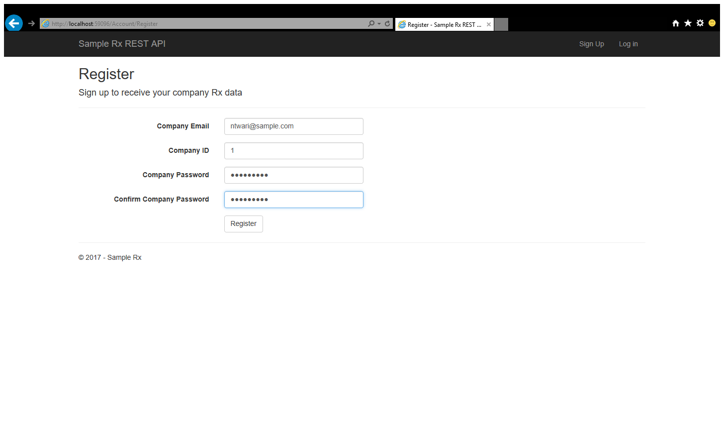](http://localhost:59096/account/register)

1. After successfully login/register, a user is presented with information on how to call the API with his/her company unique ID.

## Usage

### XML

When the users set the ‘Accept’ to ‘application/xml’

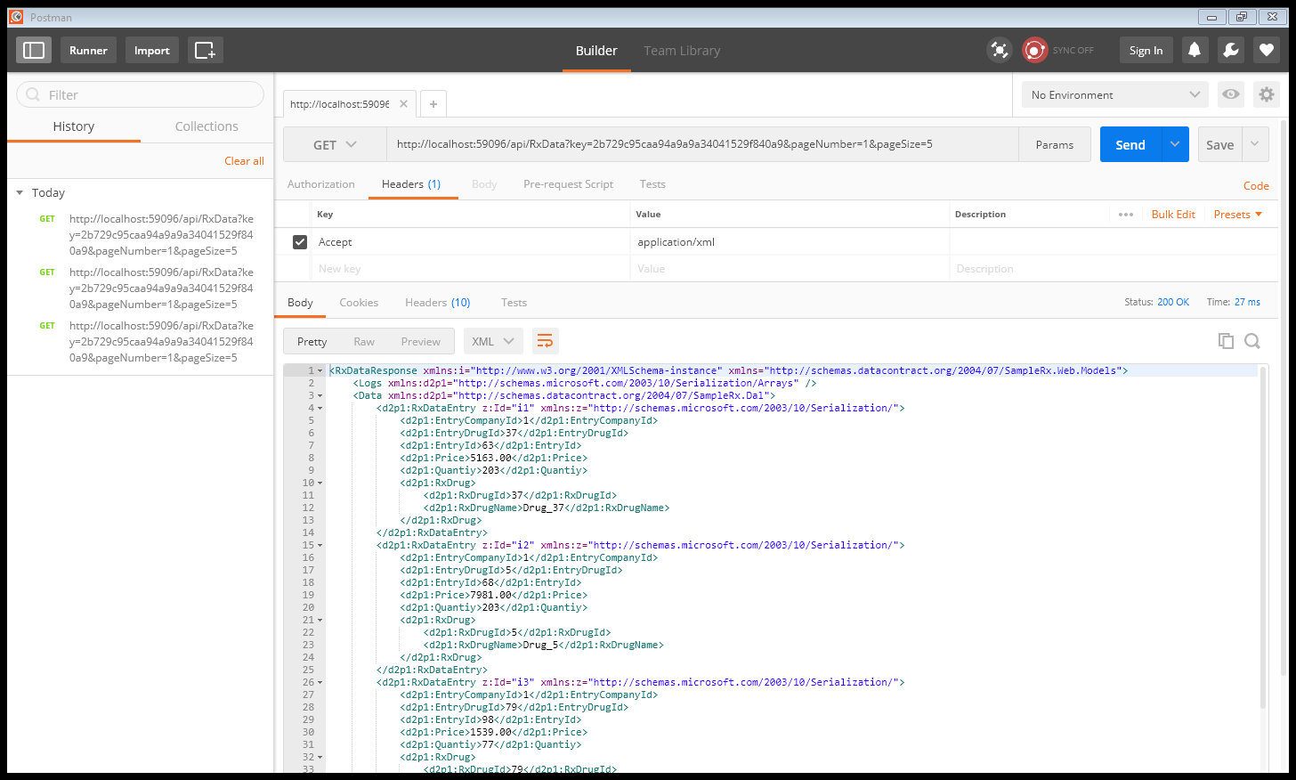

### JSON

When the users set the ‘Accept’ to ‘application/xml’

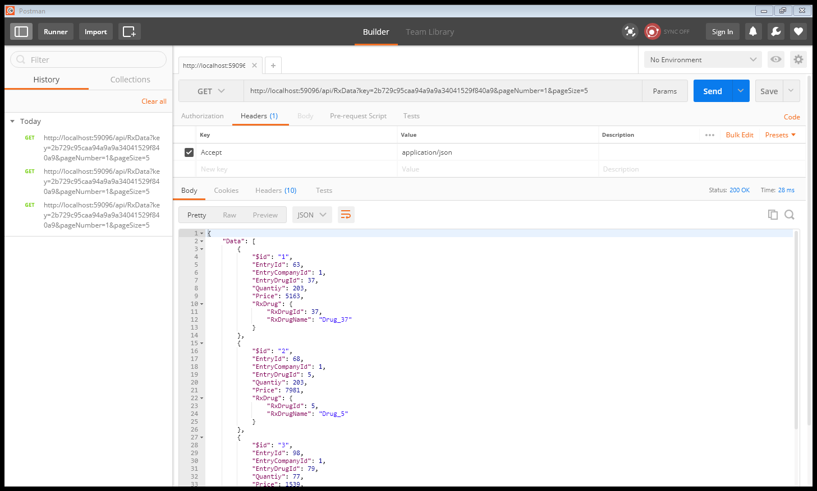

## Conclusion

Given that this is just a sample project—proof of concept, no test verification were written, solid testing to ensure that each feature works as expected.

The authorization/authentication for API is managed via the key to figure out who is allowed to get what data.