FlexDeploy – ConfigNOW plugin

This document outlines the basic design scope and initial architecture design of the ConfigNOW plugin for FlexDeploy

# Scope

The FlexDeploy – ConfigNOW plugin will:

* Allow usage of all out of the box configNOW commands from the FlexDeploy UI.
* Allow customisation of configNOW commands; **Given the client provides the custom command and properties files.**
* Expect all properties files to be correctly configured for the target server.
* Not allow customisation or modification of properties files from the FlexDeploy UI.
* Expect that the target server have all required infrastructure properly installed and configured.
* Expect that the target server has a compatible version of jython running.

# Architecture

The plugin will utilise the FlexDeploy Plugin-SDK-4.0 to provide logging and execution context. The plugin will be java based which is packaged as a JAR. The basic architecture of the plugin will be a base class called ‘BuildCommand.java’, which runs ConfigNOW commands. The BuildCommand class will be utilised by all plugin operations as it will allow command line ConfigNOW operations to be executed.

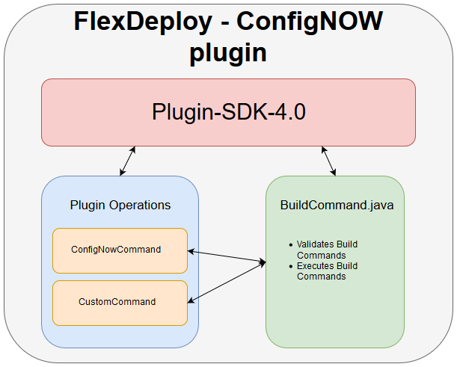

The plugin will be transferred to the client endpoint, from this endpoint all relevant ConfigNOW commands will be executed. As ConfigNOW will be ran on endpoints, it will have certain properties which will be required to perform operations correctly.

## Required Properties

Some properties are required as inputs which require user configuration. Different plugin operations may require different properties configuring.

***NOTE:*** *for the plugin to run at all, a compatible version of jython must be running on the endpoint machine for ConfigNOW to run.*

## Inherited Properties

Some properties can be inherited from FlexDeploy in the execution context for the operation. For example, the environment code can be inherited from the run context of FlexDeploy using the plugin-SDK. This will be used for knowing which environment folder to look in for corresponding properties files.

# Usage

The existing plugin operations are ConfigNowCommand and CustomCommand.

### ConfigNowCommand

This will be the default plugin operation which will be used by most clients. It will allow usage of all out of the box ConfigNOW commands. This command does not require configuration from environment instance properties or workflow inputs, however, it requires inputs from project properties. The required inputs for this operation are:

|  |  |  |  |
| --- | --- | --- | --- |
| Property Name | Description | Configured By | Required |
| FDCN_COMMAND | The ConfigNOW command to run | User configured project properties | Yes |
| FDCN_CONFIG_FILE | The properties file which will be used when running the command | User configured project properties | Yes |

This plugin operation will validate that the command provided is a valid, out of the box, ConfigNOW command and will throw an exception if a valid command is not provided. The plugin will also validate the configuration file exists for the correct environment.

### CustomCommand

This is a customisable command which will require customised ConfigNOW files to be ran. Ie: The client cannot achieve their goals with the out of the box ConfigNOW and have made additional operations with accompanying properties files.

The required inputs for this operation are:

<< To Do>>