SEAT QGIS Plugin Documentation

This document contains documentation for a Spatial Environmental Assessment Tool (SEAT) QGIS plugin. Based on previous marine hydrokinetic energy work, this plugin automates raster calculation export and display. (Coates et al. 2020.).

The documentation covers a brief overview of the plugin, plugin install and usage and description of plugin exports.

# Overview

The SEAT QGIS plugin preforms raster calculations on input rasters, displaying and saving an output raster and output raster area calculations. It follows the version 4 methodology in Coates et al., 2020.

**Current limitations of plugin**

Currently, the plugins expects a receptor and threshold roster files in the same coordinate system and appropriate layer styling files. An optional secondary constraint raster file can also be supplied. No checks are made to ensure a raster coordinate system exist and is the same for all files. No checks are make to ensure an appropriate layer styling file exists for each raster. One layer styling file is required for each raster input. The plugin works on raster band 1 only. Currently, only Geotiff rasters are supported.

The areas of the final raster are exported as a csv. This is limited to single values in the raster band greater than 0. Plugin code will need to be adjusted if these statistics change.

# Install

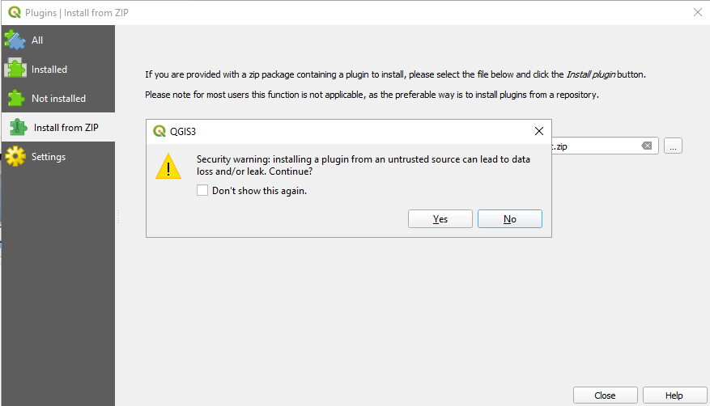Install the latest version of the plugin as a zip file from \\pfs1w\C1300-C1399\C1308_MREA_Sandia\Working_Files\QGIS Plugin\stressor_receptor_calc.zip. In QGIS go to Plugins – Manage and Install Plugins – Install from ZIP. Select the zip file referenced above in the path box and select Install. Select OK for any security warnings (Figure 1).

Figure 1. Select OK for any install prompts.

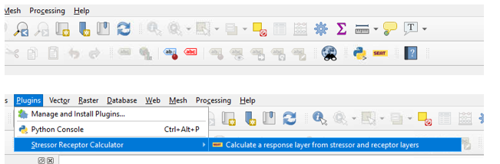When successfully installed there will be a new entry in the QGIS toolbar and under the Plugins menu (Figure 2).

Figure 2. SEAT plugin toolbar and menu locations.

# Plugin Inputs

## How to prepare input files

The plugins requires a receptor, threshold and optional secondary constraint file. When creating these files for the plugin they must have a single band, band 1, and each have a common coordinate reference system.

## How to set up and save layer styles

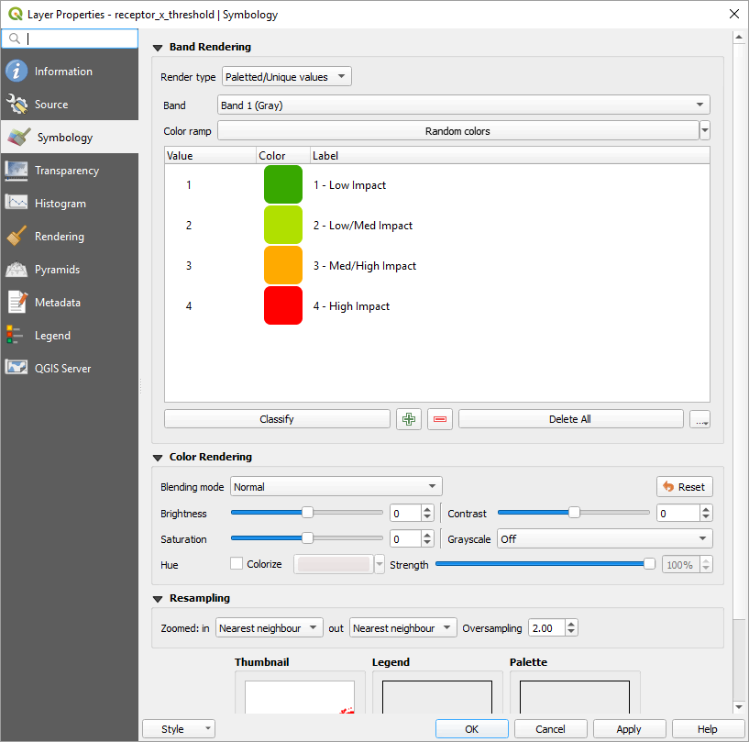Each raster input should have a layer style file that can be used to display the raster values of interest. One layer style file can be applied to multiple raster files.

Figure 3. Symobology dialog for raster layer

To create a layer style in QGIS navigate to the Symbology tab in the layer properties. Right click on a raster layer and select properties. After defining the layer’s symbology save the resulting .qml file using the options under the Style button in the lower right (Figure 3).

# Running the Plugin

To run the plugin either navigate to the Stressor Receptor Calculator menu item in the plugins menu or select the yellow and black SEAT icon in the tool bar.

The plugin dialog will open with options for setting the raster file style files. The dropdown also preloaded styles for each raster file to be defined and selected. Otherwise file paths can be pasted into the dialog. A style file should be set for Receptor, Threshold, Secondary Constraint and Output (Figure 4).

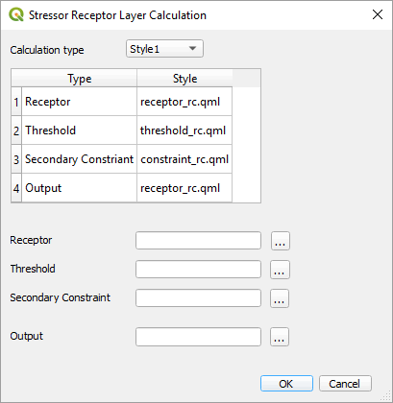Next select the input and output files. The Secondary Constraint file is optional. If left blank it will not be used in the calculation.

When input and output is correctly set press OK to run the plugin.

# Description of Plugin Output

## Description of result raster

Figure 4. Example raster file and style setup.

A result raster named result_x_threshold.tif is created and added to the current QGIS map. This has 1 raster band and the coordinate reference system of the receptor raster. It has the layer styling set by the plugin.

## Description of rasters added to current map

Input rasters and associated styling are added to the map, but marked as not visible.

## Description of csv output

CSV output of the result area calculated in square initial raster units are saved to the same folder as the output raster with the name result_x_threshold.csv. Single raster values are currently supported in the calculations in values greater than 0. Previous files are over written.

# References

Coates, Shannon, Lockhart, Gwen, Courbis, Sarah, Raghukumar, Kaustubha, McWilliams, Samuel, and Craig Jones. "Pilot Study of Integration of Wildlife Impact Analysis into Spatial Environmental Assessment Tool for Marine Hydrokinetic Energy." Paper presented at the Offshore Technology Conference, Houston, Texas, USA, May 2020. doi: <https://doi.org/10.4043/30693-MS>