SEAT QGIS Plugin December 2021 Documentation

This document contains documentation for a Spatial Environmental Assessment Tool (SEAT) QGIS plugin as of December 2021. Based on previous marine hydrokinetic energy work, this plugin automates raster calculation export and display. (Coates et al. 2020.). The documentation covers a brief overview of the plugin and plugin updates.

# Overview

The SEAT QGIS plugin preforms raster calculations on input rasters, displaying and saving an output raster and output raster area calculations. It follows the version 4 methodology in Coates et al., 2020. Please see documentations from September 2021 on setup and use.

# Updates

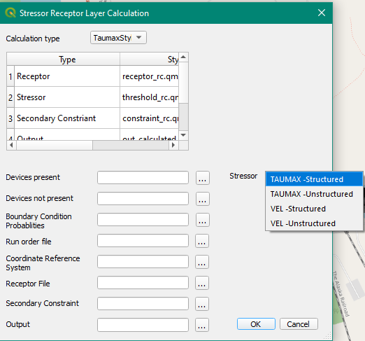Recent work has focused on expanding the SEAT QGIS plugin on structured grids using the Oregon coast example and unstructured grids on the Tanana River in Alaska. This has involved code updates and interface updates.

The interface now has options for structured and unstructured taumax inputs (Figure 1). Structured grid input risk calculations have been coded into the plugin and are being tested.

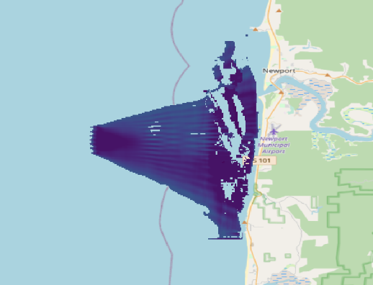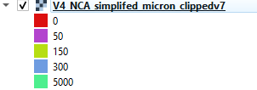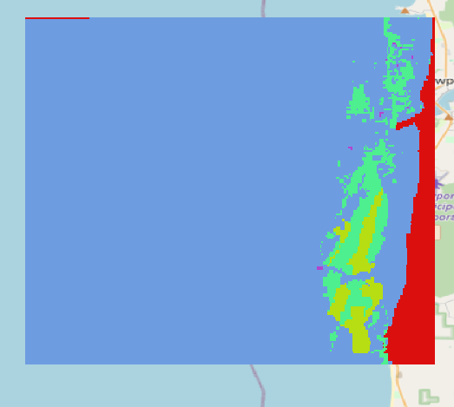Work on a grain size receptor has resulted in a grain size raster file as seen in Figure 2. While not integrated into the plugin interface it has been integrated into the structured grid code and produced results (Figure 3).

Figure 3. grainsize receptor in model

Figure 2. Rasterized Grain Size

Figure 1. SEAT Plugin Interface December 2021

Two additional structured Oregon 4x4 and 12x4 cases have been tested and produce results, but may some styling improvements (Figure 4) .

Work has been done on the unstructured model files of the Tanana River. Model results have been interpolated using a triangular interpolation approach to create the raster shown in Figure 5.

Figure 4. 4x4 and 12x4 Results

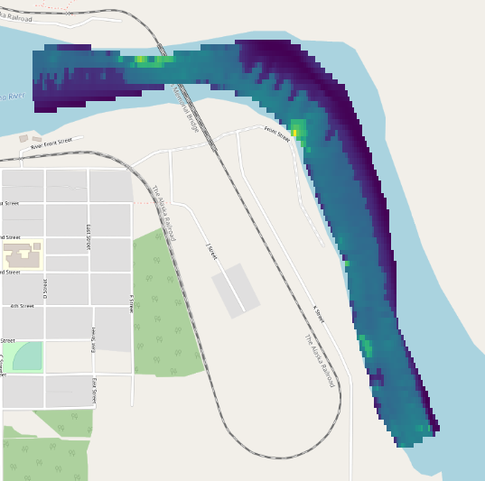

Figure 5. Tanana river rasterized

# References

Coates, Shannon, Lockhart, Gwen, Courbis, Sarah, Raghukumar, Kaustubha, McWilliams, Samuel, and Craig Jones. "Pilot Study of Integration of Wildlife Impact Analysis into Spatial Environmental Assessment Tool for Marine Hydrokinetic Energy." Paper presented at the Offshore Technology Conference, Houston, Texas, USA, May 2020. doi: <https://doi.org/10.4043/30693-MS>