SEAT QGIS Plugin September 2021 Documentation

This document contains documentation for a Spatial Environmental Assessment Tool (SEAT) QGIS plugin as of September 2021. Based on previous marine hydrokinetic energy work, this plugin automates raster calculation export and display. (Coates et al. 2020.).

The documentation covers a brief overview of the plugin, plugin install and usage and description of plugin exports.

# Overview

The SEAT QGIS plugin preforms raster calculations on input rasters, displaying and saving an output raster and output raster area calculations. It follows the version 4 methodology in Coates et al., 2020.

**Current limitations of plugin**

Currently, the plugins expects a receptor and threshold roster files in the same coordinate system and appropriate layer styling files. An optional secondary constraint raster file can also be supplied. No checks are made to ensure a raster coordinate system exist and is the same for all files. No checks are make to ensure an appropriate layer styling file exists for each raster. One layer styling file is required for each raster input. The plugin works on raster band 1 only. Currently, only GeoTIFF rasters are supported.

The plugin accepts NetCDF model output files and generated raster files in GeoTIFF format.

Currently not functional, but future updates could include the areas of the final raster exported as a csv.

# Install

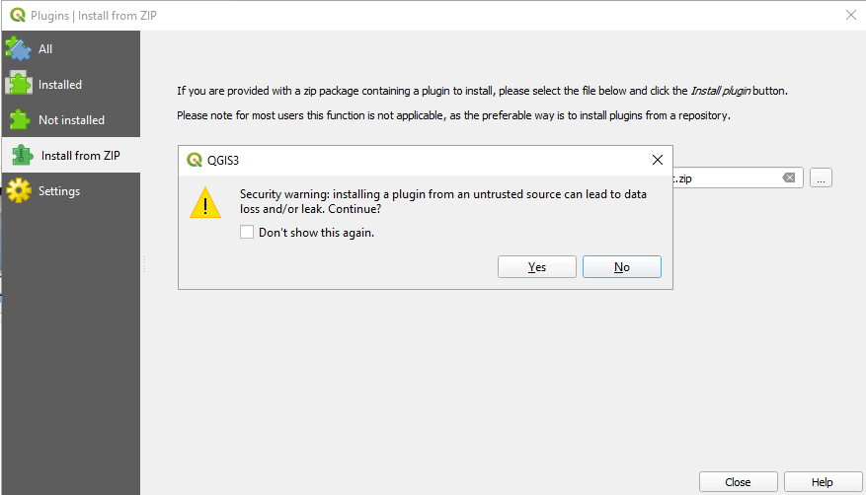Install the latest version of the plugin as a zip file from \\pfs1w\C1300-C1399\C1308_MREA_Sandia\Working_Files\QGIS Plugin\stressor_receptor_calc.zip. In QGIS go to Plugins – Manage and Install Plugins – Install from ZIP. Select the zip file referenced above in the path box and select Install. Select OK for any security warnings (Figure 1).

Figure 1. Select OK for any install prompts.

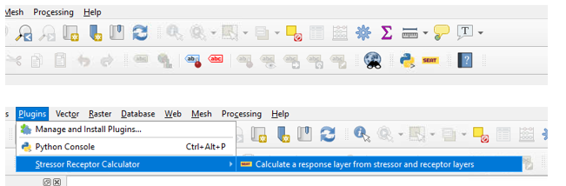When successfully installed there will be a new entry in the QGIS toolbar and under the Plugins menu (Figure 2).

Figure 2. SEAT plugin toolbar and menu locations.

## Install needed libraries

The NetCDF Python library will need to be installed for QGIS. To install, navigate to C:\Program Files\QGIS 3.16\. Run OSGeo4W.bat as an Administrator (Figure 3).

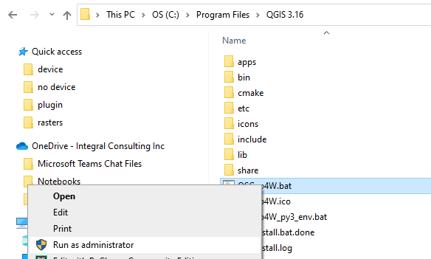

Figure 3. Run OSGeo4W.bat as an Administrator

At the prompt enter py3_env and hit Enter. Then enter pip install netcdf4 and hit Enter. See the commands below (Figure 4).

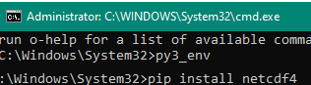

Figure 4. commands to enter at prompt from OSGeo4W.bat

# Plugin Inputs

## How to prepare input files

The plugin requires valid NetCDF or GeoTIFF input rasters and optional receptor and secondary constraint raster files. When creating raster files for the plugin the rasters must have a single band, band 1, and each have a common coordinate reference system.

## How to set up and save layer styles

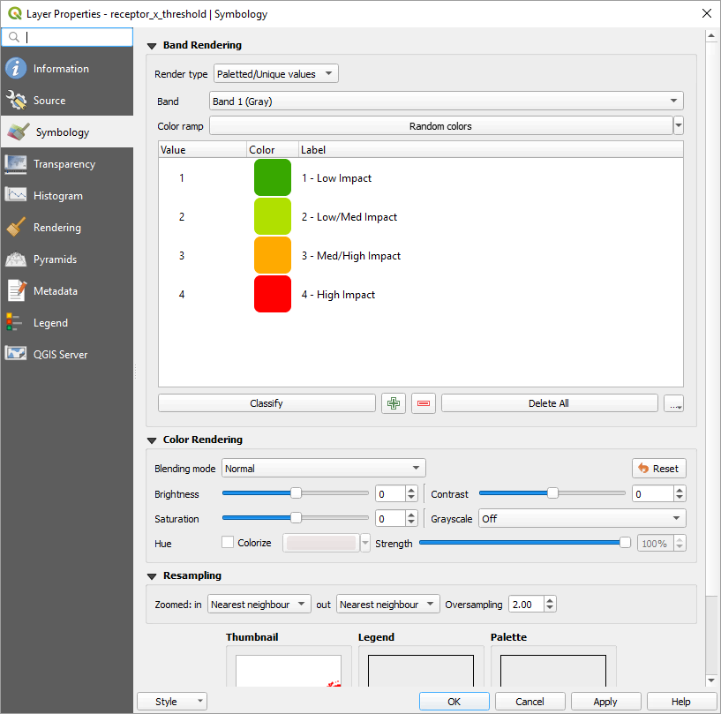Each raster input should have a layer style file that can be used to display the raster values of interest. One layer style file can be applied to multiple raster files.

Figure 5. Symobology dialog for raster layer

To create a layer style in QGIS navigate to the Symbology tab in the layer properties. Right click on a raster layer and select properties. After defining the layer’s symbology save the resulting .qml file using the options under the Style button in the lower right (Figure 3).

# Running the Plugin

To run the plugin either navigate to the Stressor Receptor Calculator menu item in the plugins menu or select the yellow and black SEAT icon in the tool bar.

The plugin dialog will open with options for setting the raster file style files. The dropdown also preloaded styles for each raster file to be defined and selected. Otherwise file paths can be pasted into the dialog. A style file should be set for Receptor, Stressor, Secondary Constraint and Output (Figure 5).

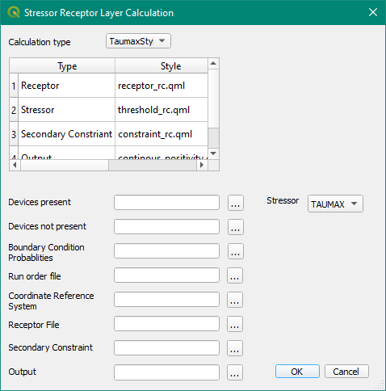Next select the input and output files. Currently NetCDF files and GeoTIFF rasters are supported by the plugin. See the table at the end of the document for input scenarios.

The Receptor and Secondary Constraint files is optional. If left blank it will not be used in the calculation.

When input and output is correctly set press OK to run the plugin.

# Description of Plugin Output

## Description of result raster

Figure 6. Example interface

A result raster named the value set in Output is created and added to the current QGIS map. This has 1 raster band and the coordinate reference system of the receptor raster. It has the layer styling set by the plugin.

## Description of rasters added to current map

Input receptor and secondary constraint rasters with associated styling are added to the map, but marked as not visible.

## Description of csv output

Not currently supported, but available in future updates are csv output of the result area calculated in square initial raster units are saved to the same folder as the output raster with the output name. Single raster values are currently supported in the calculations in values greater than 0. Previous files are over written.

# References

Coates, Shannon, Lockhart, Gwen, Courbis, Sarah, Raghukumar, Kaustubha, McWilliams, Samuel, and Craig Jones. "Pilot Study of Integration of Wildlife Impact Analysis into Spatial Environmental Assessment Tool for Marine Hydrokinetic Energy." Paper presented at the Offshore Technology Conference, Houston, Texas, USA, May 2020. doi: <https://doi.org/10.4043/30693-MS>

# Tables

All paths use \\Pfs1w\c1300-c1399\C1308_MREA_Sandia\Working_Files\QGIS Plugin\ as a base directory.

Example NetCDF inputs for Oregon WEC velocity

|  |  |  |
| --- | --- | --- |
| Input | Setting | Description |
| Calculation Type | VelStyle1 | These are settings for velocity NetCDF layers. To not have a style applied delete the Style entry |
| Stressor | VEL | Sets the Stressor variable to VEL |
| Devices present | Plugin Inputs\Oregon Coast WEC\run_dir_wecs\trim_sets_flow_inset_allruns.nc | Sets the device present NetCDF file |
| Devices not present | Plugin Inputs\Oregon Coast WEC\run_dir_nowecs\trim_sets_flow_inset_allruns.nc | Sets the device not present NetCDF file |
| Boundary Condition Probabilities | Plugin Inputs\Oregon Coast WEC\BC_Annie_Annual_SETS.csv | Sets the boundary condition probabilities |
| Run order File | Plugin Inputs\Oregon Coast WEC\run_dir_wecs\run_order_wecs.csv | Sets the run order file |
| Coordinate Receptor File | 4326 | WGS 84 coordinate system |
| Receptor File | Plugin Inputs\rasters_created\other\receptor_rc.tif | Receptor raster |
| Secondary Constraint File | Plugin Inputs\rasters_created\other\constraint_rc.tif | Secondary Constraint file |
| Output | User Supplied | Output file |

Example NetCDF inputs for Oregon WEC taumax

|  |  |  |
| --- | --- | --- |
| Input | Setting | Description |
| Calculation Type | TaumaxStyle1 | These are settings for taumax NetCDF layers. To not have a style applied delete the Style entry |
| Stressor | TAUMAX | Sets the Stressor variable to TAUMAX |
| Devices present | Plugin Inputs\Oregon Coast WEC\run_dir_wecs\trim_sets_flow_inset_allruns.nc | Sets the device present NetCDF file |
| Devices not present | Plugin Inputs\Oregon Coast WEC\run_dir_nowecs\trim_sets_flow_inset_allruns.nc | Sets the device not present NetCDF file |
| Boundary Condition Probabilities | Plugin Inputs\Oregon Coast WEC\BC_Annie_Annual_SETS.csv | Sets the boundary condition probabilities |
| Run order File | Plugin Inputs\Oregon Coast WEC\run_dir_wecs\run_order_wecs.csv | Sets the run order file |
| Coordinate Receptor File | 4326 | WGS 84 coordinate system |
| Receptor File | Plugin Inputs\rasters_created\other\receptor_rc.tif | Receptor raster |
| Secondary Constraint File | Plugin Inputs\ rasters_created\other\constraint_rc.tif | Secondary Constraint file |
| Output | User Supplied | Output file |

Example GeoTIFF inputs for Tanana WEC velocity

|  |  |  |
| --- | --- | --- |
| Input | Setting | Description |
| Calculation Type | VelStyle1 | These are settings for velocity GeoTIFF layers. To not have a style applied delete the Style entry |
| Stressor | TAUMAX | Sets the Stressor variable to TAUMAX |
| Devices present | Plugin Inputs\Tanana WEC\device\6_tanana1_tau.tif | Sets the device present GeoTIFF folder |
| Devices not present | Plugin Inputs\Tanana WEC\no device\0_tanana1_tau.tif | Sets the device not present GeoTIFF folder |
| Boundary Condition Probabilities | Plugin Inputs\Tanana WEC\boundary_conditions.csv | Sets the boundary condition probabilities |
| Run order File |  | Sets the run order file |
| Coordinate Receptor File | 4326 | WGS 84 coordinate system |
| Receptor File | Plugin Inputs\rasters_created\other\receptor_rc.tif | Receptor raster |
| Secondary Constraint File |  | Secondary Constraint file |
| Output | Users Supplied | Output file |