1. Introduction
Small game
https://stormboard.com/storm/1886510/The_Magic_Apprentice_game

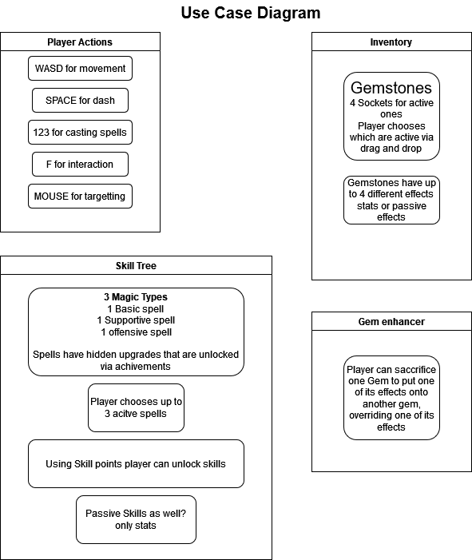

1.1. Purpose of the system
Having fun

1.2. Scope of the system
big

1.3. Objectives and success criteria of the project
Making gaME

1.4. Definitions, acronyms, and abbreviations
none

1.5. References

1.6. Overview

2. Proposed system

2.1. Overview

2.2. Functional requirements

2.3. Nonfunctional requirements
Please include the coding style here, as well as the performance as the frame rate that is to be achieved % the requirements are written in such a way that they can also be checked - later this should also be checked explicitly in the results

2.3.1. User interface and human factors

2.3.2. Documentation

2.3.3. Hardware considerations

2.3.4. Performance characteristics

2.3.5. Error handling and extreme conditions

2.3.6. Quality issues

2.3.7. System modifications

2.3.8. Physical environment

2.3.9. Security issues

2.3.10. Resource issues

2.4. Pseudo requirements

2.5. System models

2.5.1. Scenarios

2.5.2. Use case model

2.5.3. Object model

2.5.3.1. Data dictionary

2.5.3.2. Class diagrams

2.5.4. Dynamic models

2.5.5. User-interface -- navigational paths and screen mock-ups

3. Glossary

