Giovana Lisbôa Thomé

ContaíCo: A new way of understanding your finances

SÃO PAULO
2025

Giovana Lisbôa Thomé

ContaíCo: A new way of understanding your finances

Final Course Project submitted to the Institute of Technology and Leadership (INTELI), to obtain a bachelor's degree in Computer Science.
Advisor: Prof. Tomaz Mikio Sasaki

SÃO PAULO
2025

Cataloging in Publication
Library and Documentation Service
Institute of Technology and Leadership (INTELI)
December 18th, 2025



Acknowledgments

I would like to express my sincere gratitude to my family for their constant support, encouragement, and understanding throughout my academic journey. Their presence and motivation were fundamental to the completion of this work.
I also extend my appreciation to all the individuals and institutions that contributed to the construction and development of this Institution, as well as to the Computer Science faculty, whose knowledge, guidance, and dedication were essential to my academic and professional growth.
Finally, I would like to thank my colleagues and friends for their companionship, support, and shared moments of dedication, especially during long nights of study and collaboration, which made this journey both challenging and rewarding.

Resumo (mandatory item – NBR 14724, item 4.2.1.7)

A gestão de finanças pessoais tornou-se cada vez mais digital no Brasil, impulsionada pela ampla adoção de bancos digitais, fintechs e plataformas de pagamento online. Apesar desse avanço, muitos usuários enfrentam dificuldades para transformar dados financeiros disponíveis em insights claros e acionáveis, devido à complexidade, instabilidade e alto esforço exigido pelas soluções existentes. Este trabalho apresenta o desenvolvimento e a validação do ContaíCo, uma solução computacional voltada à análise de gastos pessoais por meio de uma interface conversacional integrada ao WhatsApp. O objetivo principal do projeto é projetar, implementar e validar uma ferramenta que simplifique a compreensão das finanças pessoais, aliando desenvolvimento tecnológico e viabilidade de negócio. A metodologia adotada inclui análise de mercado, definição de hipóteses, desenvolvimento de um Produto Mínimo Viável (MVP), modelagem de negócio e validação com usuários reais. Do ponto de vista técnico, a solução utiliza uma arquitetura em nuvem, integração com APIs externas e inteligência artificial para processar documentos financeiros e gerar análises automatizadas em linguagem natural. Os resultados da validação indicam alta aceitação do MVP, com avaliações positivas quanto à usabilidade, clareza das informações e intenção de uso recorrente. Além disso, o modelo financeiro demonstra viabilidade econômica, com baixo custo operacional e ponto de equilíbrio alcançável com uma base reduzida de usuários. Conclui-se que o ContaíCo atende a uma necessidade real do mercado, oferecendo uma alternativa simples, acessível e escalável para a análise de finanças pessoais, além de estabelecer bases sólidas para futuras evoluções técnicas e expansão do modelo de negócio.
Palavras-chave: gestão financeira pessoal; fintech; inteligência artificial; interface conversacional; WhatsApp.

ABSTRACT (mandatory item – NBR 14724, item 4.2.1.8)

Personal financial management has become increasingly digital in Brazil, driven by the widespread adoption of digital banking, fintech platforms, and online payment systems. Despite this evolution, many users still struggle to transform available financial data into clear and actionable insights due to the complexity, instability, and high effort required by existing solutions. This work presents the development and validation of ContaíCo, a computational solution designed to simplify personal expense analysis through a conversational interface integrated with WhatsApp. The main objective of the project is to design, implement, and validate a tool that enhances users’ understanding of their personal finances while combining technological development with business feasibility analysis. The methodology includes market analysis, hypothesis definition, Minimum Viable Product (MVP) development, business modeling, and validation with real users. From a technical perspective, the solution adopts a cloud-based architecture, integrates external APIs, and leverages artificial intelligence to process financial documents and generate automated insights in natural language. Validation results indicate strong user acceptance of the MVP, with positive feedback regarding usability, clarity of information, and intention of recurring use. Furthermore, the financial model demonstrates economic feasibility, characterized by low operational costs and a break-even point achievable with a small user base. The study concludes that ContaíCo addresses a real market need by offering a simple, accessible, and scalable alternative for personal financial analysis, while also providing a solid foundation for future technical improvements and business expansion.

Keywords: personal financial management; fintech; artificial intelligence; conversational interface; WhatsApp.

List of Illustrations

Figure 1. Competitor’s app rating……………………………………………..14
Figure 2. Competitor’s app rating……………………………………………..14
Figure 3. Competitor’s app rating……………………………………………..14
Figure 4. Competitor’s app rating……………………………………………..14
Figure 5. Competitor’s app rating……………………………………………..15
Figure 6. Competitor’s app rating……………………………………………..15
Figure 7. Competitor’s app rating……………………………………………..15
Figure 8. Competitor’s app rating……………………………………………..15
Figure 9. Competitor’s app rating……………………………………………..15
Figure 10. Competitor’s app rating……………………………………………16
Figure 10. Competitor’s app rating……………………………………………17
Figure 11. System Architecture………………………………………………..31
Figure 12. Business Model Canvas…………………………………………..36
Figure 13. Visual Identity………………………………………………………46
Figure 14. Visual Identity………………………………………………………47
Figure 15. Visual Identity………………………………………………………47
Figure 16. Visual Identity………………………………………………………47
Figure 17. Visual Identity………………………………………………………48

Summary

1 Introduction 10
2 Solution Development 18
2.1 Definition of Market Assumptions and Hypotheses: 18
2.2 Market Sizing and Analysis 20
2.3 Competitive Analysis and Differentials 23
2.4 Technological Solution 25
2.5 The Business Plan 33
2.6 Validation and Results 38
3 Conclusion 42
References 43
Appendices 43

Introduction
The increasing digitalization of financial services in Brazil has significantly transformed the way individuals interact with their personal finances. The widespread adoption of digital banks, fintech platforms, and mobile payment systems has made financial data more accessible than ever. However, despite the abundance of available information, many individuals still face difficulties in understanding their spending behavior and transforming raw financial data into clear, actionable insights. This gap highlights a persistent challenge in personal financial management: accessibility does not necessarily translate into comprehension.
Existing personal finance solutions, such as mobile applications and banking dashboards, often prioritize feature richness over usability. As a result, users are required to manually categorize expenses, navigate complex interfaces, or rely on unstable integrations through Open Finance mechanisms. These factors increase cognitive load and discourage consistent use, especially among individuals who seek quick and practical insights rather than detailed financial planning. Consequently, there is an unmet demand for solutions that reduce friction and make financial analysis a simple and habitual activity.
In parallel, conversational interfaces have emerged as an effective paradigm for human–computer interaction, particularly when integrated into platforms already embedded in users’ daily routines. In Brazil, WhatsApp stands out as one of the most widely used communication tools, cutting across age groups and socioeconomic profiles. Leveraging such a familiar channel presents an opportunity to rethink how financial insights are delivered, shifting from traditional dashboards to conversational, context-aware interactions.
Within this context, this work proposes ContaíCo, a computational solution designed to simplify personal financial analysis through a WhatsApp-based conversational interface powered by artificial intelligence. The solution enables users to submit financial documents, such as bank statements and credit card bills, and receive automated analyses expressed in natural language. By eliminating the need for manual data entry and dedicated applications, ContaíCo aims to lower adoption barriers and promote a clearer understanding of personal spending patterns.

Beyond the technical solution, this project also adopts an entrepreneurial perspective. In addition to designing and implementing a Minimum Viable Product (MVP), the work includes a comprehensive business plan that evaluates market potential, competitive landscape, revenue models, and financial feasibility. The project is therefore positioned at the intersection of software engineering, artificial intelligence, and entrepreneurship, seeking to validate not only technical feasibility but also real market relevance.
This document is structured to guide the reader through the full lifecycle of the project, from problem contextualization and solution design to implementation, validation, and analysis of results. By combining technical development with market validation, this work contributes to discussions on how conversational interfaces and AI can be applied to reduce complexity in personal financial management and create scalable, user-centered digital solutions.

  - Context and Motivation:
Personal financial management has become increasingly digital over the last decade, driven by the widespread adoption of mobile banking, fintech platforms, and online payment systems. In Brazil, this transformation is particularly evident: millions of individuals already rely on digital channels to access banking services and manage their daily transactions. Despite this progress, a significant gap remains between access to financial data and effective understanding of personal spending behavior. Many users accumulate transaction records through bank apps and credit cards but lack simple, intuitive tools to interpret this information and transform it into actionable insights.
The area of expertise of this project lies at the intersection of financial technology (fintech), artificial intelligence, and user-centered software design. Specifically, it focuses on the use of AI-driven analysis and conversational interfaces to support personal financial decision-making. Existing personal finance solutions—such as budgeting applications and bank-provided tools—often present high levels of complexity, require manual data input, or offer fragmented user experiences. As a result, they tend to discourage consistent usage, especially among users who value practicality and speed over detailed financial planning frameworks.
The core problem addressed by this project is the friction involved in personal expense analysis. While many individuals express interest in understanding how they spend their money, the effort required to categorize expenses, configure goals, or navigate feature-heavy applications often outweighs the perceived benefit. Consequently, financial control becomes an occasional task rather than a sustained habit. This gap creates an opportunity for solutions that prioritize clarity, minimal interaction, and seamless integration into users’ everyday digital routines.
ContaíCo was conceived to address this challenge by simplifying personal financial analysis through a conversational interface delivered via WhatsApp. Instead of requiring users to download and learn a new application, the solution operates within a platform that is already deeply embedded in daily communication habits across Brazil. By allowing users to submit financial data and receive clear, AI-generated insights directly through chat messages, ContaíCo reduces both cognitive and operational barriers to financial awareness.
From a market perspective, this approach reveals a substantial opportunity. Brazil has one of the largest WhatsApp user bases in the world, with over 147 million monthly active users, and more than 120 million individuals already access banking services through digital platforms. This indicates not only a large potential user base but also a population that is behaviorally prepared to engage with digital financial tools. However, the absence of lightweight, conversational, and user-friendly solutions within this ecosystem highlights an unmet demand.
The identified market opportunity lies in serving digitally active individuals who seek practical financial clarity without complexity. By targeting early adopters through a familiar communication channel and offering a subscription-based, low-cost service, ContaíCo positions itself to capture value in a market that is both large in scale and underserved in terms of usability. This context motivates the development of the proposed solution, aligning technological feasibility with a clear user need and a scalable business model.

  - Problem Definition and Value Proposition:
Personal financial control is widely recognized as an important practice for financial well-being; however, existing tools fail to support this activity in a practical and reliable way. The core problem is not the absence of solutions, but rather the high friction associated with using them.
Current approaches to personal finance management typically fall into three categories: spreadsheets (such as Excel), dedicated financial management applications, and bank-provided digital tools. While spreadsheets offer flexibility, they require manual data entry, organization, and maintenance, making them time-consuming and error-prone. As a result, they are impractical for continuous use by most individuals.
Dedicated financial management applications attempt to automate this process, often relying on Open Finance integrations. In practice, however, these integrations are frequently limited or unreliable. Users report recurring issues such as failed bank connections, incomplete data synchronization, delays in updates, and incompatibility with certain financial institutions. When automation fails, users are forced to manually input data, undermining the main value proposition of these platforms.
In addition to integration issues, many existing applications suffer from poor usability and technical instability. User feedback commonly highlights excessive bugs, application crashes, slow performance, and confusing interfaces. These problems significantly impact user trust, especially in a domain as sensitive as personal finance. When users experience data loss, incorrect balances, or repeated errors, they tend to abandon the tool altogether.
Another critical limitation is that most solutions demand users to adapt to new platforms and workflows, requiring app downloads, account creation, and continuous interaction with feature-heavy interfaces. This creates a mismatch between how financial tools are designed and how users naturally interact with digital services in their daily lives.
In summary, the main customer pain point lies in the lack of a simple, fast, and reliable way to understand personal finances. Existing solutions are either too manual, too complex, or too unstable to support consistent financial analysis. This results in frustration, low engagement, and the abandonment of financial control practices, even among users who are motivated to manage their money better.
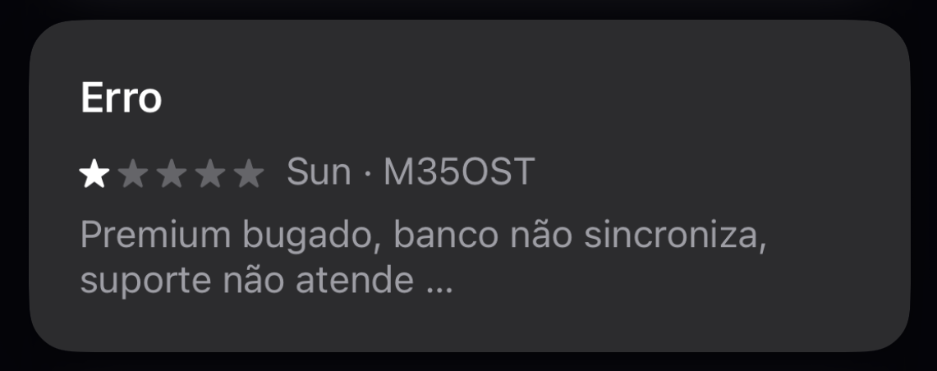
Figure 1. Competitor’s app rating
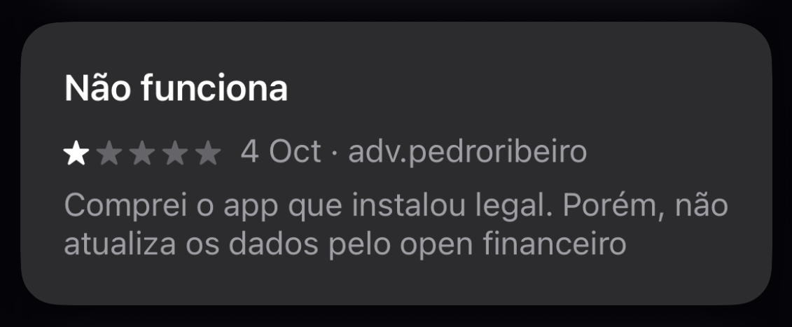
Figure 2. Competitor’s app rating
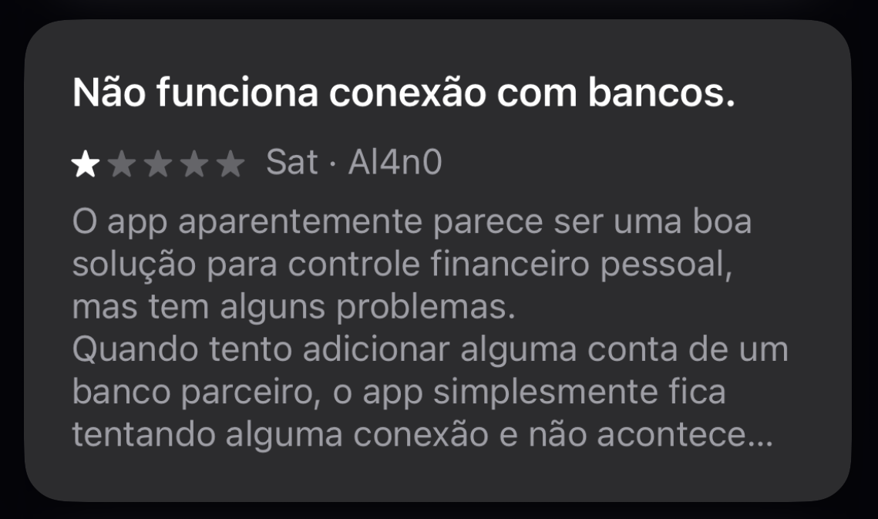
Figure 3. Competitor’s app rating
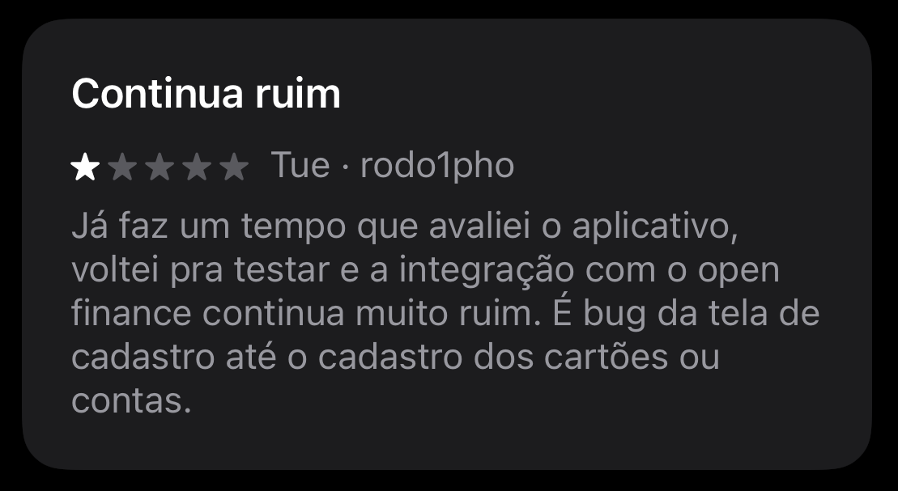
Figure 4. Competitor’s app rating
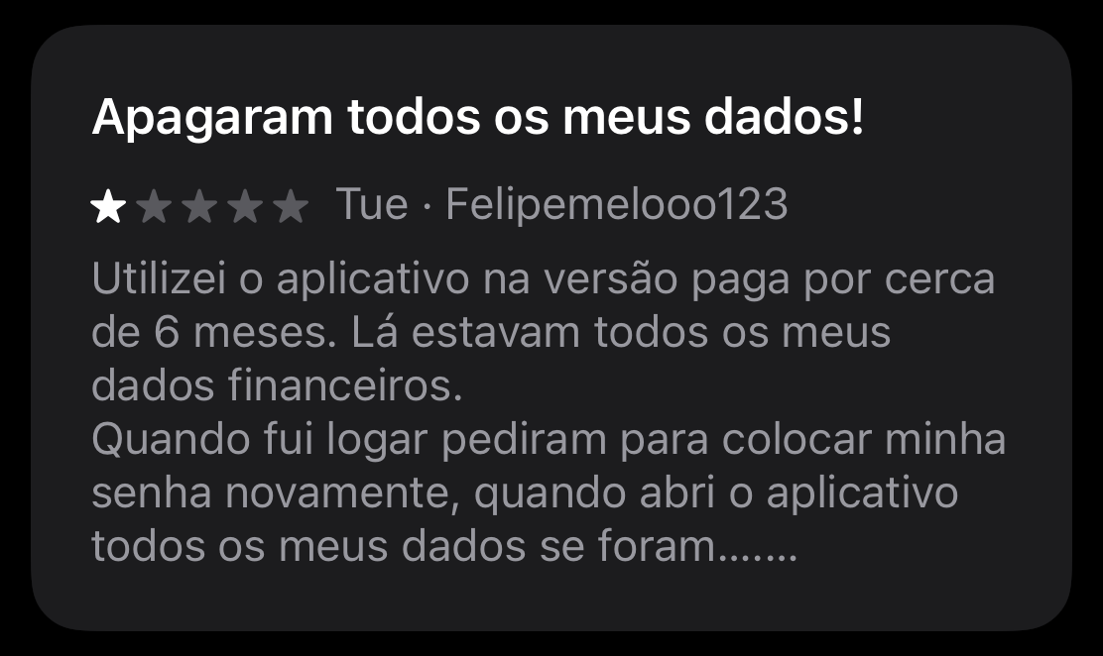
Figure 5. Competitor’s app rating
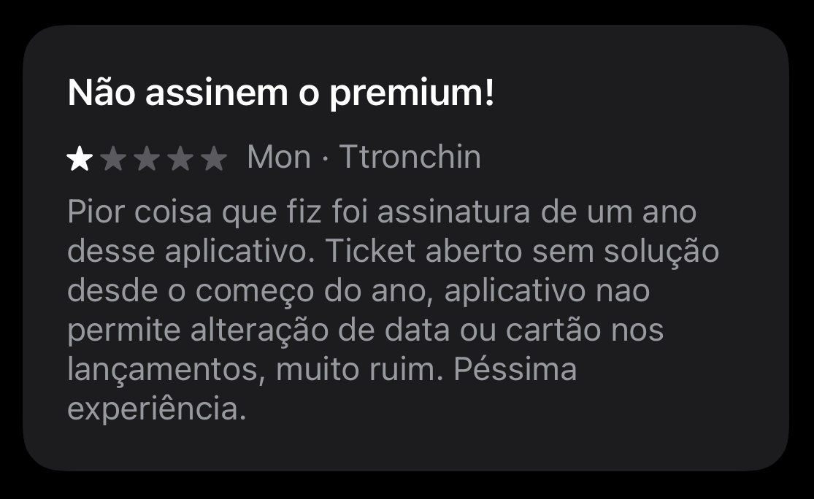
Figure 6. Competitor’s app rating

Figure 7. Competitor’s app rating

Figure 8. Competitor’s app rating
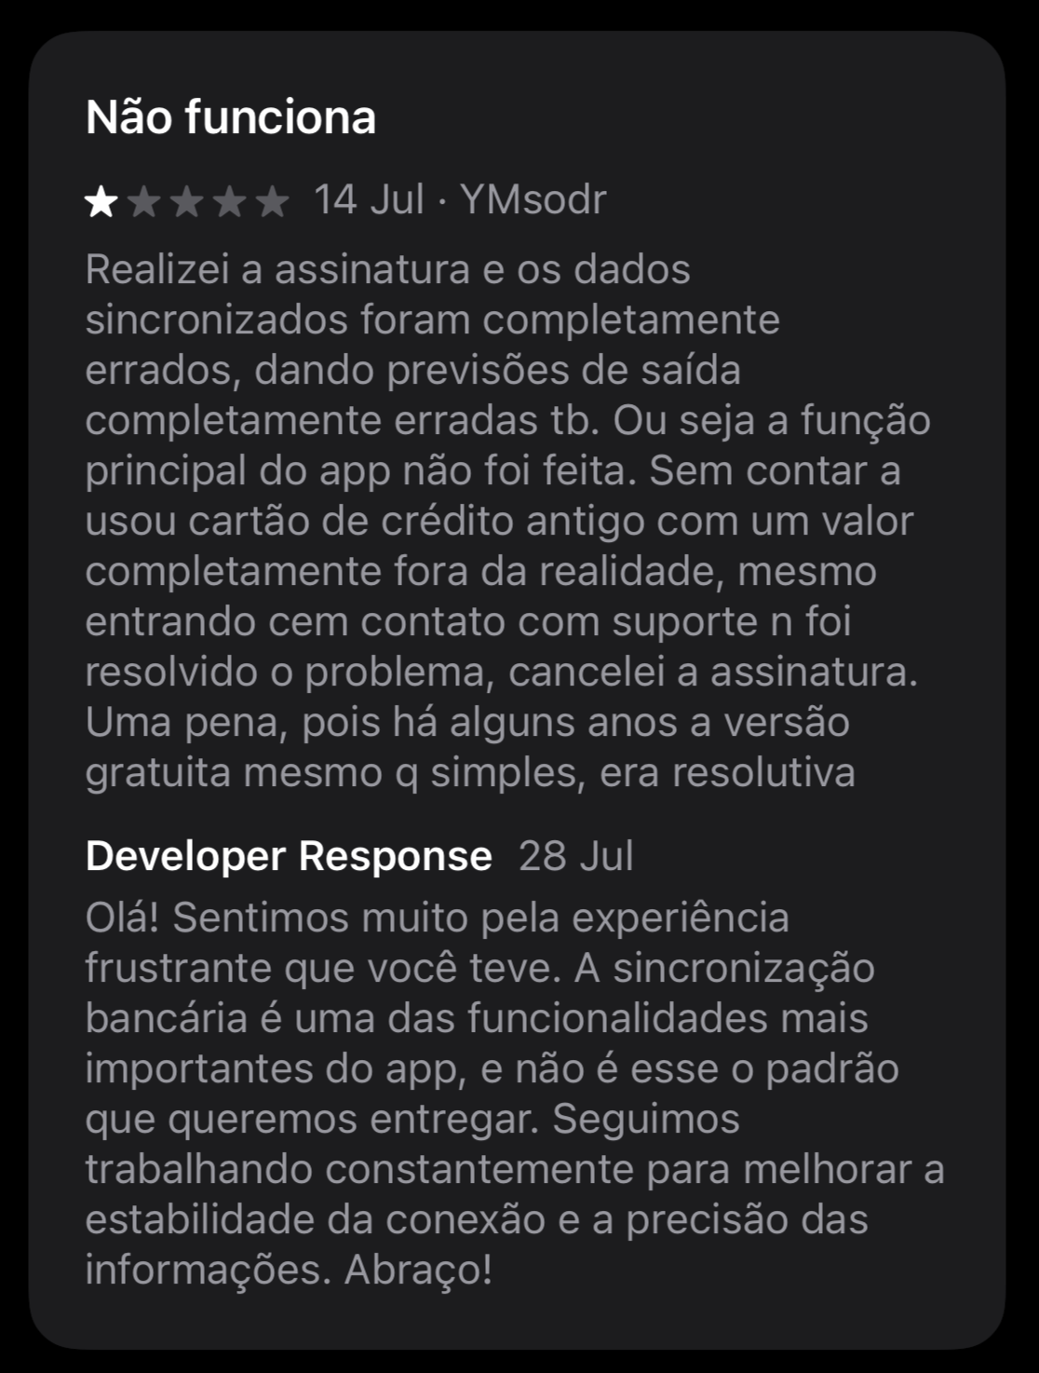
Figure 9. Competitor’s app rating
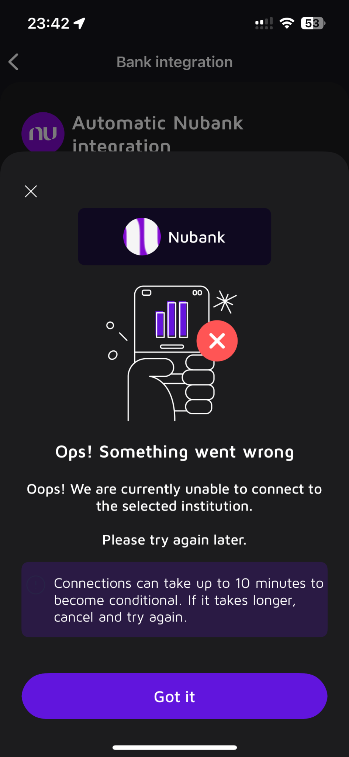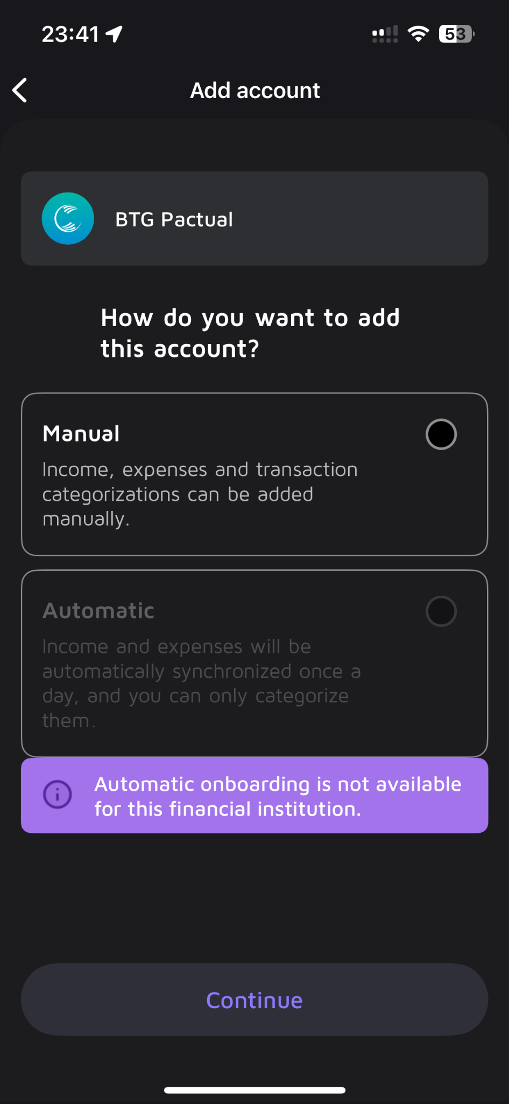
Figure 10. Competitor’s app rating

  - Objectives of the Work:
    - General Objective
The general objective of this work is to design, implement, and validate a computational solution for personal financial analysis, while simultaneously developing a business plan that evaluates its feasibility, sustainability, and introduction to the market. The project aims to integrate technological development with entrepreneurial analysis, ensuring that the proposed solution is not only technically functional but also economically viable and aligned with real user needs.

    - Specific Objectives
To achieve the general objective, the following specific objectives were defined:
- To design and develop a Minimum Viable Product (MVP) capable of performing automated personal expense analysis using artificial intelligence;
- To implement a conversational interface via WhatsApp, allowing users to interact with the system in a familiar and accessible environment;
- To build and integrate an AI-based analysis layer, responsible for extracting insights from financial documents such as bank statements and credit card bills;
- To define and implement a modular system architecture, including APIs, cloud infrastructure, and session management, ensuring scalability and maintainability;
- To conduct initial validation with users, collecting qualitative feedback related to usability, clarity of insights, and perceived value of the solution;
- To design and evaluate monetization strategies, including subscription-based (B2C) and pay-per-use models, as well as exploring the feasibility of a future B2B offering;
- To analyze operational costs, pricing structures, and break-even points, assessing the economic sustainability of the solution;
- To develop a comprehensive business plan, covering market analysis, competitive landscape, marketing strategy, operational structure, and financial projections.

  - Justification and Contributions:
The development of ContaíCo is justified by its relevance in three complementary dimensions: market, technological, and economic, all of which are grounded in observable trends in digital behavior and financial service adoption in Brazil.
From a market perspective, the solution addresses a clear gap between the widespread use of digital banking services and the lack of practical tools for personal financial analysis. According to Agência Brasil (2025), more than 120 million Brazilians accessed banking services through digital platforms, indicating a population already accustomed to managing finances online. At the same time, WhatsApp remains one of the most widely used digital platforms in the country, with over 147 million active users (FORBES BRASIL, 2025). Despite this high level of digital adoption, existing personal finance tools often fail to meet user expectations due to complexity, unreliable integrations, and poor usability. ContaíCo contributes to the market by proposing a solution that aligns financial analysis with users’ everyday communication habits, reducing friction and increasing accessibility.
From a technological perspective, the project contributes by exploring the use of artificial intelligence within a conversational interface for financial analysis. Rather than relying on traditional dashboards or feature-heavy applications, ContaíCo demonstrates how AI-generated insights can be delivered through natural language interactions in a messaging environment. This approach is particularly relevant in a context where many financial applications suffer from technical instability and limited automation. By combining AI services with a modular, cloud-based architecture, the solution illustrates how intelligent systems can be designed to prioritize clarity, reliability, and scalability—key requirements for fintech applications operating in data-sensitive environments.
From an economic perspective, the relevance of the solution lies in its feasibility and scalability. The subscription-based and pay-per-use revenue models were defined considering the operational costs of cloud infrastructure and third-party AI services. This structure allows the solution to reach financial sustainability with a relatively small user base, while maintaining the potential for growth as adoption increases. Furthermore, the evaluation of a future B2B model demonstrates how the same technological foundation can be reused to serve corporate clients, increasing revenue potential and reducing customer acquisition costs by shifting from individual to enterprise-level relationships.
In summary, this work contributes by proposing and validating a solution that simplifies personal financial analysis in a context of growing digital financial adoption. Demonstrating how artificial intelligence, conversational interfaces, and a sustainable business model can be integrated into a single solution, the project offers contributions both to applied computing and to the fintech market. These contributions are supported by current data on digital banking usage and messaging platform adoption in Brazil, reinforcing the relevance and applicability of the proposed approach (AGÊNCIA BRASIL, 2025; FORBES BRASIL, 2025).

  - Work Structure:
This work is organized into three main chapters, structured to guide the reader from the contextualization of the problem to the development, validation, and conclusions of the proposed solution.
Chapter 1 presents the Introduction, establishing the context and motivation of the project, defining the problem addressed, and presenting the objectives, justification, and contributions of the work. This chapter situates the study within the fields of fintech, artificial intelligence, and user-centered software development, clarifying its relevance from market, technological, and economic perspectives.
Chapter 2 details the Solution Development, encompassing the definition of market assumptions and hypotheses, market sizing and analysis, competitive analysis, and the description of the technological solution. This chapter also presents the system architecture, development methodology, implementation of the Minimum Viable Product (MVP), testing strategies, and technical evaluation. Additionally, it includes the complete Business Plan, covering the business model, marketing and sales strategy, financial projections, validation results, and risk mitigation plan.
Finally, Chapter 3 presents the Conclusion, summarizing the results achieved, assessing whether the proposed objectives were met, discussing the limitations of the project, and outlining future perspectives for both technical evolution and business expansion of the solution.

Solution Development

Definition of Market Assumptions and Hypotheses:
The development of ContaíCo was guided by a set of market assumptions derived from prior analysis of existing financial control solutions, observed user behavior, and preliminary validation through prototyping and business modeling. These assumptions informed both the technical design of the solution and the definition of its business strategy.
The primary assumption is that a significant portion of digitally active individuals face difficulties in maintaining consistent personal financial control due to the complexity, instability, and effort required by existing tools. Although users already generate and access financial data through digital banking platforms, transforming this data into clear and actionable insights remains a challenge. This gap is reinforced by the limitations observed in current solutions, such as unreliable Open Finance integrations, excessive manual input, and frequent technical failures, as documented during competitor analysis and user feedback collection.
Additionally, the project assumes that delivering financial insights through a conversational interface embedded in WhatsApp reduces adoption barriers. Given the widespread use of WhatsApp in Brazil and its role in daily communication, the solution was designed to fit existing user habits rather than requiring users to adapt to new platforms or workflows. This assumption guided the decision to prioritize a chat-based MVP over a traditional mobile or web application.
These assumptions were translated into three core hypotheses that structured the development of the project: the Problem Hypothesis, the Solution Hypothesis, and the Value Hypothesis.

    - Problem Hypothesis
The problem hypothesis assumes that digitally active individuals who already use banking applications struggle to analyze their personal finances in a practical and reliable way, due to the excessive effort, instability, and poor usability of existing solutions. It is further assumed that this group values clarity and speed over advanced financial planning features and is willing to pay for a solution that removes friction from the analysis process.

    - Solution Hypothesis
The solution hypothesis assumes that a conversational, AI-driven system delivered via WhatsApp is a more effective way to solve the identified problem than traditional application-based approaches. By eliminating the need for manual categorization, complex dashboards, and repeated configuration, the solution aims to lower cognitive and operational barriers to financial analysis.
This hypothesis is based on the assumption that natural language interactions, combined with automated document analysis, enable users to extract value from their financial data more efficiently. The MVP was therefore designed to accept financial documents (such as bank statements and credit card bills) and return concise insights through chat messages, prioritizing clarity and usability over feature density

    - Value Hypothesis
The value hypothesis assumes that the pricing and revenue model adopted by ContaíCo is acceptable to the target users, given the perceived benefits of convenience, time savings, and clarity. The project assumes that users are willing to pay a low monthly subscription fee for continuous access to financial insights, or alternatively, opt for a pay-per-use model when seeking occasional analysis.
This hypothesis was supported by the financial modeling conducted during the project, which demonstrated that a subscription price of approximately R$ 9,99 per month allows the business to reach break-even with a relatively small number of users, while remaining affordable for the target audience. The low variable cost per user and scalable cloud infrastructure reinforce the economic sustainability of this model

Market Sizing and Analysis
This section presents the market sizing analysis conducted for ContaíCo using the TAM, SAM, and SOM framework, followed by a detailed description of the target customer segment and persona. The analysis combines secondary market data with assumptions derived from the proposed solution’s distribution channel and business model.

    - Market Size (TAM, SAM, SOM):
The estimation of ContaíCo’s market potential was structured in three layers to progressively narrow the scope from the total reachable population to the realistically achievable early market.
    - Total Addressable Market (TAM): The Total Addressable Market represents the maximum number of users who could theoretically use the solution, assuming no constraints. As ContaíCo operates through WhatsApp, the TAM was defined as the total number of active WhatsApp users in Brazil. According to market data referenced in the project, WhatsApp has approximately 147 million active users in the country. This figure represents the broadest possible audience that could access the solution from a technological standpoint;
    - Serviceable Available Market (SAM): The Serviceable Available Market narrows the TAM to users who not only have access to WhatsApp, but also demonstrate behaviors aligned with digital financial management. Based on national statistics, approximately 120 million Brazilians accessed banking services through digital platforms. This segment reflects individuals who already interact with financial data digitally and therefore possess the minimum behavioral readiness to adopt a financial analysis tool like ContaíCo
    - Serviceable Obtainable Market (SOM): The Serviceable Obtainable Market represents the portion of the SAM that ContaíCo can realistically capture in its initial years of operation. Considering the early-stage nature of the product, a conservative adoption rate of 1% of the SAM was applied. This results in an estimated 1.2 million potential users, representing early adopters reachable through a WhatsApp-based go-to-market strategy. This estimate reflects realistic constraints related to marketing reach, brand recognition, and operational capacity during the initial phases of the business;

    - Customer Segmentation and Profiling
The target customer segment for ContaíCo consists primarily of young adults aged 18 to 30, living in urban areas and already accustomed to using digital financial services. These individuals typically use mobile banking applications, credit cards, and digital payment systems as part of their daily routines. They are comfortable with technology but are not necessarily interested in complex financial planning tools.
A key characteristic of this segment is a preference for practicality and speed. Although these users recognize the importance of financial control, they are discouraged by solutions that require manual data entry, frequent configuration, or interaction with feature-heavy interfaces. Many have attempted to use spreadsheets or financial apps in the past but abandoned them due to effort, bugs, or unreliable integrations.
From a behavioral standpoint, the target users:
    - Use WhatsApp daily as their primary communication channel;
    - Have access to bank statements and credit card bills in digital format;
    - Value clarity and summarized insights over detailed financial reports;
    - Are willing to pay a low monthly fee for solutions that save time and reduce effort.
The representative persona for ContaíCo can be described as a digitally active young professional or student who manages their finances independently but lacks the time or motivation to engage with traditional financial control tools. This user seeks quick answers—such as understanding spending patterns or identifying major expense categories—rather than long-term financial planning features.
By aligning the solution with this customer profile and delivering insights through a familiar messaging platform, ContaíCo positions itself to meet the expectations of a segment that is both underserved by existing tools and behaviorally prepared to adopt a simpler alternative.

Competitive Analysis and Differentials

Analysis of Competitors
Organizze is one of the most established personal finance applications in Brazil. It offers features such as expense categorization, budget planning, bill alerts, and Open Finance integration. Pricing is subscription-based, with paid plans required to unlock most advanced features. Despite its functional breadth, Organize faces limitations related to incomplete bank integrations and a relatively complex interface for users seeking quick insights rather than detailed planning (ORGANIZZE, 2025).
Mobills focuses heavily on credit card management and expense categorization, offering dashboards, alerts for large expenses, and Open Finance connectivity. Its pricing model follows a freemium structure, with restrictions on the free tier and paid plans required for full access. User reviews frequently report issues related to synchronization failures, bugs, and instability, particularly in bank integrations—factors that negatively affect trust in the platform (MOBILLS, 2025).
Minhas Economias provides basic tools for expense tracking and financial organization through web and mobile platforms. While it allows exporting data to spreadsheets and offers a simpler interface, it lacks automated data import and relies primarily on manual input. This limitation reduces practicality for users who seek automation and real-time insights (MINHAS ECONOMIAS, 2025).
Spreadsheets (Excel/Google Sheets) represent a widely used indirect alternative due to their flexibility and low cost. However, they depend entirely on manual data entry, require technical proficiency, and offer no automation or intelligent analysis. As a result, they are unsuitable for sustained use by users seeking convenience and speed (MICROSOFT, 2025).
A summary of the competitive landscape highlights a common pattern: existing solutions either offer automation with high complexity and instability or simplicity with excessive manual effort.

Competitive Advantage and Differentiating Factors
This section presents an analysis of the competitive landscape in which ContaíCo is positioned, identifying direct and indirect competitors operating in the Brazilian personal finance market. The analysis focuses on pricing models, core features, strengths, weaknesses, and the differentiating factors that support the competitive advantage of the proposed solution.
The Brazilian market for personal financial management solutions is composed primarily of application-based platforms and manual tools, which can be divided into direct and indirect competitors.
Direct competitors include digital platforms whose primary purpose is personal expense tracking and financial organization. The main players identified are Organizze, Mobills, and Minhas Economias. These solutions offer mobile and web applications focused on expense categorization, budget control, and financial reporting.
Indirect competitors include tools that are not designed specifically for financial management but are commonly used for this purpose, such as spreadsheets (Microsoft Excel or Google Sheets) and generic AI tools (e.g., ChatGPT). While these alternatives can partially address the problem, they require either manual effort or lack persistence, structure, and domain-specific design.

    - Competitive Advantage and Differentiating Factors
ContaíCo’s competitive advantage lies in its combination of simplicity, accessibility, and intelligent automation, delivered through a channel already embedded in users’ daily routines. Unlike its direct competitors, ContaíCo does not require users to download or learn a new application. By operating entirely through WhatsApp, the solution removes onboarding friction and aligns naturally with existing communication habits.
The primary differentiating factors of ContaíCo include:
    - Conversational delivery via WhatsApp, eliminating the need for dashboards and reducing cognitive overload;
    - AI-driven financial analysis, generating concise and contextual insights rather than static categorizations;
    - Minimal user effort, as users only need to submit financial documents without manual data entry;
    - Lightweight interaction model, prioritizing clarity and speed over feature density;
    - Lower operational and usage friction, compared to Open Finance–dependent platforms that frequently suffer from integration failures.

While established competitors benefit from brand recognition and broader feature sets, ContaíCo differentiates itself by targeting an underserved segment of users who value practicality over exhaustive financial planning tools. This positioning allows the solution to coexist with larger platforms while addressing a specific pain point that remains unresolved in the Brazilian market.
In summary, ContaíCo’s competitive advantage is not rooted in offering more features, but in offering less friction. By rethinking how financial insights are delivered (through conversation instead of applications) the solution establishes a distinct position within the personal finance ecosystem.

Technological Solution

    - Requirements and Specifications:
This section defines the functional and non-functional requirements of the system, as well as the user specifications and main use cases that guided the development of the ContaíCo MVP. These requirements were derived from the problem definition, market assumptions, and validation activities conducted throughout the project.

Functional Requirements
- The functional requirements describe the core capabilities that the system must provide in order to fulfill its intended purpose:
- Allow users to initiate interaction with the system through WhatsApp;
- Receive and process financial documents, such as bank statements and credit card invoices, sent by users;
- Extract relevant financial information from submitted documents;
- Generate automated, AI-based financial insights using natural language;
- Deliver analytical results directly through conversational messages;
- Manage user sessions and conversational context;
- Enforce usage limits for free trials and subscription plans;
- Provide clear feedback messages in cases of errors, unsupported files, or failed analyses.

Non-Functional Requirements
The non-functional requirements define quality attributes and constraints that ensure usability, reliability, and scalability:
- Usability: The system must prioritize simplicity and clarity, requiring minimal user interaction and no manual data entry;
- Performance: Responses should be generated within acceptable timeframes to maintain conversational flow;
- Availability: The service should be continuously accessible through cloud infrastructure;
- Scalability: The architecture must support growth in the number of users and requests with minimal changes;
- Security: All communication must occur over secure channels (HTTPS), protecting sensitive financial data;
- Maintainability: The system must be modular, allowing isolated updates to individual components;
- Reliability: Failures must be handled gracefully, with informative feedback to users.

User Specifications and Use Cases
The primary users of the system are digitally active individuals who already use mobile banking services and seek a practical way to understand their personal finances without interacting with complex applications.
The main use cases of the system include:
- UC1 – Financial Analysis via WhatsApp: The user sends a financial document through WhatsApp and receives a summarized analysis of spending patterns and insights.
- UC2 – Conversational Clarification: The user asks follow-up questions related to the analysis and receives contextual responses.
- UC3 – Error Handling and Feedback: The system detects unsupported or password-protected documents and informs the user with clear guidance on how to proceed.
- UC4 – Usage Control: The system tracks user interactions to enforce free trial limits and subscription rules.
These requirements and use cases guided both the architectural decisions and the prioritization of features during the MVP development, ensuring alignment between technical implementation, user expectations, and business objectives.

    - Architecture and Technology
The solution was designed following a cloud-based client–server architecture, with a clear separation of responsibilities across services and centralized deployment in a cloud environment. The system is hosted on Amazon Web Services (AWS), using an EC2 virtual machine as the execution environment for all backend components. This architectural choice prioritizes simplicity, cost efficiency, and operational control, which are essential characteristics for a Minimum Viable Product (MVP).
At a high level, the architecture combines elements of a modular monolithic deployment with microservice-oriented design principles. Although all services are deployed within the same EC2 instance, they are implemented as independent logical components, each with a well-defined responsibility. This approach enables scalability and future evolution toward a fully distributed microservices architecture, without introducing unnecessary complexity in the early stages of the project.
External clients interact with the system through two primary channels: the WhatsApp platform, via Meta’s WhatsApp Cloud API, and a web interface accessed through standard HTTP/HTTPS requests. All incoming traffic is handled by an Nginx reverse proxy, which acts as a single entry point to the system. Nginx is responsible for routing requests to the appropriate internal services, managing SSL termination, and isolating internal service endpoints from direct external access.
The core application logic is divided into three main server components: the MessageManager Server, the Analytics Server (AInalytics), and the Website Server. The MessageManager Server functions as the orchestration layer, managing conversational flows and processing webhook events received from Meta’s WhatsApp Cloud API. This service is responsible for validating user interactions, managing dialogue state, and coordinating communication between users and the analytical engine. It does not perform financial analysis directly, but instead delegates computational tasks to the Analytics Server.
The AInalytics Server is responsible for financial data processing and AI-based analysis. This component integrates directly with the OpenAI API, which is used to generate insights from user-provided financial documents and structured data. The server handles document parsing, normalization of financial information, and prompt orchestration for AI inference. By isolating analytical logic and external AI dependencies in a dedicated service, the architecture improves maintainability, facilitates cost monitoring related to AI usage, and enables future reuse in B2C and B2B contexts.
The Website Server operates independently from the conversational flow and is responsible for serving institutional content, supporting user onboarding, and enabling monetization through subscription and payment mechanisms. Although not part of the core conversational pipeline, this component plays an important role in user acquisition, credibility, and regulatory compliance.
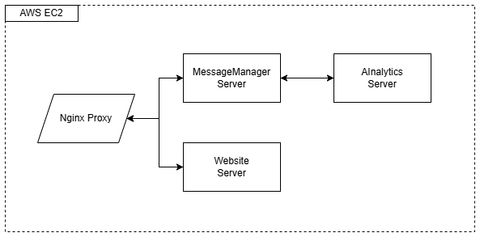
Figure 11. System Architecture
Overall, this architecture reflects a cloud-native, modular, and scalable design, suitable for early-stage validation while preserving clear paths for horizontal scaling, service isolation, and future architectural evolution. By combining a client–server model, modular services, cloud infrastructure, and external API integrations, the system balances technical robustness with operational simplicity.

    - Development and Implementation (MVP):
The development of ContaíCo followed an iterative and incremental methodology inspired by Agile principles, primarily combining elements of Scrum and Kanban. This hybrid approach was chosen due to the individual nature of the project, limited development resources, and the need for flexibility throughout the academic year.
Scrum concepts were applied through short development cycles (sprints), each with clearly defined objectives, deliverables, and validation checkpoints. These sprints were aligned with the academic modules of the Entrepreneurial Track, allowing continuous refinement of both the technical solution and the business model. Kanban principles complemented this structure by enabling continuous task prioritization, visual tracking of development activities, and rapid adjustment of scope whenever technical constraints, user feedback, or feasibility issues emerged.
This methodology proved adequate for managing a project that required both software engineering execution and entrepreneurial validation, ensuring steady progress while maintaining adaptability.
The MVP development was structured into progressive phases, each contributing to the consolidation of the solution:
- Problem Analysis and Solution Design: The initial phase focused on understanding user pain points related to personal finance management and benchmarking existing solutions. Based on this analysis, the core value proposition was defined: automated financial analysis via WhatsApp using artificial intelligence, without manual data entry.
- Architecture Definition and Infrastructure Setup: In this phase, the system architecture was designed using a cloud-based client–server model hosted on AWS. Key components such as the MessageManager, AInalytics service, and web interface were defined, along with the use of Nginx as a reverse proxy and separation of responsibilities between services.
- Core Feature Development: The main functionalities of the MVP were implemented, including WhatsApp message handling, document reception (bank statements and invoices), AI-based financial analysis, and structured response generation. Integration with external APIs (Meta Cloud API and OpenAI API) was completed during this phase.
- Validation, Refinement, and Deployment: The final phase involved deploying the MVP in a production-like environment, refining dialogue flows, implementing usage limitations (free trials), improving error handling, and ensuring system stability. Parallel to technical refinement, business documentation such as the financial model and business plan was consolidated.
The Minimum Viable Product of ContaíCo includes the following modules and features:
- MessageManager Module - Responsible for managing all WhatsApp interactions through the Meta Cloud API. This module handles message reception, user session control, request validation, usage limits (e.g., free trials), and routing of data to the analytics layer.
- AInalytics Module - A dedicated analytics service integrated with the OpenAI API. It processes financial documents sent by users, extracts relevant information, identifies spending patterns, and generates concise, personalized insights using natural language responses.
- Website Module - A supporting web interface used for institutional presentation, brand communication, and user guidance. This module also lays the foundation for future payment integration and account management features.
- Cloud Infrastructure and Deployment - The MVP is hosted on AWS EC2 instances, using Nginx as a reverse proxy to manage traffic between services. This setup ensures scalability, availability, and separation between application layers.

    - Testing and Technical Evaluation:

      - Testing Strategies
The testing strategy adopted for the ContaíCo MVP focused primarily on acceptance testing through real user interaction, complemented by manual functional validation during development. Given the MVP-oriented scope of the project, limited development time, and its exploratory nature, no formal automated unit or integration test suites were implemented at this stage.
Manual testing was continuously performed throughout development to verify the correct behavior of individual functionalities, such as message reception, document upload handling, AI-based analysis execution, and response delivery via WhatsApp. These checks ensured that each feature worked as expected under normal usage conditions before being exposed to users.
The main validation effort, however, was centered on user acceptance testing. Real users were invited to interact with the system in a production-like environment, submitting financial documents and engaging in conversations via WhatsApp. This approach allowed the evaluation of the system not only from a functional standpoint, but also from the perspective of usability, clarity, and perceived value.

      - Results and Technical Evaluation
The results obtained from acceptance testing indicate that the MVP successfully fulfills its core functional objectives. Users consistently reported that the service was fast, simple, and easy to use, with quality ratings predominantly between 4 and 5 on a 5-point scale. Additionally, the majority of respondents indicated a high likelihood of using the service on a monthly basis, with scores frequently ranging from 7 to 10 on a 10-point scale.
From a technical perspective, the end-to-end workflow—receiving messages and financial documents via WhatsApp, processing the data using artificial intelligence, and returning analytical insights—proved to be stable under typical usage scenarios. The system handled standard financial documents effectively and delivered responses within acceptable timeframes, reinforcing the feasibility of the proposed architecture.
Acceptance testing also revealed important technical limitations and improvement opportunities. The most significant issue involved the handling of password-protected PDF files, which resulted in failed analyses without adequate user feedback. Users also highlighted the absence of explicit loading messages, unclear responses when errors occurred, and the need for better message formatting and conversational guidance.
These findings were critical in evaluating the technical robustness of the MVP. While the core functionality proved reliable, the feedback highlighted the importance of improved error handling, clearer system feedback, and enhanced conversational flow to increase perceived stability and trust. The results of this testing phase directly informed the prioritization of future technical improvements.
Overall, the testing process demonstrated that the ContaíCo MVP is functionally viable and well-received by users, validating its core assumptions while clearly delineating the boundaries of the current implementation. This outcome confirms the MVP’s role as a foundation for further technical refinement and feature expansion.

The Business Plan
This section presents the consolidated Business Plan of ContaíCo, developed throughout the project and refined based on market analysis, technical feasibility, and early user validation. The plan structures the strategic, operational, and financial dimensions of the startup and serves as the foundation for its market introduction.

    - Market and Competitor Analysis:
ContaíCo targets individual users (B2C) who seek a simple and efficient way to understand and manage their personal finances. The primary customer segment consists of young adults aged 18 to 30, who are digitally native, accustomed to mobile banking and fintech solutions, and already demonstrate a moderate level of financial awareness. These users typically value convenience, speed, and clarity, and are willing to pay a modest monthly subscription for tools that reduce cognitive and operational effort in financial management.
Geographically, the initial focus is on the South and Southeast regions of Brazil, where higher purchasing power and greater adoption of digital financial services increase the likelihood of early adoption.
The SWOT analysis highlights the strategic positioning of ContaíCo within the Brazilian fintech market.
Strengths  Accessible through WhatsApp, a platform widely used on a daily basis;  No need for application installation or complex onboarding;  Simple and intuitive user experience focused on clarity and speed;  Innovative conversational approach to personal financial analysis. | Weaknesses  Limited technical and financial resources typical of an early-stage project;  MVP with a reduced feature set compared to established competitors;  Dependence on third-party APIs (Meta and OpenAI);  Initial limitations in error handling and edge-case scenarios.
Opportunities  Growing demand for simplified and automated personal finance tools;  Possibility of incremental feature expansion (categories, historical analysis, visual insights);  Potential expansion to a B2B model with banks and fintechs;  High scalability due to cloud-based architecture and low marginal costs. | Threats  Strong competition from established personal finance applications;  Ease of technical replication by larger players with more resources;  Regulatory and compliance requirements in the financial sector;  User trust and adoption risks in early stages.

    - Business Model (Business Model Canvas - BMC):

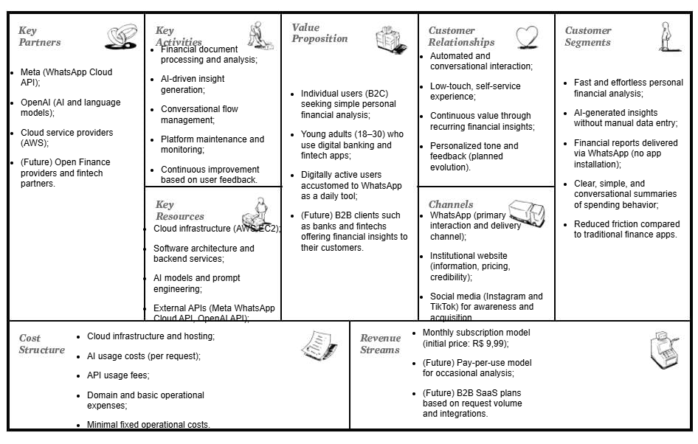
Figure 12. Business Model Canvas

    - Marketing and Sales Strategy
      - Go-to-Market Strategy
The go-to-market strategy for ContaíCo is designed to be gradual, low-cost, and brand-consistent, prioritizing early validation over aggressive scaling. The product will be launched initially as a soft launch, targeting early adopters through controlled exposure rather than mass-market campaigns. This approach allows the company to validate messaging, pricing, and user experience while maintaining operational stability.
The primary launch channel is WhatsApp, which serves not only as the core product interface but also as a central element of the brand experience. The simplicity and familiarity of the platform reinforce ContaíCo’s visual identity and positioning: clean, accessible, and frictionless. Users are guided directly from awareness to usage without requiring app downloads or complex onboarding steps.
Brand communication is supported by Instagram and TikTok, where short-form content demonstrates real use cases, such as sending a bank statement and receiving instant insights. Visual content follows the brand’s minimalist aesthetic, using consistent colors, typography, and tone to convey clarity, trust, and technological sophistication. The website complements this strategy by acting as an institutional reference point, reinforcing credibility and providing clear information about pricing and usage.

Customer Acquisition and Retention Strategies

Customer acquisition focuses on low-friction entry points and organic reach. Social media content is designed to be educational and demonstrative rather than promotional, highlighting everyday financial questions and how ContaíCo answers them in seconds. This strategy aligns with the brand’s identity by avoiding aggressive sales language and emphasizing practical value.
- Initial acquisition is reinforced through:
- Clear calls to action directing users to start a WhatsApp conversation;
- Free or limited usage to reduce adoption barriers;
- Simple, visually consistent messaging that communicates value in a few seconds.
Customer retention is driven by recurring value delivery and habit formation. By providing clear and actionable financial insights, the service encourages users to return periodically as new financial documents become available. The conversational format helps maintain engagement, while planned features such as historical analysis, reminders, and personalized report tones strengthen long-term usage.
The brand’s visual identity plays a central role in retention by fostering trust and familiarity. Consistent design, clear language, and predictable interaction patterns help users feel confident in the service, which is particularly important in financial contexts. Together, these strategies support sustainable growth by aligning marketing, product experience, and brand perception into a unified user journey.

    - Financial Projection and Feasibility:
      - Revenue Model and Pricing Structure
ContaíCo adopts a subscription-based revenue model as its primary monetization strategy, complemented by a pay-per-use option to reduce entry barriers and encourage experimentation with the service. The subscription model offers users continuous access to financial analysis and insights for a fixed monthly fee, while the pay-per-use model allows occasional users to pay per request with limited functionality.
Revenue projections were simulated across multiple price points (R$ 2, R$ 5, R$ 10, R$ 15, and R$ 20 per month) and different user base sizes, ranging from 100 to 10,000 users. Based on these simulations, the price of R$ 9,99 per month was selected as the initial pricing strategy, balancing affordability for the target audience with sufficient contribution margin to ensure financial sustainability.
The pay-per-use model was also evaluated, with prices ranging from R$ 0,05 to R$ 0,20 per request. This alternative model is not intended to replace subscriptions, but rather to function as a complementary acquisition mechanism, allowing users to test the service before migrating to a recurring plan.

      - Projected Expenses, Break-even Point, and Viability Indicators
The cost structure of ContaíCo is characterized by low fixed costs and predictable variable costs, primarily driven by cloud infrastructure usage and AI processing. Fixed monthly costs include the production environment hosted on AWS EC2, Elastic IP allocation, and domain and hosting services, totaling approximately R$ 426,11 per month for the production environment.
Variable costs are dominated by AI usage through the OpenAI API. Based on empirical measurements from early usage, the average cost per request was estimated at US$ 0.0106, corresponding to R$ 0,0636 per request. Assuming an average of 30 requests per user per month, the variable cost per active user is approximately R$ 1,91.
Using these assumptions, a break-even analysis was conducted. At the chosen price point of R$ 9,99 per month, the solution reaches break-even with approximately 53 paying users. This low break-even threshold demonstrates strong economic viability and indicates that the project can sustain itself even with a relatively small user base.
Profit projections further show that, as the number of users increases, profitability scales rapidly due to the low marginal cost per additional user. At higher adoption levels (e.g., 1,000 users), the model generates substantial positive margins, reinforcing the scalability of the solution and its potential for long-term sustainability.

      - Initial Investment Requirement
One of the main advantages of ContaíCo’s business model is the absence of significant upfront investment requirements. The solution relies on cloud-based infrastructure and usage-based APIs, eliminating the need for capital-intensive assets or physical infrastructure.
Initial costs are limited to operational expenses, such as cloud services, API consumption, and domain registration, all of which are incurred incrementally as usage grows. As a result, the project can be launched and operated with minimal initial capital, making it financially accessible and reducing the overall risk associated with early-stage deployment.
In summary, the financial projections demonstrate that ContaíCo is a low-cost, scalable, and economically viable solution, capable of reaching break-even quickly while maintaining flexibility in pricing and growth strategies.

Validation and Results
This section presents the methods and results used to validate the ContaíCo project in real market conditions. The validation process focused on assessing user acceptance of the Minimum Viable Product (MVP), perceived value, and alignment between the proposed solution and actual user needs.

    - Validation Methodology:

The validation of ContaíCo was conducted through direct user interaction with the MVP, complemented by an opinion poll designed to collect qualitative and quantitative feedback. This approach allowed the evaluation of the business hypotheses related to usability, perceived value, and willingness to use the service on a recurring basis.
Users were invited to test the service by interacting with ContaíCo through WhatsApp, submitting financial documents and receiving automated analyses. After using the service, participants were asked to complete a short online form. The form was intentionally kept simple to maximize response rates and included:
- Demographic questions (age range and gender);
- A usability and quality evaluation using a 5-point scale;
- A likelihood-of-use question measured on a 10-point scale;
- Open-ended questions for suggestions, improvements, and general feedback.
In parallel, social media channels (Instagram and TikTok) were created to introduce the service, support brand presence, and observe initial engagement behavior. Although these channels were not used for paid acquisition or A/B testing, they served as an exploratory validation tool to assess interest and communication clarity.
This validation methodology prioritizes early-stage learning, aligning with the MVP philosophy by emphasizing user feedback and behavior rather than large-scale quantitative metrics.

    - Market Validation Results

The collected responses indicate a strong positive reception of the ContaíCo MVP. Users consistently described the service as fast, simple, and easy to use, directly reinforcing the core value proposition of reducing friction in personal financial analysis.
Quantitative results show:
- Service quality ratings predominantly between 4 and 5 on a 5-point scale;
- High intention of continued use, with most users rating their likelihood of monthly usage between 7 and 10 on a 10-point scale.
- Qualitative feedback provided valuable insights into both strengths and areas for improvement. Suggested enhancements included:
- The addition of spending categories (e.g., food, transport, education);
- Displaying transaction dates within the analysis;
- Visual or percentage-based breakdowns of expenses;
- Personalized report tones (formal vs. informal);
- Follow-up questions to encourage reflection and behavioral awareness.
Users also highlighted usability-related improvements, such as clearer introductory messages, better message formatting, explicit loading indicators, and improved error handling. A recurring technical limitation identified during validation was the handling of password-protected PDF files, which negatively affected user experience when not properly acknowledged by the system.
Despite the limited number of respondents, the consistency of feedback across different age groups suggests a clear alignment between the proposed solution and user expectations, reinforcing the relevance of the identified problem and the effectiveness of the chosen approach.

    - Pivoting or Persisting
Based on the validation results, the project followed a persist-and-improve strategy rather than a pivot. The core elements of the business model—delivery via WhatsApp, AI-driven analysis, and a focus on simplicity—were validated by user feedback and did not require structural changes.
However, the validation process directly informed product refinements and roadmap prioritization. Improvements related to error handling, conversational clarity, and document processing (particularly password-protected PDFs) were identified as high-priority enhancements. Additionally, feature suggestions such as categorization, visual insights, and personalization were incorporated into the future development plan.
In summary, the validation confirmed that ContaíCo addresses a real user need and delivers value in its current form, while also providing concrete guidance for incremental improvements. This outcome demonstrates that the project achieved meaningful market validation and established a solid foundation for continued product and business evolution.

    - Risks and Mitigation Plan:
Given ContaíCo’s positioning as a WhatsApp-based fintech service with AI-driven analysis and a lean cloud infrastructure, the main risks can be grouped into financial, technological, legal/regulatory, and competitive categories. The mitigation plan below reflects the project’s current scope (MVP) and the business plan’s proposed evolution (B2C with potential B2B expansion).

Financial Risks

A critical financial risk is revenue uncertainty in the early stage, since the B2C subscription model depends on acquiring and retaining paying users at scale. Although the break-even point is low (≈53 users at R$ 9,99), insufficient conversion could delay sustainability. Mitigation includes maintaining low fixed costs, prioritizing organic acquisition channels (WhatsApp + social media), using free trials with clear limits, and applying incremental pricing validation (testing willingness to pay before scaling marketing spend).
Another relevant risk is cost volatility tied to variable usage, especially AI inference costs (OpenAI) and messaging costs (Meta) which scale with demand. The mitigation strategy is to implement usage caps per plan, monitor per-user request volume, optimize prompts to reduce token consumption, and progressively introduce tiered pricing or pay-per-use options to preserve margins as usage increases.

Technological Risks
The main technological risk is dependence on external APIs—specifically Meta’s WhatsApp Cloud API for communication and OpenAI for AI-based analysis. API outages, pricing changes, or policy updates could impact service availability or costs. The mitigation relies on the existing modular architecture (MessageManager and AInalytics separated), allowing isolated upgrades, replacement of providers if necessary, and fallback behavior (e.g., informing users of temporary limitations instead of failing silently).
A second risk involves MVP robustness and edge cases, especially the handling of password-protected documents and inconsistent input formats (a recurring issue identified during validation). Mitigation includes improving file validation, implementing explicit error responses, enabling retry/rollback mechanisms, and adding support for password input or alternative file formats. Operationally, monitoring and logging are essential to quickly detect failures and prevent repeated negative user experiences.

Legal and Regulatory Risks
Because ContaíCo processes financial documents and generates insights, there is a significant data privacy and compliance risk under Brazilian regulations (LGPD). Even if the system does not directly access bank accounts via Open Finance, it still processes sensitive financial data provided by users. Mitigation strategies include minimizing data retention (processing-only approach), applying encryption in transit (HTTPS), restricting access to stored files/logs, maintaining a clear privacy policy, and implementing user rights procedures (e.g., deletion requests and transparency about what is processed and why).
In the future B2B scenario, compliance risk increases due to stricter client requirements, audits, and contractual obligations. Mitigation would include formalizing security controls, access management, audit logs, and clear data processing agreements with corporate clients.

Competitive Risks
The main competitive risks are competition with established apps (Organizze, Mobills, Minhas Economias) and the ease of replication by larger players. Additionally, generic AI tools (e.g., ChatGPT) can replicate parts of the value proposition at zero marginal cost to the user. The mitigation approach is strategic differentiation: emphasizing WhatsApp-native delivery, simplicity, and the removal of friction; strengthening the brand and user trust; and building durable product advantages over time, such as historical tracking, personalized insights, reminders, and improved conversational experience.
For B2B, competition also includes Open Finance infrastructure players (e.g., Pluggy, Belvo, Celcoin). Mitigation here is to position ContaíCo as a communication and engagement layer, potentially partnering with those providers rather than competing directly—using them as data infrastructure while ContaíCo focuses on conversational delivery and AI insights through WhatsApp.

Conclusion

This work presented the conception, development, and validation of ContaíCo, a computational solution designed to simplify personal financial analysis through a conversational interface integrated with WhatsApp. The project addressed a relevant and practical problem: the difficulty many individuals face in transforming available financial data into clear and actionable insights, despite the growing availability of digital financial services.
From a technical perspective, the proposed solution demonstrated the feasibility of applying artificial intelligence within a cloud-based, modular architecture to process financial documents and deliver personalized insights in natural language. The architectural decisions—such as the separation of conversational orchestration and analytical processing—proved adequate for a Minimum Viable Product, enabling scalability, maintainability, and controlled operational costs. The development process followed an iterative approach, allowing continuous refinement of both technical components and user experience.
From a business standpoint, the project went beyond theoretical modeling by incorporating a structured business plan and real user validation. Market analysis identified a clear opportunity for a lightweight, accessible alternative to existing personal finance applications. Financial projections indicated economic viability, with a low break-even point and favorable scalability characteristics. The validation activities, conducted through direct interaction with users, confirmed the relevance of the value proposition and provided concrete feedback to guide future improvements.
The results of the validation phase showed high user acceptance, particularly regarding usability, simplicity, and perceived value. Although the sample size was limited, the consistency of feedback across participants reinforced the core assumptions of the project. At the same time, the validation process revealed technical and functional limitations typical of an MVP, such as the handling of edge cases and the need for improved feedback mechanisms. These findings were not obstacles but valuable inputs for the evolution of the solution.
As limitations, it is important to note that the project did not explore large-scale adoption, advanced Open Finance integrations, or comprehensive quantitative validation. Additionally, the MVP scope intentionally excluded certain features that could further differentiate the product in the long term. These aspects represent opportunities for future work rather than shortcomings of the proposed approach.

In conclusion, this work demonstrates that conversational interfaces, when combined with artificial intelligence and thoughtful system design, can effectively reduce complexity in personal financial management. ContaíCo fulfills its objective of creating and validating a computational solution with real market relevance, establishing a solid foundation for future technical enhancements, broader validation, and potential expansion into new business models.

References
AGÊNCIA BRASIL. Número de pessoas que acessam banco online cresce 22 milhões em 2 anos. Agência Brasil, 2025. Disponível em: https://agenciabrasil.ebc.com.br/economia/noticia/2025-07/numero-de-pessoas-que-acessam-banco-online-cresce-22-milhoes-em-2-anos. Acesso em: 21 nov. 2025.
FORBES BRASIL. O que fez do WhatsApp um fenômeno das mensagens? O Brasil é a resposta. Forbes Tech, 2025. Disponível em: https://forbes.com.br/forbes-tech/2025/05/o-que-fez-do-whatsapp-um-fenomeno-das-mensagens-o-brasil-e-a-resposta/. Acesso em: 21 nov. 2025.

Appendices


Figure 13. Visual Identity

Figure 14. Visual Identity

Figure 15. Visual Identity

Figure 16. Visual Identity

Figure 17. Visual Identity

