INTELI - INSTITUTO DE TECNOLOGIA E LIDERANÇA

Software Engineering

Marcos Vinicius Alves de Moura

# AI Praxis: Providing Courses for Ethical and Productive Use of Artificial Intelligence in the Workplace

**An Open Educational Platform Focused on the Ethical and Productive Use of AI Tools in the Workplace**

Undergraduate Thesis  
Submitted to the course of Software Engineering at Inteli, as a partial requirement for obtaining the degree of Bachelor in Software Engineering.  
  
Advisor: Prof. Bryan Ferreira Kano  
  
São Paulo – SP  
2025

# ABSTRACT

Currently, there is a growing interest in the application of artificial intelligence (AI) solutions in the workplace. However, this technological advancement has brought global concerns related to the unprepared or unethical use of such tools by corporations, institutions, and other organizations. This situation is further aggravated by the lack of clear regulations and the insufficient technical and ethical preparedness of professionals. In this context, the AI Praxis project proposes the development of an educational platform aimed at training professionals from various fields in the conscious and productive use of AI in professional environments. The main goal of the initiative is to offer courses and materials that foster technical skills, ethical awareness, and practical knowledge of AI tools, contributing to task optimization and more informed decision-making. The project is structured in four modules, which guide the progressive implementation of platform functionalities — built on Moodle — and the continuous expansion of its content library. All courses and materials are provided free of charge and in Portuguese, ensuring democratic access to the knowledge produced. The initiative is expected to significantly contribute to the users’ critical and technical development, encouraging a responsible and strategic use of artificial intelligence in the workplace.

Keywords: artificial intelligence; ethics; professional training; educational technology; workplace.

# RESUMO

Atualmente, observa-se um crescente interesse na aplicação de soluções baseadas em inteligência artificial (IA) no ambiente de trabalho. No entanto, esse avanço tecnológico tem sido acompanhado por uma problemática global relacionada ao uso despreparado ou antiético dessas ferramentas por corporações, instituições e demais organizações. Tal cenário é agravado pela ausência de regulamentações claras e pela falta de preparo técnico e ético dos profissionais envolvidos. Diante desse contexto, o projeto AI Praxis propõe o desenvolvimento de uma plataforma educacional voltada à capacitação de profissionais de diferentes áreas quanto ao uso consciente e produtivo da IA em seus ambientes de trabalho. A iniciativa tem como objetivo oferecer cursos e materiais que promovam o desenvolvimento de competências técnicas, reflexões éticas e o domínio prático de ferramentas de IA, contribuindo para a otimização de tarefas e a tomada de decisões mais informadas. Estruturado em quatro módulos, o projeto prevê a implementação progressiva de funcionalidades na plataforma — desenvolvida no Moodle — e a constante expansão do acervo de conteúdos. Todos os cursos e materiais disponibilizados são gratuitos e apresentados em língua portuguesa, visando garantir o acesso democrático ao conhecimento produzido. Espera-se que a iniciativa contribua significativamente para a formação crítica e técnica dos usuários, promovendo o uso responsável e estratégico da inteligência artificial no cotidiano profissional.

Keywords: inteligência artificial; ética; capacitação profissional; educação tecnológica; ambiente de trabalho.

# TABLE OF CONTENTS

1. Introduction (pg. 5)
2. Motivation and Objectives (pg. 5)
3. Module 1 - Software Development (pg. 6)
4. Module 2 - User Experience Improvement (pg. 20)
5. Module 3 - Information Security and Data Protection (pg. 21)
6. Module 4 - Development of Artificial Intelligence Solutions (pg. 22)
7. Results and Discussion (pg. 23)
8. Conclusion(pg. 24)
9. References (pg. 25)
10. Appendices (pg. 26)

# INTRODUCTION

The growing use of Artificial Intelligence (AI) at work has yielded immense advantages but also complex interrelated ethical and operational issues. With AI tools becoming increasingly available, it is essential that organizations and workers are well advised on their usage to foster both ethical accountability and productivity. This project suggests creating a platform for educational resources on the use of AI within the workplace in an ethical and effective manner. The project is based on an extensive survey of international best practices, from which Portuguese learning content was created to enable organizations and professionals to learn more and make better use of AI.

The content comprises courses, guidelines, and support material, all of which are straightforward to access and applicable to actual professional situations. Additionally, the site is hosted on a market-available Learning Management System (LMS) -Moodle- to allow for scalable and customizable content delivery. Through the division of the project into four development modules, the project guarantees an iterative and progressive process, coupled with ongoing improvement as well as congruence with user requirements and technological evolution.

# MOTIVATION AND OBJECTIVES

The rapid adoption of artificial intelligence technologies across different industries has uncovered a gap between the availability of advanced tools and professionals' preparedness to use them in an ethical and efficient way. Often, the lack of regulation and proper training has led to abuse, ethical issues, and inefficient practice. This is particularly pressing in emerging markets, where access to high-quality learning materials in the native language is often limited.

The motivation behind this project lies in the need to democratize access to information about the responsible use of AI, hence allowing employees at all levels to make informed decisions on integrating AI into their daily operations. By availing structured, usable, and contextually relevant educational materials, the project aims to develop both critical awareness and technical literacy among the participants.

The main objective of the project is to develop and implement an online platform providing free, high-quality educational content in Portuguese, focused on the ethical and efficient use of artificial intelligence in professional environments. The specific goals are as follows:

- Researching global best practices pertaining to AI ethics and productivity.

- Developing modular learning content and support materials specific to various professional profiles.

- Hosting the platform on a secure and scalable LMS for ease of access and scalability.

- Dividing the project development into four standalone modules allows for phased delivery and ongoing improvement.

Through these objectives, the project seeks to play a role in building a more educated, discerning, and prepared labor force amidst AI changes.

# MODULE 1: SOFTWARE DEVELOPMENT

## Project development planning

The first mandatory deliverable of the project consisted of a document detailing the planning of the subsequent deliverables. This planning process was based on the selection of artifacts from a predefined list of potential items. Furthermore, all deliverables were expected to adhere to a 10-week timeline, structured into five sprints of two weeks each.

**Module 1 - SOFTWARE DEVELOPMENT OR IMPLEMENTATION**

Sprint 1:

-Detailed Submission Plan (implementation plan, KPIs, and Success Metrics within the Justification) | Documentação de Projeto

Sprint 2:

-Analysis of Functional and Non-Functional Requirements and Needs | Computação

-Wireframe | Computação

- Vendor or Tech Stack Selection Report | Computação

Sprint 3:

-Project Architecture | Computação

-Functional Prototype or MVP | Computação

Sprint 4:

-Software Implementation or Deployment | Computação

-Responsible Technology Use Policy with Ethical and Sustainability Risk Assessment | Liderança

Sprint 5:

-Incident Response and Disaster Recovery Plan | Negócios

-Final Presentation + Public Report | Documentação de Projeto

**Module 2 - USER EXPERIENCE EVOLUTION**

Sprint 1:

-Detailed Submission Plan (implementation plan, KPIs, and Success Metrics within the Justification) | Documentação de Projeto

Sprint 2:

-Mapping of the Current Customer Journey with Identification of Pain Points and Improvement Opportunities | Negócios

-Wireframe | Computação

Sprint 3:

- Implementation of at Least One Accessibility Feature to Enhance the Experience for People with Disabilities | Liderança

-Feedback Mechanisms Design and Implementation | Computação

Sprint 4:

-Deployment of Improvements | Computação

-Implementation of the Revised Journey Proposal | Negócios

Sprint 5:

-Final Presentation + Public Report | Documentação de Projeto

**Module 3 - INFORMATION SECURITY AND DATA PROTECTION**

Sprint 1:

- Detailed Submission Plan (implementation plan, KPIs, and Success Metrics within the Justification) | Documentação de Projeto

Sprint 2:

-Risk and Vulnerability Analysis in Information Systems | Computação

-LGPD (or GDPR) and Applicable Data Privacy Compliance Analysis | Liderança

Sprint 3:

-Incident Response and Disaster Recovery Plan | Negócios

-Security Solutions Implementation (firewalls, antivirus, intrusion detection systems) | Computação

Sprint 4:

-Development of Information Security Policies and Procedures | Negócios

-Security Logs Monitoring and Analysis Report | Negócios

Sprint 5:

-Final Presentation + Public Report | Documentação de Projeto

**Module 4 - DEVELOPMENT OF ARTIFICIAL INTELLIGENCE SOLUTIONS**

Sprint 1:

-Detailed Submission Plan (implementation plan, KPIs, and Success Metrics within the Justification) | Documentação de Projeto

-Use Case Identification and Objective Definition for AI/ML | Negócios

Sprint 2:

-Impact and Return on Investment Analysis of Implemented Solutions | Negócios

-Data Collection, Preparation, and Cleaning for Model Training | Computação

-Risk Analysis of Ethical, Sustainability, or Employee Impact with Recommendations for Monitoring/Actions | Liderança

Sprint 3:

-Machine Learning Model Development and Training | Computação

-Model Validation and Evaluation Using Appropriate Metrics | Computação

Sprint 4:

-Integration of Models with Existing Systems or API Development | Computação

-Model Implementation and Deployment in Production Environment | Computação

Sprint 5:

-Detailed Technical Documentation of Models and Code | Computação

-Final Presentation + Public Report | Documentação de Projeto

## Platform Conceptual Design

In order to host the courses included in the solution, the Moodle cloud service was chosen, as it allowed the development of a fully customizable platform while providing essential security functionalities. Subsequently, a conceptual design was devised to illustrate the ideal configuration of the solution within Moodle, including the layout and structure of the courses available to enrolled users.

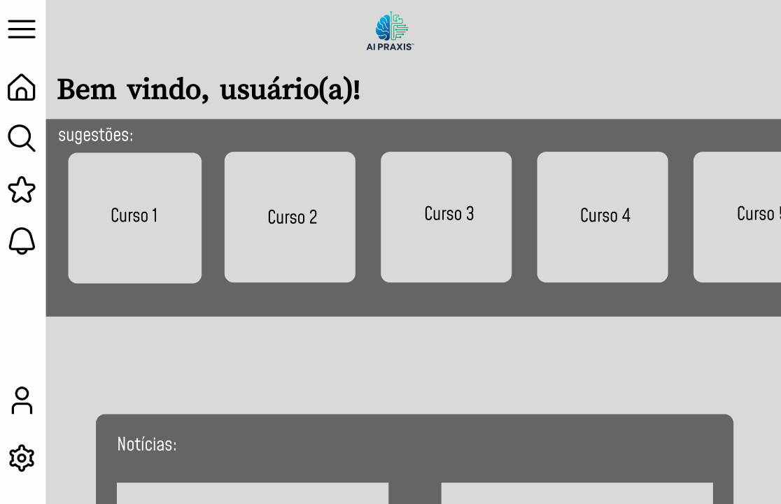

* The homepage was designed to provide users with immediate access to their enrolled courses and a newsletter component aimed at delivering daily updates on key developments in the field of artificial intelligence. Furthermore, all pages were required to include a navigation bar to facilitate access to the user profile, favorite courses, settings, and other essential platform features.

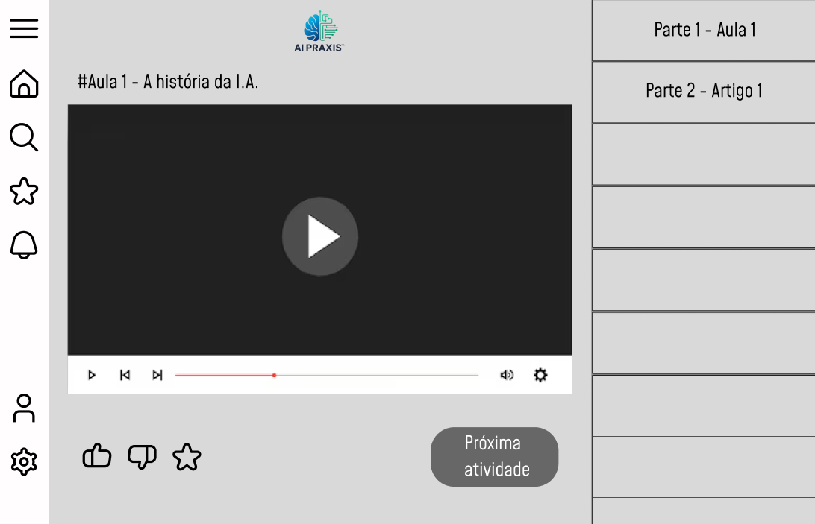

* The design of the course page aimed to facilitate intuitive navigation across course materials through the implementation of a navigation bar or equivalent component. Moreover, user progression was intentionally restricted based on activity completion, in order to support a structured and pedagogically sound learning path.

In conclusion, the platform’s design was strategically developed to ensure a seamless and user-centered learning experience. From the homepage’s immediate access to enrolled courses and curated updates, to the course page’s structured navigation and activity-based progression, each component was intentionally aligned with pedagogical best practices. This approach not only enhances usability but also reinforces an organized and effective learning path.

## Learning Management System Selection

### LMS Choice

The choice of an appropriate Learning Management System (LMS) was a vital step in the evolution of the AI Praxis platform, as its immediate effect was on user experience, scalability, and efficiency of the educational project overall. Decision-making involved a thorough analysis of business requirements, technical requirements, and long-term strategic objectives.

1. Business Requirements

The LMS needed to fulfill some important requirements:

- Functionality: Multimedia learning content support, structured learning pathways, and tracking user engagement.

- Scalability: The ability to support more and more users and courses.

- Security and Compliance: Data protection policy compliance and proper use of secure user access control.

- Cost-effectiveness: Affordable in both the short and long run, particularly considering the budget of an academic undertaking.

- Facilitation of Customization: Being able to customize the platform as per the specific requirements of AI Praxis.

1. Evaluation Criteria

To enable the selection process, the following evaluation criteria were defined:

- Extensibility and functionality to support project-specific requirements.

- Scalability, considering future expansion and course volume.

- Security and compliance capabilities are mapped to education standards.

- Maintenance and implementation cost.

- Support and maintenance, including documentation, community support, and technical support resources.

1. Alternatives Considered

It considered three LMS options: Moodle, Canvas LMS, and Open edX. All three had benefits and restrictions.

Moodle turned into a pre-eminent open-source choice characterized by high customization, a broad base of followers, and lack of licensing fees. Yet it demanded technical capabilities for setup initially and maintenance as well.

Canvas LMS provided a fresh, user-friendly interface with deep integrations; however, its full version was expensive and had limited scope for extensive customization.

Open edX is a good fit for large learning environments requiring sophisticated analytics, but due to its complexity and steep learning curve, it is less appropriate for smaller or more flexible applications like AI Praxis.

1. Final Decision

After comparing, Moodle was selected as the LMS for the AI Praxis platform. The reasons for the selection were as follows:

- Excellent degree of customization and flexibility.

- High community support and plugin availability.

- Affordability, with hosting ranging from $10–$20 a month.

- Alignment with the project's long-term vision and open-source philosophy.

1. Implementation Plan

The release was systematic in character:

I. Hosting and Setup: Moodle was hosted using MoodleCloud.

II. Platform Configuration: Courses, categories, and user permissions were established.

III. Content Development: Educational content like videos, quizzes, and interactive portions were included.

IV. Testing and Deployment: Before its official launch, the platform was tested with a small group. The LMS chosen ensures AI Praxis can offer accessible, scalable, and contextual learning experiences in Portuguese that allows for ethical and productive use of AI at the workplace.

## Developed Courses

1. How to Create an AI Usage Policy for Your Organization.

In module one of the AI Praxis program, a core course was created, which is "How to Create an AI Usage Policy for Your Organization." The course aimed to assist organizations in creating distinctive, moral, and useful guidelines that regulate artificial intelligence technologies' usage in their operating environment.

The syllabus is designed to lead practitioners through the sequential phases of creating, implementing, and sustaining an artificial intelligence use policy in accordance with international best practices and local regulatory directions. It addresses issues such as:

The significance of an in-house artificial intelligence policy.

- Identifying AI applications within the organization

- Ethical and legal aspects of AI adoption

- Responsibilities and roles of stakeholders.

- Policy templates and practical policy development tools

Different types of contents were included to enhance learning and applicability. The entire course is delivered in Portuguese and web-hosted in the Moodle environment, with the capacity to track content, analyze user progression, and provide multi-device accessibility. This module is a foundation for subsequent modules in the AI Praxis program and sets a minimum benchmark for the responsible use of artificial intelligence in organizational environments.

## Platform Description

The learning environment constructed for the AI Praxis program was constructed and hosted on Moodle, an open-source Learning Management System (LMS) selected due to its adaptability, cost-effectiveness, and large support community. The learning environment was designed to facilitate the delivery of organized study materials for the effective and ethical use of Artificial Intelligence in the workplace.

The interface was designed with usability and intuitiveness in mind, with a priority on ease of access for diverse users. The home page offers direct access to enrolled courses and will provide personalized news for artificial intelligence via an incorporated newsletter. There is a uniform navigation bar available on all pages, enabling simple access to key areas, including the user profile, course catalog, and settings.

The goal of the project is that each module helps people to advance learning, with paths of learning that increasingly advance the learner through material, new information accessible only following successful completion of required work. The site is capable of presenting a variety of content formats, such as video, reading assignments, interactive tests, and downloadable files, in Portuguese to increase accessibility and expand participation. Moodle's flexibility permitted the development of a secure, scalable, and customizable system consistent with the AI Praxis project's technical and pedagogical objectives.

The platform can be accessed using this url:<<https://ai-praxis.moodlecloud.com/>> and login with valid credentials.

**Login Page**

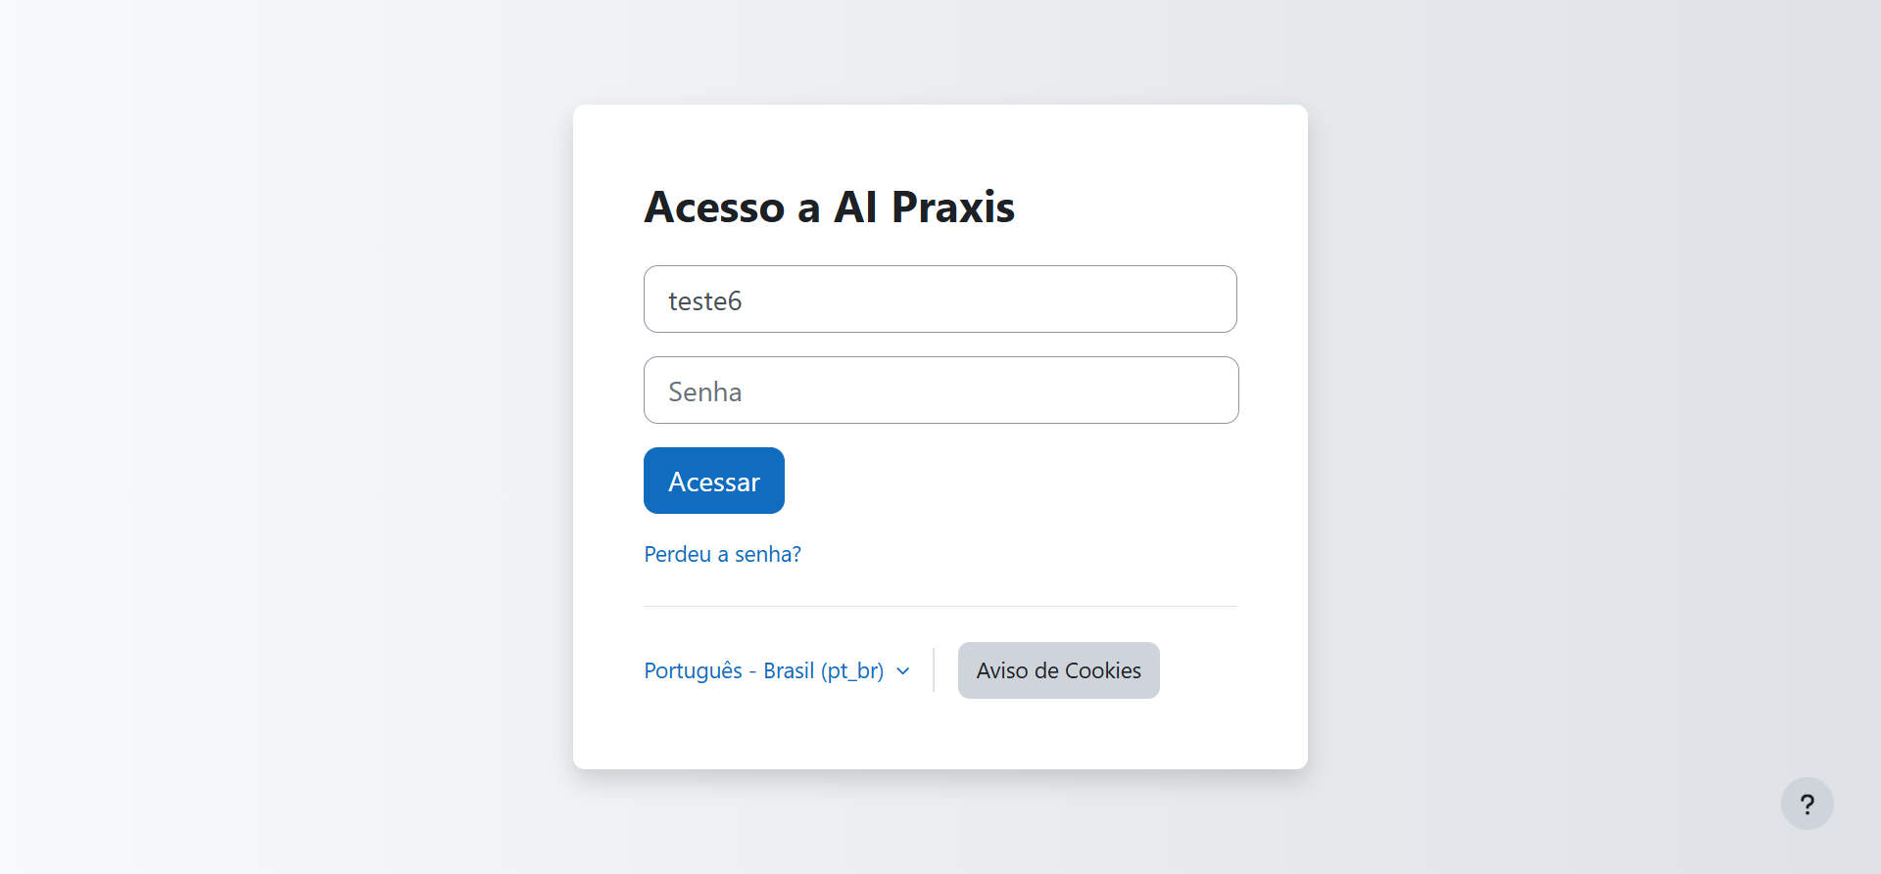

* The first page the user will encounter is the Login page. On this page, the user must register using the email address and password defined during the account creation process.

**Home P**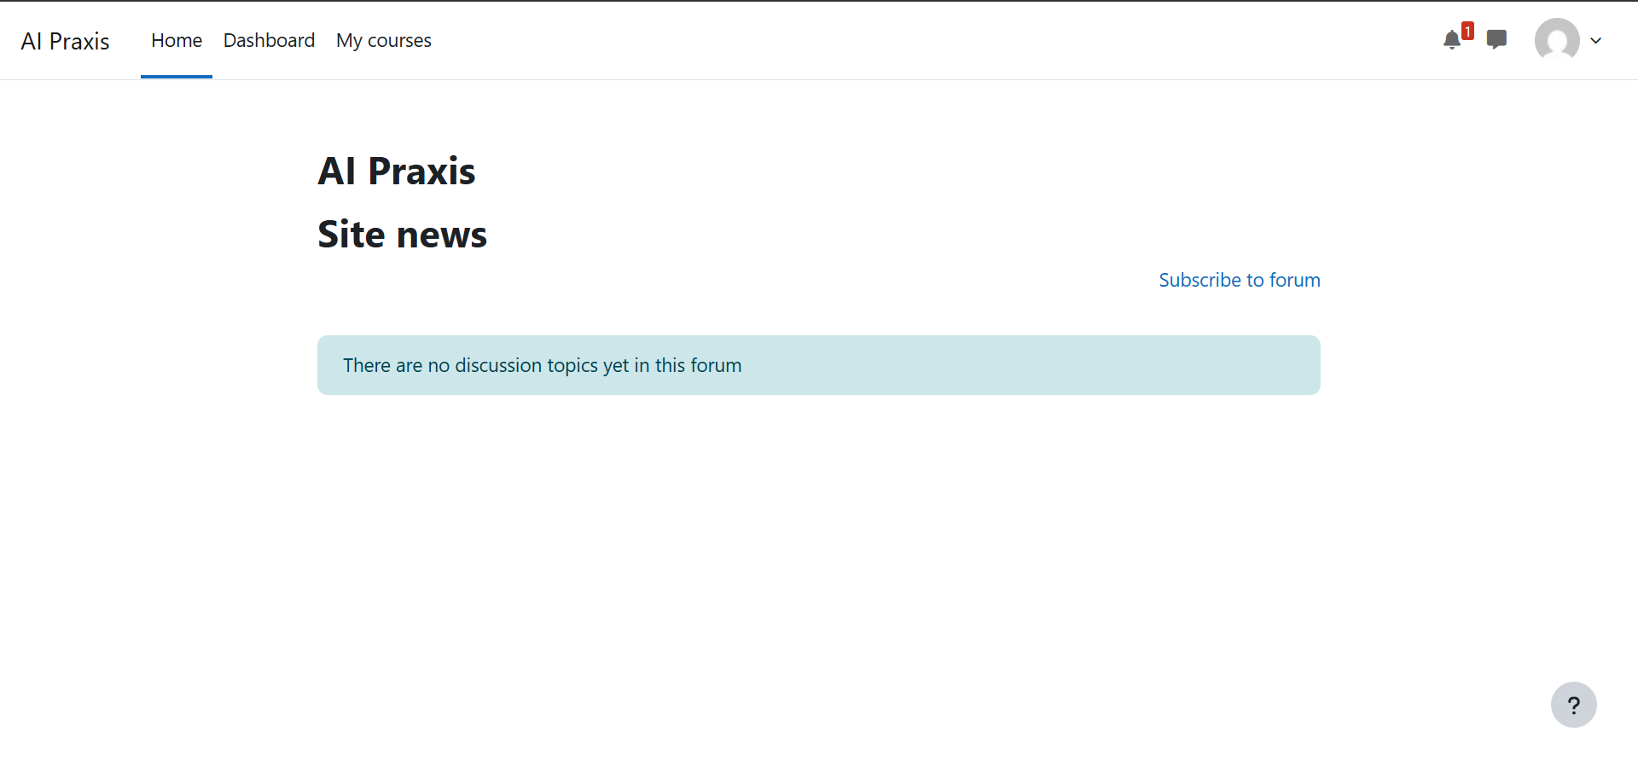

* The home page will feature a navigation bar for quick access to the platform’s main sections, along with a newsletter focused on topics related to the use of Artificial Intelligence. Additionally, this page will display the courses in which the user is currently enrolled.

**My Courses**

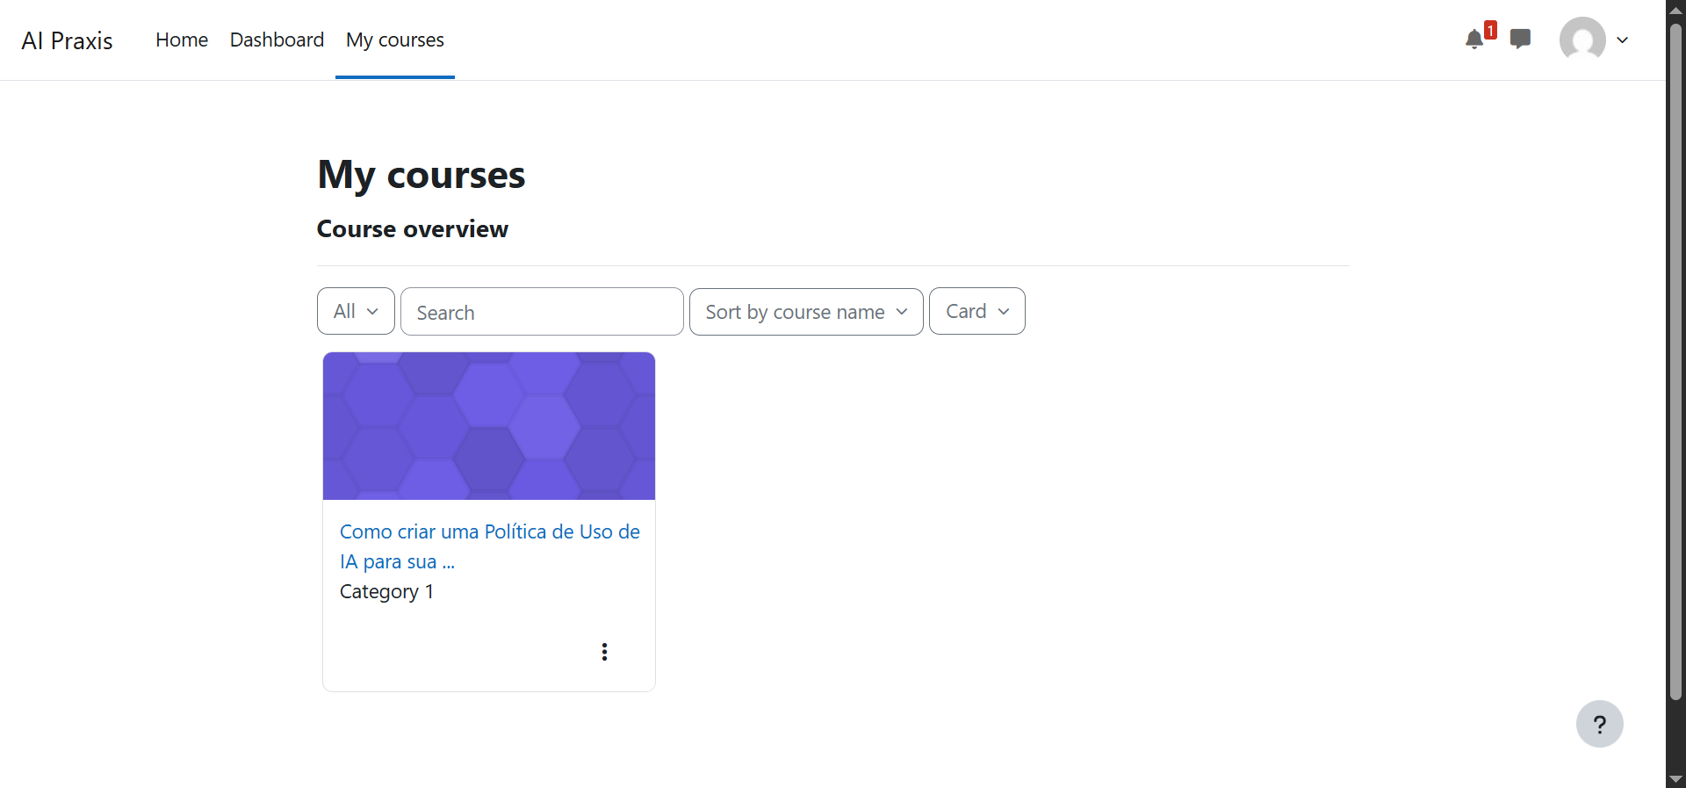

* On the 'My Courses' page, the user will have a more detailed view of the courses in which they are enrolled.

## Documentation

The development of the project was entirely supported by the preparation of documents aimed at describing and formalizing the expected outcomes of the solution, the responsibilities of each stakeholder, and the usage instructions for the platform. This comprehensive documentation facilitated the implementation of the required functionalities, as the defined deliverables provided clear guidance throughout the development process.

1. **Solution Architecture Document**

### 

The Solution Architecture Document defines the structural and technological design of the AI Praxis platform. It outlines the system components, data flow, integration points, and hosting infrastructure, with a focus on scalability, maintainability, and security. This document ensures that all stakeholders share a common understanding of the architecture and supports technical decisions throughout the development lifecycle. All documents referenced in this section are available in the project’s public GitHub repository.

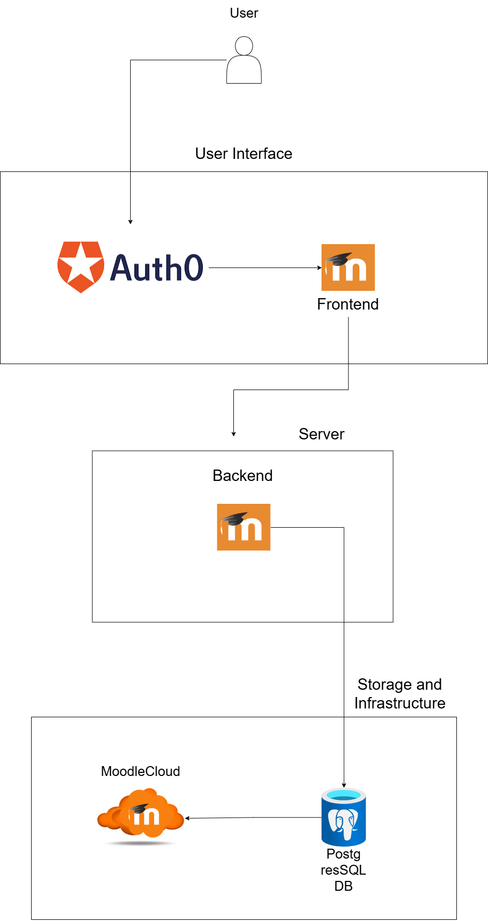

* System Components

1. User Interface Layer

* User: Interacts with the platform through the Moodle frontend.
* Moodle Frontend: Provides the user interface for accessing courses and learning materials.
* Auth0 (Optional): Manages authentication and Single Sign-On (SSO) for enhanced security.

2. Application Layer (Backend)

* Moodle Backend: Handles business logic, course management, and user requests.
* API Integrations: Facilitates communication between Moodle and external services.

3. Storage and Infrastructure Layer

* MoodleCloud: Provides hosting services and handles system-level configurations.
* PostgreSQL Database: Stores user progress, course data, and analytics.

1. **Requirements Specification Document**

The Requirements Specification Document details the functional and non-functional requirements of the AI Praxis platform. It defines the expected behavior of the system, including user roles, platform features, performance metrics, and security standards. This document serves as a reference for development, testing, and evaluation, ensuring that the solution meets its intended goals and aligns with user needs.

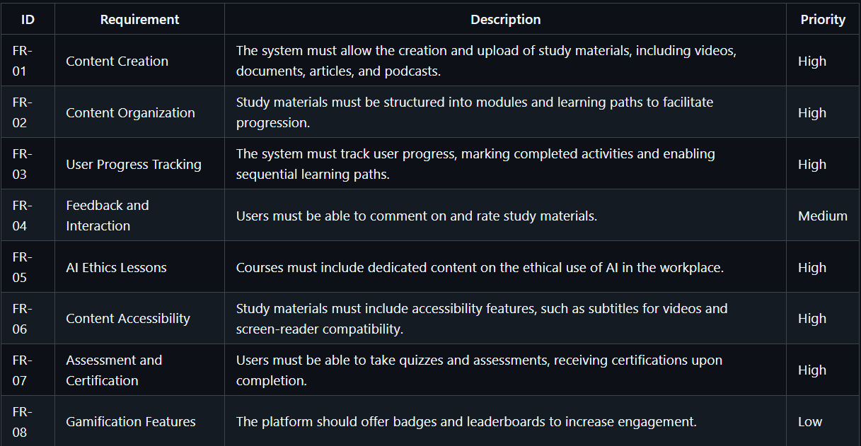

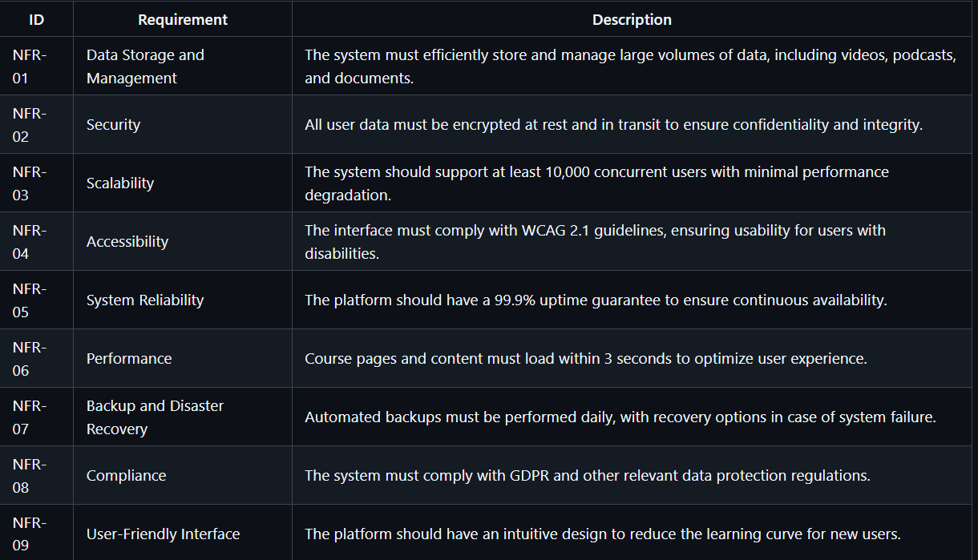

1. **Technology Usage Policy**

The Technology Usage Policy establishes clear guidelines for the ethical and responsible use of the AI Praxis platform and its resources. It includes provisions for user conduct, data privacy, intellectual property, and compliance with relevant laws and standards. The policy aims to foster a safe and productive learning environment while promoting accountability and awareness regarding the use of artificial intelligence technologies.

* **Ethical Principles:**

Transparency: Clearly communicate how technology is used and its impact.

Fairness: Avoid biases in AI systems and ensure equitable access.

Privacy: Protect user data and comply with regulations.

Human Rights: Respect fundamental rights and avoid harm.

* **Sustainability Considerations:**

Minimizing Environmental Impact: Reducing energy consumption and optimizing resources.

Responsible Hardware Use: Ensuring proper disposal and recycling of electronic waste.

Encouraging Green AI: Prioritizing energy-efficient models and infrastructure.

# MODULE 2: USER EXPERIENCE IMPROVEMENT

# MODULE 3: INFORMATION SECURITY AND DATA PROTECTION

# MODULE 4: DEVELOPMENT OF ARTIFICIAL INTELLIGENCE SOLUTIONS

# RESULTS AND DISCUSSION

Present and analyze the results of your work. Include tables, graphs, comparisons, and interpret the outcomes. Reflect on the limitations and challenges encountered.

# CONCLUSION

This chapter presents the general conclusions applicable to all four modules taught under the AI Praxis program. Each subsection recapitulates the progress, issues, and learning accrued during the respective development stages, as well as the benefits brought to the final users.

## Module I – Foundations and Early Outputs

The initial module of the AI Praxis project concentrated on establishing the foundational framework for the project, both educational and technical. The phase involved selecting the Learning Management System (LMS), designing the platform, and creating the initial educational course "How to Create an AI Usage Policy for Your Organization."

From a technical standpoint, the decision to use Moodle as the LMS proved to be a good strategy. It was a middle ground of flexibility, scalability, and cost-effectiveness that enabled the project team to customize the learning environment according to the specific needs of the project. Despite the learning curve and interface adjustments of the initial setup, Moodle provided the necessary foundation to house high-quality content in an easily accessed and user-friendly design.

Pedagogically, the first course was a pilot for the project's vision. It addressed a key gap in organizational readiness for AI by providing a systematic and practical approach to creating internal policies. The course was crafted with considerable care to be inclusive, accessible, and aligned with global best practices, while being meaningful to Portuguese-speaking professionals. The planning and documentation time and effort spent at this phase were instrumental in establishing the shape of future modules. By establishing the process for content development, roles and responsibilities, and technical parameters at a time early enough, the project team laid a good groundwork for long-term growth and scalability of the platform.

# REFERENCES

# APPENDIX A – [Title of Appendix]

Include your own supplementary materials, like source code, screenshots, questionnaires, etc.