Bruno Moitinho Leão
Israel Nunes Lopes Carvalho

YANI STUDIOS: DEVELOPMENT AND VALIDATION OF A CULTURALLY DRIVEN MOBILE GAME STUDIO

SÃO PAULO
2025

Bruno Moitinho Leão
Israel Nunes Lopes Carvalho

YANI STUDIOS: DEVELOPMENT AND VALIDATION OF A CULTURALLY DRIVEN MOBILE GAME STUDIO

Final Course Project submitted to the Institute of Technology and Leadership (INTELI), to obtain a bachelor's degree in Software Engineering
Advisor: Prof. Francisco Escobar

SÃO PAULO
2025

Cataloging in Publication
Library and Documentation Service
Institute of Technology and Leadership (INTELLI)
Data entered by the author.
(Cataloging record with international cataloging data, according to NBR 14724. The record will be completed later, after approval and before the final version is deposited. The completion of the cataloging record is the responsibility of the institution's library.)



Resumo

LEÃO, Bruno Moitinho; CARVALHO, Israel Nunes Lopes. Yani Studios: development and validation of a culturally driven mobile game studio. 2025. 56. Bachelor's Thesis - Software Engineering, Institute of Technology and Leadership, São Paulo, 2025.

This work presents the development and validation of an entrepreneurial and technological proposal focused on the creation of a mobile game studio, named Yani Studios, with an emphasis on accessibility, appreciation of Brazilian culture, and ethical monetization. The study is conducted within the context of a global mobile games market saturated with generic titles and aggressive monetization models, as well as the limited international presence of culturally representative Brazilian games. The main objective is to design and validate a computational solution — a 2D mobile game — and to structure a viable business plan for its introduction into the market. The adopted methodology combines software engineering practices, agile development methods, user-centered research, requirements elicitation and analysis, market analysis, audience discovery surveys, and structured playtesting sessions. Throughout the development process, multiple gameplay concepts were prototyped and evaluated, leading to the selection of a roguelike gameplay core based on higher engagement, mechanical clarity, and replayability potential. Results from user testing and data analysis indicate strong acceptance of culturally inspired content, preference for short gameplay sessions, demand for satisfactory performance on mid-range devices, and rejection of pay-to-win monetization models. The resulting business plan demonstrates the economic feasibility of the project through a lean operational structure, monetization based on rewarded advertisements and cosmetic items, and progressive growth strategies. The study concludes that the Yani Studios proposal presents competitive potential by integrating software engineering principles, cultural identity, and sustainable business practices, contributing both to the mobile games market and to the strengthening of the Brazilian game development ecosystem.
Keywords: mobile games; game development; software engineering; Brazilian culture; ethical monetization; digital entrepreneurship.

ABSTRACT

LEÃO, Bruno Moitinho; CARVALHO, Israel Nunes Lopes. Yani Studios: development and validation of a culturally driven mobile game studio. 2025. 56. Final course project (Bachelor) – Software Engineering, Institute of Technology and Leadership, São Paulo, 2025.

This work presents the development and validation of an entrepreneurial and technological proposal aimed at creating a mobile game studio, named Yani Studios, focused on accessibility, appreciation of Brazilian culture, and ethical monetization. The study is situated within the context of a global mobile games market saturated with generic titles and aggressive monetization practices, as well as the limited international presence of culturally representative Brazilian games. The main objective is to create and validate a computational solution — a 2D mobile game — and to structure a viable business plan for its market introduction. The adopted methodology combines agile development practices, user-centered research, persona creation, audience discovery forms, and structured playtests. Throughout the process, multiple gameplay concepts were prototyped and evaluated, leading to the selection of a roguelike core based on higher engagement, mechanical clarity, and replayability. Results obtained from playtests and audience analysis indicate strong acceptance of culturally inspired content, preference for short gameplay sessions, demand for performance on mid-range devices, and rejection of pay-to-win monetization models. The resulting business plan demonstrates the economic feasibility of the project through a lean operational structure, monetization based on rewarded advertisements and cosmetic items, and gradual growth strategies. The study concludes that Yani Studios represents a competitive and sustainable proposal by integrating technology, cultural identity, and ethical business practices, contributing both to the mobile games market and to the strengthening of the Brazilian game development ecosystem.

Keywords : mobile games; game development; Brazilian culture; ethical monetization; digital entrepreneurship.

List of Illustrations

Figure 1 – Value Proposition Canvas .................................................................... 11 Figure 2 – Persona Pedro Henrique da Silva........................................................ 19 Figure 3 – Persona Emily Johnson................................................................. 21 Figure 4 – SWOT Matrix................................................................................ 47

List of Tables

Table 1 – Risks and Mitigation Plan ........................................................................ 54

List of Abbreviations and Acronyms

B2B Business-to-Business
F2P Free-to-Play
GDPR General Data Protection Regulation
IAP In-App Purchase
KPI Key Performance Indicator
LGPD Lei Geral de Proteção de Dados
MVP Minimum Viable Product
TAM Total Addressable Market
SAM Serviceable Available Market
SOM Serviceable Obtainable Market

Summary

1 Introduction 10
2 Solution Development 14
2.1 Definition of Market Assumptions and Hypotheses: 14
2.2 Market Sizing and Analysis: 15
Total Addressable Market (TAM) 16
Serviceable Available Market (SAM) 16
Serviceable Obtainable Market (SOM) 17
Target Customer Segment 18
Persona 1 – Brazilian Player (Pedro Henrique da Silva) 19
Persona 2 – International Player (Emily Johnson) 21
2.3 Competitive Analysis and Differentials: 22
Identification of Direct and Indirect Competitors 22
Competitor Analysis: Features, Strengths, and Weaknesses 23
Definition of Competitive Advantage and Differentiating Factors 24
Summary of Competitive Position 25
2.3.1 Technological Solution 25
Functional Requirements 26
Non-Functional Requirements 26
User Specifications and Use Cases 27
Development Methodology 28
MVP Development Phases and Features 29
Phase 1 – Project Planning and Strategic Foundations 29
Phase 2 – Brand Strategy and Value Definition 30
Phase 3 – Audience Research and Personas 30
Phase 4 – Concept Exploration and Playtest Preparation 31
Phase 5 – Playtests and Concept Selection 32
Phase 6 – Playtest Analysis and Core Concept Definition 32
Phase 7 – Narrative, Lore, and Context Development 33
Phase 8 – Financial Analysis and Game Refinement 33
Phase 9 – Final Financial Analysis and Vertical Slice 34
Phase 10 – Project Closure and Final Delivery 34
Summary 35
Testing Strategies 35
Unit-Level Validation (Component Testing) 36
Integration Testing 36
Acceptance Testing (User-Centered Playtests) 37
Test Results and Technical Robustness 37
Playtest Results 37
Audience Discovery Form Results 38
Technical Robustness Assessment 39
Summary 39
2.4 The Business Plan 40
Business Overview 40
Value Proposition and Market Positioning 41
Target Market and Customers 41
Product and Development Strategy 42
Revenue Model and Monetization Strategy 42
Cost Structure and Financial Considerations 43
Growth and Scaling Strategy 43
Risk Assessment 44
Conclusion 44
SWOT Analysis 45
Strengths 45
Weaknesses 46
Opportunities 46
Threats 46
Go-to-Market Strategy 48
Customer Acquisition and Retention Strategies 49
User Acquisition 49
User Retention 49
Revenue Model and Pricing Structure 49
Projected Expenses, Break-even Point, and Viability Indicators 50
Initial Investment (Pre-Launch) 50
Operational Costs (Year 1) 50
Financial Viability and Break-even 50
Initial Investment Requirement 51
2.5 Validation and Results 51
Pivoting or Persisting 53
3 Conclusion 54
References 55

Introduction

[The introduction should present the project in general terms, establishing the context, relevance, and objectives of the work. The introduction of the entrepreneurial track projects should include the following parts:]

  - Context and Motivation:

The mobile games industry is one of the largest and fastest-growing segments of the global entertainment market. Despite this growth, the market is highly saturated with generic titles that rely heavily on repetitive mechanics and aggressive monetization strategies. As a result, many players experience fatigue, low engagement, and frustration with pay-to-win systems and excessive advertising.
In the Brazilian context, this problem is intensified by the lack of local studios with strong authorial and cultural identity capable of reaching international audiences. Brazilian culture remains underrepresented in high-quality mobile games, limiting both cultural visibility and the strengthening of the national games ecosystem.
This project is situated at the intersection of game development, entrepreneurship, and cultural representation, aiming to explore how accessible mobile games can simultaneously deliver entertainment, cultural value, and ethical business practices.
The identified market opportunity lies in creating a culturally differentiated, lightweight, and accessible mobile game that appeals to both Brazilian and international players seeking originality, meaningful content, and fair monetization.

  - Problem Definition and Value Proposition:

To clearly define the relationship between player needs and the proposed solution, the Value Proposition Canvas was used as a strategic tool. This model maps customer pains, gains, and jobs against the product’s features, pain relievers, and gain creators, ensuring alignment between the market problem and the proposed value.
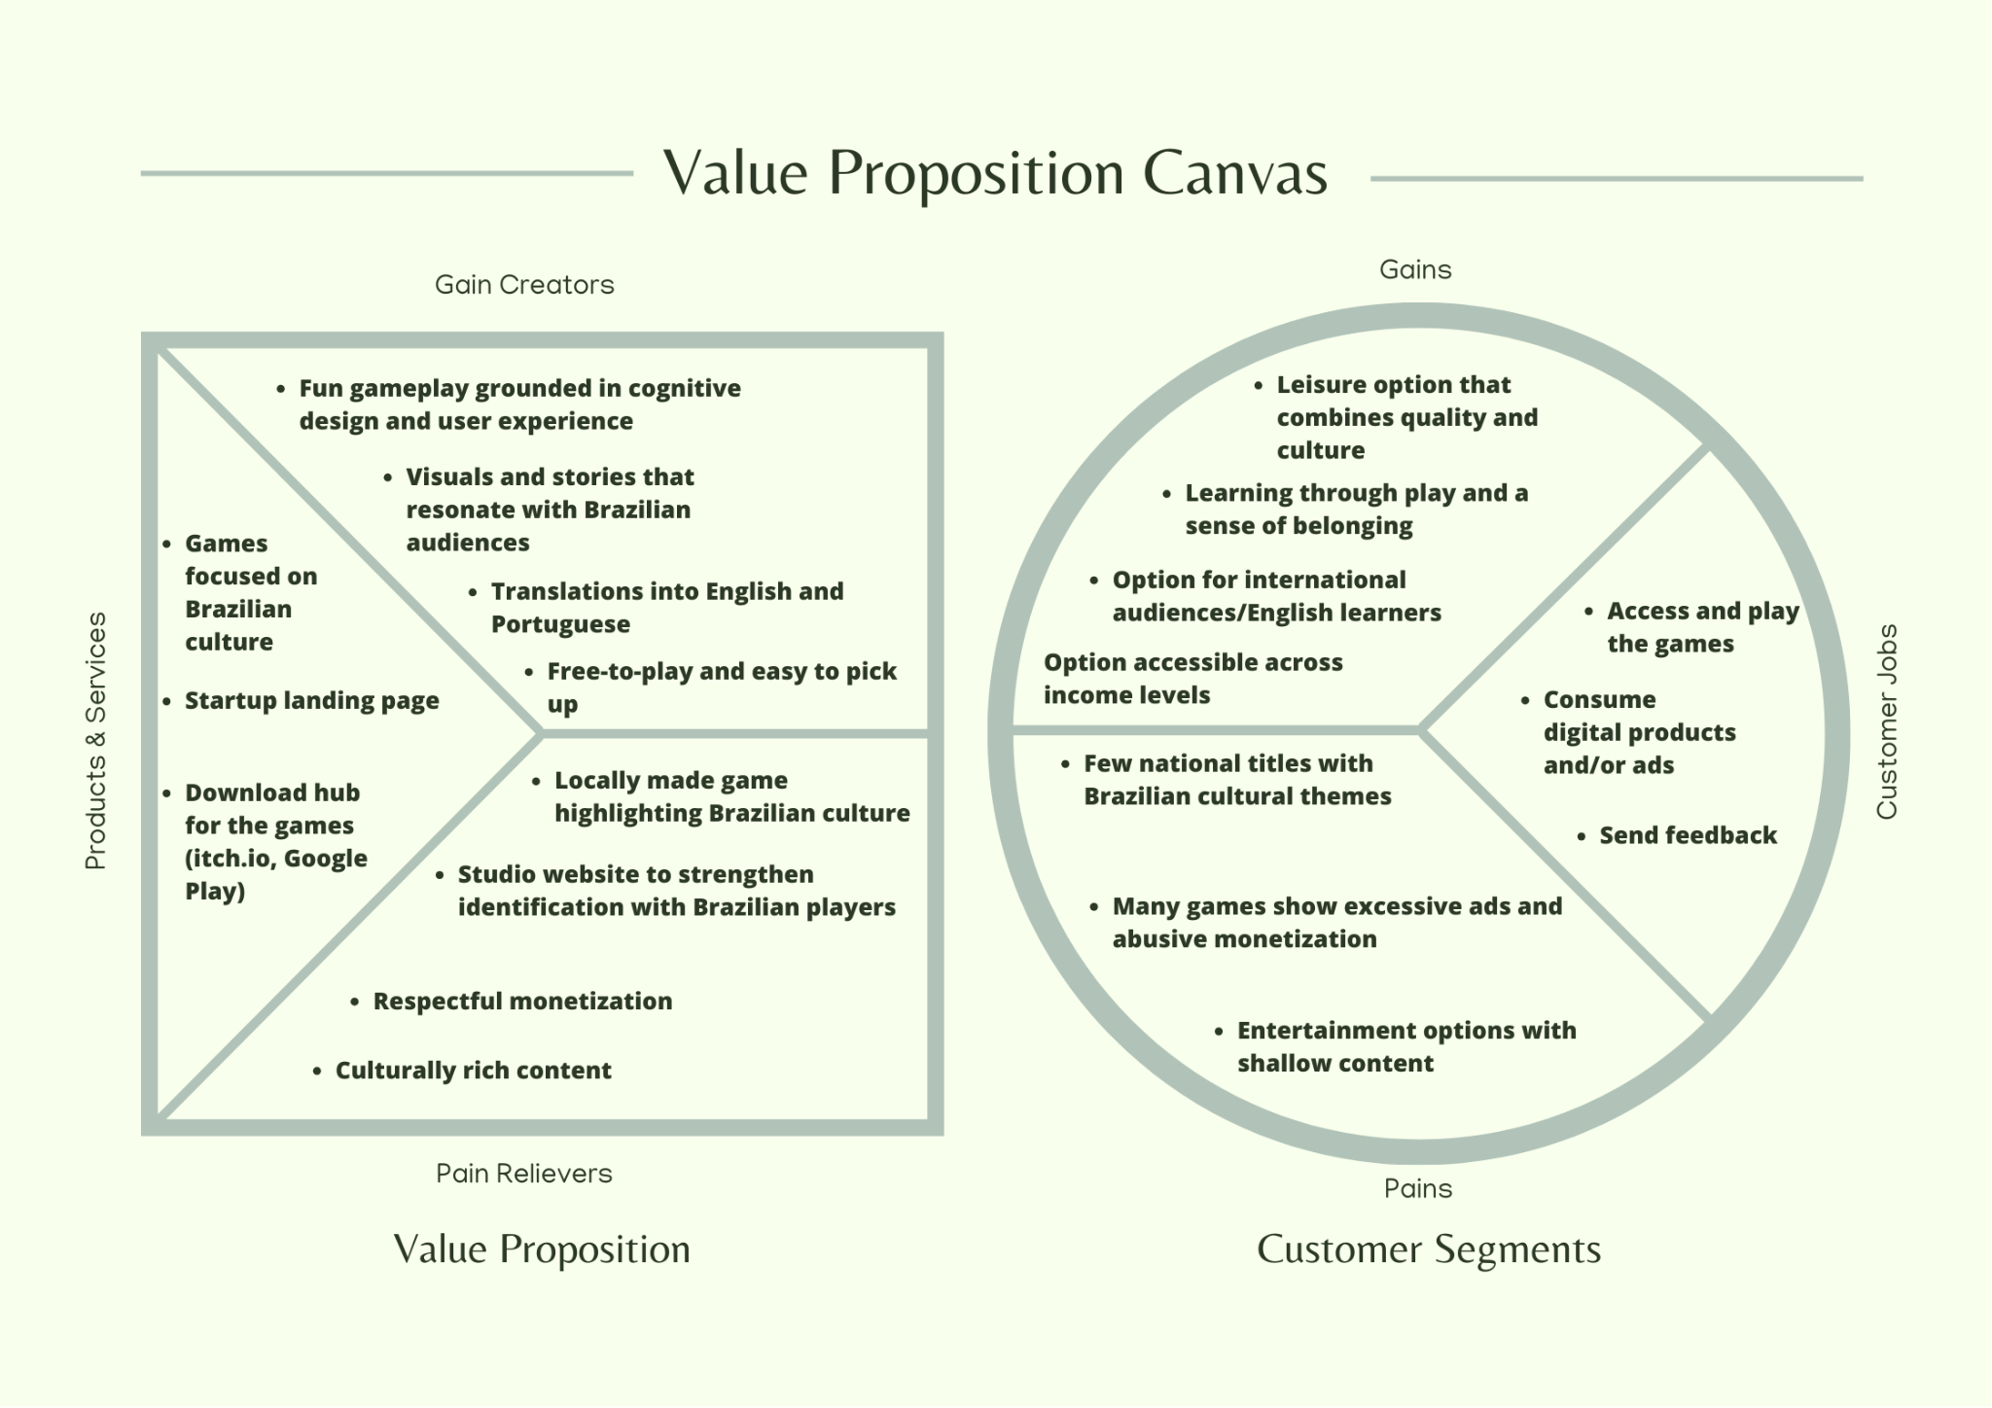
Figure 1 – Value Proposition Canvas

The core problem addressed by this project is the absence of culturally meaningful and ethically monetized mobile games that are accessible to a broad audience and capable of competing in the global market.
From the customer perspective, the main pain points include:
- Overabundance of generic mobile games with shallow content;
- Aggressive monetization models, such as pay-to-win mechanics and intrusive ads;
- Lack of authentic representation of Brazilian culture in globally distributed games;
- Limited access to games optimized for mid-range and low-end devices.
To address these issues, the project proposes a computational solution in the form of an accessible 2D mobile game, inspired by Brazilian cultural elements and social themes, designed with simple and intuitive gameplay, optimized performance, and ethical monetization.
The value proposition consists of delivering:
- Quick time-to-fun and intuitive user experience;
- Respectful representation of Brazilian culture through art, narrative, and symbolism;
- Ethical free-to-play monetization using rewarded ads and optional cosmetic items only;
- Accessibility through lightweight design and offline-friendly core gameplay.
This combination aims to alleviate player frustration while generating cultural, emotional, and entertainment value.

  - Objectives of the Work:
General Objective
To create and validate a computational mobile game solution and develop a business plan that supports its introduction into the global mobile games market.
Specific Objectives
- Design and prototype an accessible 2D mobile game optimized for low- and mid-range devices;
- Develop and test multiple gameplay concepts to identify the most promising one;
- Validate gameplay mechanics, user experience, and cultural perception through playtests;
- Define an ethical monetization strategy aligned with player expectations;
- Build a structured business plan for a culturally focused mobile game studio;
- Apply data-driven decision-making throughout development using metrics and user feedback.

  - Justification and Contributions:
From a market perspective, this project addresses a clear gap in the mobile games industry by offering a culturally differentiated product in a space dominated by generic titles. By targeting a niche of players seeking originality and cultural richness, the solution demonstrates competitive potential even with limited resources.
From a technological perspective, the project contributes by exploring lightweight development practices, performance optimization for mid-range devices, and the application of user-centered design and telemetry to guide iterative development.
From an economic and entrepreneurial perspective, the project presents a viable business model based on ethical monetization, sustainability, and scalability. It also contributes to strengthening the Brazilian games ecosystem by promoting local cultural identity while maintaining global reach.
Overall, this work demonstrates how computational solutions can integrate technology, culture, and business strategy to generate both economic value and cultural impact.

  - Work Structure:
This work is structured into three main chapters. The first chapter introduces the context, problem, objectives, and justification of the project. The second chapter presents the development of the solution, including market analysis, technological architecture, validation processes, and the business plan. The final chapter concludes the study, summarizing the results obtained and outlining future perspectives for the project.

Solution Development

Definition of Market Assumptions and Hypotheses:

This section presents the strategic assumptions that guided the development of the project. These assumptions are grounded in the analysis of the target audience, the Value Proposition Canvas, and the SWOT analysis, and they define the core hypotheses that will be validated throughout prototyping, playtests, and MVP development.

    - Problem Hypothesis
Casual and mid-core mobile players, both in Brazil and internationally, face a lack of culturally meaningful and original mobile games, as the market is saturated with generic titles that rely on shallow content and aggressive monetization.
These players experience frustration with excessive ads, pay-to-win mechanics, and the absence of respectful cultural representation, and they are willing to engage with and support games that offer accessible gameplay, ethical monetization, and authentic cultural value.

    - Solution Hypothesis
An accessible 2D mobile game, designed with simple and intuitive mechanics, optimized for mid-range devices, and enriched with Brazilian cultural references presented in a respectful and globally understandable way, is an effective solution to address this problem.
By combining quick time-to-fun, culturally inspired visuals and narratives, offline-friendly gameplay, and a strong focus on user experience, the proposed computational solution can deliver meaningful entertainment while differentiating itself in a crowded mobile market.

    - Value Hypothesis
Players are willing to accept and engage with a free-to-play monetization model that avoids pay-to-win mechanics and intrusive ads, as long as monetization is transparent, optional, and respectful.
The combination of rewarded advertisements and optional cosmetic in-app purchases is assumed to be an acceptable revenue model for the target audience, as it aligns with their expectations for fair pricing, preserves gameplay balance, and respects players’ time and financial constraints.

Market Sizing and Analysis:

This section presents the results of the estimates of market size obtained through the use of the TAM, SAM, and SOM tools, and a details of the customer profile.

    - Market Size (TAM, SAM, SOM):
This section presents a top-down market size estimation for Yani Studios using the TAM, SAM, and SOM framework. The values are based on publicly available mobile gaming market data and reasonable assumptions aligned with the project’s scope and constraints.

Total Addressable Market (TAM)
The Total Addressable Market (TAM) represents the total number of potential users in the global mobile gaming market.
- According to industry reports, the global mobile games market has approximately 2.8 billion mobile gamers worldwide, based on consolidated data from market research platforms such as Statista.
- This includes all mobile players across platforms, genres, and regions.
TAM estimation:
- TAM ≈ 2.8 billion mobile gamers globally
This represents the maximum theoretical market if the product were to reach all mobile game players.

Serviceable Available Market (SAM)
The Serviceable Available Market (SAM) narrows the TAM to players who match Yani Studios’ target profile.
Assumptions used:
- Approximately 35% of mobile gamers fall into the casual and mid-core segments that prefer short sessions and accessible gameplay.
- Within this group, an estimated 25% show interest in indie games, cultural content, or non-mainstream experiences.
- The project targets players aged 18–30, which represents roughly 40% of this segment.
SAM calculation:
- 2.8B × 35% = 980M casual/mid-core players
- 980M × 25% = 245M players interested in indie/cultural games
- 245M × 40% = ≈ 98 million players
SAM estimation:
- SAM ≈ 98 million players globally
This represents the realistic addressable audience aligned with the studio’s value proposition.

Serviceable Obtainable Market (SOM)
The Serviceable Obtainable Market (SOM) represents the portion of the SAM that Yani Studios can realistically reach in the short to medium term with its first MVP.
Assumptions used:
- Early-stage indie mobile studios typically capture 0.1% to 0.5% of their SAM through organic discovery, limited marketing, and community engagement.
- Given the niche focus on cultural differentiation and ethical monetization, a conservative estimate of 0.1% is applied.
SOM calculation:
- 98M × 0.1% = 98,000 players
SOM estimation:
- SOM ≈ 100,000 players (rounded)
This represents a realistic initial user base achievable through app store presence, word-of-mouth, and community-driven growth.
Strategic Interpretation
Although the SOM represents a small fraction of the total market, it is sufficient to validate the product, gather meaningful data, and support the sustainability of an MVP with ethical monetization. Success within this niche can later justify expansion through additional content, localization, and marketing investment.

    - Customer Segmentation and Profiling
Yani Studios targets casual and mid-core mobile players who seek accessible, meaningful, and culturally rich gaming experiences beyond generic mainstream titles. This audience values originality, fair monetization, and games that respect both players’ time and cultural identity.

Target Customer Segment
The primary customer segment consists of young adults aged 18–30 who regularly play mobile games on Android and iOS devices, mainly during short breaks, commutes, or leisure moments. These players are digitally active, culturally curious, and open to discovering indie games through app stores, social media, and online communities.
They are divided into two core sub-segments:
- Brazilian players, who seek authentic representation of Brazilian culture and feel motivated when their identity is portrayed with respect and quality.
- International players, who value originality and enjoy discovering new cultures through games, art styles, and narratives.
Players in this segment generally prefer:
- Simple and intuitive gameplay with quick time-to-fun
- Ethical free-to-play models (no pay-to-win or aggressive ads)
- Games optimized to run smoothly on low- and mid-range devices
- Cultural and narrative depth that enhances the experience without adding complexity

Persona 1 – Brazilian Player (Pedro Henrique da Silva)
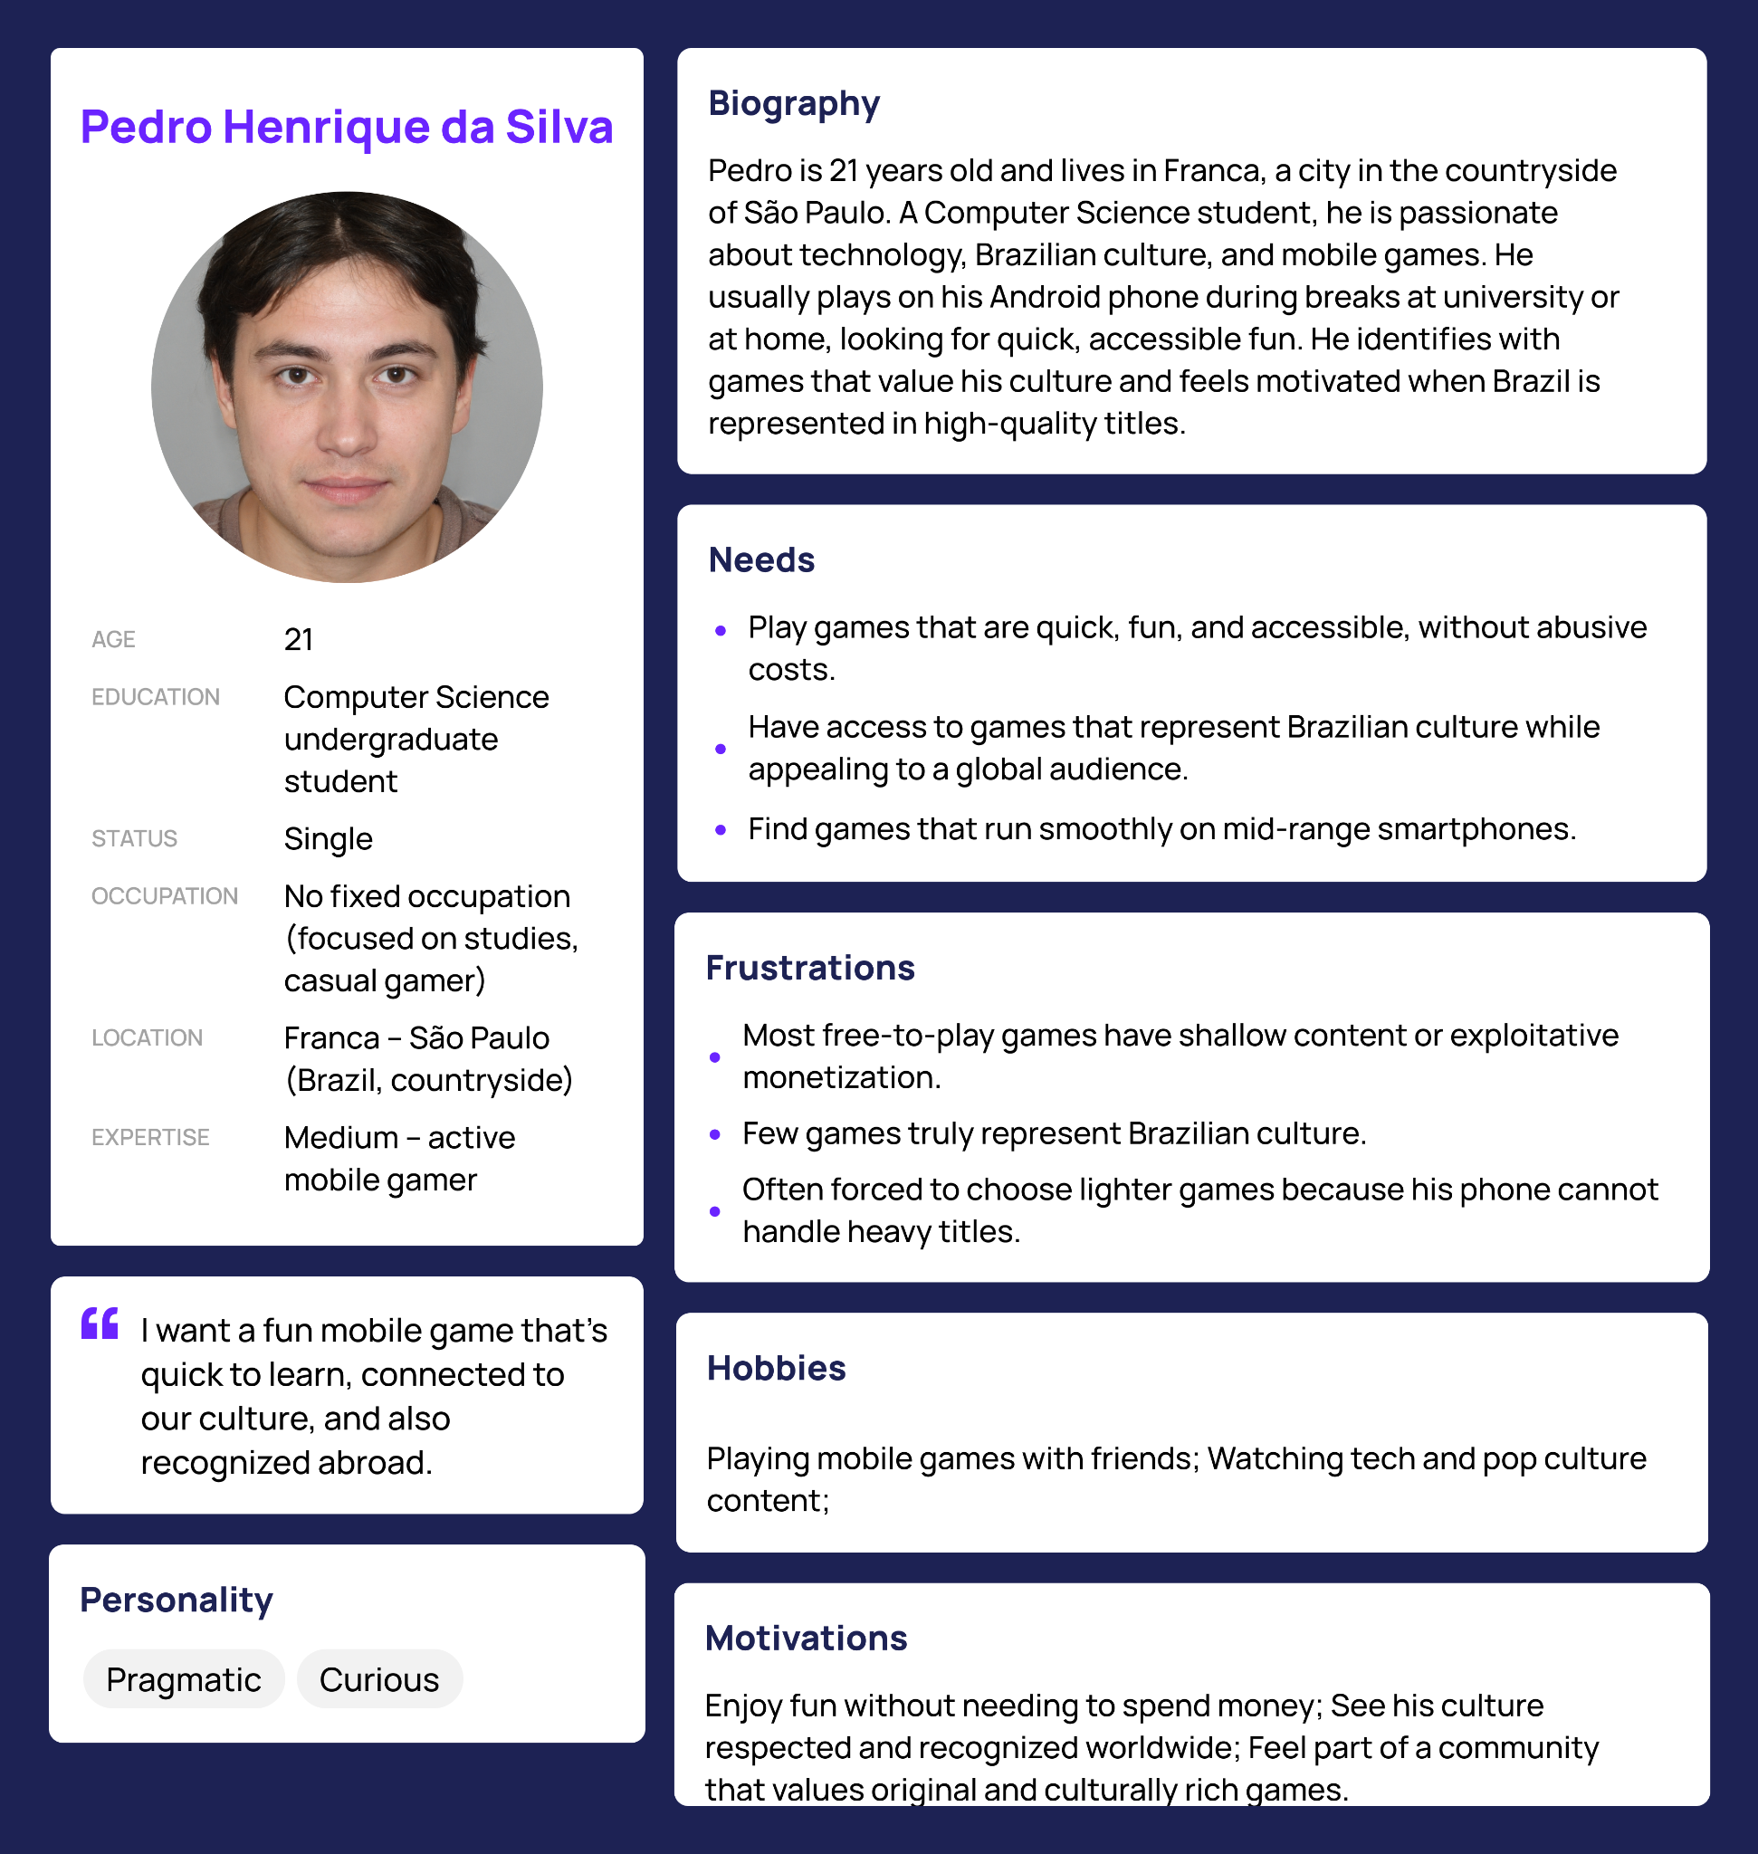
Figure 2 – Persona Pedro Henrique da Silva
Pedro Henrique da Silva is a 21-year-old Computer Science undergraduate student living in the countryside of São Paulo, Brazil. He frequently plays mobile games on his Android device, usually during breaks at university or at home, looking for quick and accessible entertainment.
Pedro values games that represent Brazilian culture authentically and feels frustrated with the lack of national titles that achieve international recognition. He dislikes exploitative monetization models and heavy ads, and often needs to choose lighter games due to hardware limitations. For him, seeing Brazilian culture treated with respect and quality is a strong source of motivation and pride.

Persona 2 – International Player (Emily Johnson)
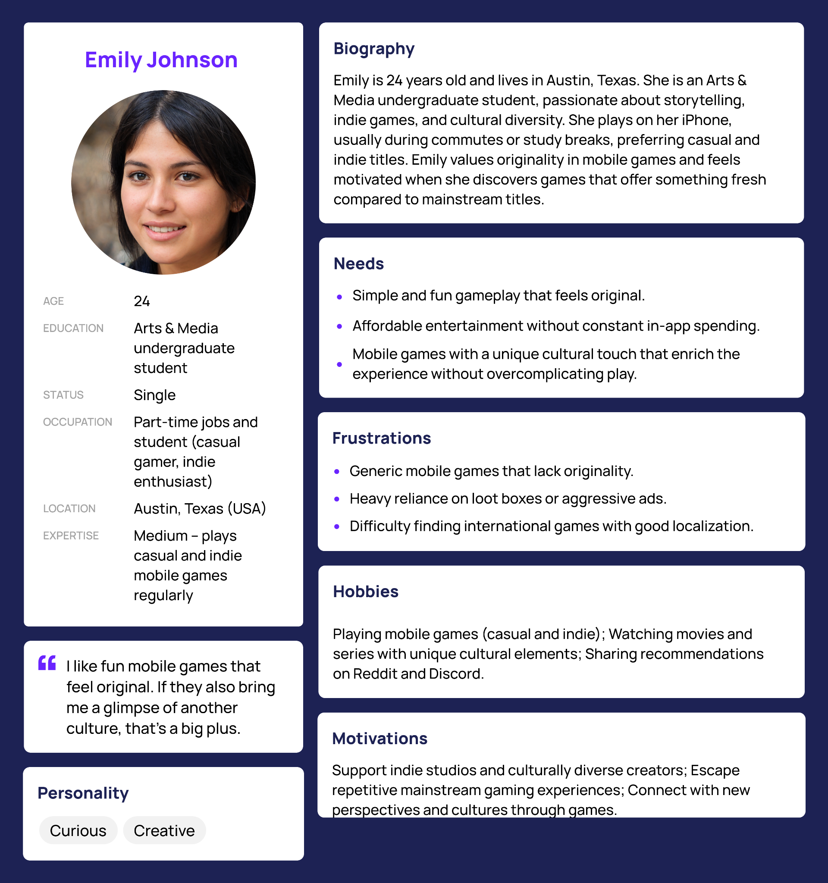
Figure 3 – Persona Emily Johnson
Emily Johnson is a 24-year-old Arts & Media undergraduate student living in Austin, Texas, USA. She enjoys casual and indie mobile games, usually playing on her iPhone during commutes or study breaks.
Emily is motivated by originality, storytelling, and cultural diversity. She actively looks for games that feel different from mainstream mobile titles and appreciates experiences that offer a glimpse into other cultures. She prefers affordable entertainment, avoids games with aggressive ads or loot boxes, and often shares recommendations in online communities such as Reddit and Discord.

Competitive Analysis and Differentials:

This subsection presents the competitive landscape of the mobile games market, identifying key competitors and highlighting the competitive advantages and differentiating factors of the proposed solution.

Identification of Direct and Indirect Competitors
The mobile gaming industry is dominated by a mix of major global publishers and independent developers, with competition spanning multiple genres and business models. The following are relevant competitors:
Direct Competitors:
These are mobile games or studios that operate in the casual to mid-core segment, include narrative or unique gameplay elements, and appeal to players seeking differentiated experiences.
- Fancade — A sandbox-style mobile game that allows players to enjoy user-generated content and multiple genres within one platform. It combines creativity with accessibility on both iOS and Android.
- Indie titles on mobile stores — Puzzle, adventure, and narrative-driven indie games such as Dungeons of Dreadrock (puzzle/adventure) and other indie hits demonstrate niches interested in design innovation rather than aggressive monetization.
Indirect Competitors:
These include high-download, high-revenue titles that compete for players’ time and engagement, even if they are not culturally driven or user-centered in the same way.
- Roblox continues to lead global mobile downloads with hundreds of millions of installs, demonstrating strong reach and community-driven play.
- Hyper-casual and casual hits such as Helix Jump and Garena Free Fire draw mass audiences through simple mechanics and aggressive user acquisition.
- Many mainstream free-to-play titles rely on in-app purchases and ads for revenue, including genres like strategy and simulation.

Competitor Analysis: Features, Strengths, and Weaknesses
Mainstream Casual Games
Games like Helix Jump, Subway Surfers, and Free Fire have extremely high install numbers and broad player bases. These titles excel in user acquisition and monetization but often feature aggressive advertising and pay-to-win mechanics.
Strengths:
- Massive global reach with strong retention and brand recognition.
- High monetization potential through in-app purchases and ads.
Weaknesses:
- Generic gameplay with limited narrative depth.
- Monetization can be intrusive, leading to player fatigue.
Indie Mobile Games
Titles like Dungeons of Dreadrock and sandbox platforms like Fancade reflect the rising presence of creative indie experiences on mobile.
Strengths:
- Innovative gameplay and higher creative freedom.
- Appeal to players seeking distinctive experiences.
Weaknesses:
- Lower visibility in app stores compared to top-grossing titles.
- Smaller budgets for marketing and scaling.

Definition of Competitive Advantage and Differentiating Factors
The proposed solution from Yani Studios positions itself uniquely in this competitive environment by combining cultural relevance, user-centered design, and ethical monetization. The main differentiating factors are:
Cultural Identity and Narrative Depth:
Unlike most mainstream mobile titles that prioritize mass monetization, the proposed game emphasizes unique storytelling and cultural representation. This fills a gap for players seeking meaning and connection, a market segment underserved by blockbuster titles.
Ethical Monetization:
The monetization model avoids pay-to-win mechanics and intrusive ads, instead using optional rewarded ads and cosmetic purchases. This approach aims to increase user satisfaction and retention rather than short-term revenue extraction — a worthwhile differentiator in a market where aggressive monetization leads to churn.
Accessibility and Optimization:
Many mainstream and even some indie games are not fully optimized for mid-range devices. The proposed solution’s lightweight technical design ensures smooth performance on a broader range of devices, increasing accessibility for players in emerging markets.
User-Centered and Data-Driven Development:
By integrating telemetry and playtest feedback, the project emphasizes iterative refinement based on real user behavior — a competitive advantage over competitors relying primarily on intuition or top-down design.

Summary of Competitive Position
The mobile gaming landscape in 2025 combines massive global hits with smaller indie experiments. While mainstream games dominate downloads and revenue, they often suffer from aggressive monetization and generic design. Indie games offer creativity but lack scale.
Yani Studios’ solution bridges these worlds by offering an experience that is:
- culturally rich and creatively differentiated;
- respectful of players’ time and economic expectations;
- optimized for accessibility on lower-tier devices;
- driven by user data and community feedback.
This strategic positioning establishes a clear competitive advantage in a market that values novelty but suffers from saturation and repetitive monetization models.

Technological Solution

This section describes the technological and computational solution proposed by the project, detailing system requirements, architecture, development methodology, and testing strategies adopted during the MVP phase.

    - Requirements and Specifications:

Functional Requirements
The system must provide the following functional capabilities:
- Allow users to play the game fully offline, with no mandatory internet connection;
- Provide intuitive touch-based controls suitable for mobile devices;
- Offer short gameplay sessions with immediate feedback and rewards;
- Include culturally inspired visual and narrative elements integrated into gameplay;
- Support ethical monetization through rewarded advertisements and optional cosmetic items;
- Store player progress locally on the device;
- Provide basic onboarding and tutorials for first-time users;
- Support localization in Portuguese and English.

Non-Functional Requirements
The system must comply with the following non-functional requirements:
- Performance: Smooth gameplay on mid-range mobile devices;
- Usability: Simple and intuitive interface with low learning curve;
- Accessibility: Clear visuals, readable typography, and simplified controls;
- Reliability: Stable execution without crashes or critical bugs;
- Portability: Compatibility with Android and iOS platforms;
- Maintainability: Modular codebase allowing future expansion and iteration;
- Efficiency: Lightweight application size and optimized memory usage.

User Specifications and Use Cases
Target Users:
- Casual and mid-core mobile players aged 14–35;
- Users playing in short sessions during breaks or commutes;
- Players interested in culturally meaningful and accessible experiences.
Main Use Cases:
- UC1: User opens the game and starts a session within a few seconds;
- UC2: User completes a short gameplay loop and receives rewards;
- UC3: User watches a rewarded advertisement voluntarily to gain optional benefits;
- UC4: User customizes visual elements using cosmetic items;
- UC5: User exits and resumes the game later without loss of progress.

    - Architecture and Technology:
The proposed system follows a standalone client architecture, optimized for mobile environments.
- Architecture Type: Local client-based architecture (offline-first);
- Server Dependency: None for core gameplay (ads and analytics optional);
- Game Engine: Godot (2D), chosen for its lightweight performance and cross-platform support;
- Programming Language: GDScript;
- Platforms: Android (primary), iOS (secondary);
- Data Storage: Local device storage for game state and progress.
This architectural approach reduces infrastructure costs, improves accessibility in regions with limited connectivity, and ensures consistent performance.

    - Development and Implementation (MVP):

Development Methodology
The project adopts an Agile methodology, inspired by Scrum, with biweekly sprints. Each sprint focuses on incremental delivery, testing, and iteration based on feedback and metrics.
Key practices include:
- Sprint planning and defined deliverables;
- Rapid prototyping and iteration;
- Continuous playtesting and feedback loops;
- Data-driven decision-making.

MVP Development Phases and Features
The development of the Minimum Viable Product (MVP) followed an iterative, sprint-based process, structured across Module 15 and Module 16. Each sprint contributed incrementally to reducing risk, validating assumptions, and refining the product from an initial concept into a playable vertical slice.

Phase 1 – Project Planning and Strategic Foundations
(Module 15 – Sprint 1)
The project began with the definition of its strategic and operational foundations.
Key activities:
- Development of the Project Plan, defining scope, objectives, constraints, and roadmap;
- Identification of the core problem and market opportunity;
- Initial definition of the studio vision and business direction.
Outcome:
- A structured roadmap guiding technical, business, and design decisions for subsequent sprints.

Phase 2 – Brand Strategy and Value Definition
(Module 15 – Sprint 2)
This phase focused on clarifying the product’s positioning and competitive differentiation.
Key activities:
- Definition of Brand Foundations, mission, and values;
- Construction of the Value Proposition Canvas, mapping player pains and gains;
- Development of the SWOT Matrix, identifying strengths, weaknesses, opportunities, and threats.
Outcome:
- Clear alignment between market needs, cultural differentiation, and ethical monetization strategy.

Phase 3 – Audience Research and Personas
(Module 15 – Sprint 3)
This phase focused on understanding the target audience through research-driven methods.
Key activities:
- Creation of a mixed-method audience discovery form, combining quantitative and qualitative questions;
- Design of the survey to evaluate player habits, preferences, cultural perception, and monetization tolerance;
- Definition of two core personas representing Brazilian and international players.
Outcome:
- Data-driven validation of the target audience profile and design priorities.

Phase 4 – Concept Exploration and Playtest Preparation
(Module 15 – Sprint 4)
In this phase, multiple gameplay concepts were explored before committing to a single solution.
Key activities:
- Definition of three alpha minigame concepts:
  - Roguelike
  - Endless Runner
  - Fishing Arcade
- Design of minimalist mechanics and repeatable core loops for fast prototyping;
- Development of a Playtest Proposal, including hypotheses, metrics, and evaluation criteria;
- Creation of an initial Business Plan aligned with the proposed value proposition.
Outcome:
- A diversified set of testable gameplay concepts ready for validation.

Phase 5 – Playtests and Concept Selection
(Module 15 – Sprint 5)
This phase focused on empirical validation through user testing.
Key activities:
- Execution of structured playtests with real users;
- Collection of qualitative feedback and quantitative usability metrics;
- Comparative analysis of engagement, accessibility, replayability, and cultural perception;
- Documentation of results in the Public Report.
Outcome:
- Selection of the Roguelike as the core gameplay model, based on superior engagement and replay potential.

Phase 6 – Playtest Analysis and Core Concept Definition
(Module 16 – Sprint 1)
With the core concept selected, the project transitioned into consolidation.
Key activities:
- Detailed analysis of playtest results and audience survey data;
- Definition of the final game concept, centered on a Roguelike structure;
- Identification of opportunities to integrate minigame mechanics as secondary features.
Outcome:
- A validated core gameplay direction grounded in player data.

Phase 7 – Narrative, Lore, and Context Development
(Module 16 – Sprint 2)
This phase expanded the game beyond mechanics into narrative structure.
Key activities:
- Development of the game’s lore, world-building, and characters;
- Integration of cultural and narrative context aligned with Brazilian themes;
- Refinement of the game’s tone and thematic identity.
Outcome:
- A cohesive narrative framework supporting the gameplay experience.

Phase 8 – Financial Analysis and Game Refinement
(Module 16 – Sprint 3)
This phase combined product refinement with economic validation.
Key activities:
- Initial financial analysis, including cost structure and revenue assumptions;
- Gameplay refinements based on earlier feedback;
- Alignment between technical scope and financial sustainability.
Outcome:
- A feasible and scalable economic model aligned with the MVP scope.

Phase 9 – Final Financial Analysis and Vertical Slice
(Module 16 – Sprint 4)
This phase delivered the most concrete version of the MVP.
Key activities:
- Finalization of the financial analysis;
- Development of a vertical slice, representing the core gameplay, narrative tone, and progression systems;
- Technical polishing and consistency checks.
- Developing the sales pitch
Outcome:
- A complete and representative MVP vertical slice and presentation

Phase 10 – Project Closure and Final Delivery
(Module 16 – Sprint 5)
The final phase focused on consolidation and delivery.
Key activities:
- Final documentation and repository organization;
- Review and integration of all project artifacts;
- Preparation of final deliverables
Outcome:
- A fully documented, validated, and deliverable MVP, ready for evaluation and future continuation.

Summary
Rather than following a linear development process, the MVP was built through continuous validation, iteration, and refinement, ensuring that technical, narrative, and business decisions were consistently aligned with real player feedback and market constraints.

    - Testing and Technical Evaluation:
This section describes the testing strategies adopted during the project and presents the results that demonstrate the functional validity, usability, and technical robustness of the proposed solution. Given the exploratory and MVP-oriented nature of the project, testing focused primarily on user-centered validation, supported by structured playtests and audience research.

Testing Strategies
The project adopted a combination of functional, integration, and acceptance-oriented testing, adapted to the context of an early-stage mobile game MVP.

Unit-Level Validation (Component Testing)
Although no automated unit tests were implemented at this stage, core mechanics were manually validated in isolation during prototyping, including:
- Player movement and control responsiveness;
- Combat interactions and hit detection;
- Reward distribution and upgrade activation;
- Input timing and feedback loops.
This ensured that each gameplay component behaved as expected before being evaluated in full gameplay sessions.

Integration Testing
Integration testing was performed through playable prototypes, focusing on how different systems interacted during real gameplay sessions. This included:
- Interaction between controls, UI, and game mechanics;
- Integration of rewards, progression, and upgrades within gameplay loops;
- Consistency between visual feedback, audio cues, and player actions;
- Stability across repeated play sessions.
These tests were conducted iteratively during development and refined based on observed issues and player feedback.

Acceptance Testing (User-Centered Playtests)
Acceptance testing was the primary evaluation strategy of the project and was conducted through:
- Structured playtests with real users;
- A mixed-method Audience Discovery Form, combining quantitative (Likert scales, rankings) and qualitative (open-ended responses) data.
Participants played three different gameplay prototypes (Roguelike, Endless Runner, and Fishing Arcade) and evaluated them based on:
- Ease of learning controls;
- Perceived fairness of difficulty;
- Engagement and replay intention;
- Understanding and acceptance of cultural elements;
- Overall enjoyment and clarity.
This approach validated whether the product met user expectations and project objectives.

Test Results and Technical Robustness

Playtest Results
Results from multiple participants demonstrated consistent patterns:
- The Roguelike prototype achieved the highest scores in engagement, replayability, and perceived mechanical quality;
- Players consistently described the controls as intuitive, responsive, and fluid;
- Combat and upgrade systems were understood quickly, indicating effective onboarding even with minimal tutorials;
- Cultural elements inspired by Brazilian mythology were positively perceived and did not cause confusion;
- No critical usability blockers or game-breaking issues were reported.
Comparative analysis showed that while the Fishing Arcade and Endless Runner prototypes were functional and enjoyable, they were perceived as better suited for secondary or complementary experiences rather than the core gameplay loop.

Audience Discovery Form Results
The Audience Discovery Form reinforced the technical and design decisions observed during playtests:
- Over 60% of respondents reported playing mobile games daily or several times per week, typically in 15–30 minute sessions, validating the short-session design;
- The majority of players used mid-range Android devices, confirming the importance of performance optimization;
- Offline play received a high importance rating (average 4.6/5), supporting the offline-first architecture;
‘
- Ethical monetization models (rewarded ads and cosmetics) showed high acceptance, while forced ads and subscriptions were poorly rated;
- Accessibility features such as clear tutorials, readable UI, and simple controls were consistently highlighted as important.

Technical Robustness Assessment
Based on testing outcomes, the product demonstrated strong technical robustness for an MVP stage:
- Stable gameplay across repeated sessions;
- No reported crashes or blocking issues during tests;
- Consistent control responsiveness and feedback;
- Performance suitable for mid-range devices;
- Scalable design capable of integrating additional content and features.
Issues identified during testing (such as onboarding clarity or pacing between combat waves) were design-level refinements, not technical failures, and directly informed subsequent iterations.

Summary
The testing process confirmed that the proposed solution is:
- Functionally sound, with stable and responsive core mechanics;
- Technically robust for its intended scope and platform;
- Validated by real users, aligning gameplay, cultural content, and monetization with audience expectations.
The combination of structured playtests and data-driven audience analysis ensured that the MVP development was guided by empirical evidence rather than assumptions, strengthening both the technical quality and market readiness of the product.

The Business Plan
This section presents the Business Plan for the proposed solution, outlining the business strategy, market positioning, value creation logic, and sustainability of the project. The plan is grounded in validated assumptions, user research, playtests, and iterative development conducted throughout the project, as well as in the initial Business Plan developed during earlier sprints.

Business Overview
Yani Studios is a mobile game studio focused on creating accessible, culturally meaningful games with ethical monetization for a global audience. The studio’s first product is a 2D mobile game centered on a Roguelike core, enriched with Brazilian cultural elements, lightweight performance, and short-session gameplay.
The business is positioned at the intersection of entertainment, culture, and technology, aiming to differentiate itself in a saturated mobile market dominated by generic titles and aggressive monetization practices. By combining cultural identity with solid technical execution, Yani Studios seeks to strengthen the Brazilian games ecosystem while reaching international players.

Value Proposition and Market Positioning
The core value proposition of Yani Studios is to deliver:
- Fun and accessible gameplay optimized for low- and mid-range devices;
- Respectful representation of Brazilian culture and socially relevant themes;
- Ethical free-to-play monetization with no pay-to-win mechanics;
- Experiences designed for short, repeatable play sessions.
The studio positions itself as an indie, culturally driven alternative to mainstream mobile games, targeting casual and mid-core players who value originality, fairness, and meaningful content. This positioning directly addresses the cultural gap and dissatisfaction with toxic monetization identified in the market analysis.

Target Market and Customers
The target audience consists of:
- Casual and mid-core mobile players aged 14–35;
- Players who engage in short play sessions during breaks or commutes;
- Users of Android and iOS devices, particularly mid-range smartphones;
- Brazilian players seeking cultural representation and international players interested in discovering new cultures through games.
This audience profile was validated through personas, audience discovery forms, and structured playtests, ensuring alignment between product design and real user expectations.

Product and Development Strategy
The initial product is an MVP developed iteratively through prototyping, testing, and validation. Multiple gameplay concepts were explored before selecting the Roguelike structure, which demonstrated superior engagement, replayability, and clarity during playtests.
The development strategy emphasizes:
- Offline-first gameplay to maximize accessibility;
- Lightweight technical architecture optimized for performance;
- Modular design allowing future expansion and content growth;
- Data-driven iteration based on player feedback, surveys, and playtest results.

Revenue Model and Monetization Strategy
The business adopts a free-to-play model with ethical monetization, consisting of:
- Optional rewarded advertisements;
- Cosmetic in-app purchases that do not affect gameplay balance.
This approach aligns with user preferences identified in surveys and playtests, minimizes player frustration, and supports sustainable revenue generation without compromising the integrity of the gameplay experience. In future stages, the Business Plan also considers potential B2B opportunities through in-game brand visibility and partnerships.

Cost Structure and Financial Considerations
The primary costs associated with the business include:
- Game development and design;
- Testing, iteration, and user research;
- Publishing and platform-related fees;
- Marketing and user acquisition at a small and controlled scale.
The project follows a lean cost structure, prioritizing low infrastructure costs through offline-first design and avoiding server-heavy solutions during early stages. Financial analyses conducted in later sprints demonstrate the feasibility of sustaining the MVP with a modest user base and scaling gradually through reinvestment.

Growth and Scaling Strategy
After validating the MVP, growth strategies include:
- Expanding content, progression systems, and replayability;
- Introducing additional cultural narratives and minigames;
- Localization into additional languages beyond Portuguese and English;
- Community-driven marketing and partnerships;
- Seeking external funding or strategic partnerships if market traction is confirmed.

Risk Assessment
Key business risks include:
- High competition in the global mobile games market;
- Revenue volatility inherent to free-to-play models;
- Limited initial visibility without large marketing budgets.
These risks are mitigated through cultural differentiation, ethical monetization, performance optimization, and data-driven decision-making, reducing dependency on aggressive acquisition strategies.

Conclusion
The Business Plan demonstrates that Yani Studios presents a viable, scalable, and differentiated business proposal, grounded in validated market assumptions and user-centered design. By combining cultural value, accessible technology, and sustainable monetization practices, the project establishes a solid foundation for a competitive and responsible entry into the global mobile games market.

    - Market and Competitor Analysis:

SWOT Analysis
The SWOT Analysis evaluates the internal and external factors that influence the viability and competitiveness of the Yani Studios project. It supports strategic decision-making by identifying strengths to leverage, weaknesses to mitigate, opportunities to explore, and threats to monitor within the global mobile games market.

Strengths
- Data-driven development approach, with concept selection and iteration guided by playtests, metrics, and user feedback rather than subjective opinions.
- Strong academic and technical supervision, with a supervising professor experienced in game development, providing methodological and technical guidance.
- Prior experience within the team in game development, software quality, and business modeling, enabling a balanced technical and entrepreneurial approach.
- Clear cultural differentiation, offering Brazilian-inspired art, narrative, and themes that stand out in a market saturated with generic titles.
- Ethical monetization strategy, avoiding pay-to-win mechanics and prioritizing rewarded ads and cosmetic purchases, which aligns with player expectations and increases trust.
- Performance-focused technical design, optimized for mid-range and low-end devices, increasing accessibility in emerging markets.

Weaknesses
- Limited development time and budget, which constrains the scope of features, content volume, and marketing reach during the MVP phase.
- Small core team, with limited capacity for parallel workstreams such as development, marketing, and community management.
- Dependence on organic growth, due to restricted resources for paid user acquisition campaigns.
- Need to balance local identity with global appeal, requiring careful localization and cultural adaptation to avoid limiting international reach.

Opportunities
- Continuous global growth of the mobile games market, creating space for new entrants with differentiated propositions.
- Underexplored niche for culturally driven Brazilian games, especially those targeting international audiences with respectful representation.
- Player fatigue with aggressive monetization, increasing demand for ethical free-to-play models.
- Technological accessibility, as lightweight engines and offline-friendly designs enable broader distribution across diverse devices and regions.
- Community-driven discovery, through social platforms, indie showcases, and word-of-mouth, which favors authentic and original projects.

Threats
- Bias against Brazilian or non-mainstream games, which can reduce visibility in global app stores.
- Revenue volatility, as rewarded ad eCPM and cosmetic IAP conversion rates may fluctuate depending on region and market conditions.
- Regulatory and compliance risks, particularly related to LGPD/GDPR if consent management and telemetry are not properly implemented.
- Fast-follow competition, where larger studios may replicate features or mechanics with higher production value and marketing power.
- Release timing risks, as launching close to major titles may negatively impact discoverability and user acquisition.
SWOT Matrix (Visual Reference)
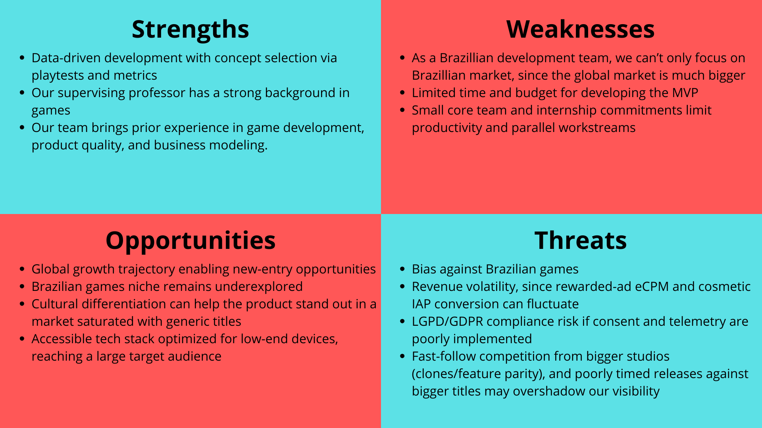
Figure 4 – SWOT Matrix

    - Marketing and Sales Strategy:

Go-to-Market Strategy
The go-to-market strategy for Yani Studios’ first mobile game is designed to be incremental, data-driven, and risk-aware, which is essential for an independent studio with limited resources.
The launch will follow a phased approach:
- Soft Launch
The Minimum Viable Product (MVP) will initially be released in selected markets, with a primary focus on Brazil and Latin America. These regions present strong cultural alignment with the product and a high concentration of mid-range mobile devices, which matches the technical scope of the game.
- Metrics Collection and Analysis
During the soft launch period, the team will closely monitor key performance metrics such as retention (D1 and D7), session length, engagement, crash rate, and monetization interaction (rewarded ads usage and cosmetic purchases).
- Iteration and Optimization
Based on collected data and qualitative feedback, adjustments will be made to onboarding, difficulty balance, progression systems, and user experience.
- Global Launch
After validating stability, engagement, and retention, the game will be released globally on Google Play and Apple App Store, with full support for Portuguese and English.
This approach minimizes financial risk while maximizing learning and product-market fit before scaling.

Customer Acquisition and Retention Strategies

User Acquisition
- App Store Optimization (ASO) focused on visual differentiation and cultural positioning.
- Organic outreach through indie game communities (Reddit, Discord, X/Twitter).
- Partnerships with small to mid-sized content creators focused on indie and culturally driven games.
- Limited paid user acquisition, capped at approximately 10% of gross revenue.

User Retention
- Short, repeatable gameplay sessions supported by a roguelike progression loop.
- Clear reward systems and meaningful progression.
- Ethical monetization with no pay-to-win mechanics.
- Offline-friendly gameplay, a feature highly valued in audience research.
- Regular lightweight updates introducing new challenges and cultural elements.

    - Financial Projection and Feasibility:

Revenue Model and Pricing Structure
The project adopts a Free-to-Play (F2P) business model with ethical monetization, composed of two primary revenue streams:
- Rewarded Advertisements
Optional ads that players voluntarily watch in exchange for non-predatory in-game benefits.
- Cosmetic In-App Purchases (IAPs)
Sales of purely cosmetic items that do not impact gameplay balance.
The estimated average ticket price for cosmetic items is R$ 19.90, with a conservative conversion rate of approximately 1% of active users.

Projected Expenses, Break-even Point, and Viability Indicators

Initial Investment (Pre-Launch)
The total estimated investment required to bring the game from development to launch is R$ 226,150.00, including team costs, infrastructure, licenses, external collaborators, and pre-launch marketing.

Operational Costs (Year 1)
- Fixed operational costs (reduced team + infrastructure): R$ 101,650.00 per year
- Marketing and user acquisition: 10% of gross revenue

Financial Viability and Break-even
Two financial scenarios were considered:
- Conservative Scenario
  - Gross Revenue: R$ 121,781.25
  - Estimated Profit: R$ 7,953.13
- Optimistic Scenario
  - Gross Revenue: R$ 405,937.50
  - Estimated Profit: R$ 263,693.75
The analysis indicates that the project can reach break-even in the first year of operation, even under conservative assumptions, demonstrating financial feasibility.

Initial Investment Requirement
The initial capital required to develop and launch the MVP is approximately:
R$ 226,150.00
This investment covers:
- Twelve months of development
- Infrastructure and publication licenses
- Market validation and initial marketing efforts

Validation and Results

    - Validation Methodology:
The validation of the business and product hypotheses was conducted using empirical and user-centered methods, ensuring that results were grounded in real market interaction rather than theoretical assumptions.
The main validation methods included:
- Functional prototyping of three gameplay concepts.
- Structured playtesting sessions with real users.
- Quantitative and qualitative questionnaires using Likert scales and open-ended questions.
- An Audience Discovery Form to assess player habits, preferences, and monetization tolerance.
This mixed-method approach enabled both behavioral measurement and subjective perception analysis.

    - Market Validation Results:

The collected data revealed consistent patterns across participants:
- The Roguelike prototype achieved the highest scores in engagement, clarity, and replayability.
- Players demonstrated strong acceptance of Brazilian cultural elements when presented in a clear and respectful manner.
- There was a clear rejection of pay-to-win mechanics and intrusive advertising.
- Offline play, short sessions, and fair progression were repeatedly highlighted as key strengths.
These findings validate the alignment between the proposed value proposition and user expectations.

Pivoting or Persisting
Based on validation results, the team decided to persist with the core business model and value proposition, while performing a scope pivot in gameplay design:
- The Roguelike structure was selected as the core gameplay loop.
- The Endless Runner and Fishing Arcade concepts were repositioned as secondary minigames rather than the primary experience.
- The ethical monetization model was maintained without changes.
This decision was fully supported by user feedback and engagement metrics.

    - Key Performance Indicators (KPIs):

The following KPIs were defined to monitor product and business performance during and after launch:
- CAC (Customer Acquisition Cost): Controlled through organic growth and limited paid acquisition.
- LTV (Lifetime Value): Estimated based on rewarded ads and cosmetic purchases.
- Retention Rate (D1, D7): Primary indicator of early engagement.
- Churn Rate: Percentage of users abandoning the game after initial sessions.
- Average Session Length: Targeting 15–30 minutes per session.
These indicators guide future iterations and scaling decisions.

    - Risks and Mitigation Plan:
Risk Category | Description | Mitigation Strategy
Financial | Revenue volatility inherent to F2P models | Hybrid monetization (ads + cosmetics)
Market | High competition in mobile gaming | Cultural differentiation and niche positioning
Technical | Device performance limitations | Lightweight, offline-first architecture
Legal | LGPD/GDPR compliance | Minimal data collection and clear consent
Competitive | Fast-follow clones | Strong art direction and cultural identity

Table 1 – Risks and Mitigation Plan

Conclusion

The objectives defined at the beginning of this project were successfully achieved.
The team developed and validated a functional MVP, confirmed market acceptance through real user testing, and structured a financially viable business model.
The results indicate strong potential for growth, particularly through content expansion, additional localization, and strategic partnerships after MVP consolidation.
This project demonstrates that it is possible to integrate software engineering, cultural identity, and digital entrepreneurship into a competitive and sustainable mobile game venture, contributing both to the global mobile games market and to the strengthening of the Brazilian game development ecosystem.

References

OSTERWALDER, Alexander; PIGNEUR, Yves; BERNARDA, Gregory; SMITH, Alan. Value Proposition Design: How to Create Products and Services Customers Want. Hoboken: John Wiley & Sons, 2014.
OSTERWALDER, Alexander; PIGNEUR, Yves. Business Model Generation: A Handbook for Visionaries, Game Changers, and Challengers. Hoboken: John Wiley & Sons, 2010.
PRESSMAN, Roger S.; MAXIM, Bruce R. Software Engineering: A Practitioner’s Approach. 9th ed. Porto Alegre: AMGH, 2021.
BASS, Len; CLEMENTS, Paul; KAZMAN, Rick. Software Architecture in Practice. 4th ed. Boston: Addison-Wesley, 2022.
VALENTE, José Armando et al. Project-Based Higher Education in Computing: Inteli on the path to innovation. Brazilian Journal of Informatics in Education, [S. l.], v. 33, p. 605–642, 2025. Available at: https://journals-sol.sbc.org.br/index.php/rbie/article/view/4320. Accessed on: Oct. 27, 2025.
GODOT ENGINE. Godot Engine Documentation. [S. l.], 2024. Available at: https://docs.godotengine.org. Accessed on: Oct. 25, 2025.
NEWZOO. Global Games Market Report. [S. l.], 2024. Available at: https://www.newzoo.com/insights/trend-reports/newzoo-global-games-market-report. Accessed on: Oct. 20, 2025.
STATISTA. Number of Mobile Gamers Worldwide. [S. l.], 2024. Available at: https://www.statista.com/statistics/748044/mobile-gamers-worldwide. Accessed on: Oct. 20, 2025.

