INTELI - INSTITUTO DE TECNOLOGIA E LIDERANÇA

JOSÉ VITOR MARCELINO
LUIZ FERNANDO COVAS
RAFAEL MATEUS ZIMMER TECHIO
YURI FREITAS ANGELO TOLEDO

From Services to SaaS: Creating a Service-First, Product-Next Startup for International Trade Companies

Final Consolidated Report (TCC)
São Paulo
2026

JOSÉ VITOR MARCELINO
LUIZ FERNANDO COVAS
RAFAEL MATEUS ZIMMER TECHIO
YURI FREITAS ANGELO TOLEDO

From Services to SaaS: Creating a Service-First, Product-Next Startup for International Trade Companies

_________________________________
Prof. Cesar Almiñana (Supervisor)
_________________________________
José Vitor Marcelino (Student)
_________________________________
Luiz Fernando Covas (Student)
_________________________________
Rafael Mateus Zimmer Techio (Student)
_________________________________
Yuri Freitas Angelo Toledo (Student)

ACKNOWLEDGMENTS
This work expresses sincere gratitude to Cesar Almiñana for his invaluable guidance, insightful corrections, and continuous support throughout the development of the project. His direction was fundamental in shaping the structure and quality of the work.
Thanks are also extended to Inteli for providing the necessary support, infrastructure, and resources that enabled the development of this project. The environment and tools offered by the institution were essential for its successful completion.

ABSTRACT
This work presents the complete development of a Service-First, Product-Next B2B startup, Kavex, focused on the international trade sector. The startup emerges from the intersection of entrepreneurial experience and a culture of continuous innovation, emphasizing close customer interaction, rapid experimentation, and validated learning as core principles. Initially, the team provided consulting-like services to identify client pain points, map workflows, and co-create tailored solutions, generating immediate value while acquiring deep sector knowledge.
Building on prior entrepreneurial experience and a network inherited from the Clonex venture builder, the startup applied these insights to design a scalable software-as-a-service (SaaS) product addressing the real market need of automating the issuance and receipt of Electronic Service Invoices (NFS-e). This report consolidates the full trajectory across four modules — from market exploration and project definition, through the conception and validation of a Minimum Viable Product (MVP), the productization and commercial structuring of the solution as a Service as a Software (SaaSo) operation, to the evolution into a multi-tenant product in real production serving multiple clients — and presents the empirical results that ground each strategic and technical decision, the limitations honestly identified, and the agenda for future work.
Keywords: SaaS; B2B; Business Model Validation; Product Development; Multi-Tenant Architecture; Foreign Trade.

LIST OF ACRONYMS
- SaaS – Software as a Service
- SaaSo – Service as a Software
- B2B – Business to Business
- NFS-e – Electronic Service Invoice (Nota Fiscal de Serviço eletrônica)
- ERP – Enterprise Resource Planning
- MVP – Minimum Viable Product
- FDE – Forward Deployed Engineer
- CSE – Customer Success Engineer
- RACI – Responsible, Accountable, Consulted, Informed
- TAM/SAM/SOM – Total / Serviceable Available / Serviceable Obtainable Market
- ARR – Annual Recurring Revenue
- ROI – Return on Investment
- IaC – Infrastructure as Code
- ICP – Ideal Customer Profile
- SLA – Service Level Agreement
- VSM – Value Stream Mapping

SUMMARY
1. Introduction
2. Methodology
3. Project Context
4. Module Artifacts
4.1 Module 1 – Market Exploration and Project Definition
4.2 Module 2 – Solution Conception and MVP Development
4.3 Module 3 – Productization, Technical Validation, and Commercial Structuring
4.4 Module 4 – Multi-Tenant Productization and Commercial Scaling
5. Results and Evidence
5.1 Operational Telemetry in Production
5.2 Market Sizing
5.3 Economic Value and Pricing
6. Limitations and Future Work
7. Conclusion
REFERENCES

1. INTRODUCTION
This work presents the development of a B2B startup, Kavex, guided by the Service-First, Product-Next model, focusing on the creation of SaaS solutions to automate the issuance and receipt of Electronic Service Invoices (NFS-e) in the context of international trade. The startup originates from the founders’ previous entrepreneurial experience, inheriting from the Clonex venture builder values such as resilience, pragmatism, and an established client network. The problem it addresses is concrete: in Brazil, the issuance and receipt of NFS-e is fragmented across thousands of municipalities, performed largely by hand, and exposed to inconsistencies, lack of traceability, and fiscal risk — a burden that is especially acute for foreign-trade companies operating on structurally compressed margins. The general objective of the work is to develop a SaaS solution to automate this flow, starting with applied consultancy and gradually evolving into a scalable product, while ensuring data security and compliance with the General Data Protection Law (LGPD) and generating dashboards, observability, and indicators for real-time monitoring and control.

2. METHODOLOGY
The methodology combines applied research with incremental development, guided by Action Research, enabling continuous learning from practical interactions with clients and hypothesis validation in real scenarios. Action Research focuses on solving real-world problems collaboratively with stakeholders, promoting continuous learning and adjustment; in this project it was used to identify client pain points, map NFS-e workflows, test technical solutions, and validate the feasibility of a scalable SaaS product. The cycle involved iterative steps of diagnosis, planning, implementation, evaluation, and reflection. Each of the four project modules — from business discovery to final product consolidation — was composed of five sprints with their own hypotheses, experiments, and validations, ensuring that solutions remained aligned with real market needs and that the technological architecture was adjusted according to practical results.

3. PROJECT CONTEXT

3.1 Startup Background
The founding team brings entrepreneurial experience and a culture of continuous innovation inherited from the Clonex venture builder. Core values include resilience, pragmatism, validated learning, and collaboration with clients and partners. Initial operations target micro, small, and medium companies in international trade, leveraging pre-existing connections and addressing urgent market needs.

3.2 Market Context
The fiscal automation market in Brazil—particularly related to the issuance and management of NFS-e within the foreign trade sector—is undergoing a structural and technological transformation. In 2024, the country registered approximately 28,800 exporting companies and 55,800 importing companies (Sebrae, 2024), and the service sector accounted for 61.6% of newly established companies, mostly micro and small enterprises that face significant challenges in fiscal compliance and document control. The issuance of NFS-e remains fragmented across more than 5,000 municipalities, of which only around 1,037 (19%) have adopted the new national standard (Fenacon, 2024), increasing maintenance costs and compliance risks for companies operating across multiple jurisdictions.
Fiscal automation thus emerges as a driver of efficiency and competitiveness. Technologies such as Artificial Intelligence, Robotic Process Automation, and Machine Learning have been applied to interpret fiscal documents in multiple formats and insert them into accounting systems, reducing processing time by up to 85% (Fenacon, 2024; UiPath, 2023). With Complementary Law No. 214/2024 making the national NFS-e standard mandatory from January 2026, the market is expected to consolidate around scalable and interoperable solutions — a strategic innovation window. Although established players such as TecnoSpeed, Codemasters, eNotas, and NFe.io exist, significant gaps remain in automation tailored to foreign trade, particularly regarding invoices from multiple municipalities and integration with systems such as Siscomex and DUIMP, and in solutions offering predictive fiscal intelligence and simplified interfaces for SMEs. Regulatory frameworks such as the LGPD (Law No. 13.709/2018) and the Bank Secrecy Law (Complementary Law No. 105/2001) impose strict requirements for data privacy and security, making compliance both a legal obligation and a competitive advantage.

3.3 Business Model and Approach
The startup applies the Service-First, Product-Next model, beginning with applied consultancy to identify pain points, map workflows, and co-create solutions. This phase generates immediate revenue, provides practical learning, and forms the foundation for a scalable SaaS product. The operating model is framed as Service as a Software (SaaSo): rather than selling a passive tool for the client to operate, Kavex embeds itself in the client’s operation and assumes responsibility for the outcome, treating the software boundary as porous and expanding it gradually as repeatable patterns are captured from the field and converted into reusable product components. This positioning explains why Kavex enters a client as a Mission Partner rather than as a traditional software vendor.

3.4 Technical Context
Throughout the project, the technical architecture evolved in step with the maturity of the product. The early prototyping and MVP phases were built on a low-code orchestration layer (n8n), with Supabase as the database, storage, and authentication layer, AI-based extraction services for interpreting fiscal documents, and integration with the client’s ERP (Conexos) through the reproduction of internal endpoints, since the ERP does not expose a public API. In the final module, this architecture was re-engineered into a cloud-native, multi-tenant platform on Amazon Web Services (AWS), designed for isolated and replicable operation across multiple clients, comprising serverless compute (AWS Lambda) per pipeline stage, relational and object persistence (PostgreSQL, Amazon S3) with distributed state control for idempotency (Amazon DynamoDB), message queuing and scheduling (Amazon SQS, Amazon EventBridge), encrypted per-tenant configuration (AWS Systems Manager Parameter Store), Infrastructure as Code (Terraform), and infrastructure observability (Amazon CloudWatch), with the application written in Node.js and TypeScript around well-established software design patterns.

3.5 Risks and Requirements
Critical risks include ERP integration, validation and configuration accuracy, data security, dependence on external APIs, and the operational footprint of a high-touch service model. Functional requirements cover automatic capture, validation, normalization, secure storage, and ERP integration of NFS-e, alongside observability dashboards and reprocessing capabilities. Non-functional requirements include availability, scalability, security, observability, modularity, and tenant isolation.

4. MODULE ARTIFACTS
The project was developed across four thematic modules, each composed of five sprints. This section consolidates the trajectory of the work, presenting the objective and the central narrative of each module followed by the key artifacts and results produced in its sprints. The client operation that grounded the empirical evidence is referenced in anonymized form, as Trading Company A — the design partner with which the solution was first deployed in production — and, from the final module, Trading Company B, the second client brought into production as the operation began to replicate.

4.1 Module 1 – Market Exploration and Project Definition
Module 1 established the strategic and technical foundations for the development of the solution, with the overarching objective of exploring the market, identifying client pain points, and selecting an initial project aligned with a service-first, product-next approach.
- Sprint 1 (Hypotheses and Objectives): three hypotheses were formulated — automating NFS-e ingestion, inventory control via invoices, and a tax simulation tool — and NFS-e ingestion automation was prioritized after analyzing feasibility, impact, and dependencies; the "Service-First, Product-Next" strategy and an incremental roadmap were defined.
- Sprint 2 (Market Research): research validated the relevance of the problem, mapped the competitive landscape, and confirmed strong demand for an end-to-end workflow combining ingestion, validation, and structured output, especially for SMEs with high invoice volumes.
- Sprint 3 (Process Mapping): the as-is NFS-e workflow of a foreign-trade partner company was mapped, revealing a highly manual, fragmented, and error-prone process, and identifying five automation opportunities.
- Sprint 4 (Technical Feasibility): feasibility was confirmed, selecting a low-code workflow platform, a managed database, and AI-based extraction integrated with the client’s ERP as the basis for rapid prototyping with immediate operational value.
- Sprint 5 (Risks, Requirements and Insights): the module consolidated insights into a unified vision, produced a risk-and-requirements matrix, and delivered a Value Stream Mapping (VSM) exposing bottlenecks and optimization opportunities.

4.2 Module 2 – Solution Conception and MVP Development
Module 2 shifted the project from problem validation toward materialization and execution, with the objective of defining a clear value proposition, structuring a viable business model, designing the MVP architecture, and initiating development capable of generating real learning through interactions with a pilot client. The value proposition and business model were consolidated through the Business Model Canvas and the Value Proposition Canvas reproduced below.
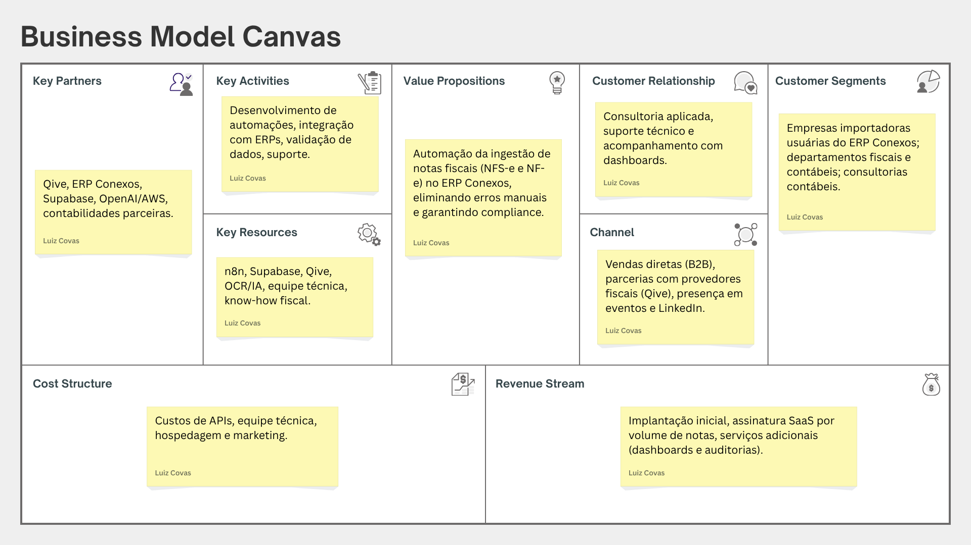
Figure 1 – Business Model Canvas of the venture (project-level; no client data).
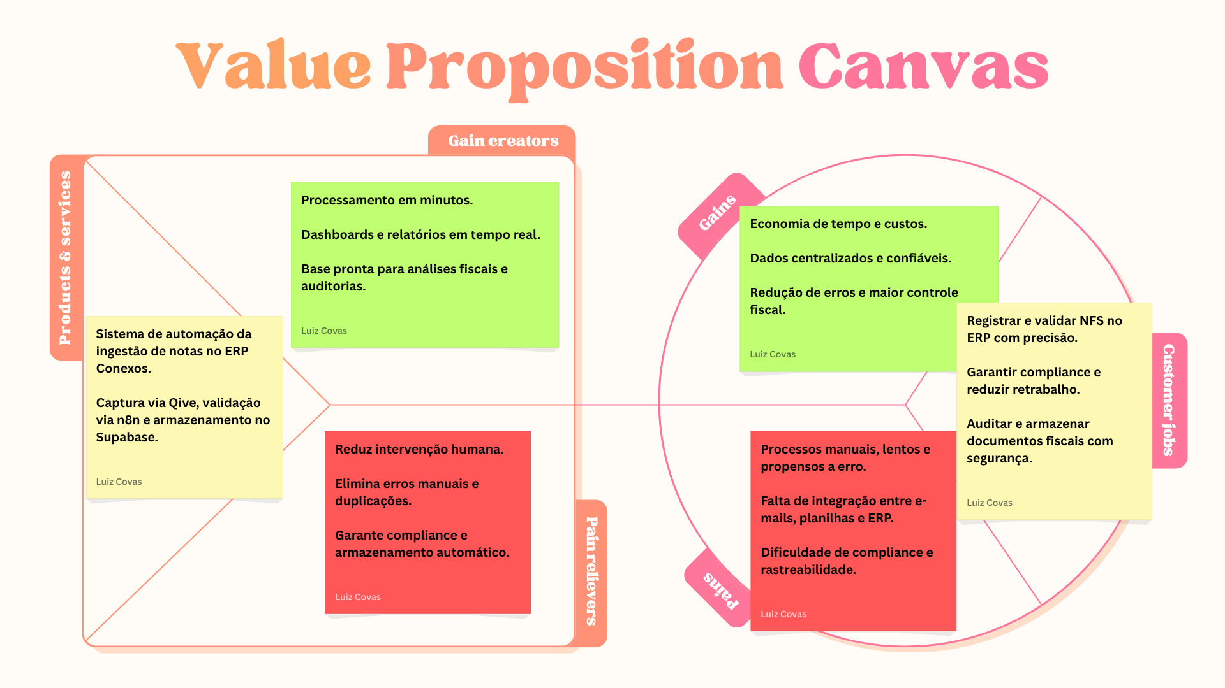
Figure 2 – Value Proposition Canvas of the venture (project-level; no client data).
- Sprint 1 (Value Proposition and Differentiators): the value proposition was formalized around an automated NFS-e ingestion flow into the client’s ERP, supported by the canvases above, and a set of competitive differentiators grounded in co-creation, rework elimination, indicator-based decision-making, and the strategic structuring of fiscal data as an informational asset.
- Sprint 2 (Initial Business Model): success metrics across commercial, operational, and financial dimensions were defined with 24-month projections, alongside a cost structure, a hybrid monetization logic, and a Service Level Agreement (SLA) tailored to the pilot, with D+1 processing commitments.
- Sprint 3 (MVP Architecture and Data Flow): a modular, cloud-based, API-oriented architecture was consolidated, separating the processing pipeline from the user-facing layer and documenting the known limitations in scalability and multi-tenant abstraction accepted as part of the MVP strategy.
- Sprint 4 (Pilot Alignment and Minimum Scope): a formal alignment document, a prioritized backlog, and explicit success criteria created a stable reference point for development and validation.
- Sprint 5 (Consolidation and SaaS Evolution Planning): a report of adjustments and a detailed backlog of future functionalities were produced, together with a preliminary roadmap linking technical decisions to the long-term SaaS vision.

4.3 Module 3 – Productization, Technical Validation, and Commercial Structuring
Module 3 advanced the project from a validated MVP toward an operationally evidenced product-service with commercial readiness, converting field learnings from the design partner (Trading Company A) into measurable evidence, formalizing the operational playbook required to scale delivery without founder dependency, and structuring the commercial strategy with market sizing and value-based pricing. The module was framed by the Service as a Software (SaaSo) model and the Forward Deployed Engineering (FDE) practice. The quantitative results produced in this module are consolidated in Section 5.
- Sprint 1 (Operational Evidence in Production): the MVP was operated in the design partner’s production environment, producing the first telemetry baseline that reframed the automation bottleneck as structural and cadastral rather than technical, and formalizing the FDE and Product TechLead roles and the SaaSo operating model.
- Sprint 2 (Strategic References and SaaSo Consolidation): the model was anchored in external references and a Definition of Done was structured around three pillars — telemetry, proactivity, and mimetization — with the limitations of each pillar documented explicitly.
- Sprint 3 (Commercial Strategy, Market Sizing, and Value-Based Pricing): the market was sized (TAM/SAM/SOM) and a value-based pricing framework was derived from the real captured value of the reference operation.
- Sprint 4 (Operational Consolidation): the FDE Bible (a five-phase delivery playbook), a RACI matrix distributing fifteen activities across the three operational roles, and the Fiscal Hub thesis were produced and grounded in the accumulated telemetry.
- Sprint 5 (Technical-Commercial Transition and Design Partner Evaluation): a two-horizon transition plan toward a parameterized product core was defined, the corrections requested by the faculty reviewer were applied, and the status of the design-partner relationship was formalized with a catalog of six monitored risks.

4.4 Module 4 – Multi-Tenant Productization and Commercial Scaling
Module 4 evolved the validated product-service into a scalable, replicable, multi-tenant product prepared for the onboarding of multiple clients, advancing the productization of the architecture, the observability of the environment, the formalization of the product’s design language, and a responsible commercial expansion strategy. The central thesis is that growth must occur without a linear increase in operational effort, with the difference between one client and another reduced essentially to configuration. By this stage, the operation had moved beyond a single design partner: Trading Company A remained in production while Trading Company B was brought into the production environment as the second client. The conceptual architecture is shown below.
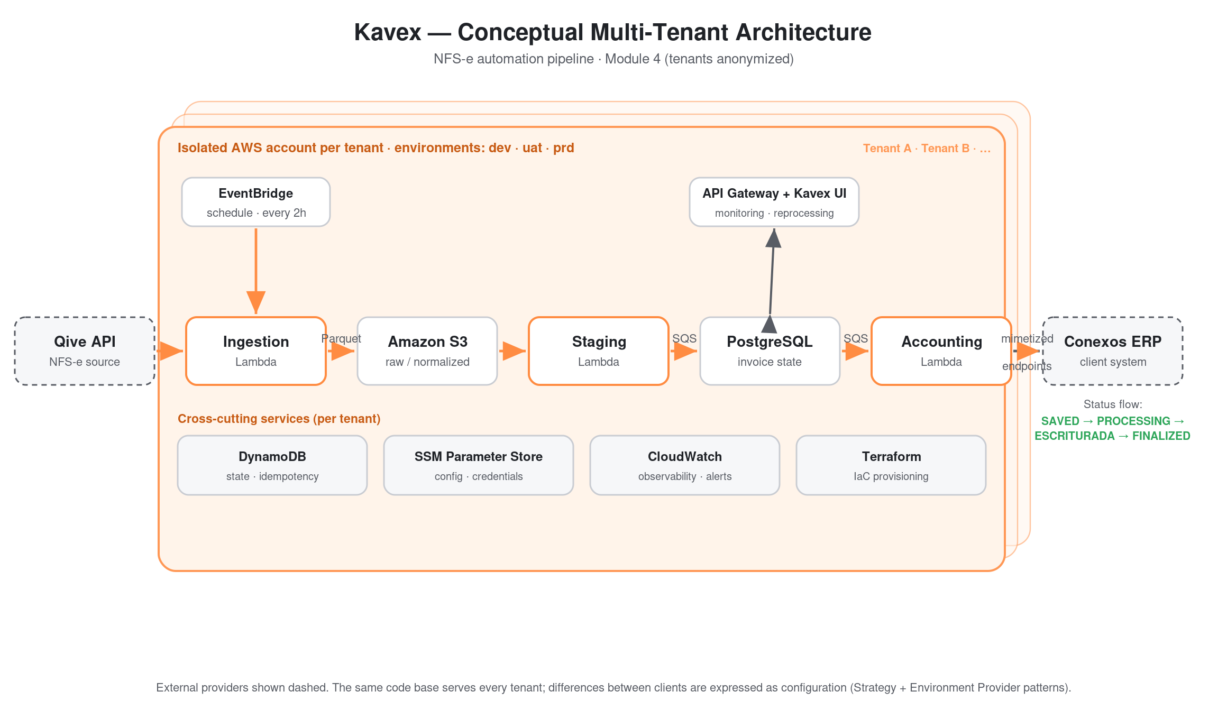
Figure 3 – Conceptual multi-tenant architecture of the Kavex NFS-e automation pipeline (client tenants anonymized).
- Sprint 1 (Multi-Tenant Architecture and Design Patterns): the low-code orchestration was replaced by a purpose-built, cloud-native codebase on AWS, with complete isolation per tenant across execution, data, and credentials; a catalog of software design patterns — most notably the Strategy Pattern for per-client business rules and an Environment Provider Pattern for per-tenant configuration — was documented so that adding a new tenant requires configuration rather than reconstruction; and a six-phase technical onboarding playbook, estimated at seven to ten business days, was formalized.
- Sprint 2 (Observability and Environment Health): two complementary observability layers were delivered — a business-oriented processing-monitoring page and an infrastructure dashboard provisioned as code — bound together by an operational runbook with a severity framework and documented failure scenarios, operationalizing the SaaSo promise of detecting failures before the client does.
- Sprint 3 (Design System and Commercial Expansion): the Kavex design system formalized the product’s visual and interaction language with white-label capability (its visual foundations are summarized in Figure 4), while the commercial expansion strategy defined an updated Ideal Customer Profile, a prospect-prioritization framework, a segmented value proposition, a value-based pricing model, and a conservative ninety-day roadmap focused on closing a second client with reference-grade delivery quality.
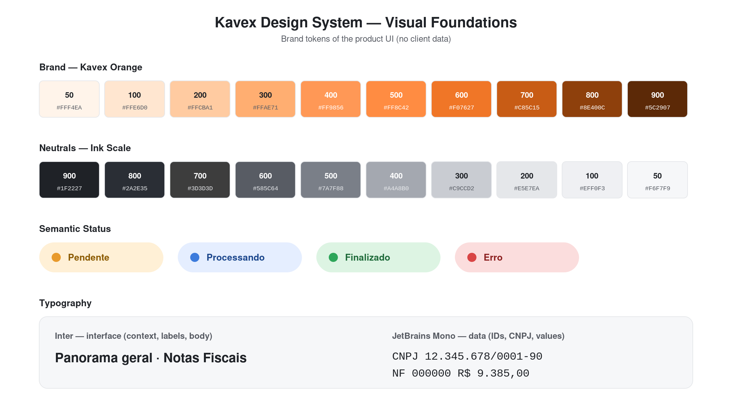
Figure 4 – Visual foundations of the Kavex design system (brand tokens; no client data).
- Sprint 4 (Final Product Pitch): the technical, operational, and commercial advances were consolidated into the final pitch, presenting the platform and the accumulated evidence as an integrated narrative that positions the product as an embedded team delivering an operational outcome rather than a self-service tool.
- Sprint 5 (Board Feedback Corrections): the corrections and observations raised by the evaluation board were incorporated into the original artifacts, prioritizing consolidation and correction over new development.

5. RESULTS AND EVIDENCE
A distinctive feature of this project is that its central decisions are anchored in empirical evidence collected during real operation with the design partner (Trading Company A), rather than in assumptions. This section consolidates the most relevant quantitative results produced across the modules. All figures are presented in anonymized form, consistent with the commercial confidentiality of the client operation.

5.1 Operational Telemetry in Production
Operating the MVP in the design partner’s production environment produced the first structured telemetry baseline. Over a controlled window of one thousand workflow executions, the results below were observed.
Indicator | Observed value
Workflow executions analyzed | 1,000
Fully automated finalization rate | 3.51%
Median time from invoice creation to posting | ~17.8 seconds
Blockers caused by absent or incorrect ERP document configuration | 60.6%
Telemetry records accumulated (workflow executions) | > 32,000
Invoice-status vigency records accumulated | ~19,500

The decisive interpretation of these numbers is that the low finalization rate is not a failure of the automation but a symptom of structural and cadastral inconsistencies in the client’s data environment: the technical backbone performed within acceptable latency (median ~17.8 seconds), while 60.6% of the blockers originated from absent or incorrect document configuration in the ERP. This finding redefined the improvement strategy — shifting the priority from engineering optimization toward the structural remediation of registration data — and justified the embedded, Forward Deployed Engineering operating model. The reconciliation routine subsequently introduced cross-checks, on a daily basis, the state of each fiscal document between the automation and the ERP.

5.2 Market Sizing
The commercial strategy translated the operation into a quantified market opportunity at the three canonical levels, derived from the structure of the Brazilian foreign-trade sector and the operational profile compatible with the SaaSo model.
Level | Estimate | Basis
TAM | ~ R$ 1.2 billion / year | ~40,000 foreign-trade companies × R$ 2,500 / month
SAM | ~ R$ 420 million / year | ~10,000 qualifying companies × R$ 3,500 / month
SOM (24 months) | 6–12 active clients · ARR R$ 576K–1.15M | high-touch ramp at ~R$ 8,000 / month

The Serviceable Obtainable Market was deliberately recalibrated from an earlier, more optimistic projection to reflect the real constraints of a high-touch operating model without a fully validated playbook or a team independent of the founders. The previously declared horizon of 30 to 60 clients was preserved as a 36-to-48-month aspiration, conditioned on three preconditions: a validated FDE playbook, at least two success cases with auditable ROI, and a technical team independent of the founders.

5.3 Economic Value and Pricing
Pricing was constructed through a value-based methodology applied to the data collected from the active operation. The qualified captured value for the reference client profile was estimated at approximately R$ 1.58 million per year, distributed across hard and auditable savings (such as prevention of lost invoices, elimination of duplicates, capture of timeliness discounts, and mitigation of undue charges), indirect verification gains, and strategic, risk-mitigation benefits. Applying a capture rate of 10% to 15% over the qualified value yields a monthly ticket of R$ 15,000 to R$ 20,000, complemented by an implementation setup fee. The coexisting ticket references were declared explicitly as a hierarchy of segmentation rather than an inconsistency, as summarized below.
Ticket level | Monthly value | Rationale
TAM | R$ 2,500 | broad weighted average across the full addressable universe
SAM | R$ 3,500 | higher-maturity subset of the addressable universe
SOM (24 months) | R$ 8,000 | short-term reference client (service + platform blend)
Operational pricing | R$ 15,000–20,000 | priority profile; value-based on captured value

The economic value was further decomposed into eight verifiable sources — direct operational savings, prevention of lost invoices, elimination of duplicates, detection of incorrect values, correction of process-vendor mismatches, reconciliation of fiscal withholdings, correct classification of expense nature and cost center, and capture of timeliness discounts coupled with mitigation of undue charges — each described with the mechanism by which the system captures or prevents the loss, allowing a prospective client to map its own operation against the categories and estimate its own captured value.

6. LIMITATIONS AND FUTURE WORK
Consistent with the reflective posture adopted throughout the project, this section records the limitations that remain open at the close of the work, framing them not as failures but as the agenda that defines the next stage of the venture.
On the technical front, the shared infrastructure layer intended to centralize observability across tenants is not yet provisioned, so monitoring still requires per-tenant consultation; the provisioning of new tenants is not yet fully covered by Infrastructure as Code, which introduces a risk of configuration drift over time; and the productization of business rules is mid-transition — the architecture already isolates rules per tenant through configuration, but the two planned horizons (a complete parameterization layer and a low-code configuration interface that progressively transfers operational autonomy from engineering to the operating team) are not yet complete. On the operational and commercial front, the operation still depends significantly on the founders for the most important technical and commercial decisions; the replicability of the playbook, although demonstrated by bringing a second client into production, requires further validation across additional clients with different operational profiles; and the formal authorization to use the design partner as a named case study remains pending, which is why all results in this report are presented in anonymized form.
The future-work agenda derived from these limitations is therefore concrete and prioritized:
- Provision the shared observability layer and consolidate full Infrastructure-as-Code coverage to make tenant onboarding a reproducible pipeline.
- Complete the parameterization horizon and build the low-code configuration interface, reducing the engineering effort required per new client.
- Continue reducing founder dependency by exercising the documented playbook with new Forward Deployed Engineers across additional clients.
- Formalize success-case authorizations and expand the predictive layer over the accumulated telemetry to anticipate fiscal anomalies before they generate financial impact.

7. CONCLUSION
This work documented the complete trajectory of building Kavex, a Service-First, Product-Next B2B startup, from the exploration of the NFS-e automation market for international trade to the operation of a multi-tenant product in real production. The path validated, with empirical evidence rather than assertion, the central thesis that controlling the fiscal data of a foreign-trade operation is a lever of margin and governance rather than a compliance cost, and that this value is best delivered through a Service as a Software model in which the company embeds itself in the client’s operation and assumes responsibility for the outcome.
The accumulated evidence is concrete. The first production telemetry demonstrated that the true bottleneck of fiscal automation in this sector is structural and cadastral rather than technical, which redefined the operating model and justified the Forward Deployed Engineering approach. The commercial thesis was quantified through explicit market sizing and a value-based pricing framework derived from real captured value, and the operation was codified into reproducible assets — the FDE Bible, the RACI matrix, the onboarding playbook, and the observability infrastructure — that transform founder-dependent knowledge into a replicable procedure. The final module proved this replicability concretely, re-architecting the solution into a cloud-native, multi-tenant platform and bringing a second client into production, so that the difference between one client and another is reduced essentially to configuration.
The project therefore concludes not as a finished product but as a validated and evidenced foundation — a company that knows what it built, knows what it is worth, knows how to price it, and has demonstrated the first concrete steps of replicating its operation, while remaining honest about the limitations that define its next stage. This combination of academic rigor, systemic thinking, and market pragmatism is the core contribution of the work to the practice of building innovative B2B solutions in complex regulatory environments.

REFERENCES
Amazon Web Services. (2024). AWS Lambda Developer Guide and AWS Well-Architected Framework. Retrieved from https://docs.aws.amazon.com
Brazil. (2001). Lei Complementar nº 105 – Dispõe sobre o sigilo das operações de instituições financeiras. Diário Oficial da União. Brasília, DF.
Brazil. (2018). Lei nº 13.709 – Lei Geral de Proteção de Dados Pessoais (LGPD). Diário Oficial da União. Brasília, DF.
Brazil. (2024). Lei Complementar nº 214 – Institui o padrão nacional da Nota Fiscal de Serviços eletrônica (NFS-e). Diário Oficial da União. Brasília, DF.
Codemasters. (2024). Hiperautomação fiscal integrada à Receita Federal. Retrieved from https://codemasters.com.br
eNotas. (2024). Automação de notas fiscais e integração com plataformas digitais. Retrieved from https://enotas.com.br
Fenacon. (2024). Emissão de Nota Fiscal de Serviços Eletrônica já atingiu 70% de adesão das capitais do país. Sistema Fenacon. Retrieved from https://fenacon.org.br
Graham, P. (2013). Do Things That Don’t Scale. Retrieved from https://paulgraham.com/ds.html
HashiCorp. (2024). Terraform Documentation. Retrieved from https://developer.hashicorp.com/terraform/docs
MDIC – Ministério do Desenvolvimento, Indústria, Comércio e Serviços / Secex. (2024). Estatísticas de Comércio Exterior. Retrieved from https://www.gov.br/mdic
NFe.io. (2024). API de emissão e gestão de notas fiscais de serviço. Retrieved from https://nfe.io
Palantir Technologies. (2024). Ontology: The Central Nervous System of the Enterprise. Retrieved from https://palantir.com
Sebrae. (2024). Número de pequenos negócios exportadores mais que dobra em uma década. Agência Sebrae de Notícias. Retrieved from https://agenciasebrae.com.br
TecnoSpeed. (2024). Soluções de automação fiscal e emissão de NFS-e em múltiplos municípios. Retrieved from https://tecnospeed.com.br
UiPath. (2023). RPA in Financial Automation: Benchmark Report 2023. UiPath Research. Retrieved from https://www.uipath.com/resources

