GitHub practices for INTELLI-HUB

Branch workflow:
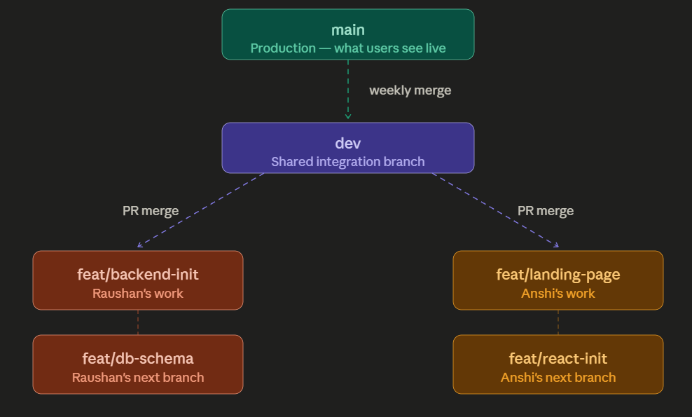

Commands forbidden
git push origin main # NEVER
git push origin dev # NEVER (unless you're doing the weekly merge PR)

Scenarios

Scenario 1: Starting fresh work
# Always start by going to dev and getting Anshi's latest changes
git checkout dev
git pull origin dev

# Now create your own branch for today's feature
git checkout -b feat/auth-backend

Scenario 2: Saving your progress
# Check what you've changed
git status

# Stage and commit
git add src/routes/auth.js
git commit -m "feat: add register endpoint with bcrypt"

# Push to GitHub (backup + Anshi can see your progress)
git push origin feat/auth-backend

Scenario 3:Your Feature is done
# Push your final changes
git push origin feat/auth-backend

Scenario 4: Anshi merged something and you need her changes
# Go to dev and pull her changes
git checkout dev
git pull origin dev

# Go back to your feature branch and bring dev's updates in
git checkout feat/auth-backend
git merge dev

Branching rule
All pushes should end with your feature branch name
git push origin feat/auth-backend # YES — your sandbox
git push origin feat/db-schema # YES — your sandbox

