Article information

Article title
BDNeuro-MRI: A Bangladeshi Clinical Brain Tumor MRI Dataset for Four-Class Deep Learning Classification

Authors
Md Irfanul Kabir Hira^{1,*}, Umme Sara¹, Mst Moriom Akter Bithee¹, Md Sohag Hossain¹, Md. Kowsar Ahmed¹, Abdullah Al Towsif¹, Md Mahmudul Hasan¹, Mohammad Shorif Uddin²

Affiliations
¹ Department of Computer Science and Engineering, National Institute of Textile Engineering and Research (NITER), Constituent Institute of University of Dhaka, Savar, Dhaka-1350, Bangladesh
² Department of Computer Science and Engineering, Jahangirnagar University, Savar, Dhaka-1342, Bangladesh

Corresponding author’s email address and Twitter handle
* Corresponding author: Md Irfanul Kabir Hira — irfanhira11@niter.edu.bd

Keywords
Brain tumor classification; MRI; dataset curation; duplicate screening; convolutional neural networks; vision transformers; transfer learning; deep learning; medical imaging

Related research article
None.

Abstract
This dataset contains 5,941 brain MRI images spanning four diagnostic classes: glioma, meningioma, pituitary tumor, and no tumor, collected from Epic Health Care, Chittagong, Bangladesh (Ethics Ref: EHC/CARD/2025/0047) under the supervision of a consultant neurologist. From an initial pool of 11,148 clinically sourced images, 833 exact duplicates (MD5 hash) and 4,374 near-duplicates (perceptual hashing, Hamming distance ≤ 5) were identified and removed before splitting, eliminating hidden train/test leakage largely unaddressed in existing public brain tumor MRI collections. All images were fully anonymized prior to release. The cleaned dataset is partitioned into training (4,160 images, 70%), validation (892 images, 15%), and test (889 images, 15%) sets using per-class stratified sampling, with zero cross-split overlap confirmed by content hash. A documented preprocessing pipeline resizes all images to 224×224 pixels, applies training-only augmentation (rotation, flipping, affine translation, and resized cropping), and performs channel-wise normalization. Seven deep-learning architectures, including CNN, Vision Transformer, Hybrid CNN–ViT, and frozen/fine-tuned ResNet50 and DenseNet121, were benchmarked to confirm the dataset is learnable and leakage-free. The dataset follows the ImageFolder convention and is publicly available on Mendeley Data (DOI: 10.17632/zwr4ntf94j.7). To our knowledge, this is the first duplicate-verified, institutionally sourced brain tumor MRI dataset from a Bangladeshi clinical setting.

Graphical abstract
Submitted as a separate file (see the “Graphical Abstract” item type in the manuscript submission system). It depicts the six-stage pipeline: clinical MRI collection → duplicate screening (MD5 + perceptual hash) → stratified 70/15/15 split with overlap verification → preprocessing (resize/tensor/normalize) → training-only augmentation → benchmarking of seven deep-learning architectures.

Specifications table
Subject area | Computer Science
More specific subject area | Medical image data curation; brain tumor MRI classification; deep learning; duplicate/leakage detection in imaging datasets
Name of your method | Duplicate-Screened Clinical MRI Curation and Preprocessing Pipeline (DS-CMCP)
Name and reference of original method | Not applicable — the pipeline customizes standard duplicate-detection (MD5 hashing; perceptual/difference hashing) and torchvision-based preprocessing techniques for clinical brain tumor MRI curation; no single prior pipeline is being reproduced.
Resource availability | Curated dataset (raw images, splits, and pretrained model weights): Mendeley Data, DOI 10.17632/zwr4ntf94j.7, https://data.mendeley.com/datasets/zwr4ntf94j/7 (no registration required). Preprocessing implemented in Python 3 using torchvision.transforms and PyTorch DataLoader.

Background
Automated deep-learning classification of brain MRI into diagnostic categories such as glioma, meningioma, pituitary tumor, and no tumor is increasingly used as a decision-support tool, with recent transfer-learning and attention-based pipelines reporting accuracies above 96–98% on four-class tasks [1–3]. However, the reliability of these results depends critically on how the underlying dataset was curated. A particularly under-reported failure mode is hidden train/test leakage caused by exact or near-duplicate images re-exported, re-compressed, or minimally cropped copies of the same scan being distributed across both splits of a released dataset, which can inflate reported performance without reflecting genuine generalization. Systematic reviews of the field converge on related, unresolved issues: dataset bias, limited cross-institutional generalizability, and inconsistent evaluation protocols [4–6]. Even newly released, expertly annotated resources illustrate the broader gap: the recently introduced BRISC dataset adds radiologist-verified segmentation masks, but its scans were collated from multiple pre-existing public repositories that originally lacked those labels, rather than collected prospectively from a defined clinical population [7]. More broadly, many public brain tumor MRI collections are distributed with heterogeneous resolutions, inconsistent folder structures, undocumented duplicate content, and minimal documentation of curation and splitting procedures [8–11], which complicates reproducibility and fair comparison across studies. A small number of existing public MRI collections do report an MD5-based exact-duplicate removal step; however, exact-hash matching alone does not catch re-exported, re-compressed, or minimally cropped copies of the same underlying scan — precisely the near-duplicate cases most likely to leak across splits — and, to our knowledge, none of these MD5-screened collections additionally verify zero cross-split overlap via a dedicated post-split content-hash check. This gap between being exact-duplicate screened and being leakage-verified is what the present method is designed to close. This motivated us to develop and document a concrete, step-by-step curation method covering clinical sourcing under ethics clearance, systematic duplicate screening, stratified splitting with leakage verification, and a fully specified preprocessing/augmentation pipeline that other groups can apply when building similar clinical imaging datasets, whether or not they use our specific dataset. We demonstrate the method on a Bangladeshi clinical MRI pool, producing the BDNeuro-MRI dataset as a worked example and validating it with seven benchmarked deep-learning architectures.
To state the novelty of this work explicitly: the contribution is not a new deep-learning architecture, but a fully documented, auditable curation protocol for clinical MRI datasets — one that combines (i) MD5 exact-duplicate screening, (ii) perceptual-hash near-duplicate screening (Hamming distance ≤ 5), and (iii) an explicit post-split content-hash verification step confirming zero train/validation/test overlap, applied for the first time to a Bangladeshi clinical brain tumor MRI pool. Unlike prior public brain tumor MRI collections, which are typically released with undocumented or absent duplicate-screening procedures, every screening decision in this pipeline is auditable via retained intermediate hash tables (Method details, Step 2), and the resulting BDNeuro-MRI dataset is offered as a concrete, benchmarked instance of that protocol that other groups can reuse or adapt.

Method details
Our goal is to publish methods that can be replicated by other researchers; this section gives the full step-by-step procedure.
1. Clinical data sourcing
MRI images were prospectively collected from Epic Health Care, 19 K.B. Fazlul Kader Road, Panchlish, Chittagong 4000, Bangladesh, under institutional ethics clearance (Ref: EHC/CARD/2025/0047), with the direct supervision of a consultant neurologist (MBBS, BCS (Health), MD (Neurology)), Department of Neuromedicine, over the period September 2025 – April 2026. Images were retained in their original JPEG or PNG format and organized by diagnostic class label: glioma, meningioma, pituitary tumor, or no tumor (healthy/control). Prior to release, every image was screened for completeness and fully anonymized, with no personally identifiable information retained, in accordance with institutional data-protection and patient-confidentiality obligations. This stage produced an initial pool of 11,148 clinically sourced images.
2. Duplicate and near-duplicate screening
Because clinical image pools are frequently re-exported or re-compressed at multiple points in the acquisition/storage workflow, the same underlying scan can appear more than once. Left unaddressed, this causes hidden train/test leakage once the pool is split. The method screens the full pool in two passes before any splitting occurs:
• Exact-duplicate screening: an MD5 content hash is computed for every image; byte-identical files are flagged and all but one copy are removed. This step identified and removed 833 exact duplicates.
• Near-duplicate screening: a perceptual (difference) hash is computed for every remaining image; pairs with Hamming distance ≤ 5 are treated as near-duplicates and redundant copies are removed. This step identified and removed 4,374 near-duplicates.
Together, these two passes reduced the initial pool of 11,148 images to 5,941 verified-unique images (5,207 images removed in total). Researchers applying this method to their own clinical pools should retain the intermediate hash tables, as they allow the screening decision for any given image to be audited after the fact.
3. Stratified splitting with cross-split leakage verification
The 5,941 verified-unique images were divided into training, validation, and test sets using per-class stratified sampling targeting a 70%/15%/15% allocation, so that class proportions are preserved within each split (Table 1). After splitting, a content-hash comparison was run across every pair of splits to confirm zero image overlap. This explicit verification step is recommended as a mandatory check whenever duplicate screening has been performed upstream.
Class | Train | Val | Test | Total
Glioma | 1534 | 329 | 328 | 2191
Meningioma | 1035 | 222 | 221 | 1478
No Tumor | 551 | 118 | 118 | 787
Pituitary | 1040 | 223 | 222 | 1485
Total | 4160 | 892 | 889 | 5941

Table 1. Class-wise distribution of images across the training, validation, and test splits produced by Step 3, after the duplicate screening in Step 2. The dataset contains 5,941 images in total, partitioned approximately 70%:15%:15%, with class proportions preserved across all three splits and zero cross-split overlap confirmed by content hash.
4. Preprocessing pipeline
All retained images are passed through a standardized four-stage preprocessing pipeline, implemented in Python using the torchvision.transforms module and applied on-the-fly via a PyTorch DataLoader (batch size 16, four parallel worker processes). The pipeline is illustrated in Figure 1.
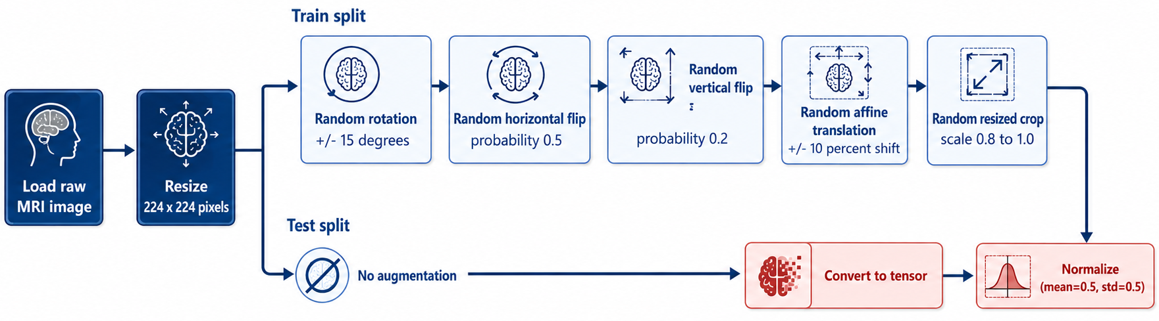
Figure 1. The four-stage preprocessing pipeline: resize → augment (training split only) → tensor conversion → channel-wise normalization.
• Stage 1 — Uniform resizing: every image is resized to 224×224 pixels by bilinear interpolation, removing native-resolution heterogeneity and ensuring compatibility with ImageNet-pretrained architectures.
• Stage 2 — Split-conditional augmentation: training images proceed through the stochastic augmentation sequence in Step 5; validation and test images bypass augmentation entirely.
• Stage 3 — Tensor conversion: transforms.ToTensor() reorders dimensions to the PyTorch convention and rescales pixel values from [0,255] to [0.0,1.0]. Grayscale images are broadcast to three channels.
• Stage 4 — Channel-wise normalization: transforms.Normalize(mean=[0.5,0.5,0.5], std=[0.5,0.5,0.5]) maps the [0.0,1.0] range to [−1.0,1.0]. Identical parameters are applied to all three branches.
5. Data augmentation (training split only)
Five stochastic operations, chosen to simulate realistic MRI acquisition variability while preserving diagnostic signal, are applied exclusively to the training split:
• Random rotation (±15°): simulates minor head tilt or scanner misalignment.
• Random horizontal flip (p = 0.5): accounts for approximate left-right anatomical symmetry.
• Random vertical flip (p = 0.2): applied at reduced probability, since the brain lacks comparable superior-inferior symmetry.
• Random affine translation (±10%): simulates imperfect centering within the imaging field of view.
• Randomly resized crop (scale 0.8–1.0): simulates variable zoom while preserving the 224×224 output size.
Intensity-based perturbations (brightness jitter, noise injection, colour jitter) are deliberately excluded, so every augmented sample remains a physically plausible variation of the clinical imaging protocol. Figure 2 shows each operation applied individually to the same representative training image.
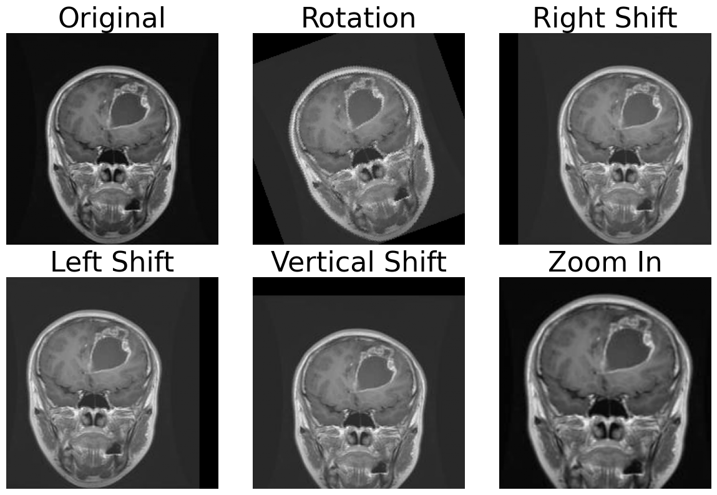
Figure 2. The five augmentation operations applied individually to the same coronal T1-weighted glioma training image (224×224 pixels after resizing).
6. Applying the method to a new clinical pool
To reproduce this method on a different clinical image pool: (a) collect and anonymize images under appropriate institutional ethics clearance, organizing them by diagnostic label; (b) compute an MD5 hash for every image and remove byte-identical duplicates; (c) compute a perceptual hash for every remaining image and remove pairs below a chosen Hamming-distance threshold (5 was used here); (d) perform per-class stratified splitting into training/validation/test sets; (e) run a content-hash comparison across all split pairs to confirm zero overlap before any model development begins; (f) apply the resize → split-conditional-augment → tensor-convert → normalize pipeline, adjusting resolution, augmentation set, and normalization constants to the target modality and downstream architecture.

Method validation
The method was validated in two ways: (i) confirming that duplicate screening materially changes the native characteristics of the released pool, and (ii) confirming that the resulting duplicate-cleaned splits remain learnable by benchmarking seven deep-learning architectures under identical preprocessing and augmentation conditions.
Native image characterization
Tables 2 and 3 characterize the native properties of the 5,941 images retained after Step 2, computed across the full released set (not a sample), giving downstream users a precise description of what they will encounter before any preprocessing is applied.
Class | Width mean | Height mean | Size mean (KB) | Min (KB) | Median (KB) | Max (KB)
Glioma | 405.50 | 406.02 | 15.71 | 3.31 | 16.32 | 70.21
Meningioma | 416.82 | 418.31 | 18.34 | 4.08 | 19.21 | 227.59
No Tumor | 290.62 | 293.67 | 19.50 | 3.39 | 11.93 | 275.97
Pituitary | 416.33 | 416.31 | 23.54 | 4.87 | 25.43 | 109.96

Table 2. Per-class native width/height/file-size statistics across the full 5,941-image dataset, computed before preprocessing.
Width (px) | Height (px) | Count (%)
512 | 512 | 3297 (55.5%)
224 | 224 | 1958 (33.0%)
225 | 225 | 73 (1.2%)
236 | 236 | 27 (0.5%)
256 | 256 | 22 (0.4%)

Table 3. Five most frequent native image resolutions across the full dataset. 512×512 and 224×224 together account for 88.5% of all images, confirming that the uniform-resizing stage of the preprocessing pipeline (Method details, Step 4) is necessary before model use.
Figure 3 shows the per-class and per-split counts produced by Step 3, together with overall class distribution, per-class split proportions, and a class×split heatmap, confirming stratified allocation was achieved in practice.
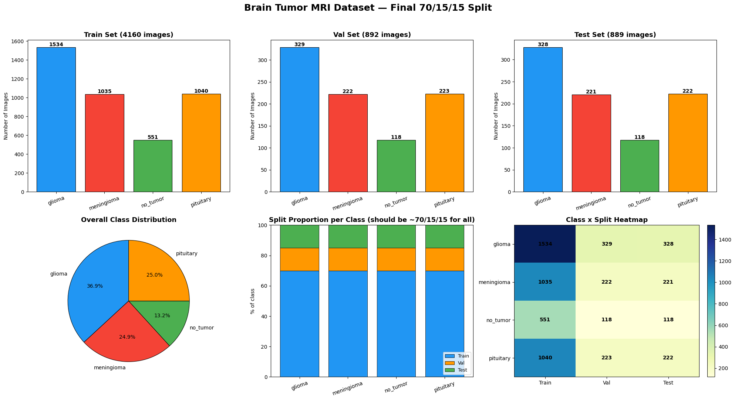
Figure 3. Class distribution analysis of the final duplicate-cleaned, 70/15/15-split dataset (5,941 images). Relative class frequencies are consistent across all three splits.
Figure 4 shows one representative image per class from the curated pool, and Figures 5–6 report pixel-intensity and quality-metric summaries computed on the curated, duplicate-cleaned images, confirming that the screening step did not introduce systematic quality artefacts.
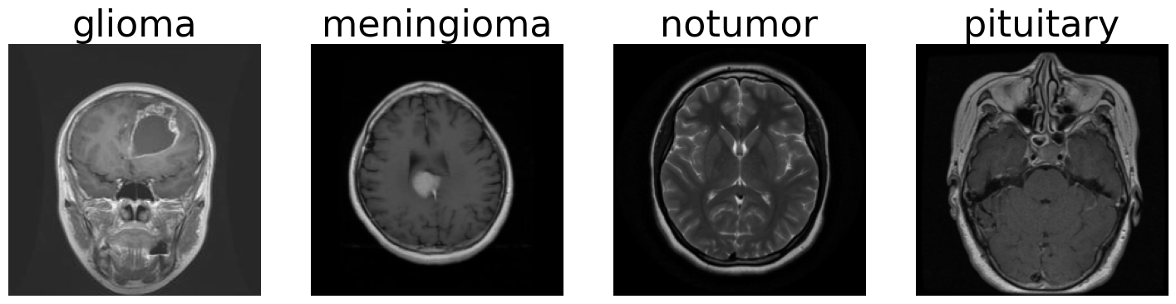
Figure 4. Representative raw MRI samples from each of the four diagnostic classes, shown at native resolution and contrast.
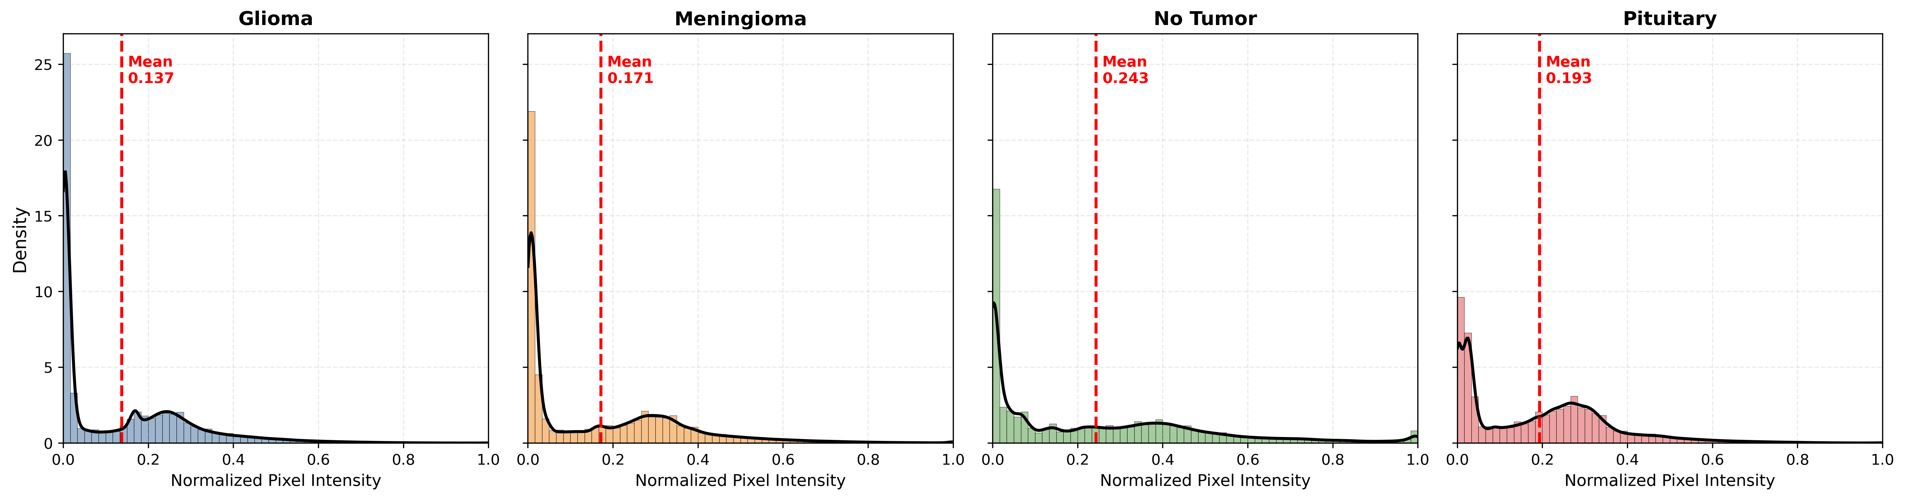
Figure 5. Pixel-intensity histograms (normalized to [0,1]) computed per class from 100 grayscale training images, resized to 224×224. All classes share a low-intensity spike near zero (background).
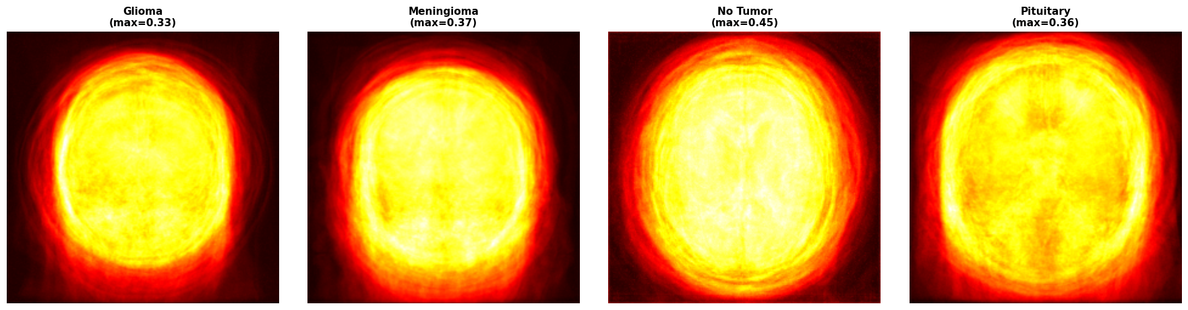
Figure 6. Class-wise mean MRI images computed by pixel-wise averaging of 100 grayscale training samples per class, displayed with a “hot” colormap.
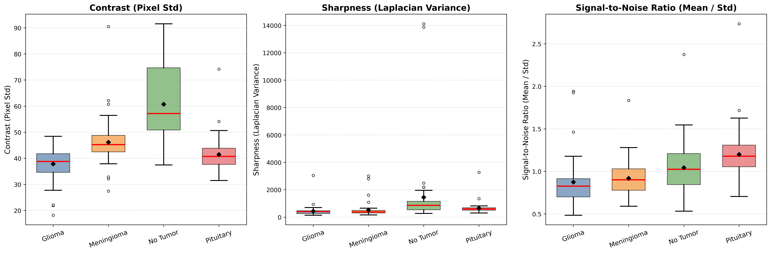
Figure 7. Boxplots of contrast, sharpness, and SNR per class from 50 randomly sampled training images. No class shows pathological quality degradation.
Downstream benchmarking
To validate that the curated, duplicate-cleaned splits remain learnable and are free of leakage-inflated performance, seven representative deep-learning architectures were trained and evaluated under identical preprocessing and augmentation conditions: a custom CNN, a Vision Transformer (ViT), and a Hybrid CNN–ViT trained from scratch; and ResNet50 and DenseNet121 under both frozen and fine-tuned pretrained configurations.
These seven architectures are deliberately trained with standard, unmodified deep-learning pipelines — conventional supervised training, off-the-shelf ImageNet-pretrained backbones, and no architecture-specific tuning beyond what is documented in Method details — because their role here is diagnostic rather than novel. A conventional, unmodified pipeline is used as a fixed external instrument to test whether the duplicate-screened, leakage-verified splits are learnable and free of leakage-inflated performance; it is deliberately not presented as a methodological contribution in itself, and no claim of architectural novelty is made for this stage. The methodological novelty of this paper lies entirely upstream of benchmarking, in the duplicate/near-duplicate screening and post-split leakage-verification protocol (Method details, Steps 2–3). Keeping the downstream benchmarking stage conventional is intentional: it ensures that the reported accuracy gains reflect the quality of the curated data rather than any architectural innovation, which would otherwise confound the validation.
Architecture | Paradigm | Test Acc. | Test F1
CNN | From scratch | 0.8470 | 0.8457
ViT | From scratch | 0.8256 | 0.8240
Hybrid CNN–ViT | From scratch | 0.8189 | 0.8201
ResNet50 | Frozen pretrained | 0.8031 | 0.8022
DenseNet121 | Frozen pretrained | 0.8706 | 0.8703
ResNet50 | Fine-tuned | 0.9708 | 0.9708
DenseNet121 | Fine-tuned | 0.9831 (best) | 0.9831 (best)

Table 4. Baseline classification performance of seven deep-learning architectures on the held-out test set (889 images). Fine-tuned DenseNet121 achieved the best result (98.31% accuracy).
Fine-tuned pretrained models achieved the strongest performance (DenseNet121: 98.31% accuracy; ResNet50: 97.08%), and frozen DenseNet121 (87.06%) outperformed the from-scratch CNN (84.70%), while frozen ResNet50 (80.31%) trailed both. This ordering fine-tuned > frozen pretrained ≈ from-scratch CNN > from-scratch transformer is consistent with expectations for a leakage-free dataset of this scale, supporting the conclusion that the duplicate-screening and splitting method (Steps 2–3) removed hidden leakage without leaving the resulting task trivially easy or unlearnable.

Limitations
The method was demonstrated on images from a single clinical facility (Epic Health Care, Chittagong, Bangladesh) under a fixed set of scanner protocols; datasets curated with this method from a single site may still require recalibration for models to generalize to other centres with different field strengths, scanner manufacturers, or contrast protocols. The perceptual-hash near-duplicate threshold (Hamming distance ≤ 5) was chosen empirically for this pool and may need adjustment for pools with different native resolutions or compression characteristics. The stratified splitting step preserves per-class proportions but does not correct pre-existing class imbalance in the source pool (in this demonstration, glioma: 36.9% vs. no tumor: 13.2%, ratio ≈ 2.78:1); users applying the method to imbalanced pools should still consider class-weighted loss functions or stratified batch sampling downstream. The method as demonstrated screens and labels images at the whole-image level only; it does not include a step for generating pixel-level segmentation masks or bounding-box annotations, and MRI sequence metadata (T1, T2, post-contrast) is not captured by the pipeline unless separately recorded at the sourcing stage.

Ethics statements
This work involved human subjects. All MRI images were prospectively collected from Epic Health Care, Chittagong, Bangladesh, under institutional ethics clearance (Ref: EHC/CARD/2025/0047), conducted in accordance with the ethical principles of the Declaration of Helsinki. Informed consent was obtained from all patients prior to data collection. All images were fully anonymized prior to handover, with no personally identifiable information retained, in strict compliance with institutional data-protection and patient-confidentiality obligations. The anonymized dataset produced by this method is released for open-access academic use under the terms approved by the ethics committee.

CRediT author statement
Md Irfanul Kabir Hira: Conceptualization, Data curation, Methodology, Software, Formal analysis, Visualization, Writing – original draft. Umme Sara: Data curation, Validation, Writing – review & editing. Mst Moriom Akter Bithee: Data curation, Validation, Writing – review & editing. Md Sohag Hossain: Data curation, Software, Formal analysis, Writing – review & editing. Md. Kowsar Ahmed: Data curation, Validation, Writing – review & editing. Abdullah Al Towsif: Data curation, Software, Writing – review & editing. Md Mahmudul Hasan: Data curation, Validation, Writing – review & editing. Mohammad Shorif Uddin: Supervision, Project administration, Writing – review & editing.

Acknowledgments
The authors gratefully acknowledge the consultant neurologist who supervised data collection and the Department of Neuromedicine, Epic Health Care, Chittagong, Bangladesh, for their expert clinical supervision and support during MRI data collection, as well as the medical and administrative personnel of Epic Health Care. The authors also thank the Department of Computer Science and Engineering, National Institute of Textile Engineering and Research (NITER), a constituent institute of the University of Dhaka, for the necessary computational and institutional support.
This research did not receive any specific grant from funding agencies in the public, commercial, or not-for-profit sectors.

Declaration of interests

☒ The authors declare that they have no known competing financial interests or personal relationships that could have appeared to influence the work reported in this paper.

☐ The authors declare the following financial interests/personal relationships which may be considered as potential competing interests:

References
[1] R. Disci, F. Gurcan, A. Soylu, Advanced brain tumor classification in MR images using transfer learning and pre-trained deep CNN models, Cancers 17 (2025) 121. doi:10.3390/cancers17010121.
[2] R. Nimmagadda, P.K. Devi, A deep learning approach for brain tumour classification and detection in MRI images using YOLOv7, Frontiers in Oncology 15 (2025) 1508326. doi:10.3389/fonc.2025.1508326.
[3] E. Zarenia, A.A. Far, K. Rezaee, Automated multi-class MRI brain tumor classification and segmentation using deformable attention and saliency mapping, Scientific Reports 15 (2025) 8114. doi:10.1038/s41598-025-92776-1.
[4] V. Satushe, V. Vyas, S. Metkar, D.P. Singh, AI in MRI brain tumor diagnosis: A systematic review of machine learning and deep learning advances (2010–2025), Chemometrics and Intelligent Laboratory Systems 263 (2025) 105414. doi:10.1016/j.chemolab.2025.105414.
[5] G. Al-Rumaihi, M.M. Khan, A. Saleh, A. Ali, L. Al-Romaihi, N. Al-Jaber, G. Al-Suliaiti, M.E.H. Chowdhury, G.R. Babu, S. Pedersen, Performance evaluation of artificial intelligence techniques in the diagnosis of brain tumors: A systematic review and meta-analysis, Cureus (2025). doi:10.7759/cureus.88915.
[6] N. Netshamutshedzi, R. Netshikweta, J.-C. Ndogmo, I.C. Obagbuwa, A systematic review of the hybrid machine learning models for brain tumour segmentation and detection in medical images, Frontiers in Artificial Intelligence 8 (2025) 1615550. doi:10.3389/frai.2025.1615550.
[7] A. Fateh, Y. Rezvani, S. Moayedi, S. Rezvani, F. Fateh, M. Fateh, V. Abolghasemi, BRISC: Annotated dataset for brain tumor segmentation and classification, Scientific Data (2026). doi:10.1038/s41597-026-06753-y.
[8] A.J. Aiya, N. Wani, Optimized deep learning for brain tumor detection: a hybrid approach with attention mechanisms and clinical explainability, Scientific Reports 15 (2025) 31386. doi:10.1038/s41598-025-04591-3.
[9] G. Jayaraman, S. Meganathan, S.S.M. Shah, M. Anuradha, R.K. Sundararajan, R. Rajakumar, A hybrid CNN–ViT framework with cross-attention fusion and data augmentation for robust brain tumor classification, Scientific Reports 15 (2025) 45769. doi:10.1038/s41598-025-28636-9.
[10] Y. Wong, E.L.M. Su, C.F. Yeong, W. Holderbaum, C. Yang, Brain tumor classification using MRI images and deep learning techniques, PLOS ONE 20 (2025) e0322624. doi:10.1371/journal.pone.0322624.
[11] V.R. Srinivas, R. Parvathi, Explainable AI-driven MRI-based brain tumor classification: a novel deep learning approach, Frontiers in Artificial Intelligence 8 (2026) 1700214. doi:10.3389/frai.2025.1700214.

