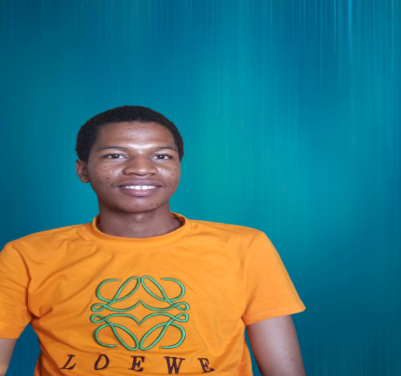

**Usman Abdullahi**

Frontend Developer

Ilorin, Nigeria

09135619423 [Uthmanabdullahi2020@gmail.com](mailto:uthmanabdullahi2020@gmail.com?subject=Welcome)

­­

**Profile**

Motivated Frontend Developer with a strong foundation in HTML, CSS, and JavaScript. Committed to delivering high-quality, responsive websites and applications. Quick learner, collaborative mindset, and up-to-date with the latest industry trends. Seeking an opportunity to contribute and grow as a Frontend Developer while creating exceptional user experiences.

**Education**

**Bachelor of Science in Information Technology (IT), Federal University of Ilorin, Kwara-State**

December 2021 – Present.

**Courses**

**Front-End Development Certification, CodeVillage LLC**

October 2022 – December 2022

**Responsive Web Development Certification, FreeCodeCamp**

October 2022 – December 2022

**References**

Aishah Abdulfatah, From CodeVillage LLC

08143694373 [aishatabdulfatah81@gmail.com](mailto:aishatabdulfatah81@gmail.com)

|  |  |  |
| --- | --- | --- |
| [Portfolio](https://celadon-dusk-f677be.netlify.app/) | [Github](https://github.com/intelligence247) | [LinkedIn](https://www.linkedin.com/in/usman-abdullahi-125a3a23b/) |

**Nationality**

Nigerian

**Skills**

HTML/CSS

JavaScript

TailWindCss

ReactJs

NextJs

Github

**Languages**

English

Yoruba

Arabic

**Hobbies**

Reading

Continuous Learning

Coding Challenges

Prototyping

UX Research