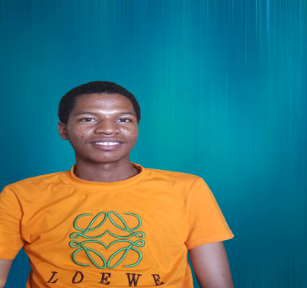

**Usman Abdullahi**

Software Engineer

Ilorin, Nigeria

09135619423 [Uthmanabdullahi2020@gmail.com](mailto:uthmanabdullahi2020@gmail.com?subject=Welcome)

C:\Users\hp\Downloads\352489_link_icon.png [Github](https://github.com/Intelligence247), [LinkedIn](https://www.linkedin.com/in/usman-abdullahi-125a3a23b/) **Profile**

Motivated Frontend developer with a strong foundation in HTML, CSS and JavaScript. Committed to delivering high quality, responsive websites and applications. Quick learner, collaborative mindset, and a up-to-date with the latest industry trends. Seeking an opportunity to contribute and grow as a Frontend Developer while creating exceptional user experience