Author's contact detailsGradient from the top left corner to the bottom right corner, blue to green color



DELHI PUBLIC SCHOOL BANGALORE SOUTH

CERTIFICATE

Name: Aniruddh Bhandarkar

Class:12 E

Roll Number: 03

School: Delhi Public School Bangalore South

This is certified to be the bona fide work of Aniruddh Bhandarkar for the academic year 2021-2022 in the subject of Computer Science.

----------------------- ----------------------

Teacher’s Signature External Examiner’s

Signature

School Seal

Date:

Table of Contents

OBJECTIVE 4

Horizontal Spring Oscillator 5

Description and Algorithm 5

Python Code 5

SAMPLE OUTPUT 5

Pendulum 5

Description and Algorithm 5

Python Code 5

SAMPLE OUTPUT 5

Simple Harmonic Motion 6

Description and Algorithm 6

Python Code 7

SAMPLE OUTPUT 8

Modules Used

Bibliography 10

# OBJECTIVE

In this project the objective is to visualize Simple Harmonic Motion (SHM). SHM is a phenomenon in physics that has repetitive motion with same frequency across an equilibrium position and the displacement of the moving object on either side of equilibrium is the same.

To study SHM 2 common phenomenon in physics are traced using Python:

* Swinging pendulum of varying lengths and mass of the bob attached to the pendulum
* Spring with a mass tied to the end performing a Simple Harmonic Motion (SHM)

For each of the phenomenon the variables in the equation are changed and then impact is observed in the simulation. The dimensions of the physical object and length of objects are varied to determine if there is any change in SHM.

The 2 phenomena are then independently plotted as a wave on XY axis demonstrating the variation in the independent dimension along x axis of time while plotting the variation in the amplitude and frequency along the Y axis.

To simulate the phenomena in Python the following packages:

* NumPy to perform data computation
* matplotlib to plot the function
* VPython to plot the simulation
* SQL connector to connect with SQL database

# Horizontal Spring Oscillator

## Description and Algorithm

The horizontal spring oscillator has a box, helical spring and a surface to which it is tethered. The box is then pushed and given a momentum in the horizontal direction and triggers SHM till the momentum exists. The momentum is on account of potential energy being converted to kinetic energy. SHM is tracing the motion of the spring on an XY axis.

Algorithm:

* Set up box, mass, pivot and spring using vector function in vpython
* While t< 50 computer
  + Acceleration, velocity, position, PE and KE
  + Increment t in steps of dt
* Use a slider function to plot the values that have been generated

## Python Code

The packages used for this simulation are:

* Matplotlib for the widgets, controls and actual plotting of the information
* Numpy to provide vector to trace movement of spring
* Vpython provides helix function which is in three-dimensional space at constant angle to a fixed axis.

## SAMPLE OUTPUT

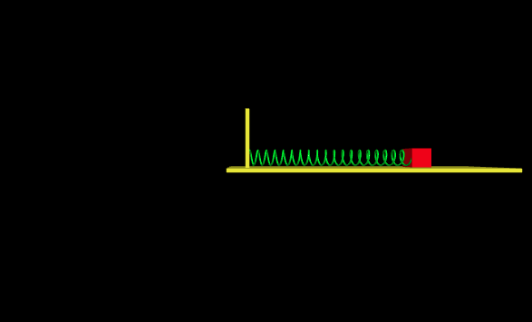

*Figure 1: Horizontal oscillator using spring and a block mass M*

# Pendulum

## Description and Algorithm

Step 1: Take input of the length of the pendulum arm

Step 2:Take the input of the pendulum mass

Step 3: Using the equation we plot the position of the bob

Step 4: Find the Angular Velocity to plot the motion of the bob

Step 5: We repeat 1 to 4 to plot the overall motion by taking rod position from bob position

## Python Code

Try and except code

while True:

try:

l = int(input("Enter the length for the Pendulum (range between 10 and 50): ")) #length of pendulum arm

if (l < 10 or l>51):

raise ValueError("The length of Pendulum should be between 10 - 50!")

m = int(input("Enter the mass of the Pendulum (range between 1 and 10): ")) #mass of pendulum weight

if (m < 1 or m>10):

raise ValueError("The mass of the Pendulum should be between 1 - 10!")

break

except ValueError as ve:

print(ve)

## SAMPLE OUTPUT

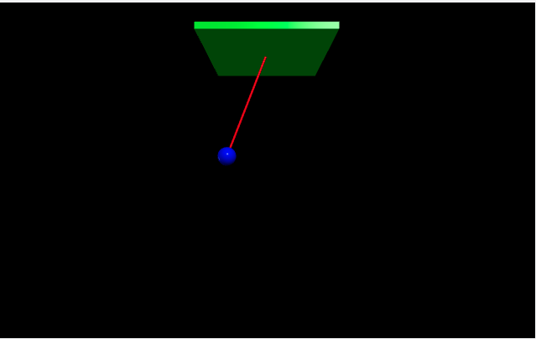

*Figure 2 Pendulum with a bob attached to the end depicting SHM*

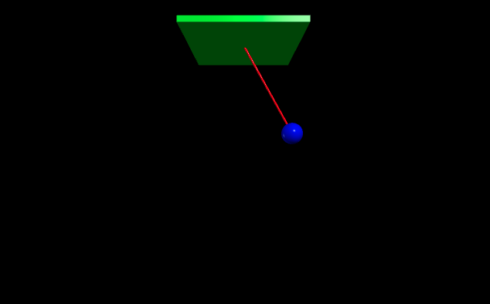

*Figure 3: SHM depicted using Pendulum*

# Simple Harmonic Motion

## Description and Algorithm

1. In SHM the time interval of each complete vibration (**time period**) is the same and the force responsible for the motion is always directed toward the equilibrium position and is directly proportional to the distance from it.
2. Understand physics phenomena and model the same mathematically while identifying the dependent and independent variables.
3. To plot SHM wave on X axis with position on Y axis plotting the formula
4. **y=A sin⁡ (ωt+ θ) where** A is the amplitude of motion, ω is the angular frequency and θ is the initial phase
5. The code uses marching in time to move along the time dimension in an sequential manner from 0s to the specified stop time in small steps
6. A function to generate data that computes the value of the waves at each point in time t from 0s in small steps as data is input
7. Once the data is ready is generated, it is stored in lists and arrays

* Set the size of each step and number of total steps
  + For example, *step = 0.5* s and *numstep = 1000*
* Define a function (*data_gen*) that will compute the value of the wave at each point in time t from 0 s in steps of 0.5 s for a 1000 times
  + For a SHM wave, at time 2.5 seconds the y position is where f is the frequency in Hz
  + For a damped wave, at time 1.0 second the y position is  
    , where λ is the decay constant
* Creating a set of arrays to store these values as required for plotting, one for the x axis and a different array of y values for each wave
* Creating empty arrays to store these sets of points
* Creating a figure with three subplots and changing the size of the window
* Associating the color and right data sets with each plot, also setting the title

## Python Code

## Sample Output

## 

*Figure 4 SHM traced for frequency of 1Hz frequency*

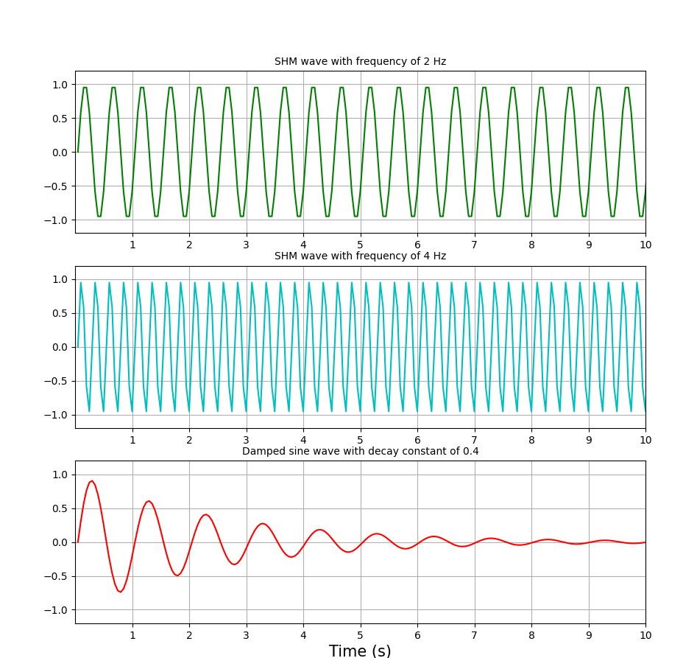

*Figure 5: SHM for 2Hz frequency and tracing a decay function*

Modules

VPython

Brief Description-A module used in 3d Graphics and Simulation of Physical Phenomena and Modelling

Usage- Used in the project for the modelling and the representation of two physical phenomena 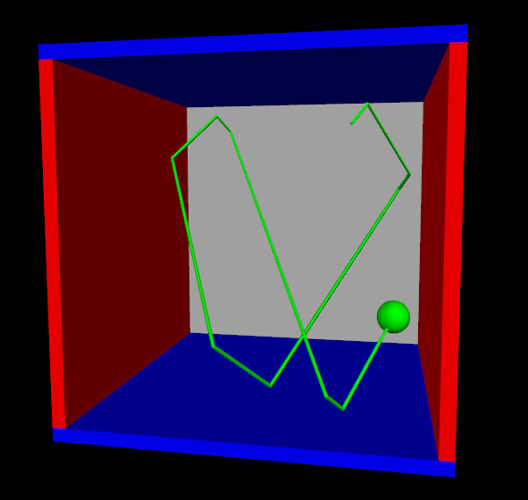

matplotlib

Brief Description-A Python module that helps provide an object-oriented API(Interface) using Graphical User Interface(GUI)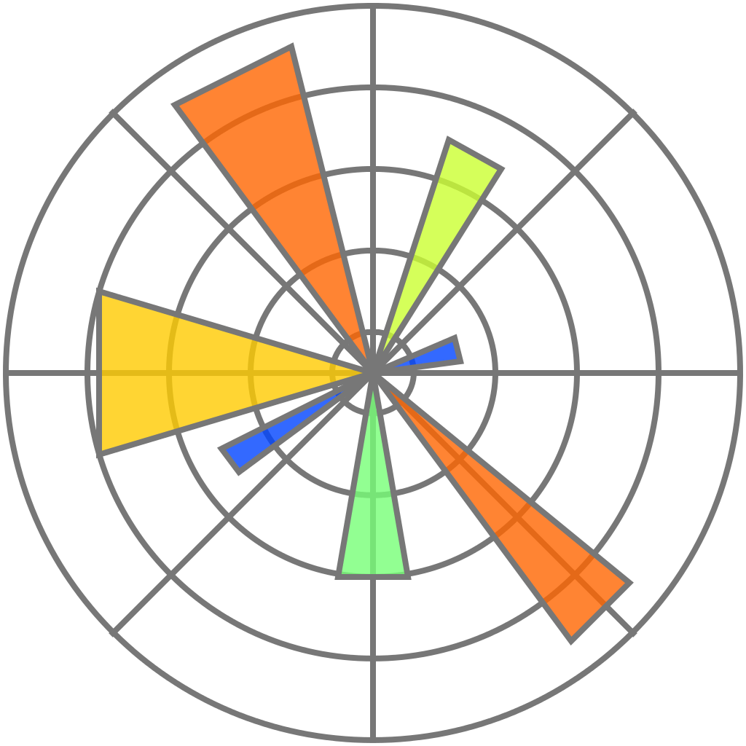

Usage-Used for Graphing SHM

NumPy

Brief Description-A



# Bibliography

1. <https://en.wikipedia.org/wiki/Simple_harmonic_motion>
2. <https://phet.colorado.edu/en/simulations/pendulum-lab>
3. <https://matplotlib.org/stable/tutorials/index>
4. <https://www.numpy.org>
5. <https://www.vpython.org>
6. <http://www.uwyo.edu/esp4t/raspberry-pi-modules/physics-modules/python-shm.html>