Introduction

The paper investigates multiclass classification problem of objects with no explicit feature representation. This problem arises in analysing biological data [17], human behavior and social interactions [1]. It considers the problem of human activity recognition. The accelerometer time series [8,15, 20] from smart phones serve to recognize human physical activity on the internet of things [2, 14]. Methods to solve this problem range from topological data analysis [18] to convolutional neural networks [6]. An extensive survey of the methods and datasets for this problem is found in [9].

In this work the dataset is comprised of time series of acceleration from three axis, which is obtained from a mobile phone or another wearable device with accelerometer. These time series are of various sizes, not aligned, and multiscaled [4]. The problem is to predict physical activity of a person. The list of activities includes walking, running, sitting or walking up/down stairs. In this setup time series are treated as complex structured objects without explicit feature description. This assumption allows to propose a flexible technology for accelerometer time series modelling. The main problem to tackle is the lack of computational resources, memory, and energy in wearable devices. This investigation proposes an approach to generate features of time series as complex structured objects. The generated features bring adequate quality of classification and require moderate resources.

The problem of classifying complex structured objects is split in two distinctive procedures. The first extracts informative features. The second one classifies objects of these feature descriptions. This research focuses mainly on comparison of different methods for feature generation [11, 12]: expert-defined functions, autoregressive model, and singular spectrum analysis. Expert-defined functions [13] include average, standard deviation, mean absolute deviation and histogram. The autoregressive model [16] builds a parametric model for each time series and uses model parameters as features for classification. The singular spectrum analysis [7] uses the eigenvalues of trajectory matrix as generated features.

The authors propose a new feature generation method. We approximate time series segments with cubic splines [3]. The spline approximates the 3-order piecewise curve at the given knots. The additional smoothness conditions makes the curve and its first and second derivatives continuous. The splines give a smooth curve and adequate quality of approximation.

The experiment was conducted on two accelerometer datasets: WISDM [21], USC-HAD [19]. We compared the performance of stated feature extraction methods, as well as different classification algorithms. The latter includes logistic regression, random forest and SVM.

Problem Statement

The accelerometer time series are represented as a set $S$ of segments $s$ of fixed length $T$ :

$$s=[x_{1},…,x_{T}]^{T}∈R^{T}.$$

One has to find a classification model $f:R^{T}→Y$ between segments from the set $S$ and class labels from a finite set $Y$. Let denote by

$$D=\{(s_{i},y_{i})\}_{i=1}^{m}$$

a given sample set, where $s_{i}∈S$ and $y_{i}=f(s_{i})∈Y$.

The authors propose to construct the model $f$ as a superposition $f=f(g)$. Here $g:R^{T}→R^{n}$ is a map from the space $R^{T}$ to the feature space $G⊂R^{n}$. Given the feature map $g$ transform the original sample set  to the new sample set

$$D_{G}=\{(g_{i},y_{i})\}_{i=1}^{m},$$

where $g_{i}=g(s_{i})∈G$.

The classification model $f=f(g,θ)$ has a vector of parameters $θ$. The optimal parameters $\overset{^}{θ}$  are given by the classification error function

$$\overset{^}{θ}={argmin}_{θ}L(θ,D_{G},μ).$$

Here the vector $μ$ represents external parameters of a particular classification model. The examples of these parameters and error functions for different classification models are given below.

To compare classification quality with results from [11, 12] we use the accuracy score:

$$accuracy=\frac{1}{m}\sum_{i=1}^{m}{\left[f\left(g(s_{i}),\overset{^}{θ}\right)=y_{i}\right]}.$$

Feature Generation Functions

The main focus of this paper is to compare different approaches for feature generation. In this section we provide analysis and motivation for each of the methods.

1. Expert Functions.

Use the expert-given feature set as a baseline for local approximation models. These functions are statistics $g_{j}$, where $g_{j}:R^{T}→R$. The description $g(s)$ of the object $s$ is the value of these statistics on the object

$$g(s)=[g_{1}(s),…,g_{n}(s)]^{T}.$$

In the paper [13] the authors proposed to use the expert functions:

mean: $\overline{x}=\frac{1}{T}\overset{T}{\underset{t=1}{∑}}x_{t}$,

standard deviation: $\sqrt{\frac{1}{T}\overset{T}{\underset{t=1}{∑}}(x_{t}−\overline{x})^{2}}$,

mean absolute deviation: $\frac{1}{T}\overset{T}{\underset{t=1}{∑}}|x_{t}−\overline{x}|$,

distribution: histogram values with 10 bins.

This feature generation procedure extracts the feature description of time series .

2. Autoregressive Model.

The autoregressive model [16] of the order $n$ generates features of time series $s$ with model parameters. Each time series is approximated by a linear combination of its previous $n−1$ components

$$x_{t}=w_{0}+\sum_{j=1}^{n−1}{w_{j}}x_{t−j}+ϵ_{t},$$

where $ϵ_{t}$ is a residual. The optimal parameters $\overset{^}{w}$ of the autoregressive model are the features $g(s)$. These parameters minimise the squared error between time series $s$ and its prediction

$$g(s)=\overset{^}{w}={argmin}_{w∈R^{n}}\left(\sum_{t=n}^{T}{∥}x_{t}−{\overset{^}{x}}_{t}∥^{2}\right).$$

This problem is a linear regression problem. Hence, for each initial time series $s$  we have to solve linear regression problem with $n$ predictors. The example of approximation using autoregressive model is demonstrated on the Fig. 1.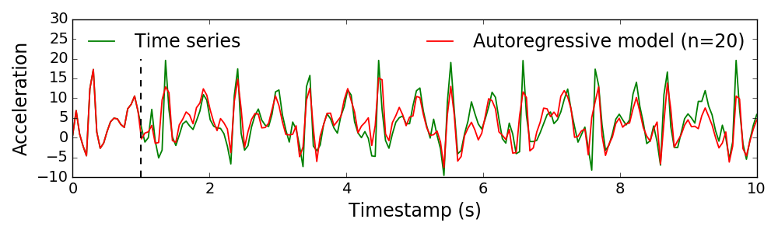

Fig. 1: Time series approximation using autoregressive model with order n = 20

3. Singular Spectrum Decomposition.

Alternative hypothesis for generation of time series is Singular Spectrum Analysis (SSA) model [7]. We construct trajectory matrix for each time series $s$ from the original sample $D$:

$$X=\left(\begin{matrix}x_{1} & x_{2} & … & x_{n} \\ x_{2} & x_{3} & … & x_{n+1} \\ … & … & … & … \\ x_{T−n+1} & x_{T−n+2} & … & x_{T}\end{matrix}\right).$$

Here $n$ is the window width, which is an external structure parameter. The singular decomposition [5] of the matrix $X^{T}X$:

$$X^{T}X=UΛU^{T},$$

where $U$ is a unitary matrix and $Λ=diag(λ_{1},…,λ_{n})$ which entries $λ_{i}$ are eigenvalues of $X^{T}X$. The spectrum of the matrix $X^{T}X$ is used as feature description of the object :

4. Spline Approximation.

The proposed method approximates time series with splines [3]. A spline is defined by its parameters: knots and coefficients. The set of knots $\{ξ_{ℓ}\}_{ℓ=0}^{M}$ are uniformly distributed over time series. The models, which are built on each the interval $[ξ_{ℓ−1};ξ_{ℓ}]$, are given by the coefficients $\{w_{ℓ}\}_{ℓ=1}^{M}$.

Optimal spline parameters are solution of a system with additional constraints of derivatives equality up to second order on the interval edges. Denote each spline segment as $p_{i}(t)$ $i=1,…,M$ and spline as a whole as $S(t)$ and write these equations:

$$\begin{matrix}S(t) & =\left\{\begin{matrix}p_{1}(t)=w_{10}+w_{11}t+w_{12}t^{2}+w_{13}t^{3}, & t∈[ξ_{0},ξ_{1}], \\ p_{2}(t)=w_{20}+w_{21}t+w_{22}t^{2}+w_{23}t^{3}, & t∈[ξ_{1},ξ_{2}], \\ ⋯ & ⋯ \\ p_{M}(t)=w_{L0}+w_{M1}t+w_{M2}t^{2}+w_{M3}t^{3}, & t∈[ξ_{M−1},ξ_{M}],\end{matrix}\right.\end{matrix}$$

For $S(t)$ to be an interpolatory cubic spline, we must also have conditions:

$$\begin{matrix}S(ξ_{t}) & =x_{t},t=0,…,M, \\ p_{i}^{′}(ξ_{i}) & =p_{i+1}^{′}(ξ_{i}),p_{i}^{″}(ξ_{i})=p_{i+1}^{″}(ξ_{i}),i=1,…,M−1, \\ p_{i}(ξ_{i−1}) & =x_{i−1},p_{i}(ξ_{i})=x_{i},i=1,…,M.\end{matrix}$$

The feature description of the time series could be assumed as the spline parameters union:

$$g(s)={\left[w_{1},…,w_{M}\right]}^{T}.$$

Fig. 2 shows the time series approximation given by splines. Compared to the autoregressive model, the splines method gives smoother approximation using almost the same number of parameters.

Fig. 2: Time series approximation using three order splines

Time Series Classification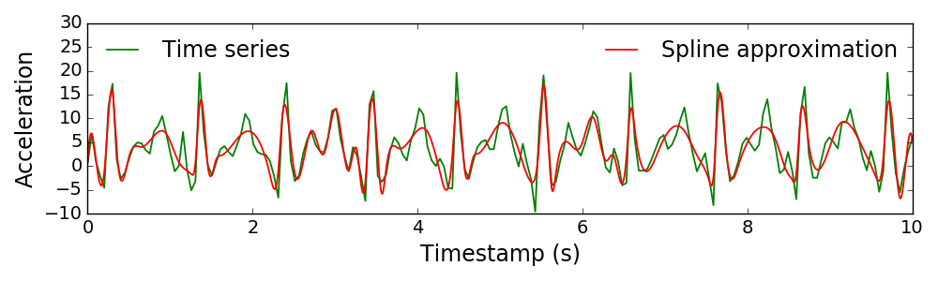

Multiclass classification uses one-vs-rest approach to train binary classifiers for each class label and then, on the prediction step, classify new object according to the most confident classifier. Three classification models are used: logistic regression, SVM, and random forest.

1. Regularized Logistic Regression.

The optimal model parameters are determined by minimising error function

$$L(θ,D_{G},μ)=\sum_{i=1}^{m}{log}(1+exp(−y_{i}[w^{T}g_{i}+b]))+\frac{μ}{2}∥w∥^{2},whereθ=\left[\begin{aligned}w \\ b\end{aligned}\right].$$

The classification rule $f(g,θ)$ is given by the sign of linear combination for the object description $g$ and parameters

2. SVM.

The optimization problem is

$$\begin{matrix}\overset{^}{θ}=\left(\begin{aligned}\overset{^}{w} \\ \overset{^}{b} \\ \overset{^}{ξ}\end{aligned}\right)={argmin}_{w,b,ξ}\frac{1}{2}∥w∥^{2}+μ\sum_{i=1}^{m}{ξ_{i}},s.t. & y_{i}\left(w^{T}g_{i}+b\right)≥1−ξ_{i}, \\ & ξ_{i}≥0,1≤i≤m.\end{matrix}$$

The objective function corresponds to the classification error function $L(θ,D_{G},μ)$. The prediction for new object is .

3. Random Forest.

The random forest exploits the idea of bagging. This is an approach of building many random unstable classifiers and aggregating their predictions. This method works especially well if we select models with low bias and high variance (due to aggregating variance is reduced) as base models. In case of random forest decision trees take the role of base models, not only objects are used for bagging, but also features. In this case we make a prediction for each new object by averaging of the single tree predictions:

$$\overset{^}{y}=\frac{1}{B}\sum_{i=1}^{B}{pred}(g_{i}),$$

where $B$ is an amount of trees used for bagging.

Experiment

In this paper we considered two different smart phone based datasets: WISDM [21] and USC-HAD [19]. The smart phone accelerometer measures acceleration along three axis with frequencies equal to 20 and 100 Hz. The WISDM dataset consists of 4321 time series. Each time series belongs to one of the six activities: Standing, Walking, Upstairs, Sitting, Jogging, Downstairs. The USC-HAD dataset contains 13620 time series with one of the twelve class labels: Standing, Elevator-up, Walking-forward, Sitting, Walking-downstairs, Sleeping, Elevator-down, Walking-upstairs, Jumping, Walking-right, Walking-left, Running. Table 1 shows the distributions of time series activities for each dataset. The length $T$ of each time series equals 200. Fig. 3 plots the example of the time series for one activity of the specific person is given.

For each dataset feature generation procedures are applied: expert functions, autoregressive model, SSA, and splines. Three classification models for each generated feature description: logistic regression, support vector machine, and random forest. The structure parameters: the length $n$ for autoregressive model, the window width $n$ for SSA, and the number of splines knots $M$ were tuned using K-fold cross validation, minimising

Table 1: Distributions of the classes for WISDM and USC-HAD datasets

|  |  |  |  |
| --- | --- | --- | --- |
|  | **Activity** | **# objects** | |
| 1 | Standing | 229 | 5.3 % |
| 2 | Walking | 1917 | 44.36 % |
| 3 | Upstairs | 466 | 10.78 % |
| 4 | Sitting | 277 | 6.41 % |
| 5 | Jogging | 1075 | 24.88 % |
| 6 | Downstairs | 357 | 8.26 % |
|  | Total | 4321 |  |

|  |  |  |  |
| --- | --- | --- | --- |
|  | **Activity** | **# objects** | |
| 1 | Standing | 1167 | 8.57 % |
| 2 | Elevator-up | 764 | 5.61 % |
| 3 | Walking-forward | 1874 | 13.76 % |
| 4 | Sitting | 1294 | 9.50 % |
| 5 | Walking-downstairs | 951 | 6.98 % |
| 6 | Sleeping | 1860 | 13.66 % |
| 7 | Elevator-down | 763 | 5.60 % |
| 8 | Walking-upstairs | 1018 | 7.47 % |
| 9 | Jumping | 495 | 3.63 % |
| 10 | Walking-right | 1305 | 9.58 % |
| 11 | Walking-left | 1280 | 9.40 % |
| 12 | Running | 849 | 6.23 % |
|  | Total | 13620 |  |

$\begin{aligned}CV(K)=\frac{1}{K}\overset{K}{\underset{k=1}{∑}}L(f_{k},D\backslash C_{k}),\end{aligned}$

where $C_{k}$ is a $\frac{K−1}{K}$ fraction of data, used for training model $f_{k}$. The hyperparameters $μ$ for classification models were also tuned using the same cross validation procedure.

The first approach for feature generation is expert functions. The main drawback of this approach is a restriction by the expert functions choice and these functions might be impossible to derive for some types of data.

The autoregressive model was tuned to find the optimal length $n$. Cross validation procedure gives optimal value $n=20$ for both dataset.

The singular spectrum analysis was tuned in the same way to find the optimal window width $n$.

Fig. 3: Time series example

to autoregressive model, cross validation procedure gives the same value $n=20$.

Fit cubic splines [3] for time series using *scipy* python library [10]. The knots $\{ξ_{ℓ}\}_{ℓ=1}^{M}$ for splines were distributed uniformly. Value of $M$  was chosen with cross validation.

The feature 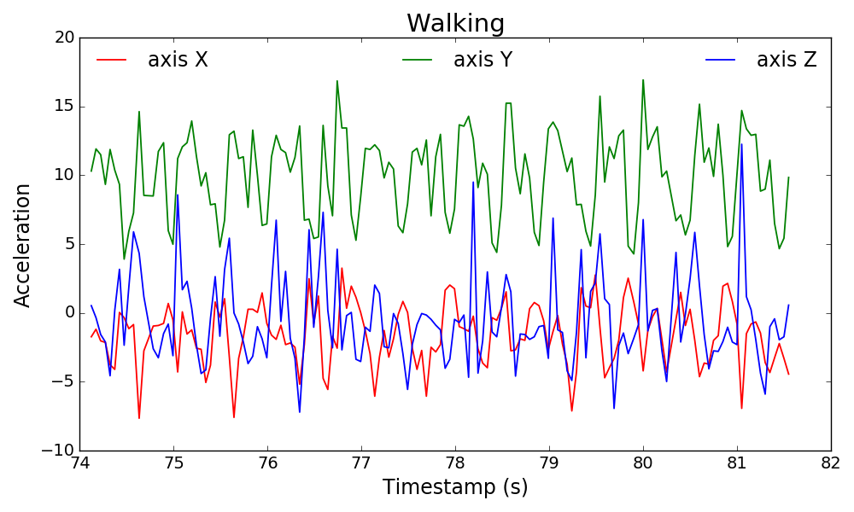extraction methods give the following number of features for both datasets: expert features: 40; autoregressive model: 60; singular spectrum analysis: 60; splines: 33.

Fig. 4 presents the accuracy scores of the experiments for the both datasets. For WISDM dataset the worst result was obtained with spline approximation. The results for expert functions, autoregressive mod

Fig. 4: Multiclass accuracy score

el, and SSA are roughly identical. For USC-HAD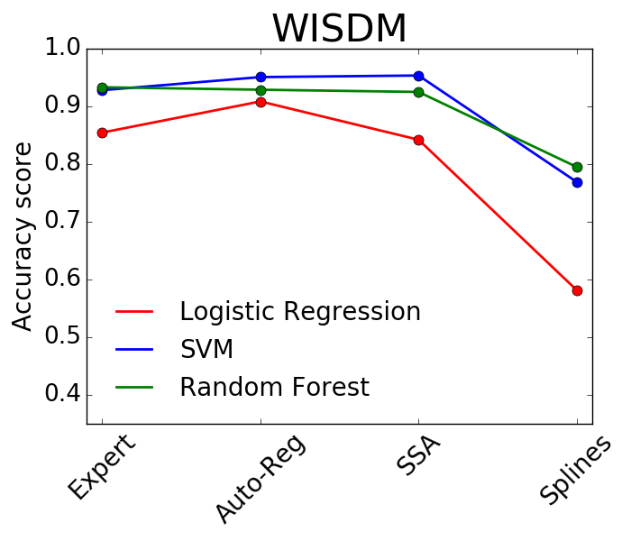 dataset the results highly depend on the classification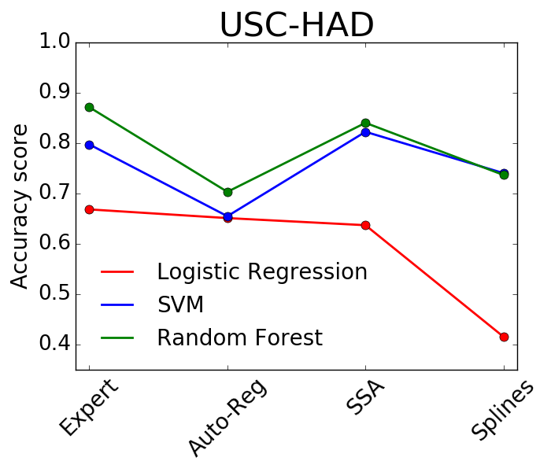 model. For both datasets logistic regression shows the worst quality, while the accuracy for support vector machine and random forest is almost the same. The spline approximation gives competitive result for USC-HAD dataset.

Table 2 and Table 3 present all results with classification accuracy scores  for each class. The first rows of these tables introduce the multiclass accuracy score for each classification model and each feature extraction procedure. Next rows are related to binary accuracy scores for each class. For WISDM dataset the best scores have the least active classes such as Standing and Sitting. For USC-HAD dataset all classes have the similar accuracy scores.

We also carried out the experiment for union of all 193 generated features. Fig. [fig::feature_union_results] demonstrates the results. Table [tbl::activities_distributions] shows class labels, that are represented on the corresponding histograms. As expected, the accuracy scores for feature union are higher in all cases. All binary accuracy scores for WISDM dataset are higher than $97\%$ for each classification model. These numbers for USC-HAD dataset is higher than $93\%$.

|  |  |  |  |  |  |  |  |  |  |  |  |  |
| --- | --- | --- | --- | --- | --- | --- | --- | --- | --- | --- | --- | --- |
|  | **Logistic Regression** | | | | **SVM** | | | | **Random Forest** | | | |
| EX | AR | SSA | SPL | EX | AR | SSA | SPL | EX | AR | SSA | SPL |
| All | 0.85 | 0.91 | 0.84 | 0.58 | 0.93 | 0.93 | 0.92 | 0.79 | 0.93 | 0.95 | 0.95 | 0.77 |
| Standing | 0.99 | 0.98 | 1.00 | 0.95 | 1.00 | 0.99 | 1.00 | 0.99 | 0.99 | 0.98 | 1.00 | 0.96 |
| Walking | 0.91 | 0.95 | 0.86 | 0.61 | 0.96 | 0.97 | 0.95 | 0.86 | 0.96 | 0.98 | 0.98 | 0.84 |
| Upstairs | 0.91 | 0.96 | 0.91 | 0.89 | 0.96 | 0.96 | 0.96 | 0.90 | 0.96 | 0.98 | 0.97 | 0.89 |
| Sitting | 0.99 | 0.98 | 1.00 | 0.99 | 1.00 | 0.99 | 1.00 | 1.00 | 0.99 | 0.98 | 1.00 | 1.00 |
| Jogging | 0.98 | 0.99 | 0.99 | 0.80 | 0.99 | 0.99 | 0.99 | 0.92 | 0.99 | 0.99 | 0.99 | 0.93 |
| Downstairs | 0.93 | 0.96 | 0.94 | 0.92 | 0.96 | 0.97 | 0.96 | 0.92 | 0.96 | 0.98 | 0.97 | 0.92 |

Table 3: Binary accuracy scores for WISDM using different feature generation methods: EX — Expert, AR — Auto-Reg, SSA and SPL for Splines

|  |  |  |  |  |  |  |  |  |  |  |  |  |
| --- | --- | --- | --- | --- | --- | --- | --- | --- | --- | --- | --- | --- |
|  | **Logistic Regression** | | | | **SVM** | | | | **Random Forest** | | | |
| EX | AR | SSA | SPL | EX | AR | SSA | SPL | EX | AR | SSA | SPL |
| All | 0.67 & 0.65 & 0.64 & 0.41 & 0.87 & 0.70 & 0.84 & 0.74 & 0.80 & 0.65 & 0.82 & 0.74 | 0.65 & 0.65 & 0.64 & 0.41 & 0.87 & 0.70 & 0.84 & 0.74 & 0.80 & 0.65 & 0.82 & 0.74 | 0.64 & 0.65 & 0.64 & 0.41 & 0.87 & 0.70 & 0.84 & 0.74 & 0.80 & 0.65 & 0.82 & 0.74 | 0.41 & 0.65 & 0.64 & 0.41 & 0.87 & 0.70 & 0.84 & 0.74 & 0.80 & 0.65 & 0.82 & 0.74 | 0.87 & 0.65 & 0.64 & 0.41 & 0.87 & 0.70 & 0.84 & 0.74 & 0.80 & 0.65 & 0.82 & 0.74 | 0.70 & 0.65 & 0.64 & 0.41 & 0.87 & 0.70 & 0.84 & 0.74 & 0.80 & 0.65 & 0.82 & 0.74 | 0.84 & 0.65 & 0.64 & 0.41 & 0.87 & 0.70 & 0.84 & 0.74 & 0.80 & 0.65 & 0.82 & 0.74 | 0.74 & 0.65 & 0.64 & 0.41 & 0.87 & 0.70 & 0.84 & 0.74 & 0.80 & 0.65 & 0.82 & 0.74 | 0.80 & 0.65 & 0.64 & 0.41 & 0.87 & 0.70 & 0.84 & 0.74 & 0.80 & 0.65 & 0.82 & 0.74 | 0.65 & 0.65 & 0.64 & 0.41 & 0.87 & 0.70 & 0.84 & 0.74 & 0.80 & 0.65 & 0.82 & 0.74 | 0.82 & 0.65 & 0.64 & 0.41 & 0.87 & 0.70 & 0.84 & 0.74 & 0.80 & 0.65 & 0.82 & 0.74 | 0.74 & 0.65 & 0.64 & 0.41 & 0.87 & 0.70 & 0.84 & 0.74 & 0.80 & 0.65 & 0.82 & 0.74 |
| Standing | 0.94 | 0.94 | 823 | 0.89 | 0.98 | 0.94 | 0.97 | 0.98 | 0.95 | 0.94 | 0.97 | 0.96 |
| Elevator-up | 0.94 | 0.94 | 0.93 | 0.92 | 0.95 | 0.95 | 0.95 | 0.95 | 0.93 | 0.94 | 0.94 | 0.93 |
| Walking-forward | 0.87 | 0.87 | 0.89 | 0.70 | 0.97 | 0.89 | 0.96 | 0.88 | 0.95 | 0.87 | 0.97 | 0.91 |
| Sitting | 0.98 | 0.95 | 0.94 | 0.96 | 0.99 | 0.96 | 0.98 | 0.99 | 0.98 | 0.96 | 0.99 | 1.00 |
| Walking-downstairs | 0.95 | 0.93 | 0.93 | 0.90 | 0.99 | 0.96 | 0.98 | 0.95 | 0.98 | 0.93 | 0.98 | 0.96 |
| Sleeping | 1.00 | 0.98 | 0.99 | 1.00 | 1.00 | 0.98 | 1.00 | 1.00 | 1.00 | 0.98 | 1.00 | 1.00 |
| Elevator-down | 0.94 | 0.94 | 0.94 | 0.91 | 0.95 | 0.95 | 0.95 | 0.95 | 0.93 | 0.94 | 0.94 | 0.93 |
| Walking-upstairs | 0.94 | 0.95 | 0.93 | 0.92 | 0.98 | 0.95 | 0.98 | 0.86 | 0.98 | 0.95 | 0.98 | 0.86 |
| Jumping | 0.99 | 0.99 | 1.00 | 0.97 | 1.00 | 0.99 | 1.00 | 0.99 | 1.00 | 0.99 | 0.97 | 0.99 |
| Walking-right | 0.91 | 0.90 | 0.91 | 0.86 | 0.97 | 0.92 | 0.96 | 0.92 | 0.96 | 0.90 | 0.97 | 0.93 |
| Walking-left | 0.89 | 0.91 | 0.90 | 889 | 0.97 | 0.93 | 0.97 | 0.93 | 0.95 | 0.91 | 0.97 | 0.93 |
| Running | 0.99 | 0.99 | 0.99 | 0.92 | 1.00 | 0.99 | 1.00 | 0.97 | 1.00 | 1.00 | 0.95 | 0.98 |

Table 4: Binary accuracy scores for USC-HAD using different feature generation methods: EX — Expert, AR — Auto-Reg, SSA and SPL for Splines

Conclusion

The paper investigates the problem of complex structured objects classification. The experiment compares various approaches of feature extraction, particularly the expert functions and local approximation

Fig. 5: Accuracy scores of classification of each class using all features

models on data from smart phone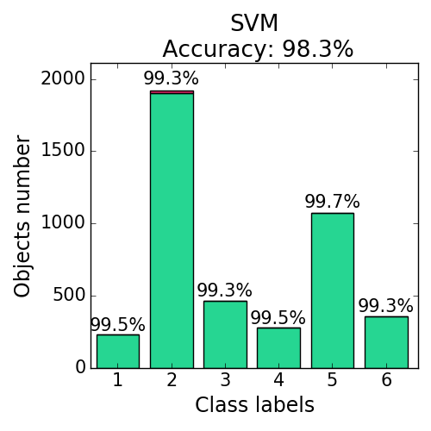 accelerometer. The logistic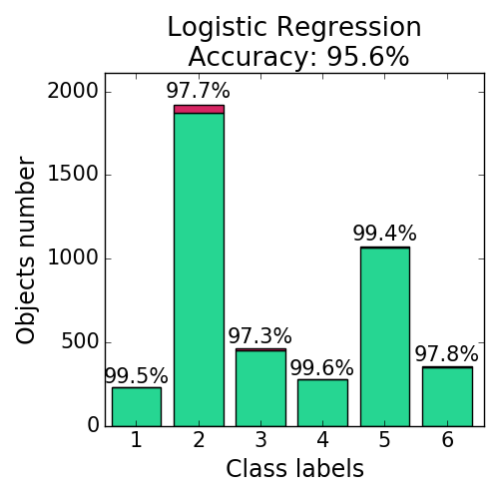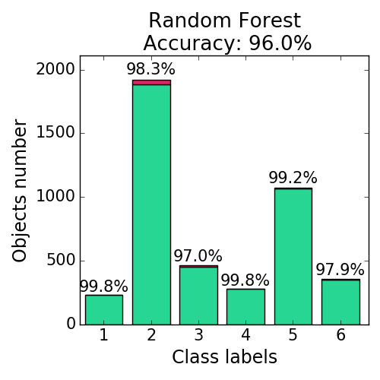 regression, SVM, and random forest are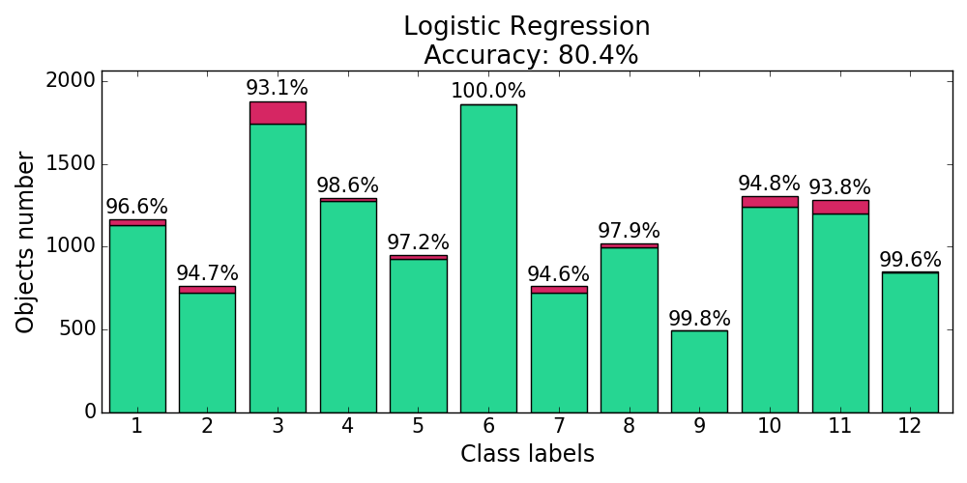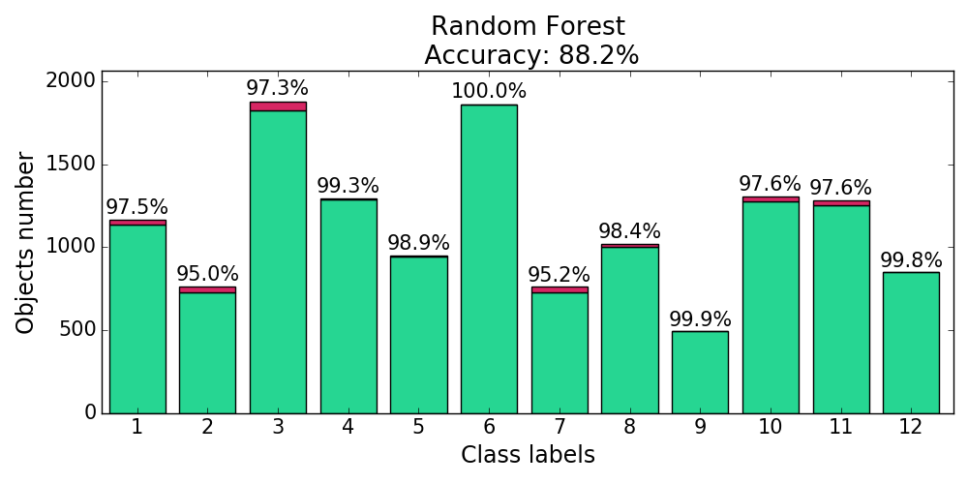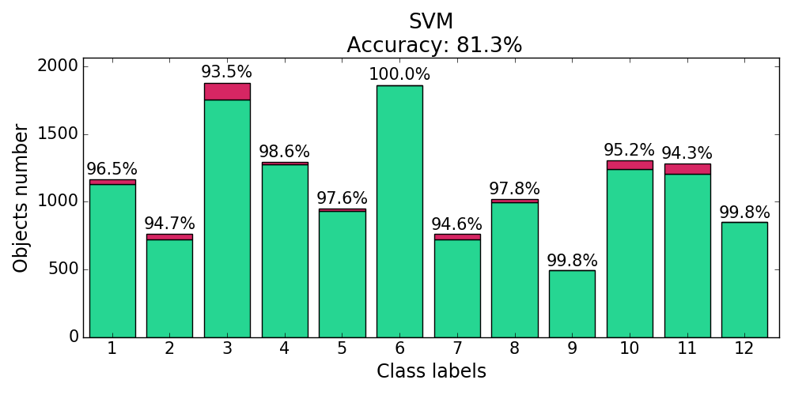 used for classification. The results show that obtained features recover the class label with the high quality. The proposed spline method gives smooth approximation of time series. The number of splines parameters was lower than for the other methods. The classification quality for splines are competitive with existing stated methods for both considered datasets. Stacking of all extracted features gives better performance.

References

1. Bao, L., Intille, S.S.: Activity recognition from user-annotated acceleration data. In: International Conference on Pervasive Computing. pp. 1–17. Springer (2004)

2. Budnik, M., Gutierrez-Gomez, E.L., Safadi, B., Pellerin, D., Quénot, G.: Learned features versus engineered features for multimedia indexing. Multimedia Tools and Applications 76(9), 11941–11958 (2017)

3. De Boor, C.: A practical guide to splines, vol. 27. Springer-Verlag (1978)

4. Geurts, P.: Pattern extraction for time series classification. In: European Conference on Principles of Data Mining and Knowledge Discovery. pp. 115–127. Springer (2001)

5. Golub, G.H., Reinsch, C.: Singular value decomposition and least squares solutions. Numerische mathematik 14(5), 403–420 (1970)

6. Hammerla, N.Y., Halloran, S., Ploetz, T.: Deep, convolutional, and recurrent models for human activity recognition using wearables. arXiv preprint arXiv:1604.08880 (2016)

7. Hassani, H.: Singular spectrum analysis: methodology and comparison. Journal of Data Science 5(2), 239–257 (2007)

8. Ignatov, A.D., Strijov, V.V.: Human activity recognition using quasiperiodic time series collected from a single tri-axial accelerometer. Multimedia tools and applications 75(12), 7257–7270 (2016)

9. Incel, O.D., Kose, M., Ersoy, C.: A review and taxonomy of activity recognition on mobile phones. BioNanoScience 3(2), 145–171 (2013)

10. Jones, E., Oliphant, T., Peterson, P.: SciPy: Open source scientific tools for Python (2001), <http://www.scipy.org/>, [Online; accessed today]

11. Karasikov, M., Strijov, V.: Feature-based time-series classification. Intelligence 24(1), 164–181 (2016)

12. Kuznetsov, M., Ivkin, N.: Time series classification algorithm using combined feature description. Machine Learning and Data Analysis 1(11), 1471–1483 (2015)

13. Kwapisz, J.R., Weiss, G.M., Moore, S.A.: Activity recognition using cell phone accelerometers. ACM SigKDD Explorations Newsletter 12(2), 74–82 (2011)

14. Lu, L., Qing-ling, C., Yi-Ju, Z.: Activity recognition in smart homes. Multimedia Tools and Applications pp. 1–18 (2016)

15. Lu, Y., Wei, Y., Liu, L., Zhong, J., Sun, L., Liu, Y.: Towards unsupervised physical activity recognition using smartphone accelerometers. Multimedia Tools and Applications 76(8)

16. Lukashin, Y.P.: Adaptive methods of short-term forecasting of time series. M.: Finance and statistics (2003)

17. Motrenko, A., Strijov, V.: Extracting fundamental periods to segment biomedical signals. IEEE journal of biomedical and health informatics 20(6), 1466–1476 (2016)

18. Umeda, Y.: Time series classification via topological data analysis. Transactions of the Japanese Society for Artificial Intelligence 32(3), D–G72_1 (2017)

19. The usc human activity dataset. <http://www-scf.usc.edu/~mizhang/datasets.html>

20. Wang, W., Liu, H., Yu, L., Sun, F.: Human activity recognition using smart phone embedded sensors: A linear dynamical systems method. In: Neural Networks (IJCNN), 2014 International Joint Conference on. pp. 1185–1190. IEEE (2014)

21. The wisdm dataset. <http://www.cis.fordham.edu/wisdm/dataset.php>