

Xojo Calendar and Time Chooser

User Documentation

V2.0



Author: Mike Cotrone

 Table of Contents

I. Project Information 3

II. Document Version History 4

III. Project Purpose (Please Read) 5

What this Project IS: 5

What this Project ISNT: 5

IIII. Quick Start Setup 6

Download Project, Copy folders, and Enable GDI 6

Create instantiation of Options and DateTimeWindow 7

IIIII. Project Option Definitions 10

General Options 10

Clock / Time Options 10

Calendar Options 12

IVII. How Do I Set a Custom Date When The Calendar Starts? 14

VII. How Do I Set the Calendars Starting Year and Ending Year? 15

VIII. How Do I Get the User Selected Results? 16

Calendar Date(s) Selection 16

Calendar Recurring Selection Type 17

User Time Selection 18

VIIII. How Do I Use the “SelectedTime” Custom Event? 19

SelectedTime Parameters 19

Example Code 19

VIIIII. How Do I Close This Chooser Now That It’s Open? 20

1. Resizing the DateTimeWindow 20

2. Resizing the Date_Time_Container 21

3. Change Setup Methods 21

4. Add a new PushButton 23

IXII. Appendix: OOP Structure: 24

Custom Event Definition Structure: 25

# Project Information

|  |  |
| --- | --- |
| Development Model: | Open Source |
| Version Control Repository: | GitHub |
| Repository Type: | Public |
| Link to Repository: | <https://github.com/mikecotrone/CalendarTimeChooser> |
| Project File Format: | “Xojo Project (xojo_project)” |
| License: | [BSD-3 Clause](http://opensource.org/licenses/BSD-3-Clause) |
| Affiliation: | This project is authored and maintained by Intelligent Visibility, Inc. |
| Author: | Mike Cotrone |
| Code Contributors: | Jim McKay |
| Doc Contributors | Gavin Smith |
| Last Doc Update: | November 14, 2014 |

# Document Version History

|  |  |  |
| --- | --- | --- |
| Version 1.0.1 | May 5, 2014 | Initial documentation |
| Version 1.0.2 | May 5, 2014 | Added more content and images to most sections |
| Version 1.0.3 | May 6, 2014 | Added section “IV” |
| Version 1.0.4 | May 6, 2014 | Added section “XII” and updated a few images |
| Version 1.0.5 | May 6, 2014 | Added section “VIII” and image |
| Version 1.0.6 | May 12, 2014 | Added Gavin Smith’s recommendations (Thanks Gavin!) |
| Version 1.0.9 | August 25, 2014 | Added gradient fill and color wheel chooser  Fixed the lack of native feel on the clock time chooser |
| Version 2.0.2 | November 14, 2014 | Fixed Bugs  Improved documentation  Added Custom Event Structure Diagram in Appendix  Added two new Feature sections:   * How Do I Set a Custom Date When The Calendar Starts? * How Do I Set the Calendars Starting Year and Ending Year? |

# Project Purpose (Please Read)

The purpose of this project was to create a professional “Calendar and Time Chooser” control for my Xojo**™** made applications. I was pleasantly surprised to see the volume of participation on this topic on the Xojo**™** Forums to where I believe this topic set a record (unofficial) for the most views.

Special Thanks to Jim McKay who made significant contributions to the code base specifically around the clock face hands and OOP restructuring. This interest and contribution help has driven me to expand this project several times.

## What this Project IS:

This project is a multi-featured Calendar and Time Chooser control tool. The following features are available to you:

General Options:

* Show “Calendar Chooser Only”, “Show Time Chooser Only”, “Show Both Choosers”
* Change background color of this tool

Clock Options:

* 12 hour or 24 hour time formats
* Multiple clock faces to choose from
* Change color of clock hands

Calendar Options:

* Change “Week Start Day”
* Include/Exclude next/previous months on calendar
* Localizations: English, Afrikaans, Dutch, French, German, Italian, Polish, Spanish, Swedish
* Allow multiple date selections
* Recurring event behavior

## What this Project ISNT:

I feel that communicating what this project is and is not is key setting the expectations.

* This project is not a clock nor a countdown timer
* It is not calendar software i.e. Outlook or Thunderbird
* This project does not employ SQLite or any other databases for data storage
* This project isn’t designed to be “parted” out as the options will dictate how the tool operates (more detail later in this document)

# Quick Start Setup

## Download Project, Copy folders, and Enable GDI

1. Download the project at <https://github.com/mikecotrone/CalendarTimeChooser> by clicking the “Download ZIP” button on the bottom right hand side of the page
2. Open “CalendarTimeChooser.xojo_project” with the Xojo IDE
3. Copy all Folders that begin with “1 – 5” to your destination project (*Note: You probably do not want the “Demo Window” folder for your destination project*)

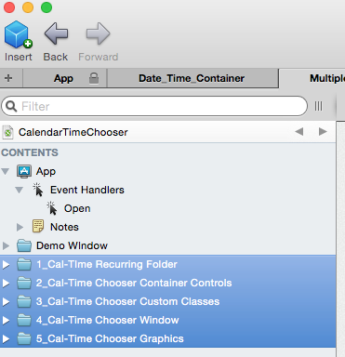

Figure 1. Depicts the six (6) folders that comprise the “Calendar and Time Chooser” project

1. Enable “GDI Plus” in your destination project (*for example: copy “app.UseGDIPlus=True” to your destination project app.open event*)

## Create instantiation of Options and DateTimeWindow

There are many ways to accomplish this step, but for this quick start example I will use a “PushButton” control that will be responsible for instantiating the “DateTimeWindow” and its options.

1. From the Xojo IDE drag a new “Class” to your project

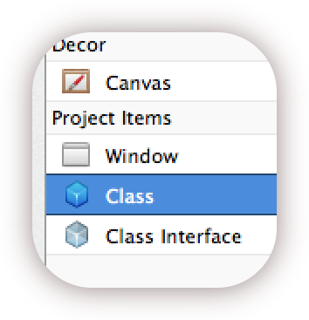

1. Name your new class “QS_PushButton”
2. Change it’s super class to “PushButton”

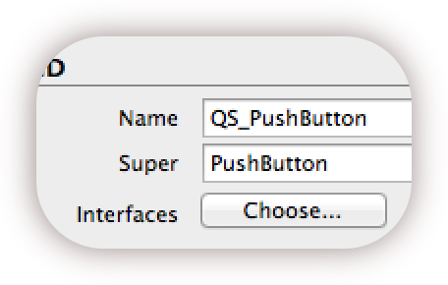

1. Add a new “Property” to the “QS_PushButton” and name it “CalTimeChooser”

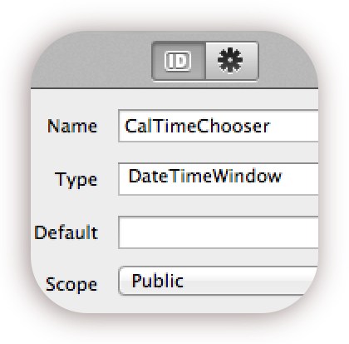

1. Change the “CalTimeChooser” property type to: DateTimeWindow
2. Add a method named “mSetOptions” to the “QS_PushButton”

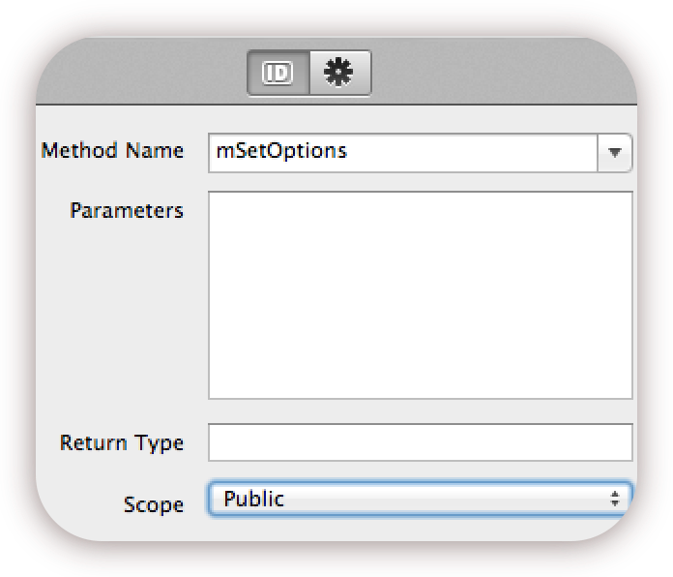

1. Add the following Code to the “mSetOptions” Method based on how you want this tool to behave in your project. (Detailed explanation of each option can be found on page 9)

// Chooser Type:

CalTimeChooser.VisiblePickers=Date_Time_Container.PickerElements.CalendarAndClock

// Chooser Window Back Color

CalTimeChooser.Date_Time_Container1.BackColor = RGB(239,239,239)

// Chooser Time Format

CalTimeChooser.Date_Time_Container1.Time_Container1.TimeMode = 12

// Chooser Clock Face Type

CalTimeChooser.ClockFaceType = Date_Time_Container.ClockFaceType.Chrome

// Chooser Clock Hands Type

CalTimeChooser.UseGraphicalClockHands=True

// Chooser Week Start

CalTimeChooser.WeekStartsOnMonday = False

// Chooser Calendar to include previous/next days on calendar

CalTimeChooser.IncludePrevNextMonthDays = True

// Calendar Localization

CalTimeChooser.LocalizationInt = 0 // 0-English

// Allow User to Select Multiple Calendar Days

CalTimeChooser.AllowMultipleCalendarSelections = False

// Calendar Start Year:: This date integer is your calendar's start date

CalTimeChooser.Date_Time_Container1.Calendar_Container1.Calendar1.StartYear = 1975

CalTimeChooser.Date_Time_Container1.Calendar_Container1.Calendar1.EndYear = 2052

1. Add the “Action” event to the “QS_PushButton”

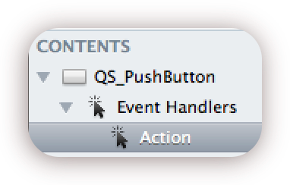

1. In the “Action” event add the following code:

CalTimeChooser = New DateTimeWindow

mSetOptions

1. Drag your newly-created custom “PushButton” control “QS_PushButton” onto a Window in your destination project

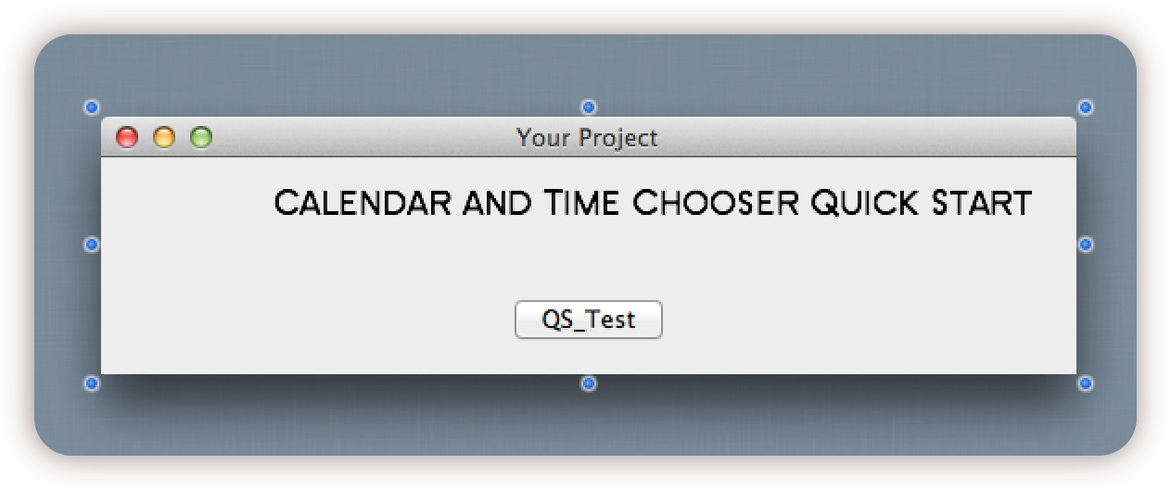

Quick start is now complete! Run your project in the IDE to see your project.

# Project Option Definitions

This section provides details for the “Calendar and Time” options that are available to change the behavior of this tool.

## General Options

|  |  |
| --- | --- |
| Calendar and Time Chooser Layout Option | |
| Description: | This option allows you to set which chooser is visible.  *Choose one option* |
| Choice #1 | CalTimeChooser.VisiblePickers=Date_Time_Container.PickerElements.CalendarAndClock |
| Choice #2 | CalTimeChooser.VisiblePickers=Date_Time_Container.PickerElements.CalendarOnly |
| Choice #3 | CalTimeChooser.VisiblePickers=Date_Time_Container.PickerElements.ClockOnly |

|  |  |
| --- | --- |
| Change Back Color of Chooser Window | |
| Description | This option will change the back color of the chooser (all choosers).  *Replace the RGB color with your desired color.* |
| Option | CalTimeChooser.Date_Time_Container1.BackColor = RGB(239,239,239) |

## Clock / Time Options

|  |  |
| --- | --- |
| Time Format | |
| Description | This option allows you to set which time format you would like.  *Choose one time format* |
| Option 1 | CalTimeChooser.Date_Time_Container1.Time_Container1.TimeMode = 12 |
| Option 2 | CalTimeChooser.Date_Time_Container1.Time_Container1.TimeMode = 24 |

|  |  |
| --- | --- |
| Clock Face Type | |
| Description | This option allows you to set which clock face is displayed graphically  *Choose one option* |
| Option 1 | CalTimeChooser.ClockFaceType = Date_Time_Container.ClockFaceType.Chrome |
| Option 2 | CalTimeChooser.ClockFaceType = Date_Time_Container.ClockFaceType.Antique |
| Option 3 | CalTimeChooser.ClockFaceType = Date_Time_Container.ClockFaceType.GoogleStyle |
| Option 4 | CalTimeChooser.ClockFaceType = Date_Time_Container.ClockFaceType.Dynamic_12hr |
| Option 5 | CalTimeChooser.ClockFaceType = Date_Time_Container.ClockFaceType.Modern |
| Option 6 | CalTimeChooser.ClockFaceType = Date_Time_Container.ClockFaceType.Roman |
| Option 7 | CalTimeChooser.ClockFaceType = Date_Time_Container.ClockFaceType.Standard |

|  |  |
| --- | --- |
| Choose Clock Hand Type | |
| Description | This option allows you to choose between the graphical clock hands or plain lines.  *Choose True or False* |
| Option | CalTimeChooser.UseGraphicalClockHands=True |

|  |  |
| --- | --- |
| Choose Clock Hand Color | |
| Description | This option allows you to the color of the minute and hour clock hands (second hand is always red) |
| Option | CalTimeChooser.Date_Time_Container1.ClockHandColor = RGB(120,20,200) |

## Calendar Options

|  |  |
| --- | --- |
| Week Begins on Monday | |
| Description | If False the week begins on Sunday  If True the week begins on Monday |
| Option 1 | CalTimeChooser.WeekStartsOnMonday = False |
| Option 2 | CalTimeChooser.WeekStartsOnMonday = True |

|  |  |
| --- | --- |
| Include / Exclude Previous/Next Months on Calendar View | |
| Description | This option enables or disables displaying the next and previous month days on the calendar. |
| Option 1 | CalTimeChooser.IncludePrevNextMonthDays = True |
| Option 2 | CalTimeChooser.IncludePrevNextMonthDays = False |

|  |  |
| --- | --- |
| Localization | |
| Description | Choose the localization Integer that you desire. |
| English | CalTimeChooser.LocalizationInt = 0 |
| French | CalTimeChooser.LocalizationInt = 1 |
| Swedish | CalTimeChooser.LocalizationInt = 2 |
| Italian | CalTimeChooser.LocalizationInt = 3 |
| Spanish | CalTimeChooser.LocalizationInt = 4 |
| Dutch | CalTimeChooser.LocalizationInt = 5 |
| German | CalTimeChooser.LocalizationInt = 6 |
| Afrikaans | CalTimeChooser.LocalizationInt = 7 |
| Polish | CalTimeChooser.LocalizationInt = 8 |
| Portuguese | CalTimeChooser.LocalizationInt = 9 |

|  |  |
| --- | --- |
| Allow Multiple Calendar Date Selections | |
| Description | If True then “Single” selection allowed only  If False then “Multiple” selection allowed |
| Option 1 | CalTimeChooser.AllowMultipleCalendarSelections = True |
| Option 2 | CalTimeChooser.AllowMultipleCalendarSelections = False |

|  |  |
| --- | --- |
| Calendar Start Year | |
| Description | Enter the “Start” year integer that you would like the calendar to allow user selection. |
| Option | CalTimeChooser.Date_Time_Container1.Calendar_Container1.Calendar1.StartYear = 1975 |

|  |  |
| --- | --- |
| Calendar End Year | |
| Description | Enter the “End” year integer that you would like the calendar to allow user selection. |
| Option | CalTimeChooser.Date_Time_Container1.Calendar_Container1.Calendar1.EndYear = 2175 |

# How Do I Set a Custom Date When The Calendar Starts?

You are able to preset a custom date for the calendar to open and select upon opening. This modification is made in a method that has a commented format example.

The default behavior is that the calendar will show open and start showing today’s date.

If you would like to change this default behavior please follow the steps in the Xojo IDE left navigation panel to make the changes.

1. Select on the folder named “3_Cal-Time Chooser Custom Classes”
2. Expand Calendar
3. Then Expand Calendar’s Methods
4. Select the SetCustomCalendarStartDate method (this method is yellow)

Now that you have this method that we will modify please take note on the following example that is provided to you (commented out) in the SetCustomCalendarStartDate method.

1. Uncomment the following code block in the SetCustomCalendarStartDate Method

// CurrentDate.Month = 5 // May

// CurrentDate.Day = 6

// CurrentDate.Year = 2042

2. Make the appropriate integer value changes that you desire.

3. Save you project and run it to see your new calendar starting date

Please Note: *All three values in this example are the data type of “INTEGER”.*

# How Do I Set the Calendars Starting Year and Ending Year?

Beginning with version 2.0.2 you are no longer able to set the start/end dates through the demo window and will be able to set these values in code. This was originally for demo purposes to showcase the feature, however keeping the “demo” option for this proved to be an OOP hassle. The following steps show in detail how to make these changes.

The default behavior is that the calendar will show starting year of “1905” and an ending year of “2061”.

If you would like to change this default behavior please following these steps in the Xojo IDE left navigation panel to make then changes.

1. Select on the folder named “3_Cal-Time Chooser Custom Classes”
2. Expand Calendar
3. Then Expand Calendar’s Methods
4. Select the SetCustomCalendarStartDate method (this method is yellow)

Now that you have this method that we will modify please take note on the following example that is provided to you (commented out) in the SetCustomCalendarStartDate method.

1, Uncomment the following code block in the SetCustomCalendarStartDate

CurrentDate.Month = 5 // May

CurrentDate.Day = 6

CurrentDate.Year = 2042

2. Make the appropriate integer value changes you desire.

3. Save you project and run it to see your new calendar starting date

Please Note: All three values in this example are the data type of “INTEGER”.

# How Do I Get the User Selected Results?

There are three custom event definitions, which will provide you the user selection results.

** *Please see Appendix for a visual representation of these Custom Events*

1. Calendar: Selected Date(s)
2. Calendar: Selected Recurring Type
3. Clock/Time: Selected Time

The following describes these events:

|  |  |
| --- | --- |
| **Calendar Date(s) Selection** | |
| Description | This event will contain the user’s selected date or dates which you may use in your application |
| Event Name | SelectedDate |
| Name Space | Date_Time_Container.Calendar_Container1 |
| Parameter Type | Date |

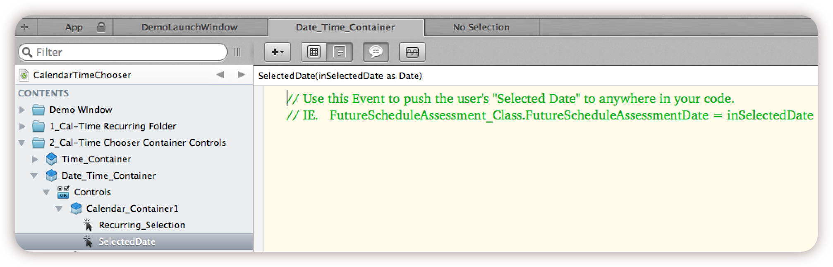

|  |  |
| --- | --- |
| **Calendar Recurring Selection Type** | |
| Description: | This event will contain the user’s recurring choice |
| Event Name: | Recurring_Selection |
| NameSpace: | Date_Time_Container.Calendar_Container1 |
| Parameter Type: | String |

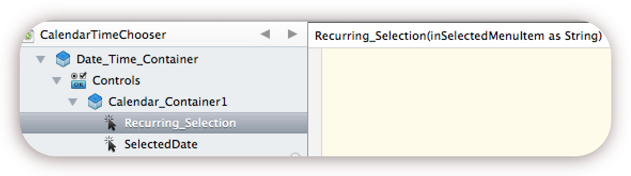

|  |  |
| --- | --- |
| **User Time Selection** | |
| Description: | This event will contain the user’s time selection |
| Event Name: | SelectedTime |
| NameSpace: | Date_Time_Container.Time_Container1 |
| Parameter Type: | Strings |

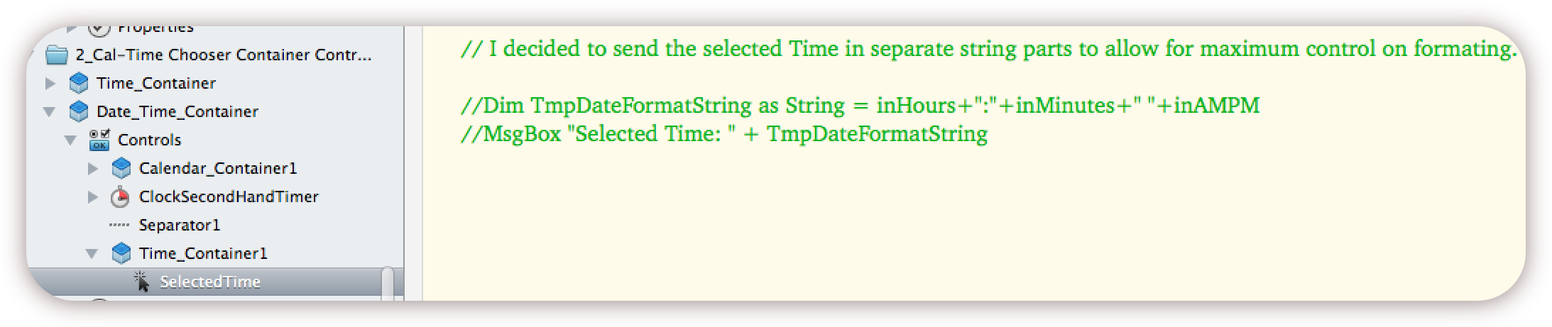

# How Do I Use the “SelectedTime” Custom Event?

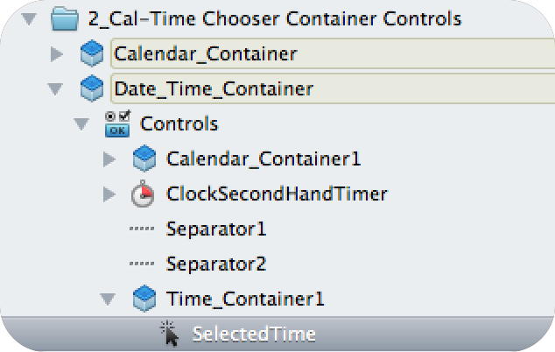

## SelectedTime Parameters

The “SelectedTime” event expects two (2) mandatory parameters with one (1) optional parameter. The goal was to provide as much flexibility to the coder by separating each time field. This allows the coder to choose exactly how they want to reassemble the time, instead of being forced into an unwanted format representation.

The following parameters as follows:

* inHours as String (mandatory)
* inMinutes as String (mandatory)
* inAMPM as String (optional and for 12 hour format only)

## Example Code

Here is example code that could be implemented in the “SelectedTime” event:

// 12 Hour Time Format

Dim TmpDateFormatString as String = inHours+":"+inMinutes+" "+inAMPM

// Now I can do something with TmpDateFormatString

OR

// 24 Hour Time Format

Dim TmpDateFormatString as String = inHours+":"+inMinutes

// Now I can do something with TmpDateFormatString

# How Do I Close This Chooser Now That It’s Open?

I purposely left it to you, the coder, on how to handle dismissing or closing the chooser when finished. I knew that some coders would like to have a “Cancel” and ”Close” button, while others may only want to enable the Keydown event for the “Escape key” or “Enter key”. Either way, this is the reason that this is not built in by default.

The following is an example that accomplishes adding a “Close” button to this project along with resizing the proper window and containers

## 1. Resizing the DateTimeWindow

We will first need to resize the “DateTimeWindow” height to 286 in order to make room for our controls to fit.

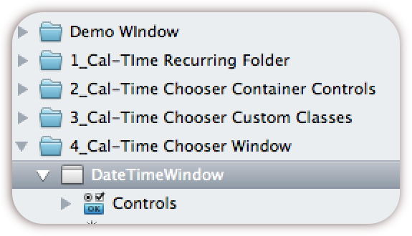

*Figure 7.1*

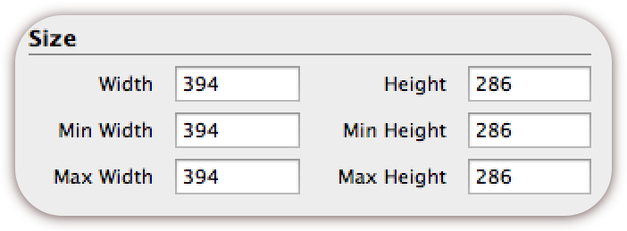

*Figure 7.2*

First change the height of the “DateTimeWindow” from 252 to 286 as shown above in *Figure 7.2*

## 2. Resizing the Date_Time_Container

Next we will need to resize the “Date_Time_Container” height from 252 to 286.

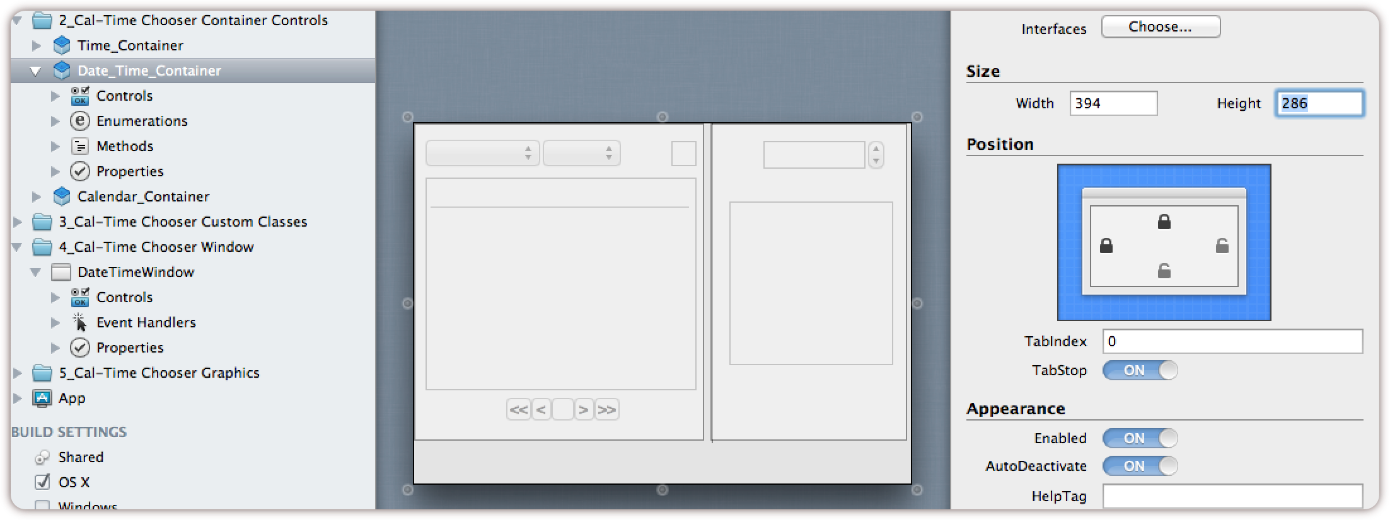

*Figure 7.3*

## 3. Change Setup Methods

When you select one of the following options “CalendarAndClock, ClockOnly, or CalendarOnly” during your implementation either one of the three below methods are launched. We must adjust their “Window.Height” line from 252 to 286

Change: mSetupForBothPickers

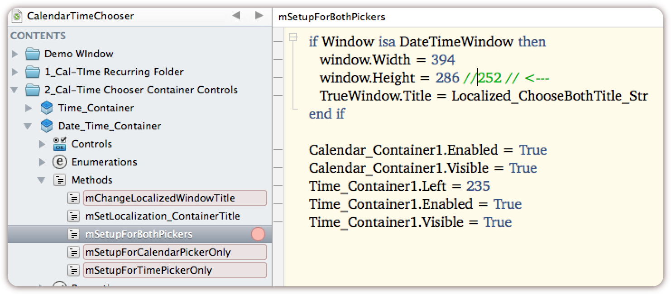

*Figure 7.4*

Change: mSetupForCalendarPickerOnly

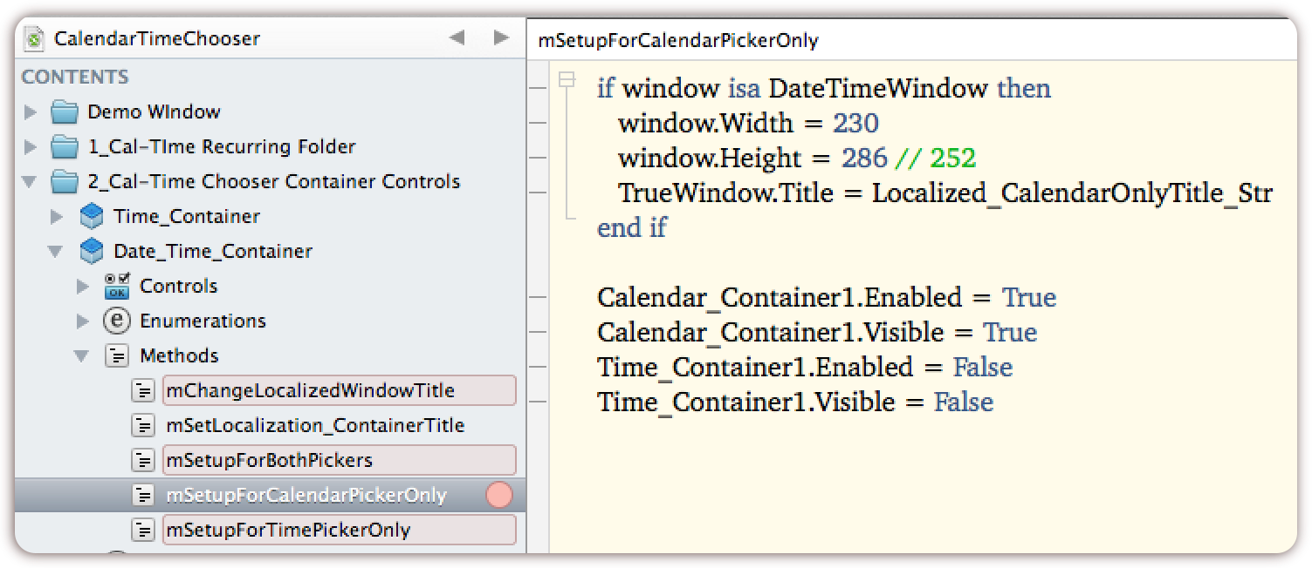

*Figure 7.5*

Change: mSetupForTimePickerOnly

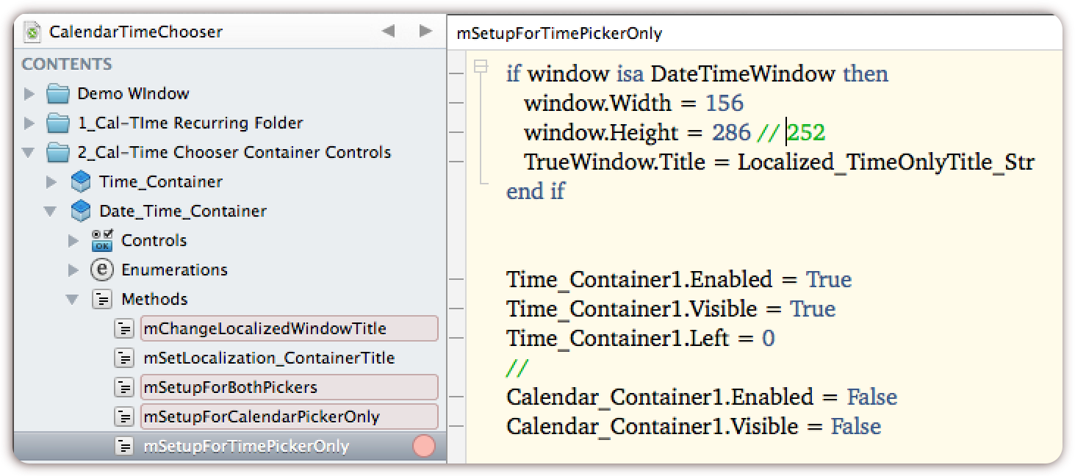

*Figure 7.6*

## 4. Add a new PushButton

In the Xojo IDE we will need to drag a new PushButton onto the project so we can turn it into the “Close” button for the Calendar/Time chooser tool. After all we need to close this after the user is finished right? ☺

1. In the Xojo IDE prepare to drag the “PushButton” control onto your project
2. Place the “PushButton” control onto the “Date_Time_Container” control (Looking on page 18 you see that this container is the Parent and a great place for this control)
3. Change the name of your new “PushButton” to “FinishedButton” and change its text to “Finished”
4. Add the “Action” event to the “FinishedButton”
5. To “Close” the control add the “Self.Close” code to the action event (see figure 7.7 below)

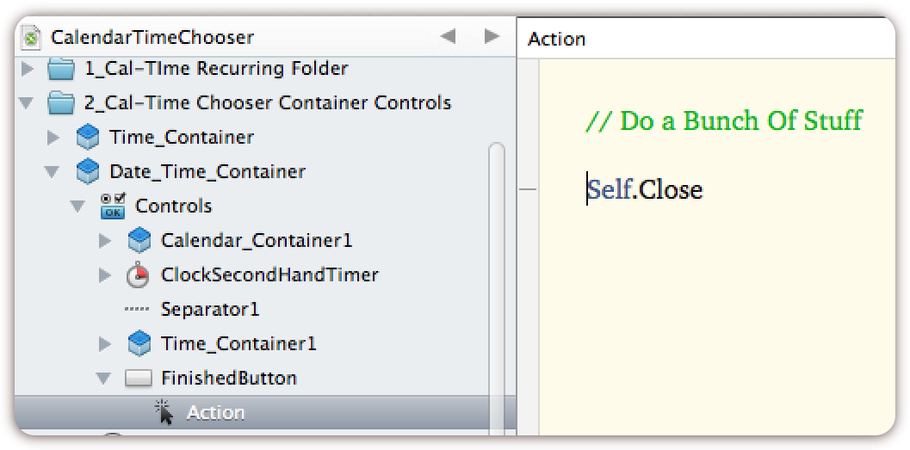

*Figure 7.7*

1. You are finished

# Appendix: OOP Structure:

The following illustration is a depiction of the object-oriented relationships between the windows, containers, and canvas classes.



# Custom Event Definition Structure:

